**WCAG2.1-Level aa &level aaa**

**Toheed Jahan Khan**

Accessibility Guidelines

Table of Contents

Introduction 2

Who do these guidelines support? 2

A Quick Review of Web Content Accessibility Guidelines (WCAG) 3

W3C principles 4

Principle 1- Perceivable 5

22 Guidelines 5

Principle 2 – Operable 9

Principle 3 – Understandable 12

Principle 4 – Robust 12

Conclusion 13

References 14

# Introduction

Accessibility is the practice of making products, devices, services, or environments as to be usable by many people as possible. We can think it as ,“ability to access”.  
We can also consider accessibility as treating every user the same and providing them equal opportunities, no matter what their situations and abilities are.

Nowadays just about everyone, everywhere, regardless of age and ability, uses a smartphone.

With that in mind, it’s more important than ever to consider all the different ways to make your app accessible to everyone to ensure an inclusive experience.

Awareness of accessibility in mobile application is growing. And many companies are realizing that providing a more equitable and inclusive experience to users allows them to broaden market reach and increase product competitiveness.

Accessibility is all about making applications available for everyone irrespective of their abilities with visual, auditory, or other cognitive impairments

### **Who do these guidelines support?**

* Low vision users – WCAG 2.1 extends contrast ratio requirements for graphics and introduces new guidelines for text and layout customization for web content and controls to support better visual perception.
* Users with cognitive, language, or learning disabilities – WCAG 2.1 includes requirements to provide additional information about the specific purpose of input controls and additional requirements to support timeouts due to inactivity.
* All users – realistically, WCAG 2.1 guidelines are all best practices to enhance usability and accessibility for all users of mobile devices.

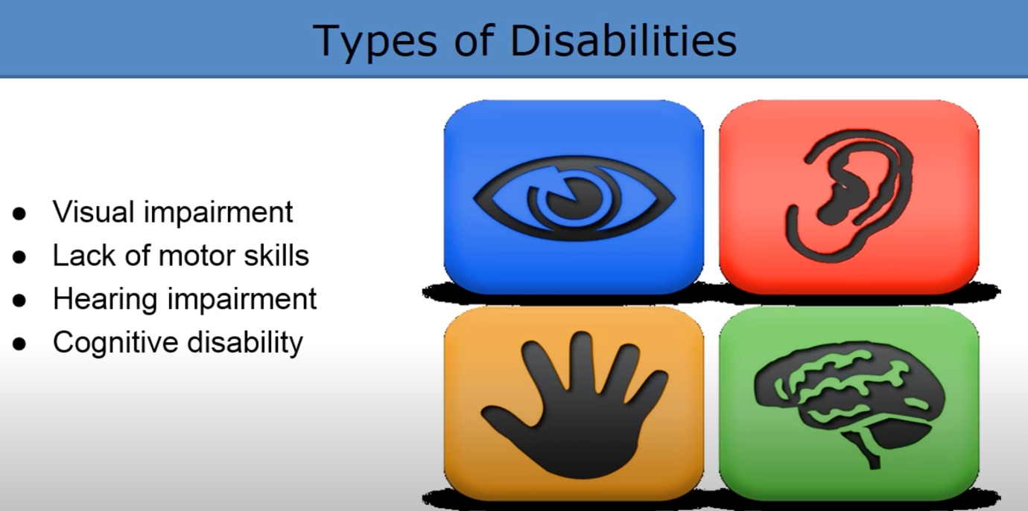

# A Quick Review of Web Content Accessibility Guidelines (WCAG)

The [Web Content Accessibility Guidelines](https://www.w3.org/WAI/standards-guidelines/wcag/) (WCAG) lays out a standard for digital accessibility. It was created and is maintained by the World Wide Web Consortium (W3C). Many international regulations are based on these guidelines, including the Communications and Video Accessibility Act (CVAA), Americans with Disabilities Act (sometimes referred to as ADA or Section 508) and Accessibility for Ontarians with Disabilities Act (AODA).

The Guidelines are comprised of 78 Success Criteria that define specific guidance for making the web or applications accessible.

In addition, the WCAG defines three levels of digital accessibility conformance: A, AA, and AAA.

The WCAG criteria aim to make web content more accessible to a wider audience of people with disabilities. All success criteria are important access issues for people with disabilities. They address things beyond the usability problems that might be faced by all users. There are three levels of WCAG compliance:

**WCAG Level A**- Minimum level(Considered the least strict) – without addressing these items, barriers exist that cannot be overcome by assistive technology.  This level affects the broadest group with the most benefits and is essential.

Level A success criteria are essential for every app. If your app doesn’t conform with WCAG Level A, it may have serious accessibility issues that prevent users with disabilities from using it.

**WCAG Level AA** - More accessible – With the minimum level of support, some barriers will still exist which impact certain groups of users.  The criteria at this level establish a level of accessibility which should work with most assistive technology on desktop and mobile devices. Addressing Level AA criteria may impact the look of a page or affect site logic to a greater extent. To meet this goal, app must conform with all Level AA and Level A success criteria.

**WCAG Level AAA** – Even more accessible(Optimal compliance)– App that conforms with WCAG Level AAA is considered optimally accessible. However, some Level AAA success criteria are extremely strict, and some AAA accessibility criteria cannot be applied everywhere.

The WCAG criteria are cumulative—to conform to WCAG Level AA, you must first conform to A. To conform to WCAG Level AAA accessibility criteria, you just first conform to A and AA.

When targeting a specific conformance level, it is helpful to have a checklist to work through the individual Success Criteria. However, keep in mind that all of the WCAG Success Criteria are important, and these are things that should be considered when developing web content and applications to ensure accessibility.

**Level A Success Criteria** are those which will have a high impact on a broad array of user populations. In other words, they (usually) don’t focus on one type of disability only. They will also have the lowest impact on the presentation logic and business logic of the site or application. Finally, implementation of these requirements will typically be the easiest.

**Level AA Success Criteria** will also have a high impact for users. Sometimes only specific user populations will be impacted, but the impact is important. Adherence to these Success Criteria may impose changes to a system or site’s presentation logic or business logic.

**Level AAA Success Criteria** are often focused on improvements for specific user populations. They may be difficult or expensive to adhere to, depending on platform limitations.

# W3C principles

The W3C has arranged the Guidelines around the following four principles. These principles lay the foundation necessary for functional access to web content and web applications.

**Perceivable**- Users must be able to perceive the information being presented (information cannot be dependent on single sensory capabilities, such as sight or hearing).

Application should be perceivable to a deaf, colour-blind, low vision or blind user.

**Operable** - Users must be able to operate the interface (the interface cannot require interaction that a user may not be able to perform, such as mouse-only operation).

**Understandable** - Users must be able to understand the information as well as the operation of the user interface (the content or operation cannot be beyond the users understanding).

Application interactions should be easy to understand. Screens components should be clear and naming should be meaningful?

**Robust**- Users must be able to access the content with a wide variety of user agents, including assistive technologies (as technologies and user agents evolve, the content should remain accessible). Application should support a variety of devices .

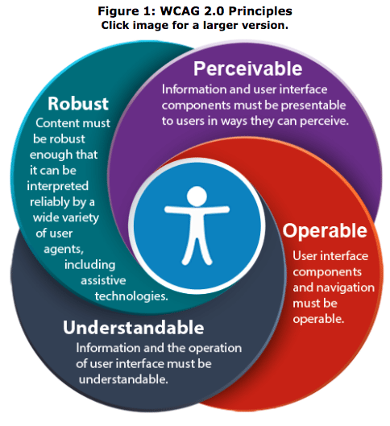

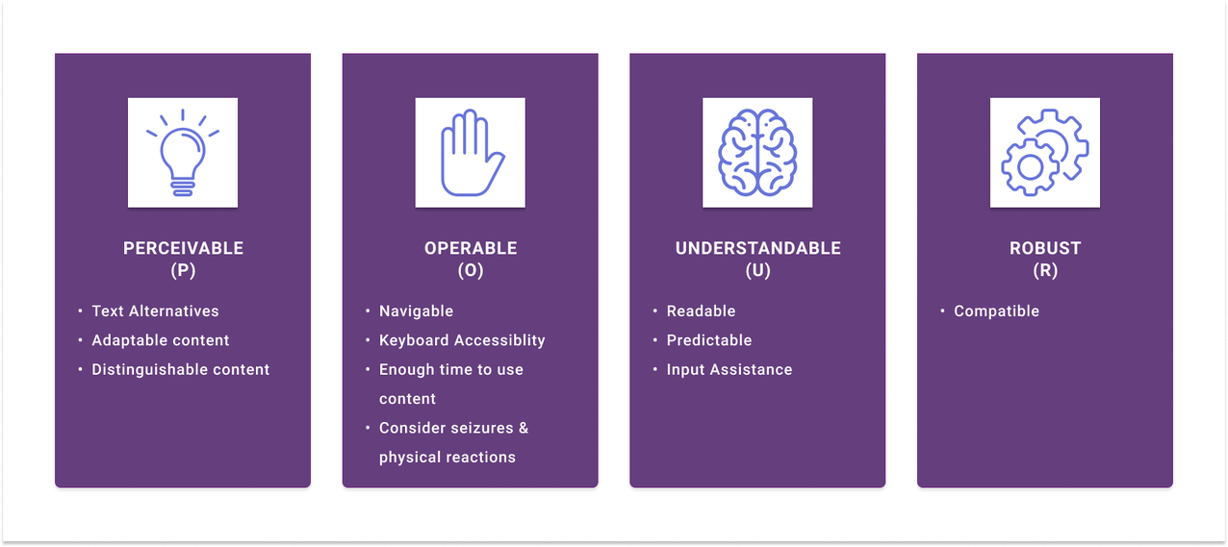

## Principle 1- Perceivable

Users must be able to perceive the information being presented (it can't be invisible to all of their senses). Does your site or application provide text alternatives for images or other non-text content?

The Guidelines under this Principle state that you should provide text alternatives for non-text content, captions and other alternatives for multimedia, making it easier for users to see and hear content. Create content that can be presented in different ways, including by assistive technologies, without losing meaning.

The perceivable principle ensures that who do not have command of one or more of their natural senses due to impairments, such as blindness or deafness. Guidelines categorized as Perceivable test whether content (e.g. audio, or image) has alternatives perceivable by people with a disability.

Content is discernible by all users, including those

### 22 Guidelines

#### Guideline 1.2 – Time-based Media

Provide alternatives for time-based media.

|  |  |
| --- | --- |
| **Level AA** | **Level AAA** |
| [**1.2.4 Captions (Live)**](https://www.w3.org/WAI/WCAG21/Understanding/captions-live.html)  Captions are provided for all live audio content in synchronized media. | [**1.2.6 Sign Language (Pre-recorded)**](https://www.w3.org/WAI/WCAG21/Understanding/sign-language-prerecorded.html)  Sign language interpretation is provided for all pre-recorded audio content in synchronized media. |
| [**1.2.5Audio Description (Pre-recorded)**](https://www.w3.org/WAI/WCAG21/Understanding/audio-description-prerecorded.html)  Audio description is provided for all pre-recorded video content in synchronized media. | [**1.2.7Extended Audio Description (Pre-recorded)**](https://www.w3.org/WAI/WCAG21/Understanding/extended-audio-description-prerecorded.html)  Where pauses in foreground audio are insufficient to allow audio descriptions to convey the sense of the video, extended audio description is provided for all pre-recorded video content in synchronized media. |

#### Guideline 1.3 – Adaptable

Create content that can be presented in different ways (for example simpler layout) without losing information or structure.

|  |
| --- |
| **Level AA** |
| **[1.3.4Orientation](https://www.w3.org/WAI/WCAG21/Understanding/orientation)** (Added in 2.1)  Content does not restrict its view and operation to a single display orientation, such as portrait or landscape, unless a specific display orientation is essential.  **Examples** where a particular display orientation may be essential are a bank check, a piano application, slides for a projector or television, or virtual reality content where content is not necessarily restricted to landscape or portrait display orientation.  Devices like smart phones & hand-held tablets have the feature of accessing the content in landscape & portrait modes. As & when the device is rotated the sensors in these devices identify the position off the device & content is displayed accordingly. The intent of this success criterion is to make sure that developers don’t restrict the usage of a mobile application or website to work in a specific mode. People with motor impairments tend to fix the devices to their wheel chair or use specifically landscape or portrait mode as it helps the users to access the content easily. Low vision and blind userslock the device either in portrait or landscape mode. When the application is rendered in the device it should render the content in whichever mode the user has chosen.  If the mobile application or the website doesn’t work in both landscape & portrait modes, then it fails this success criterion. When an application or website is moved from portrait mode to landscape mode there might be some loss of content or functionality & this is not a failure of this success criterion. In landscape mode we generally tend to have more space & hence the content will be aligned accordingly.  **Exceptions**  There are some exceptions provided for this success criterion as some content cannot be rendered in portrait mode, some of these exceptions are:  **To capture a check**: the process in a banking app can be performed only in landscape due to the larger width compared with the height of the check. In landscape mode the width is usually more than height.  A Piano app can only be accessed in landscape so that all the keys of the app can be effectively used.  **Points to Ponder**   * Don’t restrict your application or website to just work in landscape or portrait mode. * Make sure to honour the device settings while displaying the application in landscape or portrait mode. |

#### Guideline 1.4 – Distinguishable

Make it easier for users to see and hear content including separating foreground from background.

|  |  |
| --- | --- |
| Level AA | Level AAA |
| [**1.4.****3Contrast (Minimum)**](https://www.w3.org/WAI/WCAG21/Understanding/extended-audio-description-prerecorded.html)  The visual presentation of text and images of text has a contrast ratio of at least 4.5:1, except for the following  **Large Text**: Large-scale text and images of large-scale text have a contrast ratio of at least 3:1;  **Incidental**: Text or images of text that are part of an inactive user interface component, that are pure decoration, that are not visible to anyone, or that are part of a picture that contains significant other visual content, have no contrast requirement.  **Logotypes**: Text that is part of a logo or brand name has no contrast requirement. **Sufficient Techniques** **Situation A**: text is less than 18 point if not bold and less than 14 point if bold. **4.5:1**  **Situation B**: text is at least 18 point if not bold and at least 14 point if bold**. 3:1** | [**1.4.6Contrast (Enhanced)**](https://www.w3.org/WAI/WCAG21/Understanding/contrast-enhanced.html)  The visual presentation of text and images of text has a contrast ratio of at least 7:1, except for the following:  Hide full description  **Large Text**: Large-scale text and images of large-scale text have a contrast ratio of at least 4.5:1;  **Incidental**: Text or images of text that are part of an inactive user interface component, that are pure decoration, that are not visible to anyone, or that are part of a picture that contains significant other visual content, have no contrast requirement.  **Logotypes**: Text that is part of a logo or brand name has no contrast requirement. **Sufficient Techniques** **Situation A**: text is less than 18 point if not bold and less than 14 point if bold. **7:1**  **Situation B**: text is at least 18 point if not bold and at least 14 point if bold**. 4.5:1** |
| [**1.4.4Resize text**](https://www.w3.org/WAI/WCAG21/Understanding/resize-text.html)  Except for captions and images of text, text can be resized without assistive technology up to 200 percent without loss of content or functionality. |  |
| **[1.4.10Reflow](https://www.w3.org/WAI/WCAG21/Understanding/reflow)**  Content can be presented without loss of information or functionality, and without requiring scrolling in two dimensions for   * Vertical scrolling content at a width equivalent to 320 CSS pixels; * Horizontal scrolling content at a height equivalent to 256 CSS pixels;   Except for parts of the content which require two-dimensional layout for usage or meaning.  The intent is to support low vision users by enabling easier readability and tracking through responsive design. |  |
| **[1.4.11Non-text Contrast](https://www.w3.org/WAI/WCAG21/Understanding/non-text-contrast.html) (Added in 2.1)**  The visual presentation of the user interface components and graphical objects has a contrast ratio of at least 3:1 against adjacent colors.  WCAG defines user interface components as a part of the content that the user perceives as a single control for distinct function  Examples include – links, buttons, text inputs and check boxes.  Notice that these criteria doesn’t apply to inactive user interface components.  Examples of graphical objects include icons and graphs.  Notice not every part of a graph or icon needs to contrast with every other part but rather only the parts that are necessary to convey the relevant information.  The intent of the success criterion is to ensure that active user interface components and meaningful graphics can be distinguished by people with moderately low vision without the need of additional assistive technologies  is to support low vision users who many not see a full range of colors. |  |
| **[1.4.12Text Spacing](https://www.w3.org/WAI/WCAG21/Understanding/text-spacing)** (Added in 2.1)  In content implemented using markup languages that support the following text style properties, no loss of content or functionality occurs by setting all of the following and by changing no other style property.   * Line height (line spacing) to at least 1.5 times the font size; * Spacing following paragraphs to at least 2 times the font size; * Letter spacing (tracking) to at least 0.12 times the font size; * Word spacing to at least 0.16 times the font size.   **Exception**: Human languages and scripts that do not make use of one or more of these text style properties in written text can conform using only the properties that exist for that combination of language and script.  **Accessible Spacing and White Space**  Adding more padding around the text provides a less cluttered experience and reduces the cognitive load on the user. |  |

## Principle 2 – Operable

Operability, the second principle, pertains to the idea all features should be fully employable by everyone, regardless of the limitations of the user. An example of a failure for the operable principle would be an application that does not allow for alternative control input, such as a keyboard, or one that has set time limits for actions. Give users enough time to read and use content. Both of the mentioned examples could impede the operability of a mobile application for an individual with a motor disability.

User interface components and navigation must be operable. This means that users must be able to operate the interface (the interface cannot require interaction that a user cannot perform).

Make all functionality available from a keyboard.

#### Guideline 2.1 – Keyboard Accessible

Make all functionality available from a keyboard.

|  |
| --- |
| **Level AAA** |
| [2.1.3Keyboard](https://www.w3.org/WAI/WCAG21/Understanding/keyboard-no-exception.html) (No Exception)  All functionality of the content is operable through a keyboard interface without requiring specific timings for individual keystrokes. |

#### Guideline 2.2 – Enough Time

Provide users enough time to read and use content.

|  |
| --- |
| **Level AAA** |
| [**2.2.3 No Timing**](https://www.w3.org/WAI/WCAG21/Understanding/no-timing.html)  Timing is not an essential part of the event or activity presented by the content, except for non-interactive synchronized media and real-time events. |
| [**2.2.4 Interruptions**](https://www.w3.org/WAI/WCAG21/Understanding/interruptions.html)  Interruptions can be postponed or suppressed by the user, except interruptions involving an emergency. |
| [**2.2.5 Re-authenticating**](https://www.w3.org/WAI/WCAG21/Understanding/re-authenticating.html)  When an authenticated session expires, the user can continue the activity without loss of data after re-authenticating. |
| [**2.2.6 Timeouts**](https://www.w3.org/WAI/WCAG21/Understanding/timeouts)(Added in 2.1)  Users are warned of the duration of any user inactivity that could cause data loss, unless the data is preserved for more than 20 hours when the user does not take any actions.  Example – Banking applications – session timeouts |

#### Guideline 2.3 – Seizures and Physical Reactions

Do not design content in a way that is known to cause seizures or physical reactions.

|  |
| --- |
| **Level AAA** |
| [**2.3.3Animation from Interactions**](https://www.w3.org/WAI/WCAG21/Understanding/animation-from-interactions) (Added in 2.1)  Motion animation triggered by interaction can be disabled, unless the animation is essential to the functionality or the information being conveyed.   * [**iOS:** Reduce Motion on iPhone, iPad or iPod touch](https://support.apple.com/en-gb/HT202655)   **NOTE**  The impact of animation on people with vestibular disorders can be quite severe. Triggered reactions include nausea, migraine headaches, and potentially needing bed rest to recover. |

#### Guideline 2.4 – Navigable

Provide ways to help users navigate, find content, and determine where they are.

|  |  |
| --- | --- |
| **Level AA** | **Level AAA** |
| **[2.4.6 Headings and Labels](https://www.w3.org/WAI/WCAG21/Understanding/headings-and-labels.html)**  Headings and labels describe topic or purpose.  The intent of this success criterion is help users understand what information is on the screen and how that information is organized. When headings and labels are clear and descriptive users can find the information they seek more easily and can understand the relationships between different parts of their content more easily.  Descriptive headings are especially useful for users who have disabilities that make reading slow or for people with limited short-term memory. Form Input controls with labels that clearly describe the content and format that is expected to be entered helps users successfully complete each form. | [**2.4.9 Link Purpose (Link Only)**](https://www.w3.org/WAI/WCAG21/Understanding/link-purpose-link-only.html)  A mechanism is available to allow the purpose of each link to be identified from link text alone, except where the purpose of the link would be ambiguous to users in general. |
| **[2.4.7 Focus Visible](https://www.w3.org/WAI/WCAG21/Understanding/focus-visible.html)**  Any keyboard operable user interface has a mode of operation where the keyboard focus indicator is visible. |  |

#### Guideline 2.5 – Input Modalities

Make it easier for users to operate functionality through various inputs beyond keyboard.

|  |
| --- |
| **Level AA** |
| [**2.5.5 Target Size**](https://www.w3.org/WAI/WCAG21/Understanding/target-size) (Added in 2.1)  Apple’s [iPhone Human Interface Guidelines](https://developer.apple.com/iphone/library/documentation/UserExperience/Conceptual/MobileHIG/DesigningNativeApp/DesigningNativeApp.html#//apple_ref/doc/uid/TP40006556-CH4-SW1) recommends a minimum target size of 44 pixels wide 44 pixels tall.  **Reasons why size matters**  In archery, hitting bullseye is the most difficult shot to make. This is because the target area is the smallest on the board. The same concept applies to mobile interface design.  For example, users that are of an older demographic might not be able to easily tap smaller buttons in your UI. When we design buttons that take up most of the width of the screen it will allow them to successfully complete the action more often.  Small targets are difficult to tap accurately. This requires more cognitive effort for the user and can leave them feeling frustrated and dissatisfied after making mistakes. |
| [**2.5.6 Concurrent Input Mechanisms**](https://www.w3.org/WAI/WCAG21/Understanding/concurrent-input-mechanisms) (Added in 2.1)  This success criterion is intended to ensure that users will not be required to interact with their device in a certain way, and will be allowed to use their preferred input method. Users may change between mobile and Bluetooth keyboards, or between assistive technologies, depending on their changing context.  **Exceptions**:  For the purposes of this success criterion, limitations to input method may be essential if required for security purposes, or if it would affect the functionality of the page, such as a web page that teaches people to type not recognizing speech inputs.  **Who it helps:**  Users who use a bluetooth keyboard to interact with a mobile touchscreen device.  Users who use multiple input methods: A user may switch between speech input when they are working alone and keyboard input when they are talking with a co-worker.  The user must be able to switch between different input devices while working with your content. You cannot assume that someone on a mobile device will only use touch. They may also use speech input and they may attach a keyboard. A speech input user may prefer to switch to the keyboard when entering a password to protect privacy. Many laptop computers provide a keyboard and touch screen and the user can switch from one to the other.  Certain applications require the use of a particular input device to perform a task. For example, a mobile application that teaches the finger positions of guitar chords requires a touch interface. The touch interface is essential to teaching the user to play the guitar.  **Who Benefits?**  People with repetitive stress injuries may use different input devices to avoid overuse or pain. They may switch between speech, mouse, and keyboard depending upon the content. People with hand tremors who have difficulty activating small targets may prefer using the keyboard to navigate to items. Everyone benefits when we can use the input mechanism of choice for each task. An example is my iPad Pro with a detachable keyboard. I usually prefer the keyboard because I can type faster on a physical keyboard. However, if I fold the keyboard away, the onscreen keyboard displays and I can continue with it. When I unfold the physical keyboard, the onscreen keyboard goes away. Correctly coded applications will switch between the keyboard methods seamlessly.  Test your content with various input mechanisms, speech, mouse/pointer, touch, and keyboard. Make certain the user can switch between different input types. |

## Principle 3 – Understandable

Information and the operation of the user interface must be understandable.

Users must be able to understand the information as well as the operation of the user interface (the content or operation cannot be beyond their understanding).

Information and user interface components must be presentable to users in ways they can perceive. This means that users must be able to perceive the information being presented (it can't be invisible to all of their senses).

Provide text alternatives for non-text content. Provide captions and other alternative for multimedia.

Create content that can be presented in different ways, including by assistive technologies, without losing meaning. Make it easier for users to see and hear content.

#### Guideline 3.2 – Predictable

Make Web pages appear and operate in predictable ways

|  |
| --- |
| **Level AA** |
| **3.2.3Consistent Navigation**  When navigation mechanisms are repeated then they must occur in the same relative order each time they are repeated unless a specific change is initiated by the user. The intent of the success criterion is to encourage the use of consistent presentation and layout for the user who interact with repeated content or need to access specific information or functionality more than once.  Consistence navigation allows users to predict the location of the content they are looking for and find it quickly when they encounter it again |

## Principle 4 – Robust

Content must be robust enough that it can be interpreted by a wide variety of user agents, including assistive technologies.

Users must be able to access the content as technologies advance (as technologies and user agents evolve, the content should remain accessible).

Information and user interface components must be presentable to users in ways they can perceive. This means that users must be able to perceive the information being presented (it can't be invisible to all of their senses).

Provide [text alternatives](http://www.w3.org/WAI/WCAG20/quickref/#text-equiv) for non-text content.

Provide [captions and other alternatives](http://www.w3.org/WAI/WCAG20/quickref/#media-equiv) for multimedia.

Create content that can be [presented in different ways](http://www.w3.org/WAI/WCAG20/quickref/#content-structure-separation), including by assistive technologies, without losing meaning.

Make it easier for users to [see and hear content.](http://www.w3.org/WAI/WCAG20/quickref/#visual-audio-contrast)

#### Guideline 4.1 – Compatible

Maximize compatibility with current and future user agents, including assistive technologies.

|  |
| --- |
| **Level AA** |
| [**4.1.3 Status Messages**](https://www.w3.org/WAI/WCAG21/Understanding/status-messages)  (Added in 2.1)  In content implemented using markup languages, status messages can be programmatically determined through role or properties such that they can be presented to the user by assistive technologies without receiving focus.  **What are status messages?**  Success toasts, form errors, cart updates, interstitial loading indicators, dynamically updating number of search results are some examples of status messages. Note that the focus does not shift to such messages but visual users are aware of them. Also, any modification of status messages, off-screen messages like delete confirmation can be considered as status messages.  **How do we meet this criterion?**  With the evolution of ARIA, automatic announcement of status messages in web pages are now possible. We can use either aria-live regions or role=”alert” to announce the status updates. However, we need to practise caution. Too much of aria-live regions would kill accessibility. For example, a page contains a carousel that updates automatically. Now, do we announce the slide change through aria-live? First, such a dynamic update is a status message? The answer is ‘a double no.’ This is a content update and not a status message. Besides, such live region usage will interfere with screen readers preventing the users from performing the primary tasks. Note that mobile apps also must announce status messages with appropriate roles and properties applicable within the mobile programming languages.  **Points to Ponder**   * Ensure all success toasts and error messages are announced by screen reader * Do not fill the pages with live regions. Decide which is an important update and qualifies a status message intelligently * Ensure focusable messages are not considered as status messages. |

# Conclusion

Develop your mobile apps with accessibility in mind. Accessibility is not only a “nice” thing to do — your app quality increases as you make it more accessible.

Incorporating all of these accessibility features into your app can be a challenge. But with that said, it’s really worth it in the long run. First of all, trying your best to accommodate people with disabilities is just the right thing to do.

However, by doing so, you’re also broadening your scope and opening up your app to a whole new audience.

Certain people may have initially been discouraged from downloading or using your mobile app.

Once you implement these accessibility features you’ll end up making more money from new users.

The checklist above is a great resource to help you get started on the right track to making your app as accessible as possible.

Incorporate these best practices and you can be sure that your app will be a success today as well as tomorrow.

Many companies don't want to deal with accessibility because they're worried it'll take a long time to incorporate and comes with a significant cost burden. However, accessibility shouldn't be seen as an add-on feature but as an essential part of your mobile app.

An excellent approach to accessibility is to build accessibility into your app workflow rather than address it at the end. When you build an accessible mobile app, you make your app inclusive of everyone, both with and without a disability. With a tool like **Bitrise**, you can automate accessibility checks for your mobile apps and confidently roll out apps that meet accessibility standards.

Mobile apps including mobile web apps may be subject to one or more accessibility standards. Additionally, the main international standards for accessible web content the WCAG 2 Guidelines are a good foundation for ensuring mobile apps are accessible to people with disabilities.

# References

[How to Meet WCAG (Quick Reference)](https://www.w3.org/WAI/WCAG21/quickref/?versions=2.1&showtechniques=124%2C143&currentsidebar=%23col_overview&levels=a&technologies=html%2Ccss%2Cwai-aria%2Cjs%2Cserver%2Csmil%2Cpdf%2Cflash%2Csl#audio-only-and-video-only-prerecorded)

[Pearson - Accessibility-guidance-for-assessment](https://accessibility.pearson.com/guidelines/accessibility-guidance-for-assessment/content/)