**Project Report  
  
ShikshaSarthi Chandrapur**

***Empowering Unemployed Graduates as Private Tutors in Chandrapur***

Submitted by: Naheed N. Hussain

# 1. Executive Summary

ShikshaSarthi Chandrapur is a social initiative to enroll and train unemployed graduates/postgraduates in Chandrapur to become private tutors for students from Class 1 to 10. The platform offers free registration, structured training, localized tutoring opportunities, and school placement assistance to empower aspiring educators and improve grassroots education.

# 2. Objectives

* Identify and register aspiring tutors (graduates/postgraduates).
* Provide structured training on pedagogy, communication, and subject expertise.
* Connect tutors with local students (1st to 10th standard).
* Build a verified tutor database for Chandrapur schools.
* Generate employment and raise educational outcomes.

# 3. Target Group

Unemployed graduates/postgraduates from Chandrapur seeking to become private tutors. End users include students (Classes 1 to 10) and private schools.

# 4. Project Phases

* Phase 1: Data Collection & Free Registration
* Phase 2: Training & Certification Program (15-30 days)
* Phase 3: Tutor-Student Matching based on locality
* Phase 4: Recommendation for private/CBSE school recruitment

# 5. Resources Needed

* Digital platform (website & app)
* Training team & coordinators
* Marketing tools and posters
* Offline centers for training & demo classes

# 6. Estimated Budget (Year 1)

| Expense Head | Estimated Cost |
| --- | --- |
| Digital Platform Development | ₹3,00,000 |
| Field Staff & Training Experts | ₹5,00,000 |
| Training Materials & Venue | ₹1,50,000 |
| Promotions and Outreach | ₹2,00,000 |
| Miscellaneous/Admin | ₹1,00,000 |
| Total | ₹12,50,000 |

# 7. Expected Outcomes

* 500+ aspiring tutors enrolled
* 300+ tutors placed with local students
* 3000+ students benefitting from tuitions
* 100+ tutors recommended for school jobs

# 8. Key Challenges & Solutions

* Lack of experience – Solution: Practical training and mentoring
* Mobility – Solution: Match tutors within walking distance
* Quality assurance – Solution: Feedback from parents and periodic reviews
* Parental trust – Solution: Provide ID cards and demo classes
* Sustainability – Solution: Partner with CSR, NGOs, and schools

# 9. Long-Term Vision

Make Chandrapur a district-wide model for private tutoring, expand to nearby districts, reduce dropout rates, and enhance learning outcomes sustainably.

# 10. Infographics & Visual Data

## Budget Allocation Pie Chart

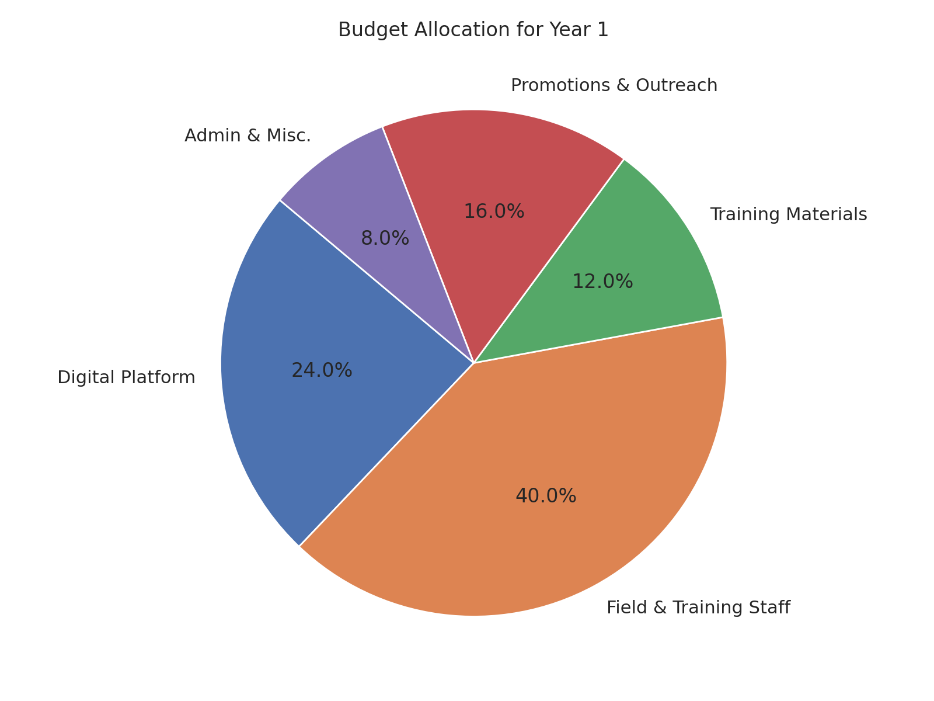

This chart represents the estimated distribution of the Year 1 budget across major components.

## Tutor Enrollment Flow

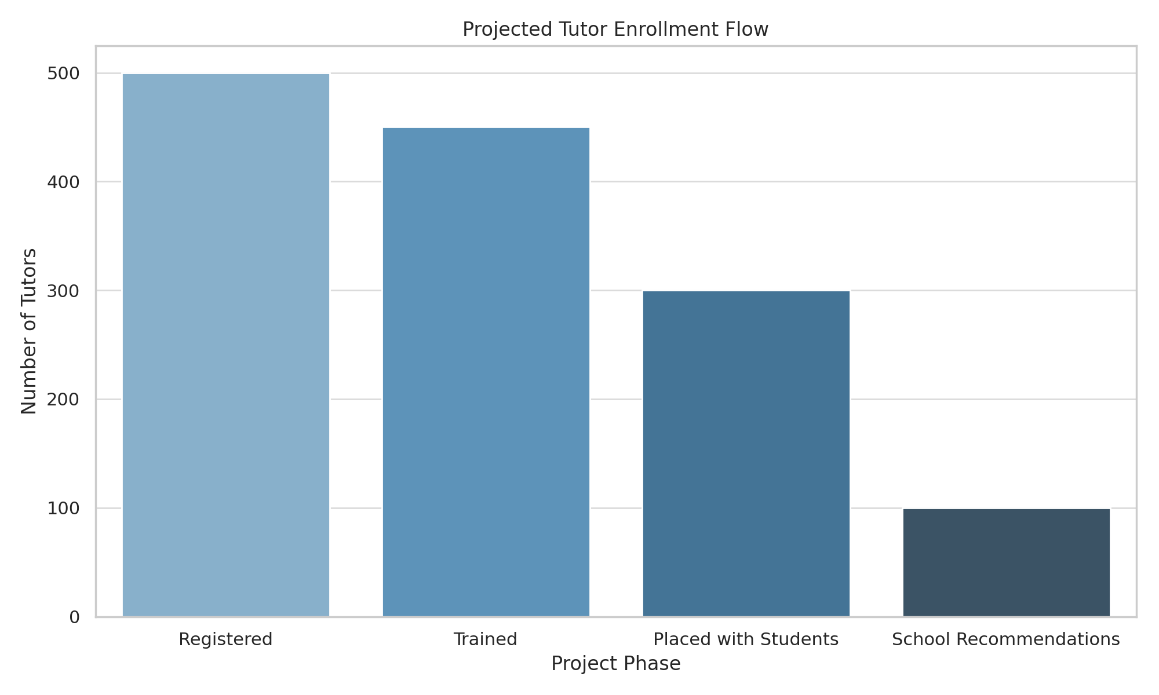

This bar graph illustrates the projected flow of tutors from registration to school recommendations.

## Tutor-Student Mapping Projection

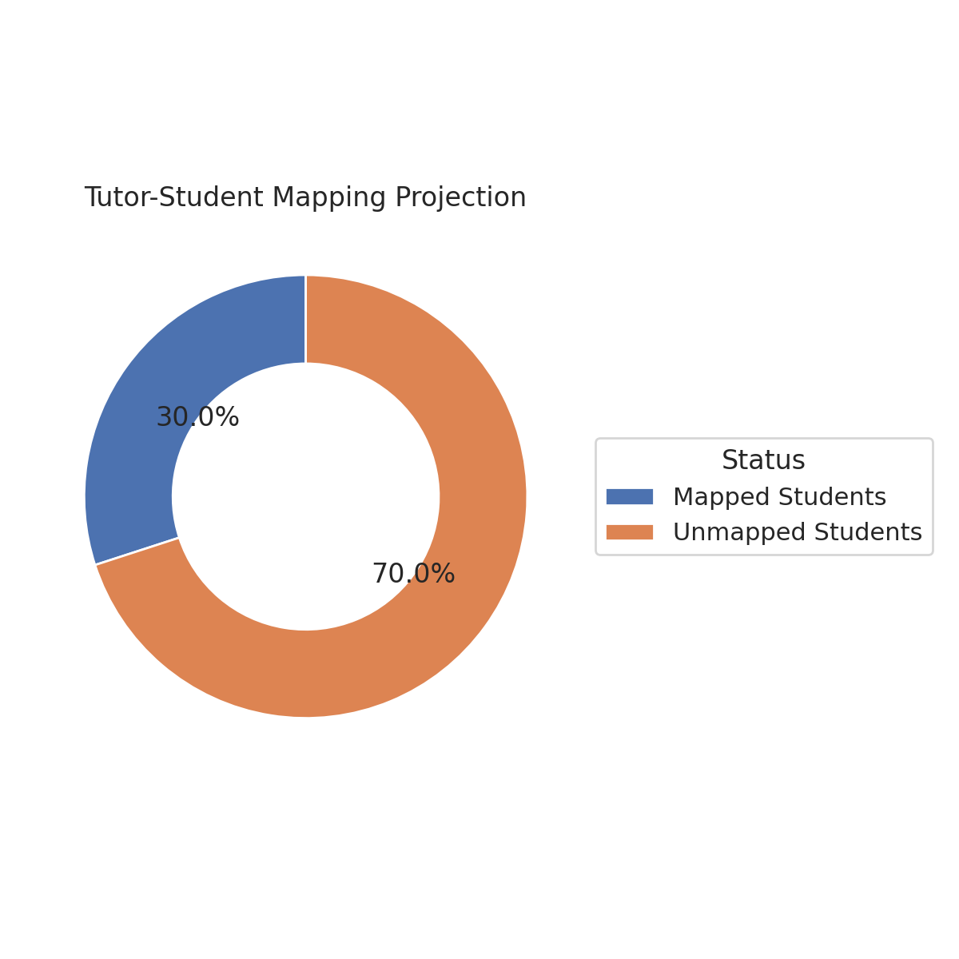

This doughnut chart shows the projected proportion of students successfully mapped to trained tutors.

Office address- Shikshsarthi

Shahin Apartment Near Alfalah Masjid Mul Road Chandrapur-442401 (M.S)

Contact-9422835926/8788422886