

**CSE 103: Structured Programming**

**Spring 2019**

**East West University**

**Department of computer Science and Engineering**

**PROJECT**

**UNIT CONVERTER**

**SUBMITTED**

**BY**

**Md Tohidul Haque Sagar**

**SUBMITTED**

**TO**

**Dr. Ahmed Wasif Reza**

**Chairperson**

**Department of Computer Science and Engineering**

**East West University**

**CSE103 – Structured Programming**

**Project Evaluation Rubrics**

|  |  |  |  |  |
| --- | --- | --- | --- | --- |
|  |  | **Max.** |  | **Awarded** |
|  | |  |  |  |
| **A. Report** | |  |  |  |
|  |  |  |  |  |
| i. | Introduction / Problem statement |  |  |  |
|  |  |  |  |  |
| iv. | System Design |  |  |  |
|  |  |  |  |  |
| v. | Program output (Screen shots) |  |  |  |
|  |  |  |  |  |
| vi. | Source code |  |  |  |
|  | |  |  |  |
| vii. Disk/CD neatly attached (Y/N) | |  |  |  |
|  | |  |  |  |
|  | |  |  |  |
| **B. Source Code** | |  |  |  |
|  |  |  |  |  |
| i. | Style |  |  |  |
|  |  |  |  |  |
|  | Indentation |  |  |  |
|  |  |  |  |  |
|  | Self-documentation |  |  |  |
|  |  |  |  |  |
| ii. | Modularity (small size functions) |  |  |  |
|  |  |  |  |  |
| iii. | Error reporting capabilities |  |  |  |
|  |  |  |  |  |
| iv. | Code efficiency, strategy, and originality |  |  |  |
|  | |  |  |  |
|  | |  |  |  |
| **C. Program Execution** | |  |  |  |
|  |  |  |  |  |
| i. | Compile without errors |  |  |  |
|  |  |  |  |  |
| ii. | User friendly |  |  |  |
|  |  |  |  |  |
| iii. | Error free during runtime |  |  |  |
|  |  |  |  |  |
| iv. | Program output |  |  |  |
|  | |  |  |  |
|  | |  |  |  |
| **D. Presentation and Demonstration [Psychomotor Domain]** | |  |  |  |
|  | |  |  |  |
| i. Presentation and communication skills (**Soft skill)** | |  |  |  |
|  | |  |  |  |
|  | |  |  |  |
| **E. Bonus** | |  |  |  |
|  |  |  |  |  |
| i. | Extra significant features |  |  |  |
|  |  |  |  |  |
|  | **TOTAL** |  | **11** |  |
|  |  |  |  |  |

2

**CSE103 – Structured Programming**

**Project Declaration**

**(Student 1)**

**Student ID 2019-1-60-156**

**Name Md Tohidul Haque Sagar**

**Session Spring 2019**

**Project No. 06: Unit converter**

**Date submitted 11.04.2019**

**Deadline of the project 11.04.2019**

**My contribution in doing this 50%**

**project (in percentage) in the group**

**Description of my contribution in this Writing the source****code. Making the report.**

**project in the group**

**Number of hours I spent in doing this 27 hours**

**project**

**We hereby certify that this project represents the work done by all our group members with our contribution clearly stated above without copying from any other resources. We declare that no part of our work has been copied from or by other groups, and that no collusion has taken place with any other persons or groups.**

**We certify that any disks submitted with this project have been virus checked and have no viruses on them.**

(1) Signature: …………………………… Date: ........................................

INTRODUCTION

WHAT IS A UNIT CONVERTER?

Unit converter is an application which enables someone to convert a unit to other unit. In this application user will choose what type of conversion he/she wants; such as length or time etc. Then the possible options will be shown from which the user will choose the units he/she wants to convert from and to.

The options and conversions are loaded from the files and conversions are done by two types of functions. Someone can easily edit the converter by adding new units to the files. All the conversions done by the user are recorded into a history file.

**FLOW CHART**

**P.T.O**

**FLOW CHART**

Show result

Call the requested function

Request =5

Request= 1,2,3,4

Input option

Convert the query from ‘from’ to ‘to’

Input from, to and query

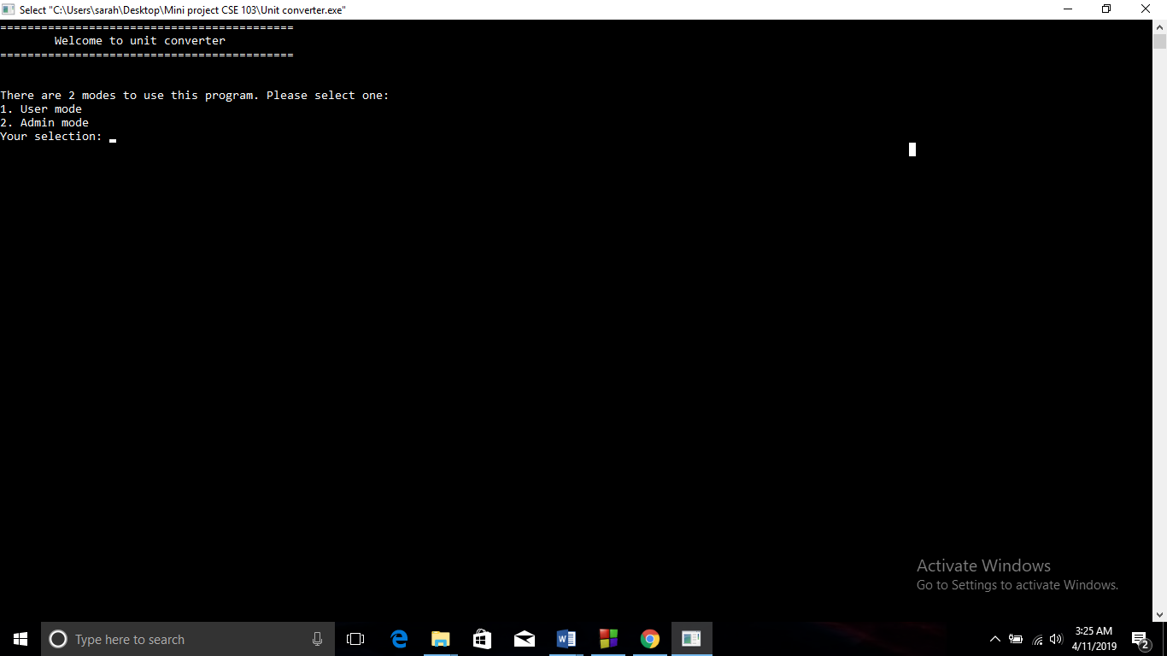

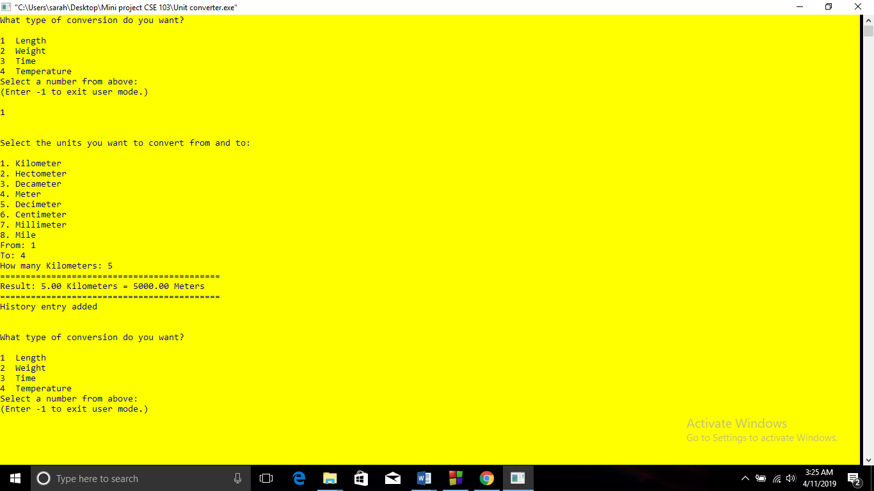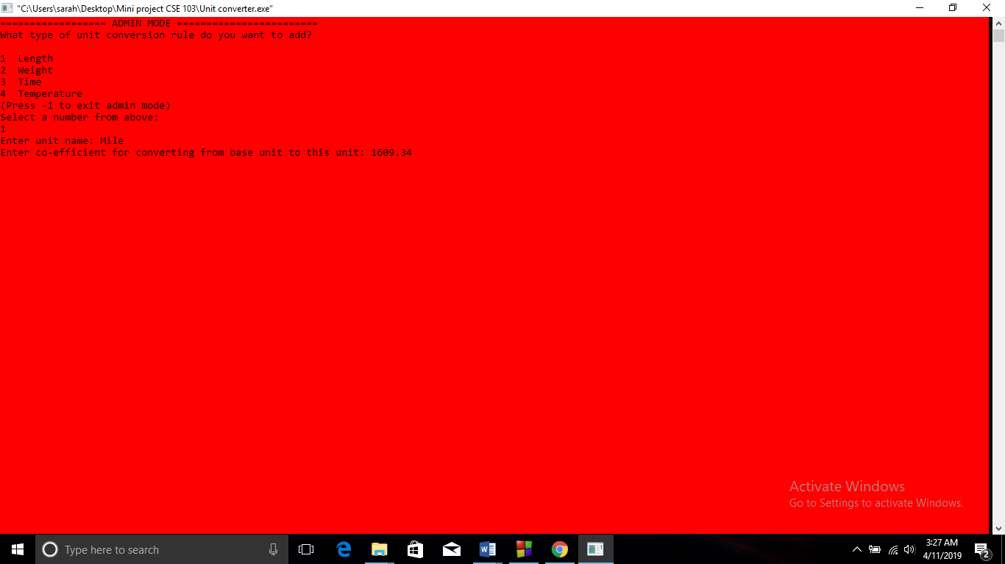

Limitations

* If we used GUI then it would be more user friendly. As it is a terminal program the user experience will not be that much good.
* The number which will be converted and the result cannot be huge. Otherwise the program will crash.

Extra Features

* All the conversions are recorded in a history file.
* Admin can add features to the program by using admin option.
* As the program is very flexible it can be developed farther more.

Conclusion

Unit converter is a very handy tool in our day to day life. As our converter can be easily developed it can be used as a regular application.