Name : Nguyen Huu Hao

Student ID: 2031200078

Q1. Python program to print “Hello Python”

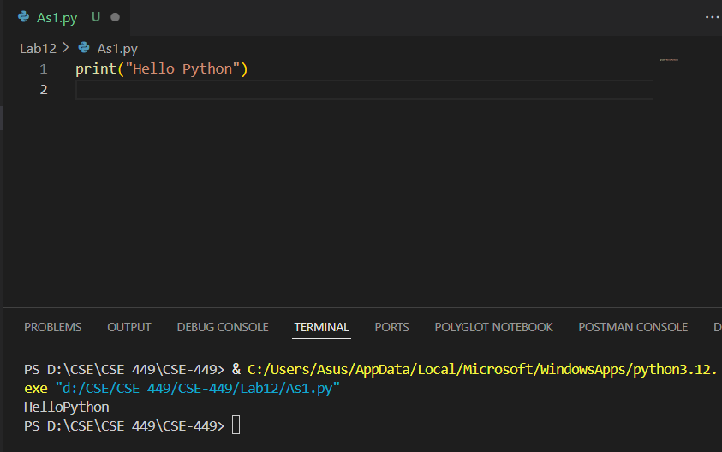

Q2. Python program to do arithmetical operations

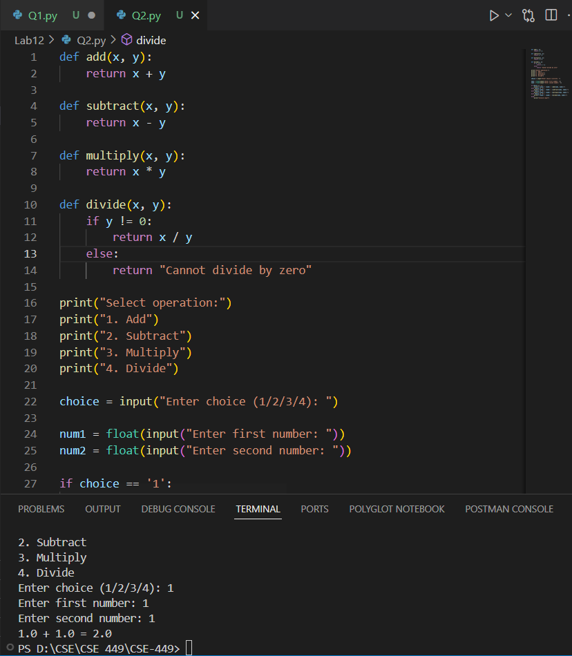

Q3. Python program to find the area of a triangle

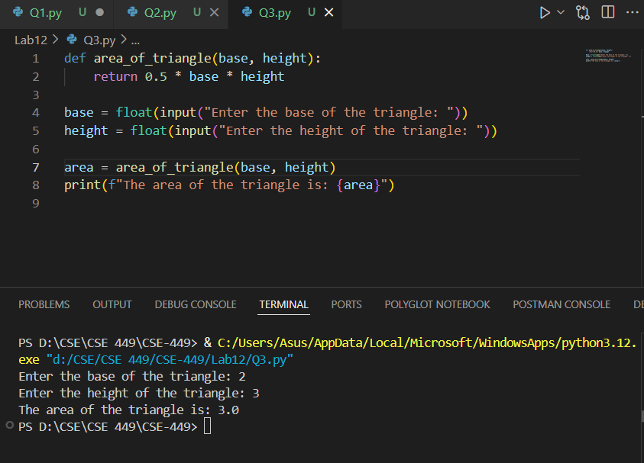

Q4. Python program to generate a random number

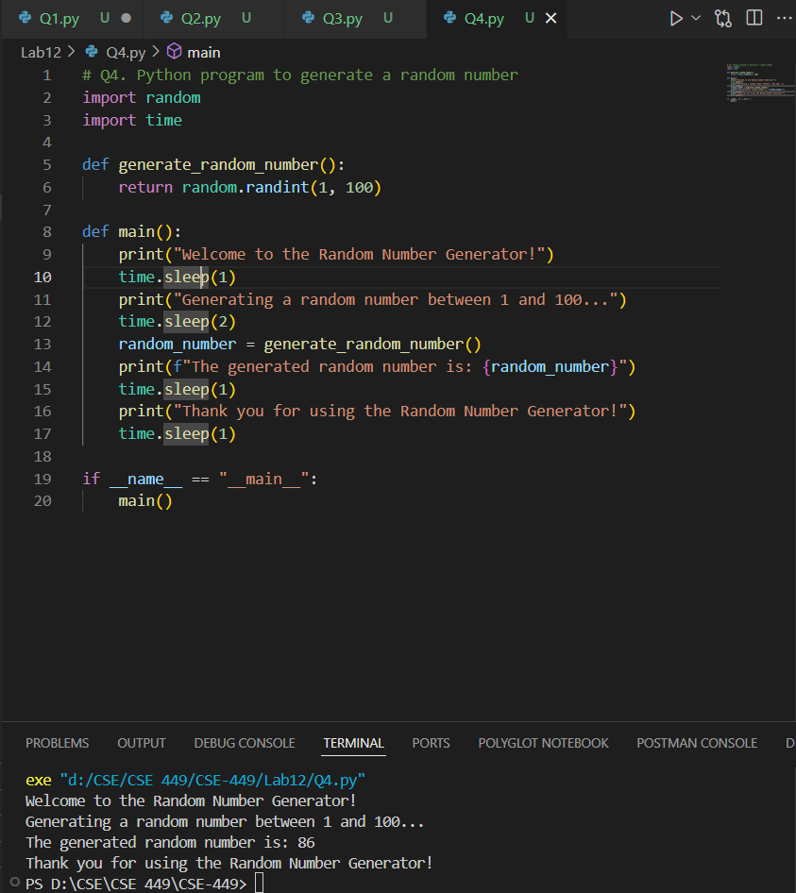

Q5. Python program to Find the Factorial of a Number

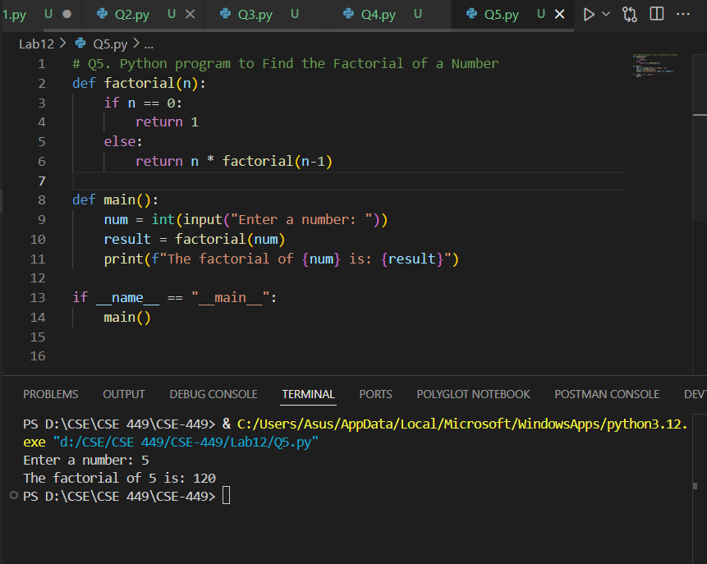

Q6. Python program to Find LCM

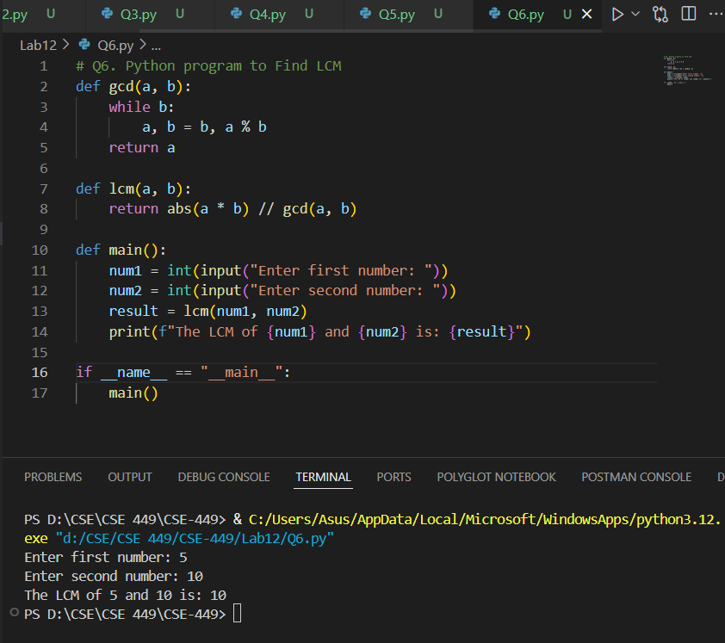

Q7. Python program to Find HCF

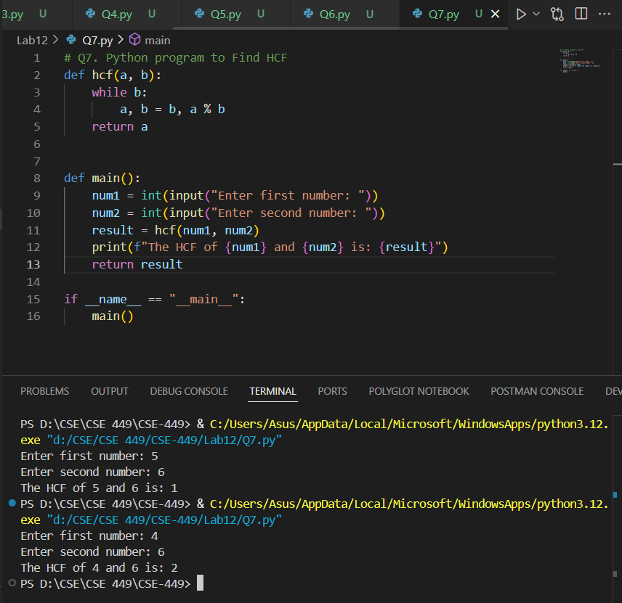

Q8. Python program to Convert Decimal to Binary, Octal and Hexadecimal

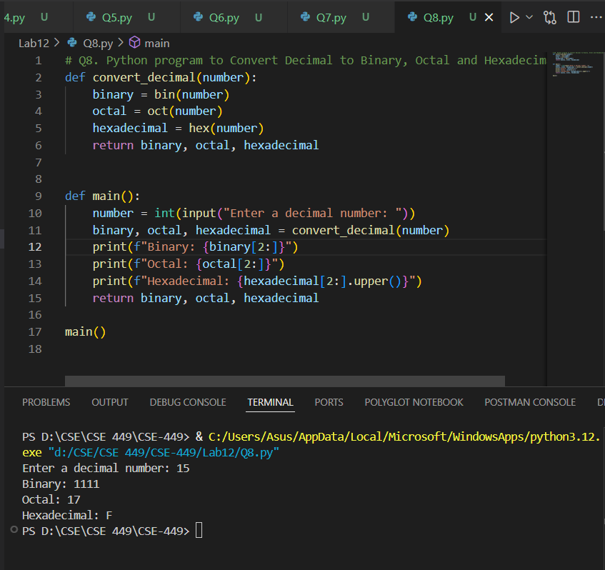

Q9. Python program to Find Factorial of Number Using Recursion

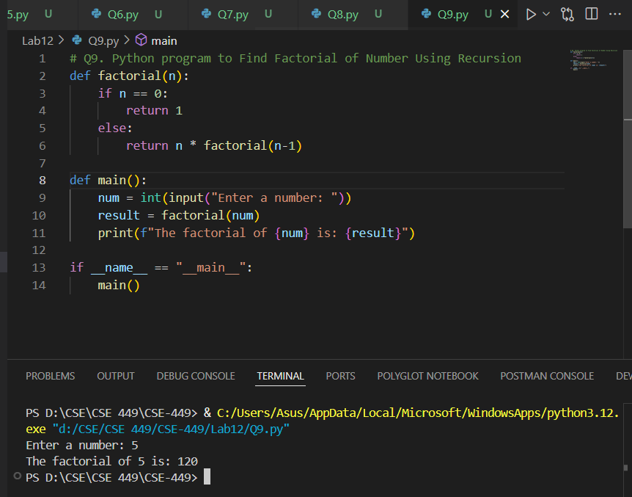

Q10. Python program to print the elements of an array

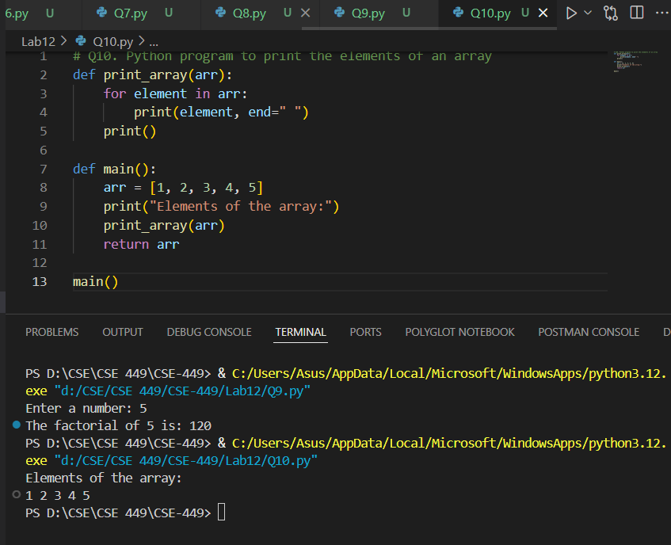

Q11. Python program to print the element of an array in reverse order

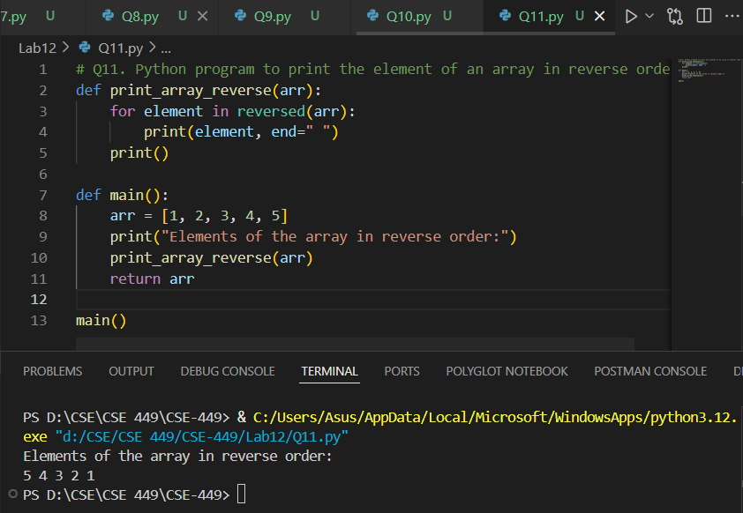

Q12. Python program to Add two Matrices

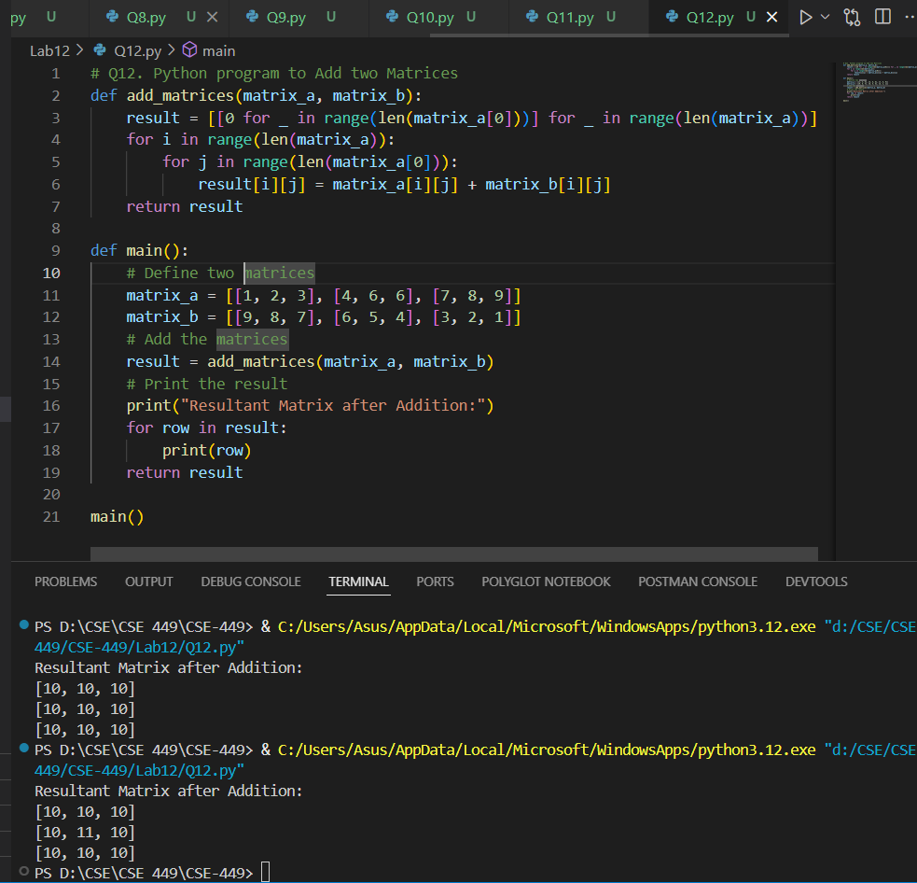

Q13. Python program to Multiply Two Matrices

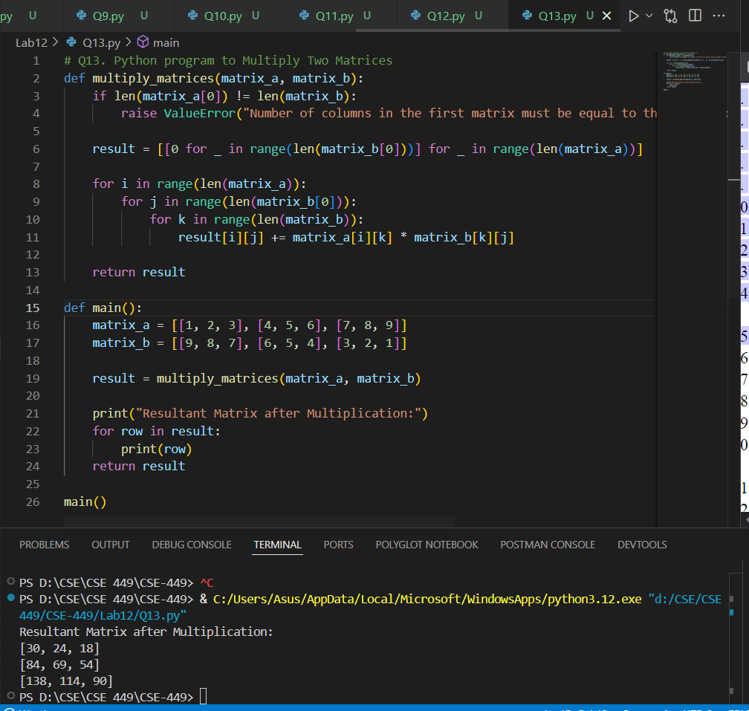

Q14. Python program to append element in the list and update list with insertion of elements, removing an element, comparison of two lists, etc

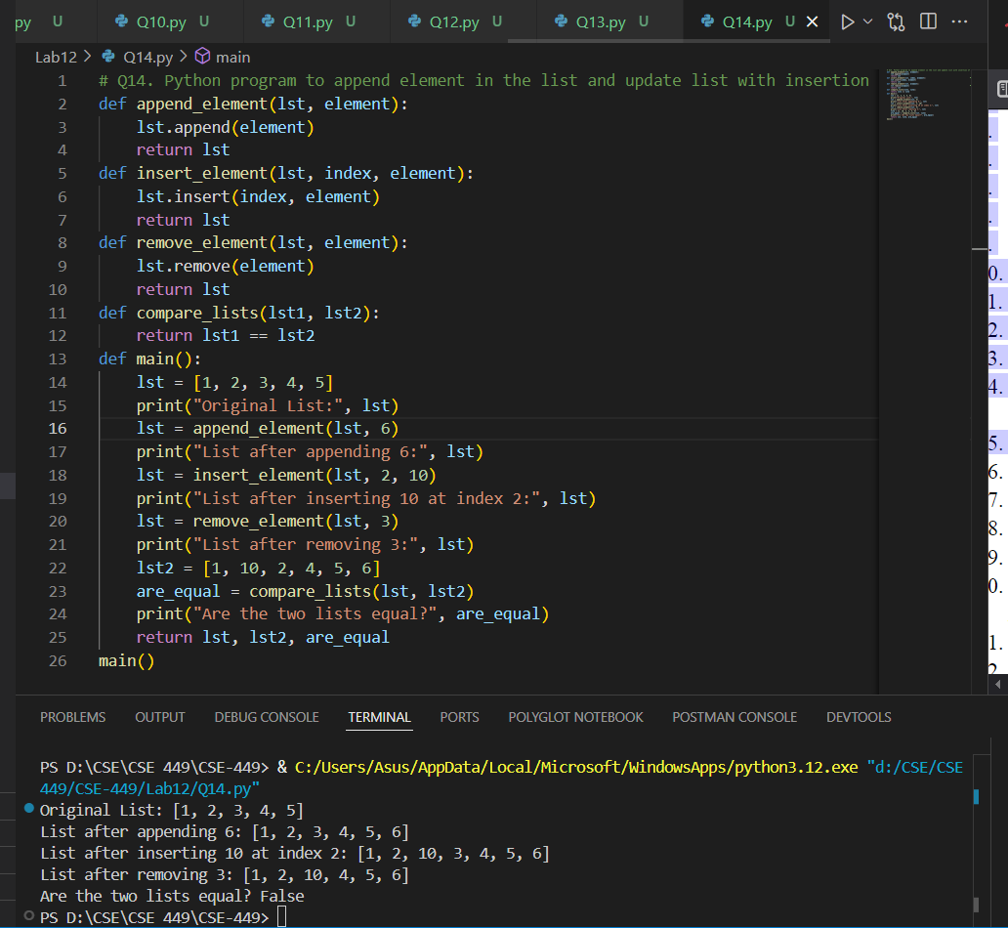

Q15. Python program to create a dictionary

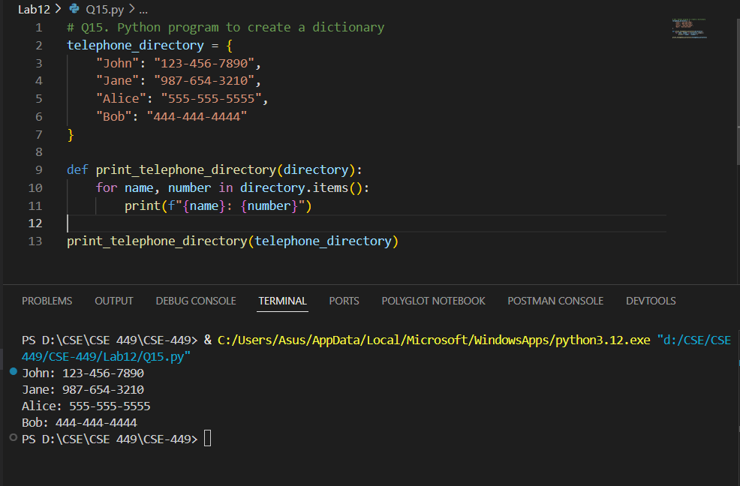

Q16. Python program to convert list to dictionary

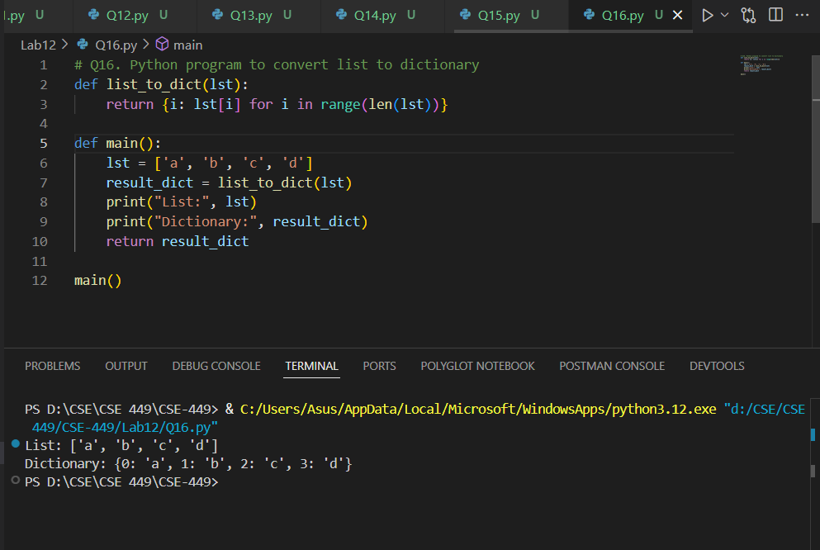

Q17. Python program to sort a dictionary

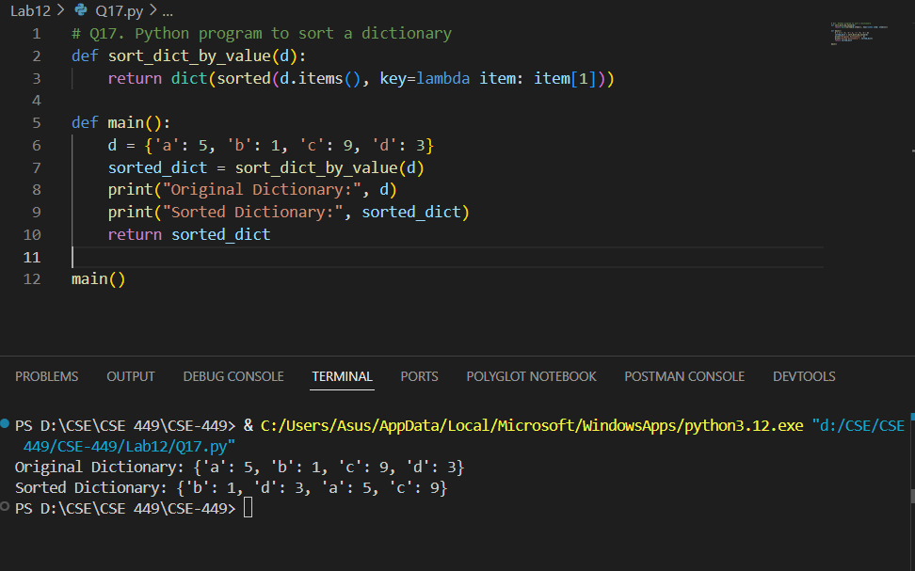

Q18. Python program to Merge two Dictionaries

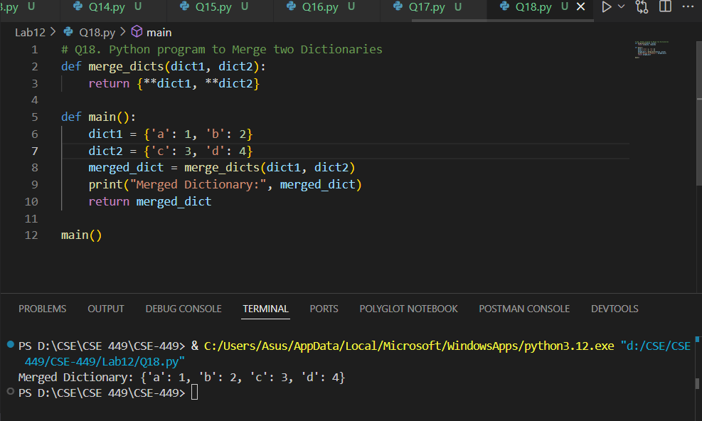

Q19. Binary Search in Python

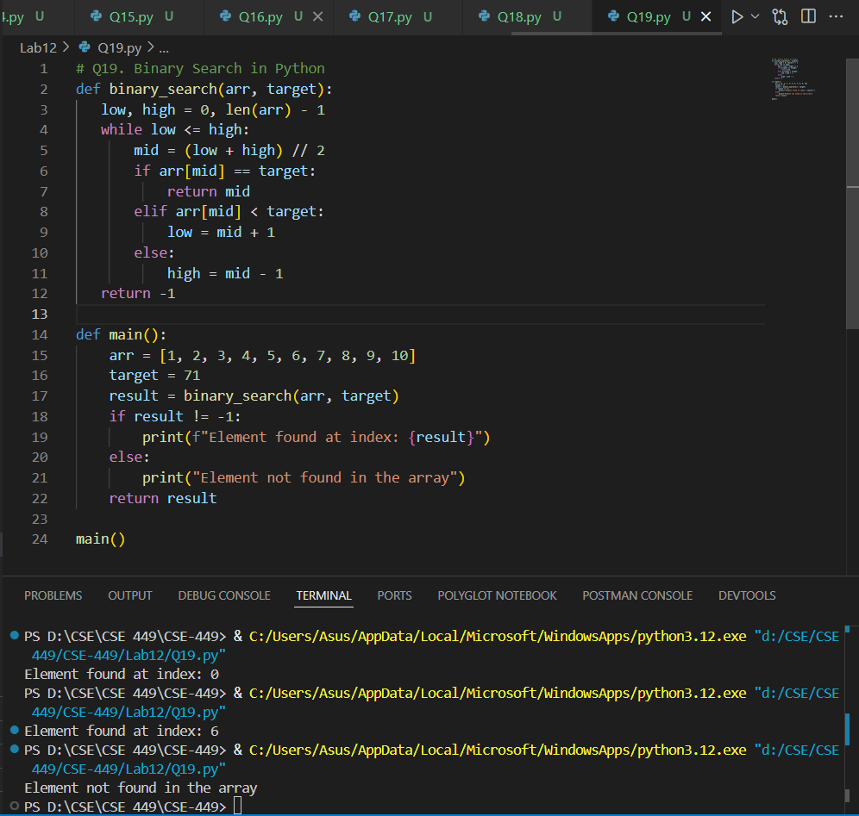

Q20. Linear Search in Python

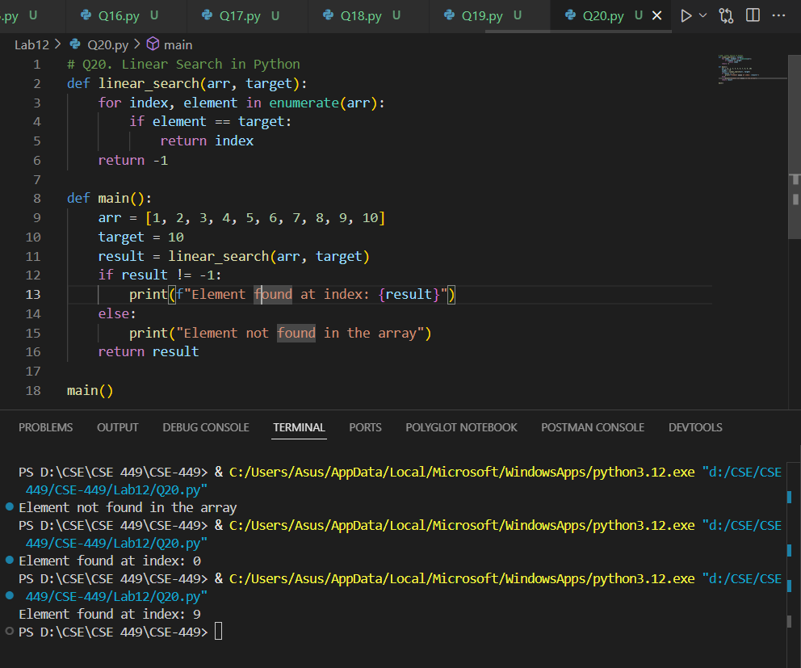

Q21. Bubble Sort in Python

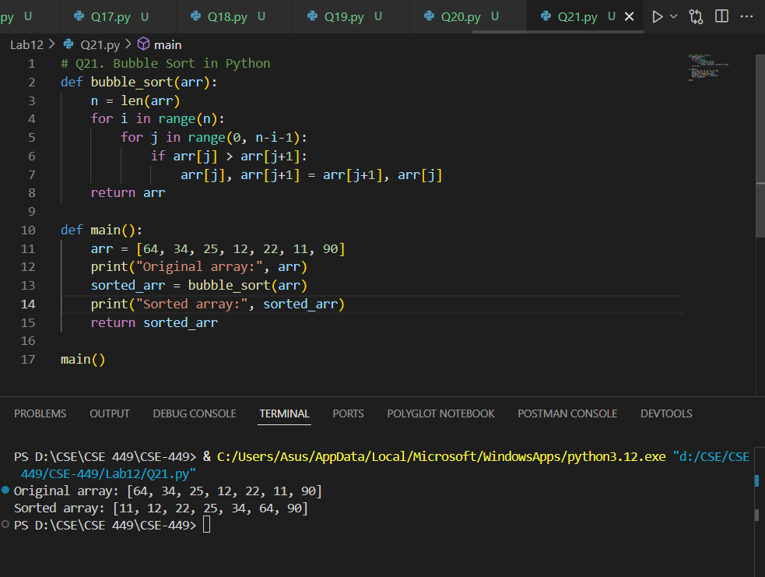

Q22. Insertion Sort in Python

