**CSE 449 Lab 3**

Name: Nguyễn Hữu Hào

Student Id: 2031200078

Assignment 1: Write a Program to Implement Breath First Search using Python

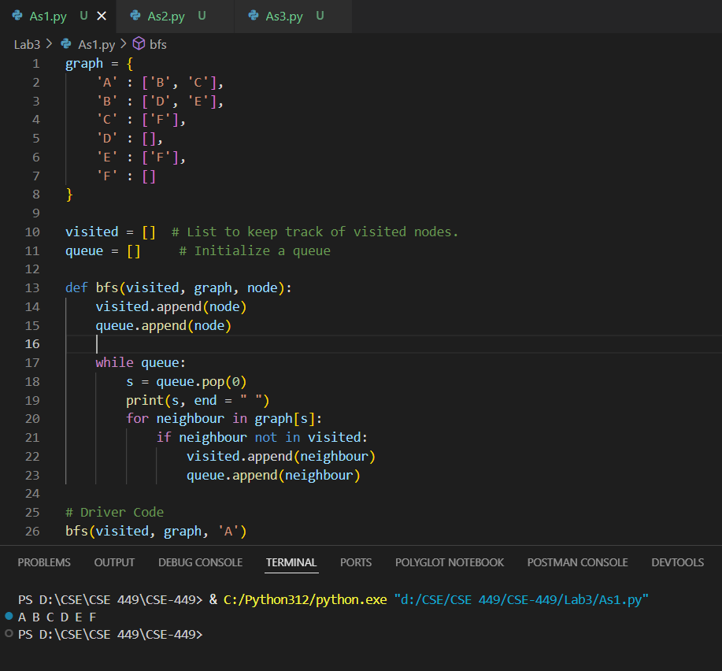

Assignment 2: Write a Program to Implement Depth First Search using Python

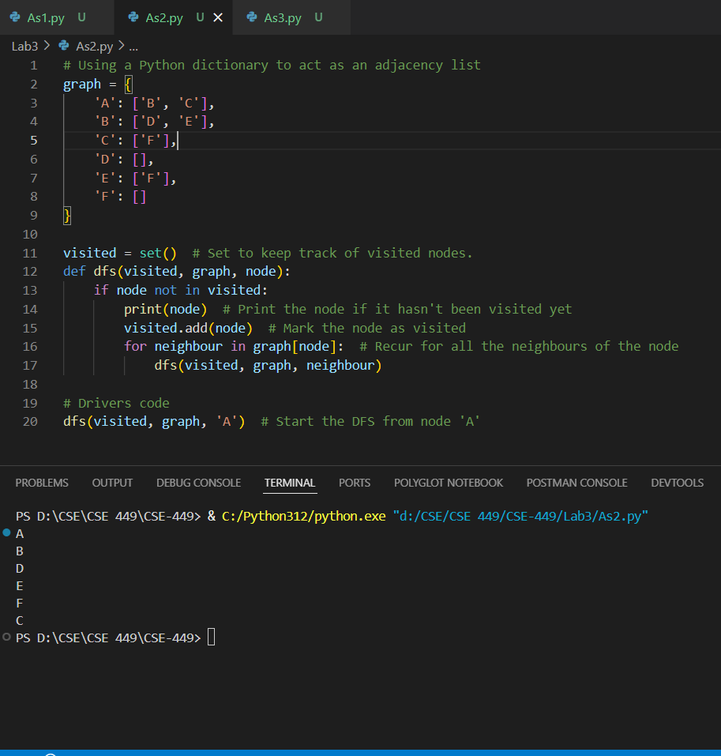

Assignment 3: Write a Program to Implement Tic-Tac-Toe game using Python

