PHENIKAA UNIVERSITY
PHENIKAA SCHOOL OF COMPUTING
⸎⸎⸎⸎⸎

PROJECT REPORT
SOFTWARE ARCHITECTURE
Topic: Building a Web-Based Library Management System
Team : Group 1
Student : Nguyễn Trường Sơn- 23010313
Nguyễn Đăng Hiếu- 23010049
Đỗ Hữu Đại- 23010825
Bùi Đắc Hợp- 23012022
Instructors : Vũ Quang Dũng
Class : Software Architecture(N01)

Hanoi, February 4, 2025
Contents
Preface 3
I Introduction and Planning 5
A. Introduction to the topic: Library management system 5
1. Reasons for choosing the topic 5
2. Objectives of the research topic 5
3. Significance of the topic 5
4. Project Scope 6
B. Process Model: Agile 6
1. High flexibility 6
2. Appropriate to the scale and scope of the topic 6
3. Enhance testing and feedback. 6
4. Improve teamwork effectiveness 7
5. Aligned with learning objectives 7
II. Project Requirements 7
A. Functional requirements 7
1. User management 7
2. E-book management 7
3. Book management 7
4. Borrowing-Returning management 8
5. Statistics/Reporting 8
B. Non-functional requirements (ASR) 8
1. Performance: 8
2. Security: 8
3. Usability 8
4. Scalability 9
C. Modeling 9
1. Main Actor 9
2. Use Case diagram 10
III. System design 19
A. Architectural Design 19
1. Monolithic Architecture 19
2. Application Architecture 20
B. C4 model 23
1. System Context Diagram 23
2. Container Diagram 24
3. Component Diagram (Backend Level) 25
4. Code Diagram 26
C. Technical Stack and Data Model 27
1. Technical Stack 27
2. Data Model 28
IV. Testing & Verification 30
A. Test Scenario 30
B. Unit test 32
1. Definition 32
2. Unit Test Scope in the Project 32
3. Unit Test Example 33
C. API test 33
1. Definition 33
2. API Test Scope in the Project 33
3. API Test Example 34
V. Conclusion and Future Development 34
A. Evaluation and Lessons Learned 34
B. Future Development Directions 35

Preface
In the era of rapid development in information technology, the application of software systems in management and operations has become an inevitable trend across many fields of social life. Technology not only helps save time and reduce errors but also enhances productivity and work efficiency. Especially in the field of education and training, the support of management software systems has increasingly demonstrated its important and indispensable role.
Libraries serve as centres for storing, preserving, and providing knowledge to students, lecturers, and the research community. However, traditional management methods based on manual records or paperwork often face numerous difficulties. As the volume of books continues to grow, record-keeping becomes more error-prone, information retrieval is time-consuming, and it is challenging to promptly meet the diverse needs of readers. These limitations not only reduce management efficiency but also negatively affect the user experience of library services.
Given this situation, the computerization of library management has become an urgent requirement. A library management software system capable of automating key operations—such as managing book information, reader records, borrowing and returning processes, searching, and statistical reporting—can effectively overcome the shortcomings of traditional management approaches. Moreover, such a system helps save resources, improve service quality, and contribute to the digital transformation of learning and research activities.
Based on these requirements, our group conducted research and developed a Library Management System. This software is designed with a user-friendly and intuitive interface, integrating essential functions such as book management, user management, and borrowing–returning operations, while also allowing for the expansion of additional features in the future. Through this project, we aim not only to create a useful tool to support library management but also to enhance our own skills in programming, analysis, design, and software implementation.
With the efforts made and the knowledge accumulated throughout our learning process, we hope that this project will provide practical value in both academic and real-world applications. Furthermore, it serves as an important foundation for the continued development of software systems that support management needs in various other fields.

Bảng phân công công việc
Week | Main Phase | Key Tasks | Responsible Members | Expected Outcomes
Week 1 | Project Initiation & Requirement Analysis | - Analyze library business processes  - Identify system requirements  - Assign team responsibilities | All members | Requirement specification, project plan
Week 2 | System Architecture Design | - Design C4 model  -Define overall system architecture | Nguyen Truong Son | C4 architecture diagrams
Week 3 | Account & Authentication | - Account module development (register, login, logout, profile)  - UserProfile model  - Membership State Pattern implementation  - Account forms | Nguyen Truong Son, Nguyen Dang Hieu | Completed account & authentication module
Week 4 | Design Interface | Design wireframes and UI mockups for core screens. | Bui Dac Hop  Do Huu Dai
Week 5 | Library Core Features | - Library app development  - Book catalog, search, book details- Review system | Nguyen Dang Hieu | Core library functionalities implemented
Week 6 | Borrowing & Membership Logic | - Borrow validation logic based on membership level-  Renew/extend book logic  - Library UI templates | Nguyen Truong Son, Nguyen Dang Hieu | Borrowing and renewal features completed
Week 7 | Librarian & Admin Module | - Librarian dashboard development  - Book, user, and borrow record management  - Background management commands | Nguyen Dang Hieu | Librarian/admin module completed
Week 8 | Ebook & External Integration | - Ebook reader module  - Cloudinary integration for ebook storage  - Email (SMTP) and Google Maps API integration | Nguyen Truong Son | Ebook features and external services integrated
Week 9 | Testing & Documentation | - Integration testing- End-to-end testing  - Use Case documentation | Bui Dac Hop  Do Huu Dai | Tested system and complete documentation
Week 10 | Finalization & Presentation | - Bug fixing and optimization  - Code review  - Slide preparation and system demo  - Final report completion | All members | Final project submission

I Introduction and Planning

Introduction to the topic: Library management system

Reasons for choosing the topic
Manual library management has many shortcomings, such as: difficulty in controlling many books, easy errors in record keeping, time-consuming searching, and difficulty in meeting the diverse needs of readers.
To overcome these limitations, the group chose the topic "Library Management System" with the goal of applying information technology to automate basic library operations.

Objectives of the research topic
- Develop a library management system capable of efficiently managing book information, reader data, and book borrowing and returning.
- The interface is designed to be intuitive and easy to use for both managers and users.
- Applying knowledge of programming, databases, and software development processes to real-world situations.
- Laying the groundwork for future system expansion and upgrades (adding features such as online book ordering, electronic document management, etc.).

Significance of the topic
- In practical terms: This research contributes to addressing the limitations of manual library management methods, reducing the workload for library staff, and improving management efficiency and reader service quality.
- Academically: This topic helps the student consolidate and apply their learned knowledge of programming, databases, system analysis and design, while also developing teamwork and project management skills.
- Socially: Supporting and promoting the digitalization process in the field of education and training, meeting the growing learning and research needs of students, lecturers, and readers.

Project Scope
- The system focuses on basic functions: book information management, user management, book borrowing and returning, and book searching.
- Target users: librarians and readers.
- Technology used: Django combined with a database management system to ensure data storage and processing capabilities.
- This project is currently only at the experimental stage and serves educational purposes; it has not yet been implemented on a large scale in practice.

Process Model: Agile
In the software development process, choosing the right development model plays a crucial role, directly affecting the progress, quality, and completion of the product. For the Library Management System project, our team decided to apply the Agile model for the following reasons:

High flexibility
  - Agile allows the development process to be broken down into multiple iterations (iterations/sprints). In each iteration, the team can build and refine a part of the system's functionality.
  - If there are changes in requirements or errors are discovered, the team can easily adjust in the next round, avoiding wasted time like the Waterfall model (sequential, difficult to change).

Appropriate to the scale and scope of the topic
  - The topic focuses only on a few basic functions (book management, user management, book borrowing and returning, login and permission management).
  - With Agile, the team can prioritize developing core functionalities first, then gradually add supporting functionalities, ensuring that the system always has a working version for testing and evaluation.

Enhance testing and feedback.
  - After each sprint, the team can test the system, check for bugs, and receive feedback from the instructor or the team members themselves.
  - This allows for continuous product improvement, resulting in better quality compared to testing at the end of the project.

Improve teamwork effectiveness
  - Agile encourages frequent interaction and communication among team members. Teams can hold quick to update progress, assign tasks, and address issues promptly.
  - As a result, progress is tightly controlled, avoiding situations where work piles up or functions are overlooked.

Aligned with learning objectives
  - Applying Agile helps teams hone their project management, teamwork, and change-response skills – all crucial skills in software development.
Conclusion: With its advantages in flexibility, adaptability to change, enhanced testing, and high level of collaboration, the Agile model is a suitable choice for developing a library management system within the timeframe and scope of this project.

II. Project Requirements

A. Functional requirements
A library management system needs to fulfill the following main functions:

1. User management
- Register a user account.
- Log in/log out of the system.
- Manage personal information.
- Assign permissions: Librarian and User.
- Register as a member.

2. E-book management
- Add new books.
- Edit book information.
- Delete books.
- Search/look up books by title, author, or genre.

3. Book management
- Add new books.
- Edit book information
- Delete books
- Search/look up books by title, author, or category/genre.
- Send deadline reminders

4. Borrowing-Returning management
- Register to borrow books
- Update return information
- Manage book status
- Statistics of borrowing-returning activities

5. Statistics/Reporting
- Statistics on the number of books by category/genre
- Statistics on the number of borrowings per user

B. Non-functional requirements (ASR)
In addition to its primary functions, the system needs to meet several non-functional requirements as follows:

1. Performance:
  - Average page/data load time < 2 seconds.
  - Handle a minimum of 20-30 simultaneous users.
=> These requirements influence decisions related to database optimization, caching mechanisms, and server architecture.

2. Security:
- Clear access control: Librarians have full data management rights; users only have the right to borrow/return books and search for information.
- Sensitive data (passwords) are encrypted.
  - The system has a secure login mechanism.
=> These requirements affect authentication design, data storage, and security architecture.

3. Usability
  - User-friendly interface, easy to use, supports quick search.
  - Important functions (borrowing, returning, searching books) are easily accessible in 1–2 steps.
  - Error/reminder notifications are provided when incorrect data is entered, or invalid operations are performed.
=> These requirements guide UI structure, navigation design, and user interaction flow.

4. Scalability
  - The system can be expanded with new features (e.g., online book ordering, email reminders).
  - The database is designed to be flexible and easily scalable.
=> These requirements impact modular system architecture and database schema design.

C. Modeling

1. Main Actor
- User
- Librarian
- Admin
- System

- User
- Register / Login
- Search books
- View list books and detail books
- Borrow books
- Return book
- Renew borrowed book s
- Write review
- Purchase Membership
- Librarian
- Book management
- User management
- Manage book record
- Check book status
- Check statistics
- Admin
- Librarian management
- System management
- E-book management

Actor-Use Case Relationship
Actor | Use case
User | Register/Login, Search book, view detail, borrow book, return book, extend book, write review
Librarian | Book management, user management, borrowing and returning management.
Admin | Librarian management, System management, System management

2. Use Case diagram
- Admin
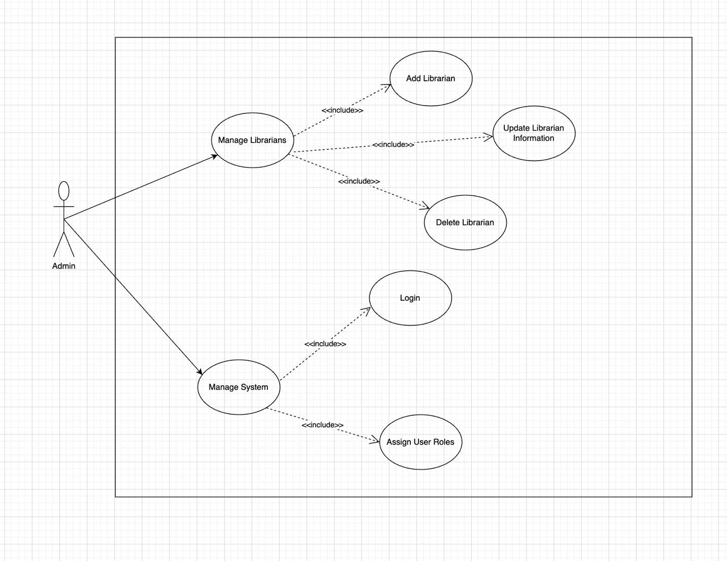
- User
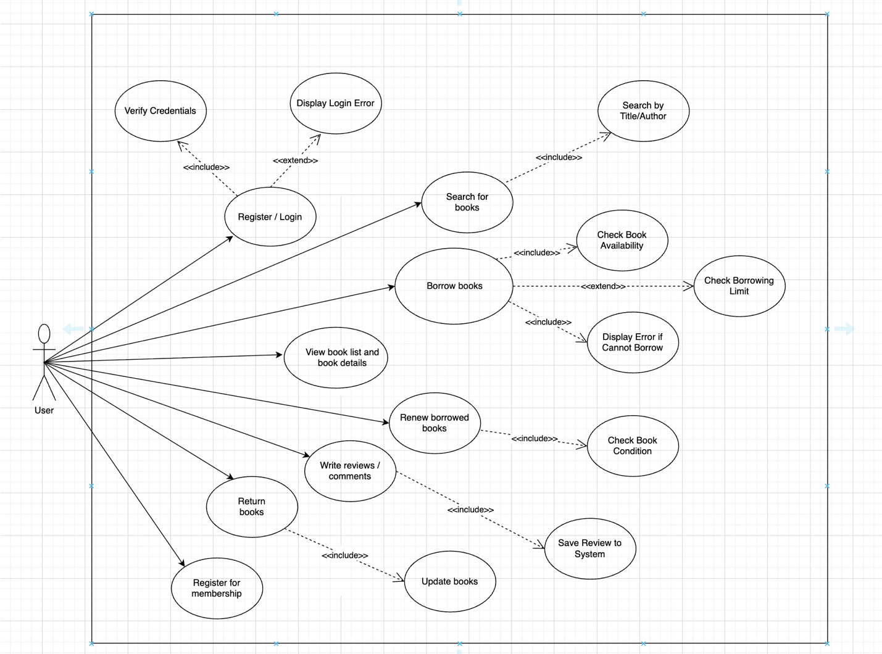
-Librarian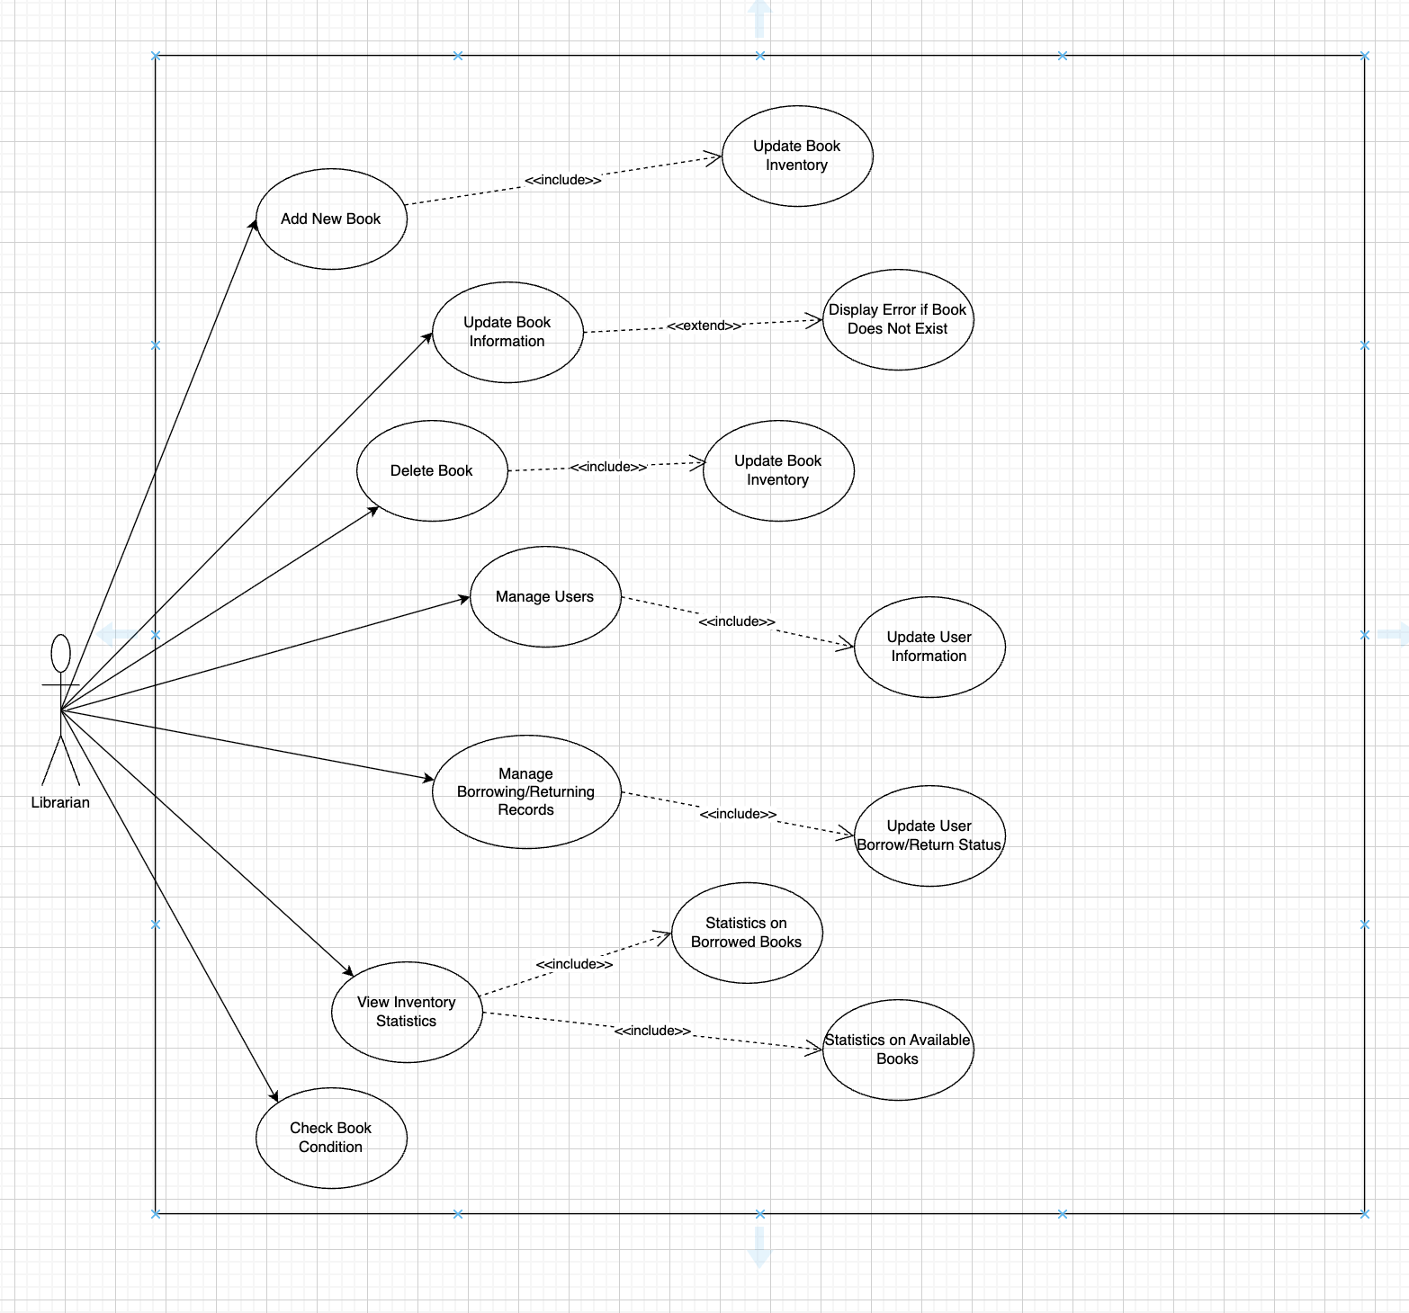

Main use case for User
Use Case 1: Register/Login
Item | Description
Use Case Name | Register / Login
Goal | Allow users to create a new account or log in to the system to access book management features
Primary Actor | User
Preconditions | The user already has an account (for login)
Main Flow | 1. The user selects “Register / Login”  2. The system displays the information input interface  3. The user enters username and password  4. The system validates the information (<>)  5. If valid → login is successful  6. If invalid → the system displays a “Login error message” (<>)
Postconditions | • The user is successfully logged into the system  • The system records the user session

Use Case 2: Search for Books
Item | Description
Use Case Name | Search for Books
Goal | Help users quickly find the desired books in the library
Primary Actor | User
Preconditions | The user is logged into the system
Main Flow | 1. The user selects “Search for Books”  2. The system displays the search bar3. The user enters a book title or author name (<>)  4. The system processes the request and displays matching results  5. The user selects a book to view detailed information
Postconditions | The user can view the list of books and detailed information of the selected book

Use Case 3: Borrow Books
Item | Description
Use Case Name | Borrow Books
Goal | Allow readers to borrow books conveniently while the system records the borrowing transaction
Primary Actor | User
Preconditions | • The reader is logged into the system  • The selected book is available in stock
Main Flow | 1. The reader selects “Borrow Books”  2. The system displays a list of available books (title, ID, author, quantity)  3. The reader searches for and selects a book  4. The system checks borrowing conditions:  • Borrowing limit has not been exceeded  • No violations (overdue, lost books, etc.)  • The book is still available  5. The system records the borrowing transaction (reader ID, book ID, borrow date, due date)  6. The system updates the book quantity (decrease by one)  7. The system displays “Borrow successful”
Postconditions | • The borrowing transaction is stored in the system  • Book quantity is updated  • The reader receives confirmation

Use Case 4: Renew Borrowed Books
Item | Description
Use Case Name | Renew Borrowed Books
Goal | Allow users to extend the borrowing period if conditions are met
Primary Actor | User
Preconditions | • The user is currently borrowing the book  • The book is not reserved by another user
Main Flow | 1. The user selects “Renew Book”  2. The system checks the book status (<>)  3. If eligible → the system updates the new due date  4. If not eligible → the system displays “This book cannot be renewed”
Postconditions | The borrowing period is successfully extended

Use Case 5: Write a Review
Item | Description
Use Case Name | Write a Review
Goal | Allow users to submit reviews and comments for books they have read
Primary Actor | User
Preconditions | The user has read or borrowed the book
Main Flow | 1. The user selects “Write Review / Comment”  2. The system displays the input form  3. The user enters the review content  4. The system saves the review to the database (<>)  5. The system displays “Review submitted successfully”
Postconditions | The review is stored and displayed in the book detail section
Main use case for Librarian
Use Case 1: Add a New Book
Item | Description
Use Case Name | Add a New Book
Goal | The librarian adds a new book to the library system to serve readers.
Primary Actor | Librarian
Preconditions | The librarian has logged in to the system.
Main Flow | 1. The librarian selects the “Add New Book” function.  2. The system displays the interface for entering book information (book ID, title, author, category/genre, quantity, description, etc.).  3. The librarian enters all required book information.  4. The system checks whether the book already exists (<>).  5. If the book does not exist, the system adds the new book to the database.  6. The system updates the book inventory (<>).  7. The system displays “Book added successfully.”
Postconditions | The new book is added to the system and the inventory is updated accurately.

Use Case 2: Update Book Information
Item | Description
Use Case Name | Update Book Information
Goal | The librarian edits book information when changes occur (title, author, description, quantity, etc.).
Primary Actor | Librarian
Preconditions | The book already exists in the system.
Main Flow | 1. The librarian selects “Update Book Information.”  2. The system displays the list of available books.  3. The librarian selects the book to edit.  4. The librarian updates the book information.  5. The system validates the updated data.  6. The system updates the inventory (<>).  7. The system displays “Book information updated successfully.”
Postconditions | Book information is updated in the database.

Use Case 3: Delete a Book
Item | Description
Use Case Name | Delete a Book
Goal | The librarian removes books that are no longer used or have been discarded.
Primary Actor | Librarian
Preconditions | The book exists in the system.
Main Flow | 1. The librarian selects “Delete Book.”  2. The system displays the list of books.  3. The librarian selects the book to delete.  4. The system asks for confirmation.  5. After confirmation, the system deletes the book from the database.  6. The system updates the inventory (<>).  7. The system displays “Book deleted successfully.”
Postconditions | The book is removed from the system and the inventory is updated accurately.

Use Case 4: Manage Users
Item | Description
Use Case Name | Manage Users
Goal | The librarian monitors, updates, and manages reader/user information.
Primary Actor | Librarian
Main Flow | 1. The librarian selects “User Management.”  2. The system displays the list of users.  3. The librarian can add a new user, update user information (<>), or delete a user if necessary.  4. The system saves changes and displays “User information updated successfully.”
Postconditions | User data is updated in the system.

User Case 5: Manage Borrow/Return Slips
Item | Description
Use Case Name | Manage Borrow/Return Slips
Goal | The librarian monitors, records, and updates borrowing and returning information of readers.
Primary Actor | Librarian
Preconditions | The system already manages the list of readers and books.
Main Flow | 1. The librarian selects “Manage Borrow/Return Slips.”  2. The system displays the list of existing loan records.  3. The librarian creates, edits, or confirms return slips.  4. The system updates borrowing–returning information (<>).  5. The system saves data and displays “Updated successfully.”
Postconditions | Borrow/return records are updated in the system.

III. System design

A. Architectural Design

1. Monolithic Architecture
Monolithic Architecture is an architectural pattern in which the entire software system is built, deployed, and executed as a single unified application. All core functionalities of the system, including user interface handling, business logic, and data access, are tightly integrated within one codebase and run as a single process.
In a monolithic system, different functional modules communicate with each other through direct method calls rather than network-based communication. The application typically uses a shared database to store and manage all system data. Any update or modification to the system requires rebuilding and redeploying the entire application.
This architectural pattern offers simplicity in development, testing, and deployment, especially during the early stages of a project. It is well-suited for small to medium-sized systems with clearly defined requirements and limited scalability demands. However, as the system grows in size and complexity, monolithic architecture may introduce challenges in maintainability, scalability, and fault isolation.
In this project, the Monolithic Architecture is selected due to the relatively small scope of the system and the use of the Django framework. This approach simplifies the overall system design, reduces deployment complexity, and allows the development team to focus on implementing core functionalities efficiently.
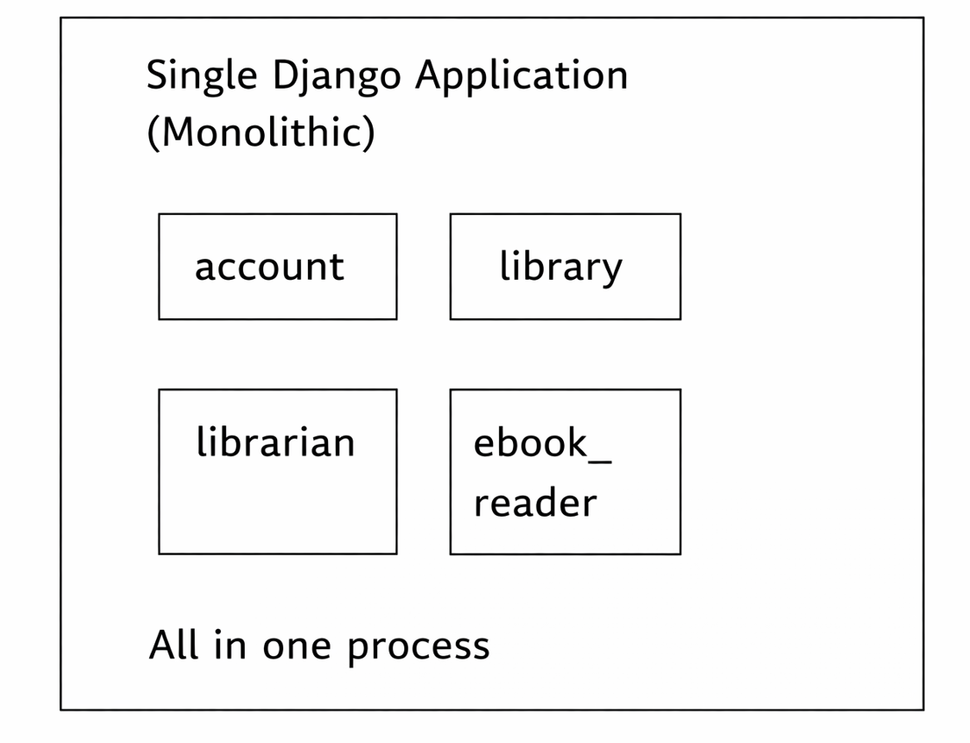

2. Application Architecture
2.1 Architectural Style
The system uses a combination of:
- Django MVT (Model-View-Template)
- Layered Architecture
- Modular Architecture
2.2. High-Level Architecture Diagram
┌────────────────────────────────────┐
│ PRESENTATION LAYER │
│ - Django Templates (HTML, CSS, JavaScript) │
│ - Static Files │
└────────────────────────────────────┘
↑
│ (renders)
┌────────────────────────────────────┐
│ APPLICATION LAYER │
│ - Views (views.py) - Request handling & business logic │
│ - URL Routing (urls.py) │
│ - Forms (forms.py) - Data validation │
│ - Middleware Stack │
└────────────────────────────────────┘
↑
│ (queries/updates)
┌────────────────────────────────────┐
│ DOMAIN LAYER │
│ - Models (models.py) - Data structure & business rules │
│ - Design Patterns (State, Factory) │
│ - Django ORM │
└────────────────────────────────────┘
↑
│ (ORM)
┌─────────────────────────────────────┐
│ DATA LAYER │
│ - SQLite (Development) / MySQL (Production) │
└─────────────────────────────────────┘
↑
┌─────────────────────────────────────┐
│ EXTERNAL SERVICES │
│ - Cloudinary (File Storage) │
│ - Gmail SMTP (Email Service) │
│ - Google Maps API (Location Services) │
└─────────────────────────────────────┘

2.3. Detailed architecture
a) Django MVT Pattern
- Model Layer
Location: models.py in each app
Responsibilities:
- Define data structure (database schema)
- Implement business logic (methods)
- Define relationships (ForeignKey, OneToOne, ManyToMany)
- Data validation

- View layer
Location: views.py in each app
Responsibilities:
- Handle HTTP requests
- Execute business logic
- Interact with Models via ORM
- Prepare context for Templates
- Return HTTP responses (HTML/JSON)
- Template Layer
Location: templates/ in each app
Responsibilities:
- Render user interface (HTML)
- Receive context from Views
- Use template tags and filters
- Template inheritance

b) Modular Architecture
The system is divided into 4 independent modules:
- Account Module
Purpose: User authentication and profile management
Components:
- Models: UserProfile
- Views: register, login, logout, profile, change_password
- Templates: register.html, login.html, profile.html
- Features: Authentication, membership management, State Pattern implementation
- Library Module
Purpose: Library operations for end users
Components:
- Models: Review
- Views: search, borrow_book, renew_book,book_detail_view
- Templates: catalog.html, book_detail.html, borrowed_books.html
- Features: Book browsing, borrowing, renewal, reviews
- Librarian Module
Purpose: Administrative operations
Components:
- Models: Book, BorrowRecord
- Views: librarian_dashboard, add_book, update_book, return_book_api
- Templates: managebook.html, manageuser.html
- Features: Book management, user management, borrow record management, email reminders
- Ebook Module
Purpose: Digital book reading
Components:
- Models: Ebook
- Views: digital, read_ebook_view
- Templates: digital.html, read_ebook.html
- Features: Ebook listing, reading, Cloudinary integration

B. C4 model

1. System Context Diagram
The Library Management System is a Django-based web application that supports online library operations. It provides services for managing books, users, and borrowing activities.
The system is used by three main actors:
- User: Searches books, borrows/returns or extends loans, writes reviews, and reads ebooks via a web interface (HTTP).
- Librarian: Manages books and user records, and sends deadline reminders through the system (HTTP).
- Admin: Manages and administers the overall system configuration (HTTP).
The system also integrates with external systems:
- Gmail SMTP is used to send account confirmation and deadline reminder emails (SMTP).
- Cloudinary is used to store and serve ebook and media files (HTTP).
- Google Maps API is embedded to display map information within the system (HTTPS).
This diagram defines the system boundary and shows how the Library Management System interacts with users and external services.
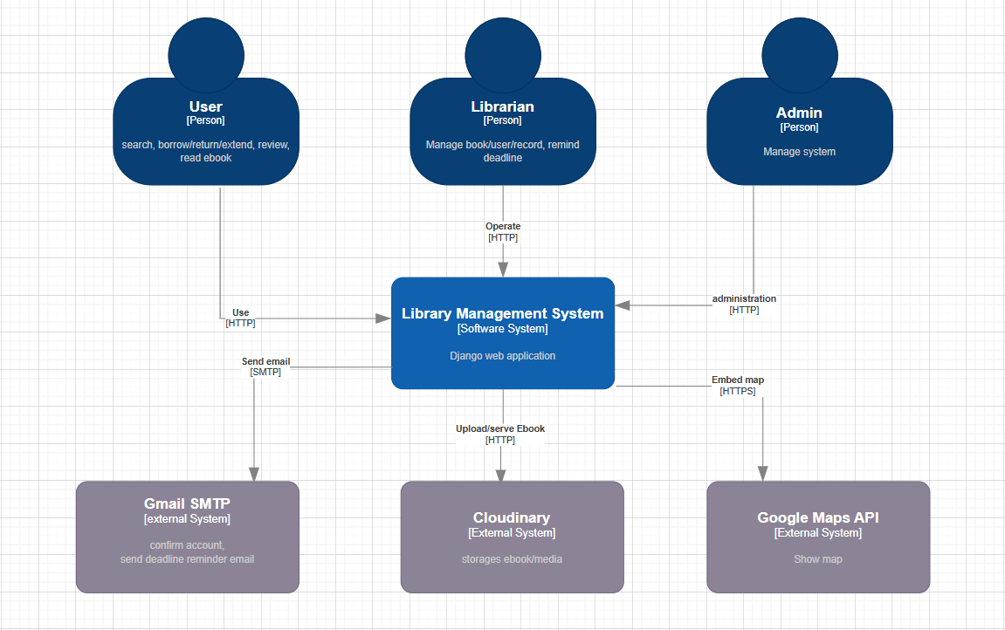

2. Container Diagram
The Library Management System is composed of several containers working together to deliver the system’s functionality.
The core container is the Django Web Application, which handles server-rendered HTML pages, JSON/REST APIs, authentication and authorization, and business logic such as searching books, borrowing/returning, and reviewing.
A Database (SQLite in development and MySQL in production) is used to store users, books, borrowing records, reviews, and ebook metadata. The Django Web Application and the Background Job Processor access the database via the Django ORM.
The Background Job Processor runs scheduled tasks and asynchronous jobs, such as sending deadline reminders and overdue notifications.
The system integrates with external services:
- Gmail SMTP for authentication emails and reminder notifications.
- Cloudinary for uploading and serving ebook and media files over HTTPS.
- Google Maps API for embedding map data into the web application.
This diagram shows how the system is decomposed into containers and how each container communicates with internal and external components.
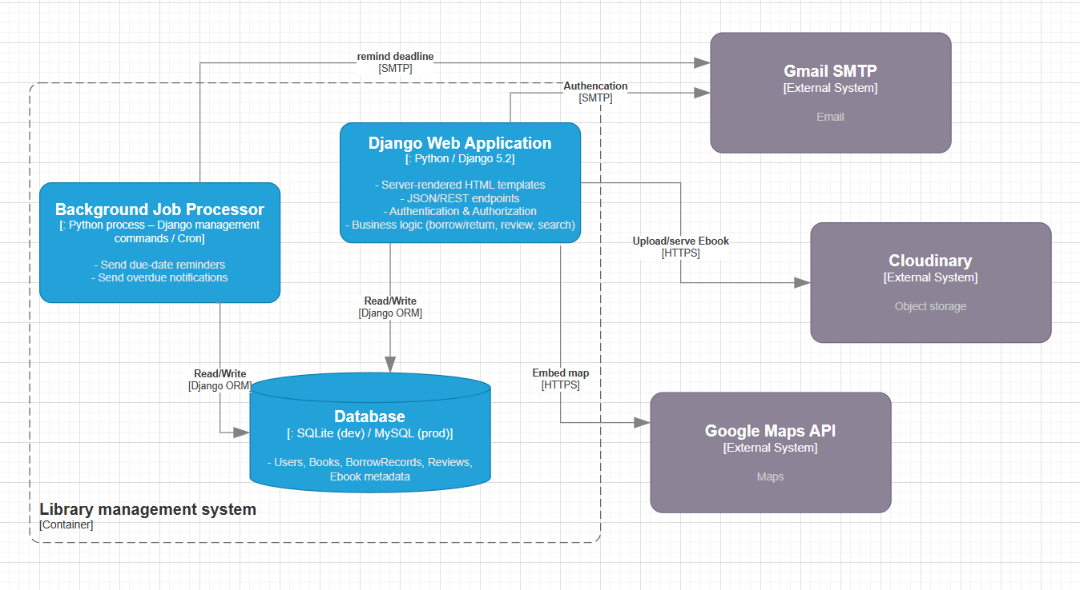

3. Component Diagram (Backend Level)
The Library Management System consists of multiple Django components coordinated through URL Routing. Core functions are handled by the Account, Library, Librarian, and Ebook components, while UI Templates render HTML pages. Domain Models define and manage system data and interact with the database via Django ORM. Reminder Commands handle scheduled notifications and send emails through Gmail SMTP. The system also integrates with external services such as Cloudinary for ebook storage and Google Maps API for map display.
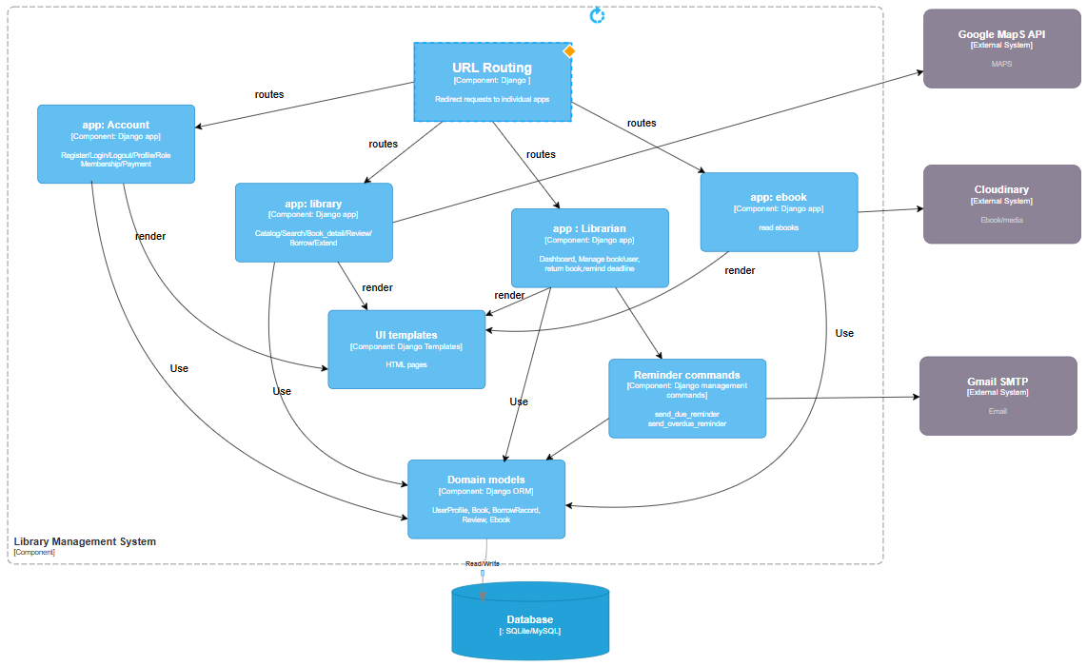

4. Code Diagram
This diagram describes the code-level design of the Library Management System using Django models.
Each User is associated with a UserProfile that stores role, membership level, and borrowing constraints.
Book represents physical book information and can have multiple Reviews and BorrowRecords.
BorrowRecord manages borrowing lifecycle data, including due dates, status, and renewal logic.
An optional Ebook entity is linked to a book to store digital content metadata.

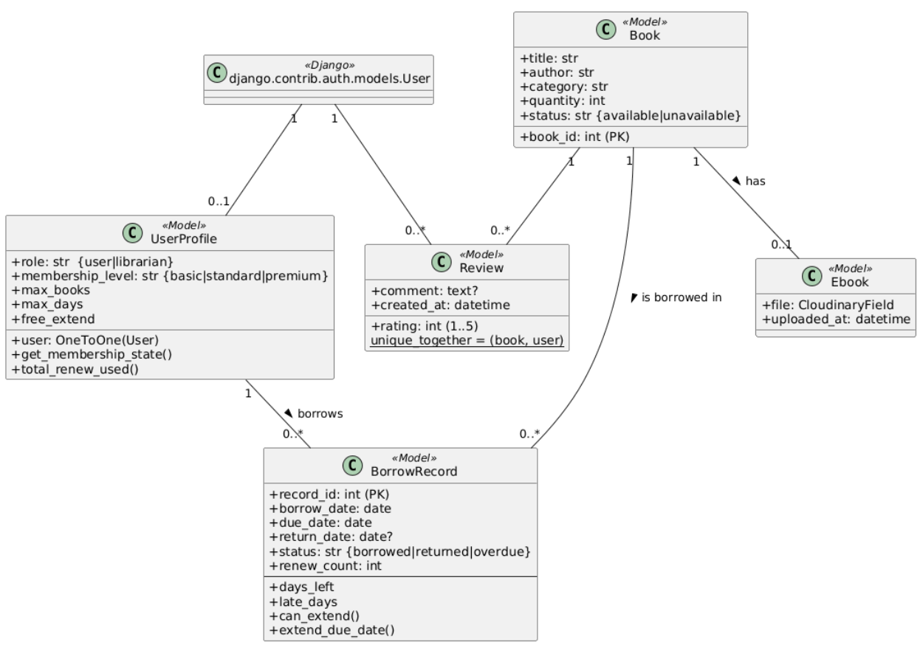

C. Technical Stack and Data Model

1. Technical Stack
The Library Management System (LMS) is developed using a modern and widely adopted technology stack that supports rapid development, maintainability, and scalability within a monolithic architecture.
- Backend Framework:
The system is implemented using Django, a high-level Python web framework that follows the MTV (Model–Template–View) pattern. Django provides built-in support for authentication, authorization, ORM, and security features, which helps reduce development complexity.
- Frontend Technologies:
The user interface is built using HTML, CSS, and JavaScript, combined with Django Templates for server-side rendering. This approach allows seamless integration between frontend and backend within a single Django application.
- Database Management System:
The system uses a relational database such as MySQL or PostgreSQL. Django ORM is utilized to map database tables to Python models, enabling efficient data access and manipulation.
- Authentication and Authorization:
Django’s built-in Authentication System is used to manage user login, logout, and role-based access control for different user types, including librarians and library users.
- Email Service Integration:
An external email service such as Gmail SMTP or SendGrid is integrated to send automated notifications, including borrowing confirmations and due-date reminders.

2. Data Model
The data model of the Library Management System is designed using a relational approach to ensure data consistency and integrity. Core entities and their relationships are defined based on the main business requirements of the library.
Data model
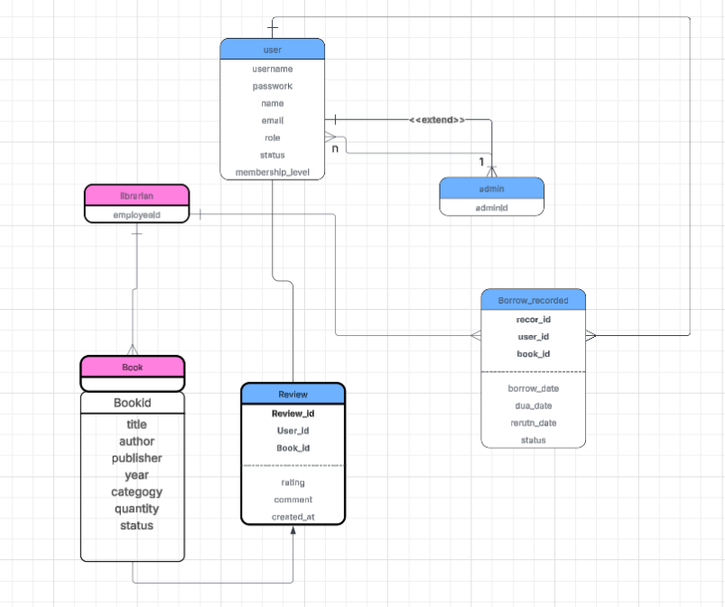
Class diagram
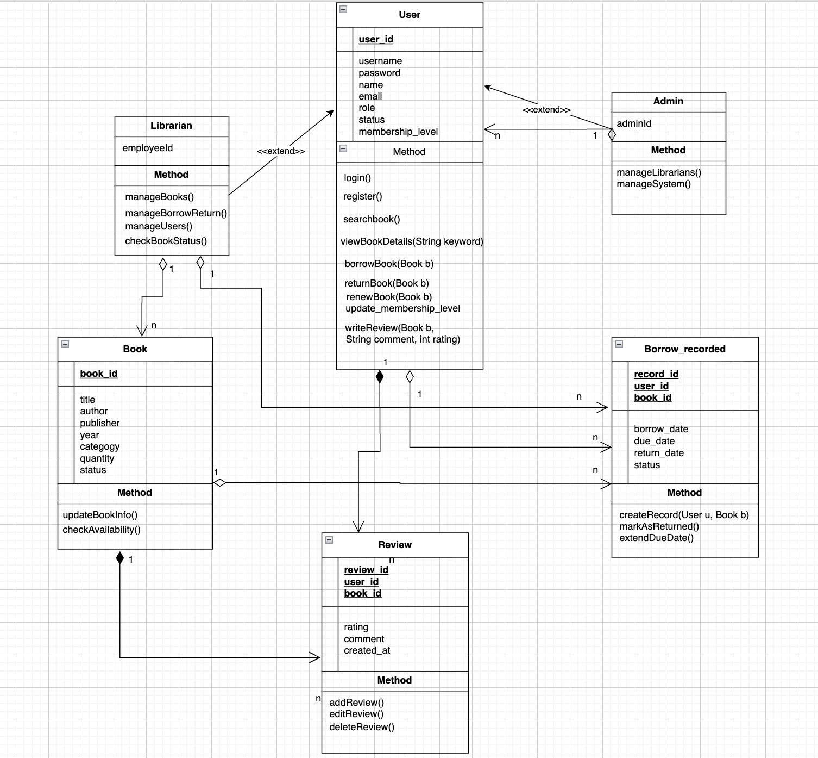

IV. Testing & Verification

A. Test Scenario
Test Scenario 1: User Registration and Login
Step | Expected Result | Actual Result | Status
1. Open Register page |  | OK | Pass
  Registration form is displayed
2. Enter valid user information | User account is created successfully | Account created | Pass
3. Log in with registered account | User logs in successfully | Login success | Pass
4. Log out of the system | User is logged out | Logged out | Pass
Verification:
User can register, log in, and log out successfully with valid information.

Test Scenario 2: User Permission Management
Step | Expected Result | Actual Result | Status
1. Login as Librarian |  | OK | Pass
  Librarian dashboard displayed
2. Assign role "User" to an account | Permission updated successfully | Updated | Pass
3. Assign role "Librarian" to an account | Permission updated successfully | Updated | Pass
Verification:
System correctly assigns and updates user permissions.

Test Scenario 3: Book Management (Add / Edit / Delete / Search)
Step | Expected Result | Actual Result | Status
1. Librarian logs into the system | Login successful, librarian dashboard displayed | OK | Pass
2. Librarian adds a new book (title, author, genre) | Book is added successfully and shown in book list | Book added correctly | Pass
3. Librarian edits book information | Updated information is saved and displayed | Book info updated | Pass
4. Librarian deletes a book | Book is removed from the system | Book deleted | Pass
5. Search book by title/author/genre | Correct search results are displayed | Results correct | Pass
Verification:
Screenshots show successful add, edit, delete, and search operations in the book management module.

Test Scenario 4: Borrowing – Returning Management
Step | Expected Result | Actual Result | Status
1. User logs into the system | Login successful | OK | Pass
2. User registers to borrow a book | Borrow request is a | Borrow registered | Pass
3. System updates book status to “Borrowed” | Book status changes correctly | Status updated | Pass
4. Librarian updates return information | Return date recorded successfully | Return updated | Pass
5. System updates book status to “Available” | Book becomes available again | Status correct | Pass
Verification:
Borrowing and returning records are updated correctly, and book status changes match the borrowing lifecycle.

Test Scenario 5: Statistics and Reporting
Step | Expected Result | Actual Result | Status
1. Librarian opens statistics page | Statistics dashboard displayed | OK | Pass
2. View statistics by category/genre | Correct number of books shown per category | Data accurate | Pass
3. View statistics of borrowings per user | Borrow count displayed correctly for each user | Data correct | Pass
4. Refresh statistics after new borrow | Statistics update in real time | Updated instantly | Pass
Verification:
Statistical reports accurately reflect the current state of books and borrowing activities in the system.

B. Unit test

1. Definition
Unit Tests are tests that verify the smallest units of code independently, without dependencies on other components.

2. Unit Test Scope in the Project
Account Module:
- UserProfile model tests: profile creation, membership levels, upgrade functionality
- MembershipState class tests: BasicState, StandardState, PremiumState
- UserProfile properties and methods testing
Library Module:
- Review model tests: review creation, unique constraints, string representation
Librarian Module:
- Book model tests: book creation, string representation
- BorrowRecord model tests: record creation, days_left calculation, late_days, can_extend(), extend_due_date() methods
Ebook Module:
- Ebook model tests: ebook creation, relationship with Book

3. Unit Test Example
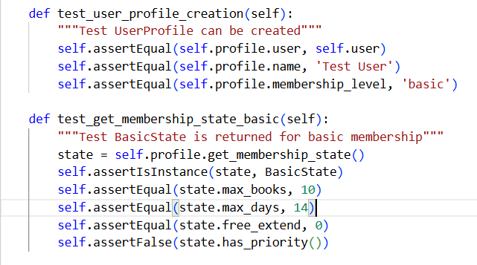

C. API test

1. Definition
API Tests verify HTTP endpoints, checking request/response handling, authentication, authorization, and client-server interactions.

2. API Test Scope in the Project
Account Module APIs:
- POST /account/register/ - User registration
- POST /account/login/ - User login
- GET /account/profile/ - View profile (requires authentication)
- GET /account/logout/ - User logout

Library Module APIs:
- GET /library/catalog/ - Browse books catalog
- GET /library/search/ - Search books
- GET /library/autocomplete/ - Autocomplete search
- GET /library/book-detail/<id>/ - View book details
- POST /library/borrow/ - Borrow book (JSON API)
- GET /library/borrowed_books/ - View borrowed books
- POST /library/renew/<id>/ - Renew book
- POST /library/book-detail/<id>/ - Submit book review

Librarian Module APIs:
- GET /librarian/managebook/ - Librarian dashboard (requires librarian role)
- POST /librarian/api/add-book/ - Add new book (JSON API)
- PUT /librarian/api/books/<id>/ - Update book (JSON API)
- DELETE /librarian/api/books/<id>/ - Delete book (JSON API)
- POST /librarian/api/return-book/<id>/ - Return book
- POST /librarian/send-due-reminder/ - Send due date reminder email
- POST /librarian/send-overdue-reminder/ - Send overdue reminder email

Ebook Reader Module APIs:
- GET /ebook_reader/digital/ - List ebooks
- GET /ebook_reader/read/<id>/ - Read ebook

3. API Test Example
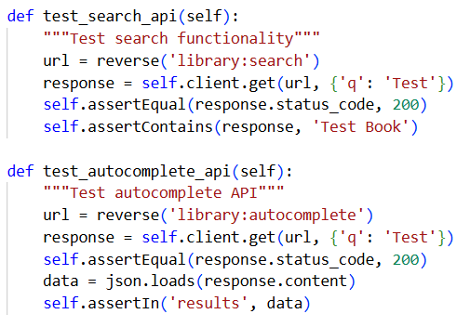

V. Conclusion and Future Development

A. Evaluation and Lessons Learned
After the process of designing and developing the online Library Management System using Django, the team successfully completed most of the planned core functionalities.
The system meets the main requirements, including:
- Managing book information, users, and borrowing–returning processes
- Implementing user role management (librarian and library user)
- Supporting library location display through the Google Maps API
- Allowing online document and PDF file storage via Cloudinary
- Providing a user-friendly interface that is easy to use and operates stably
- Offering flexible and efficient search functionality
Limitations:
- Librarians cannot fully manage all displayed content within the system
- Statistical and visual reporting features have not yet been implemented
- User authorization is still at a basic level
- The system has not been deployed in a real production environment and currently runs only locally
Lessons Learned:
- More detailed planning for testing and performance optimization is required
- Greater use of project management tools (such as Trello or GitHub Projects) should be encouraged
- Teamwork skills need improvement, including better task distribution and time management

B. Future Development Directions
In the future, the system can be further expanded and enhanced with the following features:
- Statistics and Reporting:
  - Visual charts displaying the number of borrowed books, available inventory, and active users
- Artificial Intelligence (AI) Integration:
  - Recommending suitable books to users based on their borrowing history
- Online Payment and Fee Management:
  - Integrating payment gateways to collect borrowing fees or overdue penalties
- Mobile Application Development:
  - Building Android and iOS applications to allow users to search for and borrow books more conveniently
- Production Deployment:
  - Deploying the system to cloud platforms such as PythonAnywhere, AWS, or Heroku to enable online access

