PHENIKAA UNIVERSITY
PHENIKAA SCHOOL OF COMPUTING
⸎⸎⸎⸎⸎

PROJECT REPORT
SOFTWARE ARCHITECTURE
Topic: Building a Web-Based Library Management System
Team : Group 1
Student : Nguyễn Trường Sơn– 23010313
Instructors : Vũ Quang Dũng
Class : Software Architecture(N01)

Hanoi, February 4, 2025
Contents
Preface 3
I Introduction and Planning 4
A. Introduction to the topic: Library management system 4
1. Reasons for choosing the topic 4
2. Objectives of the research topic 4
3. Significance of the topic 4
4. Project Scope 5
B. Process Model: Agile 5
1. High flexibility 5
2. Appropriate to the scale and scope of the topic 5
3. Enhance testing and feedback. 5
4. Improve teamwork effectiveness 6
5. Aligned with learning objectives 6
II. Project Requirements 6
A. Functional requirements 6
1. User management 6
2. E-book management 6
B. Non-functional requirements 7
1. Performance: 7
2. Security: 7
3. Usability 7
4. Scalability 7
C. Modeling 7
1. Main Actor 7
2. Use Case diagram 8
III. System design 14
A. Architectural Design: Monolithic Architecture 14
B. C4 model 14
1. System Context Diagram 14
2. Container Diagram 15
3. Component Diagram (Backend Level) 16
C. Technical Stack and Data Model 17
1. Technical Stack 17
2. Data Model 18
IV. Conclusion and Future Development 19
A. Evaluation and Lessons Learned 19
B. Future Development Directions 20

Preface
In the era of rapid development in information technology, the application of software systems in management and operations has become an inevitable trend across many fields of social life. Technology not only helps save time and reduce errors but also enhances productivity and work efficiency. Especially in the field of education and training, the support of management software systems has increasingly demonstrated its important and indispensable role.
Libraries serve as centres for storing, preserving, and providing knowledge to students, lecturers, and the research community. However, traditional management methods based on manual records or paperwork often face numerous difficulties. As the volume of books continues to grow, record-keeping becomes more error-prone, information retrieval is time-consuming, and it is challenging to promptly meet the diverse needs of readers. These limitations not only reduce management efficiency but also negatively affect the user experience of library services.
Given this situation, the computerization of library management has become an urgent requirement. A library management software system capable of automating key operations—such as managing book information, reader records, borrowing and returning processes, searching, and statistical reporting—can effectively overcome the shortcomings of traditional management approaches. Moreover, such a system helps save resources, improve service quality, and contribute to the digital transformation of learning and research activities.
Based on these requirements, our group conducted research and developed a Library Management System. This software is designed with a user-friendly and intuitive interface, integrating essential functions such as book management, user management, and borrowing–returning operations, while also allowing for the expansion of additional features in the future. Through this project, we aim not only to create a useful tool to support library management but also to enhance our own skills in programming, analysis, design, and software implementation.
With the efforts made and the knowledge accumulated throughout our learning process, we hope that this project will provide practical value in both academic and real-world applications. Furthermore, it serves as an important foundation for the continued development of software systems that support management needs in various other fields.

I Introduction and Planning

Introduction to the topic: Library management system

Reasons for choosing the topic
Manual library management has many shortcomings, such as: difficulty in controlling many books, easy errors in record keeping, time-consuming searching, and difficulty in meeting the diverse needs of readers.
To overcome these limitations, the group chose the topic "Library Management System" with the goal of applying information technology to automate basic library operations.

Objectives of the research topic
- Develop a library management system capable of efficiently managing book information, reader data, and book borrowing and returning.
- The interface is designed to be intuitive and easy to use for both managers and users.
- Applying knowledge of programming, databases, and software development processes to real-world situations.
- Laying the groundwork for future system expansion and upgrades (adding features such as online book ordering, electronic document management, etc.).

Significance of the topic
- In practical terms: This research contributes to addressing the limitations of manual library management methods, reducing the workload for library staff, and improving management efficiency and reader service quality.
- Academically: This topic helps the student consolidate and apply their learned knowledge of programming, databases, system analysis and design, while also developing teamwork and project management skills.
- Socially: Supporting and promoting the digitalization process in the field of education and training, meeting the growing learning and research needs of students, lecturers, and readers.

Project Scope
- The system focuses on basic functions: book information management, user management, book borrowing and returning, and book searching.
- Target users: librarians and readers.
- Technology used: Django combined with a database management system to ensure data storage and processing capabilities.
- This project is currently only at the experimental stage and serves educational purposes; it has not yet been implemented on a large scale in practice.

Process Model: Agile
In the software development process, choosing the right development model plays a crucial role, directly affecting the progress, quality, and completion of the product. For the Library Management System project, our team decided to apply the Agile model for the following reasons:

High flexibility
  - Agile allows the development process to be broken down into multiple iterations (iterations/sprints). In each iteration, the team can build and refine a part of the system's functionality.
  - If there are changes in requirements or errors are discovered, the team can easily adjust in the next round, avoiding wasted time like the Waterfall model (sequential, difficult to change).

Appropriate to the scale and scope of the topic
  - The topic focuses only on a few basic functions (book management, user management, book borrowing and returning, login and permission management).
  - With Agile, the team can prioritize developing core functionalities first, then gradually add supporting functionalities, ensuring that the system always has a working version for testing and evaluation.

Enhance testing and feedback.
  - After each sprint, the team can test the system, check for bugs, and receive feedback from the instructor or the team members themselves.
  - This allows for continuous product improvement, resulting in better quality compared to testing at the end of the project.

Improve teamwork effectiveness
  - Agile encourages frequent interaction and communication among team members. Teams can hold quick to update progress, assign tasks, and address issues promptly.
  - As a result, progress is tightly controlled, avoiding situations where work piles up or functions are overlooked.

Aligned with learning objectives
  - Applying Agile helps teams hone their project management, teamwork, and change-response skills – all crucial skills in software development.
Conclusion: With its advantages in flexibility, adaptability to change, enhanced testing, and high level of collaboration, the Agile model is a suitable choice for developing a library management system within the timeframe and scope of this project.

II. Project Requirements

A. Functional requirements
A library management system needs to fulfill the following main functions:

1. User management
- Register a user account.
- Log in/log out of the system.
- Manage personal information.
- Assign permissions: Librarian and User.
- Register as a member.

2. E-book management
- Add new books.
- Edit book information.
- Delete books.
- Search/look up books by title, author, or genre.

B. Non-functional requirements (ASR)
In addition to its primary functions, the system needs to meet several non-functional requirements as follows:

1. Performance:
  - Average page/data load time < 2 seconds.
  - Handle a minimum of 20-30 simultaneous users.

2. Security:
- Clear access control: Librarians have full data management rights; users only have the right to borrow/return books and search for information.
- Sensitive data (passwords) are encrypted.
- The system has a secure login mechanism.

3. Usability
  - User-friendly interface, easy to use, supports quick search.
  - Important functions (borrowing, returning, searching books) are easily accessible in 1–2 steps.
  - Error/reminder notifications are provided when incorrect data is entered, or invalid operations are performed.

4. Scalability
  - The system can be expanded with new features (e.g., online book ordering, email reminders).
  - The database is designed to be flexible and easily scalable.

C. Modeling

1. Main Actor
- User
- Librarian
- Admin
- System

- User
- Register / Login
- Search books
- View list books and detail books
- Borrow books
- Return book
- Renew borrowed book s
- Write review
- Purchase Membership
- Librarian
- Book management
- User management
- Manage book record
- Check book status
- Check statistics
- Admin
- Librarian management
- System management
- E-book management
Actor-Use Case Relationship
Actor | Use case
User | Register/Login, Search book, view detail, borrow book, return book, extend book, write review
Librarian | Book management, user management, borrowing and returning management.
Admin | Librarian management, System management, System management

2. Use Case diagram

- Admin
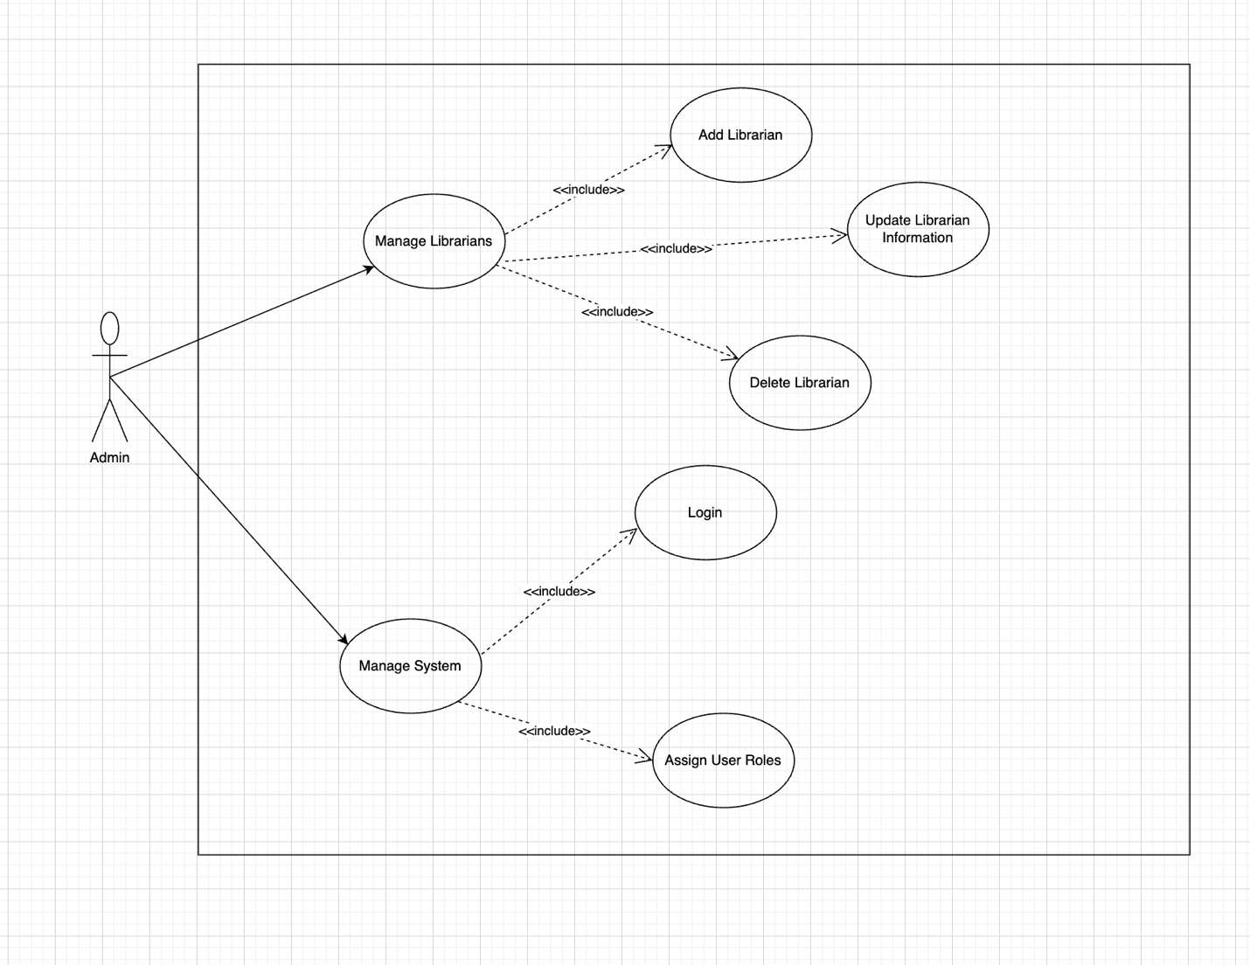
- User
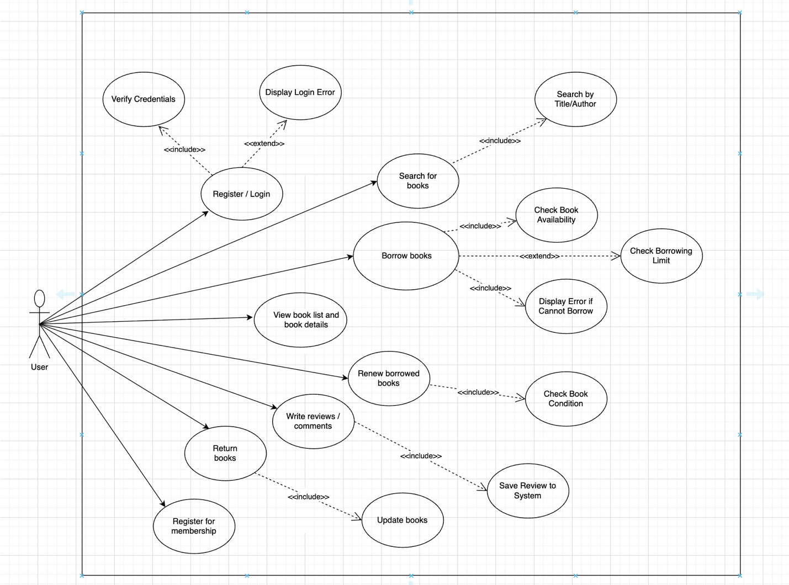

- Librarian
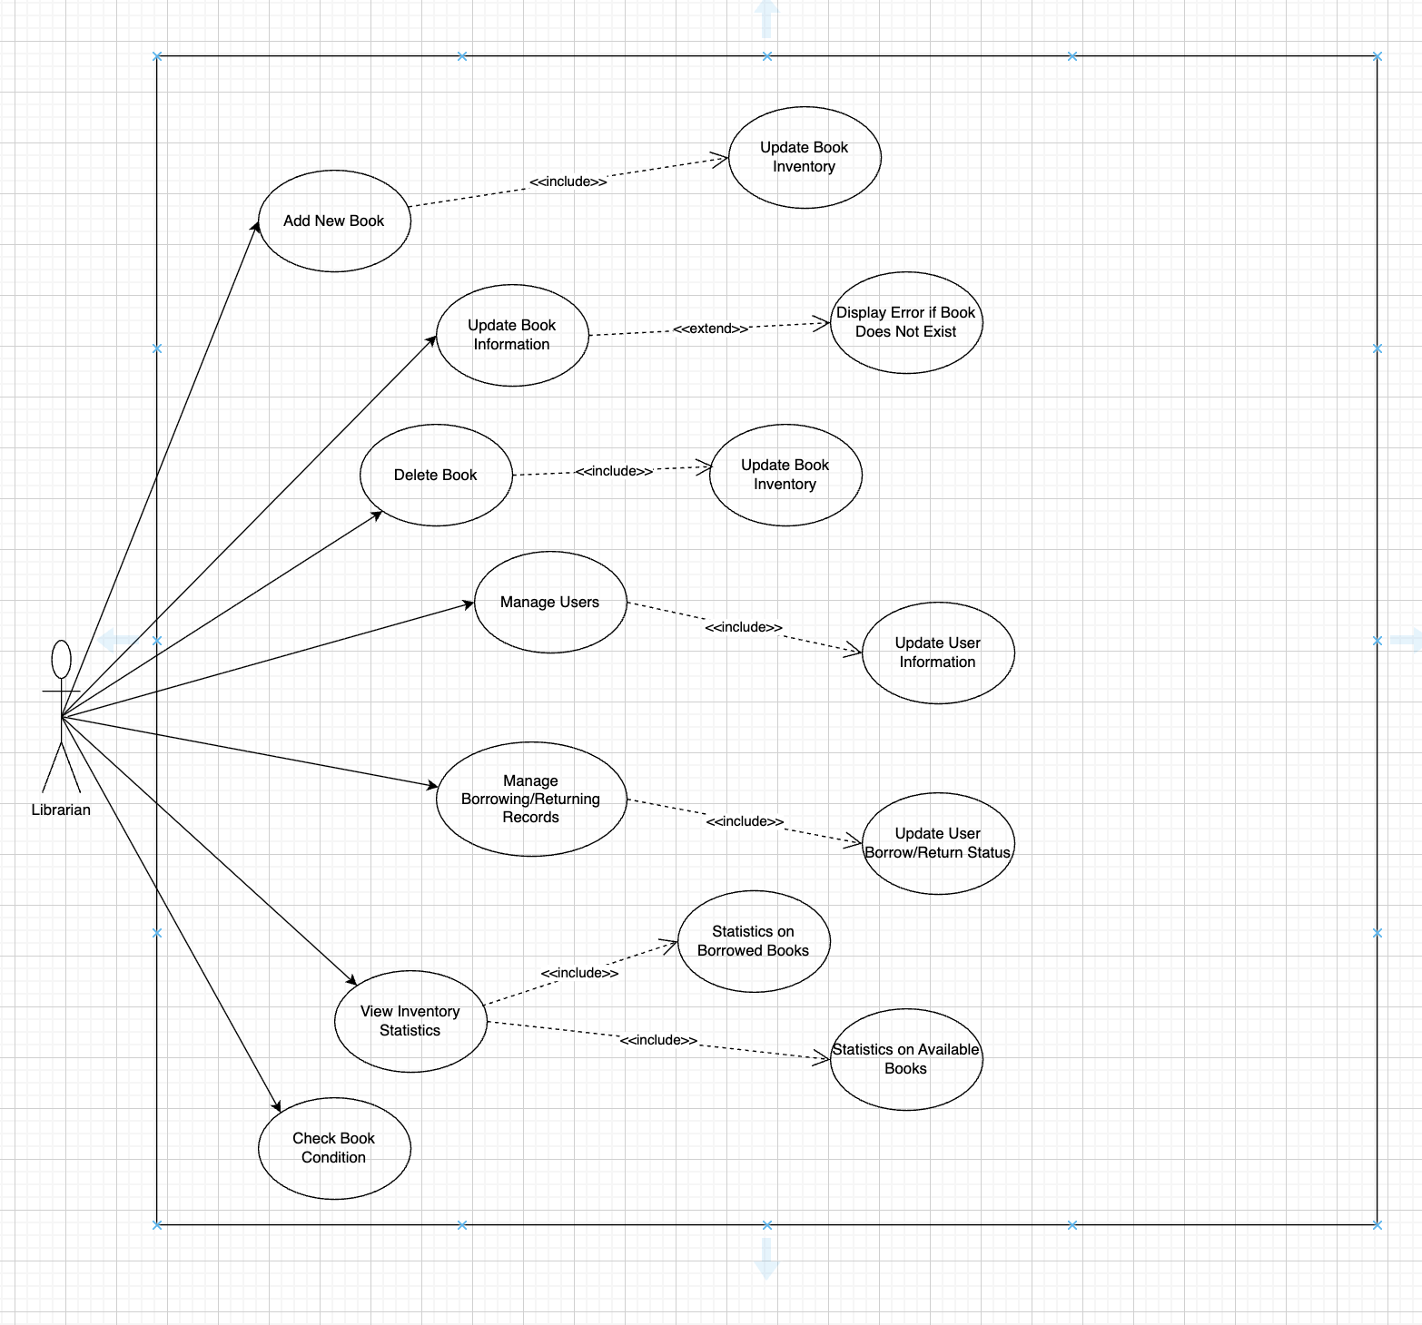

Main use case for User
Use Case 1: Register/Login
Item | Description
Use Case Name | Register / Login
Goal | Allow users to create a new account or log in to the system to access book management features
Primary Actor | User
Preconditions | The user already has an account (for login)
Main Flow | 1. The user selects “Register / Login”  2. The system displays the information input interface  3. The user enters username and password  4. The system validates the information (<>)  5. If valid → login is successful  6. If invalid → the system displays a “Login error message” (<>)
Postconditions | • The user is successfully logged into the system  • The system records the user session

Use Case 2: Search for Books
Item | Description
Use Case Name | Search for Books
Goal | Help users quickly find the desired books in the library
Primary Actor | User
Preconditions | The user is logged into the system
Main Flow | 1. The user selects “Search for Books”  2. The system displays the search bar3. The user enters a book title or author name (<>)  4. The system processes the request and displays matching results  5. The user selects a book to view detailed information
Postconditions | The user can view the list of books and detailed information of the selected book

Use Case 3: Borrow Books
Item | Description
Use Case Name | Borrow Books
Goal | Allow readers to borrow books conveniently while the system records the borrowing transaction
Primary Actor | User
Preconditions | • The reader is logged into the system  • The selected book is available in stock
Main Flow | 1. The reader selects “Borrow Books”  2. The system displays a list of available books (title, ID, author, quantity)  3. The reader searches for and selects a book  4. The system checks borrowing conditions:  • Borrowing limit has not been exceeded  • No violations (overdue, lost books, etc.)  • The book is still available  5. The system records the borrowing transaction (reader ID, book ID, borrow date, due date)  6. The system updates the book quantity (decrease by one)  7. The system displays “Borrow successful”
Postconditions | • The borrowing transaction is stored in the system  • Book quantity is updated  • The reader receives confirmation

Use Case 4: Renew Borrowed Books
Item | Description
Use Case Name | Renew Borrowed Books
Goal | Allow users to extend the borrowing period if conditions are met
Primary Actor | User
Preconditions | • The user is currently borrowing the book  • The book is not reserved by another user
Main Flow | 1. The user selects “Renew Book”  2. The system checks the book status (<>)  3. If eligible → the system updates the new due date  4. If not eligible → the system displays “This book cannot be renewed”
Postconditions | The borrowing period is successfully extended

Use Case 5: Write a Review
Item | Description
Use Case Name | Write a Review
Goal | Allow users to submit reviews and comments for books they have read
Primary Actor | User
Preconditions | The user has read or borrowed the book
Main Flow | 1. The user selects “Write Review / Comment”  2. The system displays the input form  3. The user enters the review content  4. The system saves the review to the database (<>)  5. The system displays “Review submitted successfully”
Postconditions | The review is stored and displayed in the book detail section

III. System design

A. Architectural Design: Monolithic Architecture
Monolithic Architecture is an architectural pattern in which the entire software system is built, deployed, and executed as a single unified application. All core functionalities of the system, including user interface handling, business logic, and data access, are tightly integrated within one codebase and run as a single process.
In a monolithic system, different functional modules communicate with each other through direct method calls rather than network-based communication. The application typically uses a shared database to store and manage all system data. Any update or modification to the system requires rebuilding and redeploying the entire application.
This architectural pattern offers simplicity in development, testing, and deployment, especially during the early stages of a project. It is well-suited for small to medium-sized systems with clearly defined requirements and limited scalability demands. However, as the system grows in size and complexity, monolithic architecture may introduce challenges in maintainability, scalability, and fault isolation.
In this project, the Monolithic Architecture is selected due to the relatively small scope of the system and the use of the Django framework. This approach simplifies the overall system design, reduces deployment complexity, and allows the development team to focus on implementing core functionalities efficiently.

B. C4 model

1. System Context Diagram
The Library Management System is a software system designed to support library operations, including book borrowing and returning, user account management, and library inventory management.
External Actors
Librarian
- Manage books, authors, and categories
- Handle borrowing and returning processes
- Manage library users

Library User (Reader)
- Search for books
- Register an account
- View borrowing and returning history
Email System
- Send borrowing confirmation notifications
- Send due-date reminder emails
Relationships
- Librarians and library users interact with the LMS through a web-based interface
- The LMS sends notification emails via an external email system
Diagram objective: To identify the system boundary and all external actors interacting with the system.

2. Container Diagram
Main Containers
Web Application (Frontend)
- Technology: HTML, CSS, JavaScript
- Responsibilities:
- Provide user interfaces for librarians and library users
- Send requests to the Backend API
Backend Application
- Technology: Django
- Responsibilities:
- Handle borrowing and returning business logic
- Perform authentication and authorization
- Provide RESTful APIs
Database
- Technology: MySQL
- Stores:
- Books
- Users
- Borrow records
- Transaction history
Email Service (External)
- Technology: Gmail SMTP / SendGrid
- Responsibility:
  - Send email notifications
Relationships
- Web Application ↔ Backend Application (HTTP/HTTPS)
- Backend Application ↔ Database (SQL)
- Backend Application → Email Service (SMTP/API)
Diagram objective: To illustrate the main deployment units of the system and how they communicate with each other.

3. Component Diagram (Backend Level)
Backend Components
Authentication Component
- User login
- Role-based authorization (Librarian / Library User)
Book Management Component
- CRUD operations for books
- Manage authors, categories, and book locations
User Management Component
- Manage library user accounts
- Manage librarian accounts
Borrowing Component
- Handle book borrowing
- Handle book returning
- Check book availability
Notification Component
- Send borrowing confirmation emails
- Send due-date reminder notifications
Reporting Component (Optional)
- Generate reports of most borrowed books
- Generate overdue borrowing reports
Relationships
- Controllers invoke business components
- The Borrowing Component interacts with the Book Management and User Management components
- The Notification Component is triggered by borrowing and returning events

C4 model diagram
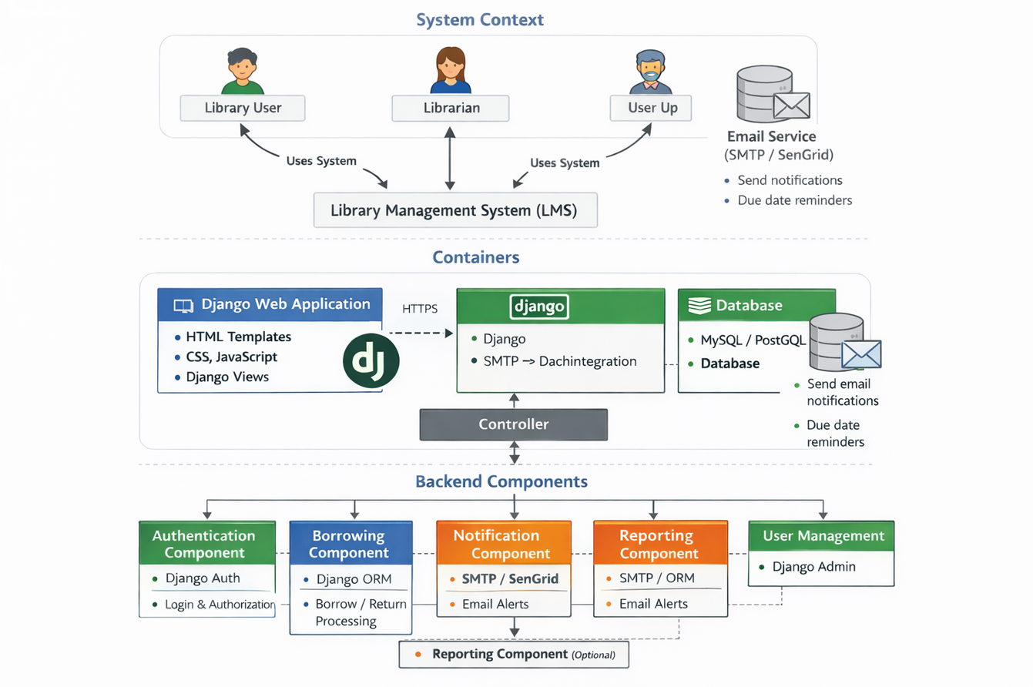

C. Technical Stack and Data Model

1. Technical Stack
The Library Management System (LMS) is developed using a modern and widely adopted technology stack that supports rapid development, maintainability, and scalability within a monolithic architecture.
- Backend Framework:
The system is implemented using Django, a high-level Python web framework that follows the MTV (Model–Template–View) pattern. Django provides built-in support for authentication, authorization, ORM, and security features, which helps reduce development complexity.
- Frontend Technologies:
The user interface is built using HTML, CSS, and JavaScript, combined with Django Templates for server-side rendering. This approach allows seamless integration between frontend and backend within a single Django application.
- Database Management System:
The system uses a relational database such as MySQL or PostgreSQL. Django ORM is utilized to map database tables to Python models, enabling efficient data access and manipulation.
- Authentication and Authorization:
Django’s built-in Authentication System is used to manage user login, logout, and role-based access control for different user types, including librarians and library users.
- Email Service Integration:
An external email service such as Gmail SMTP or SendGrid is integrated to send automated notifications, including borrowing confirmations and due-date reminders.
- Communication Protocols:
  - HTTP/HTTPS for client–server communication
  - SMTP or REST API for email delivery

2. Data Model
The data model of the Library Management System is designed using a relational approach to ensure data consistency and integrity. Core entities and their relationships are defined based on the main business requirements of the library.

Data diagram
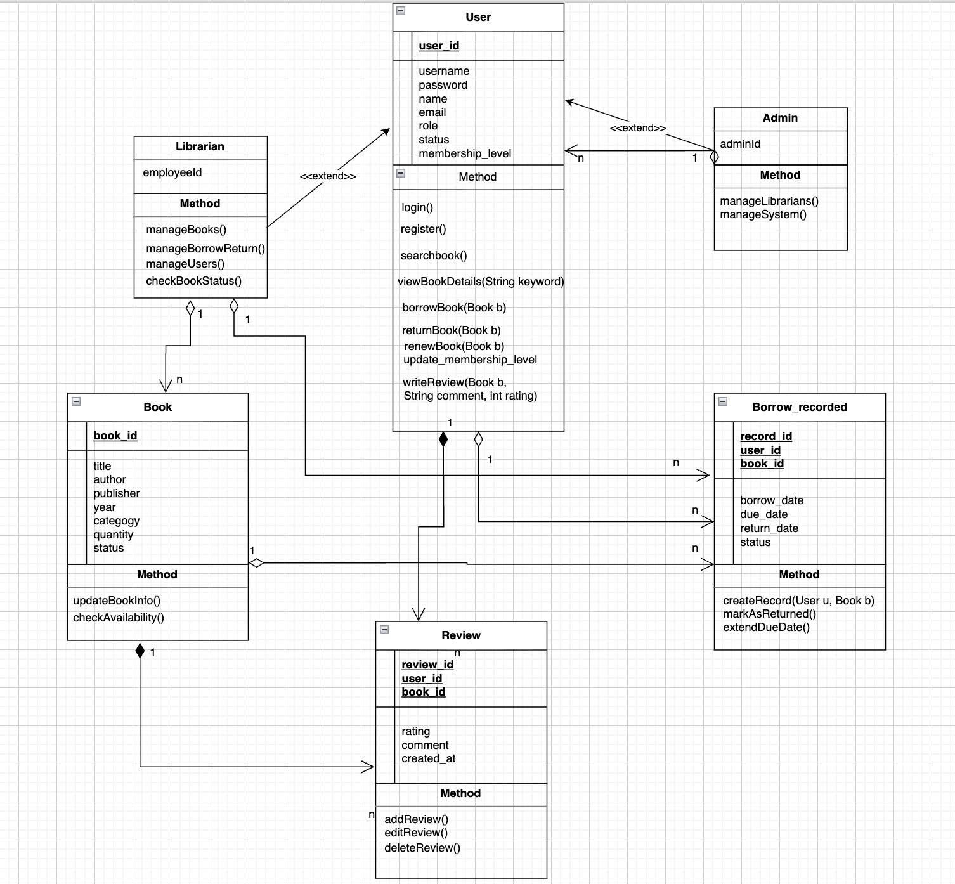

IV. Conclusion and Future Development

A. Evaluation and Lessons Learned
After the process of designing and developing the online Library Management System using Django, the team successfully completed most of the planned core functionalities.
The system meets the main requirements, including:
- Managing book information, users, and borrowing–returning processes
- Implementing user role management (librarian and library user)
- Supporting library location display through the Google Maps API
- Allowing online document and PDF file storage via Cloudinary
- Providing a user-friendly interface that is easy to use and operates stably
- Offering flexible and efficient search functionality
Limitations:
- Librarians cannot fully manage all displayed content within the system
- Statistical and visual reporting features have not yet been implemented
- User authorization is still at a basic level
- The system has not been deployed in a real production environment and currently runs only locally
Lessons Learned:
- More detailed planning for testing and performance optimization is required
- Greater use of project management tools (such as Trello or GitHub Projects) should be encouraged
- Teamwork skills need improvement, including better task distribution and time management

B. Future Development Directions
In the future, the system can be further expanded and enhanced with the following features:
- Statistics and Reporting:
  - Visual charts displaying the number of borrowed books, available inventory, and active users
- Artificial Intelligence (AI) Integration:
  - Recommending suitable books to users based on their borrowing history
- Online Payment and Fee Management:
  - Integrating payment gateways to collect borrowing fees or overdue penalties
- Mobile Application Development:
  - Building Android and iOS applications to allow users to search for and borrow books more conveniently
- Production Deployment:
  - Deploying the system to cloud platforms such as PythonAnywhere, AWS, or Heroku to enable online access

