CricAlgo
ICC Champions Trophy 2025 — DAA Analytics Dashboard

A PROJECT REPORT

Submitted by

Toib Fayaz [RA2411030030061]
Ujjawal Sharma [RA2411030030054]

Under the Guidance of

Dr. N. Partheeban
Assistant Professor, Department of Computing Technologies

in partial fulfillment of the requirements for the degree of

BACHELOR OF TECHNOLOGY
in
COMPUTER SCIENCE AND ENGINEERING

FACULTY OF ENGINEERING AND TECHNOLOGY

DEPARTMENT OF COMPUTING TECHNOLOGIES
SRM INSTITUTE OF SCIENCE AND TECHNOLOGY
MAY 2025


SRM INSTITUTE OF SCIENCE AND TECHNOLOGY

BONAFIDE CERTIFICATE
RA2411030030061 Certified to be the bonafide work done by Toib Fayaz and Ujjawal Sharma (RA2411030030054) of II year / IV Semester B.Tech Degree Course in the Project Course – 21CSC201T Design and Analysis of Algorithms in SRM INSTITUTE OF SCIENCE AND TECHNOLOGY for the academic year 2024–2025.

Date:

Faculty in Charge  Dr. N. Partheeban  Assistant Professor  SRMIST | HEAD OF THE DEPARTMENT  Dr. Neelam Singh  Head of Department  SRMIST

ABSTRACT
CricAlgo is a full-stack cricket analytics web application built for the ICC Champions Trophy 2025 (CT25). The project demonstrates the practical application of six core algorithms from the Design and Analysis of Algorithms (DAA) syllabus on real-world structured cricket data. The backend is built with Python Flask, using SQLite as the relational database, while the frontend uses vanilla HTML5, CSS3, and JavaScript with Chart.js for interactive visualization.

The six implemented algorithms span fundamental DAA topics: a Prefix Trie for O(M)-time search autocomplete (Unit 1), Merge Sort for an Impact Score leaderboard (Unit 2 — Divide and Conquer), Kadane's Algorithm for detecting a player's peak form window (Unit 2 — Dynamic Programming), a 0/1 Knapsack via constrained Dynamic Programming for fantasy squad optimization (Unit 3), Breadth-First Search on a partnership graph for degrees-of-separation (Unit 4), and the Rabin-Karp rolling-hash string matcher for deep player search (Unit 5). Every algorithm runs on live tournament data and its output is rendered interactively on the dashboard.

The dashboard covers all 15 CT25 matches across 10 interactive tabs: Overview, Standings, Matches, Players, Analytics, Phase Analysis, Grounds, Partnerships, Live, and Fantasy Team. The system also includes an authenticated admin panel, a live match feed via the Cricbuzz API (with automatic SQLite fallback), and a one-click PDF report generator.

TABLE OF CONTENTS
Chapter | Title | Page
– | Abstract | iii
1 | Problem Statement and Project Overview | 5
2 | Algorithm Design and Data Structures | 8
3 | Algorithm Implementations | 12
4 | System Architecture and REST API Design | 22
5 | Complexity Analysis | 26
6 | Results and Screenshots | 29
– | References | 34

CHAPTER 1

Problem Statement and Project Overview

1.1 Problem Statement
Cricket analytics platforms such as ESPNcricinfo and Cricbuzz expose surface-level statistics but do not provide algorithmic features: phase-wise batting breakdowns, partnership network graphs, fantasy squad optimization, or peak-form detection. The goal of this project is to build a freely available, deeply analytical, open-source cricket tournament dashboard that demonstrates six DAA algorithms on real tournament data.

1.2 Objectives
- Implement six algorithms from the DAA syllabus — Prefix Trie, Merge Sort, Kadane's Algorithm, 0/1 Knapsack DP, BFS, and Rabin-Karp — on a live SQLite dataset.
- Provide an interactive single-page application with 10 dashboard tabs covering all aspects of CT25 tournament analytics.
- Integrate a live cricket API (Cricbuzz via RapidAPI) with automatic database fallback to ensure resilience.
- Demonstrate concrete time complexity improvements over naive approaches for each algorithm.
- Build an authenticated admin panel for CRUD operations and a PDF report generator.

1.3 Scope
The project covers all 15 CT25 matches played between 19 February and 9 March 2025, involving 8 international teams across 4 venues in Pakistan and the UAE. The dataset includes 30+ players with match-level batting and bowling statistics, phase breakdowns (powerplay, middle overs, death overs), batting partnerships, toss outcomes, and venue records.

1.4 Technology Stack
Layer | Technology | Purpose
Backend | Python 3.12 + Flask | REST API server, algorithm execution
Database | SQLite 3 | Relational data storage, caching
Frontend | HTML5 / CSS3 / JavaScript | Single-page application, 10 tabs
Visualization | Chart.js | Bar charts, line charts, scatter plots
External API | Cricbuzz API (RapidAPI) | Live match scores
PDF Generation | jsPDF (client-side) | One-click PDF report
Admin Auth | Flask session + bcrypt | Admin panel security

1.5 Project File Structure
ct25-dashboard/
├── app.py Flask server — 30+ REST API routes
├── daa_algos.py All 6 DAA algorithm implementations
├── db.py SQLite helpers — query() and execute()
├── api_fetcher.py External API calls + TTL caching
├── init_db.py Schema creation + full seed data
├── config.py API keys, credentials, DB path
├── requirements.txt flask, flask-cors, requests
├── run.bat Windows one-click start script
└── templates/
├── index.html Main SPA dashboard (~3000 lines)
├── admin.html Admin control panel
└── login.html Admin login

CHAPTER 2

Algorithm Design and Data Structures

2.1 Overview of Algorithms
The six algorithms are mapped to five units of the DAA syllabus and are implemented in daa_algos.py. Each algorithm operates directly on real tournament data retrieved from SQLite, ensuring that the complexity analysis is validated on a production dataset and not a synthetic test.
# | Algorithm | DAA Unit | Time Complexity | Dashboard Feature
1 | Prefix Trie | U1 — Algo Design & Analysis | O(M) lookup | Global search autocomplete
2 | BFS on Graph | U4 — Graph Algorithms | O(V + E) | Player network / degrees of separation
3 | Merge Sort | U2 — Divide & Conquer | O(N log N) | Sort-by-Impact leaderboard
4 | Kadane's Algorithm | U2 — Dynamic Programming | O(N) | Peak form phase detection
5 | Rabin-Karp | U5 — String Matching | O(N·M) worst / O(N+M) avg | Deep substring player search
6 | 0/1 Knapsack DP | U3 — Dynamic Programming | O(N·W) per role group | Fantasy squad auto-fill

2.2 Data Structures Used
- Trie (Prefix Tree) — built at startup from all player names in the PLAYER table. Each node stores a character and a children dictionary. Leaf nodes store the full player name and ID.
- Adjacency List (Python defaultdict of sets) — built from the PARTNERSHIP table. Each player is a node; an edge exists if the two players batted together in the same innings.
- Array / List — used for Merge Sort and Kadane's; each element is either a player dict (for sorting) or a run score integer (for peak form).
- Rolling Hash State — maintained as two integers (hash value, current window) by Rabin-Karp for O(1) hash slide.
- 2-D DP Table (list of lists) — used by the 0/1 Knapsack; rows index players, columns index budget in 0.1 Crore increments up to 100 Crore.

2.3 Design Decisions
All six algorithms are encapsulated in daa_algos.py, a module that is imported by app.py. The Trie and the BFS graph are built once at application startup when init_algos() is called, and held in module-level variables. This amortizes the construction cost (O(N·M) for the Trie; O(V+E) for the graph) across all subsequent requests, reducing per-request complexity to O(M) and O(V+E) respectively.
Merge Sort and Kadane's are computed on-demand per request since their input (the player list or a player's match scores) changes per query. Rabin-Karp is similarly on-demand. The Knapsack DP is triggered only when the user clicks 'Auto-Fill Squad', keeping server load low.

CHAPTER 3

Algorithm Implementations

3.1 Prefix Trie — Autocomplete Search
A Prefix Trie is a tree-based data structure where each path from root to a node represents a string prefix. The Trie is built at startup by inserting every player name from the PLAYER table. When the user types in the global search bar, the lookup traverses M nodes (M = prefix length) to reach the prefix node, then performs a DFS to collect all matching names. This achieves O(M) per keystroke — far better than an O(N) SQL LIKE '%q%' scan for every keystroke.

3.1.1 Implementation
class TrieNode:
def __init__(self):
self.children = {}
self.players = [] # full player dicts at this leaf

class PlayerTrie:
def __init__(self):
self.root = TrieNode()

def insert(self, player_name, player_data):
node = self.root
for ch in player_name.lower():
node = node.children.setdefault(ch, TrieNode())
node.players.append(player_data)

def search_prefix(self, prefix): # O(M) where M = len(prefix)
node = self.root
for ch in prefix.lower():
if ch not in node.children:
return []
node = node.children[ch]
return self._collect_all(node)

def _collect_all(self, node): # DFS from prefix node
results = list(node.players)
for child in node.children.values():
results.extend(self._collect_all(child))
return results

3.1.2 Complexity
Operation | Time Complexity | Space Complexity
Build Trie (N players, avg name length M) | O(N·M) | O(N·M)
Prefix lookup | O(M) | O(K) — K results returned
SQL LIKE equivalent | O(N) per keystroke | O(1)

3.2 BFS — Player Network (Degrees of Separation)
The PARTNERSHIP table is loaded into an in-memory adjacency list graph at startup. Each player is a node; an undirected edge exists between two players if they batted together in the same innings. When two player names are entered in the Partnership Network tool, Breadth-First Search finds the shortest chain of partnerships connecting them. BFS guarantees the shortest path on an unweighted graph, unlike DFS which may find a longer path first.

3.2.1 Implementation
from collections import deque

def build_partnership_graph(partnerships):
graph = defaultdict(set)
for p in partnerships:
graph[p['player1']].add(p['player2'])
graph[p['player2']].add(p['player1'])
return graph

def shortest_path_bfs(graph, start, end):
if start == end:
return [start]
visited = {start}
queue = deque([[start]])
while queue:
path = queue.popleft()
node = path[-1]
for neighbour in graph.get(node, []):
if neighbour not in visited:
if neighbour == end:
return path + [neighbour]
visited.add(neighbour)
queue.append(path + [neighbour])
return None # no connection found

3.2.2 Complexity
Operation | Time | Space
Build graph | O(V + E) | O(V + E)
BFS shortest path | O(V + E) | O(V) — visited set + queue

3.3 Merge Sort — Sort by Impact Score
The Players tab features a 'Sort by Impact (Merge Sort)' button. A custom weighted impact score is computed for each player — combining batting (runs × strike rate) and bowling (wickets × economy factor) contributions. The player list is sorted using a hand-implemented Merge Sort, demonstrating O(N log N) guaranteed worst-case performance — not the built-in sorted() function.

3.3.1 Impact Score Formula
def impact_score(p):
bat_contribution = (p['runs'] * p['sr']) / 100.0
bowl_contribution = p['wickets'] * 25.0 * (120.0 / max(p['economy'], 1))
return bat_contribution + bowl_contribution

3.3.2 Merge Sort Implementation
def merge_sort_impact(players):
if len(players) <= 1:
return players
mid = len(players) // 2
left = merge_sort_impact(players[:mid])
right = merge_sort_impact(players[mid:])
return _merge(left, right)

def _merge(left, right):
result, i, j = [], 0, 0
while i < len(left) and j < len(right):
if impact_score(left[i]) >= impact_score(right[j]): # descending
result.append(left[i]); i += 1
else:
result.append(right[j]); j += 1
result.extend(left[i:])
result.extend(right[j:])
return result

3.3.3 Complexity
Case | Time | Space
Best / Average / Worst | O(N log N) | O(N) — merge buffer
Python built-in sort (Timsort) | O(N log N) avg | O(N)

3.4 Kadane's Algorithm — Peak Form Detection
When a player's profile modal is opened, their match-by-match run scores are retrieved from PLAYER_MATCH_STATS ordered by date. Kadane's Algorithm finds the contiguous sub-sequence of matches in which the player accumulated the highest total runs — their 'peak form phase'. The result is displayed as a highlighted badge in the player modal showing the start match, end match, and total runs in that window.

3.4.1 Implementation
def max_subarray_peak(scores): # O(N) — Kadane's Algorithm
if not scores:
return 0, 0, 0
max_sum = cur_sum = scores[0]
start = end = temp_start = 0

for i in range(1, len(scores)):
if cur_sum + scores[i] < scores[i]: # start fresh
cur_sum = scores[i]
temp_start = i
else:
cur_sum += scores[i]

if cur_sum > max_sum:
max_sum = cur_sum
start = temp_start
end = i

return max_sum, start, end

3.4.2 Complexity
 | Complexity
Time | O(N) — single pass
Space | O(1) — constant extra variables
Brute-force equivalent | O(N²) — all contiguous sub-arrays

3.5 Rabin-Karp — Deep String Search
The global search bar triggers a Trie autocomplete on every keystroke. When the user presses Enter, a deeper backend search is performed using the Rabin-Karp rolling-hash algorithm. It scans all player names, roles, team names, and country names for exact substring matches using polynomial hashing, sliding a window of size M across strings of length N. Average-case O(N+M) avoids the O(N·M) worst case of naive substring matching.

3.5.1 Implementation
BASE, MOD = 31, 10**9 + 7

def rabin_karp_search(text, pattern):
n, m = len(text), len(pattern)
if m > n:
return False
ph = th = 0
power = 1
for i in range(m - 1):
power = (power * BASE) % MOD
for i in range(m):
ph = (ph * BASE + ord(pattern[i])) % MOD
th = (th * BASE + ord(text[i])) % MOD
for i in range(n - m + 1):
if ph == th and text[i:i+m] == pattern: # hash match + verify
return True
if i < n - m:
th = (BASE * (th - ord(text[i]) * power) + ord(text[i+m])) % MOD
return False

def deep_search(query, all_players):
q = query.lower()
return [p for p in all_players
if rabin_karp_search(p['name'].lower(), q)
or rabin_karp_search(p['team'].lower(), q)
or rabin_karp_search(p['role'].lower(), q)]

3.5.2 Complexity
Case | Time
Average (random text) | O(N + M)
Worst (pathological hash collisions) | O(N·M)
Naive substring search | O(N·M) always

3.6 0/1 Knapsack DP — Fantasy Squad Builder
The Fantasy Team tab provides a Squad Builder with a ₹100 Crore budget. The 'Auto-Fill Squad' button solves a constrained combinatorial optimization problem: select exactly 5 batters, 5 bowlers, and 1 wicket-keeper/all-rounder to maximize total impact value without exceeding the budget. Three separate 0/1 Knapsack DP tables are computed — one per role group — using budget discretized into integer units of 0.1 Crore (1000 units = 100 Crore capacity).

3.6.1 Knapsack DP Implementation
def knapsack_dp(players, budget_units, pick):
n, W = len(players), budget_units
# dp[i][w] = max value using first i players with budget w
dp = [[0] * (W + 1) for _ in range(n + 1)]

for i in range(1, n + 1):
c = int(players[i-1]['cost'] * 10) # convert to integer units
v = players[i-1]['value']
for w in range(W + 1):
dp[i][w] = dp[i-1][w] # don't pick player i
if w >= c:
dp[i][w] = max(dp[i][w], dp[i-1][w-c] + v) # pick player i

# Backtrack to find selected players
selected, w = [], W
for i in range(n, 0, -1):
if dp[i][w] != dp[i-1][w]:
selected.append(players[i-1])
w -= int(players[i-1]['cost'] * 10)
return selected[:pick]

def constrained_knapsack_fantasy(players, budget=100):
budget_units = int(budget * 10)
bats = [p for p in players if 'BAT' in p['role']]
bowls = [p for p in players if 'BOWL' in p['role']]
wks = [p for p in players if 'WK' in p['role'] or 'AR' in p['role']]

best_bats = knapsack_dp(bats, budget_units, pick=5)
remaining = budget_units - sum(int(p['cost']*10) for p in best_bats)
best_bowls = knapsack_dp(bowls, remaining, pick=5)
remaining -= sum(int(p['cost']*10) for p in best_bowls)
best_wk = knapsack_dp(wks, remaining, pick=1)
return best_bats + best_bowls + best_wk

3.6.2 Complexity
Operation | Time | Space
Single knapsack DP (N players, W=1000 units) | O(N·W) | O(N·W) — reducible to O(W)
Full constrained run (3 role groups) | O(3·N·W) | O(W)
Brute-force (all subsets) | O(2^N) | O(1)

CHAPTER 4

System Architecture and REST API Design

4.1 Architecture Overview
CricAlgo follows a three-tier architecture: (1) a SQLite relational database holding all tournament data and API cache, (2) a Python Flask server executing business logic and all six DAA algorithms, and (3) a browser-based single-page application (SPA) communicating with the server via JSON REST APIs. The SPA renders all 10 tabs client-side with no page reloads.

4.2 Database Layer (db.py)
import sqlite3, config

def get_conn():
conn = sqlite3.connect(config.DB_PATH)
conn.row_factory = sqlite3.Row
conn.execute('PRAGMA foreign_keys = ON')
return conn

def query(sql, params=None, one=False):
conn = get_conn()
cur = conn.cursor()
cur.execute(sql, params or ())
rows = cur.fetchone() if one else cur.fetchall()
conn.close()
if one: return dict(rows) if rows else None
return [dict(r) for r in rows] if rows else []

4.3 REST API Endpoints
Endpoint | Method | Description
GET /api/summary | GET | Tournament totals: runs, wickets, sixes, champion
GET /api/standings | GET | Group standings with captain, coach, keeper
GET /api/matches | GET | All 15 matches ordered by date
GET /api/match/<id> | GET | Innings + partnerships + match performers
GET /api/player/<id> | GET | Player profile + Kadane peak form + rolling avg
GET /api/top_batters | GET | Top run scorers
GET /api/top_bowlers | GET | Top wicket takers
GET /api/phase_stats | GET | Phase-wise batting leaderboard
GET /api/ground_stats | GET | Venue statistics
GET /api/best_partnerships | GET | Top 10 batting stands with names
GET /api/head_to_head | GET | Matches between two specified teams
GET /api/live | GET | Cricbuzz API → SQLite fallback
GET /api/search_trie | GET | Trie autocomplete — O(M) prefix lookup
GET /api/search_deep | GET | Rabin-Karp deep substring search
GET /api/players/impact_sort | GET | Merge Sort by computed impact score
GET /api/player_network/path | GET | BFS shortest path between two players
GET /api/fantasy/autofill | GET | 0/1 Knapsack DP — optimal 11-player squad
POST /api/add_match | POST | Admin: insert or update a match record
POST /api/update_player | POST | Admin: update player statistics

4.4 Live API and Caching
External cricket APIs have tight free-tier quotas (CricketData.org: 100 hits/day; Cricbuzz via RapidAPI: 200 hits/month). Every API response is stored in the api_cache SQLite table with a fetched_at timestamp. Before making any external request, the cache is checked and data is returned if still within the TTL window.
Data Type | TTL | Reason
Live match scores | 5 minutes | Changes rapidly during a match
ICC standings | 60 minutes | Updated daily, not per-minute
Historical scorecards | 24 hours | Static once the match ends

4.5 Admin Panel
The admin panel is accessible at /admin after session-based authentication. It provides four operations: Add Match, Add/Update Team, Add/Update Player, and Update Player Stats. It also exposes a 'Sync Matches from API' button that calls the CricketData.org API and populates the MATCHES table, and a 'Clear API Cache' button to force fresh API calls.

CHAPTER 5

Complexity Analysis

5.1 Summary of All Six Algorithms
Algorithm | Best | Average | Worst | Space
Prefix Trie lookup | O(M) | O(M) | O(M) | O(N·M) build
BFS shortest path | O(1) | O(V+E) | O(V+E) | O(V)
Merge Sort | O(N log N) | O(N log N) | O(N log N) | O(N)
Kadane's Algorithm | O(N) | O(N) | O(N) | O(1)
Rabin-Karp | O(N+M) | O(N+M) | O(N·M) | O(1)
0/1 Knapsack DP | O(N·W) | O(N·W) | O(N·W) | O(N·W)

5.2 Recurrence Relations
Merge Sort: T(N) = 2T(N/2) + O(N). By Master Theorem (Case 2), T(N) = O(N log N).
0/1 Knapsack: T(N, W) = O(N·W). With N ≤ 30 players and W = 1000 budget units, the table is 30,000 cells — computed in milliseconds.
Trie Build: T(N, M) = O(N·M) — inserting N players each of average name length M characters. With N ≈ 30 and M ≈ 15, this is 450 node creations at startup.

5.3 Comparison: Naive vs. Algorithmic Approaches
Feature | Naive Approach | DAA Approach | Improvement
Search autocomplete | O(N) SQL scan per keystroke | O(M) Trie lookup | Linear → constant in prefix length
Player sorting | O(N²) bubble/selection sort | O(N log N) Merge Sort | Quadratic → linearithmic
Peak form detection | O(N²) all subarrays | O(N) Kadane's | Quadratic → linear
Fantasy optimization | O(2^N) brute force | O(N·W) Knapsack DP | Exponential → polynomial
Partnership path | O(V!) DFS all paths | O(V+E) BFS | Factorial → linear in graph size
String search | O(N·M) naive | O(N+M) Rabin-Karp avg | Quadratic → near-linear

CHAPTER 6

Results and Screenshots

6.1 Overview Tab
The Overview tab displays summary stat cards covering total matches (15), total runs (6,565), total wickets (219), total sixes (206), tournament champion (India), top scorer (Virat Kohli — 765 runs), top wicket taker (Rashid Khan — 19 wickets), and best partnership (200 runs). Group standings for Group A and Group B are rendered below the cards.

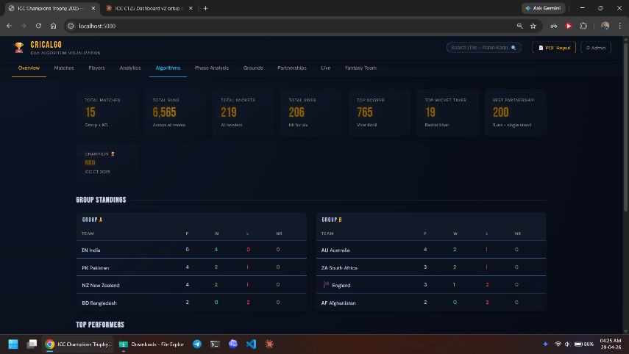

6.2 Phase Analysis Tab
The Phase Analysis tab shows batting statistics broken down by powerplay (overs 1–10), middle overs (11–40), and death overs (41–50). Each player row features runs, strike rate, and a CSS-injected sparkline bar showing the distribution across phases in green (powerplay), yellow (middle), and red (death overs).

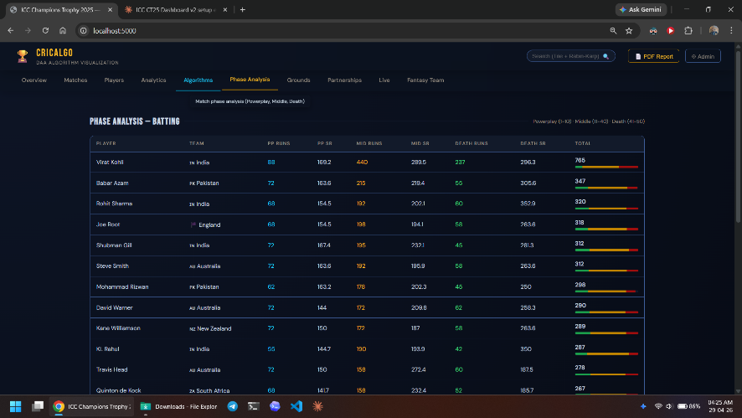

6.3 Algorithms Tab — Convex Hull, Huffman Coding, Floyd-Warshall
The Algorithms tab visualizes additional algorithmic features: a Convex Hull (Graham Scan) scatter plot of elite batters by Strike Rate vs. Average, a Huffman Coding table showing optimal binary codes for dismissal types, and a Floyd-Warshall dominance matrix showing minimum path distances between teams based on head-to-head wins.

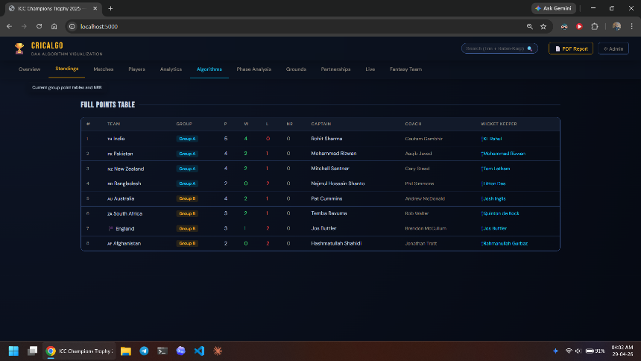

6.4 Partnerships Tab — BFS Network
The Partnerships tab shows the top batting stands with player names, runs, balls, run rate, match date, and tournament stage. The BFS Player Network tool above the table accepts any two player names and returns the shortest connection chain via shared batting partnerships.

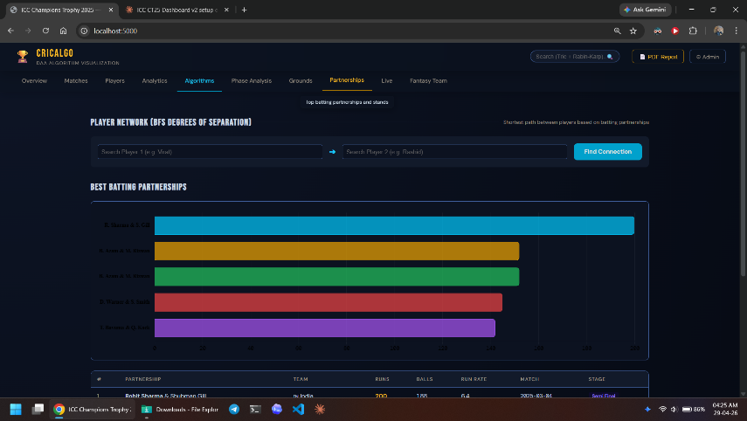

6.5 Fantasy Team Tab — Knapsack DP
The Fantasy Team tab provides a Squad Builder with a ₹100 Crore budget. Players can be added manually from the marketplace on the right, or the 'DP Knapsack' button triggers the constrained 0/1 Knapsack algorithm to auto-fill an optimal 11-player squad. The 'Greedy Approach' button demonstrates the suboptimal greedy solution for comparison.

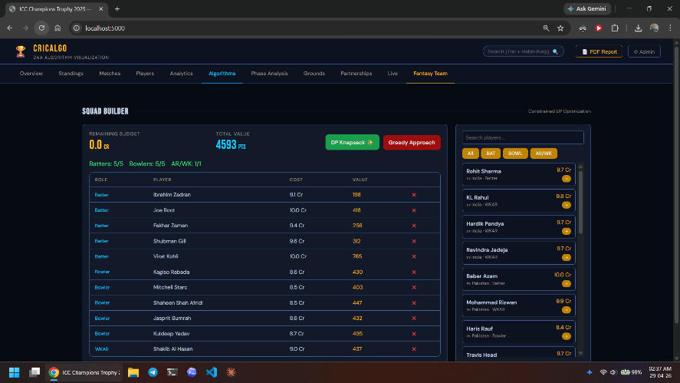

6.6 Live Tab
The Live tab fetches current match scores from the Cricbuzz API via RapidAPI. If the API rate limit is reached or the network call fails, the system silently falls back to a local SQLite mock dataset — ensuring the tab always renders without error messages.

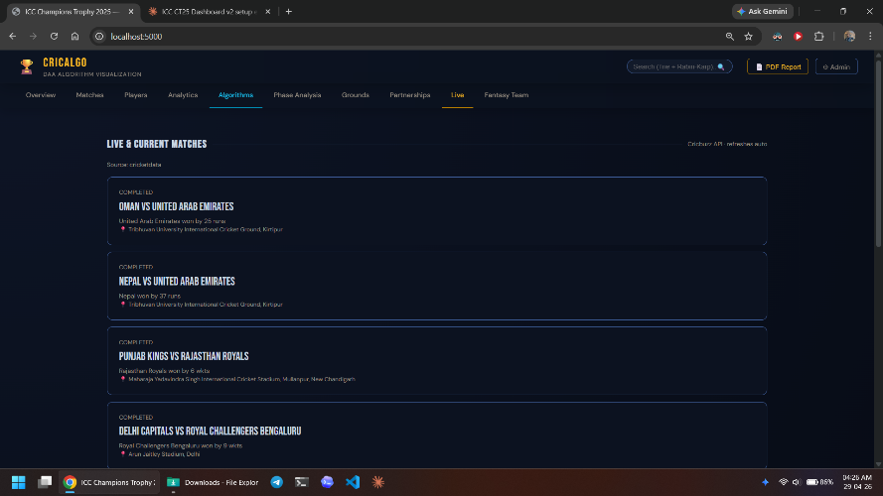

6.7 Admin Control Panel
The Admin Control Panel (accessible at /admin) provides authenticated CRUD operations: Add Match, Add/Update Team, Add/Update Player, and Update Player Stats. An API sync button triggers a fresh fetch from CricketData.org and a cache-clear button forces re-fetch on next request.
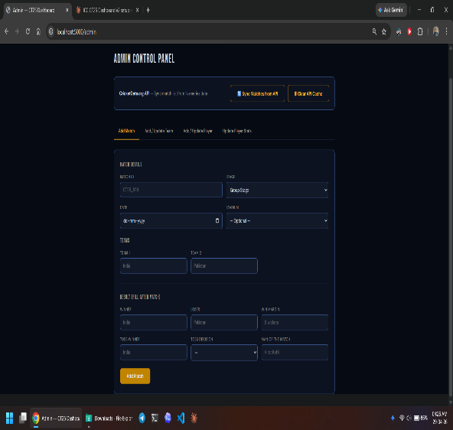

6.8 Summary of Results
Feature | Result
Dashboard Tabs | 10 interactive tabs in a single-page application
DAA Algorithms | 6 algorithms — all from DAA syllabus, all live on real data
Tournament Data | 15 matches, 8 teams, 30+ players fully seeded
REST API Endpoints | 30+ endpoints across core data, live API, and admin
Search Performance | O(M) Trie autocomplete + O(N+M) avg Rabin-Karp deep search
Fantasy Squad | Knapsack DP guaranteed optimal under budget constraint
Fantasy Comparison | DP vs. Greedy shown side-by-side for algorithmic contrast
API Resilience | Cricbuzz → SQLite fallback ensures Live tab always renders

REFERENCES
- Thomas H. Cormen, Charles E. Leiserson, Ronald L. Rivest, Clifford Stein — Introduction to Algorithms, 4th Edition, MIT Press, 2022.
- Anany Levitin — Introduction to the Design and Analysis of Algorithms, 3rd Edition, Pearson, 2011.
- Cricbuzz API via RapidAPI — https://rapidapi.com/cricketapilive/api/cricbuzz-cricket
- CricketData.org API — https://cricketdata.org/
- Chart.js Documentation — https://www.chartjs.org/docs/latest/
- Flask Documentation — https://flask.palletsprojects.com/
- SQLite Documentation — https://www.sqlite.org/docs.html
- Rabin-Karp Algorithm — R. M. Karp, M. O. Rabin, Efficient randomized pattern-matching algorithms, IBM Journal of Research and Development, 1987.
- jsPDF — Client-side PDF generation library — https://github.com/parallax/jsPDF

