POSTS AND TELECOMMUNICATIONS
INSTITUTE OF TECHNOLOGY | HCMC

MediConnect
INTEGRATED HEALTHCARE CLINIC &
TELEMEDICINE MANAGEMENT SYSTEM

DATABASE DESIGN • SQL IMPLEMENTATION • WEB INTEGRATION

PROJECT INFORMATION | DETAIL
Course | INT1313 – Databases
Group | G2
Project | Healthcare Clinic & Telemedicine Portal
Technology | MySQL 8.x · Python Flask · HTML / CSS
Document | Revised technical report · November 2026

Team members
- Lê Nguyễn Quốc Hùng · n24dece070@student.ptithcm.edu.vn
- Trần Hoàng Hải Đăng · n24dece059@student.ptithcm.edu.vn
- Trần Quốc Huy · n24dece074@student.ptithcm.edu.vn

Note Submission date and instructor name should be inserted once confirmed by the course announcement. This report intentionally avoids inventing unverified timings or test outcomes.

Report overview
This revised report aligns the conceptual design with the implemented MySQL schema named Phrase3 and documents the Phase 4 Flask application. It preserves the project scope and 58 original business rules, updates table definitions and queries, adds both implemented views and insert triggers, and separates observed test evidence from pending verification.
CONFIRMED BASELINE* | VALUE
Base tables | 13
Total table rows | 11,432
Appointment view rows | 2,540
Prescription detail view rows | 1,534
Roles | ADMIN · DOCTOR · PATIENT
Application type | Server-rendered Flask (no REST API required)

Note *Counts were observed in MySQL Workbench screenshots from 1 November 2026, before any later interactive changes. Re-run COUNT(*) for the final submission snapshot. Counts alone do not certify all business rules.

Table of Contents
SECTION | PAGE
1. Introduction & Project Scope | 4
1.1 System Objective | 4
1.1.1 Core Entities and Their Responsibilities | 5
1.1.2 Role-Based Users and Workflow | 6
1.2 Business Rules and Constraints | 6
1.3 Role-Based Capabilities | 11
2. Database Design | 12
3. Data Dictionary – Implemented Schema | 16
4. Database Implementation | 21
5. Verification, Integrity & Security | 33
6. Phase 4 – Flask Integration & Demonstration | 36
Appendix A – Reproducibility Checklist | 39
Appendix B – Database Verification SQL | 39
Appendix D – DDL Reference | 40

1. Introduction & Project Scope
The Healthcare Clinic & Telemedicine Portal is a centralized database system designed to support comprehensive healthcare information management, clinical workflow coordination, and administrative operations for a clinic providing both traditional in-person consultations and telemedicine services. The system manages multi-role user authentication and access control, patient profiles, doctor information, doctor schedules, appointment booking, follow-up appointments, consultation sessions, medical histories, and digital prescriptions.
The system is intended to keep healthcare information consistent, secure, accurate, and reliable. It also prevents scheduling conflicts and enforces strong relationships among doctors, schedules, appointments, consultation sessions, medical histories, and prescriptions.
Role-Based Access Control (RBAC) is applied with three main roles: ADMIN, DOCTOR, and PATIENT. General Practitioners and Specialists share common doctor information, so DOCTOR is modeled as a supertype with GENERAL_PRACTITIONER and SPECIALIST as total and disjoint subtypes.

1.1 System Objective
The main objective of the system is to provide a reliable database for storing and managing the essential information of a healthcare clinic.
- Manage user credentials and enforce Role-Based Access Control (RBAC) across ADMIN, DOCTOR, and PATIENT roles.
- Maintain centralized patient profiles containing demographic, contact, emergency contact, and baseline clinical information.
- Manage doctor information and professional credentials.
- Distinguish General Practitioners from Specialists using Total and Disjoint EER specialization.
- Link medical specialists to their corresponding clinical specialties.
- Manage doctors' working schedules and availability while preventing overlapping schedule slots.
- Coordinate appointment bookings and support patient self-booking, administrator-assisted booking, and doctor-created follow-up appointments.
- Manage consultation sessions and enforce that each consultation session is based on a valid appointment.
- Record actual consultation start time, end time, duration, modality, and clinical notes.
- Maintain longitudinal medical history and diagnosis records.
- Manage prescriptions issued by attending doctors during valid clinical sessions.
- Maintain data integrity and prevent inconsistent healthcare records.
- Provide a rigorous conceptual database model for later logical design, SQL implementation, and Python web development.

1.1.1 Core entities and their responsibilities
The original Group G2 proposal identifies 13 core entities supporting MediConnect, from account management and doctor classification to appointment booking, clinical records and prescriptions. The descriptions below are adapted from the Entity Overview in the original g02 report; physical table names and fields follow the implemented Phrase3 database where they differ.
ENTITY | PURPOSE IN THE CLINIC WORKFLOW
USER_ACCOUNT | Stores system login credentials and role information for ADMIN, DOCTOR and PATIENT users. It provides the account identity used for role-based access control.
PATIENT | Stores each patient’s profile, including full name, blood type, allergies, chronic diseases and emergency contact. The patient record is linked to appointments and clinical information.
DOCTOR | Stores doctors’ names, contact information and professional license numbers. Doctor records connect to schedules, appointments and prescriptions; IsActive supports Phase 4 soft deletion.
GENERAL_PRACTITIONED | Represents doctors classified as general practitioners. DoctorID is both the subtype’s primary key and a reference to DOCTOR.
SPECIALIST | Represents specialist doctors and links each specialist to one clinical specialty using SpecialtyID.
SPECIALTY | Maintains the catalog of medical specialties used to classify specialist doctors.
DOCTOR_SCHEDULE | Stores doctors’ scheduled working dates, start and end times, and availability status. Appointments refer to a selected working schedule.
APPOINTMENT | Records a booked consultation between one patient and one doctor, including the selected schedule, date and time, estimated duration, modality, status and optional preceding appointment.
CONSULTATION_SESSION | Records consultations that actually take place for appointments, including session times, duration, in-person or virtual type, clinical notes and an optional meeting URL.
MEDICAL_HISTORY | Stores diagnoses, symptoms, record dates and progress notes for patients, linked to the consultation sessions in which those observations were recorded.
PRESCRIPTION | Records prescription headers issued by doctors for patients during consultation sessions, including the issue date. Detailed medication instructions are kept separately.
PRESCRIPTION_ITEM | Connects a prescription to each prescribed medication and records its dosage, frequency, duration and special instructions.
MEDICATION | Maintains the medication catalog, including medicine names and descriptions, referenced by prescription items.

1.1.2 Role-based users and workflow
The USER_ACCOUNT role distinguishes three types of application users. ADMIN, DOCTOR and PATIENT represent authorization roles rather than three additional database tables.
- ADMIN — Manages user accounts, patient and doctor profiles, doctor schedules and appointment records, including allowed appointment changes.
- DOCTOR — Views assigned appointments, conducts consultations, records clinical information, issues prescriptions and may create follow-up appointments.
- PATIENT — Books appointments, views personal appointments and prescriptions, and participates in in-person or telemedicine consultations.
Workflow relationship. A registered user can be associated with a doctor or patient profile. The clinic records a doctor’s working schedule, then an appointment for a patient with that doctor. A completed visit may generate a consultation session, medical history records and prescriptions containing one or more medication items. Section 1.2 defines the business rules governing these relationships.

1.2 Business rules and constraints
The BR identifiers below preserve the original Phase 1 specification. They are requirements, not proof that every rule is implemented as a database constraint. Coverage is analysed in Sections 4–6. The physical table name GENERAL_PRACTITIONED is retained because it exists in the deployed schema.

Accounts and roles · BR1–BR5
ID | REQUIREMENT
BR1 | Each user account must have a unique UserID.
BR2 | Each user account must have a unique, non-null Username and a secure password hash.
BR3 | Every account must be assigned exactly one role: ADMIN, DOCTOR, or PATIENT.
BR4 | Every registered doctor and patient must be linked to exactly one valid USER_ACCOUNT.
BR5 | An account cannot be deleted while active dependent operational records require it.

Patients · BR6–BR12
ID | REQUIREMENT
BR6 | Each patient must have a unique patient key (Patient).
BR7 | Each patient must have basic identifying and contact information.
BR8 | A patient profile records baseline health information including blood type, allergies, chronic diseases, and emergency contact information.
BR9 | A patient can have zero, one, or many appointments over time.
BR10 | Each appointment belongs to exactly one patient.
BR11 | A patient can participate in zero, one, or many consultation sessions.
BR12 | A patient can have multiple medical history records and multiple prescriptions.

Doctors and classification · BR13–BR20
ID | REQUIREMENT
BR13 | Each doctor must have a unique DoctorID.
BR14 | Each doctor must have full name, contact information, and a unique LicenseNumber.
BR15 | Every doctor must be classified as either a General Practitioner or a Specialist.
BR16 | GENERAL_PRACTITIONED is a subtype of DOCTOR.
BR17 | SPECIALIST is a subtype of DOCTOR.
BR18 | Each Specialist must be associated with exactly one SPECIALTY.
BR19 | GENERAL_PRACTITIONED and SPECIALIST are disjoint; a doctor cannot belong to both.
BR20 | The specialization is total; every DOCTOR belongs to one of the two subtypes.

Doctor schedules · BR21–BR25
ID | REQUIREMENT
BR21 | A doctor can have zero, one, or many schedule records.
BR22 | Each schedule record belongs to exactly one doctor.
BR23 | Each schedule specifies ScheduleDate, StartTime, EndTime, and AvailabilityStatus.
BR24 | A doctor must not have overlapping working schedule periods on the same date.
BR25 | An appointment may only use an active and available working schedule.

Appointments · BR26–BR35
ID | REQUIREMENT
BR26 | Each appointment must have a unique AppointmentID.
BR27 | Each appointment must be associated with exactly one patient and exactly one doctor.
BR28 | An appointment can be created by a patient, ADMIN, or assigned DOCTOR according to system permissions.
BR29 | Each appointment must specify date/time, estimated duration, and modality: In-person or Telemedicine.
BR30 | Status must be Scheduled, Checked-In, Completed, Cancelled, or No-show.
BR31 | A doctor-created follow-up appointment must reference the preceding appointment through a recursive relationship.
BR32 | If a patient does not attend, the appointment status must be updated to No-show.
BR33 | Cancelled and No-show appointments remain recorded in appointment history.
BR34 | A doctor must not have overlapping active appointments.
BR35 | Cancelled and No-show appointments are not treated as active appointments for conflict checking.

Consultation sessions · BR36–BR40
ID | REQUIREMENT
BR36 | Each consultation session must have a unique SessionID.
BR37 | A consultation session can only exist for a valid appointment.
BR38 | Each consultation session must be linked to exactly one appointment and must use the patient and doctor assigned to that appointment.
BR39 | Each session records exact start time, end time, and computed actual duration in minutes.
BR40 | Each session records clinical notes and whether it is In-person or Virtual.

Medical history · BR41–BR44
ID | REQUIREMENT
BR41 | A patient may accumulate multiple medical history records.
BR42 | Each medical history record belongs to one patient and is linked to the consultation session in which the diagnosis was established.
BR43 | A record contains diagnosis, symptoms, record date, and progress notes.
BR44 | Previous medical history records are permanent clinical archives and should not be deleted.

Prescriptions and medication · BR45–BR49
ID | REQUIREMENT
BR45 | Each prescription must have a unique PrescriptionID.
BR46 | A prescription must be issued for a valid patient by a valid doctor and linked to a valid consultation session.
BR47 | The prescription doctor must be the attending doctor assigned to the related consultation and appointment.
BR48 | Each prescription must contain one or more PRESCRIPTION_ITEM records.
BR49 | Each prescription item must reference a valid MEDICATION and define dosage, frequency, duration, and special instructions.

Cross-entity and telemedicine integrity · BR50–BR58
ID | REQUIREMENT
BR50 | APPOINTMENT.DoctorID must match the DoctorID of the selected DOCTOR_SCHEDULE.
BR51 | AppointmentDateTime must occur on the selected ScheduleDate and fall within its StartTime-EndTime interval.
BR52 | MEDICAL_HISTORY can only be created when the related APPOINTMENT has Status = Completed.
BR53 | PRESCRIPTION can only be created when the related APPOINTMENT has Status = Completed.
BR54 | PRESCRIPTION.patient key (Patient) must match the patient key (Patient) of the referenced APPOINTMENT.
BR55 | PRESCRIPTION.DoctorID must match the DoctorID of the referenced APPOINTMENT.
BR56 | The CONSULTATION_SESSION referenced by PRESCRIPTION or MEDICAL_HISTORY must belong to the same APPOINTMENT referenced by that clinical record.
BR57 | A telemedicine appointment must use a Virtual consultation session when the consultation is conducted remotely.
BR58 | A Virtual consultation session may store a meeting URL or virtual consultation reference required for remote patient-doctor interaction.

1.3 Role-based capabilities
CAPABILITY | ADMIN | DOCTOR | PATIENT
Log in; view authorized content | Yes | Yes | Yes
Create appointment | Yes | Yes | Yes
View appointment details | All | Own | Own
Create medical prescription | Yes | Own sessions | No
View prescription | All | Own issued | Own received
Manage patient and doctor records | Yes | No | No
Edit/delete eligible appointments or prescriptions | Yes | No | No
Manage doctor classification and schedules | Yes | Limited / assigned | No
Soft-delete inactive doctor subject to rules | Yes | No | No

2. Database Design

2.1 Conceptual EER and model alignment
Figure 2.1 presents the original conceptual EER diagram prepared by Group G2. It illustrates the main entities and relationships of MediConnect, including the doctor specialization, appointment workflow, consultation sessions, and prescriptions.
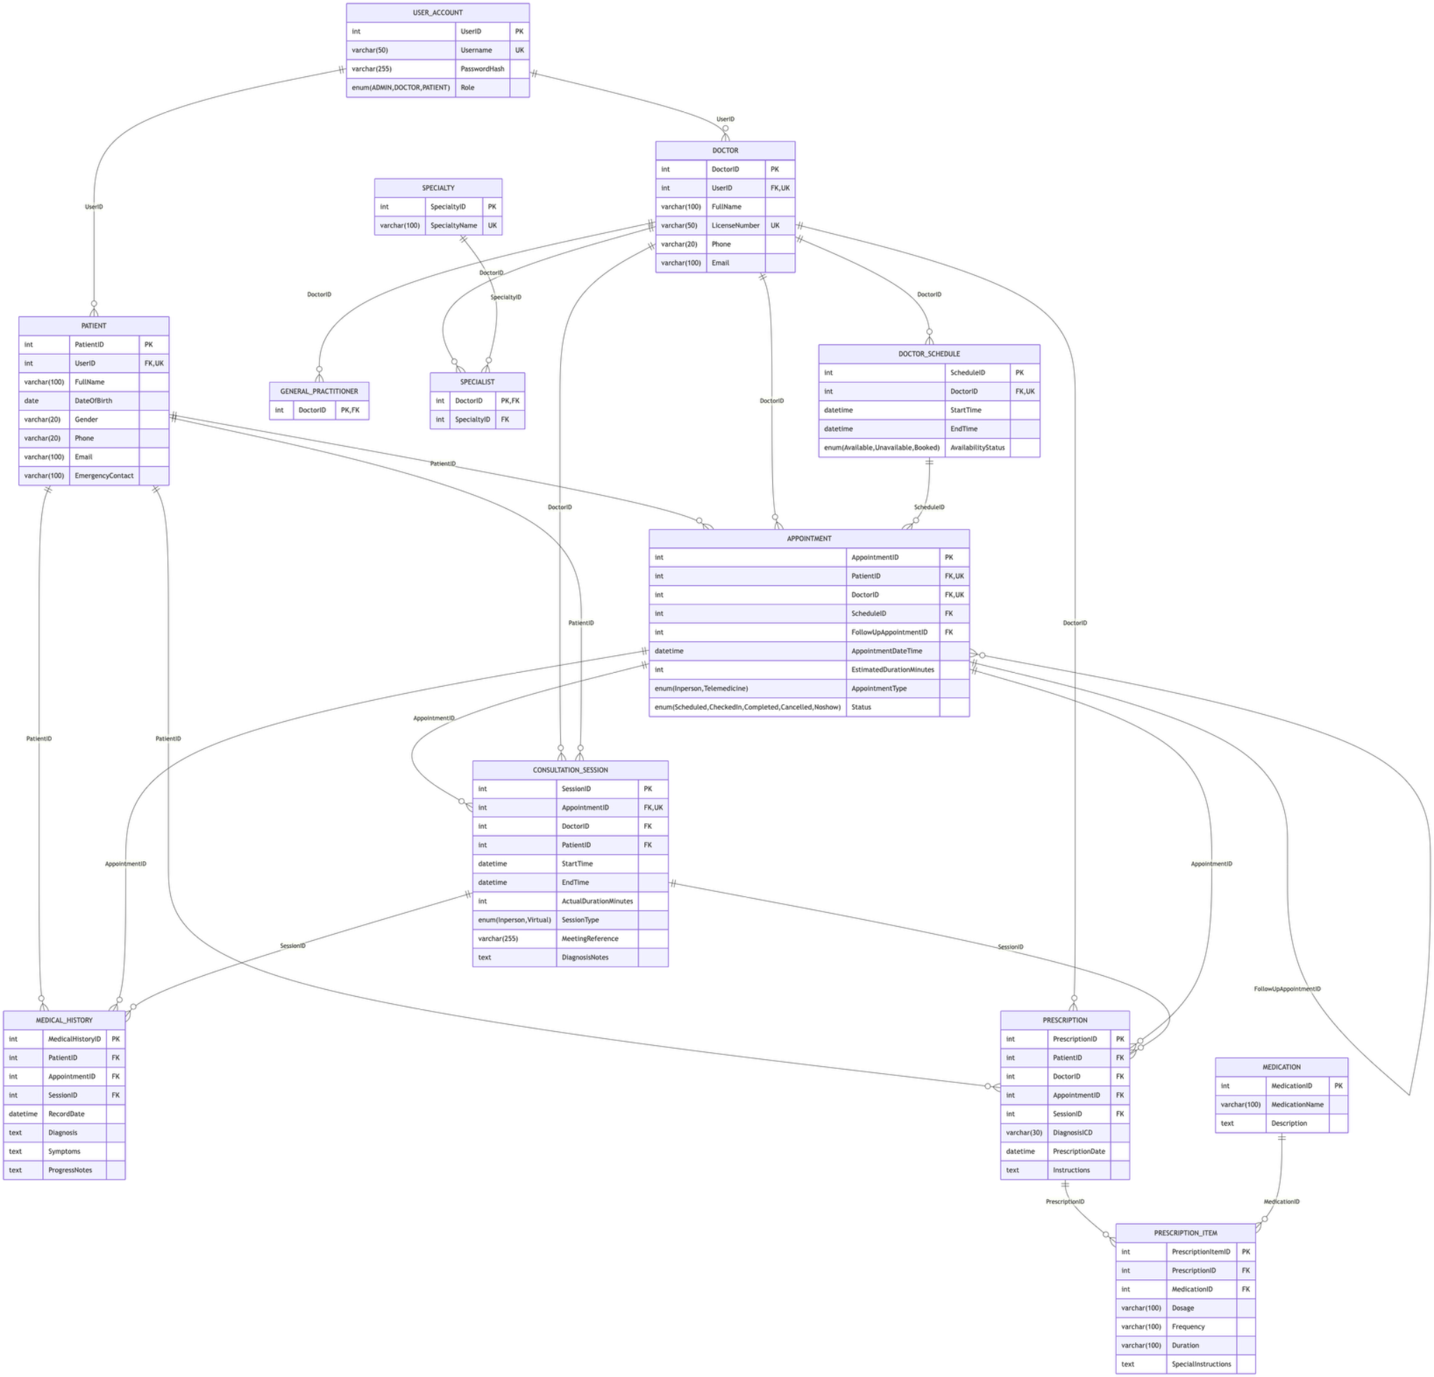
Figure 2.1. Original EER diagram of MediConnect, provided by Group G2.
Model-alignment note: This is the team's original conceptual diagram, not a screenshot of the deployed MySQL schema. Some labels were refined during implementation (for example, PATIENT.Patient instead of PatientID; APPOINTMENT.Modality instead of AppointmentType; and GENERAL_PRACTITIONED instead of GENERAL_PRACTITIONER). Sections 2.3, 3 and 4 use the implemented Phrase3 names and constraints.

2.2 Entity and relationship mapping
ENTITY | PRIMARY KEY | PURPOSE
USER_ACCOUNT | UserID | Login identity and single role
PATIENT | Patient | Patient profile and baseline health information
DOCTOR | DoctorID | Doctor profile, professional license and active state
GENERAL_PRACTITIONED | DoctorID | Doctor subtype: general practice
SPECIALIST | DoctorID | Doctor subtype linked to SPECIALTY
SPECIALTY | SpecialtyID | Medical specialty vocabulary
DOCTOR_SCHEDULE | ScheduleID | Doctor working date and time range
APPOINTMENT | AppointmentID | Booked encounter, modality and status
CONSULTATION_SESSION | SessionID | One session for a given appointment
MEDICAL_HISTORY | MedicalHistoryID | Diagnosis and clinical observations
PRESCRIPTION | PrescriptionID | Prescription header from a session
PRESCRIPTION_ITEM | PrescriptionItemID | Medication, dosage and directions for a prescription
MEDICATION | MedicationID | Medicine catalog

Key relationships in the implemented schema
RELATIONSHIP | CARDINALITY / EXPLANATION
USER_ACCOUNT → PATIENT / DOCTOR | 1 : 0..1 via UNIQUE nullable UserID; many unlinked imported profiles can exist
DOCTOR → DOCTOR_SCHEDULE | 1:N
DOCTOR → GENERAL_PRACTITIONED / SPECIALIST | 1:0..1 for each subtype; total+disjoint intended business rule
SPECIALTY → SPECIALIST | 1:N
PATIENT → APPOINTMENT | 1:N
DOCTOR → APPOINTMENT | 1:N
DOCTOR_SCHEDULE → APPOINTMENT | 1:N by ScheduleID
APPOINTMENT → APPOINTMENT | Self-FK PrecedingAppointmentID for follow-up
APPOINTMENT → CONSULTATION_SESSION | 1:0..1 (UNIQUE AppointmentID)
CONSULTATION_SESSION → MEDICAL_HISTORY | 1:N
CONSULTATION_SESSION → PRESCRIPTION | 1:N
PRESCRIPTION → PRESCRIPTION_ITEM | 1:N
MEDICATION → PRESCRIPTION_ITEM | 1:N

Note An appointment’s patient/doctor is inherited by a consultation session through its AppointmentID. MEDICAL_HISTORY and PRESCRIPTION store Patient and/or DoctorID plus SessionID, but not a separate AppointmentID. These values must agree with the linked session’s appointment.

2.3 Relational schema summary
USER_ACCOUNT (UserID, Username, PasswordHash, Role)
PATIENT (Patient, UserID, FullName, BloodType, Allergies, ChronicDiseases, EmergencyContact)
DOCTOR (DoctorID, UserID, FullName, ContactInfo, LicenseNumber, IsActive)
GENERAL_PRACTITIONED (DoctorID)
SPECIALIST (DoctorID, SpecialtyID)
SPECIALTY (SpecialtyID, SpecialtyName)
DOCTOR_SCHEDULE (ScheduleID, DoctorID, ScheduleDate, StartTime, EndTime, AvailabilityStatus)
APPOINTMENT (AppointmentID, Patient, DoctorID, ScheduleID, PrecedingAppointmentID, AppointmentDateTime, EstimatedDuration, Modality, Status, CreatedBy)
CONSULTATION_SESSION (SessionID, AppointmentID, StartTime, EndTime, ActualDuration, SessionType, ClinicalNotes, MeetingURL)
MEDICAL_HISTORY (MedicalHistoryID, Patient, SessionID, Diagnosis, Symptoms, RecordDate, ProgressNotes)
PRESCRIPTION (PrescriptionID, Patient, DoctorID, SessionID, IssueDate)
PRESCRIPTION_ITEM (PrescriptionItemID, PrescriptionID, MedicationID, Dosage, Frequency, Duration, SpecialInstructions)
MEDICATION (MedicationID, MedicationName, Description)

2.4 Normalization review

First normal form (1NF)
All implemented tables use scalar columns. Repeated medication entries are represented by PRESCRIPTION_ITEM rows rather than a repeating group in PRESCRIPTION. Each table has a declared primary key. This provides a defensible 1NF argument for the physical schema.

Second normal form (2NF)
Every table uses a single-column declared primary key, so a non-key attribute cannot be partially dependent on a proper subset of that primary key. The original report treated (PrescriptionID, MedicationID) as an additional candidate key, but the provided DDL does not declare this pair UNIQUE. That assertion has been removed.

Third normal form (3NF) and BCNF
The principal documented dependencies are PK → remaining columns, Username → account fields (UNIQUE), LicenseNumber → doctor fields (UNIQUE), and AppointmentID → consultation-session fields (UNIQUE). These support 3NF/BCNF analysis for the listed determinants. However, a complete BCNF proof requires an exhaustive check of business-level functional dependencies, not simply a list of primary keys; therefore this report does not claim a formal proof for all 13 tables without further evidence.
RELATION | RELEVANT DETERMINANT | DOCUMENTED CONSTRAINT
USER_ACCOUNT | UserID; Username | PK; UNIQUE Username
DOCTOR | DoctorID; LicenseNumber | PK; UNIQUE LicenseNumber
PATIENT | Patient; UserID when non-null | PK; UNIQUE nullable UserID
CONSULTATION_SESSION | SessionID; AppointmentID | PK; UNIQUE AppointmentID
PRESCRIPTION_ITEM | PrescriptionItemID | PK; pair (PrescriptionID, MedicationID) is not UNIQUE

Note USER_ACCOUNT.Role and PATIENT/DOCTOR.UserID permit NULL in the SQL dump, even though some conceptual rules describe mandatory values. They require application validation or a future schema migration if strict database-level mandatory enforcement is desired.

3. Data Dictionary – Implemented Schema
The dictionary below is reconstructed from the provided MySQL export tables.sql (Phrase3, MySQL 8.4.11) and the subsequently applied Phase 4 DOCTOR.IsActive column. It supersedes the old Phase 1 dictionary, which named several nonexistent columns and incorrectly declared AUTO_INCREMENT. The actual primary keys are explicit INT identifiers, not AUTO_INCREMENT.

3.1 USER_ACCOUNT
COLUMN | TYPE | KEY / NULLABILITY | MEANING
UserID | INT | PK; NOT NULL | Account identifier
Username | VARCHAR(50) | UNIQUE; NOT NULL | Unique login name
PasswordHash | VARCHAR(255) | NOT NULL | Stored credential hash
Role | VARCHAR(10) | NULL; DEFAULT NULL | ADMIN / DOCTOR / PATIENT

3.2 PATIENT
COLUMN | TYPE | KEY / NULLABILITY | MEANING
Patient | INT | PK; NOT NULL | Patient identifier
UserID | INT | UNIQUE; FK → USER_ACCOUNT.UserID; NULL; DEFAULT NULL | Optional linked account
FullName | VARCHAR(100) | NOT NULL | Patient legal name
BloodType | VARCHAR(5) | NULL; DEFAULT NULL | Blood group
Allergies | TEXT | NULL | Allergy notes
ChronicDiseases | TEXT | NULL | Known long-term conditions
EmergencyContact | VARCHAR(20) | NULL; DEFAULT NULL | Emergency contact

3.3 DOCTOR
COLUMN | TYPE | KEY / NULLABILITY | MEANING
DoctorID | INT | PK; NOT NULL | Doctor identifier
UserID | INT | UNIQUE; FK → USER_ACCOUNT.UserID; NULL; DEFAULT NULL | Optional linked account
FullName | VARCHAR(100) | NOT NULL | Doctor full name
ContactInfo | VARCHAR(50) | NULL; DEFAULT NULL | Contact information
LicenseNumber | VARCHAR(50) | UNIQUE; NOT NULL | Unique medical license
IsActive | TINYINT(1) | NOT NULL; DEFAULT 1 | 1=active; 0=soft-deleted (Phase 4)

3.4 GENERAL_PRACTITIONED
COLUMN | TYPE | KEY / NULLABILITY | MEANING
DoctorID | INT | PK; FK → DOCTOR.DoctorID; NOT NULL | General-practitioner doctor FK

3.5 SPECIALIST
COLUMN | TYPE | KEY / NULLABILITY | MEANING
DoctorID | INT | PK; FK → Doctor.DoctorID; NOT NULL | Specialist doctor FK
SpecialtyID | INT | FK → Specialty.SpecialtyID; NOT NULL | Linked medical specialty

3.6 SPECIALTY
COLUMN | TYPE | KEY / NULLABILITY | MEANING
SpecialtyID | INT | PK; NOT NULL | Specialty identifier
SpecialtyName | VARCHAR(100) | NOT NULL | Specialty label

3.7 DOCTOR_SCHEDULE
COLUMN | TYPE | KEY / NULLABILITY | MEANING
ScheduleID | INT | PK; NOT NULL | Working-slot identifier
DoctorID | INT | FK → DOCTOR.DoctorID; NOT NULL | Assigned doctor
ScheduleDate | DATE | NOT NULL | Date of work
StartTime | TIME | NOT NULL | Shift start (TIME)
EndTime | TIME | NOT NULL | Shift end (TIME)
AvailabilityStatus | VARCHAR(20) | NOT NULL | Available / Booked / Unavailable

3.8 APPOINTMENT
COLUMN | TYPE | KEY / NULLABILITY | MEANING
AppointmentID | INT | PK; NOT NULL | Appointment identifier
Patient | INT | FK → PATIENT.Patient; NOT NULL | Patient FK
DoctorID | INT | FK → DOCTOR.DoctorID; NOT NULL | Doctor FK
ScheduleID | INT | FK → DOCTOR_SCHEDULE.ScheduleID; NOT NULL | Assigned working slot
PrecedingAppointmentID | INT | FK → APPOINTMENT.AppointmentID; NULL; DEFAULT NULL | Prior appointment for follow-up
AppointmentDateTime | DATETIME | NOT NULL | Planned start date/time
EstimatedDuration | INT | NOT NULL | Estimated visit length, minutes
Modality | VARCHAR(20) | NULL; DEFAULT NULL | In-person / Telemedicine
Status | VARCHAR(20) | NULL; DEFAULT 'Scheduled' | Scheduled / Checked-In / Completed / Cancelled / No-show
CreatedBy | VARCHAR(50) | NOT NULL | Role/user attribution string

3.9 CONSULTATION_SESSION
COLUMN | TYPE | KEY / NULLABILITY | MEANING
SessionID | INT | PK; NOT NULL | Consultation identifier
AppointmentID | INT | UNIQUE; FK → APPOINTMENT.AppointmentID; NOT NULL | Originating appointment (unique)
StartTime | DATETIME | NOT NULL | Actual starting instant
EndTime | DATETIME | NOT NULL | Actual ending instant
ActualDuration | INT | NOT NULL | Session length in minutes
SessionType | VARCHAR(20) | NULL; DEFAULT NULL | In-person / Virtual
ClinicalNotes | TEXT | NULL | Clinical narrative
MeetingURL | VARCHAR(255) | NULL; DEFAULT NULL | Optional virtual meeting URL

3.10 MEDICAL_HISTORY
COLUMN | TYPE | KEY / NULLABILITY | MEANING
MedicalHistoryID | INT | PK; NOT NULL | Record identifier
Patient | INT | FK → PATIENT.Patient; NOT NULL | Patient FK
SessionID | INT | FK → CONSULTATION_SESSION.SessionID; NOT NULL | Session FK
Diagnosis | TEXT | NOT NULL | Diagnosis text
Symptoms | TEXT | NULL | Symptoms text
RecordDate | DATE | NOT NULL | Clinical record date
ProgressNotes | TEXT | NULL | Progress notes

3.11 PRESCRIPTION
COLUMN | TYPE | KEY / NULLABILITY | MEANING
PrescriptionID | INT | PK; NOT NULL | Prescription identifier
Patient | INT | FK → PATIENT.Patient; NOT NULL | Receiving patient
DoctorID | INT | FK → DOCTOR.DoctorID; NOT NULL | Issuing doctor
SessionID | INT | FK → CONSULTATION_SESSION.SessionID; NOT NULL | Related consultation
IssueDate | DATE | NOT NULL | Prescription date

3.12 PRESCRIPTION_ITEM
COLUMN | TYPE | KEY / NULLABILITY | MEANING
PrescriptionItemID | INT | PK; NOT NULL | Item identifier
PrescriptionID | INT | FK → PRESCRIPTION.PrescriptionID; NOT NULL | Parent prescription
MedicationID | INT | FK → MEDICATION.MedicationID; NOT NULL | Prescribed medication
Dosage | VARCHAR(50) | NOT NULL | Dose text
Frequency | VARCHAR(50) | NOT NULL | Administration schedule
Duration | VARCHAR(50) | NOT NULL | Therapy duration
SpecialInstructions | TEXT | NULL | Other directions

3.13 MEDICATION
COLUMN | TYPE | KEY / NULLABILITY | MEANING
MedicationID | INT | PK; NOT NULL | Medicine catalog identifier
MedicationName | VARCHAR(100) | UNIQUE; NOT NULL | Unique medicine name
Description | TEXT | NULL | Medicine details

4. Database Implementation

4.1 Environment and DDL decisions
The deployed schema is Phrase3, with 13 InnoDB tables. The supplied physical schema is preserved; Phase 4 adds DOCTOR.IsActive (TINYINT(1) NOT NULL DEFAULT 1) to implement soft deletion without removing historical foreign-key references. Primary keys are supplied by the application, because the database export does not use AUTO_INCREMENT.
Note DDL examples are explanatory excerpts for documentation. Do not execute CREATE TABLE or CREATE TRIGGER statements over the existing populated database. Recoverable scripts and database backups should be stored separately from the report.
-- Inspect rather than recreate an existing database.
USE Phrase3;
SHOW FULL TABLES;
SHOW CREATE TABLE DOCTOR;
SHOW CREATE TABLE APPOINTMENT;
SHOW INDEX FROM APPOINTMENT;

4.2 Views for reporting and the web interface
These two views were confirmed to return 2,540 appointment rows and 1,534 prescription-item rows in the recorded baseline, showing the JOIN relationships are populated. Views do not store independent copies of the underlying records.

vw_AppointmentDetails
CREATE OR REPLACE VIEW vw_AppointmentDetails AS
SELECT a.AppointmentID, p.FullName AS PatientName,
d.FullName AS DoctorName, a.AppointmentDateTime,
a.EstimatedDuration, a.Modality, a.Status
FROM APPOINTMENT a
JOIN PATIENT p ON a.Patient = p.Patient
JOIN DOCTOR d ON a.DoctorID = d.DoctorID;

vw_PrescriptionDetails
CREATE OR REPLACE VIEW vw_PrescriptionDetails AS
SELECT pr.PrescriptionID, p.FullName AS PatientName,
d.FullName AS DoctorName, pr.IssueDate,
m.MedicationName, pi.Dosage, pi.Frequency,
pi.Duration, pi.SpecialInstructions
FROM PRESCRIPTION pr
JOIN PATIENT p ON pr.Patient = p.Patient
JOIN DOCTOR d ON pr.DoctorID = d.DoctorID
JOIN PRESCRIPTION_ITEM pi
ON pr.PrescriptionID = pi.PrescriptionID
JOIN MEDICATION m ON pi.MedicationID = m.MedicationID;

4.3 Triggers and scheduling integrity
The deployed project uses two BEFORE INSERT triggers on APPOINTMENT. Their observed behavior was tested with invalid and valid bookings during Phase 3. The definitions below document the intended implementations; confirm the exact server definitions with SHOW CREATE TRIGGER before final submission.

4.3.1 trg_prevent_overlap
DELIMITER $$
CREATE TRIGGER trg_prevent_overlap
BEFORE INSERT ON APPOINTMENT
FOR EACH ROW
BEGIN
IF NEW.EstimatedDuration <= 0 THEN
SIGNAL SQLSTATE '45000'
SET MESSAGE_TEXT = 'Invalid appointment duration';
END IF;
IF NEW.Status NOT IN ('Cancelled', 'No-show')
AND EXISTS (
SELECT 1 FROM APPOINTMENT a
WHERE a.DoctorID = NEW.DoctorID
AND a.Status NOT IN ('Cancelled','No-show')
AND NEW.AppointmentDateTime <
DATE_ADD(a.AppointmentDateTime,
INTERVAL a.EstimatedDuration MINUTE)
AND DATE_ADD(NEW.AppointmentDateTime,
INTERVAL NEW.EstimatedDuration MINUTE)
> a.AppointmentDateTime
) THEN
SIGNAL SQLSTATE '45000'
SET MESSAGE_TEXT = 'Doctor has overlapping appointment';
END IF;
END$$
DELIMITER ;

4.3.2 trg_validate_appointment_schedule
DELIMITER $$
CREATE TRIGGER trg_validate_appointment_schedule
BEFORE INSERT ON APPOINTMENT
FOR EACH ROW
BEGIN
DECLARE valid_schedule INT DEFAULT 0;
SELECT COUNT(*) INTO valid_schedule
FROM DOCTOR_SCHEDULE ds
WHERE ds.ScheduleID = NEW.ScheduleID
AND ds.DoctorID = NEW.DoctorID
AND ds.ScheduleDate = DATE(NEW.AppointmentDateTime)
AND ds.AvailabilityStatus = 'Available'
AND NEW.AppointmentDateTime >=
TIMESTAMP(ds.ScheduleDate, ds.StartTime)
AND DATE_ADD(NEW.AppointmentDateTime,
INTERVAL NEW.EstimatedDuration MINUTE)
<= TIMESTAMP(ds.ScheduleDate, ds.EndTime);
IF valid_schedule = 0 THEN
SIGNAL SQLSTATE '45000'
SET MESSAGE_TEXT = 'Invalid doctor schedule or appointment time';
END IF;
END$$
DELIMITER ;

Note Both triggers protect INSERT only. The Flask application checks appointment edits, but direct UPDATE statements from other clients can bypass these insert triggers. Database-side BEFORE UPDATE triggers are recommended if the same invariant must hold regardless of the client. Some BRs (e.g., overlapping work schedules, clinical status consistency) require separate enforcement/validation and must not be represented as enforced by these two triggers alone.

4.4 Index inventory and performance design
The original report lists the following extra indexes. They support doctor-time lookups, modality and date reporting, and chronological browsing. Existence and performance are not inferred from the proposed SQL list; run SHOW INDEX and EXPLAIN ANALYZE to verify them on the final MySQL installation.
PROPOSED INDEX | TABLE | COLUMNS
idx_appointment_doctor_datetime | APPOINTMENT | DoctorID, AppointmentDateTime
idx_appointment_modality_datetime | APPOINTMENT | Modality, AppointmentDateTime
idx_appointment_datetime | APPOINTMENT | AppointmentDateTime
idx_schedule_date_start | DOCTOR_SCHEDULE | ScheduleDate, StartTime
idx_medical_history_recorddate | MEDICAL_HISTORY | RecordDate
idx_prescription_issuedate | PRESCRIPTION | IssueDate
idx_patient_fullname | PATIENT | FullName

SHOW INDEX FROM APPOINTMENT;
SHOW INDEX FROM DOCTOR_SCHEDULE;
EXPLAIN ANALYZE SELECT * FROM APPOINTMENT WHERE DoctorID=1 ORDER BY AppointmentDateTime DESC LIMIT 20;

4.5 Ten advanced business queries
The previous document contained four queries with obsolete column names. They are replaced below with ten SQL examples written for the supplied Phrase3 schema. These queries have been reviewed against table/column definitions, but each should be executed in Workbench and its actual result screenshot recorded before declaring PASS.

Q01 · Appointments by specialty and modality
Summarize clinic workload for general and specialist doctors.
SELECT COALESCE(s.SpecialtyName, 'General Practice') AS Specialty,
a.Modality, COUNT(*) AS TotalAppointments,
SUM(a.Status = 'Completed') AS Completed,
SUM(a.Status = 'Cancelled') AS Cancelled
FROM APPOINTMENT a
JOIN DOCTOR d ON d.DoctorID = a.DoctorID
LEFT JOIN SPECIALIST sp ON sp.DoctorID = d.DoctorID
LEFT JOIN SPECIALTY s ON s.SpecialtyID = sp.SpecialtyID
GROUP BY s.SpecialtyName, a.Modality
ORDER BY TotalAppointments DESC;

Q02 · Patient clinical history
Return diagnosis and medicine history for a selected existing patient.
SELECT p.Patient, p.FullName, a.AppointmentDateTime,
mh.RecordDate, mh.Diagnosis, mh.ProgressNotes,
d.FullName AS DoctorName, m.MedicationName,
pi.Dosage, pi.Frequency, pi.Duration
FROM PATIENT p
JOIN APPOINTMENT a ON a.Patient = p.Patient
JOIN DOCTOR d ON d.DoctorID = a.DoctorID
JOIN CONSULTATION_SESSION cs
ON cs.AppointmentID = a.AppointmentID
LEFT JOIN MEDICAL_HISTORY mh ON mh.SessionID = cs.SessionID
LEFT JOIN PRESCRIPTION pr ON pr.SessionID = cs.SessionID
LEFT JOIN PRESCRIPTION_ITEM pi
ON pi.PrescriptionID = pr.PrescriptionID
LEFT JOIN MEDICATION m ON m.MedicationID = pi.MedicationID
WHERE p.Patient = 1
ORDER BY a.AppointmentDateTime DESC;

Q03 · Doctor completion and duration
Compute workload and average consultation duration by doctor.
SELECT d.DoctorID, d.FullName,
COUNT(a.AppointmentID) AS TotalAppointments,
SUM(a.Status = 'Completed') AS Completed,
ROUND(AVG(cs.ActualDuration), 1) AS AvgMinutes
FROM DOCTOR d
LEFT JOIN APPOINTMENT a ON a.DoctorID = d.DoctorID
LEFT JOIN CONSULTATION_SESSION cs
ON cs.AppointmentID = a.AppointmentID
GROUP BY d.DoctorID, d.FullName
ORDER BY Completed DESC, TotalAppointments DESC;

Q04 · Telemedicine awaiting consultation
Find upcoming online appointments including missing session links.
SELECT a.AppointmentID, a.AppointmentDateTime,
p.FullName AS PatientName, d.FullName AS DoctorName,
cs.MeetingURL, a.Status
FROM APPOINTMENT a
JOIN PATIENT p ON p.Patient = a.Patient
JOIN DOCTOR d ON d.DoctorID = a.DoctorID
LEFT JOIN CONSULTATION_SESSION cs
ON cs.AppointmentID = a.AppointmentID
WHERE a.Modality = 'Telemedicine'
AND a.Status IN ('Scheduled','Checked-In')
AND a.AppointmentDateTime >= NOW()
ORDER BY a.AppointmentDateTime;

Q05 · Appointment counts by working schedule
Compare schedule capacity with actual booking count.
SELECT ds.ScheduleID, ds.ScheduleDate,
ds.StartTime, ds.EndTime, d.FullName,
COUNT(a.AppointmentID) AS ActiveAppointments
FROM DOCTOR_SCHEDULE ds
JOIN DOCTOR d ON d.DoctorID = ds.DoctorID
LEFT JOIN APPOINTMENT a
ON a.ScheduleID = ds.ScheduleID
AND a.Status NOT IN ('Cancelled','No-show')
GROUP BY ds.ScheduleID, ds.ScheduleDate,
ds.StartTime, ds.EndTime, d.FullName
ORDER BY ds.ScheduleDate DESC;

Q06 · Frequent patients
Find patients who have booked at least three appointments.
SELECT p.Patient, p.FullName,
COUNT(a.AppointmentID) AS TotalAppointments
FROM PATIENT p
JOIN APPOINTMENT a ON a.Patient = p.Patient
GROUP BY p.Patient, p.FullName
HAVING COUNT(a.AppointmentID) >= 3
ORDER BY TotalAppointments DESC;

Q07 · Cancellation / no-show rates
Identify doctors with appointment-status problems.
SELECT d.DoctorID, d.FullName,
COUNT(*) AS Total,
SUM(a.Status = 'Cancelled') AS Cancelled,
SUM(a.Status = 'No-show') AS NoShows,
ROUND(100 * SUM(a.Status IN ('Cancelled','No-show'))
/ NULLIF(COUNT(*),0),2) AS LostRatePct
FROM DOCTOR d
JOIN APPOINTMENT a ON a.DoctorID = d.DoctorID
GROUP BY d.DoctorID, d.FullName
ORDER BY LostRatePct DESC;

Q08 · Most prescribed medicines
Rank medications by number of prescription items.
SELECT m.MedicationID, m.MedicationName,
COUNT(pi.PrescriptionItemID) AS TimesPrescribed,
COUNT(DISTINCT pi.PrescriptionID) AS DistinctPrescriptions
FROM MEDICATION m
LEFT JOIN PRESCRIPTION_ITEM pi
ON pi.MedicationID = m.MedicationID
GROUP BY m.MedicationID, m.MedicationName
ORDER BY TimesPrescribed DESC;

Q09 · Monthly modality trend
Compare visits by month and consultation modality.
SELECT DATE_FORMAT(AppointmentDateTime,'%Y-%m') AS Month,
Modality, COUNT(*) AS TotalAppointments,
SUM(Status = 'Completed') AS Completed
FROM APPOINTMENT
GROUP BY DATE_FORMAT(AppointmentDateTime,'%Y-%m'), Modality
ORDER BY Month, Modality;

Q10 · Patients without appointments
Detect registered patients with no appointment history.
SELECT p.Patient, p.FullName
FROM PATIENT p
WHERE NOT EXISTS (
SELECT 1 FROM APPOINTMENT a WHERE a.Patient = p.Patient
)
ORDER BY p.Patient;

4.5.1 Historical query result evidence (baseline dataset, 20 October 2026)
The following screenshots were supplied by Group G2 from MySQL Workbench. They document ten ORIGINAL Phase 3 queries executed on the small initial dataset, before the subsequent bulk import of 11,101 records. One schedule query was captured in two screenshots. The screenshots are cropped to show representative result rows and readable columns; source data values have not been changed.
Important comparability note: the original query numbering and output columns are not identical to the revised SQL examples in Section 4.5. These historic figures demonstrate earlier execution, not execution results of the revised Q01–Q10 and not current database totals. For the final performance evaluation, rerun each revised SQL statement on the present Phrase3 database and attach its current result and EXPLAIN ANALYZE output.
Legacy Query 01 — Appointment details
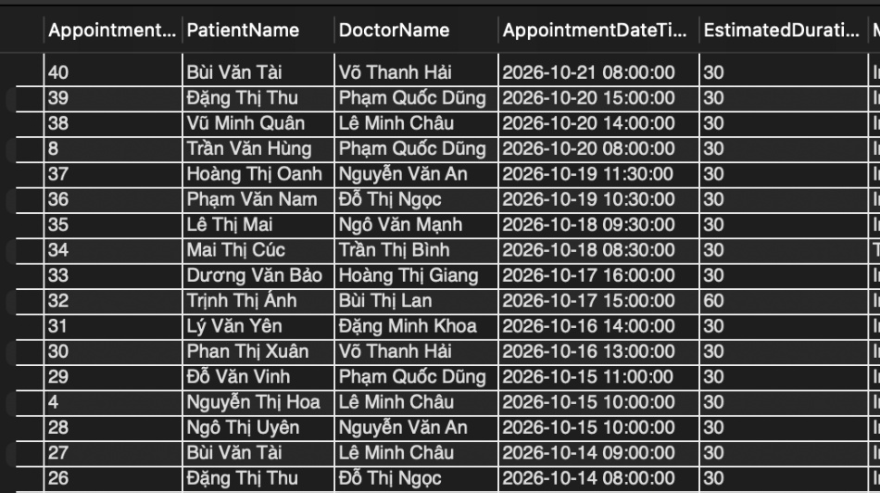
Figure 4.5-H01. Legacy Query 01: appointment details (20 Oct 2026, selected rows).
Observation: Initial appointment list showing patient, doctor, date, modality and status.
Legacy Query 02 — Doctor schedules and booking counts
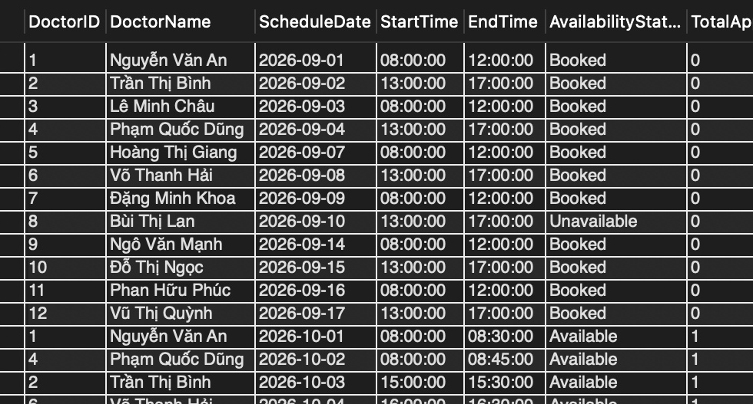
Figure 4.5-H02. Legacy Query 02: doctor schedules and booking counts (20 Oct 2026, selected rows).
Observation: Working-shift dates, availability and appointment counts (first captured view).
Legacy Query 02 — additional result screenshot
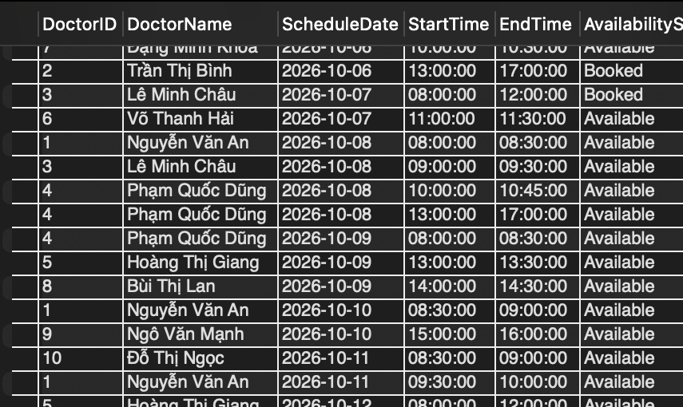
Figure 4.5-H03. Legacy Query 02: doctor schedules (continued) (20 Oct 2026, selected rows).
Observation: Additional working-shift records from the second original screenshot.
Legacy Query 03 — Patient medical histories
The wide Workbench result is shown as two horizontally cropped views of the same screenshot to keep the text readable.
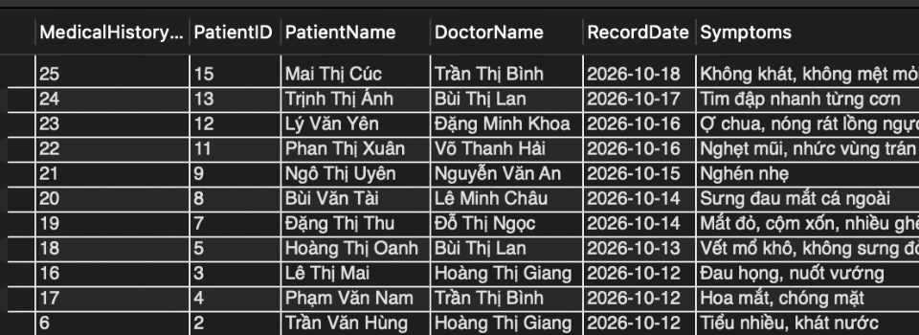
Figure 4.5-H04 — panel 1/2. Legacy Query 03: patient medical histories (20 Oct 2026, selected rows).
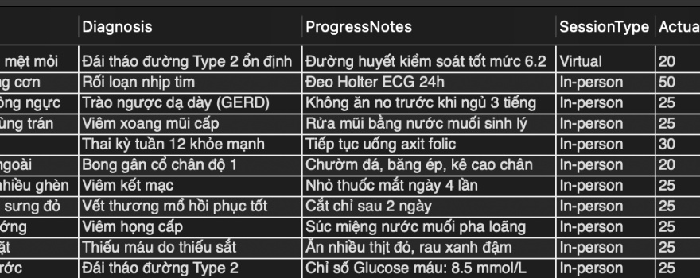
Figure 4.5-H04 — panel 2/2. Legacy Query 03: patient medical histories (20 Oct 2026, selected rows).
Observation: History records with diagnosis, symptoms, progress notes and session details.
Legacy Query 04 — Prescription details
The wide Workbench result is shown as two horizontally cropped views of the same screenshot to keep the text readable.
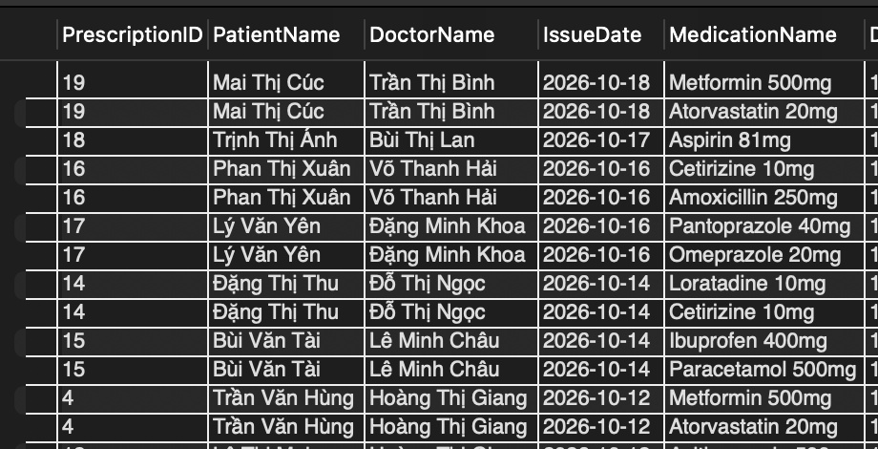
Figure 4.5-H05 — panel 1/2. Legacy Query 04: prescription details (20 Oct 2026, selected rows).
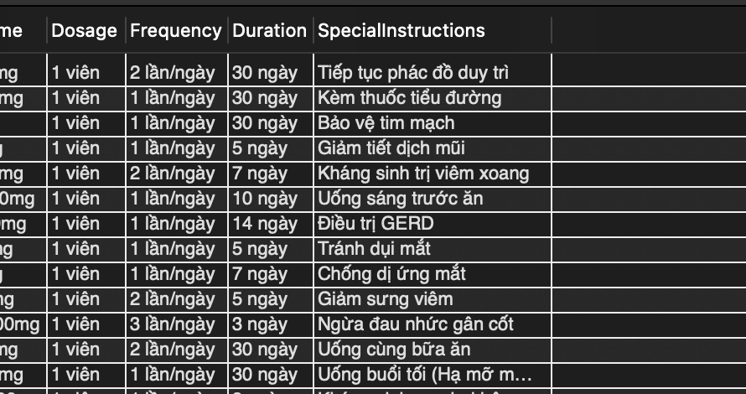
Figure 4.5-H05 — panel 2/2. Legacy Query 04: prescription details (20 Oct 2026, selected rows).
Observation: Prescription items, medicines, dose/frequency, duration and instructions.
Legacy Query 05 — Appointment totals per doctor
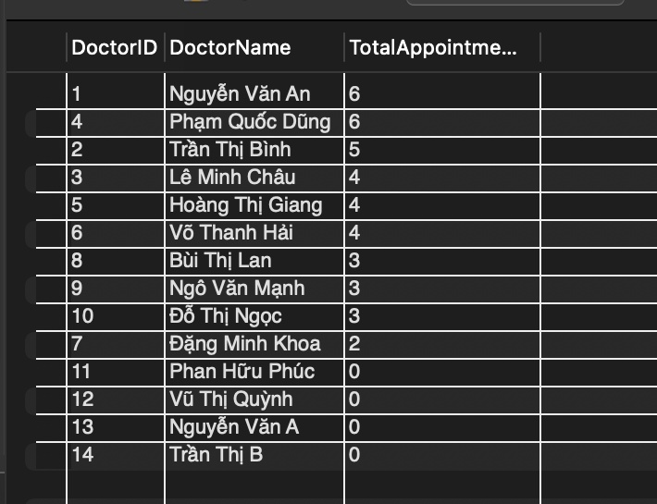
Figure 4.5-H06. Legacy Query 05: appointment totals per doctor (20 Oct 2026, selected rows).
Observation: Initial workload counts by doctor.
Legacy Query 06 — Frequent patients
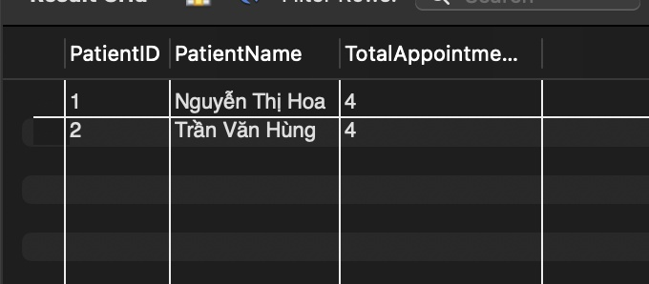
Figure 4.5-H07. Legacy Query 06: frequent patients (20 Oct 2026, selected rows).
Observation: Two patients each had four appointments in the baseline dataset.
Legacy Query 07 — Patients without appointments
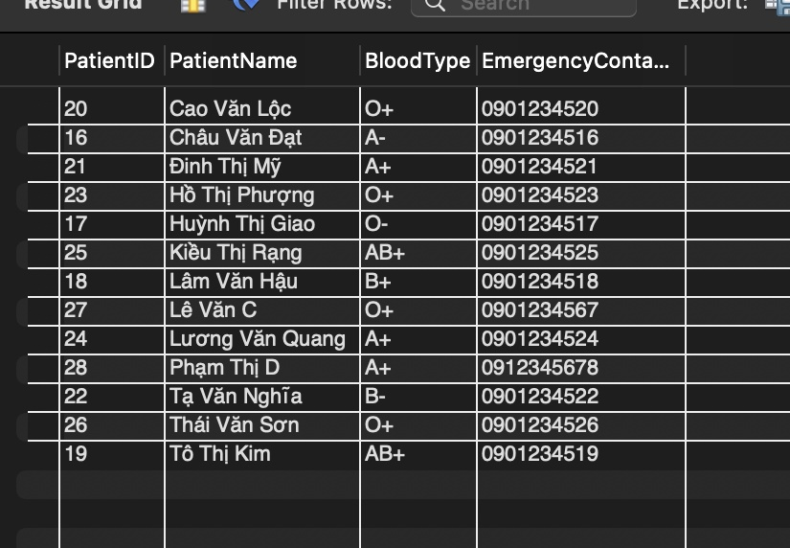
Figure 4.5-H08. Legacy Query 07: patients without appointments (20 Oct 2026, selected rows).
Observation: Patients without appointment records in the baseline dataset.
Legacy Query 08 — Above-average doctor workloads
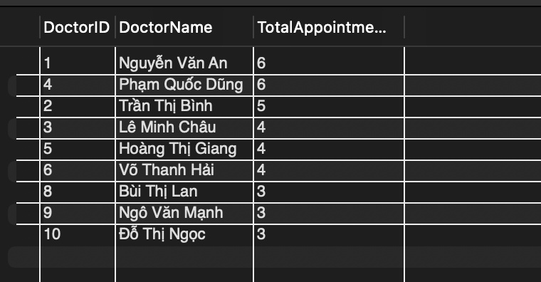
Figure 4.5-H09. Legacy Query 08: above-average doctor workloads (20 Oct 2026, selected rows).
Observation: Doctors whose appointment totals exceed the initial workload threshold.
Legacy Query 09 — Telemedicine statistics
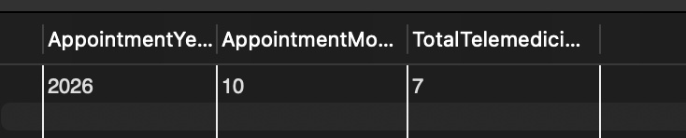
Figure 4.5-H10. Legacy Query 09: telemedicine statistics (20 Oct 2026, selected rows).
Observation: Historic summary shows seven telemedicine appointments in October 2026.
Legacy Query 10 — Doctor subtype distribution
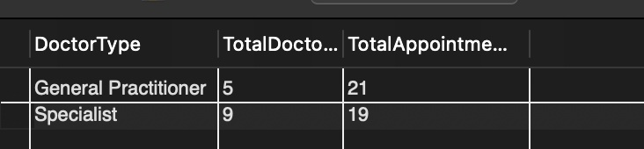
Figure 4.5-H11. Legacy Query 10: doctor subtype distribution (20 Oct 2026, selected rows).
Observation: Initial general-practitioner versus specialist appointment counts.
Data note. Baseline screenshots reflect approximately 40 appointments and 14 doctors. Later validation recorded 2,540 appointments, 102 doctors and 11,432 total rows across the 13 tables. The old screenshots are intentionally labeled as archival to avoid presenting the original results as current performance evidence.

4.6 Index and query testing procedure
For each query, collect a Workbench screenshot, row count and representative result. To compare indexing effects, use EXPLAIN ANALYZE with a documented index configuration on a test database and record its actual timing and access path. No runtime measurements are asserted without captured execution results.
CASE | REQUIRED EVIDENCE | STATUS
Q01–Q10 | Actual result grid / row count | To capture
IDX-01 | SHOW INDEX FROM relevant tables | To capture
IDX-02 | EXPLAIN ANALYZE / execution plan | To capture
IDX-03 | Measured before/after results (only if performed) | Not yet evidenced

5. Verification, Integrity & Security

5.1 Dataset snapshot – observed evidence
TABLE | OBSERVED ROWS*
USER_ACCOUNT | 1,106
PATIENT | 1,002
DOCTOR | 102
GENERAL_PRACTITIONED | 41
SPECIALIST | 61
SPECIALTY | 22
DOCTOR_SCHEDULE | 1,539
APPOINTMENT | 2,540
CONSULTATION_SESSION | 1,525
MEDICAL_HISTORY | 1,025
PRESCRIPTION | 820
PRESCRIPTION_ITEM | 1,534
MEDICATION | 115
TOTAL | 11,432

*This is the observed baseline from the team’s Workbench screenshots dated 1 November 2026. Later website inserts can change totals. The original report’s phrase “11,000 additional records” refers to the import batch; total rows are not identical to new rows.
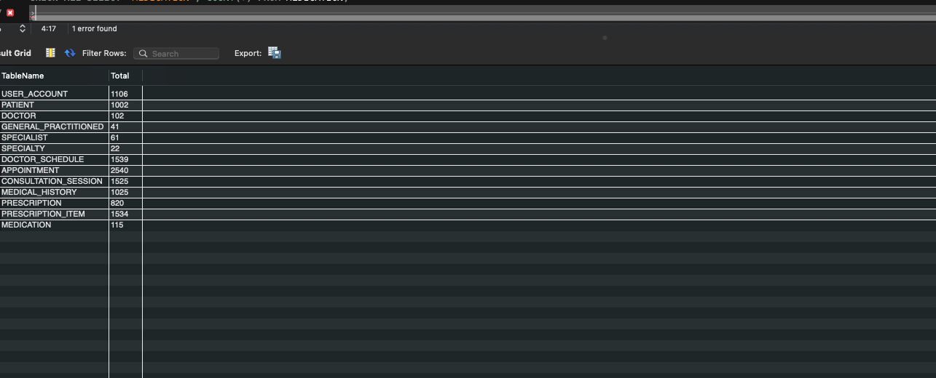
Figure 5.1. Workbench row counts across the 13 populated tables (recorded baseline).

5.2 View and trigger verification
TEST / OBJECT | EVIDENCE AVAILABLE | OBSERVED / REQUIRED RESULT
vw_AppointmentDetails | Workbench COUNT(*) from project demonstration | 2,540 rows, observed
vw_PrescriptionDetails | Workbench COUNT(*) from project demonstration | 1,534 rows, observed
trg_prevent_overlap | Phase 3 insert tests reviewed with the team | Overlapping active booking rejected
trg_validate_appointment_schedule | Phase 3 insert tests reviewed with the team | Outside-shift, wrong-doctor and unavailable-slot insert rejected
BEFORE UPDATE validation | Insert triggers are not UPDATE triggers | Database-wide guarantee still pending

USE Phrase3;
SELECT COUNT(*) AS TotalAppointmentView FROM vw_AppointmentDetails;
SELECT COUNT(*) AS TotalPrescriptionView FROM vw_PrescriptionDetails;
SELECT TRIGGER_NAME, EVENT_MANIPULATION, ACTION_TIMING
FROM INFORMATION_SCHEMA.TRIGGERS
WHERE TRIGGER_SCHEMA = 'Phrase3';

5.3 Acceptance test matrix
CASE | SCENARIO | EXPECTED | STATUS
AUTH-01 | Logged-out user opens management route | Redirect to login | To reconfirm
AUTH-02 | ADMIN authentication | Admin dashboard shown | Observed in screenshots
AUTH-03 | DOCTOR / PATIENT role separation | Only own appointment and prescription records | Pending 3-role user test
AP-01 | Valid scheduled appointment | Stored and shown in view | Pending UI test
AP-02 | Overlapping appointment INSERT | Rejected with SQLSTATE 45000 | Observed Phase 3
AP-03 | Wrong / unavailable schedule INSERT | Rejected with SQLSTATE 45000 | Observed Phase 3
AP-04 | Admin UPDATE creates overlap | Rejected, not saved | Pending full test
RX-01 | Doctor prescribes after completed session | Header and items saved | Pending role test
RX-02 | Patient attempts another patient's record | Denied by app authorization | Pending URL test
DEL-01 | Patient referenced by appointment/Rx | Deletion blocked | Pending specific case
DEL-02 | Doctor has appointments in previous 30 days | Soft deletion blocked | Pending specific case
DEL-03 | Doctor eligible for archive | IsActive changed to 0 | Requires verification
DEL-04 | Restore archived doctor | IsActive changed to 1 | Verify after restore feature is merged
UI-01 | Create doctor with subtype | DOCTOR + exactly one subtype | Specialist add observed in screenshot

5.4 Authorization and data handling
MediConnect uses role values in USER_ACCOUNT and server-side Flask authorization checks. USER_ACCOUNT provides credentials, while PATIENT.UserID and DOCTOR.UserID associate an account with a profile where such a link exists. Authentication/session handling is application-level RBAC; it must not be described as database GRANT/REVOKE unless MySQL users and privileges are separately configured and tested.
- Administrative routes require the ADMIN role; doctor and patient pages must restrict records by the signed-in profile identifier.
- PasswordHash should contain a modern slow password hash; never store or print working credentials in the report.
- Database access should use parameterized SQL, transactions for multi-table mutations and a private .env configuration.
- The development debugger must be disabled when the website is made accessible to other devices. Use trusted networks and synthetic records only.
- POST operations should include CSRF checks and authorization at the server rather than relying on hidden navigation buttons.

5.5 Known enforcement boundaries
Note The deployed MySQL DDL does not enforce every BR directly. In particular, total/disjoint specialization, a mandatory linked account for every imported profile, some status transitions, update-time schedule validation and cross-entity clinical consistency require application logic and/or additional triggers. Document the distinction during defense rather than claiming all rules are database-enforced.

6. Phase 4 – Flask Integration & Demonstration

6.1 Architecture and stack
The Phase 4 implementation is a server-rendered Flask web application. HTML forms are submitted to Flask routes, which validate authorization and input, issue SQL using mysql-connector-python, and render Jinja2 templates. It does not require a separate REST API or Postman to demonstrate user-interface/database integration.
LAYER | COMPONENT | FUNCTION
Presentation | HTML, Jinja2, CSS / Bootstrap | Data tables, forms, notifications, navigation
Application | Python Flask | Login, routes, authorization, checks, transactions
Data access | mysql-connector-python | Parameterized SELECT and data mutations
Storage | MySQL Phrase3 | 13 base tables, 2 views, triggers and indexes

6.2 Implemented application modules
MODULE | ROUTE | INTENDED OPERATION
Authentication | /login, /logout | ADMIN, DOCTOR and PATIENT access, application sessions
Dashboard | / | Aggregate system counts and navigation
Patients | /patients | Admin listing, creation, edit and guarded deletion
Doctors | /doctors | Admin listing, creation, subtype choice, editing and soft deletion
Schedules | /schedules | Admin views and creation with validation
Accounts | /accounts | Admin account list and password reset
Appointments | /appointments | Role-scoped listing, creation and authorized modification
Prescription management | /prescriptions | Role-scoped listing, issue, detail and guarded deletion

The application source and demo plan should be included in the submission repository. The existence of a route is not equivalent to a confirmed passing end-to-end test; the acceptance matrix in Section 5 distinguishes these.
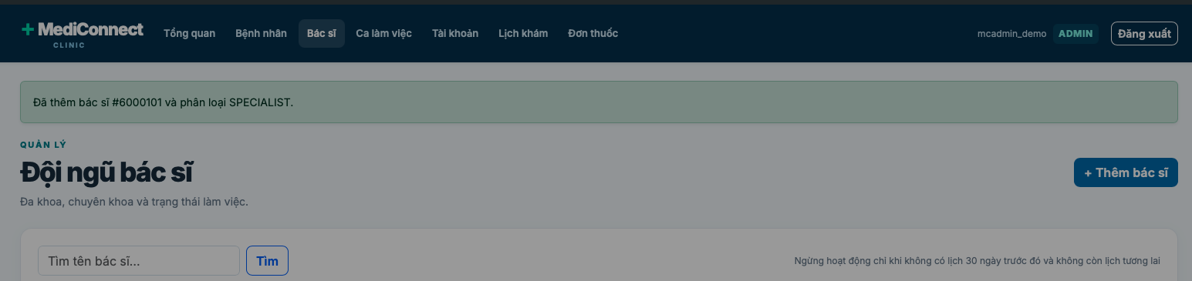
Figure 6.1. Admin doctors page showing confirmation after adding a specialist (demo screenshot).

6.3 Admin / Doctor / Patient workflow

Admin
Adds patient or doctor (general practice vs specialty), creates working slots, creates or edits appointments, manages accounts, issues prescriptions, and performs guarded removal operations.

Doctor
Signs in with linked DOCTOR.UserID; sees own appointments, may book and complete eligible appointments, and issues prescriptions linked to own completed consultations.

Patient
Signs in with linked PATIENT.UserID; sees own appointment and prescription records, and requests new appointments within valid schedules.

6.4 Deletion and recovery rules
For doctors, the approved classroom rule is: allow archive only if the doctor had no appointment during the preceding 30 days. The project also checks for active future bookings before a doctor is archived. Soft deletion stores IsActive=0 so prescriptions and clinical history remain linked to the doctor; restoring the doctor changes IsActive back to 1. Actual restoration on the website requires that the restore route/button be present in the final deployed code.
For patients, a deletion request must be blocked if there are related appointments, prescriptions or other dependent clinical history. For prescriptions, related PRESCRIPTION_ITEM records must be removed first within the same transaction when an authorized deletion is permitted. Historical clinical records should be preserved according to the stated data-retention policy.

6.5 Demonstration script
STEP | ACTION | EVIDENCE TO SHOW
1 | Log in as ADMIN | Dashboard and authorized admin navigation
2 | Add a specialist doctor | Both DOCTOR and SPECIALIST rows; specialty selected
3 | Add a patient | New PATIENT row and account linkage if created
4 | Create valid appointment | Appointment list + View 1
5 | Attempt a conflicting time slot | Trigger error handled without a partial insert
6 | Log in as DOCTOR | Only assigned appointments; complete a session and issue Rx
7 | Log in as PATIENT | Only own appointments and prescriptions
8 | Test permitted and forbidden deletion | 30-day guard, patient dependency guard; optional restore

6.6 Limitations and next improvements
- Add database-level BEFORE UPDATE validation if direct SQL edits must obey the same appointment constraints as inserts.
- Verify total/disjoint doctor subtype enforcement and schedule-overlap BR24 at the database level.
- Complete role-specific acceptance tests and retain screenshots with actual PASS / FAIL outcomes.
- Deploy only with trusted access, correct security configuration and non-sensitive synthetic test data.

Appendix A – Reproducibility and submission checklist
- Include a sanitized database export / DDL without real credentials.
- Include the Phase 3 mock-data script, but do not rerun it on the already populated database.
- Capture current COUNT(*) from all 13 tables and both views after the last Phase 4 updates.
- Include SHOW CREATE TRIGGER for both deployed insert triggers and SHOW INDEX output.
- Attach the tested versions of all 10 SQL queries and EXPLAIN/EXPLAIN ANALYZE evidence.
- Include Flask source, templates, requirements.txt, example .env and a clear README.
- Capture role-specific screenshots and mark each acceptance test with observed result and date.
- Add the official course due date, instructor name, repository URL and team contribution evaluation before submission.

Appendix B – Database verification SQL
USE Phrase3;
SELECT 'USER_ACCOUNT' AS TableName, COUNT(*) AS Total FROM USER_ACCOUNT
UNION ALL SELECT 'PATIENT', COUNT(*) FROM PATIENT
UNION ALL SELECT 'DOCTOR', COUNT(*) FROM DOCTOR
UNION ALL SELECT 'GENERAL_PRACTITIONED', COUNT(*) FROM GENERAL_PRACTITIONED
UNION ALL SELECT 'SPECIALIST', COUNT(*) FROM SPECIALIST
UNION ALL SELECT 'SPECIALTY', COUNT(*) FROM SPECIALTY
UNION ALL SELECT 'DOCTOR_SCHEDULE', COUNT(*) FROM DOCTOR_SCHEDULE
UNION ALL SELECT 'APPOINTMENT', COUNT(*) FROM APPOINTMENT
UNION ALL SELECT 'CONSULTATION_SESSION', COUNT(*) FROM CONSULTATION_SESSION
UNION ALL SELECT 'MEDICAL_HISTORY', COUNT(*) FROM MEDICAL_HISTORY
UNION ALL SELECT 'PRESCRIPTION', COUNT(*) FROM PRESCRIPTION
UNION ALL SELECT 'PRESCRIPTION_ITEM', COUNT(*) FROM PRESCRIPTION_ITEM
UNION ALL SELECT 'MEDICATION', COUNT(*) FROM MEDICATION;

SELECT COUNT(*) FROM vw_AppointmentDetails;
SELECT COUNT(*) FROM vw_PrescriptionDetails;
SHOW COLUMNS FROM DOCTOR LIKE 'IsActive';
SELECT TRIGGER_NAME, EVENT_MANIPULATION, ACTION_TIMING
FROM INFORMATION_SCHEMA.TRIGGERS
WHERE TRIGGER_SCHEMA = 'Phrase3';

Appendix D – DDL reference for 13 base tables
The following DDL is derived from the original Phrase3 MySQL export and is presented for inspection. Statements are ordered by dependencies. The DOCTOR.IsActive line shows the separately applied Phase 4 extension. This appendix is not an import script; never re-run it over a populated Phrase3 database.

D.1 USER_ACCOUNT
CREATE TABLE `USER_ACCOUNT` (
`UserID` int NOT NULL,
`Username` varchar(50) NOT NULL,
`PasswordHash` varchar(255) NOT NULL,
`Role` varchar(10) DEFAULT NULL,
PRIMARY KEY (`UserID`),
UNIQUE KEY `Username` (`Username`),
CONSTRAINT `user_account_chk_1` CHECK ((`Role` in
(_utf8mb4'ADMIN',_utf8mb4'DOCTOR',_utf8mb4'PATIENT')))
) ENGINE=InnoDB DEFAULT CHARSET=utf8mb4;

D.2 SPECIALTY
CREATE TABLE `SPECIALTY` (
`SpecialtyID` int NOT NULL,
`SpecialtyName` varchar(100) NOT NULL,
PRIMARY KEY (`SpecialtyID`)
) ENGINE=InnoDB DEFAULT CHARSET=utf8mb4;

D.3 MEDICATION
CREATE TABLE `MEDICATION` (
`MedicationID` int NOT NULL,
`MedicationName` varchar(100) NOT NULL,
`Description` text,
PRIMARY KEY (`MedicationID`),
UNIQUE KEY `MedicationName` (`MedicationName`)
) ENGINE=InnoDB DEFAULT CHARSET=utf8mb4;

D.4 PATIENT
CREATE TABLE `PATIENT` (
`Patient` int NOT NULL,
`UserID` int DEFAULT NULL,
`FullName` varchar(100) NOT NULL,
`BloodType` varchar(5) DEFAULT NULL,
`Allergies` text,
`ChronicDiseases` text,
`EmergencyContact` varchar(20) DEFAULT NULL,
PRIMARY KEY (`Patient`),
UNIQUE KEY `UserID` (`UserID`),
CONSTRAINT `patient_ibfk_1` FOREIGN KEY (`UserID`) REFERENCES `USER_ACCOUNT` (`UserID`)
) ENGINE=InnoDB DEFAULT CHARSET=utf8mb4;

D.5 DOCTOR
CREATE TABLE `DOCTOR` (
`DoctorID` int NOT NULL,
`UserID` int DEFAULT NULL,
`FullName` varchar(100) NOT NULL,
`ContactInfo` varchar(50) DEFAULT NULL,
`LicenseNumber` varchar(50) NOT NULL,
`IsActive` tinyint(1) NOT NULL DEFAULT 1,
PRIMARY KEY (`DoctorID`),
UNIQUE KEY `LicenseNumber` (`LicenseNumber`),
UNIQUE KEY `UserID` (`UserID`),
CONSTRAINT `doctor_ibfk_1` FOREIGN KEY (`UserID`) REFERENCES `USER_ACCOUNT` (`UserID`)
) ENGINE=InnoDB DEFAULT CHARSET=utf8mb4;

D.6 GENERAL_PRACTITIONED
CREATE TABLE `GENERAL_PRACTITIONED` (
`DoctorID` int NOT NULL,
PRIMARY KEY (`DoctorID`),
CONSTRAINT `general_practitioned_ibfk_1` FOREIGN KEY (`DoctorID`) REFERENCES `DOCTOR`
(`DoctorID`)
) ENGINE=InnoDB DEFAULT CHARSET=utf8mb4;

D.7 SPECIALIST
CREATE TABLE `SPECIALIST` (
`DoctorID` int NOT NULL,
`SpecialtyID` int NOT NULL,
PRIMARY KEY (`DoctorID`),
KEY `SpecialtyID` (`SpecialtyID`),
CONSTRAINT `specialist_ibfk_1` FOREIGN KEY (`DoctorID`) REFERENCES `Doctor` (`DoctorID`),
CONSTRAINT `specialist_ibfk_2` FOREIGN KEY (`SpecialtyID`) REFERENCES `Specialty`
(`SpecialtyID`)
) ENGINE=InnoDB DEFAULT CHARSET=utf8mb4;

D.8 DOCTOR_SCHEDULE
CREATE TABLE `DOCTOR_SCHEDULE` (
`ScheduleID` int NOT NULL,
`DoctorID` int NOT NULL,
`ScheduleDate` date NOT NULL,
`StartTime` time NOT NULL,
`EndTime` time NOT NULL,
`AvailabilityStatus` varchar(20) NOT NULL,
PRIMARY KEY (`ScheduleID`),
KEY `DoctorID` (`DoctorID`),
CONSTRAINT `doctor_schedule_ibfk_1` FOREIGN KEY (`DoctorID`) REFERENCES `DOCTOR` (`DoctorID`)
) ENGINE=InnoDB DEFAULT CHARSET=utf8mb4;

D.9 APPOINTMENT
CREATE TABLE `APPOINTMENT` (
`AppointmentID` int NOT NULL,
`Patient` int NOT NULL,
`DoctorID` int NOT NULL,
`ScheduleID` int NOT NULL,
`PrecedingAppointmentID` int DEFAULT NULL,
`AppointmentDateTime` datetime NOT NULL,
`EstimatedDuration` int NOT NULL,
`Modality` varchar(20) DEFAULT NULL,
`Status` varchar(20) DEFAULT 'Scheduled',
`CreatedBy` varchar(50) NOT NULL,
PRIMARY KEY (`AppointmentID`),
KEY `Patient` (`Patient`),
KEY `DoctorID` (`DoctorID`),
KEY `ScheduleID` (`ScheduleID`),
KEY `PrecedingAppointmentID` (`PrecedingAppointmentID`),
CONSTRAINT `appointment_ibfk_1` FOREIGN KEY (`Patient`) REFERENCES `PATIENT` (`Patient`),
CONSTRAINT `appointment_ibfk_2` FOREIGN KEY (`DoctorID`) REFERENCES `DOCTOR` (`DoctorID`),
CONSTRAINT `appointment_ibfk_3` FOREIGN KEY (`ScheduleID`) REFERENCES `DOCTOR_SCHEDULE`
(`ScheduleID`),
CONSTRAINT `appointment_ibfk_4` FOREIGN KEY (`PrecedingAppointmentID`) REFERENCES
`APPOINTMENT` (`AppointmentID`),
CONSTRAINT `appointment_chk_1` CHECK ((`Modality` in (_utf8mb4'In-
person',_utf8mb4'Telemedicine'))),
CONSTRAINT `appointment_chk_2` CHECK ((`Status` in (_utf8mb4'Scheduled',_utf8mb4'Checked-
In',_utf8mb4'Completed',_utf8mb4'Cancelled',_utf8mb4'No-show')))
) ENGINE=InnoDB DEFAULT CHARSET=utf8mb4;

D.10 CONSULTATION_SESSION
CREATE TABLE `CONSULTATION_SESSION` (
`SessionID` int NOT NULL,
`AppointmentID` int NOT NULL,
`StartTime` datetime NOT NULL,
`EndTime` datetime NOT NULL,
`ActualDuration` int NOT NULL,
`SessionType` varchar(20) DEFAULT NULL,
`ClinicalNotes` text,
`MeetingURL` varchar(255) DEFAULT NULL,
PRIMARY KEY (`SessionID`),
UNIQUE KEY `AppointmentID` (`AppointmentID`),
CONSTRAINT `consultation_session_ibfk_1` FOREIGN KEY (`AppointmentID`) REFERENCES
`APPOINTMENT` (`AppointmentID`),
CONSTRAINT `consultation_session_chk_1` CHECK ((`SessionType` in (_utf8mb4'In-
person',_utf8mb4'Virtual')))
) ENGINE=InnoDB DEFAULT CHARSET=utf8mb4;

D.11 MEDICAL_HISTORY
CREATE TABLE `MEDICAL_HISTORY` (
`MedicalHistoryID` int NOT NULL,
`Patient` int NOT NULL,
`SessionID` int NOT NULL,
`Diagnosis` text NOT NULL,
`Symptoms` text,
`RecordDate` date NOT NULL,
`ProgressNotes` text,
PRIMARY KEY (`MedicalHistoryID`),
KEY `Patient` (`Patient`),
KEY `SessionID` (`SessionID`),
CONSTRAINT `medical_history_ibfk_1` FOREIGN KEY (`Patient`) REFERENCES `PATIENT` (`Patient`),
CONSTRAINT `medical_history_ibfk_2` FOREIGN KEY (`SessionID`) REFERENCES
`CONSULTATION_SESSION` (`SessionID`)
) ENGINE=InnoDB DEFAULT CHARSET=utf8mb4;

D.12 PRESCRIPTION
CREATE TABLE `PRESCRIPTION` (
`PrescriptionID` int NOT NULL,
`Patient` int NOT NULL,
`DoctorID` int NOT NULL,
`SessionID` int NOT NULL,
`IssueDate` date NOT NULL,
PRIMARY KEY (`PrescriptionID`),
KEY `Patient` (`Patient`),
KEY `DoctorID` (`DoctorID`),
KEY `SessionID` (`SessionID`),
CONSTRAINT `prescription_ibfk_1` FOREIGN KEY (`Patient`) REFERENCES `PATIENT` (`Patient`),
CONSTRAINT `prescription_ibfk_2` FOREIGN KEY (`DoctorID`) REFERENCES `DOCTOR` (`DoctorID`),
CONSTRAINT `prescription_ibfk_3` FOREIGN KEY (`SessionID`) REFERENCES
`CONSULTATION_SESSION` (`SessionID`)
) ENGINE=InnoDB DEFAULT CHARSET=utf8mb4;

D.13 PRESCRIPTION_ITEM
CREATE TABLE `PRESCRIPTION_ITEM` (
`PrescriptionItemID` int NOT NULL,
`PrescriptionID` int NOT NULL,
`MedicationID` int NOT NULL,
`Dosage` varchar(50) NOT NULL,
`Frequency` varchar(50) NOT NULL,
`Duration` varchar(50) NOT NULL,
`SpecialInstructions` text,
PRIMARY KEY (`PrescriptionItemID`),
KEY `PrescriptionID` (`PrescriptionID`),
KEY `MedicationID` (`MedicationID`),
CONSTRAINT `prescription_item_ibfk_1` FOREIGN KEY (`PrescriptionID`) REFERENCES
`PRESCRIPTION` (`PrescriptionID`),
CONSTRAINT `prescription_item_ibfk_2` FOREIGN KEY (`MedicationID`) REFERENCES `MEDICATION`
(`MedicationID`)
) ENGINE=InnoDB DEFAULT CHARSET=utf8mb4;

