Name: Antoine BLANCHARD

ID: 1893423

Project: SOA individual assignment

SongFinder

Description:

This project is a music platform aggregator. It can find a song on Spotify, Deezer, Itunes and Youtube.

I chose these APIs because it allows to group the purchase, the listening and the visualization of a music in an application.

I developed this project in nodeJS with the framework IONIC, it’s a quick language to develop a little project like this and it’s modern and reliable.

API used:

Spotify (REST): International music platform to listen music.

Deezer (SOAP): French music platform to listen music.

Itunes (REST): International music platform to buy music.

Youtube (REST): video-sharing website to watch music videos.

Changes:

In my subject I said that I will use the soundcloud and Chartlyrics API’s, but these two APIs became HS during my project. I replaced it with deezer and itunes to keep the same logic of operation.

Manual:

1 - Search page.



Write a music title or artiste here to start the search.

2 - Results page.

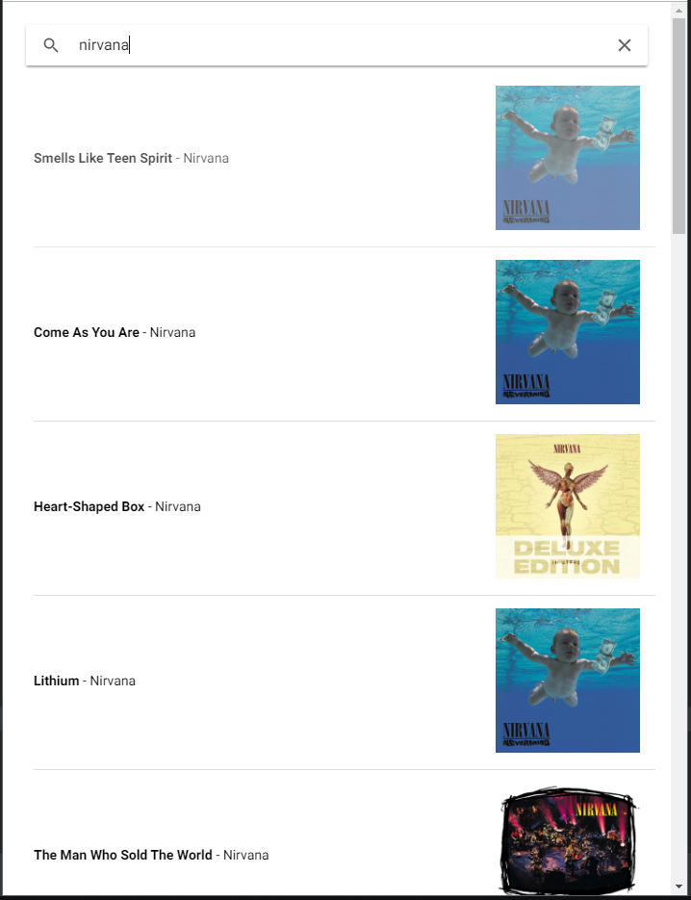

Select a track in the list to continue.

3 - Track page.

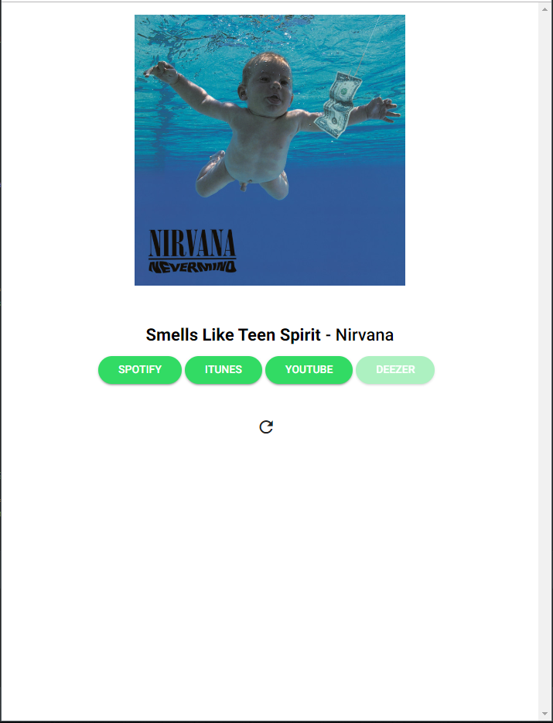

If a link is disabled, it’s because this song is unavailable on this platform.

To return at home, you can click on the reload button.

You can see the different music platforms available.