Co-Working Space AIS
Project Documentation
Multi-Activity Entertainment & Study Hub
Accounting Information System
Python | PyQt5 | SQLite | Desktop Application

1. Introduction

The Multi-Activity Co-Working Space Accounting Information System (AIS) is a desktop application designed to manage and automate the financial and operational processes of a multi-activity entertainment and study hub. The system is built using Python, PyQt5 (for the graphical user interface), and SQLite (as the database engine).

The co-working space offers three main types of rooms:

Room Type | Description | Pricing Model
Study Rooms | Quiet study environments with multiple seats | Flat hourly rate
Gaming Rooms | Gaming stations with PS5, Xbox consoles | Flat hourly rate (premium pricing)
Cinema Hall | Full cinema experience with large seating | Per-person hourly rate

The system provides a unified platform for session management, dynamic billing, inventory (snacks & beverages) control, expense tracking, and financial reporting. With recent updates, it now features comprehensive Double-Entry Accounting (General Ledger, Balance Sheet, Income Statement), advanced Role-Based Access Control (RBAC), a Customer Loyalty Program, Advanced Booking capabilities, and Automated PDF Invoice generation.

Technology Stack
Component | Technology
Programming Language | Python 3.x
GUI Framework | PyQt5 (Fusion Style)
Database | SQLite 3
Architecture | Layered (Database → Business Logic → UI)
Design Pattern | Manager Pattern (RoomManager, SessionManager, etc.)

2. Problem Statement

Managing a multi-activity co-working space that offers study rooms, gaming rooms, and a cinema hall — each with different pricing models — presents several operational and financial challenges:

- Manual Session Tracking: Without an automated system, tracking which rooms are occupied, when sessions started, and calculating duration-based billing is error-prone and time-consuming.
- Complex Dynamic Pricing: Each room type has a different pricing formula. Study rooms charge a flat hourly rate. Gaming rooms charge a premium flat rate. Cinema halls charge per person per hour. Manually computing these during busy hours leads to billing errors.
- Inventory Mismanagement: The space sells snacks, drinks, and hot beverages. Without a system, tracking stock levels, sales linked to specific sessions, and identifying low-stock items is difficult.
- Expense Tracking Gaps: Operational expenses (rent, electricity, internet, salaries, maintenance) are often recorded in scattered spreadsheets, making it hard to get a consolidated view.
- Lack of Financial Visibility: Without segment reporting, management cannot make data-driven decisions about pricing, room allocation, or cost optimization.
- No Real-Time Status: There is no live dashboard to see room occupancy, active sessions, or key financial metrics at a glance.

No Customer Retention Tools: The lack of a loyalty program makes it difficult to track returning customers and offer appropriate rewards.
Scheduling Conflicts: The inability to schedule future reservations leads to double-booking and inefficient room utilization.
Basic Accounting Limitations: Standard single-entry cash flow tracking lacks professional financial visibility, requiring a transition to full Double-Entry Accounting to properly manage equity and assets.
Lack of Security and Access Control: Without role-based access control, sensitive financial data, unit costs, and pricing configurations are exposed to all employees.
Core Problem: The absence of an integrated system that unifies session management, billing, inventory, expenses, and financial reporting into a single, real-time, easy-to-use application.

3. Objectives

3.1 Primary Objectives
# | Objective | Description
1 | Automated Session Management | Start and end room sessions with automatic timestamp tracking, duration calculation, and room status updates
2 | Dynamic Billing Engine | Automatically calculate bills based on room type, duration, number of people, and linked snack purchases
3 | Inventory Control | Track product stock levels, process sales, handle restocking, and trigger low-stock alerts
4 | Expense Management | Record, categorize, and track all operational expenses with full CRUD operations
5 | Financial Reporting | Generate comprehensive reports including revenue per room type (segment reporting), total revenue, expenses, and net profit
6 | Secure Authentication & RBAC | Enforce Role-Based Access Control (Admin/Employee) to secure sensitive operations and inventory costs.
7 | Double-Entry Accounting | Implement standard accounting practices including Journal Entries, General Ledger, Balance Sheet, and Income Statement.
8 | Advanced Booking System | Allow staff to schedule, manage, and validate future room reservations securely.

3.2 Secondary Objectives
# | Objective | Description
6 | Real-Time Dashboard | Provide a live overview showing room statuses, active sessions, revenue, and profit at a glance
7 | Discount Support | Allow discounts when ending sessions
8 | Minimum Billing Policy | Enforce a minimum 30-minute billing policy to ensure fair revenue
9 | Low-Stock Alerts | Automatically flag products whose stock falls below a configurable threshold
10 | Modern UI/UX | Deliver a dark-themed, visually appealing interface with gradient cards, glow effects, and intuitive navigation
11 | Loyalty Program | Track customer engagement and spending to provide dynamic loyalty rewards and discounts.
12 | Financial Year Reset | Enable administrators to safely reset transactional data for a new financial year while preserving core entities.
13 | PDF Invoices | Automatically generate downloadable and printable PDF invoices for sessions and sales transactions.

4. Data Flow Diagrams (DFD)

4.1 Context Diagram (Level 0)
The Context Diagram shows the system as a single process interacting with external entities: Customer, Manager/Admin, and Supplier. It illustrates the high-level data flows in and out of the AIS system.

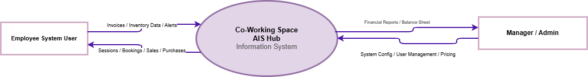
Figure 1: Context Diagram (Level 0) — Co-Working Space AIS

4.2 Level 1 DFD
The Level 1 DFD decomposes the system into its five major processes, showing the data stores and how data flows between processes, external entities, and stored data.

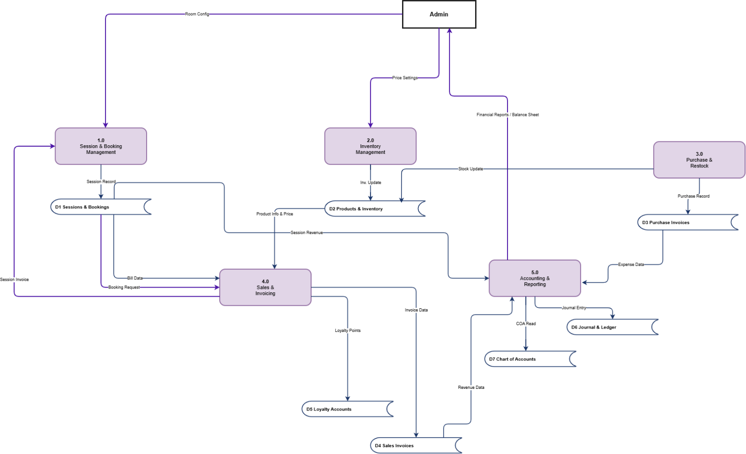
Figure 2: Level 1 DFD — Co-Working Space AIS

Level 1 Process Descriptions
Process | Name | Description
1.0 | Session Management | Handles starting/ending sessions, checking room availability, updating room status (Available ↔ Occupied)
2.0 | Billing Engine | Calculates room charges using dynamic pricing, adds linked snack purchases, applies discounts, generates final bill
3.0 | Inventory Management | Manages product catalog, processes sales (linked to sessions or standalone), handles restocking, monitors low stock
4.0 | Expense Management | Records operational expenses (Rent, Electricity, Salaries, etc.), supports categorization and deletion
5.0 | Financial Reporting | Generates segment reports (revenue per room type), calculates total revenue, expenses, net profit, and analytics
6.0 | Booking & Loyalty Management | Manages advanced room reservations, prevents scheduling conflicts, and tracks customer loyalty points.
7.0 | Security & Double-Entry Accounting | Handles user authentication (RBAC), journal entries, equity tracking, balance sheet generation, and system resets.

5. Entity-Relationship Diagram (ERD)

The ERD illustrates the database schema of the AIS system, showing all entities, their attributes, and the relationships between them.

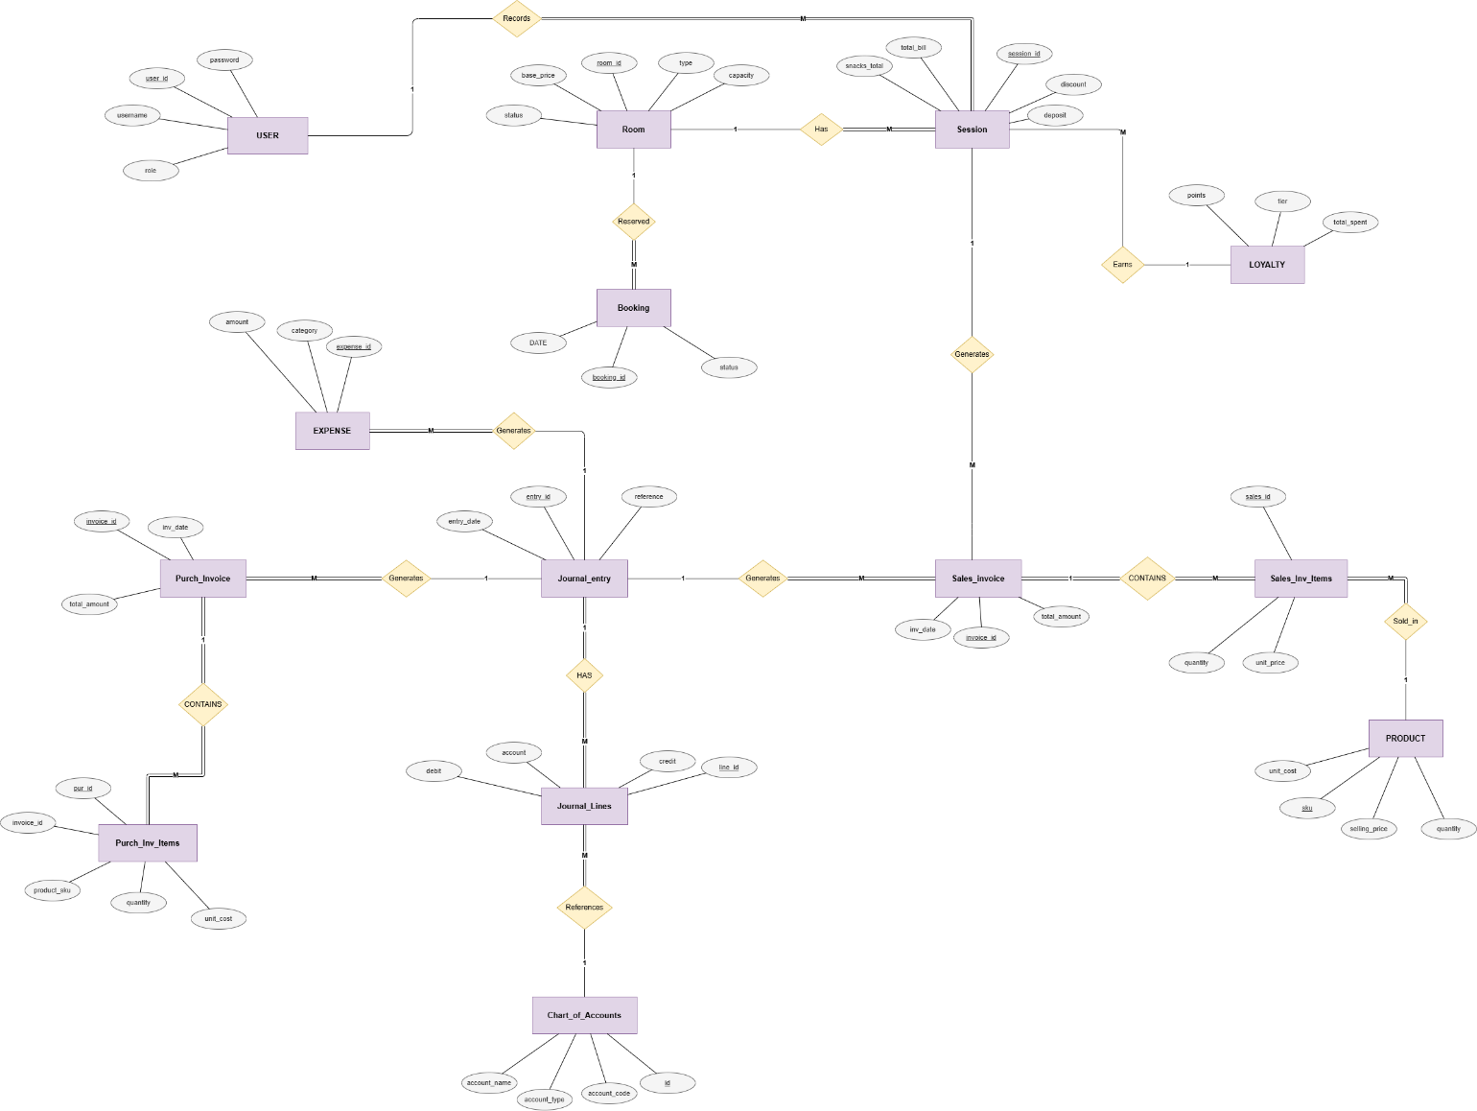

6. Flowcharts

6.1 Overall System Flow
Shows the application startup sequence and how users navigate between the five main modules.
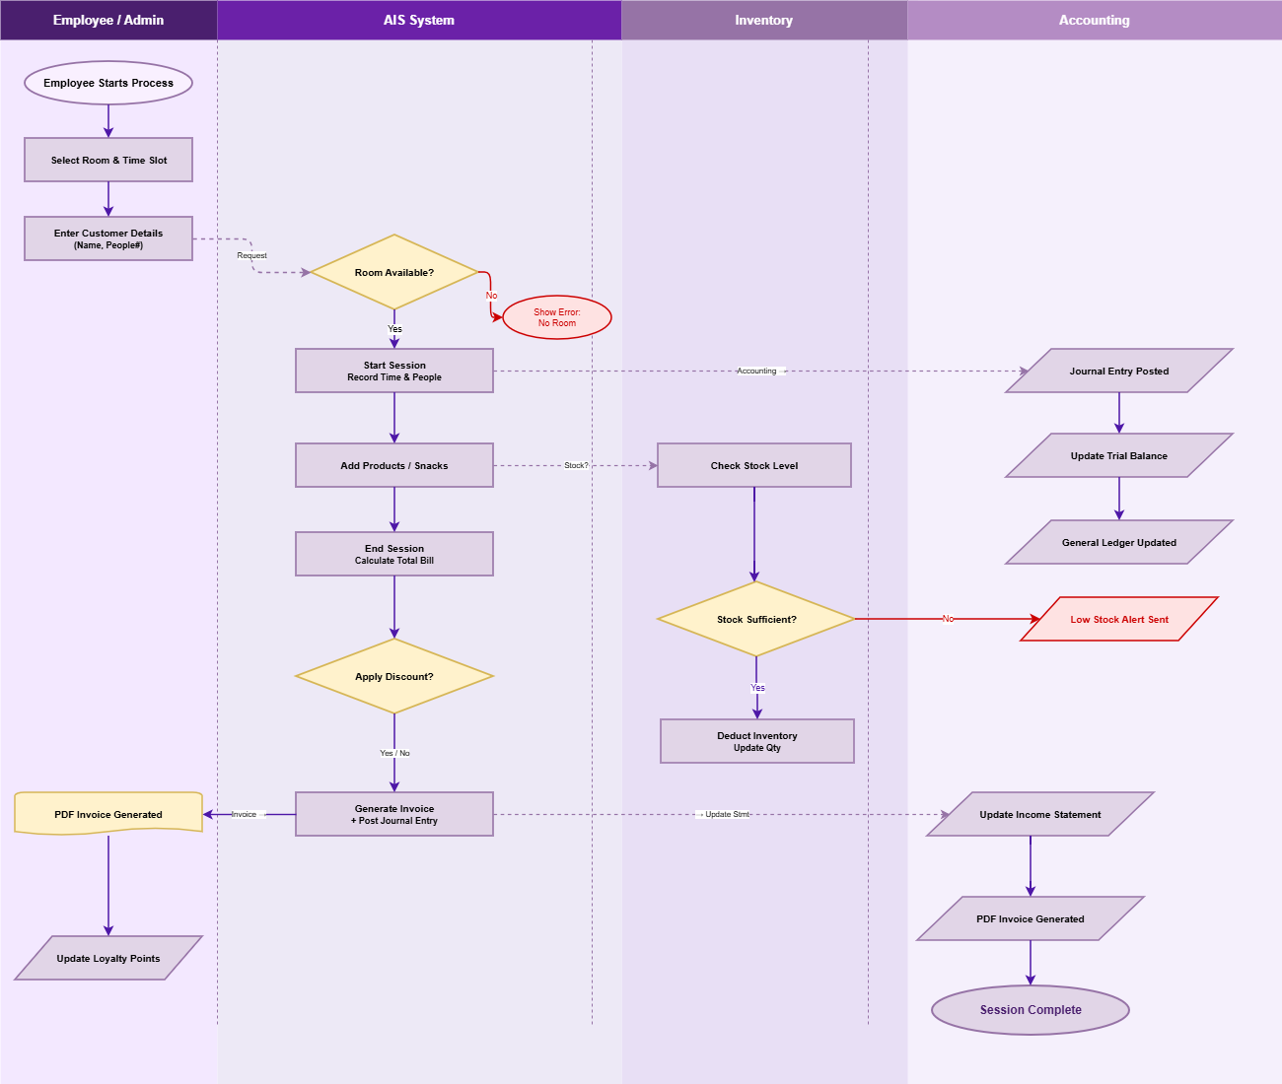
Figure 4: Overall System Flow

Figure 5: Session Management Flow

6..4 Inventory Management Flow
Covers the three core inventory operations: selling products (with optional session linking), restocking items, and adding new products to the catalog, as well as the low-stock detection logic.

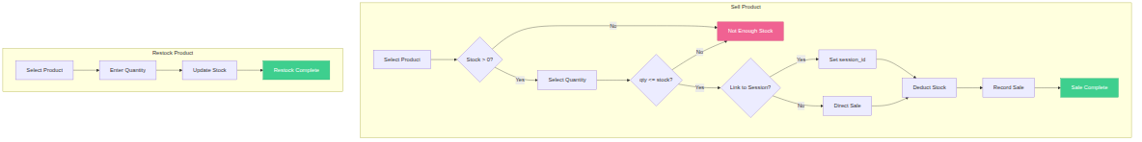
Figure 7: Inventory Management Flow

Appendix: Dynamic Pricing Formula

Pricing Formulas
Room Type | Formula | Notes
Study | Room Charge = base price × duration hours | Flat rate per hour
Gaming | Room Charge = base price × duration hours | Premium flat rate per hour
Cinema | Room Charge = base price × duration hours × people | Per-person hourly rate
Min Billing | duration hours = MAX (actual hours, 0.5) | Minimum 30 minutes enforced
Total Bill | Total = Room Charge + Snacks Total - Discount | Total = MAX (Total, 0)

Default Room Pricing
Room | Type | Base Price (EGP/hr) | Capacity
Study Room A | Study | 20.0 | 6
Study Room B | Study | 20.0 | 8
Gaming Room 1 | Gaming | 50.0 | 4
Gaming VIP | Gaming | 80.0 | 2
Cinema Hall | Cinema | 35.0 | 20

