

Alexandria University

Faculty of Engineering

Numerical Analysis

**Final Project Report**

Submitted to

Dr. Zeinab Eid

Eng. Heba Abd El-Atty

By

Amira Hossam ID: 5312

Mariam Medhat ID: 5351

Basma Hesham ID: 5432

Toka Sherif ID: 5492

Nada El Shafey ID: 5612

1. **Bisection method**

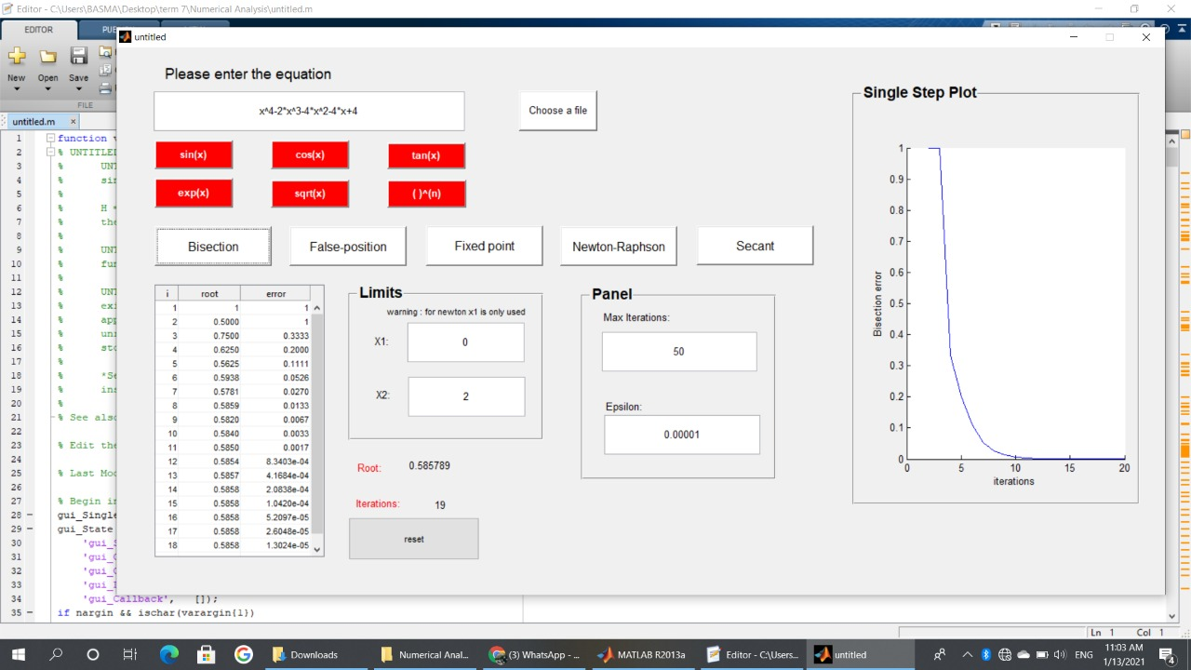

1. 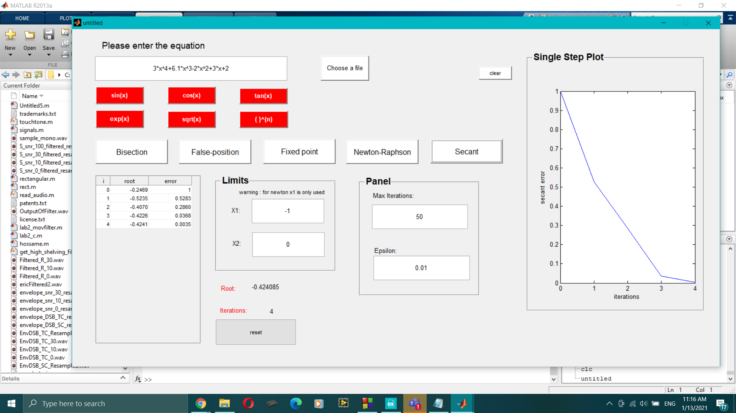**2)Secant method**

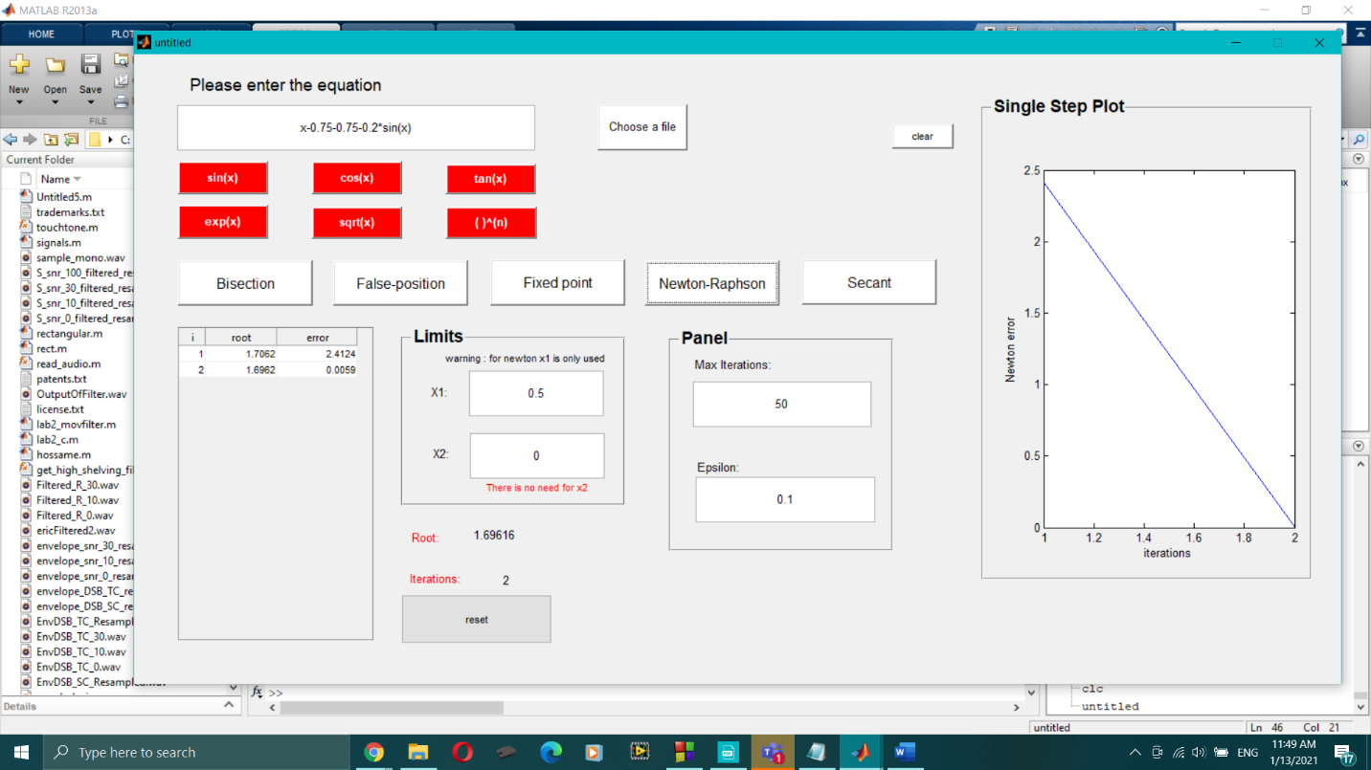**3)Newton Rapslon**

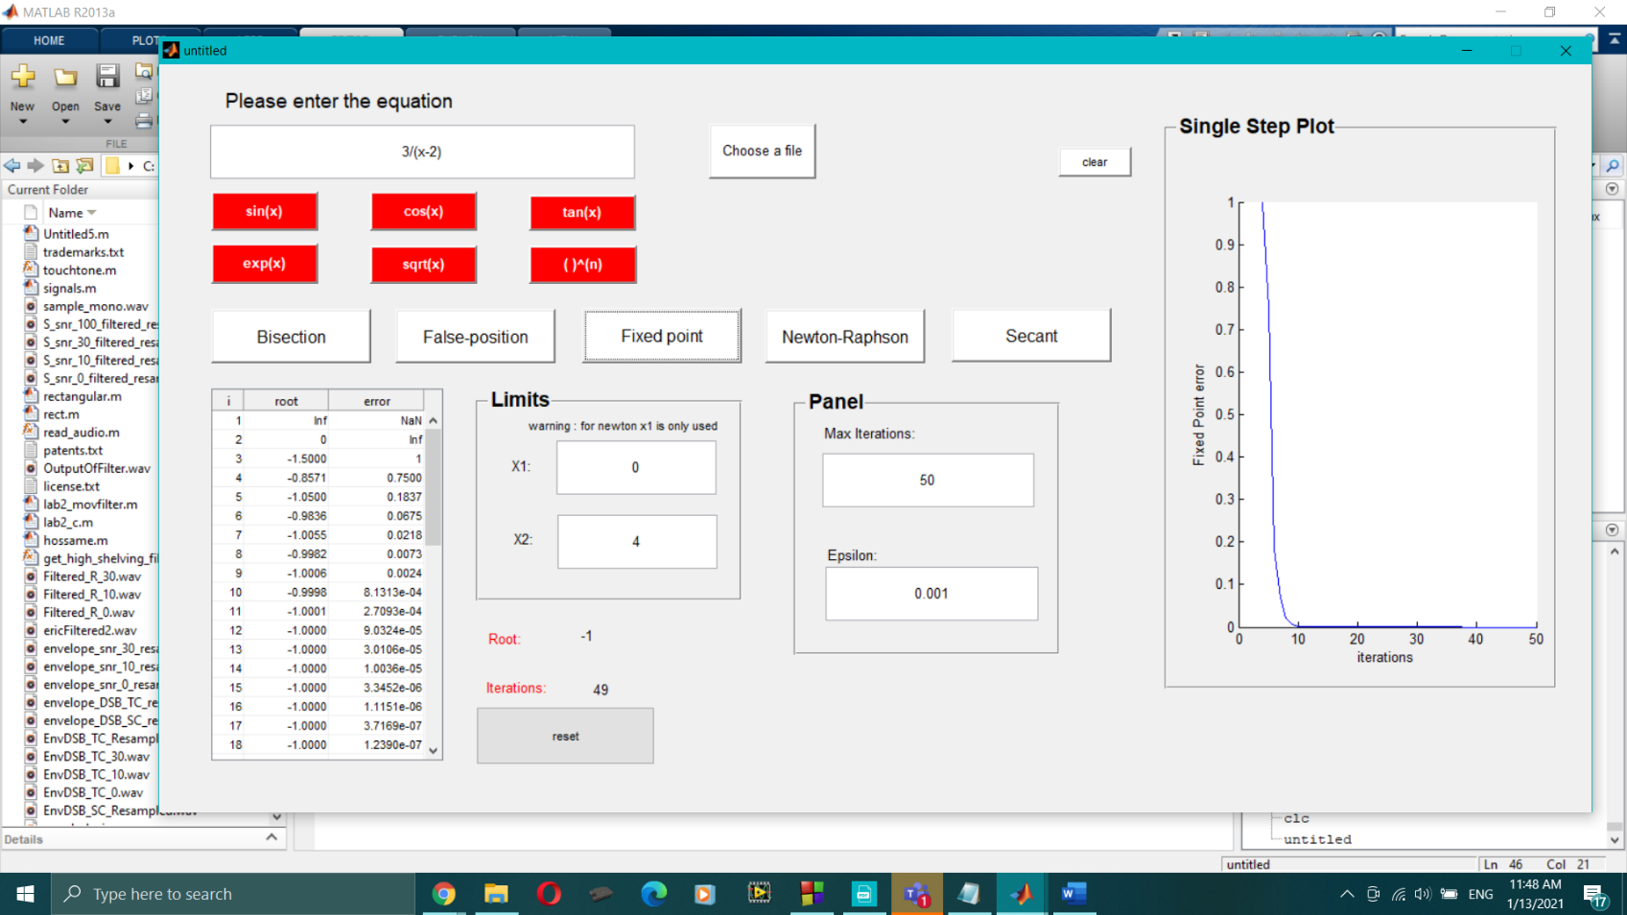**4)Fixed Point**

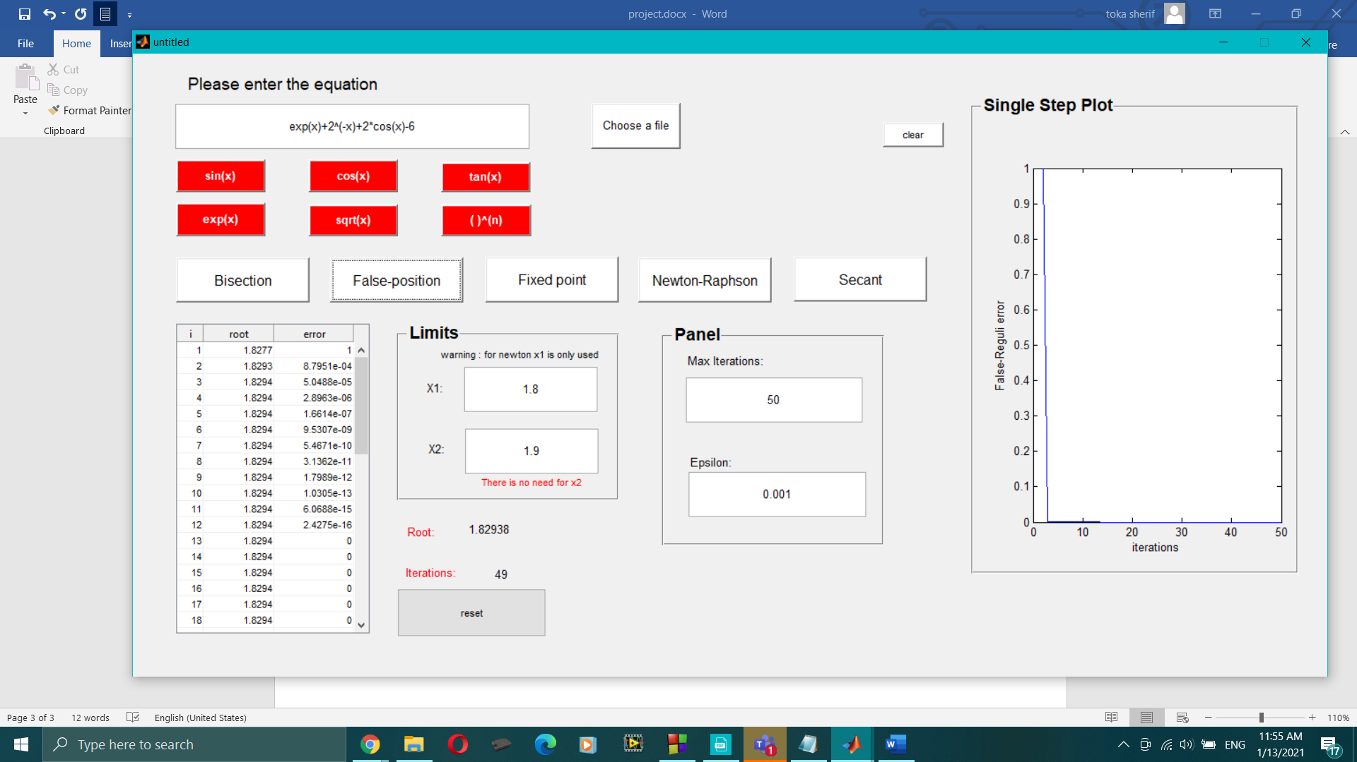**5) False-Reguli**