**Edge detection report**

* **first derivative edge detector**

using differentiated matrices

on x and y

hx = [-0.5 0 0.5 ; -0.5 0 0.5 ; -0.5 0 0.5];

hy = [-0.5 -0.5 -0.5 ; 0 0 0 ;0.5 0.5 0.5];

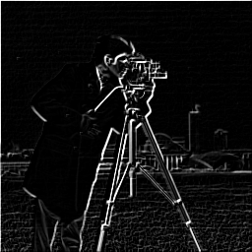

using the first derivative of gaussian filter

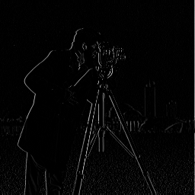

* **Laplacian of Gaussian "second derivative edge detector"**

Using Laplacian matrix

h = [0 1 0 ; 1 -4 1 ; 0 1 0];

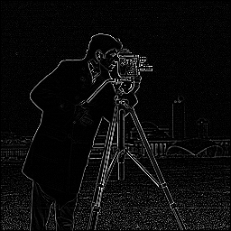

using differentiated matrices

on x and y again

for the output of

first derivative

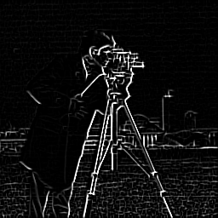

Using second derivative of Gaussian filter

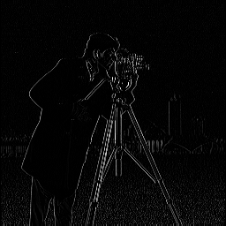

* **Canny edge detector**

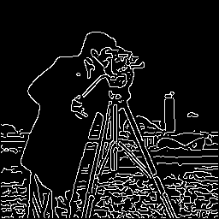

**My point of view:**

**Canny edge detector shows more details than the second derivative and the second derivative shows more details than the first derivative.**

**Depends on the level of details in the image and the edges needed to be shown we can choose between the second derivative and canny edge detectors .**

**Note :**

**The image used here is “cameraman.tif” mage ‘it exists in matlab’.**