Cairo University  
Faculty of Computers and Artificial Intelligent

**CS251**

**Software Engineering I**

Parking System

Software Design

Mennatallah Mohammed Ibrahim El Sharawy

Alaa Ashraf Youssef

Toka Hamdy Mohammed

Omar Magdy Adel

May/2022

Contents

Team 3

Document Purpose and Audience 3

System Models 3

I. Class diagrams 3

Important Algorithm 4

II. Sequence diagrams 5

Class - Sequence Usage Table 6

Ownership Report 6

Policy Regarding Plagiarism: 7

# Team

|  |  |  |  |
| --- | --- | --- | --- |
| **ID** | **Name** | **Email** | **Mobile** |
| 20201048 | Toka Hamdy Mohammed | doudyhamdy.th@gmail.com | 01140640015 |
| 20201178 | Mennatallah mohammed Ibrahim | menahmohamed2002@gmail.com | 01068924028 |
| 20200329 | Alaa Ashraf Youssef |  | 01006873341 |
| 20200355 | Omar Magdy Adel |  | 01124273671 |

# Document Purpose and Audience

This document contains the class diagram which contains all the classes that are found in the implementation and shows all the attributes and functions of each class to let the customer understand how the system works and also it contains the sequence diagram for the most complex use cases and every sequence diagram has a use case description which explains in details the flow of the events and how the system do function of the use case and show how the functions are called .

# System Models

## I. Class diagrams

| **Class ID** | **Class Name** | **Description & Responsibility** |
| --- | --- | --- |
| 1 | Controller | It is responsible for parking in and paring out and calculate total income by adding fees, |
| 2 | DataBase | It stores all lists we need in the System number of slots we have and its info, number of vehicles we have, and its info and fees list it stores fees of each car. |
| 3 | Relation | it is responsible to interact with garage owner to input needed data and displays free slots for him and displays messages if an error occurred. |
| 4 | Slot | It is responsible to give every Slot an ID and set it is depth and width and change it is status if a car is parked in or no. |
| 5 | Vehicle | It is responsible to set car info like model, depth, width etc.. and with it is arrival and departure time. |
| 6 | ParkIn | It is responsible to park the car using a selected configuration by garage owner. |
| 7 | BestFit | It is responsible to park the car using best-fit configuration depends on car width and depth comparing to the slot. |
| 8 | FirstSlot | It is responsible to park the car using First come first served configuration that parks the car in first free slot available. |
| 9 | ParkOut | It is responsible to get the car owner out and free its slot and mark the departure time. |
| 10 | Time | It is responsible to detect the arrival and departure time of the car owner to the Garage. |

### Important Algorithm

None

## II. Sequence diagrams

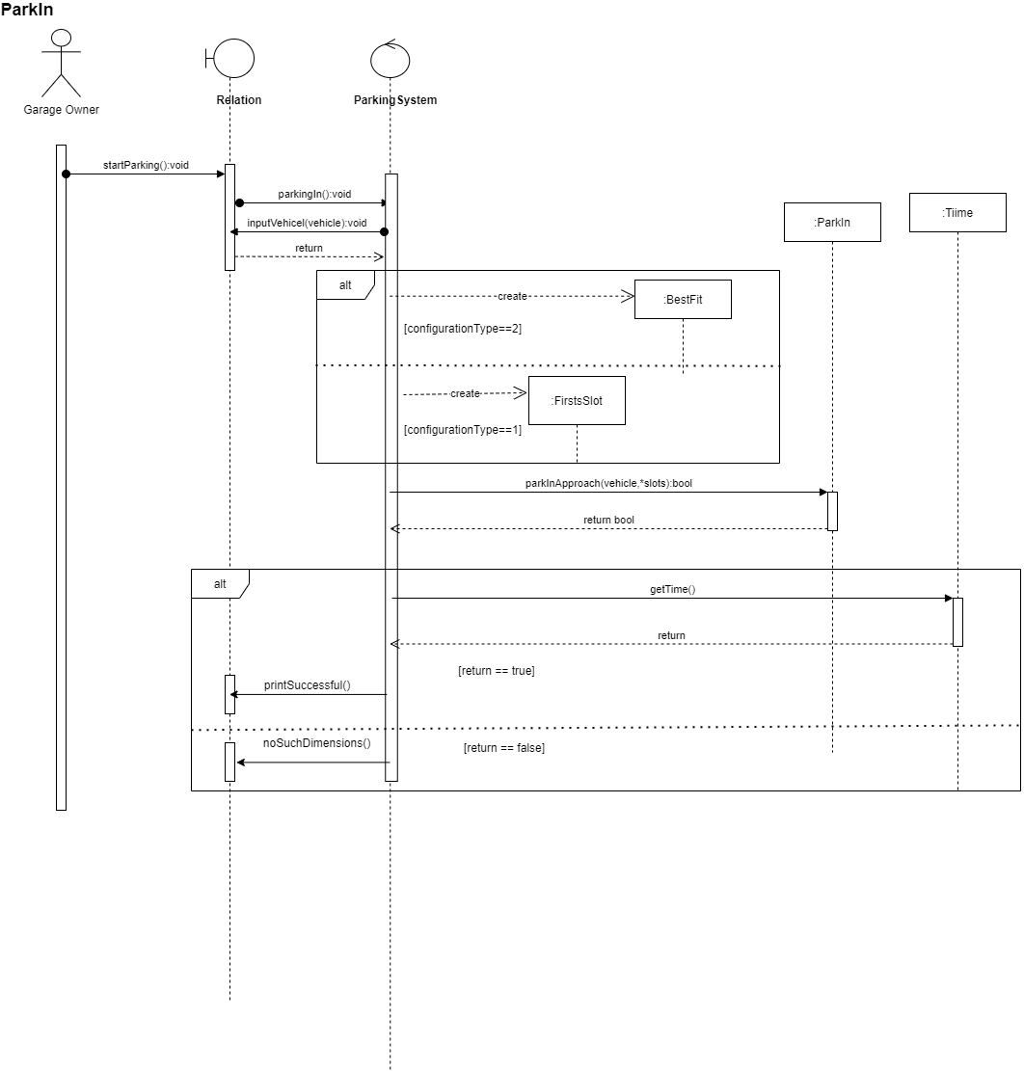

### Class - Sequence Usage Table

| **Class Name** | **Sequence Diagrams** | **Overall used methods** |
| --- | --- | --- |
| Controller | ParkIn,BestFit,Parkout | parkingIn,parkingOut,calculateTotalIncome,calculateFees. |
| DataBase | NONE | NONE |
| Relation | Setup,ParkIn,BestFit,Parkout | noSuchDimensions,inputVehicle,inputVehicleId,inputSlots,setConfiguration,printSuccessful,unkownVehicle,nonAvailableSlots,displayAvailableSlots,invalidDimensionMessage,printConfiguration,printFee,startparkin,startparkout,SetUpTheGarage |
| Slot | NONE | Setslotwidth,setslotdepth,setoff,seton,setid,getid,getstate,getslotwidth,getslotdepth |
| Vehicle | NONE | setmodelname,setidnum, setmodelyear,setdepth,setwidth, setarrival,setdepature,getmodelname,getid,getmodelyear,getdepth,getwidth,getarrivaltime,getdepaturetime |
| ParkIn | ParkIn, | *parkinApproach* |
| BestFit | BestFit | parkinApproach |
| FirstSlot | NONE | parkinApproach |
| ParkOut | ParkOut | parkout |
| Time | ParkIn,ParkOut | gettime |

# Ownership Report

|  |  |
| --- | --- |
| **Item** | **Owners** |
| Class diagram Class usage table, sequence diagram and class usage table | *All team have participated in doing it* |
|  |  |