TokaLab – Validation Checks

TokaLab aims at integrating different modules. Any kind of modification should be validated before release to ensure bugs and computational issues. To ensure this, TokaLab team provides two levels of validation, self-validation and responsible validation.

Self-validation consists of running some scripts inside the validation folder and compare the results with the expected results, presented in this document.

Responsible validation is a validation performed by module responsibles before adding your modifications in the main scripts.

For any issue, you can contact [tokalab.fusion@gmail.com](mailto:tokalab.fusion@gmail.com).

# SimPla – Simulated Plasma

## SimPla_Validation_01

This script run aims at calculating the equilibrium in three standard TokaLab scenarios:

* Single Null (SN)
* Double Null (DN)
* Negative Triangularity (NT)

At the end of the script, the following figure should be plotted:

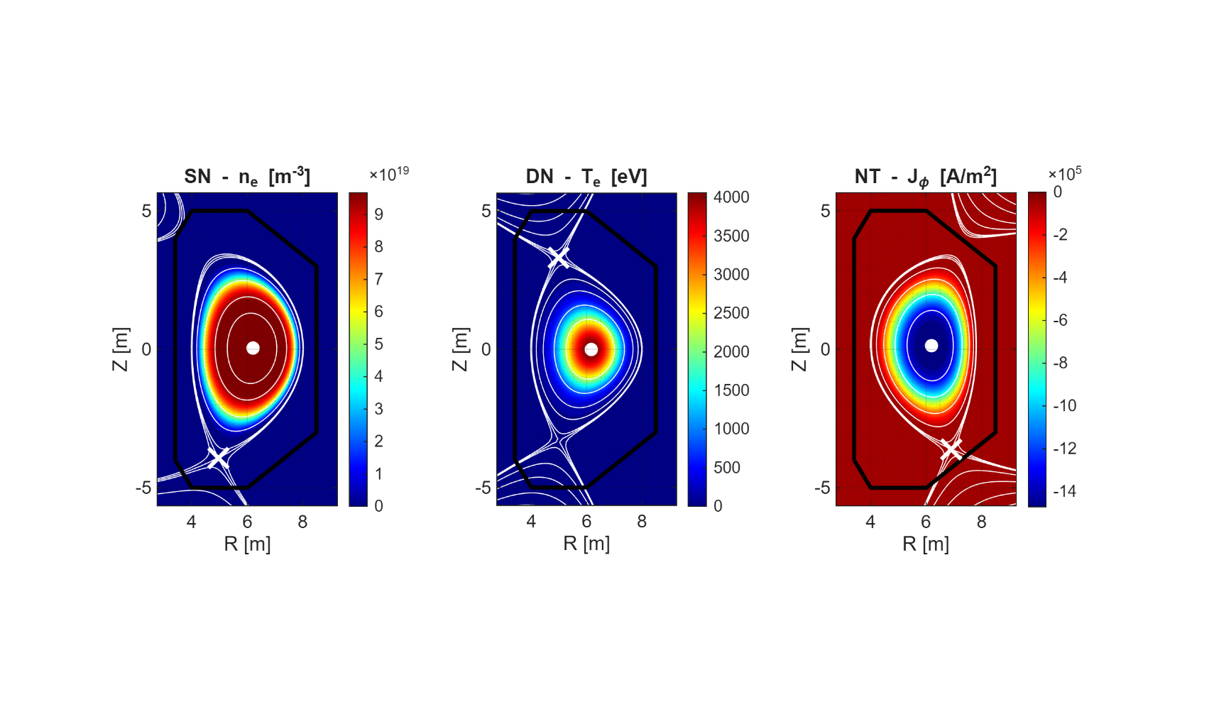

Figure 1 – Output from SimPla_Validation_01.

By running your code, you should compare the results with the ones reported above. More specifically, you have to check:

1. Shape and order of magnitude of density in SN, temperature in DN, and toroidal current in NT cases.
2. Positions pf O and X points, indicated by a big white point and cross respectively. O-point is expected to be in the centre, while X-point should cross the separatrix. It has to be considered that X-point for double null case may be located or in the top or in the bottom as a function of minor variability and numerical errors (both are X-points, but the code, at the moment, finds only one X-point).