Financial & Mobility Intelligence Platform

Executive Summary
The Financial & Mobility Intelligence Platform is a data-driven system designed to help financial institutions and digital service providers extract actionable insights from customer behavior. The platform combines financial transactions, mobility activity, and behavioral data streams into a unified intelligence layer that supports decision-making, revenue optimization, and risk management.
Unlike traditional analytics platforms that focus only on static financial records, this system integrates real-time behavioral signals such as spending patterns, mobility usage, and engagement trends. This enables organizations to move from passive reporting to active, data-driven decision systems.
The platform is built around a central multi-source data pipeline, responsible for ingesting, transforming, and enriching diverse datasets into structured, analytics-ready outputs. These outputs power downstream systems such as:
- Financial intelligence dashboards
- Credit risk and loan recommendation engines
- Customer segmentation and monetization strategies
- Mobility and payment-driven behavioral analysis

Core Value
The platform connects three critical layers of modern digital ecosystems:
- Financial Institutions:
  - Gain deeper insight into customer behavior to improve credit decisions, optimize revenue streams, and personalize financial products.
- Digital Platforms (Mobility & Payments):
  - Leverage behavioral data to enhance pricing strategies, predict demand, and integrate financial services such as micro-loans and subscription models.
- End Users (Indirect Impact):
  - Benefit from more relevant financial products, fairer credit assessment, and personalized service offerings.

Elevator Pitch
“An intelligent data platform that transforms financial and behavioral data into actionable insights, enabling organizations to optimize revenue, reduce risk, and build smarter customer experiences.”

Key Performance Indicators (KPIs)

Data Platform Metrics
- Successful ingestion of multiple data streams (financial, mobility, behavioral)
- Data processing latency under 5 minutes for batch pipelines
- Data accuracy > 95% after validation and cleaning

Business Intelligence Metrics
- Ability to generate customer financial profiles and segments
- Identification of high-value and high-risk customers
- Generation of automated recommendations (loans, pricing, offers)

System Reliability Metrics
- 99% pipeline uptime
- Fault-tolerant data ingestion and processing
- Logged and traceable data transformations

Why This Project Stands Out?
This platform goes beyond typical portfolio projects by demonstrating:
- End-to-end data engineering (pipelines + storage + processing)
- Applied data science (feature engineering + ML-ready datasets)
- Business-driven thinking (revenue optimization + risk analysis)
- Cross-domain integration (finance + mobility + behavioral systems)

Objectives & Core Value
The Financial & Mobility Intelligence Platform is designed to deliver measurable value through structured data processing, intelligent analytics, and decision support systems. Its objectives are divided into short-term (MVP) and long-term (scalable intelligence platform) goals.

MVP Objectives
The initial phase focuses on building a strong data foundation through a functional, reliable pipeline and basic analytics outputs.
Key Objectives:
- Develop a multi-source data pipeline
  - Ingest financial, behavioral, and mobility datasets
  - Support both batch ingestion and simulated real-time data
- Establish structured data layers
  - Raw → Clean → Feature (analytics-ready)
  - Ensure consistency, traceability, and data validation
- Generate core customer insights
  - Build initial feature tables:
    - Customer financial summary
    - Spending patterns
    - Behavioral activity
- Enable basic analytics use cases
  - Identify:
    - High-value customers
    - High-risk customers
    - Spending trends
- Demonstrate end-to-end pipeline flow
  - From ingestion → transformation → analytics outputs
  - Fully working on local + containerized environment

Mid-Term Objectives
Once the pipeline is stable, the focus shifts to intelligence and decision-making capabilities.
Key Objectives:
- Enhance feature engineering
  - Introduce customer scoring systems:
    - Risk score
    - Customer lifetime value
    - Engagement score
- Integrate machine learning models
  - Credit risk prediction
  - Customer segmentation (clustering)
  - Recommendation systems
- Expand data sources
  - Add mobility/ride data
  - Add payment activity
  - Introduce external economic indicators
- Enable real-time or near real-time updates
  - Simulate streaming pipelines
  - Update behavioral features dynamically

Long-Term Objectives
The long-term vision is to evolve into a fully intelligent decision platform used in financial and digital ecosystems.
Key Objectives:
- Build a financial decision intelligence system
- Support product-level decisioning
  - Personalized offers
  - BNPL (PayJustNow-style systems)
  - Subscription and pricing models
  - Advanced pyramid scheme analysis
- Prepare for scalable architecture
  - Modular services for:
    - Data pipeline
    - Analytics
    - ML inference

  - Automated loan recommendations
  - Dynamic pricing strategies
  - Revenue optimization insights
- Enable cross-domain intelligence
  - Combine:
    - Financial behavior
    - Mobility patterns
    - Payment activity
- Develop predictive capabilities
  - Spending forecasts
  - Default risk predictions
  - Demand forecasting (mobility system)

System Architecture – Pipeline & Financial Intelligence Platform
The first major architecture system focuses on the relationship between the Multi-Source Data Pipeline and the Financial Intelligence Platform, also referred to as FIP.
The pipeline acts as the data backbone of the platform. It collects, validates, cleans, enriches, and transforms raw data into reliable analytics-ready outputs. The Financial Intelligence Platform then consumes these outputs to support customer analysis, credit decisioning, revenue optimization, loan recommendations, and strategic banking insights.
The architecture is intentionally designed so that the pipeline and the FIP are connected but not tightly coupled. This means the pipeline can evolve independently as a data engineering system, while the FIP can evolve independently as a business intelligence and decision-support application.

Data Pipeline Architecture
The Data Pipeline is responsible for converting raw customer, transaction, loan, repayment, and behavioural data into trusted intelligence assets.
At MVP level, the pipeline can run as scheduled batch jobs. As the platform matures, it can support near real-time ingestion and event-driven processing.

Pipeline Responsibilities
The pipeline is responsible for:
- Ingesting data from multiple sources or generating it for the due course
- Validating incoming data
- Storing raw data for traceability
- Cleaning and standardizing records
- Creating customer-level feature tables
- Preparing ML-ready datasets
- Producing analytics outputs for downstream platforms
- Logging pipeline failures and data-quality issues
The key design rule is:
- The pipeline owns data quality, transformation, and feature generation.
The FIP should not be responsible for cleaning raw transactions or building heavy aggregations during user requests.

Pipeline Input Sources
The pipeline receives data from several financial data streams.
Core Input Sources
Customer profile data
  - Customer ID
  - Age group
  - Employment type
  - Income band
  - Region
  - Account status
Bank account data
- Account type
- Account balance
- Account age
- Monthly deposits
- Monthly withdrawals
Transaction data
- Transaction amount
- Transaction category
- Merchant
- Timestamp
- Payment channel

Loan data
- Loan type
- Loan amount
- Interest rate
- Repayment term
- Loan status
Repayment history
- Payment due date
- Actual payment date
- Late payment count
- Missed payment status
Digital engagement data
- App logins
- Online banking activity
- Product page visits
- Offer interactions

External economic data
- Interest rate trends
- Inflation indicators
- Regional economic signals
For the MVP, these can be created using a combination of public datasets and synthetic data generation. Later, the same architecture can support APIs, streaming events, and direct integrations.

Pipeline Internal Layers

Layer 1 — Ingestion Layer
The ingestion layer loads data from files, APIs, mock services, and simulated event streams.
At MVP stage, ingestion can support:
- CSV uploads
- Excel uploads
- JSON files
- Synthetic data generators
- Scheduled external data pulls
The ingestion layer should not transform the data heavily. Its main responsibility is to receive data and store it safely.

Layer 2 — Raw Data Layer
The raw layer stores data exactly as received.
The purpose of the raw layer is:
- Reprocessing
- Debugging
- Auditing
- Data lineage
- Recovery from transformation errors
Example raw tables:
- raw_customers
- raw_accounts
- raw_transactions
- raw_loans
- raw_repayments
- raw_digital_activity
- raw_external_economic_data
Raw data should be mostly append-only.

Layer 3 — Validation Layer
The validation layer checks whether incoming records are usable.
Examples of validation rules:
- Customer ID must exist
- Transaction amount must be numeric
- Transaction date must be valid
- Loan status must match allowed values
- Repayment date cannot be before loan issue date
- Required columns must exist
- Duplicate transaction IDs must be flagged
Invalid data should be stored separately in:
- pipeline_error_logs
- rejected_records
- data_quality_issues
This makes the system auditable and realistic.

Layer 4 — Clean Data Layer
The clean layer stores corrected and standardized records.
Example clean tables:
- clean_customers
- clean_accounts
- clean_transactions
- clean_loans
- clean_repayments
- clean_digital_activity
Typical cleaning tasks include:
- Removing duplicates
- Standardizing date formats
- Normalizing transaction categories
- Handling missing values
- Standardizing customer identifiers
- Mapping merchant names to categories
- Ensuring consistent currency formats

Layer 5 — Feature Engineering Layer
This is one of the most important parts of the pipeline.
The feature layer converts clean records into customer-level indicators.
Example feature outputs:
- Average monthly income
- Average monthly spending
- Savings rate
- Debt-to-income ratio
- Account balance volatility
- Number of missed repayments
- Late repayment frequency
- Transaction frequency
- Digital engagement score
- Product interest score
- Credit utilization ratio
- Financial stability score
These features become the foundation for analytics, ML models, and business recommendations.

Layer 6 — Analytics / Gold Layer
The gold layer contains business-ready tables consumed by the FIP (Financial Intelligence Platform).
Example output tables:
- customer_financial_summary
- customer_risk_profile
- customer_value_profile
- customer_segment_profile
- loan_recommendation_features
- product_recommendation_features
- customer_alerts
- model_scoring_inputs
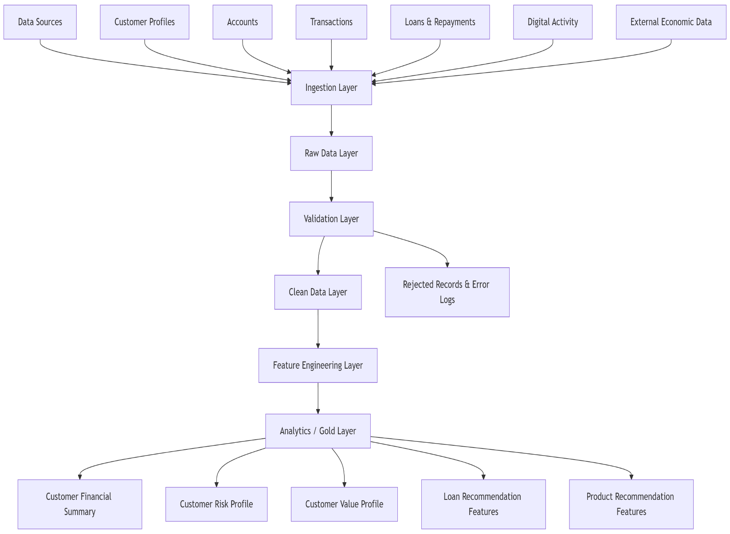
These tables form the contract between the pipeline and the Financial Intelligence Platform.

Pipeline Processing Jobs
The pipeline should be organized into clear jobs.

Core Jobs
- Ingest customer data
- Ingest transaction data
- Ingest loan and repayment data
- Validate incoming records
- Clean and standardize data
- Build customer financial summaries
- Build risk profile features
- Build customer value features
- Build recommendation feature tables
- Log failures and pipeline metrics
This makes the pipeline easy to monitor, debug, and extend.

Financial Intelligence Platform Architecture
The Financial Intelligence Platform is the business-facing system that consumes prepared pipeline outputs and turns them into actionable banking insights.
The FIP is not just a dashboard. It is a decision-support platform for banks, fintech companies, and financial analysts.
Its purpose is to help answer:
- Who are the most valuable customers?
- Who is likely to default?
- Who should receive a loan offer?
- Which customers should receive premium products?
- Which customers are becoming financially unstable?
- Which customers are good candidates for BNPL (Buy Now, Pay Later) - style services?
- Which customers should be targeted for retention?

FIP Responsibilities
The FIP is responsible for:
- Reading analytics-ready pipeline outputs
- Running credit scoring logic
- Running customer segmentation logic
- Generating loan recommendations
- Generating product recommendations
- Displaying customer intelligence dashboards
- Providing analyst-facing reports
- Exposing APIs for customer insights
The key design rule is:
- The FIP owns decisioning, recommendations, visualization, and business workflows.
It should consume trusted data from the pipeline instead of processing raw data directly.

FIP Core Components

Financial API Layer
The API layer exposes endpoints used by the frontend dashboard.
Example API responsibilities:
- Fetch customer summaries
- Fetch customer risk profiles
- Fetch customer segments
- Fetch loan recommendations
- Fetch revenue opportunities
- Fetch alerts
- Export reports

Decision Engine
The decision engine is the core intelligence layer inside the FIP.
It combines:
- Rule-based logic
- ML model outputs
- Business constraints
- Recommendation scoring
At MVP stage, some decisions can be rule-based. Later, they can be replaced or enhanced by ML models.

Credit Analysis Module
This module evaluates customer creditworthiness.
It uses pipeline-generated features such as:
- Income stability
- Debt-to-income ratio
- Late repayment count
- Account balance volatility
- Existing loan exposure
- Transaction consistency
Outputs may include:
- Risk category
- Credit score band
- Recommended credit limit
- Default probability
- Reason codes
Example results:
- Customer Risk Level: Medium
- Reason: Stable income, but high debt-to-income ratio and two late repayments in the last six months.

Loan Recommendation Module
This module recommends loan products based on the customer profile.
Possible recommendations:
- Personal loan
- Short-term loan
- Business loan
- Emergency micro-loan
- No loan recommended
The recommendation should include explainability.
Example:
- Recommended Product: Small Personal Loan
- Reason: Customer has stable monthly income, low missed payments, and moderate disposable income.

Revenue Optimization Module
This module identifies how a financial institution can increase revenue from existing customers.
Examples:
- Offering premium accounts to high-income customers
- Offer credit cards to customers with stable spending
- Offer BNPL product to customers with good repayment behavior
- Offer investment product to customers with high surplus income
- Offer retention benefits to dormant customers
- Offering transport or lifestyle bundles based on spending categories
This is one of the strongest differentiators of the platform because it connects technical analytics to business growth.

Customer Segmentation Module
This module groups customers into business-friendly segments.
Example segments:
- Premium high-income customers
- Credit-ready customers
- Risky borrowers
- Dormant customers
- Growth potential customers
- Financially stressed customers
- Heavy digital users
- BNPL-ready customers
The MVP can start with rule-based segmentation. Later, clustering models can be introduced.

Dashboard / Frontend Layer
The dashboard is used by analysts, relationship managers, or business users.
Key dashboard pages:
- Executive overview
- Customer list
- Customer profile
- Risk analysis
- Loan recommendations
- Product recommendations
- Revenue opportunities
- Customer segments
- Alerts and exceptions
Frontend technology can be React with Vite, matching your preferred React setup.

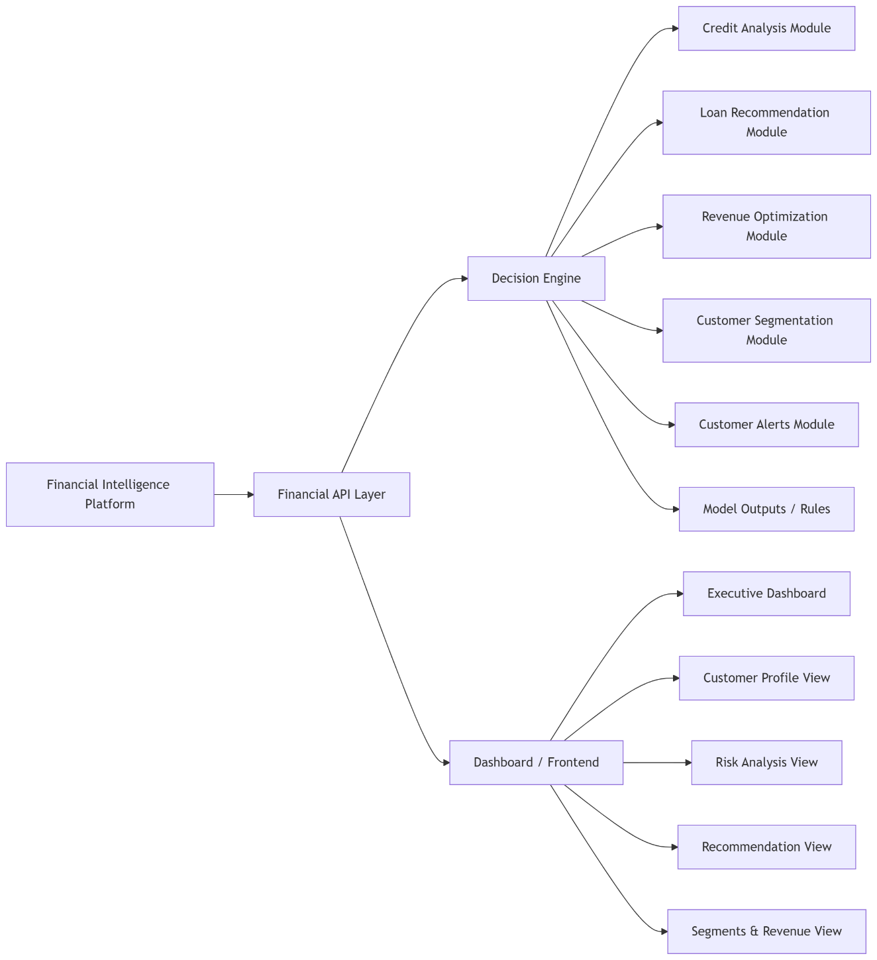
Relationship Between Pipeline and FIP
The pipeline and FIP are connected through the analytics/gold layer.
The pipeline prepares the data.
The FIP consumes the data and turns it into business decisions.
This separation is important because it prevents the FIP from becoming overloaded with data engineering responsibilities.

Proposed Relationship
The proposed architecture is:
The FIP should mainly read from the pipeline’s gold-layer outputs.
Example shared tables:
- customer_financial_summary
- customer_risk_profile
- customer_value_profile
- customer_segment_profile
- loan_recommendation_features
- product_recommendation_features
- customer_alerts
These tables act as the data contract between both systems.

Data Ownership
Pipeline Owns
- Raw data
- Clean data
- Feature engineering
- Data quality rules
- Pipeline logs
- Gold-layer analytics tables
FIP Owns
- User-facing dashboards
- Analyst workflows
- Recommendation display logic
- Decision rules
- ML inference services
- Business reports

Why This Relationship Works
This design gives the project:
- Clear separation of concerns
- Better performance
- Easier debugging
- Stronger data governance
- Easier ML integration
- More realistic enterprise architecture
- Better scalability for future systems
It also allows the same pipeline to later support the Mobility + Payment Platform without rewriting the financial platform.

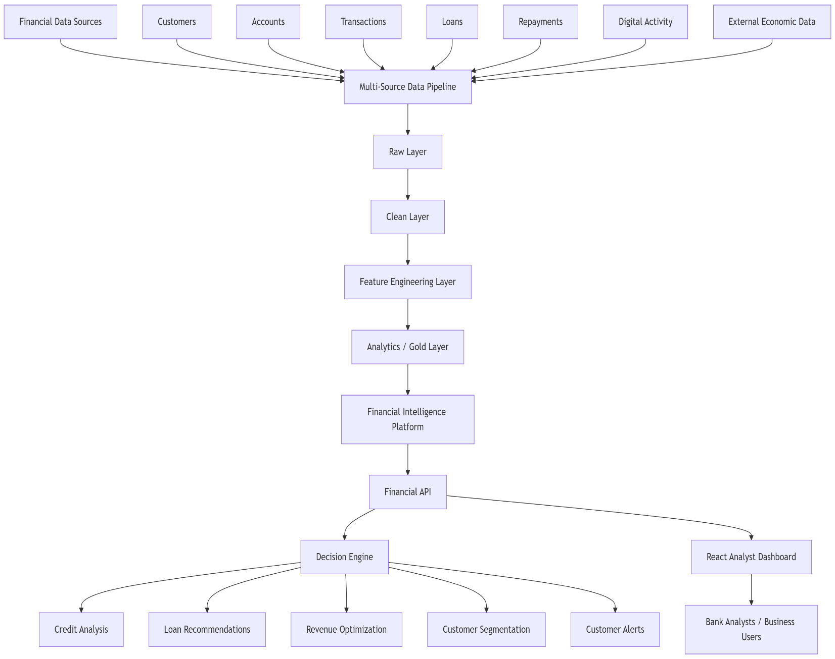

MVP Architecture
At MVP stage, the system should remain simple but well-structured.
A full microservices architecture is not needed yet.

MVP Components
Python pipeline scripts
- Ingestion
- Cleaning
- Feature engineering
PostgreSQL
- Raw tables
- Clean tables
- Gold-layer tables
FastAPI backend
- Reads gold-layer tables
- Exposes FIP endpoints
React frontend
- Analyst dashboard
- Customer profile views
- Recommendation pages
Docker Compose
- Local environment
- Database
- API
- Frontend
Optional Redis
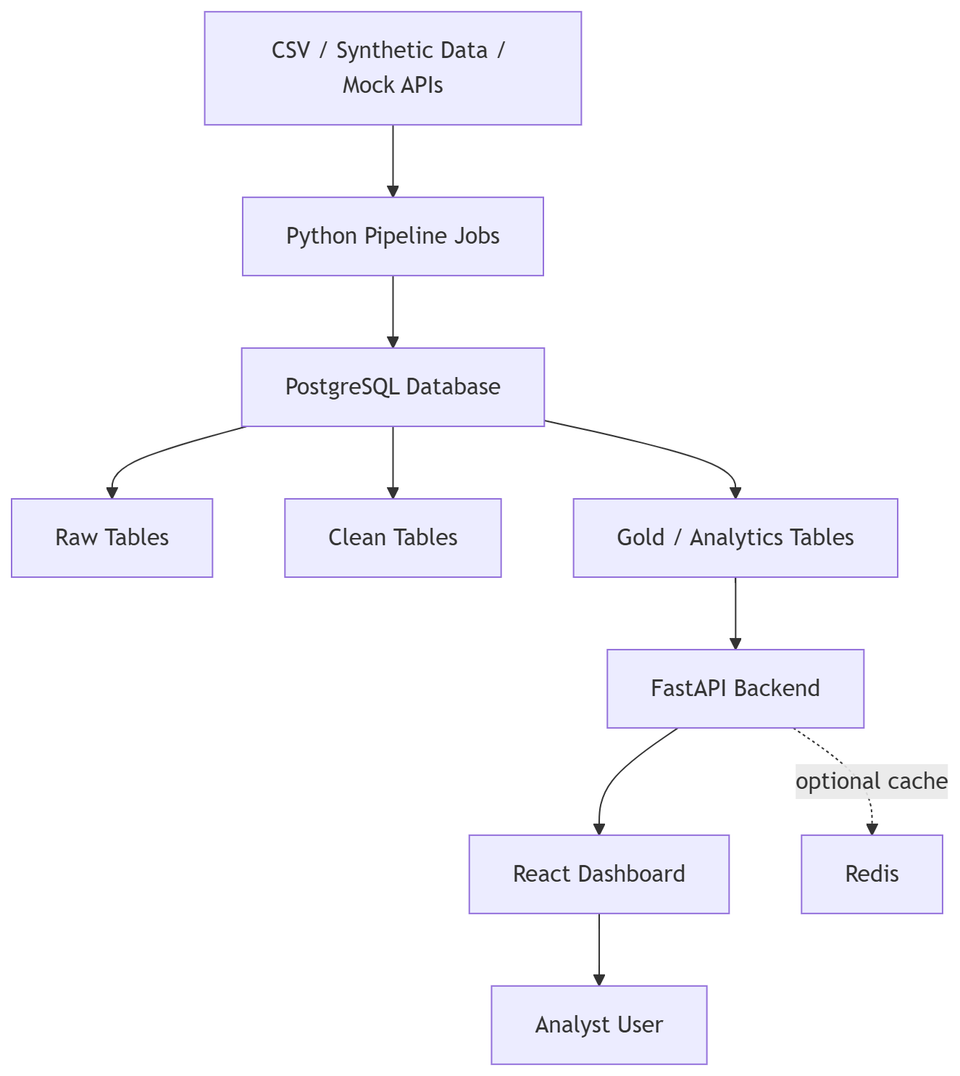
- Cache expensive dashboard queries

Target Production Architecture
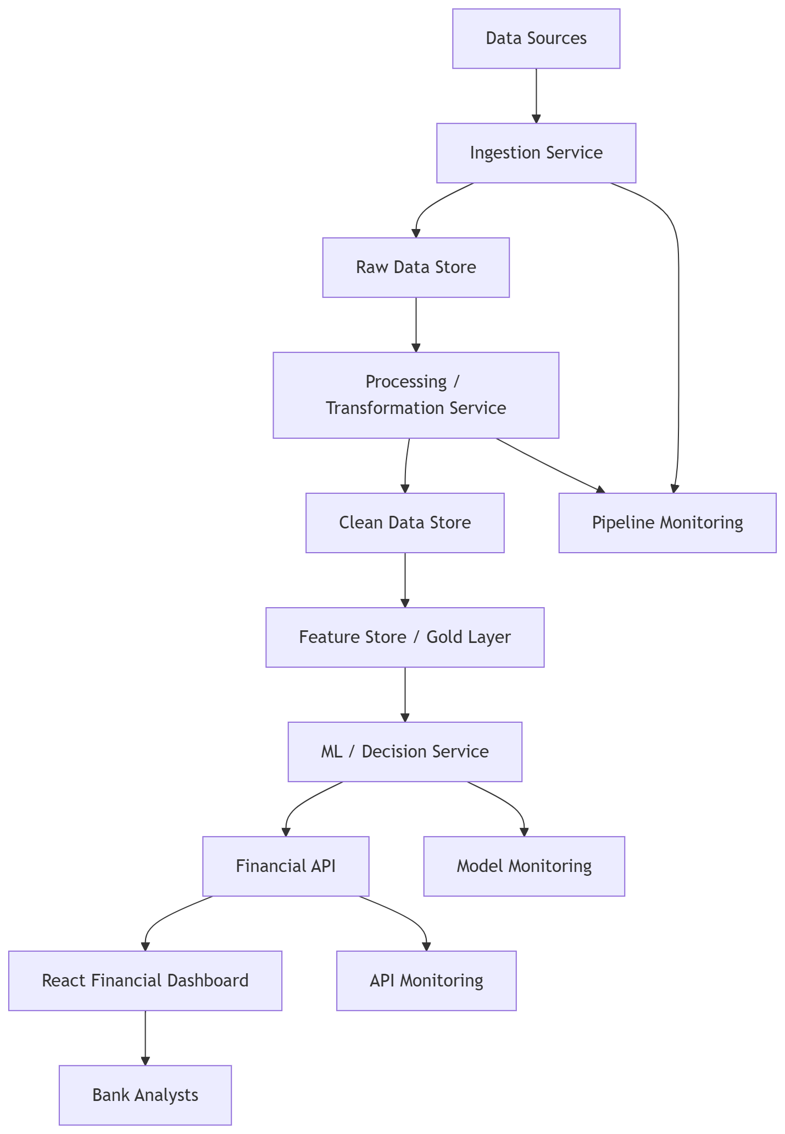

System Flow & Use Cases – Pipeline & FIP
The System Flow & Use Cases section explains how data moves through the Multi-Source Data Pipeline and how the Financial Intelligence Platform (FIP) uses that processed data to generate customer insights, risk analysis, loan recommendations, and revenue opportunities.
This section focuses on the operational behavior of the first architecture block:
Pipeline + Financial Intelligence Platform
The goal is to show how the system works from raw data ingestion all the way to business-facing recommendations.

Core Use Cases
The system has several core use cases that demonstrate the value of the pipeline and the FIP.

Use Case 1 — Data Ingestion Flow
The data ingestion flow brings raw financial and behavioral data into the pipeline. This is the first step before any analysis, scoring, or recommendation can happen.
Actors
- Data engineer / system scheduler
- Pipeline ingestion service
- External or internal data sources
- PostgreSQL database
Flow
- The pipeline receives data from CSV files, mock APIs, generated datasets, or scheduled jobs.
- The ingestion service checks whether the file or source format is supported.
- The system captures metadata about the ingestion batch.
- Raw records are inserted into raw tables.
- The ingestion batch is marked as successful, partially successful, or failed.
- If records fail basic checks, they are written to an error log.
Example Raw Tables
- raw_customers
- raw_accounts
- raw_transactions
- raw_loans
- raw_repayments
- raw_digital_activity
Acceptance Criteria
- Raw data is stored without destructive transformation.
- Each ingestion batch has a batch ID.
- Failed records are logged.
- The system can trace which records came from which source.
- The pipeline can rerun or reprocess a previous batch if needed.
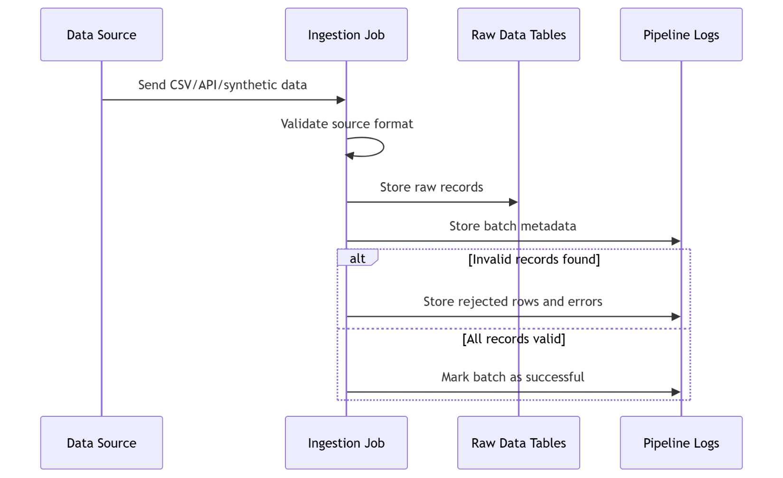

Use Case 2 — Data Validation & Cleaning Flow
This flow ensures that raw data is reliable enough to be used for analytics and ML feature creation.
Actors
- Pipeline validation job.
- Cleaning job
- Raw data tables
- Clean data tables
- Error log tables
Flow
- The validation job reads new records from raw tables.
- It checks required fields, formats, data types, and business rules.
- Valid records move to the cleaning stage.
- Invalid records are sent to rejected_records or data_quality_issues.
- The cleaning job standardizes dates, categories, currencies, and identifiers.
- Cleaned records are inserted into clean tables.
- Pipeline metrics are updated.
Example Validation Rules
- customer_id must not be null.
- transaction_amount must be numeric.
- transaction_date must be valid.
- loan_status must be one of the accepted values.
- Duplicate transaction IDs must be flagged.
- Repayment date cannot be earlier than loan issue date.
Acceptance Criteria
- Invalid records do not enter clean tables.
- Each validation error has an explainable reason.
- Cleaning logic is reproducible.
- Clean tables use consistent naming and data formats.
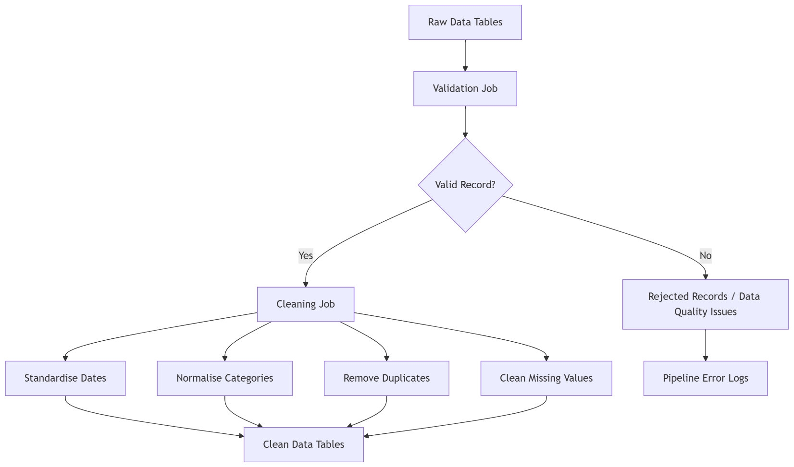
- The pipeline logs the number of processed, accepted, and rejected records.

Use Case 3 — Feature Engineering Flow
The feature engineering flow converts clean financial data into customer-level intelligence that can be used by the FIP.
This is where the project becomes powerful because it moves beyond storing transactions and starts creating meaningful business indicators.
Actors
- Feature engineering job
- Clean tables
- Analytics / gold layer
- ML preparation tables
Flow
- The feature engineering job reads from clean tables.
- It aggregates transactions at customer level.
- It calculates income, spending, savings, debt, repayment, and engagement features.
- It creates customer-level summaries.
- It writes outputs into analytics/gold-layer tables.
- These outputs become available to the FIP.
Financial Behavior Features
- Average monthly income
- Average monthly spends.
- Savings rate
- Income stability
- Account balance volatility.
- Spending category distribution
Credit Risk Features
- Debt-to-income ratio
- Missed repayment count.
- Late repayment frequency
- Existing loan exposure
- Credit utilization ratio.
Customer Value Features
- Estimated customer lifetime value.
- Monthly revenue generated
- Product usage count
- Engagement score
- High-value transaction count
Recommendation Features
- Loan eligibility score.
- BNPL readiness score
- Premium product suitability score
- Retention risk score
Acceptance Criteria
- Customer-level feature tables are generated successfully.
- Features are updated on a scheduled basis.
- Each feature has a clear definition.
- Feature tables can be used directly by ML models or rule engines.
- The FIP does not need to recalculate heavy aggregations.
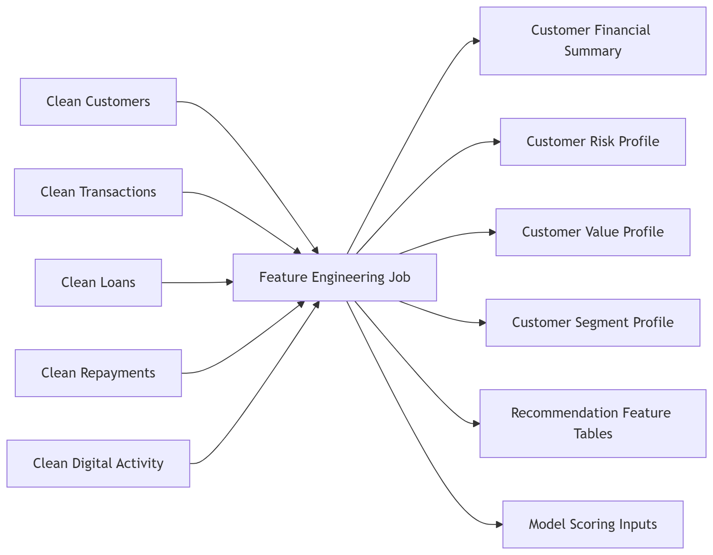

Use Case 4 — Customer Risk Scoring Flow
This flow allows the FIP to determine whether a customer is low-risk, medium-risk, or high-risk.
The scoring can start as a rule-based system and later evolve into a trained ML classification model.
Actors
- Pipeline feature tables
- FIP decision engine
- Credit analysis module
- Analyst dashboard
Flow
- The pipeline produces customer_risk_profile.
- The FIP reads customer risk features from the gold layer.
- The credit analysis module applies scoring logic or ML inference.
- A risk category is generated.
- Reason codes are attached to explain the score.
- The result is displayed on the customer profile dashboard.
Example Risk Inputs
- Late repayment count
- Debt-to-income ratio
- Account balance volatility
- Income consistency
- Existing loan exposure
- Missed payment history
Example Output
Risk Category: Medium Risk
Risk Score: 62/100

Reason Codes:
- Stable monthly income
- High debt-to-income ratio
- Two late repayments in the last six months
- Moderate account balance volatility

Acceptance Criteria
- Every scored customer has a risk category.
- The score includes reason codes.
- Analysts can filter customers by risk level.
- Risk scoring does not require querying raw transaction data.
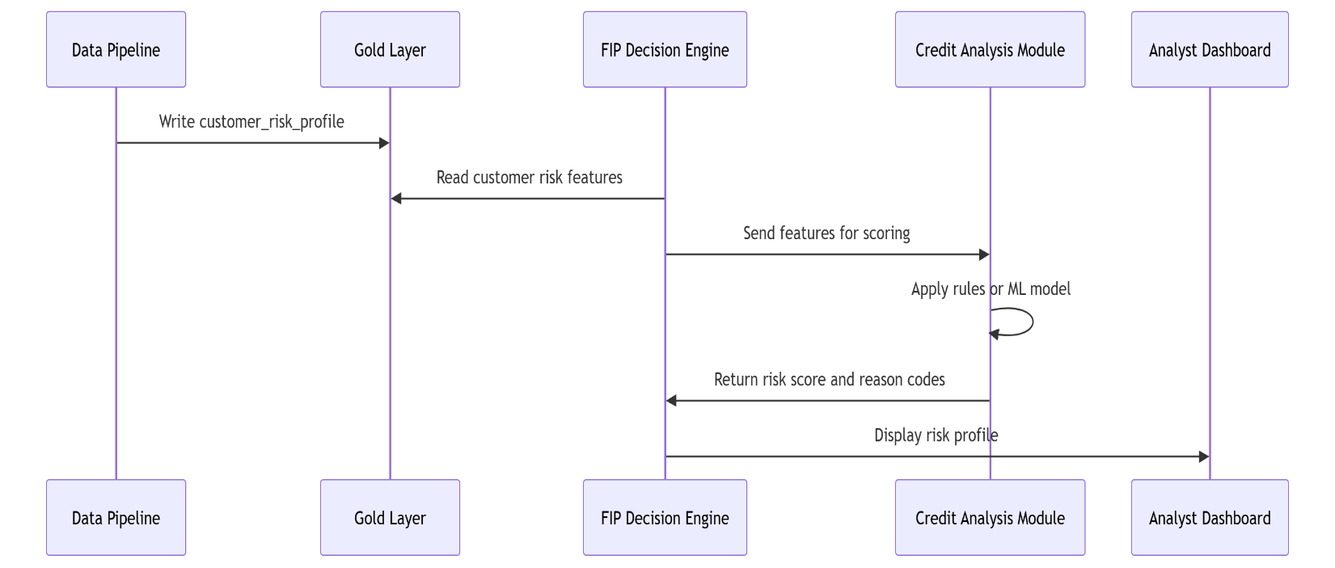
- Risk scores can be refreshed after each pipeline runs.

Use Case 5 — Loan Recommendation Flow
The loan recommendation flow identifies which customers should receive loan offers and what type of loan may be suitable.
This is one of the main business-value flows for banks.
Actors
- Pipeline feature tables
- FIP decision engine
- Loan recommendation module
- Analyst dashboard
Flow
- The pipeline generates loan_recommendation_features.
- The FIP reads the customer’s income, repayment, debt, and risk indicators.
- The decision engine checks eligibility.
- The recommendation module selects the most suitable loan product.
- The system generates an explanation.
- The result appears in the analyst dashboard.
Example Recommendation Logic
IF income_stability is high
AND income_range is high
AND debt_to_income_ratio is low
AND missed_repayments = 0
AND risk_category = low
THEN recommend high personal loan

Example Output
Recommended Product: Personal Loan
Suggested Amount: R25,000
Risk Level: Low
Reason: Stable income, low debt exposure, no missed repayments

Acceptance Criteria
- The system can recommend a loan or reject recommendation.
- Each recommendation includes a reason.
- Recommendations are based on pipeline-produced features.
- Analysts can view recommended amount, product type, and risk level.
- Customers with high-risk profiles are excluded or flagged.
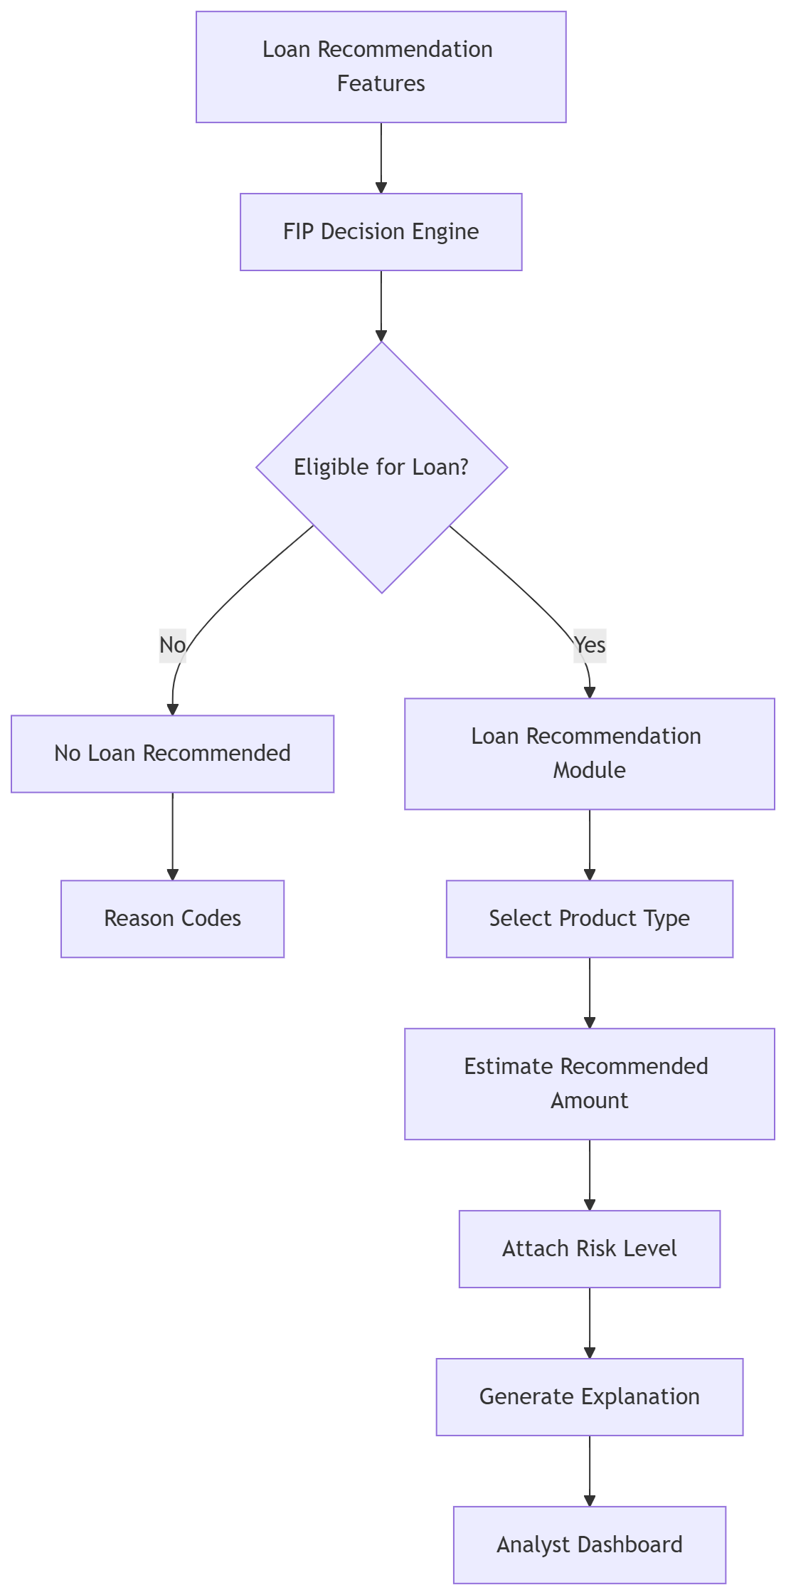

Use Case 6 — Revenue Opportunity Detection Flow
This flow identifies ways a bank/company can increase revenue from its existing customer base.
This is a strong differentiator because it shows that the platform does not only reduce risk; it also helps grow revenue.
Actors
- Pipeline gold-layer tables
- FIP revenue optimization module
- Analyst dashboard
- Business users
Flow
- The pipeline generates customer value and product recommendation features.
- The FIP reads customer financial summaries and value profiles.
- The revenue optimization module identifies monetization opportunities.
- Customers are ranked by opportunity value.
- Recommended actions are generated.
- Analysts view opportunities in the dashboard.
Example Revenue Opportunities
- High-income customer → premium banking account
- High surplus income → investment product
- Strong repayment history → BNPL-style product
- Heavy card usage → credit card offer
- Dormant customer → retention incentive
- High transport spends → mobility-linked subscription product
- Regular salary deposits → salary advance product
Example Output
Customer Segment: High-Income Premium Candidate
Recommended Action: Offer premium account bundle
Expected Value: High
Reason: Customer has high income, strong savings rate, high digital engagement, and low credit risk.

Acceptance Criteria
- Revenue opportunities are generated from customer-level features.
- Each opportunity includes a recommendation reason.
- Customers can be ranked by expected value.
- Analysts can filter by product type, segment, and risk level.
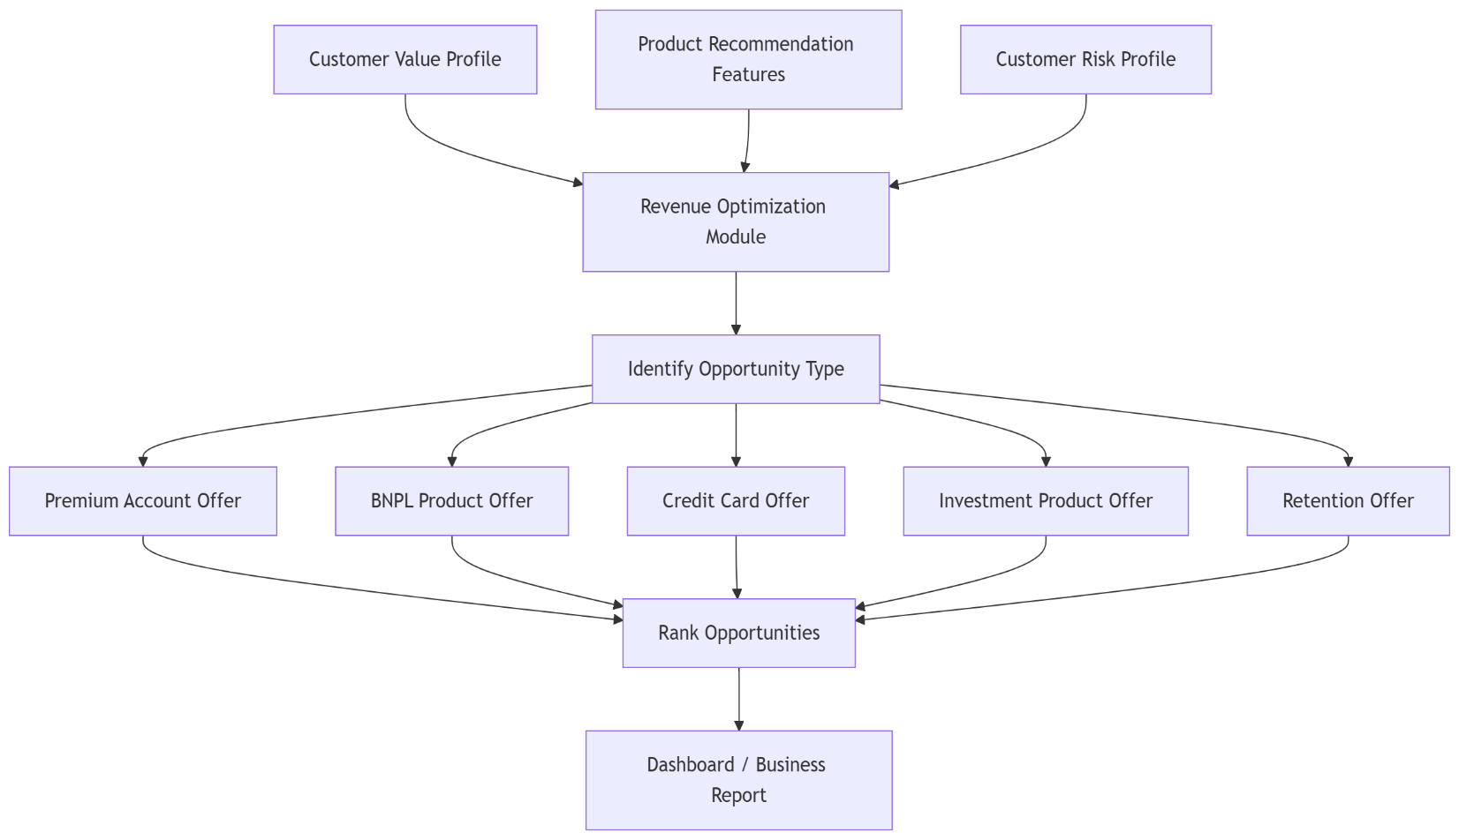
- The module supports both rule-based and ML-assisted recommendations.

Use Case 7 — Customer Segmentation Flow
Customer segmentation groups customers into meaningful categories for business decision-making.
The MVP can start with rule-based segmentation. Later, clustering models such as K-Means can be introduced.
Actors
- Pipeline feature tables
- Segmentation module
- Analyst dashboard
Flow
- The pipeline generates customer financial, risk, and engagement features.
- The segmentation module groups customers using rules or ML clustering.
- Segment labels are assigned.
- Segment profiles are stored or exposed through the FIP API.
- Analysts use the dashboard to explore customer groups.
Example Segments
- Premium high-income customers
- Credit-ready customers
- Risky borrowers
- Financially stressed customers
- Dormant customers
- BNPL-ready customers
- Growth-potential customers
- Heavy digital users
Acceptance Criteria
- Every customer belongs to a segment.
- Segment rules or model logic are documented.
- Analysts can filter by segment.
- Segment summaries are visible on the dashboard.
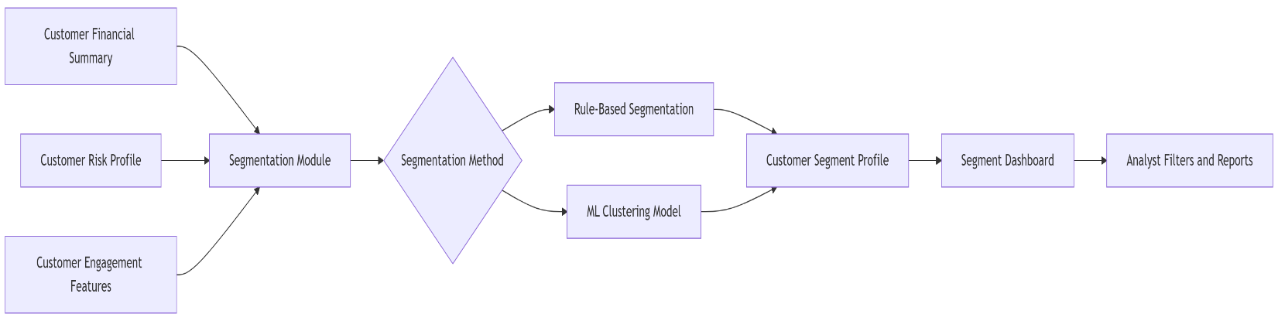
- Segments can be refreshed after new pipeline runs.

Use Case 8 — Analyst Dashboard Flow
The analyst dashboard provides the final user-facing layer of the FIP.
It allows business users to explore insights without directly interacting with the database or pipeline.
Actors
- Analyst / relationship manager
- React frontend
- FIP API
- Gold-layer tables
- Decision engine
Flow
- Analyst logs into the FIP dashboard.
- Dashboard requests summary metrics from the FIP API.
- The API reads gold-layer tables and decision outputs.
- Dashboard displays customer summaries, risk levels, segments, and opportunities.
- Analyst filters customers by risk, segment, product recommendation, or value.
- Analysts open a customer profile for deeper analysis.
- Analyst exports or saves insights if needed.
Dashboard Pages
- Executive overview
- Customer list
- Customer profile
- Risk analysis
- Loan recommendations
- Revenue opportunities
- Customer segmentation
- Alerts
Acceptance Criteria
- Dashboard loads precomputed insights quickly.
- Analysts can filter and search customers.
- Customer profiles include explainable scores.
- Recommendations include reason codes.
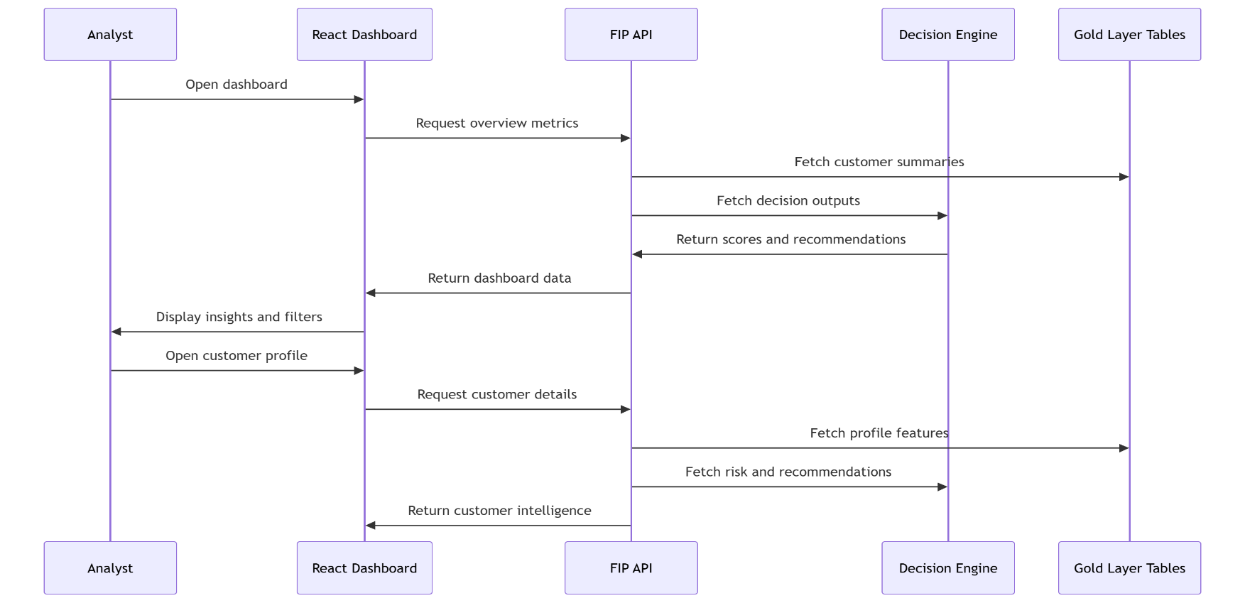
- Dashboard does not run heavy transformations in real time.

Scheduled Pipeline Flow
The pipeline can run on a schedule during the MVP.
Example schedule:
- Daily ingestion of generated transactions
- Daily cleaning and validation
- Nightly feature engineering
- Nightly customer scoring refresh
- Weekly segment refresh
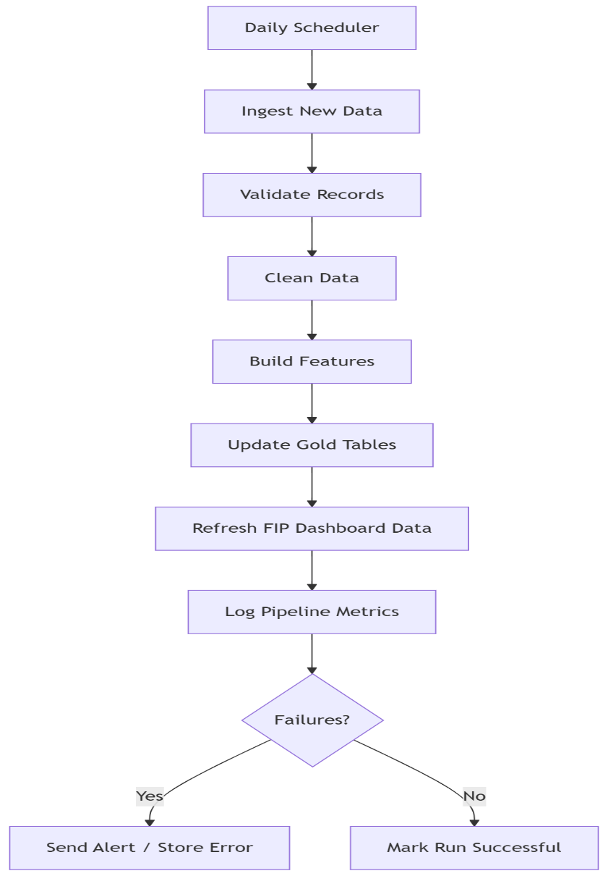
- Monthly model retraining later

Key Business Workflows Supported
The Pipeline + FIP architecture supports the following business workflows:

Credit Decisioning
Used to determine whether a customer is safe to lend to.
Outputs:
- Risk score
- Risk category
- Recommended credit limit
- Reason codes

Loan Targeting
Used to identify customers who are likely to qualify for loan products.
Outputs:
- Loan eligibility
- Suggested loan type
- Suggested amount
- Recommendation explanation

Revenue Optimization
Used to find monetization opportunities within the existing customer base.
Outputs:
- Premium product candidates
- BNPL candidates
- Credit card candidates
- Investment product candidates
- Retention candidates

Customer Monitoring
Used to detect changes in customer behavior.
Outputs:
- Financial distress alerts
- Dormancy alerts
- Increased risk alerts
- High-value customer alerts

Strategic Reporting
Used by business teams to understand the full customer base.
Outputs:
- Segment distribution
- Risk distribution
- Revenue opportunity summaries
- Product recommendation summaries

Error Handling and Failure Flow
A realistic pipeline must handle failure properly.
Failure Scenarios
- File format is invalid
- Required columns are missing
- Duplicate records are detected
- API source is unavailable
- Data quality threshold fails
- Transformation job fails
- Database write fails
- Model scoring job fails
Failure Handling Approach
- Store rejected records separately.
- Log failure reason.
- Mark pipeline batch as failed or partially successful.
- Alert developer/admin.
- Allow failed batches to be reprocessed.
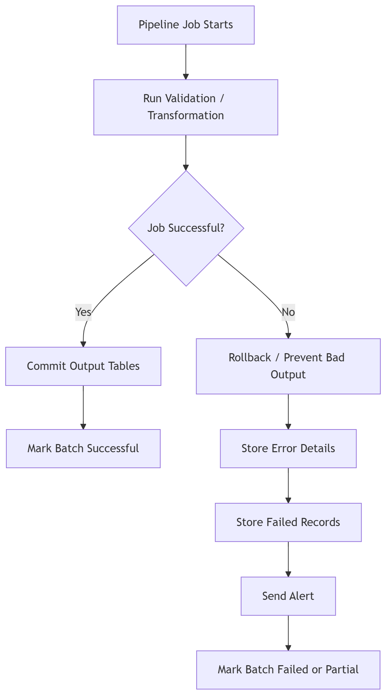
- Do not overwrite trusted gold-layer tables with incomplete data.

Data Model & Storage – Pipeline & Financial Intelligence Platform
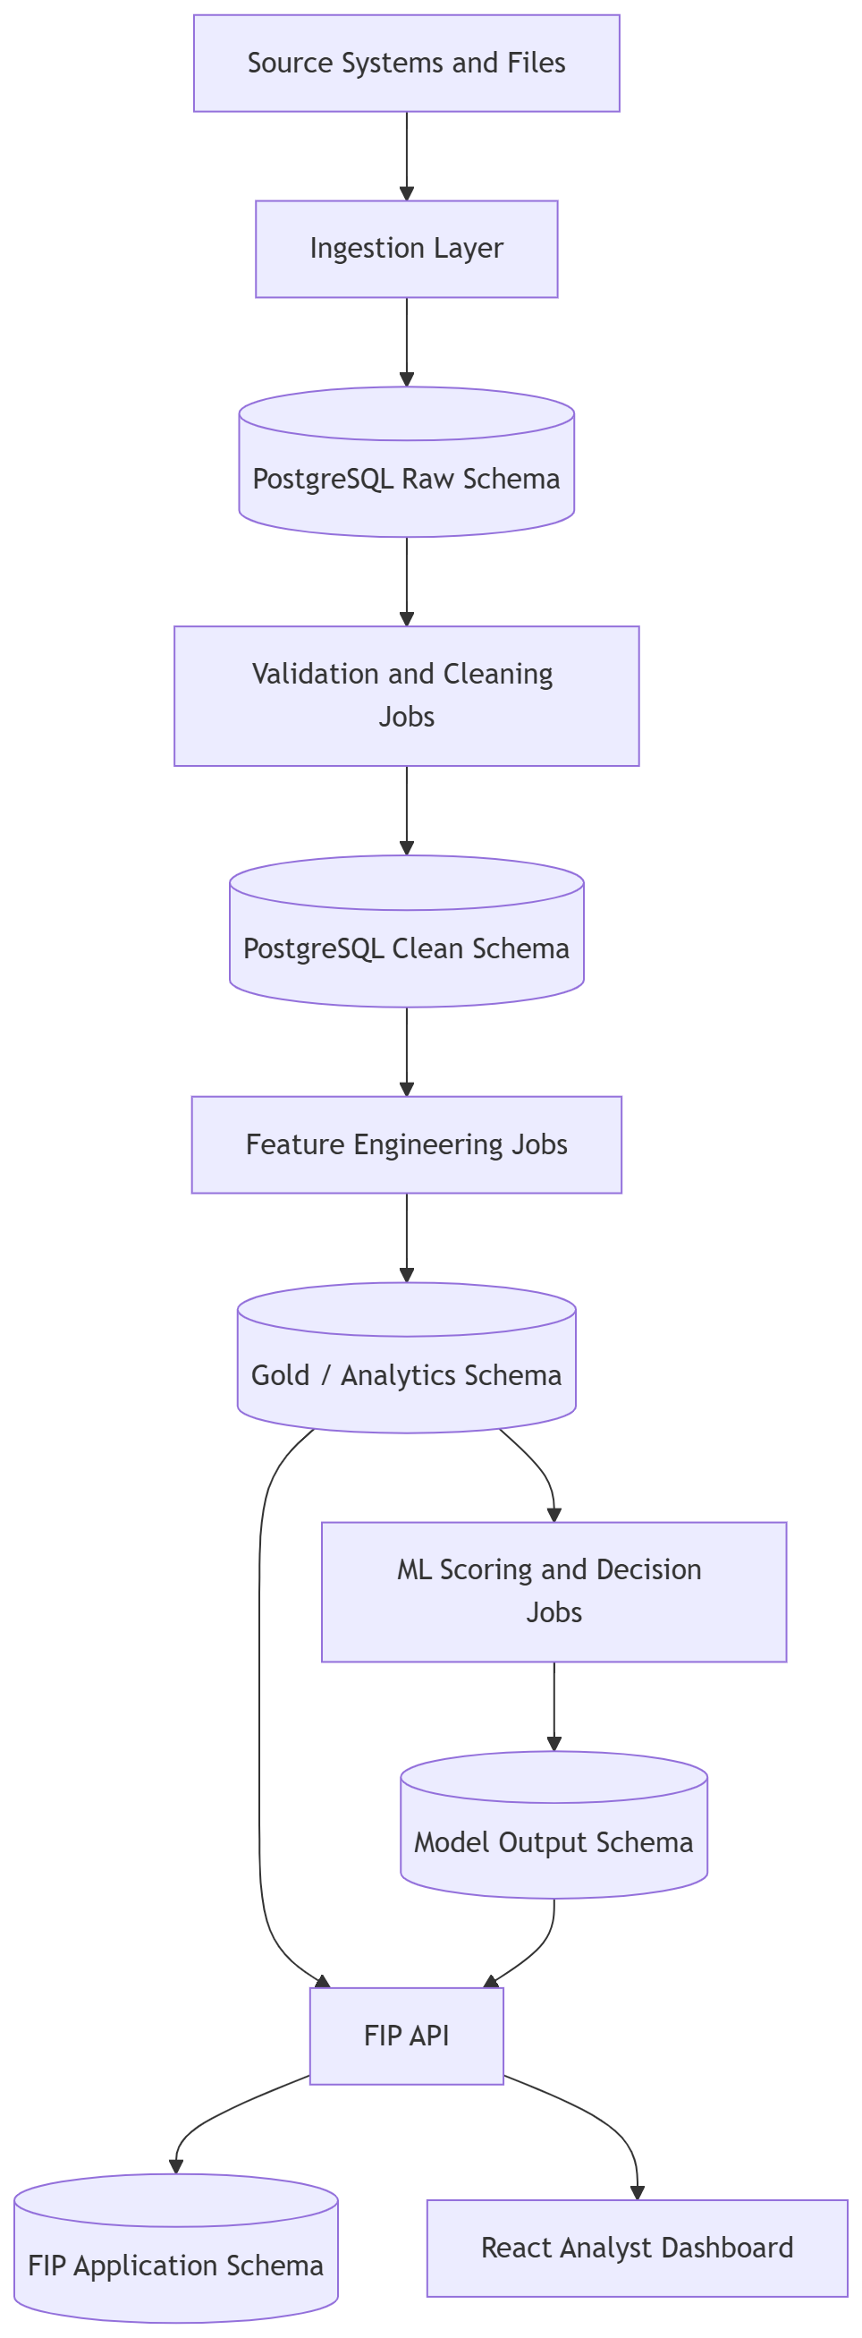
This section defines the full storage structure and data model for the Multi-Source Data Pipeline and the Financial Intelligence Platform (FIP). The design separates raw ingestion data, cleaned operational data, analytics-ready gold tables, model outputs, and FIP application workflow tables.

Storage Architecture

Logical Database Schemas
Recommended PostgreSQL schemas:
- raw – stores source data exactly as received.
- clean – stores validated and standardized operational data.
- gold – stores analytics-ready customer intelligence tables.
- ml – stores model inputs, model runs, predictions, and explanations.
- fip – stores Financial Intelligence Platform application workflows.
- ops – stores ingestion batches, pipeline logs, rejected records, audit trails, and data quality metrics.

Main Entity Groups
- Customer and identity data
- Account data
- Transaction data
- Loan and repayment data
- Digital engagement data
- External economic data
- Gold-layer customer intelligence data
- ML scoring and prediction data
- FIP user workflow data
- Pipeline operations and audit data

Core ER Diagram
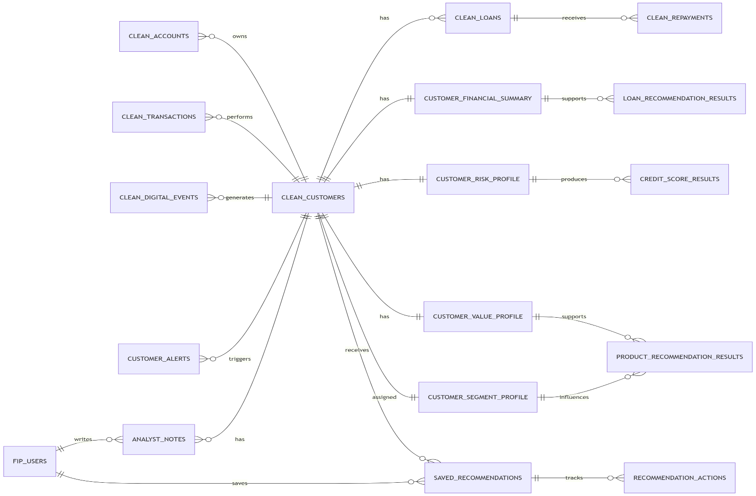

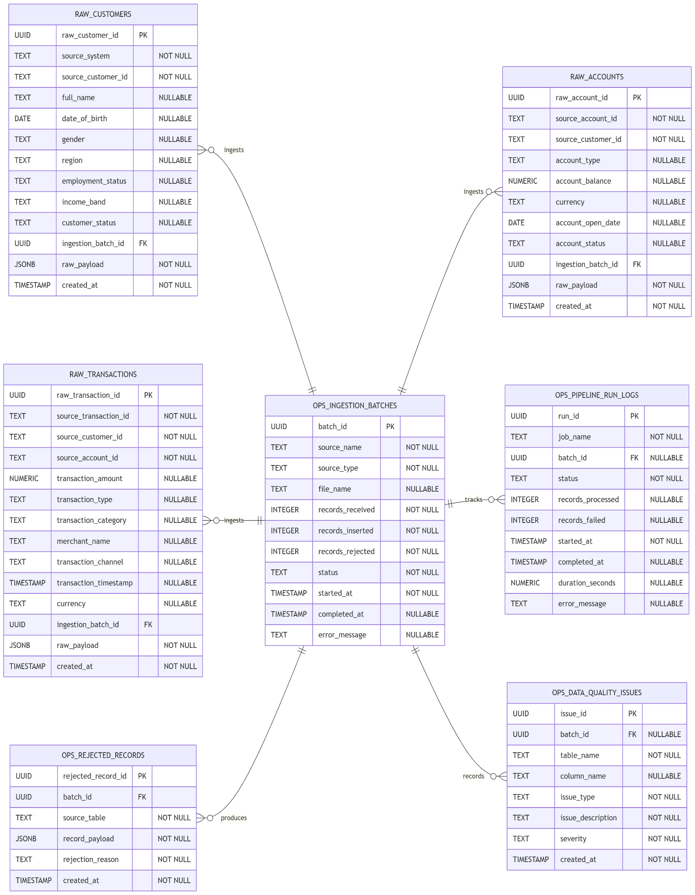
Raw Data and Operations ERD

Clean Core Banking ERD
This diagram shows the cleaned, trusted banking data model.
It includes:
- Customers
- Accounts
- Transactions
- Loans
- Repayments
- Digital activity
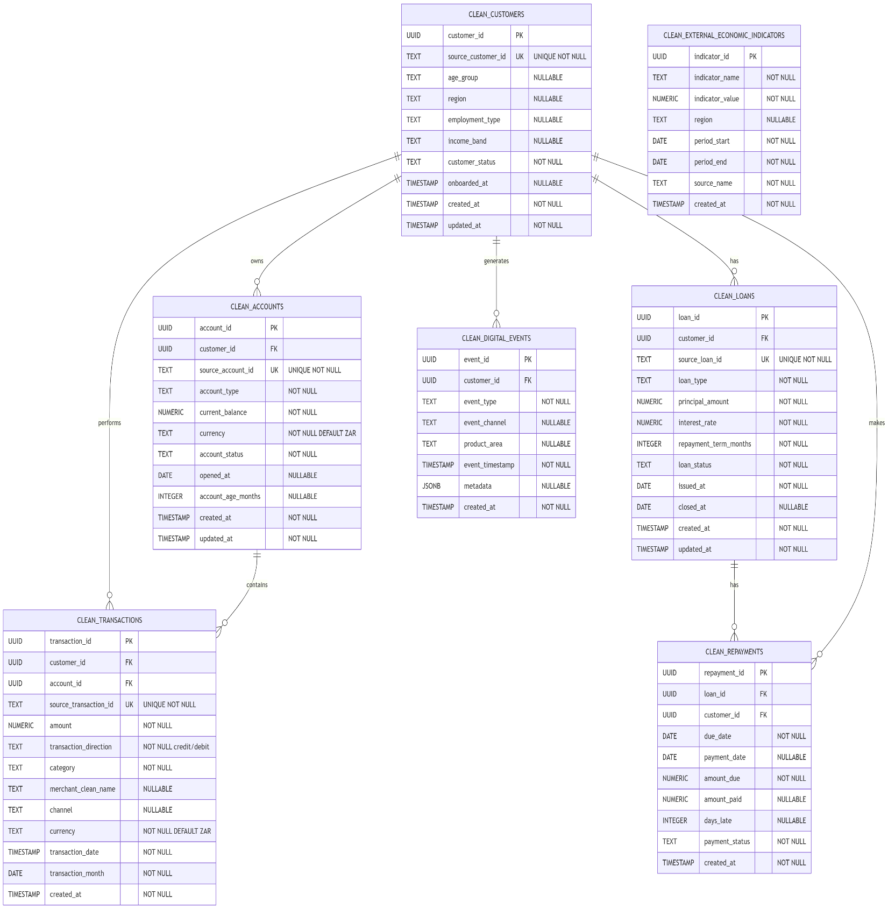
- External economic indicators

Gold and ML Intelligence ERD
This diagram shows the intelligence layer.
It connects:
- Customer summaries
- Risk profiles
- Value profiles
- Segments
- Recommendation features
- Alerts
- ML models
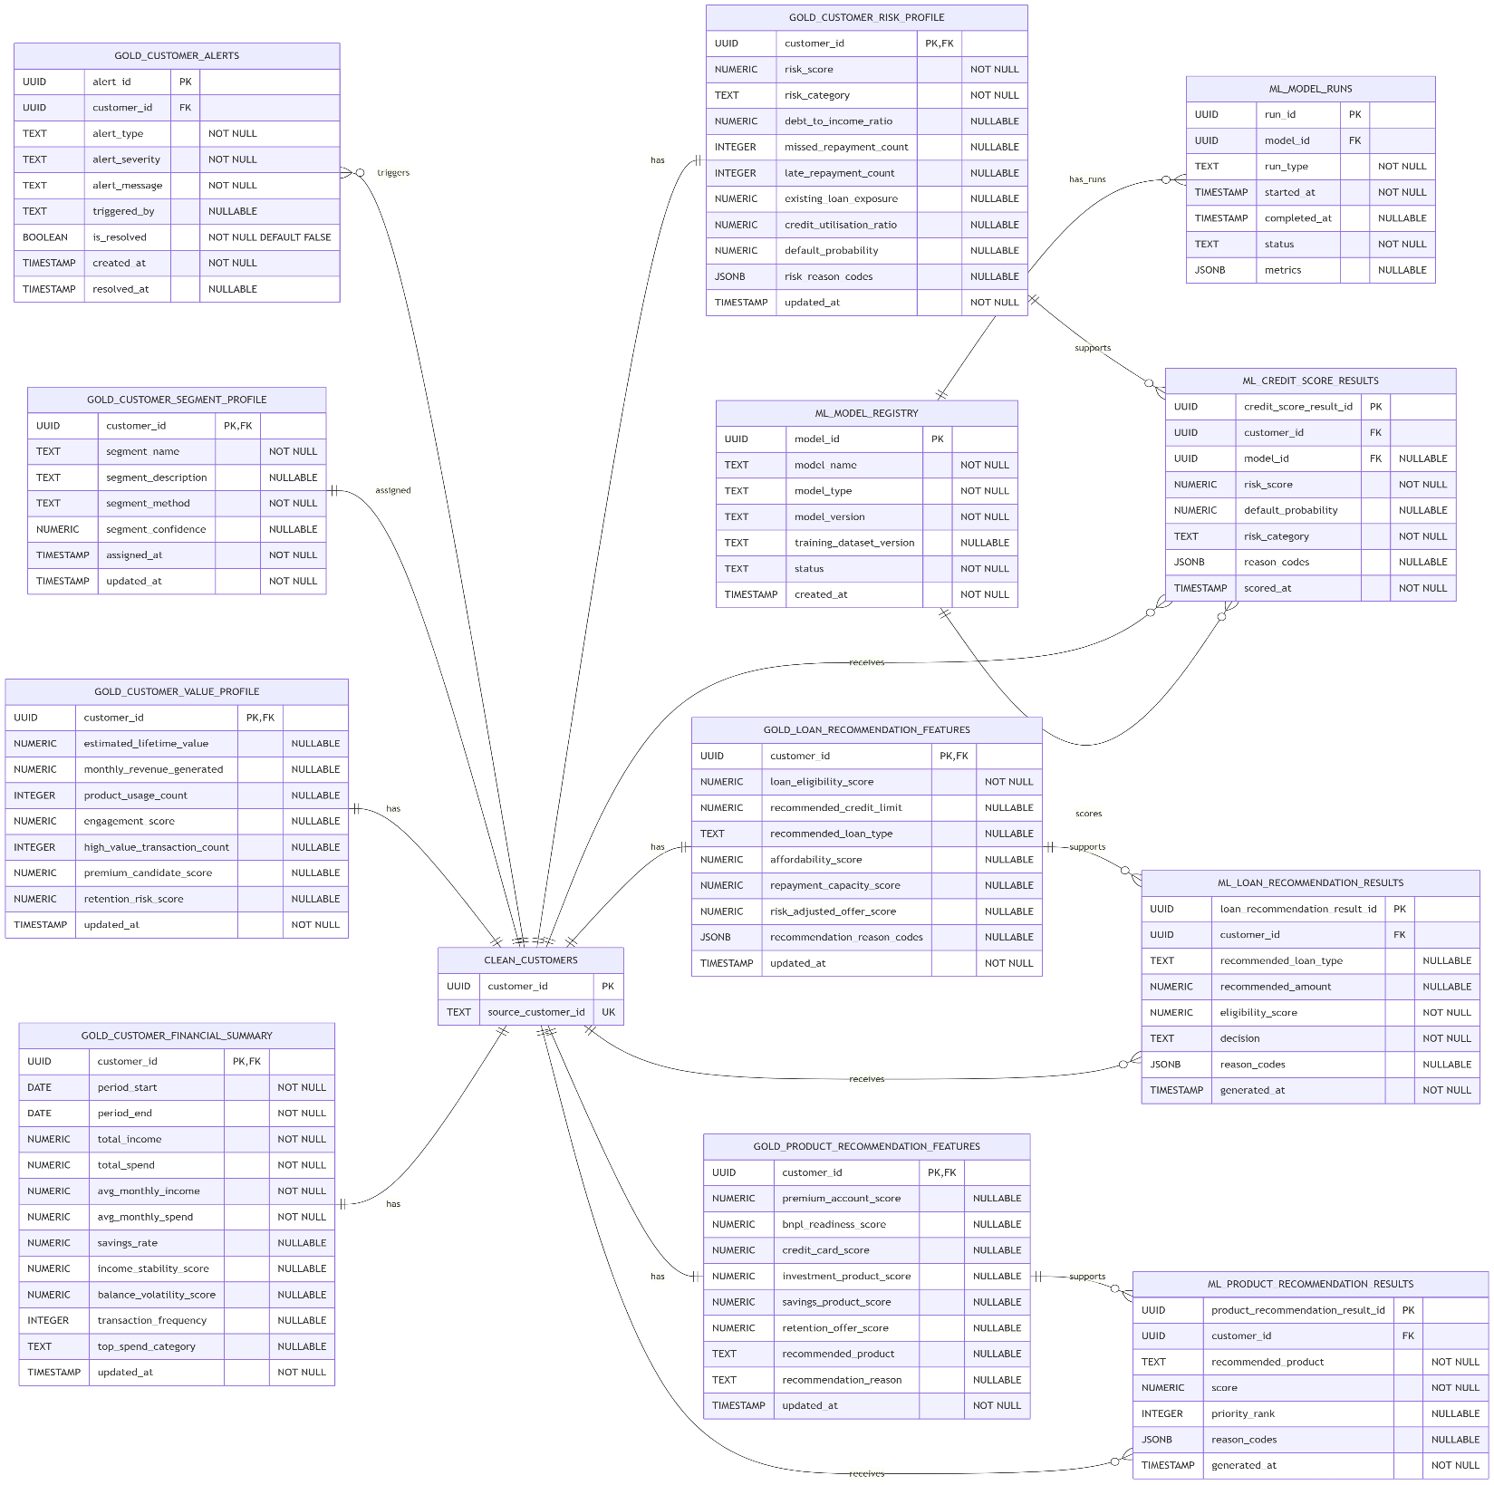
- ML outputs

Financial Intelligence Platform Application ERD
This diagram shows the application-side tables used by analysts, risk managers, and relationship managers.
It includes:
- FIP users
- Notes
- Saved recommendations
- Recommendation actions
- Reports
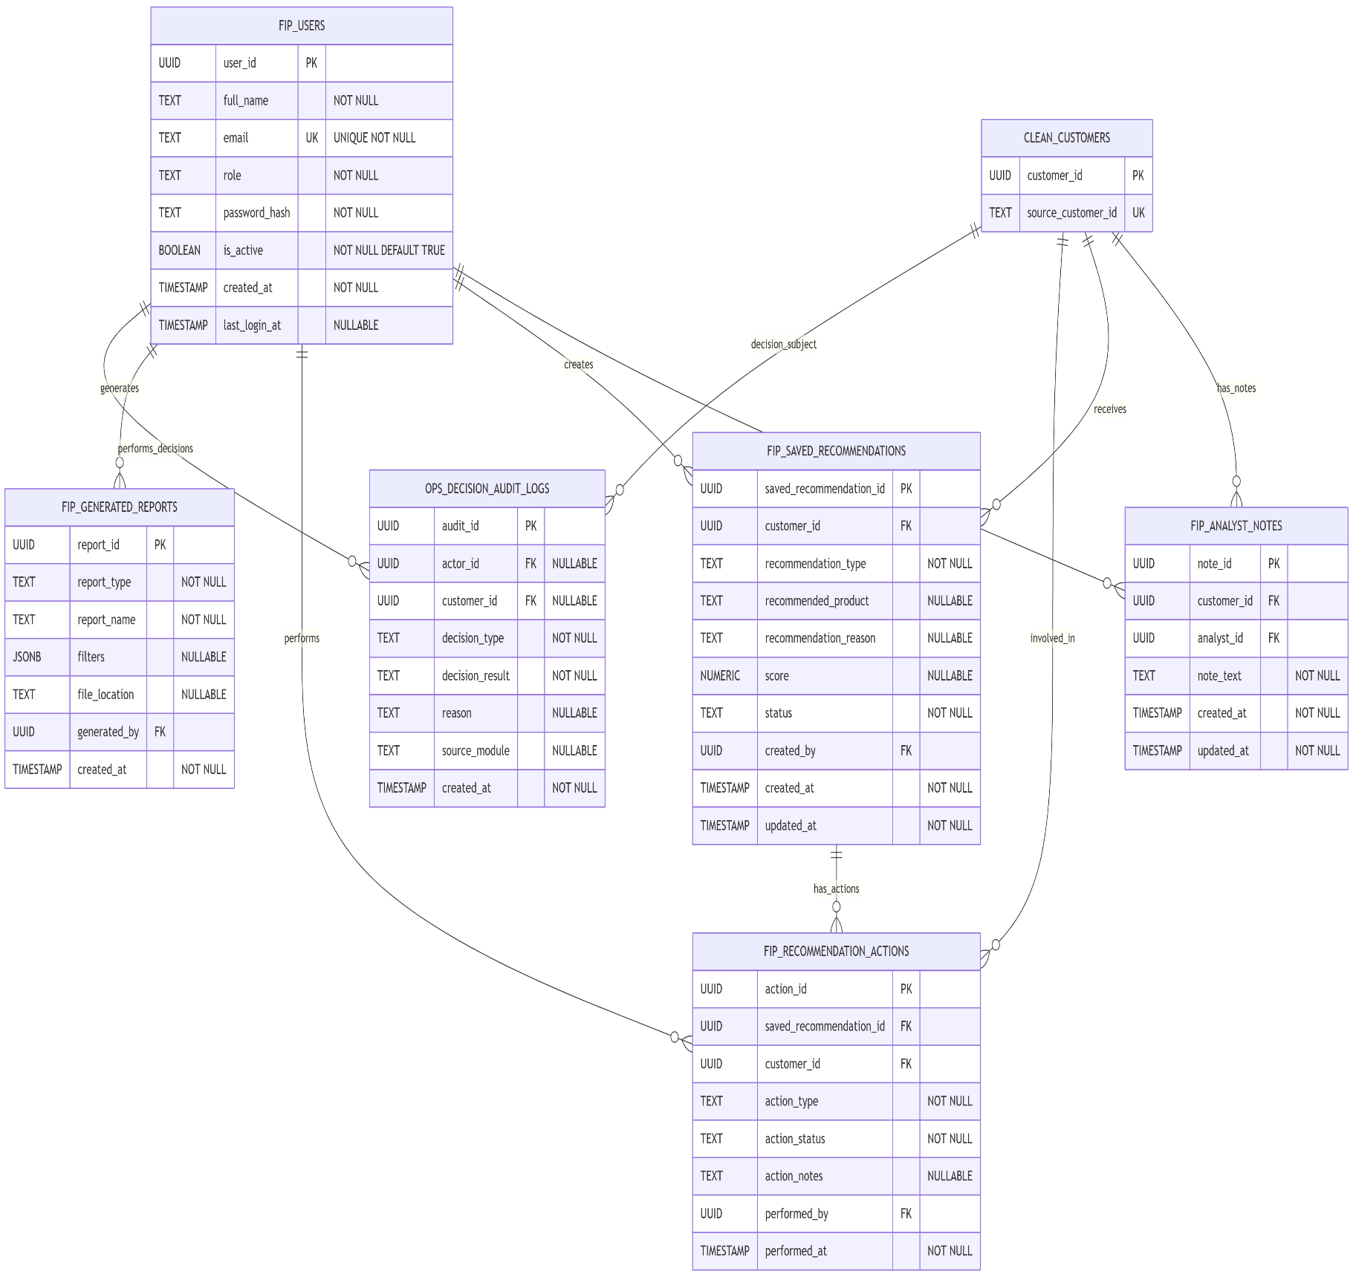
- Decision audit logs

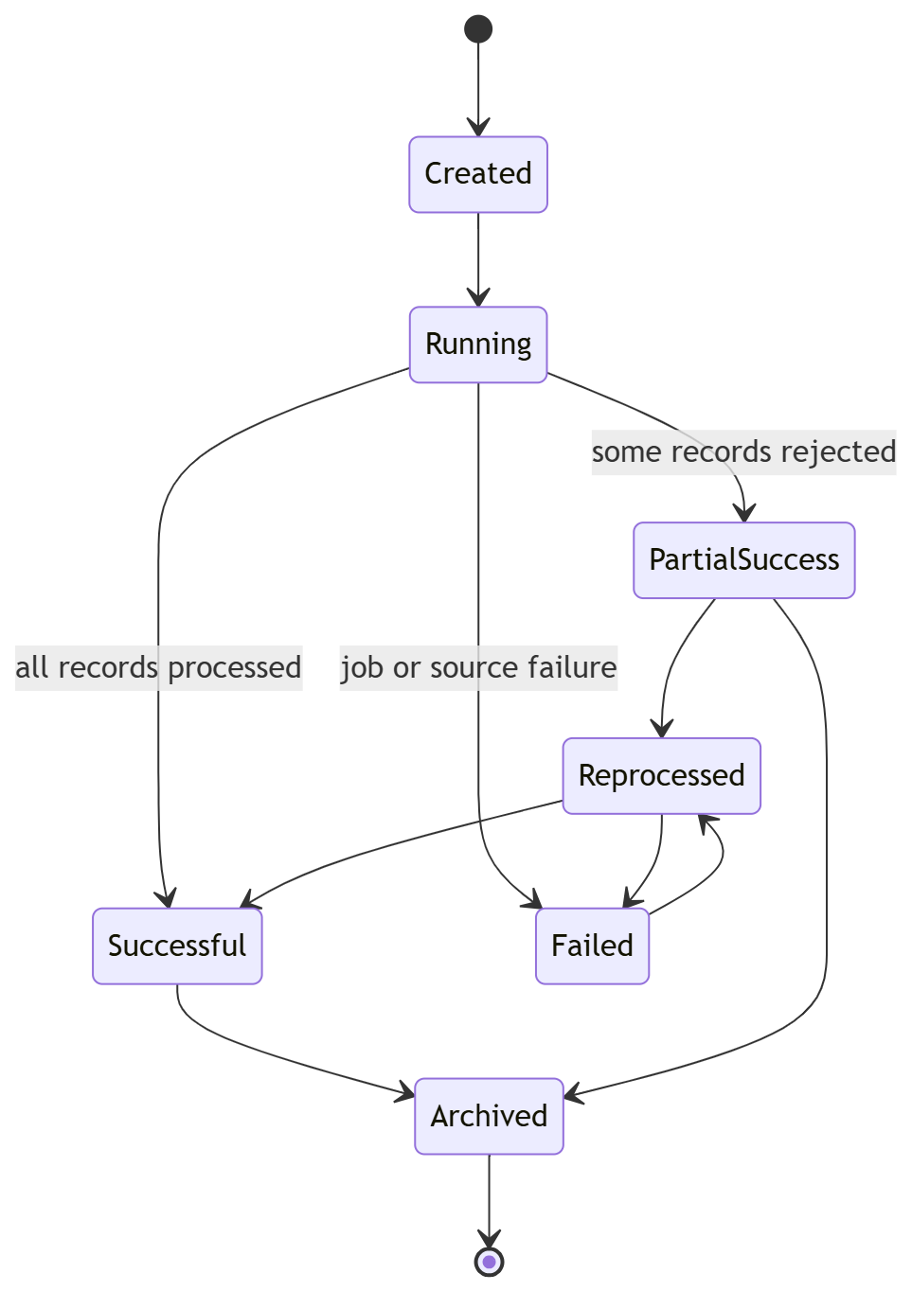
State Diagram – Ingestion Batch

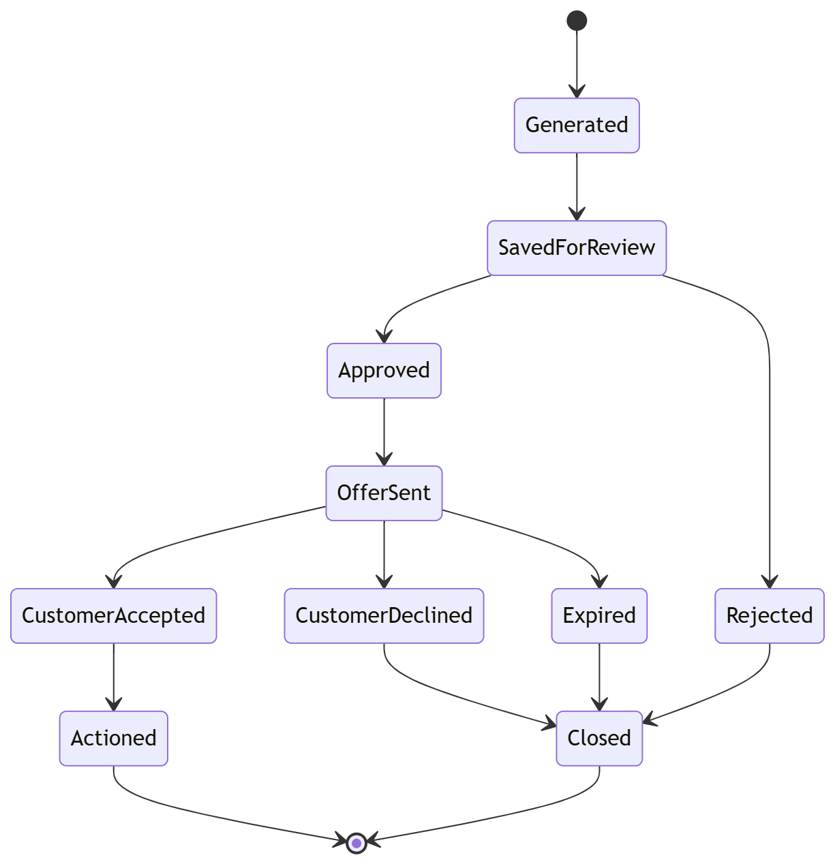
State Diagram – Recommendation Lifecycle

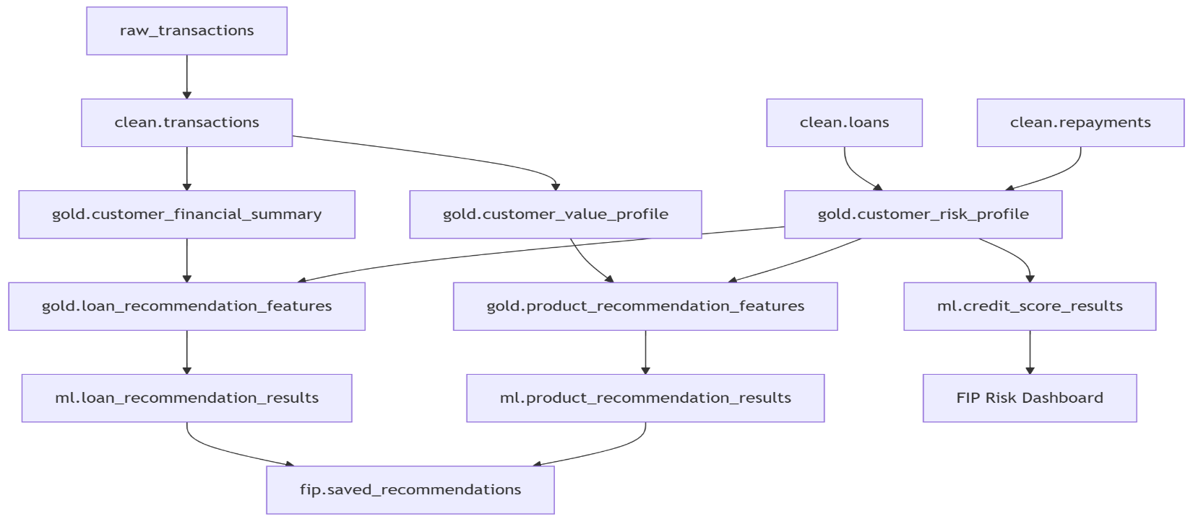
Data Lineage Diagram

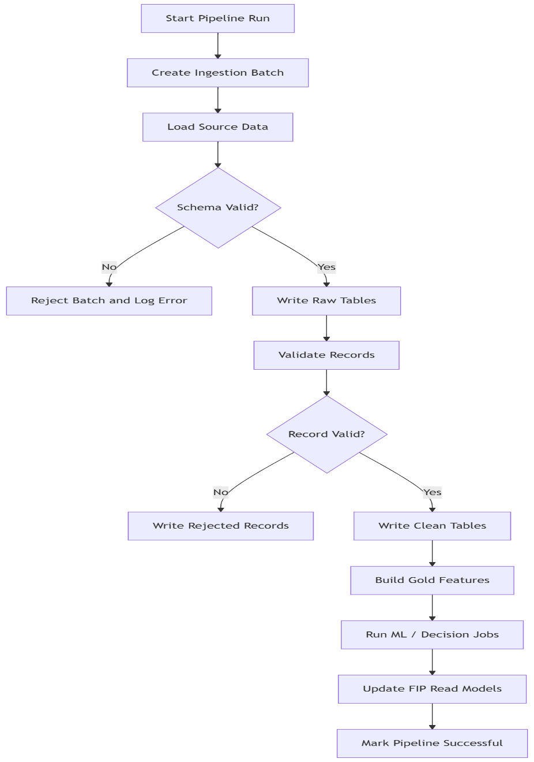
Pipeline Logic Flow

Storage Performance Strategy
Recommended indexes:
- clean.customers(source_customer_id)
- clean.accounts(customer_id)
- clean.transactions(customer_id, transaction_date)
- clean.transactions(category, transaction_month)
- clean.loans(customer_id, loan_status)
- clean.repayments(customer_id, payment_status)
- gold.customer_risk_profile(risk_category, risk_score)
- gold.customer_segment_profile(segment_name)
- gold.product_recommendation_features(recommended_product)
- fip.saved_recommendations(customer_id, status)
Recommended partitioning candidates:
- clean.transactions by transaction_month
- raw.raw_transactions by ingestion month
- ops.pipeline_run_logs by month
- ops.decision_audit_logs by month

Data Governance Rules
- Raw data must be append-only where possible.
- Clean tables must contain only validated records.
- Gold tables must be reproducible from clean tables.
- FIP should not directly query raw tables.
- Every recommendation must have reason codes.
- Every ingestion run must have a batch ID.
- Failed transformations must not overwrite trusted gold-layer outputs.
- Sensitive fields must not be logged in plain text.

Technology Stack & Justification – Pipeline & FIP
The Technology Stack & Justification section defines the tools, frameworks, databases, orchestration systems, and supporting services used to build the Multi-Source Data Pipeline and the Financial Intelligence Platform (FIP).
The stack is designed around four principles:
- Practical for a solo developer
- Strong enough for enterprise-style architecture
- Scalable without overengineering too early
- Relevant to data engineering, data science, and software engineering roles

Technology Strategy
The platform should start simple but be designed with clear upgrade paths.
The recommended approach is:
MVP: Modular Monolith + PostgreSQL + Python Jobs + FastAPI + React
Growth: Orchestrated Pipelines + ML Services + Caching + Monitoring
Production: Separate Pipeline, API, ML, and Dashboard Services

Recommended Core Stack

Programming Language – Python
Use For
- Data ingestion
- Data cleaning
- Feature engineering
- ML model training
- Pipeline orchestration scripts
- Backend API with FastAPI
Justification
Python is the strongest choice for this project because it supports both data engineering and machine learning workflows.
It gives access to:
- Pandas for transformations
- scikit-learn for ML models
- SQLAlchemy for database interaction
- FastAPI for backend APIs
- Great ecosystem for analytics and automation

Data Pipeline Stack

Pandas
Use For
- Reading CSV/Excel datasets
- Cleaning raw records
- Aggregating customer-level metrics
- Creating feature tables
Justification
Pandas is ideal for the MVP because it allows fast development of transformations before introducing heavier distributed tools.
Example use cases:
- Calculate average monthly income
- Calculate spending by category
- Detect missing values
- Build risk features
- Generate gold-layer tables
Trade-Off
Pandas is not ideal for very large datasets, but for MVP and portfolio scale it is perfect.
Future Upgrade
If data grows heavily:
Pandas → Polars / PySpark / dbt / Spark

SQLAlchemy
Use For
- Connecting Python jobs to PostgreSQL
- Writing clean ORM (Object-Relational Mapping) models
- Running database inserts/updates
- Managing reusable database logic
Justification
SQLAlchemy allows the pipeline and API to interact with PostgreSQL in a structured way instead of using raw SQL everywhere.
This improves:
- Maintainability
- Reusability
- Testing
- Data model clarity

Alembic
Use For
- Database migrations
- Schema versioning
- Controlled table changes
Justification
Because this project has many tables across multiple schemas, migrations are important.
Alembic helps track changes like:
- Adding columns
- Creating indexes
- Updating constraints
- Creating new tables
This makes the project look much more production ready.

Prefect
Use For
- Pipeline orchestration
- Scheduled jobs
- Retry logic
- Pipeline monitoring
- Task dependency management
Justification
Prefect is recommended for this project because it is easier to start with than Airflow and is more beginner-friendly for a solo developer.
It can manage jobs like:
- ingest_customers
- ingest_transactions
- validate_records
- clean_transactions
- build_financial_summary
- build_risk_profile
- build_recommendation_features
Why Prefect Over Airflow for MVP
Prefect is better for MVP because:
- Faster setup
- Cleaner Python-native workflow
- Less infrastructure overhead
- Easier local development
Airflow can be introduced later when pipelines become more complex and team based.

Database & Storage Stack

PostgreSQL
Use For
- Raw data storage
- Clean banking tables
- Gold analytics tables
- ML output tables
- FIP application tables
- Audit and operations logs
Justification
PostgreSQL is the best database choice for this platform because it supports:
- Relational integrity
- Foreign keys
- Indexing
- JSONB columns
- Analytics queries
- Partitioning
- ACID (Atomicity, Consistency, Isolation, and Durability) transactions
It can handle both structured relational data and semi-structured fields like:
- raw_payload JSONB
- reason_codes JSONB
- metrics JSONB
- filters JSONB
Why PostgreSQL Fits the Project
This system is highly relational:
- Customers own accounts
- Customers perform transactions
- Customers have loans
- Loans have repayments
- Customers receive recommendations
- Analysts take actions

Redis
Use For
- Caching dashboard queries
- Temporary pipeline locks
- Rate limiting
- Short-lived API data
- Background task broker if needed
Justification
Redis improves performance for repeated queries, especially in the FIP dashboard.
Example cached data:
- Segment summaries
- Risk distribution
- Top revenue opportunities
- Frequently viewed customer profiles
MVP Note
Redis is optional in the earliest MVP, but useful once the dashboard starts querying large gold tables.

Object Storage
Use For
- Uploaded CSV/Excel files
- Raw source files
- Generated reports
- Model artifacts
- Exported analytics files
Options
- AWS S3
- GCP Cloud Storage
- Azure Blob Storage
- MinIO
Large files should not be stored directly in PostgreSQL. Instead, store the file in object storage and keep only metadata or file paths in the database.

Backend Stack – FIP API

FastAPI
Use For
- Financial Intelligence Platform API
- Customer profile endpoints
- Risk score endpoints
- Recommendation endpoints
- Dashboard APIs
- Report generation endpoints
Justification
FastAPI is a strong fit because it is:

- Python-based
- Fast
- API-first
- Easy to document with OpenAPI
- Good for ML integration
Why FastAPI Instead of Flask Here
For this platform, FastAPI is better because the FIP is mainly API-driven and will serve a React frontend.
Flask is still good, but FastAPI gives:
- Better automatic API documentation
- Type validation with Pydantic
- Easier ML service integration
- Cleaner async support

Pydantic
Use For
- API request validation
- API response schemas
- Data contracts between services
- Input validation for actions and filters
Pydantic helps enforce clean API contracts.

Frontend Stack – FIP Dashboard

React with Vite
Use For
- Analyst dashboard
- Customer profiles
- Risk views
- Recommendation pages
- Revenue opportunity reports
- Segment exploration
Justification
React with Vite is recommended because it is fast, modern, and aligns with your preferred React setup.
The FIP dashboard can include:
- Executive dashboard
- Customer search
- Customer profile page
- Risk analysis page
- Loan recommendation view
- Product recommendation view
- Customer segmentation page
- Alerts page

UI Libraries
Recommendation
- Tailwind CSS
- shadcn/ui
- Recharts
- Lucide React
Use For
- Clean dashboard UI
- Cards and tables
- Charts and visualizations
- Icons
- Responsive layouts
Justification
This combination gives the project a polished, professional look without spending too much time building UI components from scratch.

Machine Learning Stack

scikit-learn
Use For
- Credit risk classification
- Customer segmentation
- Product recommendation scoring
- Churn/dormancy prediction
- Anomaly detection
Possible Models
- Logistic Regression
- Random Forest
- Gradient Boosting
- K-Means
- Isolation Forest

XGBoost or LightGBM
Use For
- More advanced credit risk scoring
- Loan eligibility prediction
- Customer value prediction
Justification
Tree-based boosting models are strong for structured tabular data, which fits this banking dataset well.
MVP Note
Do not start with XGBoost immediately. Start with:
Rules → Logistic Regression / Random Forest → XGBoost

MLflow
Use For
- Model version tracking
- Experiment tracking
- Metrics logging
- Model artifact storage
Justification
MLflow makes the ML side look production-aware.
It helps track:
- Which model version was used
- Which dataset version trained it
- What metrics it achieved
- When it was deployed/scored
MVP Note
MLflow can be added after the first working ML model.

DevOps & Environment Stack

Docker
Use For
- Local development
- Running PostgreSQL
- Running Redis
- Running FastAPI
- Running pipeline jobs
- Consistent environments
Example Services
- postgres
- redis
- pipeline-worker
- fastapi
- react-frontend
- mlflow
Docker Compose is perfect for MVP because it gives you multi-service architecture without needing Kubernetes too early.

GitHub Actions
Use For
- CI/CD
- Running tests
- Linting
- Building Docker images
- Running database migration checks
Recommended pipeline:
Lint → Test → Build Docker Image → Run Migrations Check

Monitoring & Observability Stack

Prometheus
Use For
- API metrics
- Pipeline run metrics
- Job success/failure counts
- Request latency
- Error rates

Grafana
Use For
- Visual monitoring dashboards
Example dashboards:
- Pipeline health
- API latency
- Database performance
- Failed ingestion batches
- Model scoring volume

Sentry
Use For
- Application error tracking
- Backend exceptions
- Frontend errors
- FastAPI runtime issues

Structured Logging
Use For
- Pipeline debugging
- Audit trails
- Error investigation
- Run history
Recommended format:
{
"timestamp": "2026-06-02T10:00:00Z",
"service": "pipeline",
"Job_name": "build_customer_risk_profile",
"status": "failed",
"Batch_id": "uuid",
"error": "missing required column"
}

Recommended MVP Stack
For the first working version, use:
Frontend: React + Vite + Tailwind + Recharts
Backend: FastAPI + Pydantic
Pipeline: Python + Pandas + SQLAlchemy
Database: PostgreSQL
Orchestration: Prefect
Caching: Redis optional
ML: scikit-learn
DevOps: Docker Compose + GitHub Actions
Monitoring: Basic logs first, then Prometheus/Grafana

This gives you a strong balance between:
- Practicality
- Professionalism
- Data engineering
- ML readiness
- Full-stack capability

Target Production Stack
As the platform grows:
Frontend: React + Vite
Backend: FastAPI
Pipeline: Prefect or Airflow
Database: Managed PostgreSQL
Cache: Managed Redis
Object Storage: S3 / Azure Blob / GCS
ML Tracking: MLflow
Monitoring: Prometheus + Grafana + Sentry
Deployment: Docker containers on ECS / Cloud Run / Azure Container Apps
CI/CD: GitHub Actions
Secrets: Cloud secret manager

