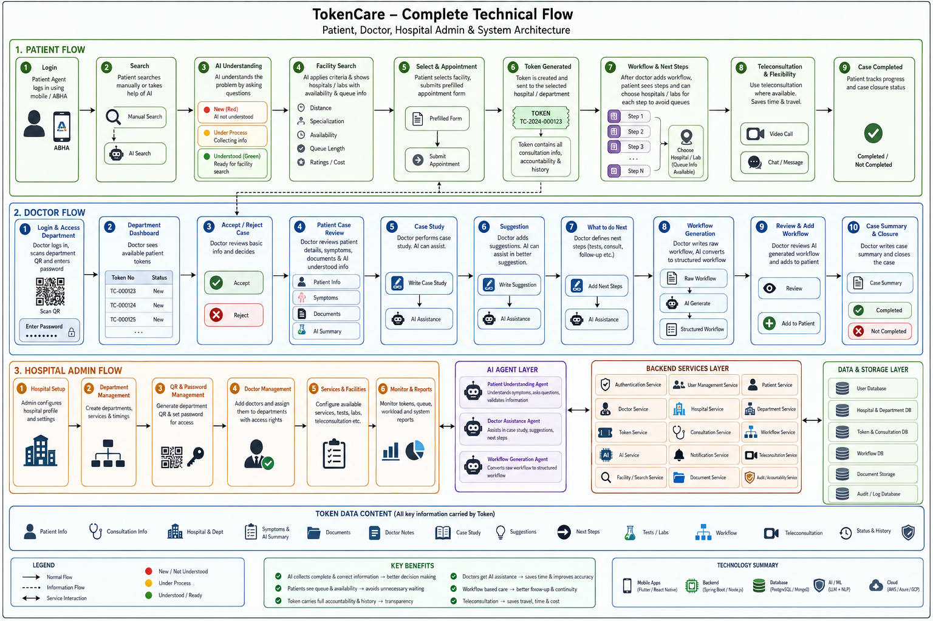

TokenCare
1. Patient Flow — TokenCare
A. Login & Patient Dashboard
- Patient opens TokenCare.
- Patient logs in using the common login mechanism with their mobile number / ABHA-linked identity.
- After successful authentication, the patient dashboard opens.
- The patient can:
  - Search for a hospital/facility.
  - View existing tokens and consultations.
  - View available documents.
  - Track active patient workflows.
  - Access AI assistance.
B. Search for Healthcare
- Patient clicks Search from the dashboard.
- The patient can either:
  - Manually search/select a hospital, clinic, department, lab, etc., or
  - Ask TokenCare AI to understand the problem and recommend suitable facilities.
C. AI-Based Patient Understanding
The AI uses three states:
- 🔴 Red — New AI: AI has not yet understood the patient's problem.
- 🟡 Yellow — Under Process: AI is collecting and processing information.
- 🟢 Green — Understood: AI has understood the patient and is ready for the next step.
When the patient starts the AI flow:
- AI asks the patient questions about the problem.
- AI identifies missing information.
- Patient provides additional information.
- AI continues asking relevant questions until it has sufficient information.
- AI summarizes what it has understood.
- Patient validates the information.
- If the patient says No, AI asks for clarification/correction.
- If the patient says Yes, the case becomes ready for healthcare-facility matching.
D. Facility Search & Queue Avoidance
After the patient confirms the AI-understood information:
- TokenCare applies relevant search/sorting criteria.
- Patient can see suitable:
  - Hospitals
  - Clinics
  - Departments
  - Labs
  - Other available healthcare facilities
- The system can help the patient choose based on factors such as:
  - Facility type
  - Distance
  - Availability
  - Queue/token situation
  - Other applicable criteria
- The objective is to allow the patient to choose a suitable facility before physically reaching it, reducing unnecessary waiting and queues.
E. Appointment / Token Request
- Patient selects a hospital/department.
- TokenCare opens a prefilled appointment/request form.
- Patient only needs to provide or confirm the remaining information.
- Patient accepts applicable terms/conditions.
- Patient submits the request.
- The request reaches the relevant hospital/department dashboard.
- The patient receives a token representing the consultation/care journey.
F. Token as the Patient's Care Journey
The token is more than a queue number. It carries the relevant information and history associated with that consultation, including:
- Patient information
- Consultation information
- Hospital/department information
- Case details
- Doctor interaction
- Documents
- Tests
- Suggestions
- Workflow
- Status/progress
- Accountability/history of actions
- Applicable teleconsultation information
The token therefore provides a traceable record of the patient's consultation journey.
G. Doctor-Added Workflow
After the doctor evaluates the patient and adds a workflow:
- The patient can see the workflow.
- Each workflow element can provide appropriate next-step options.
- For a required test/lab/service, the patient can see available hospitals/labs/facilities that can provide that service.
- The patient can select an appropriate facility and continue the process without unnecessarily joining multiple physical queues.
- The patient can track completed, pending, and upcoming workflow elements.
H. Teleconsultation & Flexibility
Where supported by the workflow/facility, the patient can use teleconsultation instead of physically visiting the facility.
The overall patient experience is therefore:
Login → Search → AI understands patient → Patient validates → Facility matching → Appointment/token → Doctor consultation → Doctor workflow → Patient follows workflow → Hospital/lab selection for each required step → Teleconsultation/physical visit as applicable → Case completion.

2. Doctor Flow — TokenCare
A. Doctor Login
- Doctor opens TokenCare.
- Doctor completes the common login process.
- Doctor enters the doctor-side system.
- Doctor can access a particular hospital department by scanning the department QR code.
B. Department Authentication
- Doctor scans the available department QR code.
- TokenCare identifies the corresponding hospital/department.
- Doctor enters the department password provided by the hospital administrator.
- After successful authentication, the doctor enters the department dashboard.
C. Department Dashboard
The doctor can see:
- Department information
- Available patient tokens
- Token status
- Patient/case information
- Available documents
- Pending cases
The doctor selects an available patient token to start the consultation.
D. Accept / Reject Case
For each incoming case:
- Doctor reviews the available patient information.
- Doctor can Accept the case.
- Doctor can Reject the case where appropriate.
- Once accepted, the doctor proceeds with the patient's case.
E. Patient & Case Review
The doctor can review:
- Patient details
- Symptoms/problem
- Information collected by AI
- Documents
- Previous case information where available
- AI-generated/inferred information
- Existing workflow
- Relevant consultation information
AI-generated information remains available to assist the doctor but can be reviewed/validated by the doctor.
F. Case Study
Doctor performs the case study.
The doctor can add:
- Patient observations
- Case details
- Clinical findings
- Relevant information
- Headline/case-study information
If the doctor needs assistance, AI can help fill or structure the case study.
G. Suggestion
Doctor can create recommendations/suggestions for the patient.
For example:
- Diet
- Medication-related instructions where appropriate
- Lifestyle suggestions
- Follow-up recommendations
- Other patient-care instructions
The doctor can write a raw suggestion and use AI assistance to structure or improve it.
H. What to Do Next
Doctor defines the next steps.
These may include:
- Tests
- Blood test
- Sugar test
- Consultation with another doctor
- Referral
- Follow-up
- Other healthcare actions
The doctor can use AI to help determine or structure the next steps.
I. AI Workflow Generation
The doctor can write a raw workflow in natural language.
Example concept:
Doctor's raw input → AI generates structured workflow → Doctor reviews → Doctor accepts/adds workflow
The AI-generated workflow can contain ordered workflow elements such as:
Test → Result → Specialist consultation → Follow-up → Next action
The doctor remains responsible for reviewing and adding the workflow.
J. Patient Workflow & Facility Selection
Once the workflow is added:
- The workflow becomes part of the patient's token/care journey.
- Patient can see each required workflow element.
- For applicable steps, the patient can see available hospitals/labs/facilities that can perform that step.
- This allows the patient to choose a suitable facility and reduces unnecessary queueing.
- The workflow provides continuity between the doctor, patient, hospital, and other healthcare services.
K. Case Closure
When the consultation/case is complete:
- Doctor writes the case summary.
- Doctor reviews the case information.
- Doctor closes the case as:
  - Completed, or
  - Not Completed.
- The closure and relevant consultation information remain associated with the patient's token.
L. Token Accountability
The token maintains the consultation journey so that relevant actions and information remain traceable.
The doctor-side journey is:
Login → Scan department QR → Department password → Department dashboard → Patient token → Accept/Reject → Case study → Suggestions → Next steps → AI assistance → Workflow generation → Doctor review → Add workflow → Patient follows workflow → Case summary → Complete/Not Complete.

3. Hospital Admin Flow — TokenCare
A. Hospital Administration
The hospital administrator manages the hospital-side configuration that allows doctors and departments to operate within TokenCare.
The administrator is responsible for configuring the hospital's:
- Hospital profile
- Departments
- Department access
- Doctor access
- Department QR codes
- Department passwords
- Available healthcare services
- Applicable workflow/facility information
B. Hospital & Department Setup
- Admin logs into the hospital administration system.
- Admin creates/configures the hospital profile.
- Admin creates the required departments.
- Each department is associated with its TokenCare access.
- Admin generates/configures the department QR code.
- Admin establishes the corresponding department password.
- The QR code and password are provided/available to authorized doctors.
This allows a doctor to physically enter the correct department environment by:
Scan QR → Identify Department → Enter Admin-provided Password → Access Department Dashboard
C. Doctor / Department Access
Admin controls which doctors are permitted to work within the hospital/department.
The administrator can manage:
- Doctor registration/access
- Department assignment
- Department permissions
- Access credentials
- Department availability
This provides controlled access instead of allowing an unauthorized doctor to enter a department dashboard.
D. Token & Queue Management
The hospital receives patient requests/tokens in the appropriate department.
The department dashboard allows the hospital/department to manage the incoming patient flow.
The TokenCare model aims to move from a traditional:
Patient arrives → waits in physical queue → registration → waits again → consultation
toward:
Patient information → AI understanding → facility/department selection → token → controlled consultation flow
This helps the hospital organize patient demand and helps patients avoid unnecessary physical queues.
E. Consultation Infrastructure
The hospital provides the infrastructure required for the doctor to process the token.
The token can carry the relevant consultation information so that the doctor does not need to repeatedly collect the same basic information from the patient.
The hospital therefore becomes part of a traceable consultation journey rather than only being a place where the patient physically waits.
F. Hospital/Lab Availability
For workflow elements requiring another service, the TokenCare ecosystem can expose available facilities such as:
- Hospitals
- Clinics
- Laboratories
- Diagnostic facilities
- Specialist services
This allows a patient to select an appropriate facility for the next workflow step and supports queue avoidance and distributed healthcare delivery.
G. Teleconsultation
Where the hospital supports it, the administrator can make teleconsultation services available through the TokenCare ecosystem.
This gives the patient flexibility to complete suitable consultations remotely instead of requiring every interaction to be physical.
H. Accountability & Traceability
The TokenCare token acts as the connecting object between the patient, doctor, department, hospital, workflow, and relevant healthcare services.
It can maintain the relevant consultation trail, including:
- Who handled the case
- Consultation information
- Case progression
- Workflow actions
- Documents
- Tests/services
- Suggestions
- Status
- Case completion
- Relevant timestamps/history
This creates accountability across the consultation journey.
I. Overall Hospital Admin Flow
Admin Login → Configure Hospital → Configure Departments → Create QR/Department Access → Set Department Password → Manage Doctor Access → Receive Patient Tokens → Department/Doctor Processes Case → Workflow Added → Patient accesses required hospital/lab/service → Teleconsultation where applicable → Consultation tracked through Token → Case completed/closed.
Overall TokenCare Ecosystem
PATIENT
Patient problem
↓
AI understands & validates
↓
Hospital/department selection
↓
Token generated
↓
Doctor consultation
↓
Doctor + AI create workflow
↓
Patient follows workflow
↓
Hospital/Lab/Service selection for each step
↓
Teleconsultation or physical visit
↓
Case completion
DOCTOR
Login
↓
Scan Department QR
↓
Department Password
↓
Department Dashboard
↓
Patient Token
↓
Accept/Reject
↓
Case Study
↓
Suggestion
↓
What to Do Next
↓
AI-assisted Workflow
↓
Review & Add Workflow
↓
Case Summary
↓
Complete / Not Complete
HOSPITAL ADMIN
Admin Login
↓
Hospital Configuration
↓
Department Configuration
↓
QR + Password
↓
Doctor Access Management
↓
Department/Token Management
↓
Hospital/Lab/Service Availability
↓
Teleconsultation Support
↓
Accountability & Consultation Tracking
Core principle: The token is the central thread of the healthcare journey. It connects the patient, doctor, hospital, department, workflow, documents, tests, services, teleconsultation and case history—while TokenCare's AI reduces information gaps and the system reduces unnecessary waiting and queue dependency.

