**Toker Ahmed**

**Homework 5 Web API**

**1. Missing Database Driver**

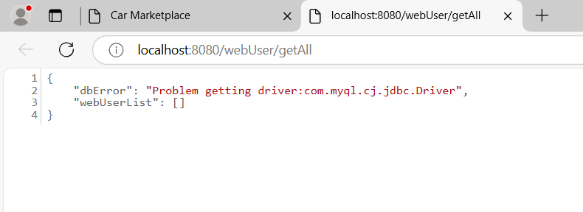

This error occurred because in DbConn.java file, the string value of DRIVER variable was misspelled, and as a result the problem getting driver error occurred.

It was fixed by typing the correct string value.

**2. Database Unreachable**

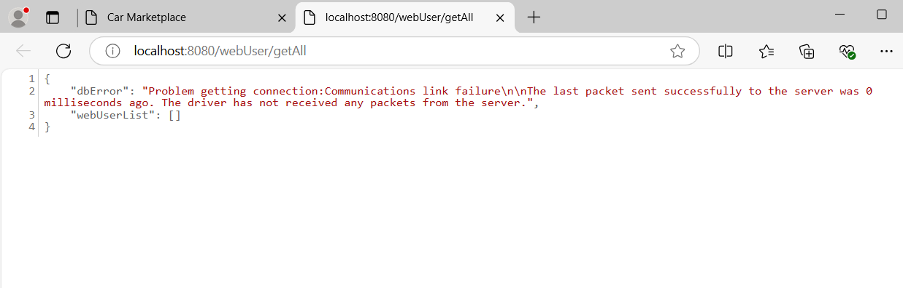

This error occurred by not tunneling into the database, and as a result, the connection with the database could not be established.

It was fixed by tunneling in, i.e writing the command, “ssh -L 3307:cis-linux2.temple.edu:3306 [tup19966@cis-linux2.temple.edu](mailto:tup19966@cis-linux2.temple.edu) “ in my command prompt.

**3. Database Not Authorized**

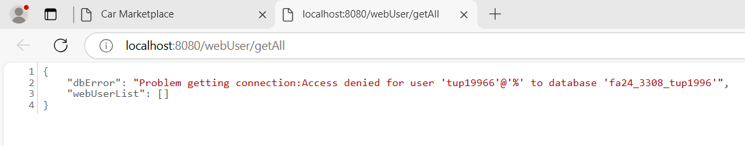

This error occurred by not using the correct database schema value in the variable dbAndPass from DbConn.java file.

It was fixed by correctly spelling the database schema value.

**4. Syntax error in SQL Statement**

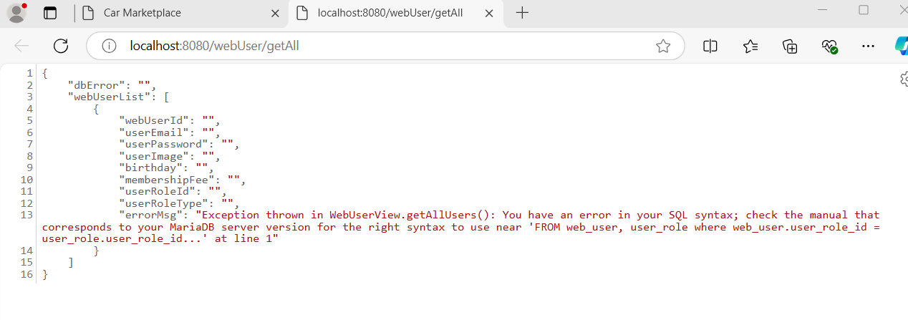

This error occurred because there was an extra comma at the end of select statement.

It was fixed by removing the extra comma.

**5. Error Extracting Data from Result Set (bad column name)**

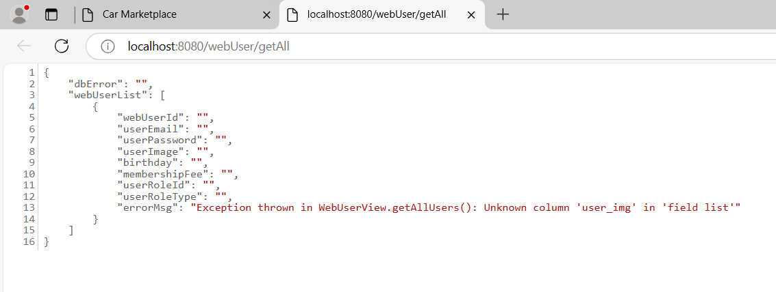

This error occurred because there was no column named user_img in the webuser table. Changing it to user_image column name fixed the error.

**6. Error Extracting Data from Result Set (wrong data type)**

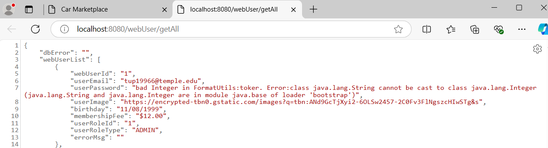

This error occurred because userPassword variable was formatted as integer instead of string. It was fixed by correctly formatting it, i.e using Format.fmtString() for userPassword.