**1. STUDENT NAME**

Toker Ahmed

**2. URL to STUDENT WEB SITE**

https://cis-linux2.temple.edu/tomcat10/fa24_3308_tup19966/index.html

**3**. **user_role TABLE DESIGN**

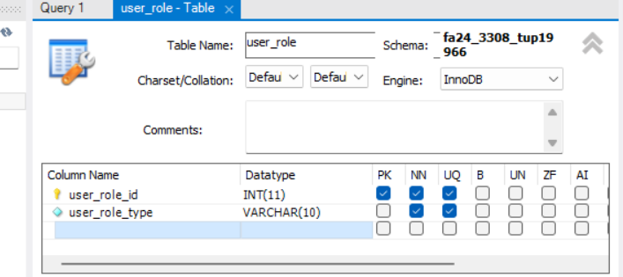

4. **web_user TABLE DESIGN and FOREIGN KEY**

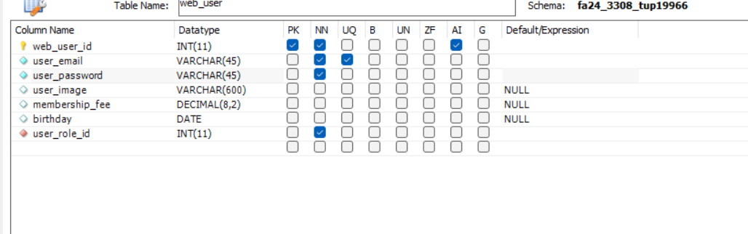

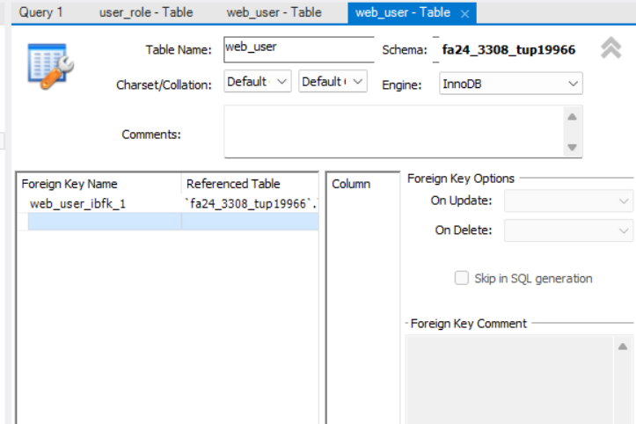

**5. “OTHER” TABLE DESIGN and FOREIGN KEY**

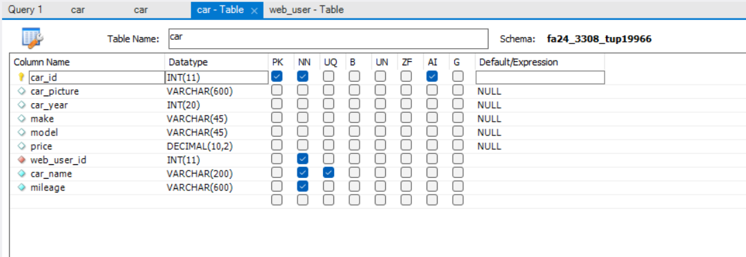



**6. DATA ENTRY ERRORS**

**a) Error: Duplicate user_role PK**

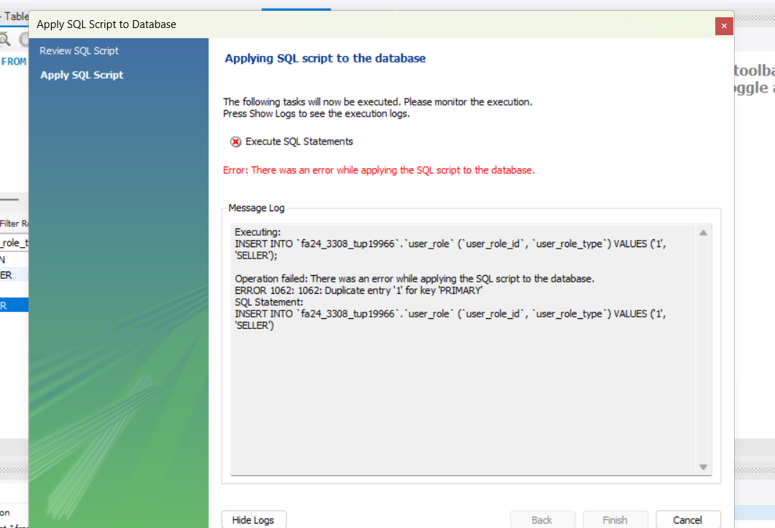

**b) Error: Invalid user_role FK in web_user record**

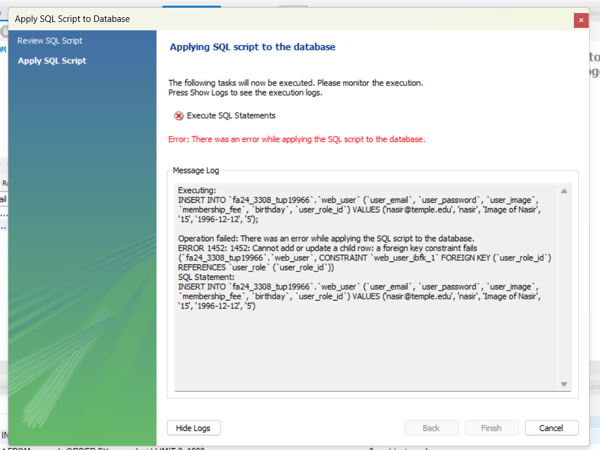

**c) Error: Cannot delete a user_role record that’s referenced by a web _user record**

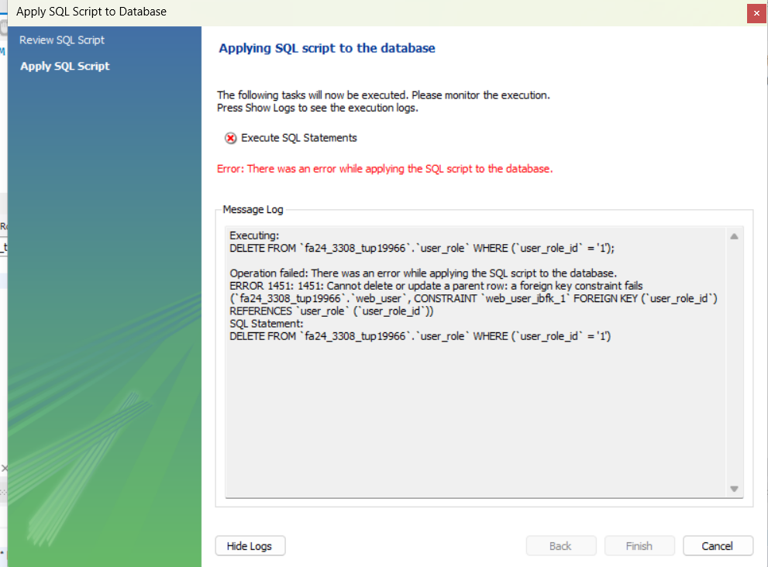

**d) Invalid web_user FK in “other” record**

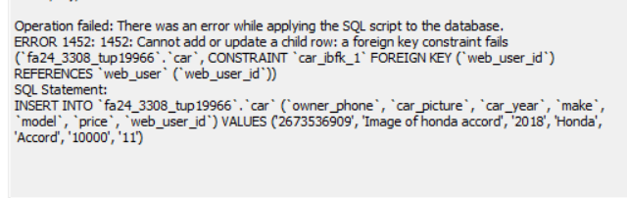

**e) Error trying to delete a web_user record that’s referenced by an “other” record**

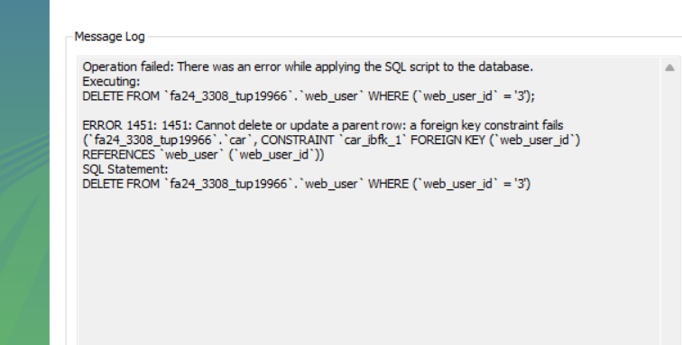

**6. SELECT STATEMENTS**

**a) USER_ROLE: all rows, all columns, sorted by user_role_id.**

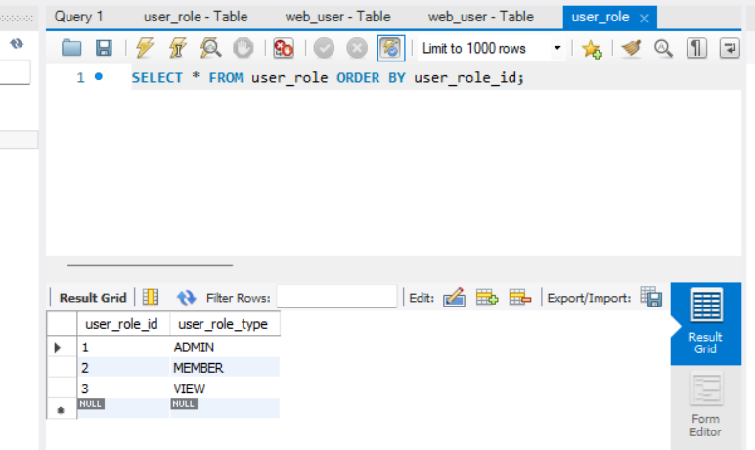



**b) WEB_USER: all rows, all columns, sorted by web_user_id.**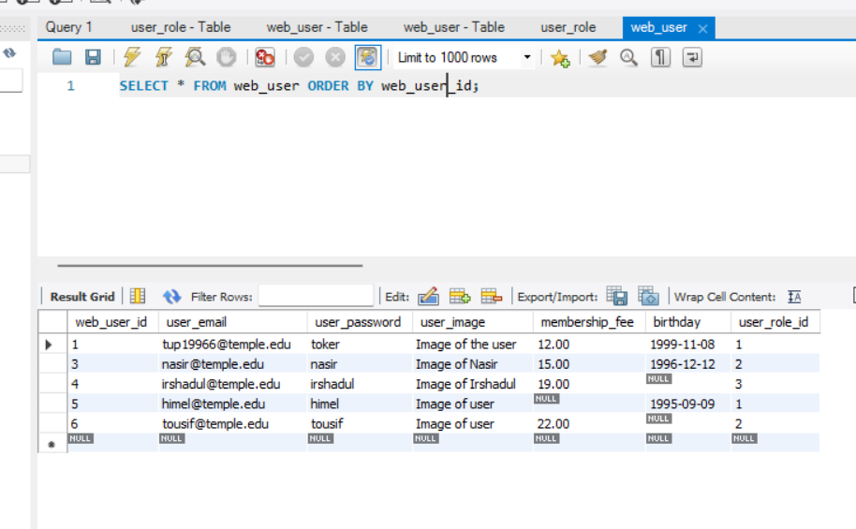



**c) WEB_USER JOINED WITH USER_ROLE: all rows, certain columns, sorted.**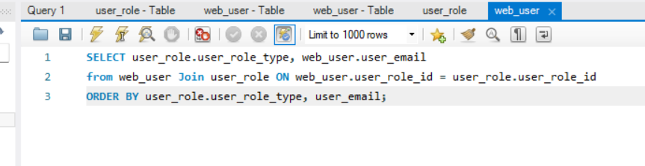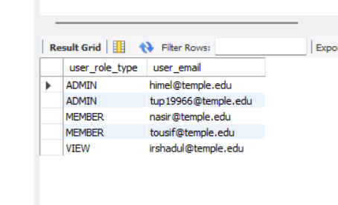

**f) “OTHER”: all rows, all columns, sorted by the id of your “other” table.**

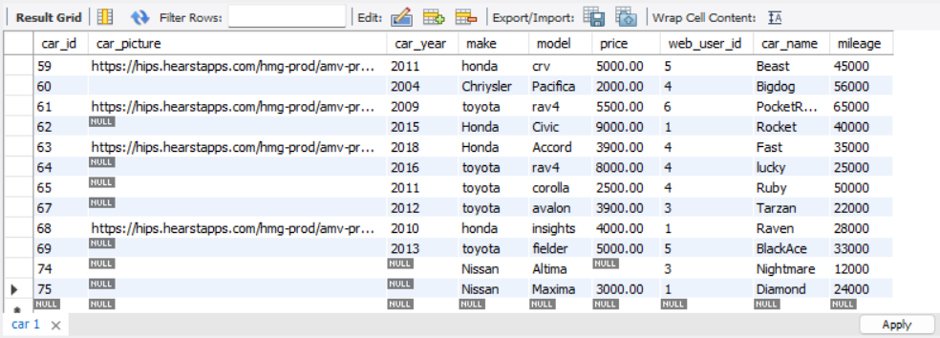

**g) “OTHER” JOINED WITH WEB_USER all rows, certain columns, sorted.**

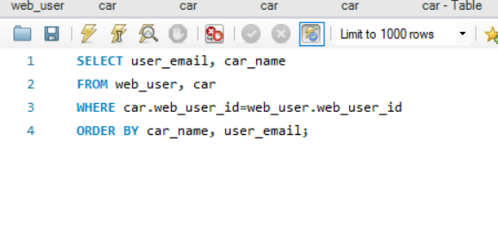

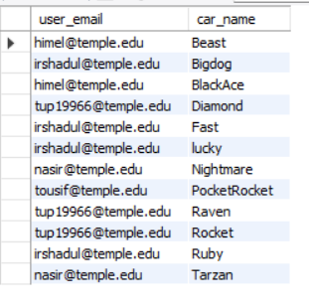



**h) “OTHER” JOINED WITH WEB_USER some rows, certain columns, sorted.**

