COMP3123 Assignment 1
API Testing Screenshots and Evidence
Akinwunmi Eludoyin | Student ID: 101567797
Employee Management REST API | Node.js, Express.js, MongoDB | Testing with Postman and MongoDB Shell

1. API Health Check
GET /api/health returns 200 OK and confirms the MongoDB connection.
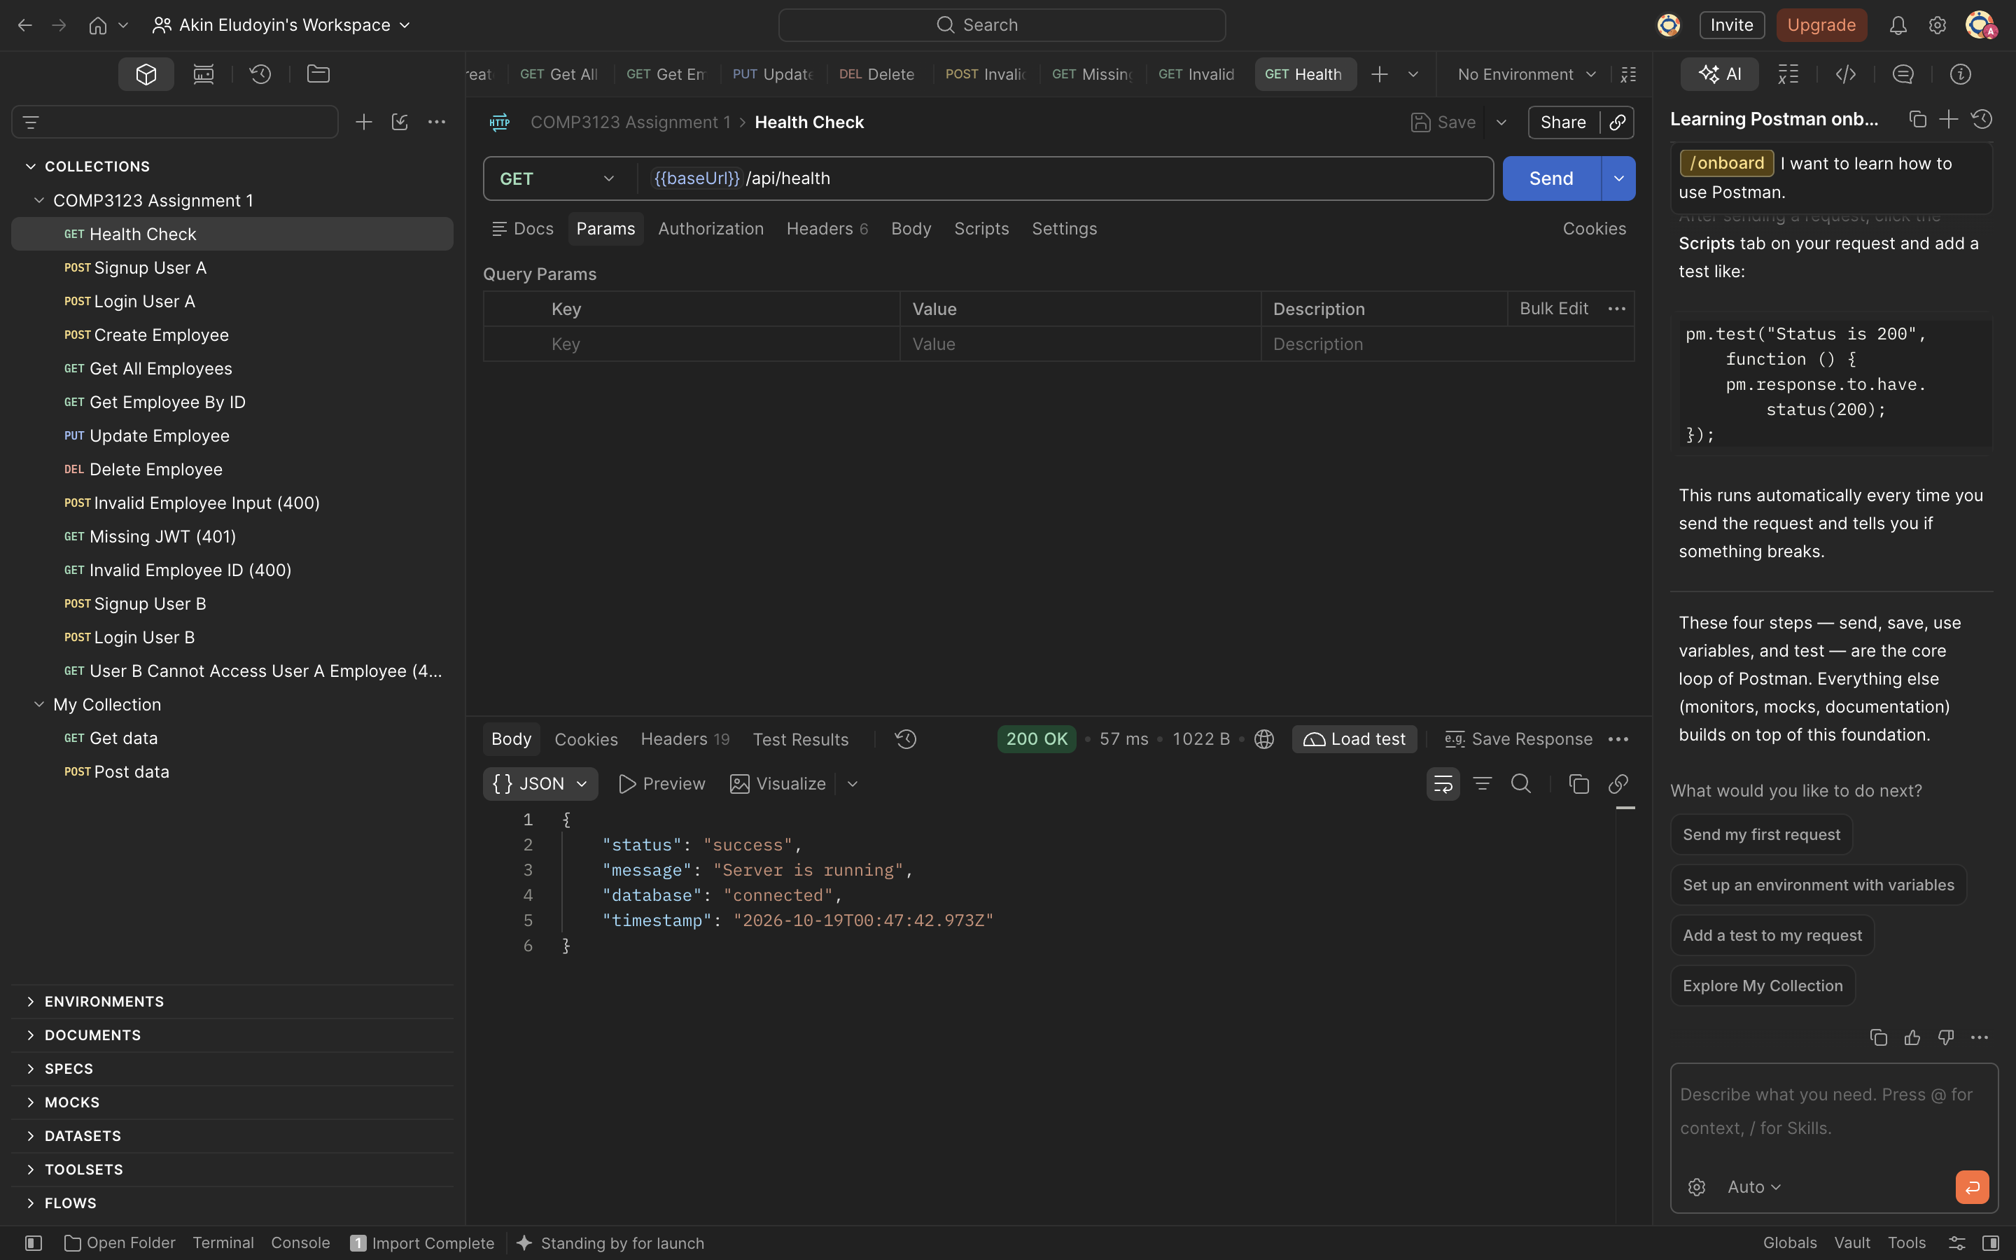

2. User Login
POST /api/v1/user/login returns 200 OK and provides a JWT for authenticated requests
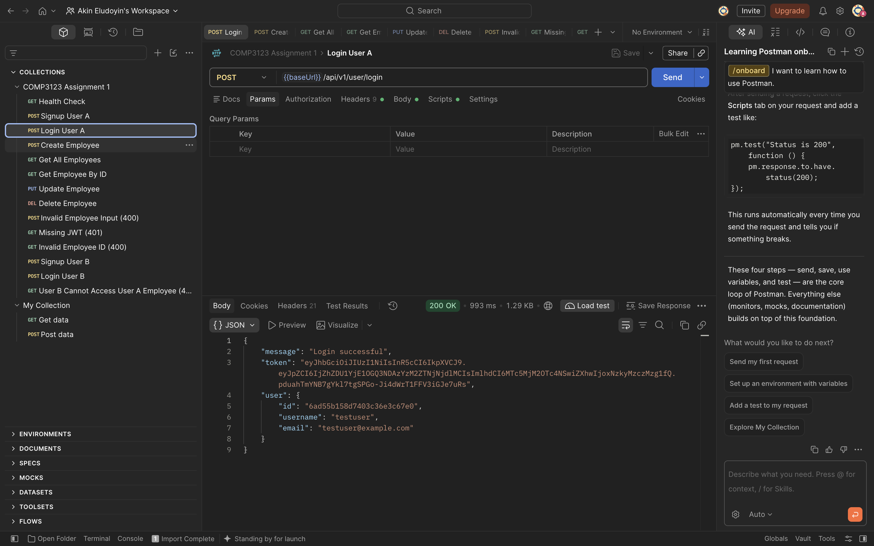

3. Create Employee
POST /api/v1/emp/employees returns 201 Created with the new employee record.
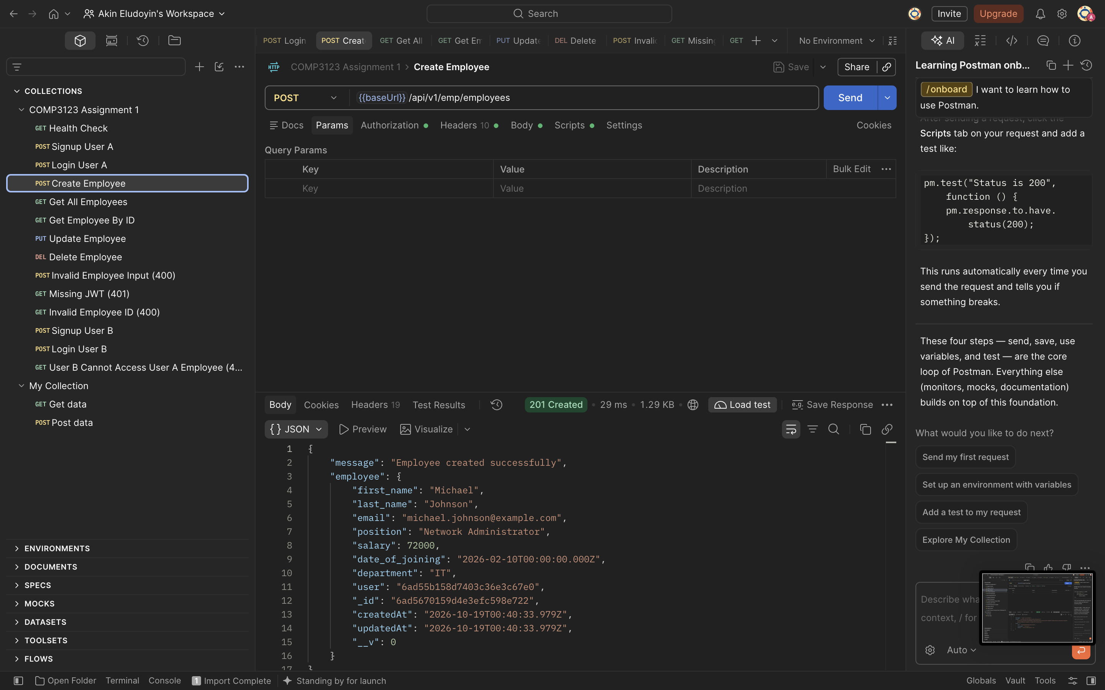

4. Get All Employees
GET /api/v1/emp/employees returns 200 OK and lists employee records.
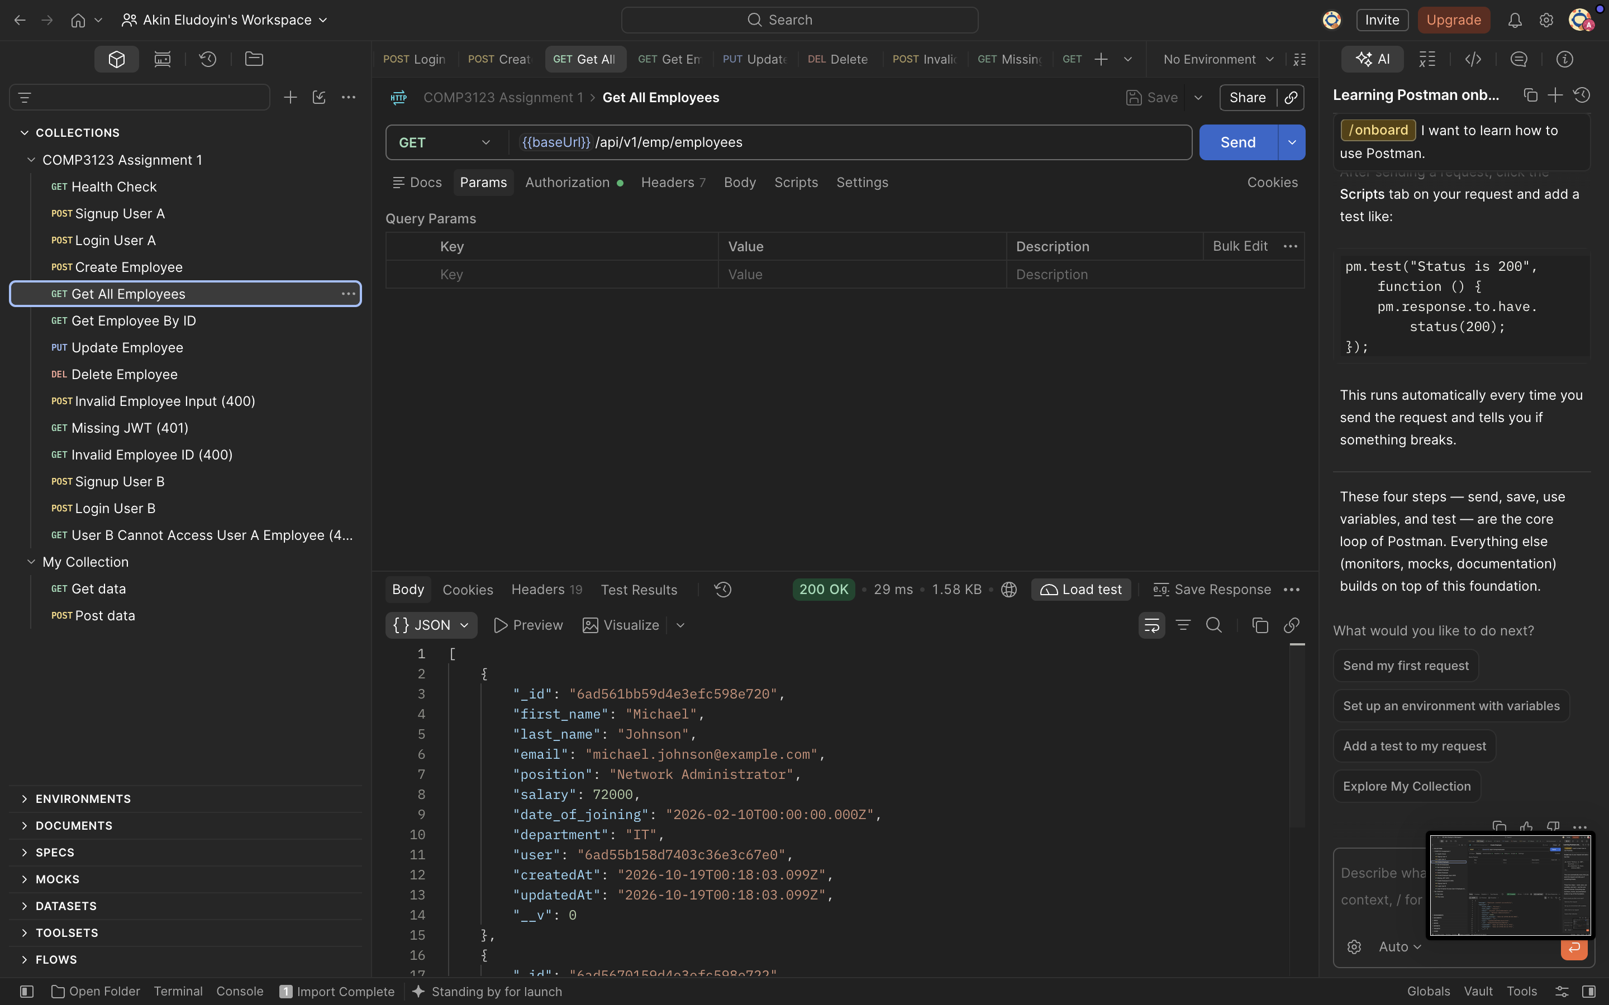

5. Get Employee by ID
GET /api/v1/emp/employees/:id returns 200 OK with the requested employee.
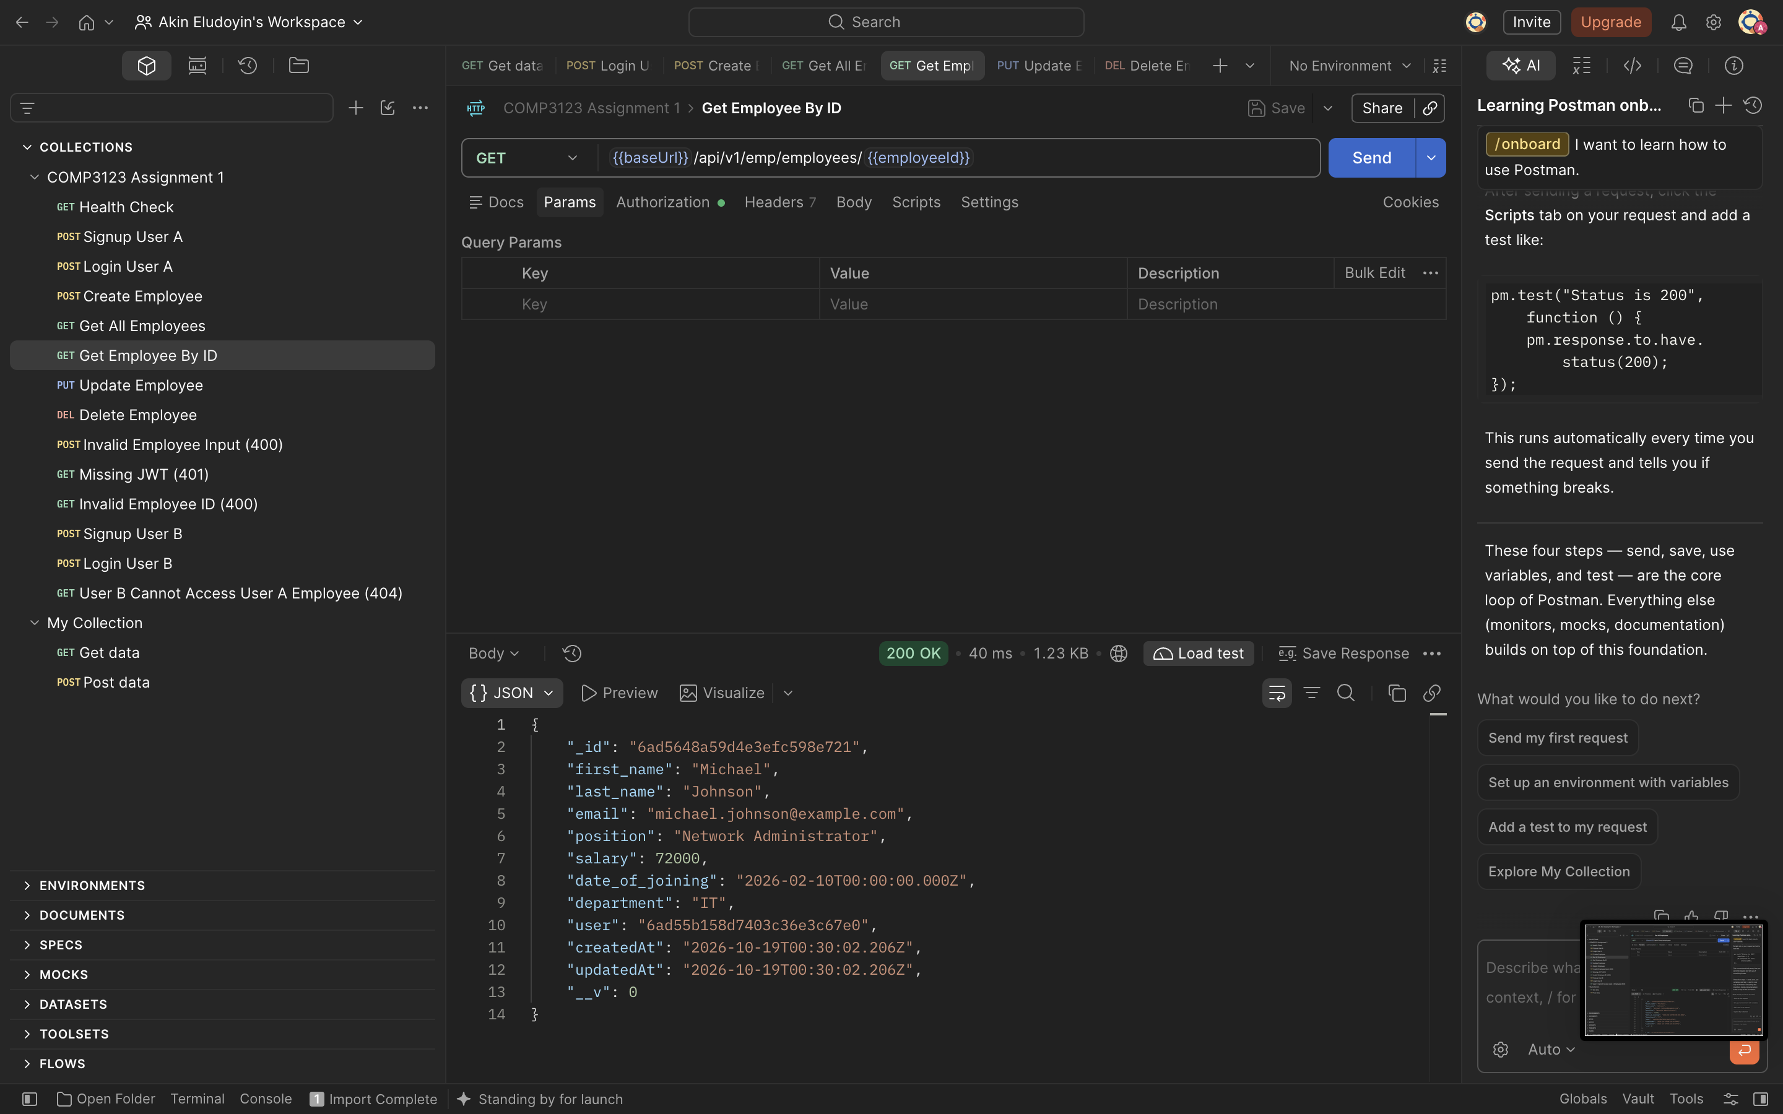

6. Update Employee
PUT /api/v1/emp/employees/:id returns 200 OK and displays the updated employee.
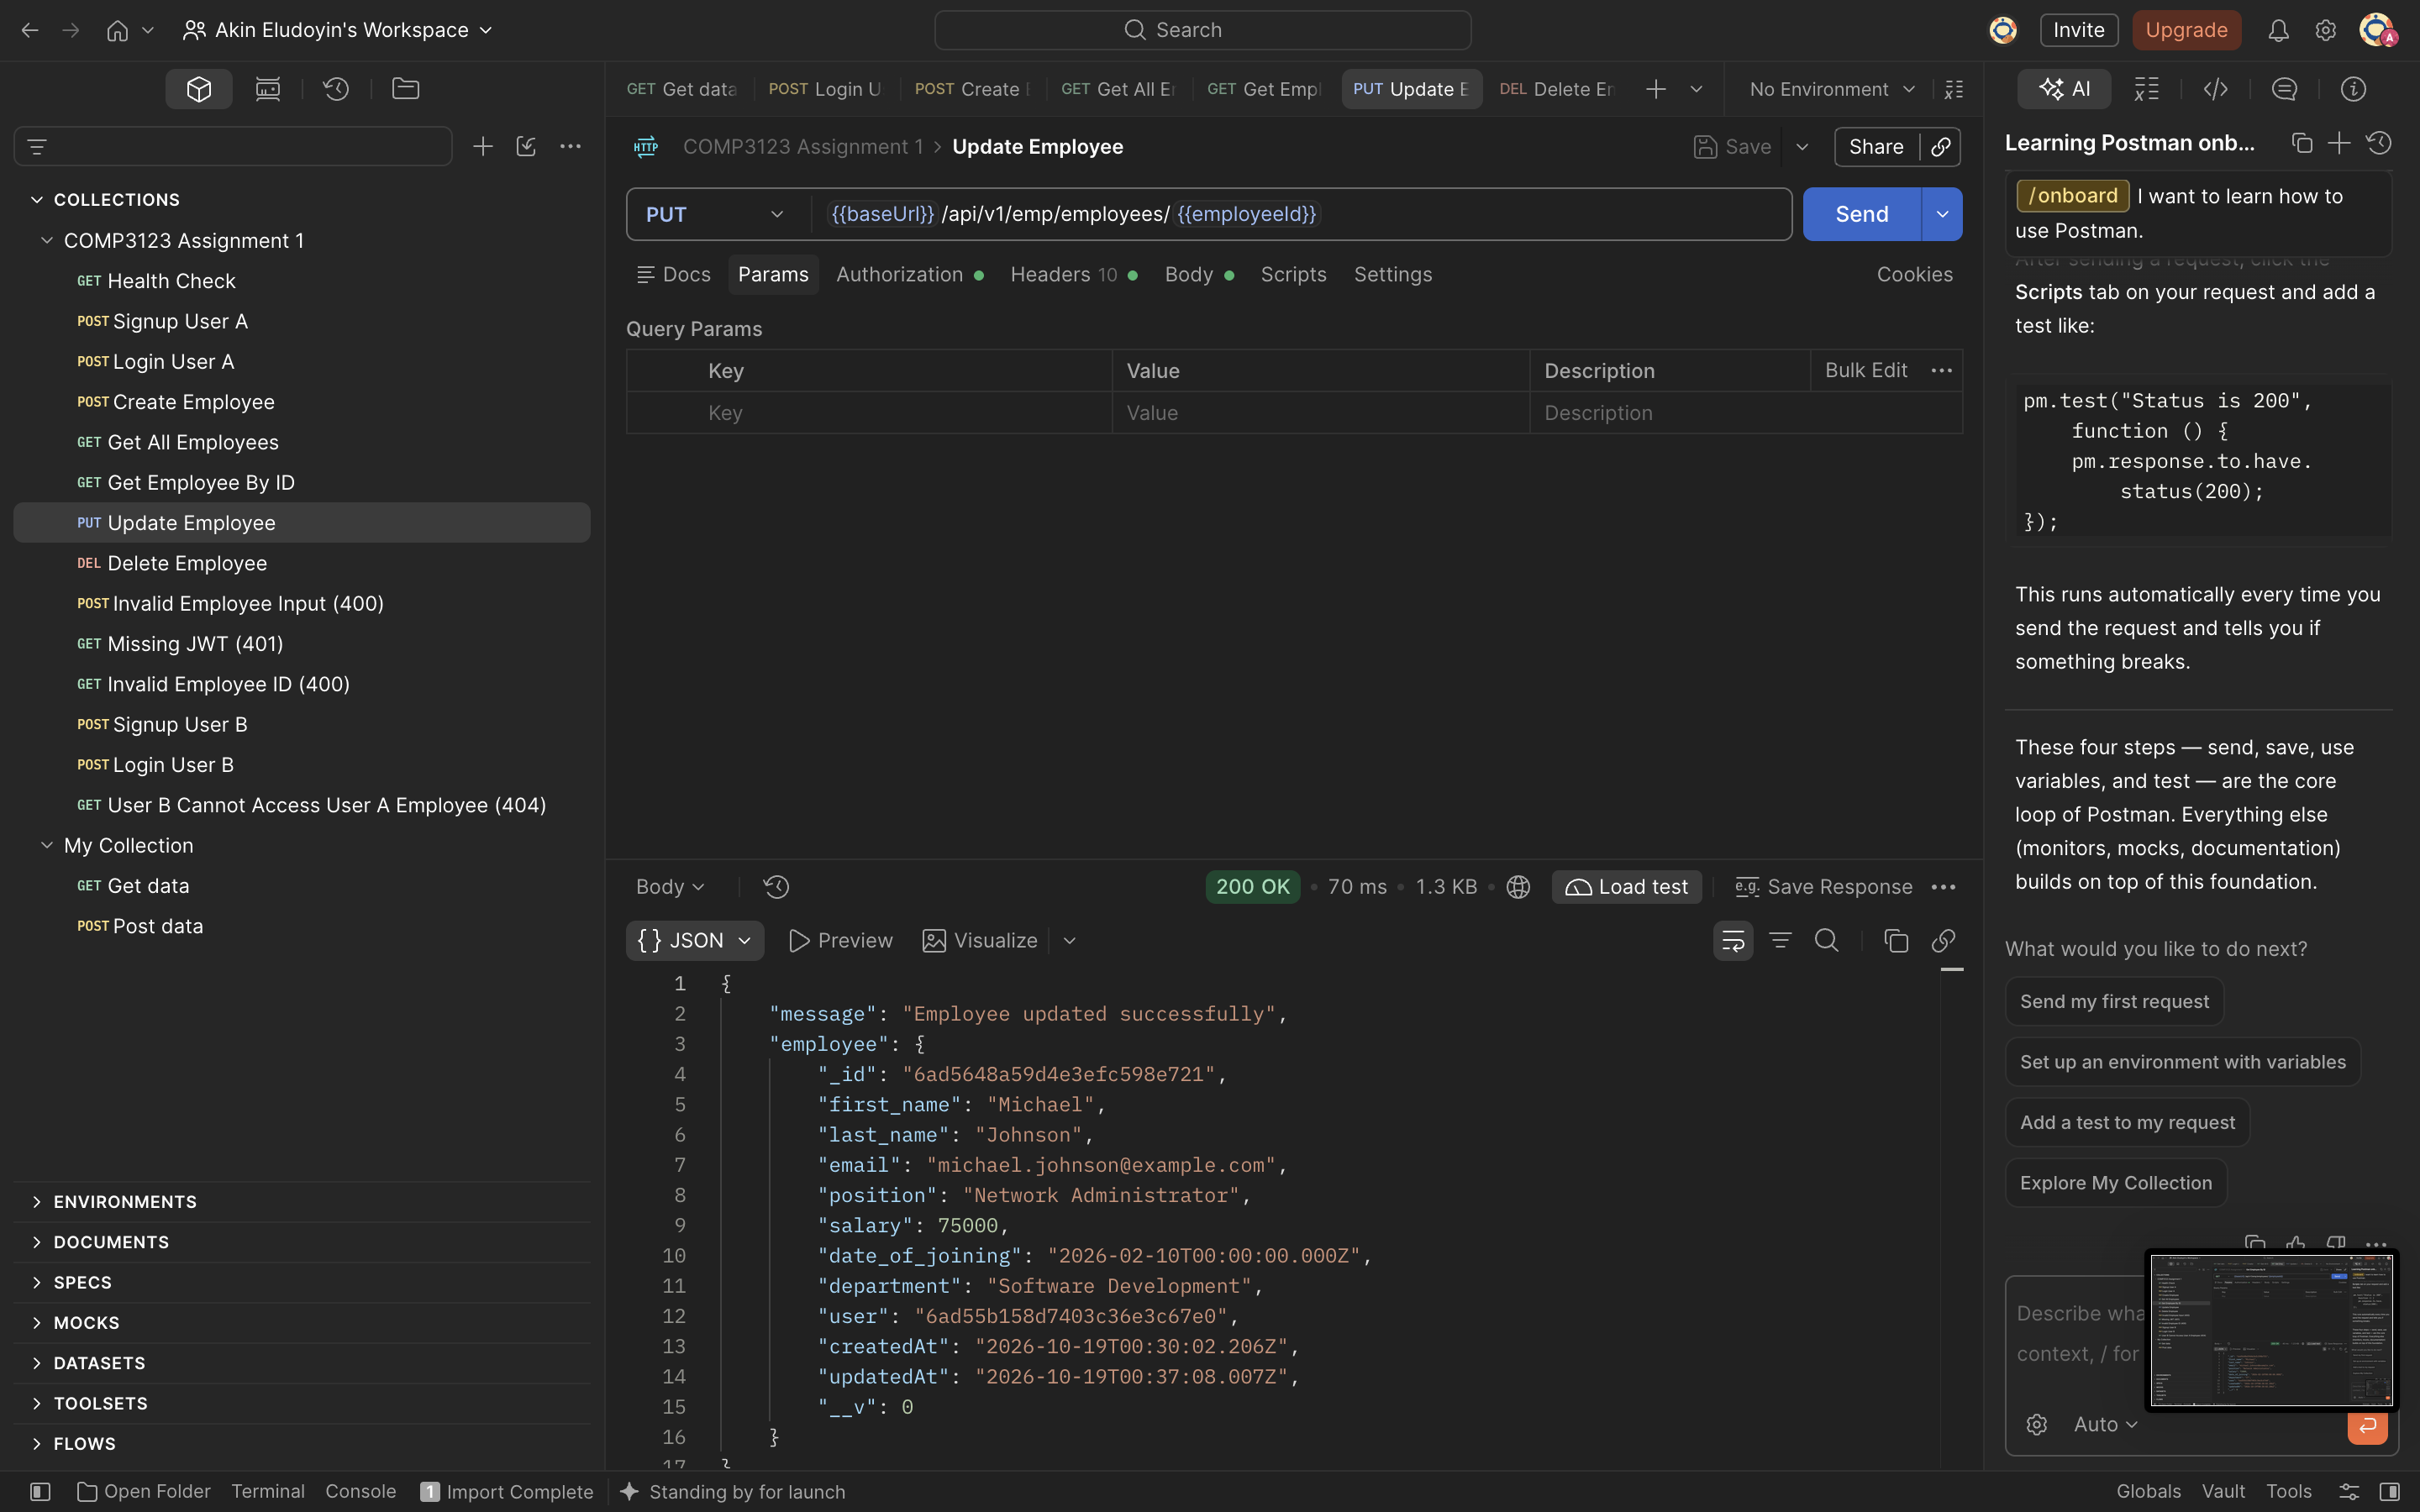

7. Delete Employee
DELETE /api/v1/emp/employees?eid=... returns 204 No Content.
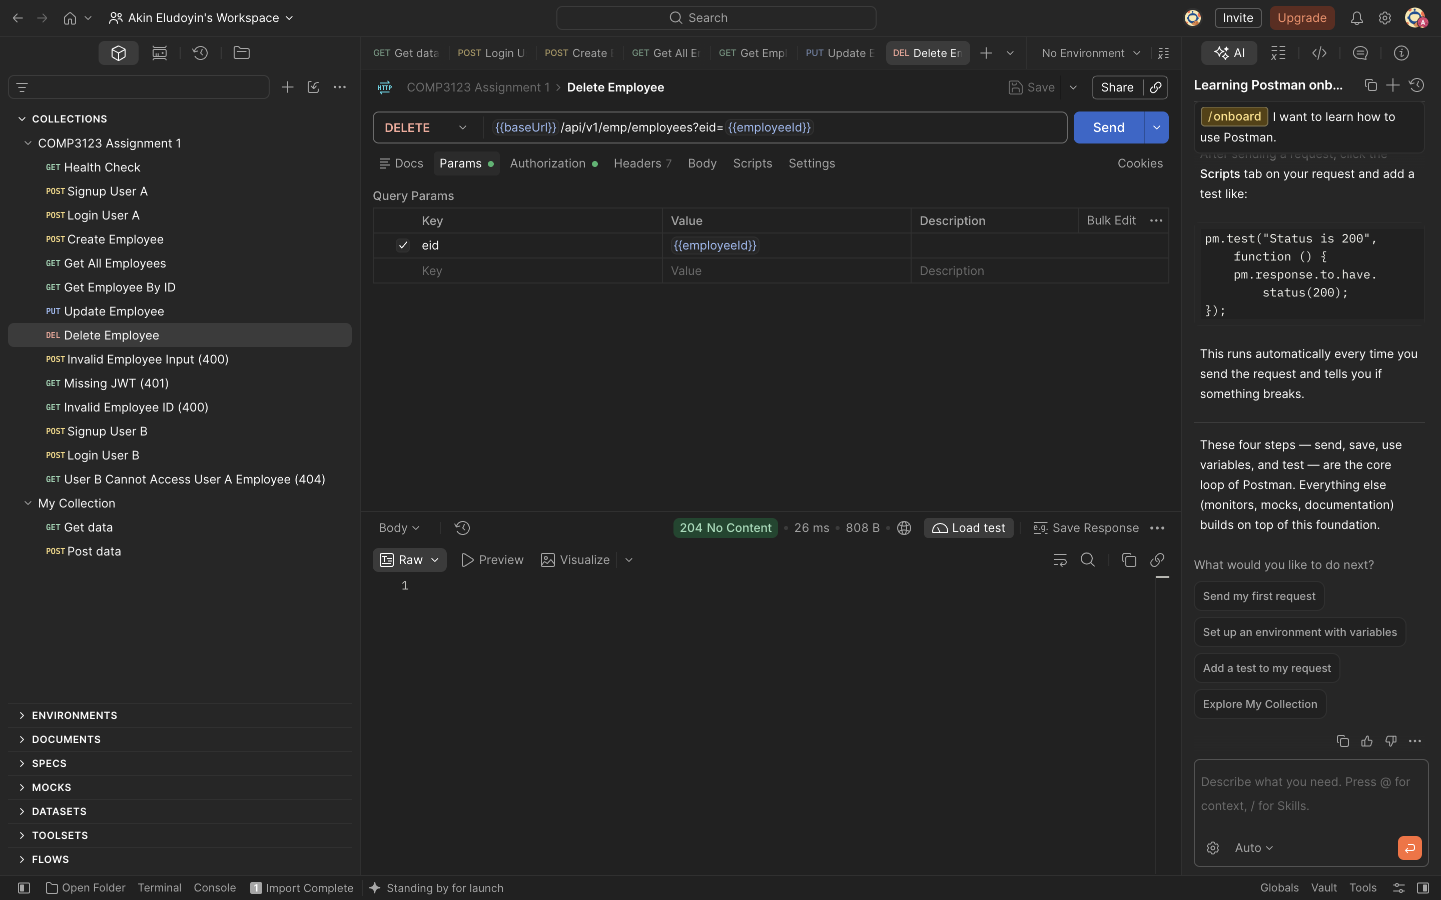

8. Employee Input Validation
Invalid email and negative salary are rejected with HTTP 400 Bad Request.
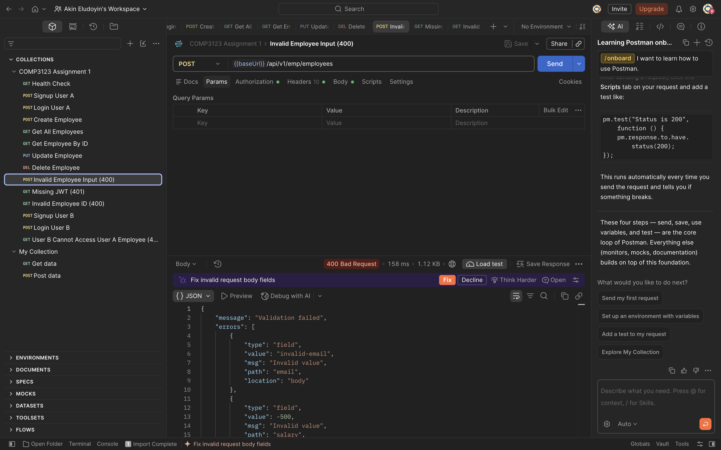

9. Authentication Required
An employee request without a JWT is rejected with HTTP 401 Unauthorized.
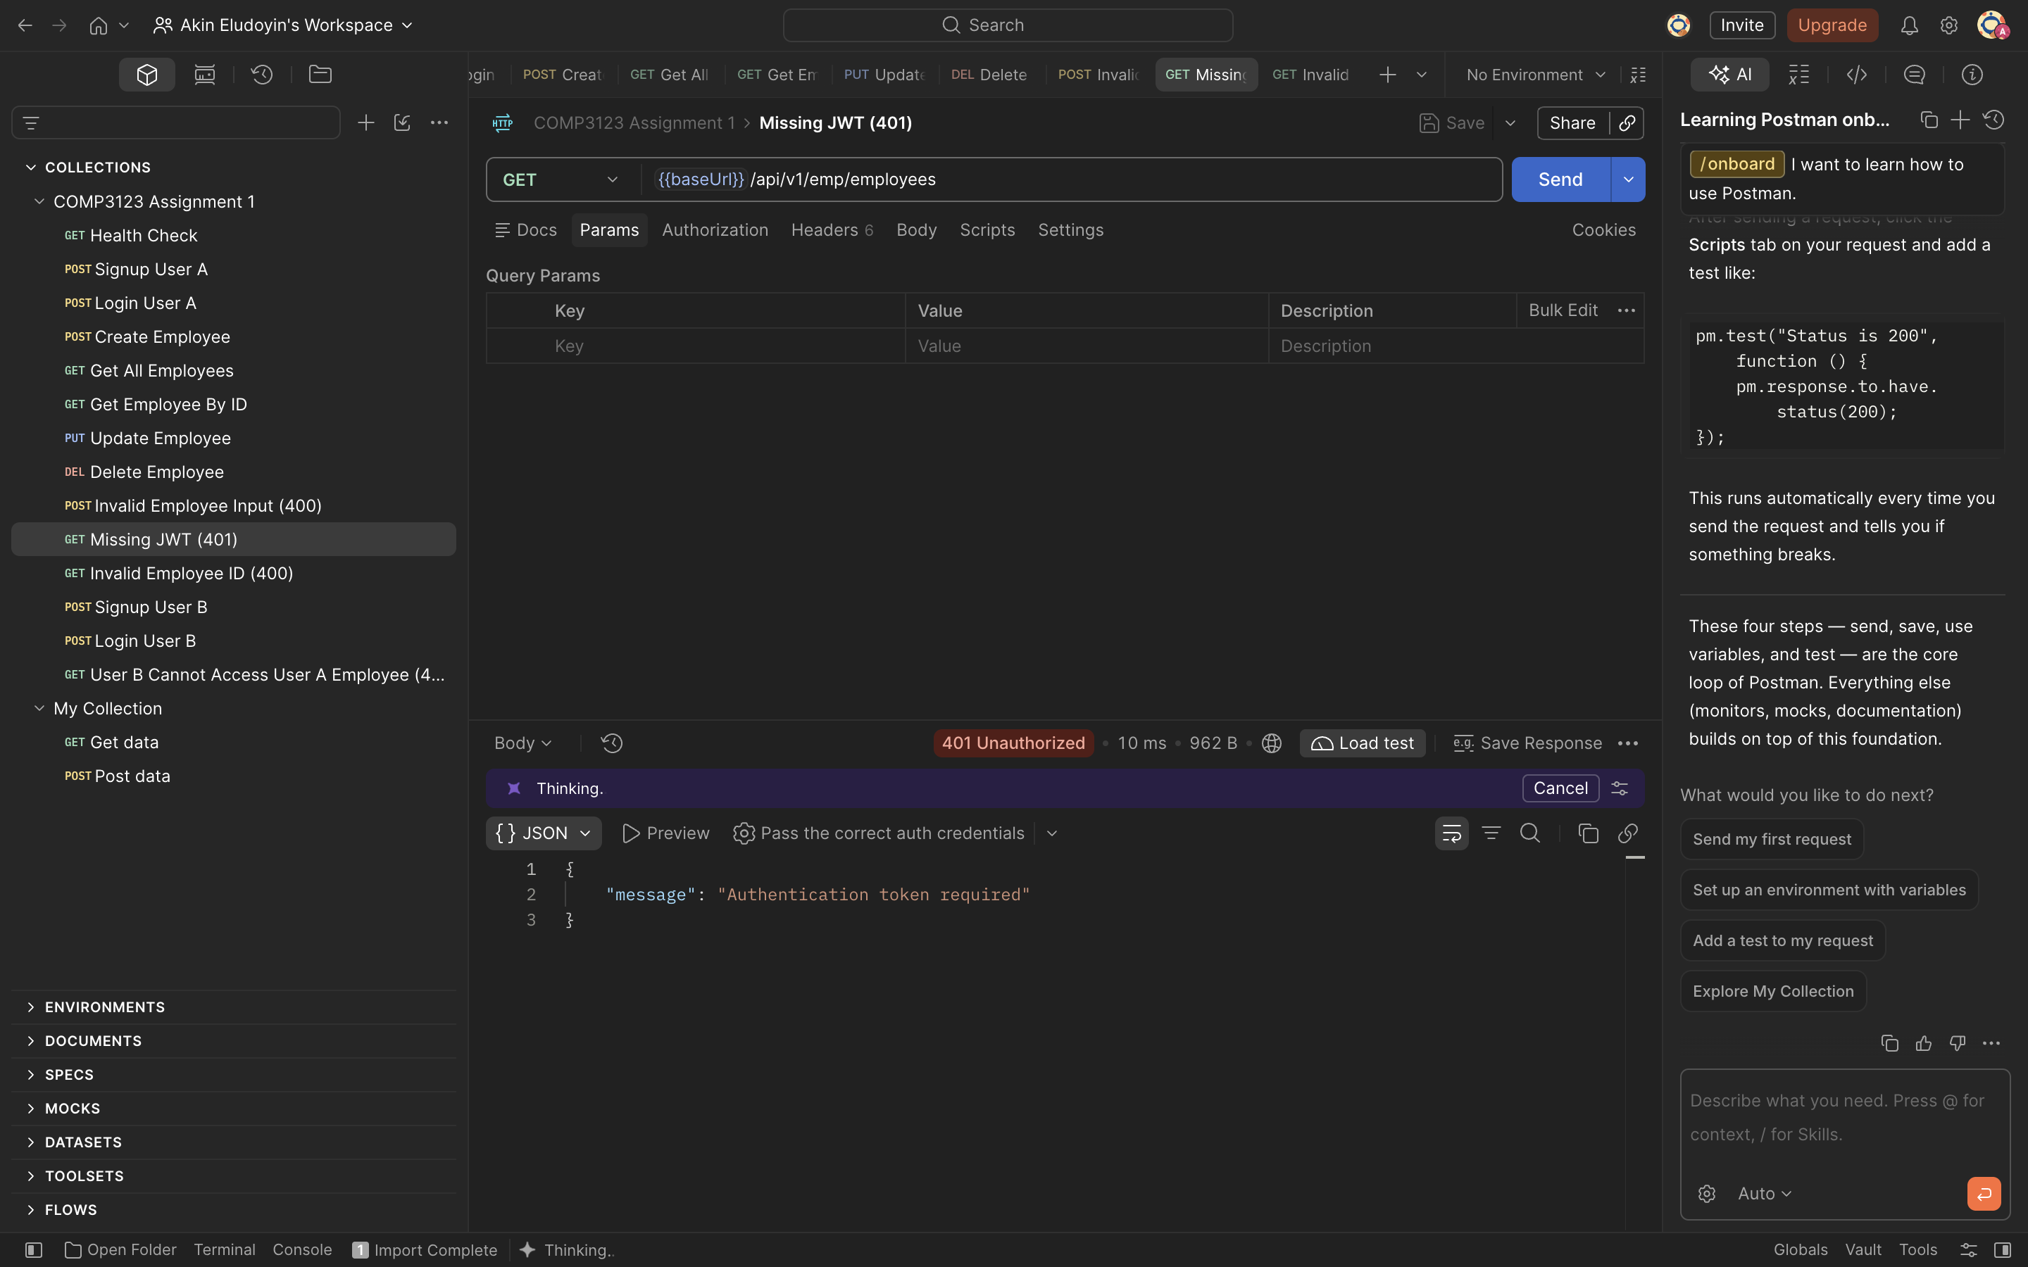

10. Invalid Employee ID
An invalid employee ID is rejected with HTTP 400 Bad Request.
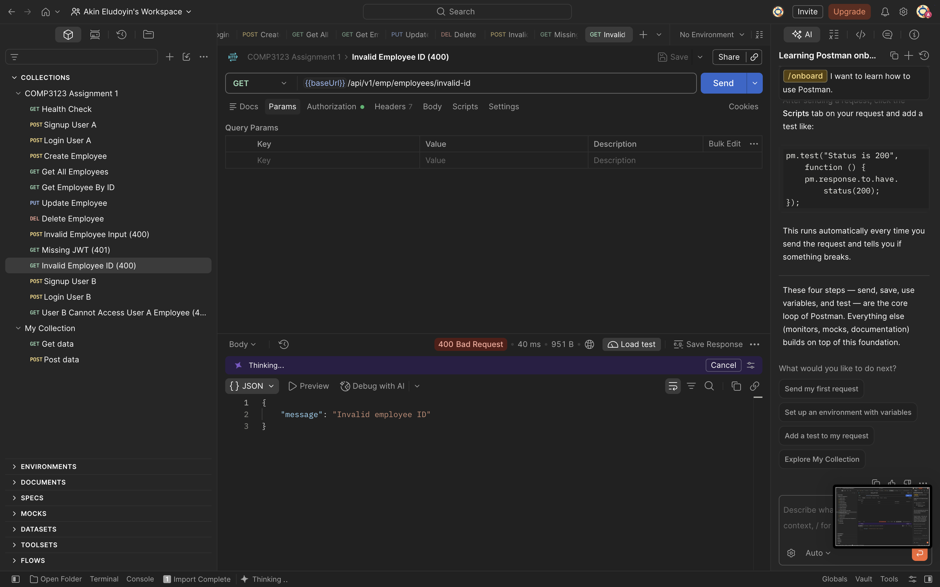

11. Login Rate Limiting
After 20 failed login attempts, subsequent requests return HTTP 429 Too Many Requests.
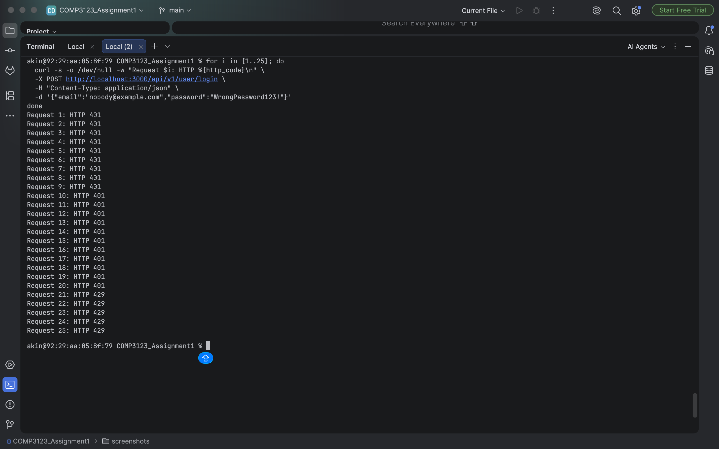

12. MongoDB Password Hashing
The MongoDB users collection stores bcrypt password hashes rather than plaintext passwords.
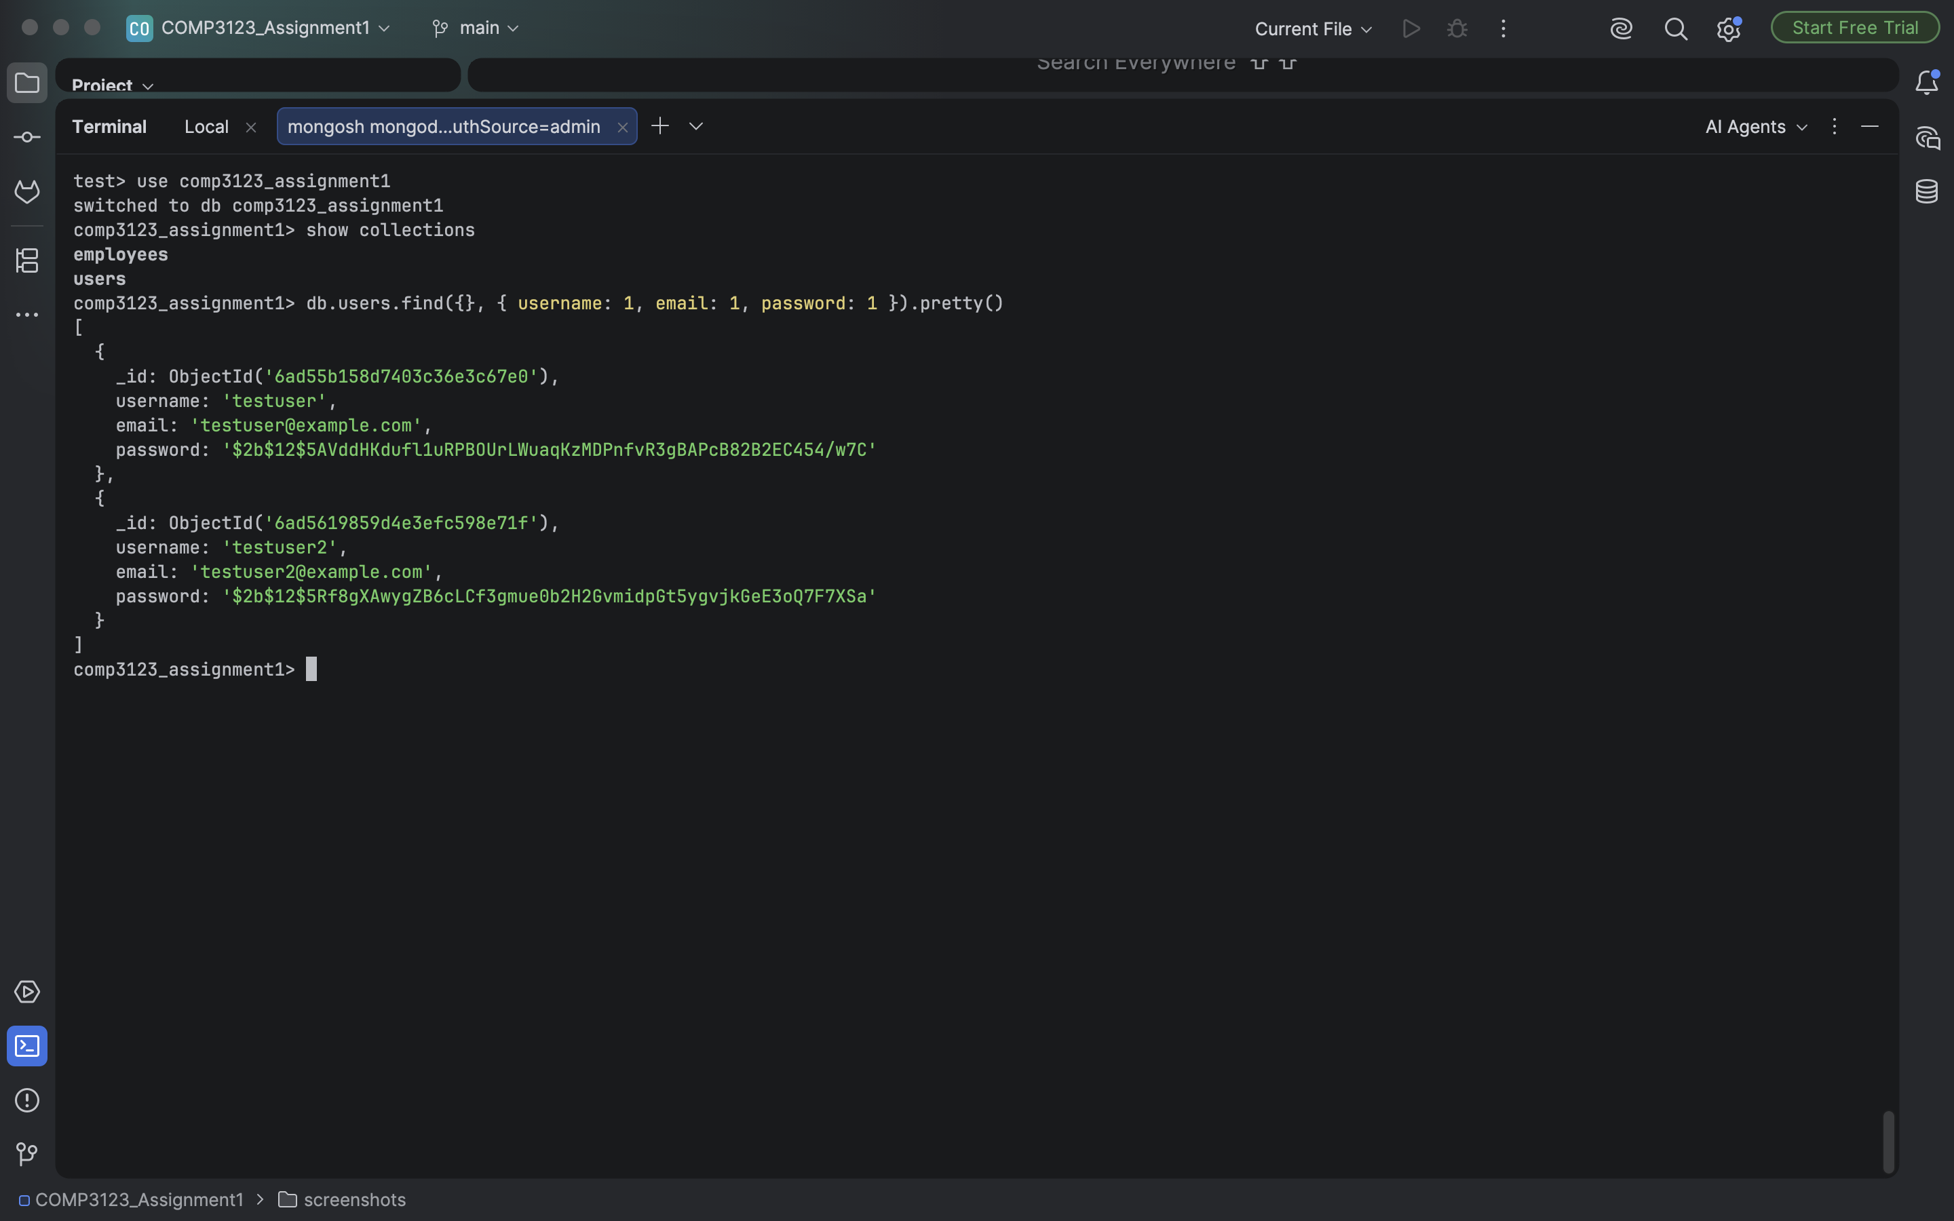

13. MongoDB Employee Ownership
The employees collection stores the user ID associated with each employee record.
