**МИНИСТЕРСТВО ОБРАЗОВАНИЯ И НАУКИ РЕСПУБЛИКИ КАЗАХСТАН**

**СӘТБАЕВ УНИВЕРСИТЕТІ**

|  |
| --- |
|  |

Институт __________________________________

Кафедра __________________________________

ЕСЕП __________________________________

Првктика түрі__________________________________

Првктика орты__________________________________

Ондіріс __________________________________

Мамндық __________________________________

орындаған__________________________________

университет жетекшісі

__________________________________

__________________________________

__________________________________

**Алматы 2019**

КазҰТЗУ 709-16-Ү-Практика есебі

**Practical work report of second course**

Project: Bazis

Location sayiran satbayev street

Project engineer: Sayed Hamez Habibi

Contact

+77473962096

hamezvip@gmail.com

**Introduction**

According to our university policy we done practical work and this report consider the practical work issues.

We had three weeks practical work in construction site. The project is headed in Bazis construction engineering company Sayiran Catbayev Street. The purpose of this practice was about reinforcement concert wall concert block walls foundation also The aim of this practical work was to know how we can work from Architectural map in site, to know about some construction material concepts (block, metal, concrete, base or foundation, concrete mesh, beam and columns.

**Key words:** Block, metals, base or foundation, concrete, beam and columns.

Block is a large solid piece of hard material, especially rock, stone, or wood, typically with flat surfaces on each side. RCC Reinforced concrete beams need strengthening when the existing steel bars in the beam are unsafe or insufficient, or when the loads applied to the beam are increased. In such cases, there are different solutions that could be followed:I-ADDING REINFORCEMENT STEEL ...

A reinforced concrete column is a structural member designed to carry compressive loads, composed of concrete with an embedded steel frame to provide reinforcement. For design purposes, the columns are separated into two categories: short columns and slender columns we will have discussion on Analyzing part.

Concrete reinforcing mesh with rectangular or square mesh pattern is a kind of welded wire fabric, which can improve the bonding to concrete, minimize the concrete cracking that may occur as a result of concrete shrinkage. And the standard of reinforcing mesh is usually 6 m long × 2.4 m wide. With flat even surface and firm structure, it is used extensively for reinforcement of road surfaces, masonry walls, and concrete structures in building. Besides, it is also can be used as large animal enclosure, quarantine caging, gabion or various fences.

**Explanation:**

**CALCULATION OF THE NUMBER OF BLOCKS FOR HOUSE CONSTRUCT**

The variety of the construction market allows you to choose the most appropriate material for construction of a house, based on the purpose of the building, in which climatic zone it is located and the estimated cost estimates. In addition to wood and brick, recently building blocks have become widespread.

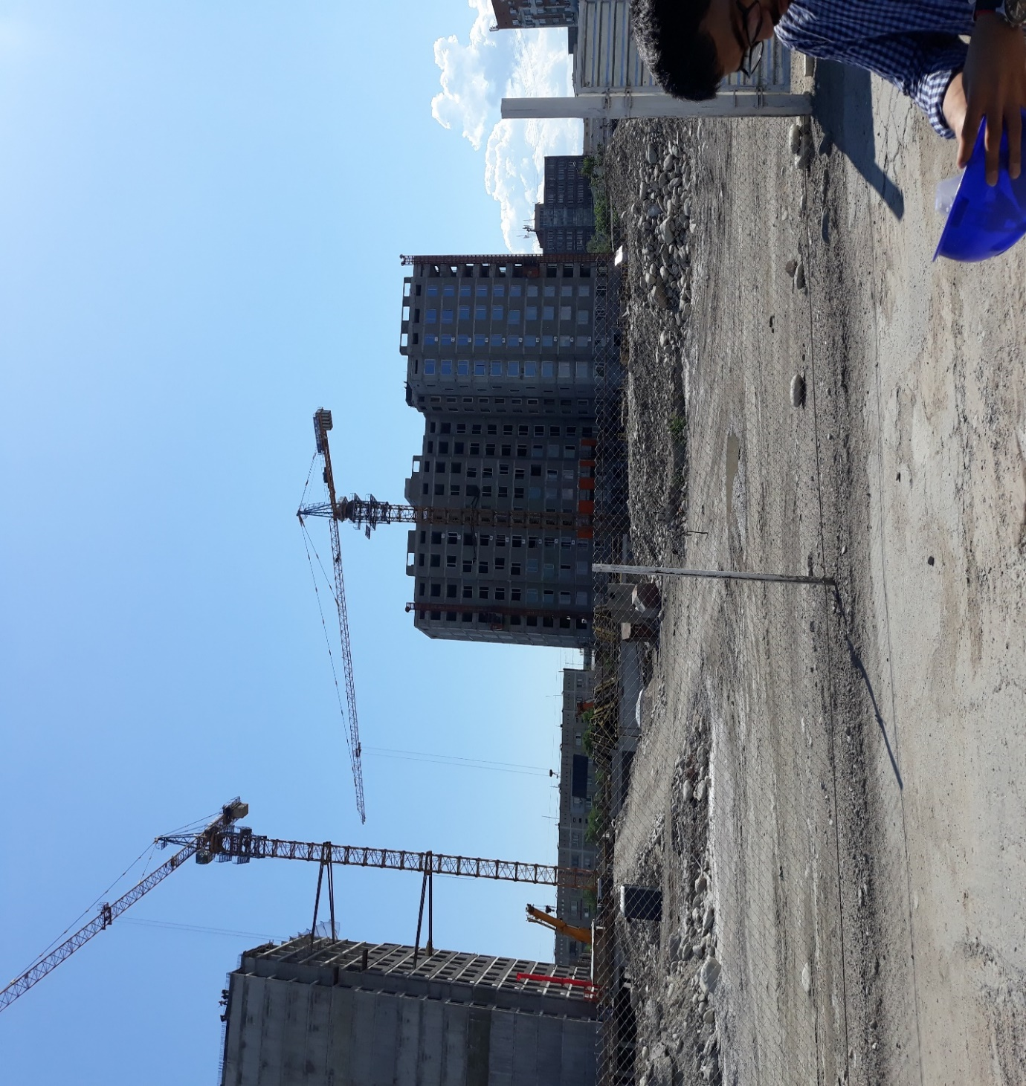

**TYPES OF BLOCKS AND THEIR APPLICATION**

**-CHARACTERISTIC FEATURES OF MATERIAL**

Production of building blocks has reached a new level, the modification of the composition of the material allows us to endow it with the necessary properties depending on the needs of consumers. The use of building blocks for the construction of monolithic frame buildings and low buildings is reasonably popular solution. A variety of sizes, configurations and properties allow them to be used when equipping a precast foundation, for external structures and internal partitions. The properties of the blocks indicate the numerous advantages of the material:

* Construction is carried out in compressed lines, there is no need to operate special equipment.
* The blocks are characterized by a high level of durability and thermal insulation, this allows significant savings on the purchase of additional insulation.
* Compared to wooden log houses, the process of housing construction is much easier, and the period of operation increases due to the high wear resistance of the blocks
* The lightness of the material relative to brick or reinforced concrete allows you to save on a powerful foundation.
* Blocks do not need increased insulation from moisture, like wood.

**CLASSIFICATION OF PRODUCTS**

According to the origin of the product are divided into natural and artificial material. The natural version is much more expensive than the products manufactured at the factory. This is due to the cost of mining the rock, its subsequent careful processing and polishing. The most popular solution for the use of natural materials is decorative facades. The production of artificial products is based on mixing solutions of different composition using vibroforming equipment. Depending on the feedstock, the material is endowed with the required indicators of density, strength and insulating properties. Artificial building blocks are:

* foam concrete
* gas or gas silicate
* lightweight aggregate
* on the basis of opilkobeton
* polystyrene concrete etc

The first types - the most acceptable option for the construction of capital housing. Each of the options has undoubted advantages and minor drawbacks. One type is characterized by high thermal insulation properties, but strength indicators are not at a sufficiently high level, and, conversely, with increased strength, frost resistance indicators are reduced. If necessary, housing construction is organized with the use of two types of material so that in their qualities they mutually complement each other. In any case, all subspecies of lightweight concrete contribute to the formation of a favorable microclimate in the constructed house due to the creation of natural ventilation

* Construction products. The main purpose - the construction of load-bearing walls. This is due to the high strength and thermal conductivity of products, as well as considerable weight. The use of additional insulation - a prerequisite for the operation of residential premises in the cold period.
* Construction products. The main purpose is the construction of load-bearing walls. This is due to the considerable weight. There is a need for additional insulation in the cold period.
* Heat-insulating blocks are intended for walls of frame constructions or internal partitions. Can be used as insulation of external structures. Low thermal conductivity, light weight and low strength - the main characteristic properties of the material.

The ideal option, combining all the necessary qualities of frost resistance, strength, lightness and at the same acceptable cost, has not yet been developed. Each specific building in the definition of material requires an individual approach.

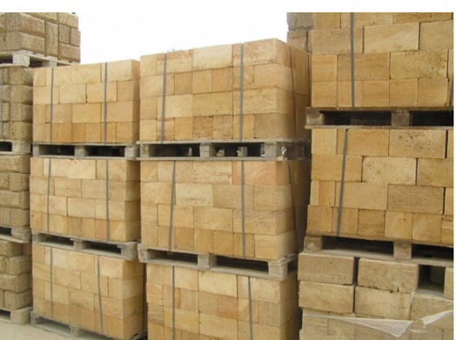

**CALCULATION TECHNIQUE FOR BUILDING A HOUS**E

By correctly determining the amount of material required, you will protect yourself from the costs of additional delivery of missing products or unjustified surplus. Basically, the sale of blocks is carried out both individually and in cubic meters. For example, we will use gas silicate blocks. They are available in various sizes, allowing you to select a separate option for the supporting structures of internal partitions. Initial data:

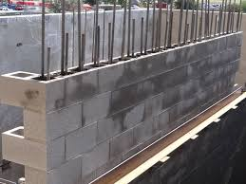

* gas silicate blocks 200/300/600 mm;
* design parameters of the house: width - 8 m, length - 15 m, height - 2.8 m;
* wall thickness - 0.3 m;
* Doorways - 2 pcs., Dimensions 1,2x2 m;
* Windows: 1 large 2x1.2 m, 3 medium 1.6x1.2 m, 1 small for office space - 0.8x1 m.
* length of internal partitions: 8 and 15 m, wall thickness 0.2m;
* doors inside the house 4 pcs., dimensions 1,2x2 m.

**Calculation procedure:**

* The volume of 1 gas silicate block: 0.2 x 0.6 x 0.3 = 0.036 m3.
* The number of 1 m3 of products is determined by dividing 1 / 0.036 = 27.8 pcs.
* Determine the perimeter of the outer side surfaces: (8 + 15) x2 = 46m.
* Calculate the area of ​​external structures. In addition to a block height of 0.2 m, a mortar suture should be provided, approximately it is 15 mm, i.e. 0,015m. Therefore, to determine the number of rows, the height of the house is divided by the height of a single product, taking into account the mortar joint: 2.8: (0.2 + 0.015) = 13 rows. Without taking into account the mortar seam, the side surface height is 13x0.2 = 2.6 m. The calculation of the area of ​​external structures is defined as the product of the perimeter and height: 46x2.6 = 119.6 m2.
* Calculation of the area of ​​openings for doors: 2x (1.2x2) = 4.8 m2.
* Window openings area: 2x1.2 + 3x (1.6x1.2) + 0.8x1 = 8.96 m2.
* The total area of ​​doorways and windows rounded to 0.1: 4.8 + 8.96 = 13.8 m2.
* The net area of ​​external walls: 119.6-13.8 = 105.8 m2.
* Block area: 0.2х0.6 = 0.12 m2, in 1 square meter: 1 / 0.12 = 8.33 blocks.
* The number of blocks for external side surfaces: 105.8x8.33 = 881 pcs.
* The area of ​​internal partitions: (8 + 15) x2.6 = 59.8 m2.
* The area of ​​internal doorways: 4x (1.2x2) = 9.6 m2.
* The net area of ​​the internal partitions: 59.8-9.6 = 50.2 m2.
* Block area: 0.3х0.6 = 0.18 m2, in 1 square meter there are: 1 / 0.18 = 5.56 pcs.
* The number of blocks for internal partitions: 50.2x5.56 = 279 pcs.
* Total amount of material: 881 + 279 = 1160 pcs.
* Total volume: 1160 / 27.7 = 42 m3. Having determined the net area of ​​supporting structures and internal partitions, calculations can be made in another way:
* The volume of material for load-bearing structures is calculated by multiplying the area by the wall thickness: 105.8 x0.3 = 31.74 m3.
* The volume of blocks for internal partitions: 50.2 x0.2 = 10.04 m3.
* To determine the required number of products: 41.78 / 0.036 = 1160 pieces.
* Lack of mathematical abilities is not an obstacle for calculating the number of blocks. Use the online calculator and proceed to the purchase of material for the construction of future housing.

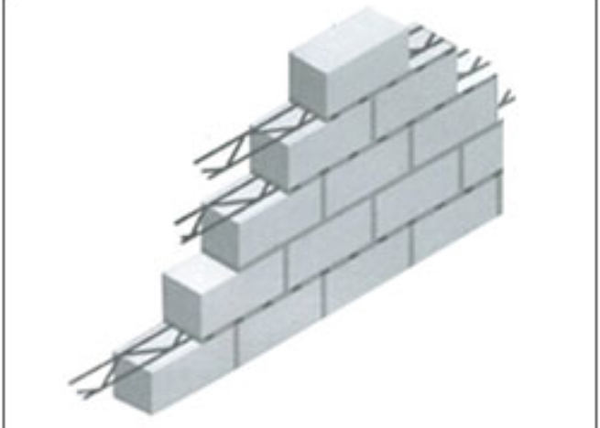

**Concrete reinforcing mesh**:

Concrete reinforcing mesh with rectangular or square mesh pattern is a kind of welded wire fabric, which can improve the bonding to concrete, minimize the concrete cracking that may occur as a result of concrete shrinkage. And the standard of reinforcing mesh is usually 6 m long × 2.4 m wide. With flat even surface and firm structure, it is used extensively for reinforcement of road surfaces, masonry walls, and concrete structures in building. Besides, it is also can be used as large animal enclosure, quarantine caging, gabion or various fences.

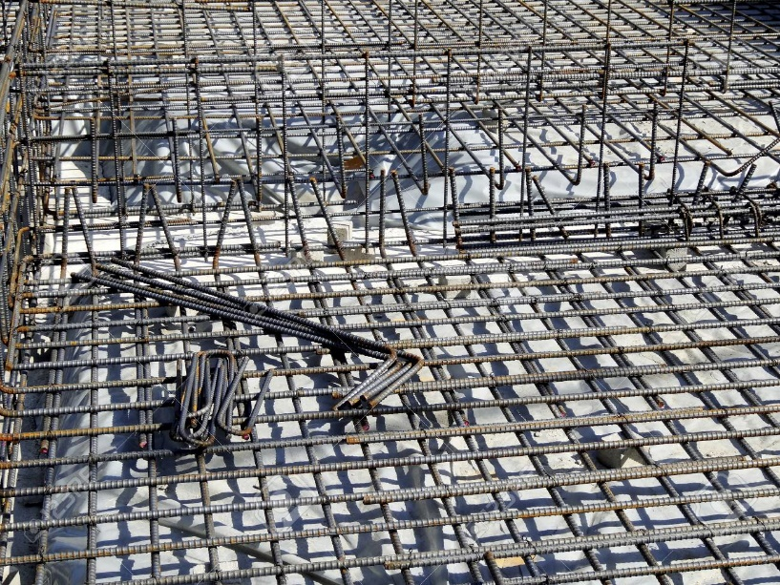

CRM-01: Concrete reinforcing mesh with thread improves bonding to concrete.

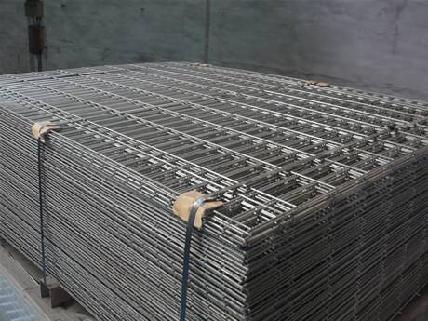

CRM-02: Concrete reinforcing mesh packaging.

**Specifications of concrete reinforcing mesh**

* Material: carbon steel or stainless steel.
* Surface treatment: galvanized.
* Concrete mesh heavy type (diameter of rods above 10 mm).
* Light type (diameter of rods from 3 mm up to 10 mm).
* Mesh shape: rectangular or square.
* Distance between rods: 100, 200, 300, 400 or 500 mm.
* Mesh sheet width: 650–3800 mm.
* Mesh sheet length: 850–12000 mm
* Standard reinforcing mesh size: 2 × 4 m, 3.6 × 2 m, 4.8 × 2.4 m, 6 × 2.4 m.

**Table 1: Common Dimension of Reinforcing Mesh 3.6 m × 2 m**

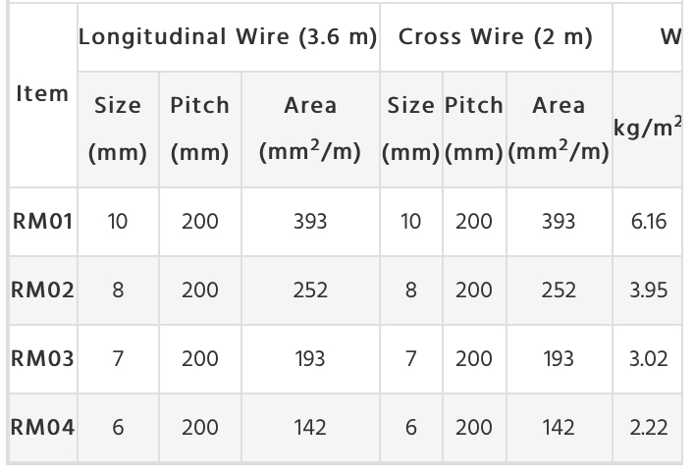

**Table 2: Common Dimension of Reinforcing Mesh 4.8 m × 2.4 m**

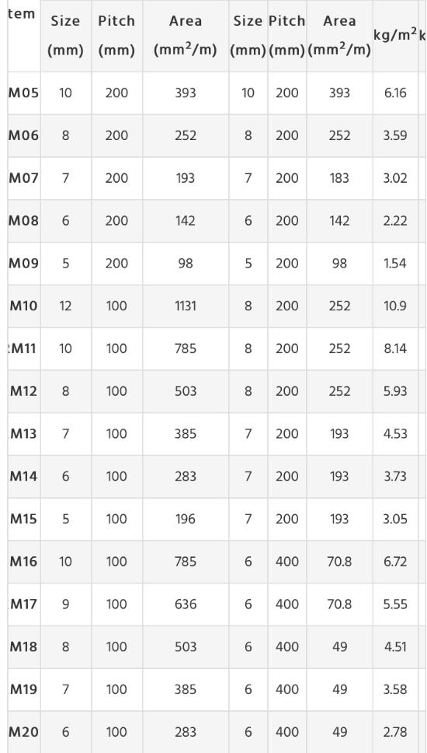

**Features of concrete reinforcing mesh**

* High strength, not easy to break
* Improve bonding to concrete,
* minimize concrete cracking.
* Flat even surface and firm structure.
* Corrosion and rust resistant.
* Durable and long service life.

**Applications of concrete reinforcing mesh**

* Reinforcement of concrete structures in building.
* Reinforcement of road surfaces.
* Reinforcement of masonry walls.
* Manufacture of various fences
* Used as large animal enclosure, quarantine caging or gabion.

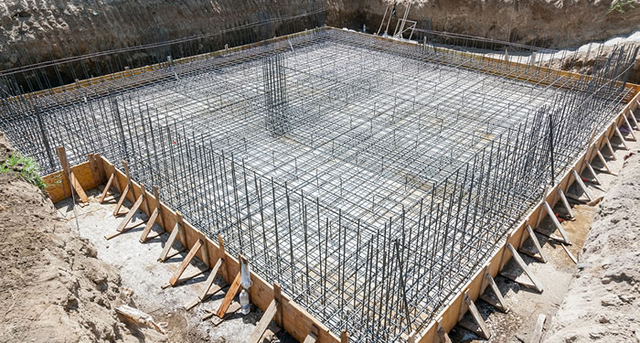

CRM-06: Concrete reinforcing mesh used at industrial site.

Foundation:

In engineering, a foundation is the element of a structure which connects it to the ground, and transfers loads from the structure to the ground. Foundations are generally considered either shallow or deep. Foundation engineering is the application of soil mechanics and rock mechanics (Geotechnical engineering) in the design of foundation elements of structures.

Foundations provide the structure's stability from the ground.

To distribute the weight of the structure over large area so as to avoid overloading of the soil beneath.

To anchor the structures against the changing natural forces like Earthquakes, floods, frost-heave, tornado or wind.

To load the sub-stratum evenly and thus prevent unequal settlement.

To provide a level surface for building operations.

To take the structure deep into the ground and thus increase its stability, preventing overloading.

Specially designed foundation helps in avoiding the lateral movements of the supporting material.

The best foundation:

They are:The design and the construction of the foundation is done such that it can sustain as well as transmit the dead and the imposed loads to the soil. This transfer has to be carried out without resulting in any form of settlement that can result in any form of stability issues for the structure.

Differential settlements can be avoided by having a rigid base for the foundation. These issues are more pronounced in areas where the superimposed loads are not uniform in nature.

Based on the soil and area it is recommended to have a deeper foundation so that it can guard any form of damage or distress. These are mainly caused due to the problem of shrinkage and swelling because of temperature changes.

The location of the foundation chosen must be an area that is not affected or influenced by future works or factors.

Types of foundation:

Shallow foundations, often called footings, are usually embedded about a metre or so into soil. One common type is the spread footing which consists of strips or pads of concrete (or other materials) which extend below the frost line and transfer the weight from walls and columns to the soil or bedrock.

Another common type of shallow foundation is the slab-on-grade foundation where the weight of the structure is transferred to the soil through a concrete slab placed at the surface. Slab-on-grade foundations can be reinforced mat slabs, which range from 25 cm to several meters thick, depending on the size of the building, or post-tensioned slabs, which are typically at least 20 cm for houses, and thicker for heavier structures.

A deep foundation is used to transfer the load of a structure down through the upper weak layer of topsoil to the stronger layer of subsoil below. There are different types of deep footings including impact driven piles, drilled shafts, caissons, helical piles, geo-piers and earth stabilized columns. The naming conventions for different types of footings vary between different engineers. Historically, piles were wood, later steel, reinforced concrete, and pre-tensioned concrete.

Steps of placement of reinforcement in foundation

Building with concrete involves many steps to achieve the best results, including forming, grading, placing, and finishing. One critical step is placing the reinforcing bars, or rebar, correctly, and this article will explain how this is done.



Steps



1. Plan the project. For structural concrete construction, an engineer and architect will usually do the technical design work and provide specific information regarding the sizes, configuration, and placement of rebar in the associated concrete work. Planning the actual fabrication and placement, as well as the schedule of the work is your first task.
2. Purchase the rebar. For simple projects like typical building foundations and slab reinforcement, you can most likely buy the necessary rebar from a building supply center or home improvement warehouse. For complicated applications such as grade beams, foundation walls, tanks, and other projects, you will need to have specific shapes formed by a rebar fabrication specialist. Here are some examples:

Stirrups - These are shaped rebar that hold the lateral reinforcement in a certain configuration, often called a cage. They create a framework that keeps these larger bars in position, and may be round, square, rectangular, or even complex combinations of shapes.

Dowels - These are usually L shapes, or straight lengths of rebar with a ninety degree bend on one end.

Corner bars - These are also L shapes, with each side of the ell the same length.

Offset bends - These range from a simple Z shape to complex angles, used in reinforcing concrete walkway steps and steps (changes in elevation) in concrete footings.

Hairpins - These are U shaped rebar that are often used to interlock two or more individual mats of rebar to give lateral strength to the concrete casting.

Candy canes - As the name implies, these are straight lengths of rebar with a U shaped bend on one or both ends, again to interlock two or more parallel reinforcing mats.

3. Consult your reinforcing placement drawings/plan. If you purchase your rebar from a fabricator, the supplier will usually review your structural engineer's or architect's plans and produce a shop drawing with details and identifying tags for each type of rebar used in the project. For simpler projects, your building plans should provide spacing requirements and bar sizes. Use these documents to determine where and what rebar is needed in individual locations.

4. Choose the method you will use to tie the rebar. Most times, rebar is tied with annealed steel wire, either bought in four pound bulk rolls, or if using a bag tie spinner, in bundles of precut wire pieces with loops formed on both ends. The latter are easier for novices to use, but somewhat more expensive, the former is often the choice of experience rebar tiers (rodbusters).

5. Prepare the area where the concrete is to be placed. The ground should be graded and compacted after any needed subgrading, excavations, and underground rough ins for plumbing and electrical utilities is finished. Lay out the actual perimeter or form lines for the concrete placement after the grading and compaction and associated testing is done.

6. Decide whether the concrete forms will be installed prior to placing your rebar. For large footings where heavy rebar is to be used, the formwork usually is done first, for concrete walls and grade beams, one side of the form may be built prior to tying the rebar, but the rebar will need to be tied in place before the formwork is completed so bars can be positioned and tied in place. For concrete slabs, the subgrade (ground underneath the slab) is often pre-treated for termites, and a moisture barrier or damp proofing is installed before the mat is tied.

7. Shake out the rebar. This involves removing individual bars, stirrups, and dowels from their respective bundles according to the placement drawing counts. An example would be a slab measuring 12 feet (3.7 m) by 12 feet (3.7 m) with rebars at 8 inch (20.3 cm) centers in one direction, and 12 inch (30.5 cm) centers the other. Determine the size of bars required in each direction, mark two or three bars with the appropriate layout measurements in each direction, and count the marks to determine how many rebar are required for each direction. Often, the placement drawings are specific, such as "18 (number 5) rebar, 11 foot 6 inches (15.2 cm) long, one half each way". This gives the following information: You need the given quantity, 18, rebar, size 5 (5/8 inch diameter), with 9 bars laying in each direction, the top rows perpendicular to the bottom ones.

8. Tie your rebar. This is the primary focus of this article. Tying the bars so that they remain in their correct respective positions is critical to achieve the desired strength of the completed concrete structure.

9. Place each rebar in its respective position according to the layout described in the previous steps. The layout bars (or mark bars) can be marked with a soapstone marker, a paint pen, a piece of lumber crayon, or with spray paint.

10. Select the appropriate type of tie you will use. For the bag ties (Snap Ties, not to be confused with the snap ties described later). For ordinary slab mats, where the force of the concrete interacting with the rebar during its placement is minimal, and movement of the mats is unlikely, using a simple, single twist of wire around each rebar intersection, twisted together tightly, will suffice. This tie is known as a snap tie, and can be made with the snap tie pre cut ties and a spinner, noted earlier. It can also be done easily with a pair of 9 inch (22.9 cm) lineman's pliers and bulk wire held on the road buster's work belt in a wire reel. For other applications where the force of the concrete placement may displace the rebars, or where more strength is needed to hold bars in the proper configuration, more complicated ties may be used. Here are some of them, with a simplified description of how they are made:

Figure 8 ties - These are made by pulling the wire around the rear (from the rodbuster) bar, diagonally across the front bar, back around the rear bar, diagonally in the opposite direction across the front bar, and then twisting back around the beginning wire. You then cut the wire feeding off the reel, and bend the cut ends back towards the tie so no sharp ends project from the tie. These ties will help hold perpendicular bars tightly together while helping to prevent them from racking, or moving diagonally.

Saddle ties - Similar to the figure 8 tie, you begin by passing the wire feeding from your reel behind the rear bar, then across the front bar staying parallel to the bar. You then pass it behind the rear bar again, back around the front bar on the opposite side. You now twist the ends together, cut the feed wire, and bend the cut ends back. This tie is often used when tying rebar for walls or other vertical application where the rodbuster will actually climb on the rebar framework to access higher portions of the wall. The figure 8 and saddle tie can often be interchanged, however, technically speaking, there are advantages to each one in certain circumstances.

Combinations of figure 8 and saddle ties with additional wraps around vertical rebars can be used to increase the hold of the tie so bars cannot slip downward when weight is applied to them or the plastic concrete is dropped into the form.

11. Use your pliers for tying these ties efficiently. For all the above mentioned ties, you pull the feeding end from the wire reel with your non-dominant (hereafter regarded as left, please reverse for right handed persons) hand. Grip the end of the wire with your pliers in your right hand, and poke, or push it behind the rebar described in the first step of your chosen tie. Bend or angle the end toward the place you will be grabbing the end in the next step of the tie, then reach from that side, grip it again with the pliers, pull it toward the next place you will route it to, pulling enough slack wire to complete the tie. Hold resistance on the wire with your left hand, so the wire bends snugly against the bar you are wrapping in each stage of the tie. Release the wire so that the pliers can be used to grip it, and do so, pulling the end around the bar and twist the two ends of the wire together. Pull or tug the wire with the pliers so the tie is tight.

12. Tie all the bars required in their correct positions. Check your plans to make sure each component of the reinforcement is in place. Often, in structural concrete reinforcement, you will find several elements that interface together in addition to the basic rebar mat discussed so far. Here are a few to note:

Block dowels - When placing a concrete foundation which will have concrete masonry units (block) erected on it, you will usually find the plans require installing block dowels, or vertical rebar to reinforce cells at a required spacing to give the subsequent block wall sufficient strength to withstand conditions to which it will be exposed, or to help it support loads it will carry as an overall part of the structure you are building. These bars are tied to the foundation rebar (footing bars) in a location that will place them in the center of individual block cells. For them to be placed correctly, you will need to establish the wall line, then determine the spacing of these cells. If your layout begins at a corner, using 8 X 16 inch regular block, you can place the first dowel 4 inches (10.2 cm) inside the outside wall line, 4 inches (10.2 cm) from the corner, then space additional bars at their required distances in multiples of 8 inches (20.3 cm). For example, at 16, 24, or 32 inch centers. This is known as blockwork spacing.

Bulkhead dowels - In instances where a footing will not be completed in a single concrete placement, you will need to dowel out of the bulkhead form so the next placement will be structurally tied to the latter one. Make sure the dowels extend far enough that the lateral reinforcement will overlap enough to maintain the strength of the rods used. Typically, rebar lap is calculated in bar diameters. An example would be the number 5 rebar mentioned earlier. It has a diameter of 5/8 of an inch, and the required lap might be 40 bar diameters. Multiplying the diameter 5/8 by 40, you will get 200⁄8 or 25 inches (63.5 or 63.5 cm).

Note that in structural concrete, other types of imbeds and inserts may be required. Place rebar in such a manner as to allow installation of anchor bolts, sleeves, embedded weld plates, inserts, or other items in their respective correct locations without interference. In general terms, these items require more precise positioning, so offsetting one or two rebars may be required.

13. Chair or support your rebar. Once the mat or cage is assembled, you must hold it in position so the the concrete will cover it completely. Rebar chairs or concrete brick are often used for this purpose. Place these positioners at a spacing that will not allow the rebar to bend or deflect enough to reduce the coverage you wish to obtain with the concrete you place in you forms. For a 12 inch (30.5 cm) thick footing, the rebar mat is usually placed about 4 inches (10.2 cm) from the bottom of the concrete, and side clearances range from 2 to 4 inches (5.1 to 10.2 cm).

14. Observe the rebar configuration while the concrete is placed. If shifting occurs, support the rebars with a handled tool like a shovel wedged so that you can achieve sufficient leverage to hold its position, or alter the direction of flowing concrete so force is applied in the opposite direction.

15. Cap or otherwise protect any exposed bars while working near them. Rebar that is sheared, or mechanically cut has very sharp surfaces at the location of these cuts. Construction workers have suffered serious injuries and have also been killed when they have fallen on projecting rebar dowels.

Finally in conclusion I learn to how work in site with map what is reinforced concert reinforced blokes how they works how we can fix it how we can make it making of mortar also I achieve and learn that how we can connect wires with each other in foundation part also in beam and columns also how to make a block reinforced wall … and it was a fantastic and important issue for my spatiality.

