**Project Title: ONLINE EMPLOYEE PAYROLL MANAGEMENT SYSTEM**

**(BY III Year M.Sc. (2016-17))**

**Student Name: RollNo:**1. Krupa Deria 3095

2. Chandni Soni 3157

**Internal Project Guide:** Pooja Gandhi

**Name of Company/Institution:** iMOBDEV TECHNOLOGIES PVT LTD.

**Date of Submission:** 20/4/2017

**Submitted to:** K. S. School of Business Management

M. Sc. In Computer Applications and Information Technology

**Acknowledgment**

Thank you respected sir and madam for giving us such a wonderful opportunity for developing the project. This project has given us the chance to enhance our technical and logical communication skills and due to this opportunity, it will be very helpful to us in our future career.

Our college is really doing great work of providing such an opportunity to the students. It is our pleasure to grab these opportunities which is very helpful in our future jobs.

We are very lucky to have Dr. Kalyani Patel madam as our coordinator to give us such a big opportunity to work upon and also providing us many helping hands in the form of internal guides i.e. our dear faculty members.

A special thanks to Miss. Pooja Gandhi madam, our internal guide, who guided us in our project whenever we were facing any problems. She provided us the right guidance and motivated us to complete our project tasks with full enthusiasm.

We are also thankful to iMobdev Technologies Pvt. Ltd. , who gave us the opportunity to develop a project for them and for giving us the guidance.

Last but not the least, we want to thank all our mentors, teachers, company staff members and the people who were of great help in our project development.

**Index**

1. **Company Profile**
2. **Project Profile**
3. **Current System**
4. **Proposed System**
5. **Tools and Platforms Used (Reason)**
6. **System Flow Diagram, UML Diagrams**
7. **Data Dictionary**
8. **Input /Output design**
9. **Validation**
10. **Maintenance**
11. **Future Scope**

**References**

**Bibliography**

1. **COMPANY PROFILE**

A shutter of iMOBDEV Technologies was opened up 7 years ago. From the first day the company attempt to come up with the conspicuous outcomes for website and mobile app development. As now the company have a team of 100+ masterminds working together and successfully finished 500+ projects of global clients.

Company’s well defined IT services are as follows:

* UI/UX Design
* Mobile Application Development
* Web Application Development
* Internet Marketing

Project delivered by company are as follows:

* School alert app
* RentBillow
* BeHungrys
* Artista
* BODYALIGNPRO
* FIT+HEALTHY
* Restaurant2Night
* Blink Rescue
* MEDI RESCUE
* Studio Booking
* FOTOSURG

………many more

**2. PROJECT PROFILE**

**a. CURRENT SYSTEM**

The company was using manual system for calculating salary and managing the attendance by bio matric scanner .They had to depend on the third party, who gave them a tool for the same. If it not worked properly, then they have to call them, after that their technical person come and take it and then return it after 10 to 15 days so between these days they had to suffer from many such issues. It was quite complex for the system to manage the various employee related functionalities. So the company decided adopt for the online system.

**b. PROPOSED SYSTEM**

An Online System, where employees can apply for leaves and superior of employee can approve / reject leave requests. HR Manager can manage attendance of all employees and manage Payroll of all employees, managing shifts, allotting particular branch of the company to add new or existing employees. There is also a feature of online chatting for communicating the information amongst the stakeholders of the system.

1. **Tools and Platforms Used**

**PHP**

* PHP is a server scripting language, and a powerful tool for making dynamic and interactive Web pages.
* PHP is a widely-used , free, and efficient alternative to competitors such as Microsoft’s ASP.
* It is open source scripting language and are executed on the server.
* It is free to download and use.
* It is powerful enough to be at the core of the biggest blogging system on the web ( WordPress ) !
* It is deep enough to be a beginner’s first server side language.
* It is deep enough to run the largest social network (Facebook).

**XAMPP**

* XAMPP is a free and open source cross-platform web server solution stack package developed by Apache Friends, consisting mainly of the Apache HTTP Server, MariaDB database and interpreters for scripts written in the PHP and Perl Programming languages.
* It is a simple that makes it extremely easy for developers to create a local web server for testing and deployment purposes.

**4. SYSTEM FLOW DIAGRAM , UML DIAGRAMS**

**UML DIAGRAMS**

**1)SEQUENCEDIAGRAM**

1. **USE CASE DIAGRAM**



1. **EMPLOYEE MODULE IN USE CASE DIAGRAM**



1. **ACTIVITY DIAGRAM**



1. **CLASS DIAGRAM**



1. **LEAVE MODULE IN STATE DIAGRAM**



1. **EMPLOYEE MODULE IN STATE DIAGRAM**



1. **PAYROLL MODULE IN STATE DIAGRAM**



1. **DEPLOYMENT DIAGRAM**



**SYSTEM FLOW DIAGRAM**



**5. DATA DICTIONARY**

**branch**

|  |  |  |  |  |
| --- | --- | --- | --- | --- |
| **Field Name** | **Data type** | **Size** | **Constrain** | **Description** |
| Branch_id | INT | 5 | PRIMARY KEY | ID of branch |
| Name | CHAR | 25 | NOT NULL | Name of branch |
| Branch_Address | VARCHAR | 50 | NOT NULL | Branch Address of company |
| Phone_number | INT | 10 | NOT NULL | Phone number of branch |
| Email | VARCHAR | 20 |  | Official email of branch |
| Establishment_date | DATE |  | NOT NULL | Establishment date of branch |
| Created_by | CHAR | 25 | NOT NULL | Name of the one who logged in and adds new branch |
| Created_date | DATE |  | NOT NULL | Created date of entry |
| Modified_date | DATE |  | NOT NULL | Modified date of entry |
| Status | INT | 1 | NOT NULL | (Either Active or Inactive) |

**designation**

|  |  |  |  |  |
| --- | --- | --- | --- | --- |
| **Field Name** | **Data type** | **Size** | **Constrain** | **Description** |
| Designation_id | INT | 5 | PRIMARY KEY | ID of designation |
| Designation_name | CHAR | 25 | NOT NULL | Name of designation |
| Super_id | INT | 5 | NOT NULL | The ID which is superior |
| Super_id_name | CHAR | 25 | NOT NULL | Name of the employee who is superior to current employee |
| Created_date | DATE |  | NOT NULL | Created date of entry |
| Modified_date | DATE |  | NOT NULL | Modified date of entry |
| Status | TINYINT | 1 | NOT NULL | Either Active or Inactive |

**department**

|  |  |  |  |  |
| --- | --- | --- | --- | --- |
| **Field Name** | **Data type** | **Size** | **Constrain** | **Description** |
| Department_id | INT | 5 | PRIMARY KEY | ID of department |
| Department_name | VARCHAR | 20 | NOT NULL | Name of department |
| Created_date | DATE |  | NOT NULL | Created date of entry |
| Modified_date | DATE |  | NOT NULL | Modified date of entry |
| Status | TINYINT | 1 | NOT NULL | Either Active or Inactive |

**shift**

|  |  |  |  |  |
| --- | --- | --- | --- | --- |
| **Field Name** | **Data type** | **Size** | **Constrain** | **Description** |
| Shift_id | INT | 5 | PRIMARY KEY | ID of particular shift |
| Shift_name | CHAR | 25 | NOT NULL | Name of shift |
| In_time | TIME |  | NOT NULL | Entrance time of employee |
| Out_time | TIME |  | NOT NULL | Leaving time of employee |
| Created_date | DATE |  | NOT NULL | Created date of entry |
| Modified_date | DATE |  | NOT NULL | Modified date of entry |
| Status | TINYINT | 1 | NOT NULL | Either active or Inactive |

**employee_leaves**

|  |  |  |  |  |
| --- | --- | --- | --- | --- |
| **Field Name** | **Data type** | **Size** | **Constrain** | **Description** |
| Employeeleaves_id | INT | 5 | PRIMARY KEY | ID of employee leaves |
| Leaveday_type | CHAR | 12 | NOT NULL | Full Day / First Half / Second Half |
| Leave_type | CHAR | 2 | NOT NULL | (Sick Leave(SL)/Casual Leave(CL)) |
| Leave_from_date | DATE |  | NOT NULL | Date from which leave is taken |
| Leave_to_date | DATE |  | NOT NULL | Till which date leave is to be taken |
| Employee_id | INT | 5 | FOREIGN KEY | ID of employee |
| Employee_name | CHAR | 30 | NOT NULL | Name of employee |
| Action_taken_by_id | INT | 5 | NOT NULL | ID of the person who takes action for leaves |
| Leave_reason_description | VARCHAR | 50 |  | Reason for leave |
| Leave_reject_reason_description | VARCHAR | 50 |  | Reason for rejecting the leave |
| Created_date | DATE |  | NOT NULL | Created date of entry |
| Modified_date | DATE |  | NOT NULL | Modified date of entry |
| Status | TINYINT | 1 | NOT NULL | Either Active or Inactive |

**holidays**

|  |  |  |  |  |
| --- | --- | --- | --- | --- |
| **Field Name** | **Data type** | **Size** | **Constrain** | **Description** |
| Holiday_id | INT | 5 | PRIMARY KEY | ID for holiday |
| Holiday_name | CHAR | 30 | NOT NULL | Name of holiday |
| Holiday_description | VARCHAR | 50 | NOT NULL | Description of holiday |
| Holiday_date | DATE |  | NOT NULL | Date on which holiday is to be taken |
| Created_date | DATE |  | NOT NULL | Created date of entry |
| Modified_date | DATE |  | NOT NULL | Modified date of entry |
| Status | TINYINT | 1 | NOT NULL | Either Active or Inactive |

**payroll**

|  |  |  |  |  |  |
| --- | --- | --- | --- | --- | --- |
| **Field Name** | **Data type** | **Size** | **Constrain** | **Description** | |
| Payroll_id | INT | 5 | PRIMARY KEY | ID of payroll | |
| Payroll_month | INT | 2 | NOT NULL | Month of payroll | |
| Payroll_year | INT | 4 | NOT NULL | Year of payroll | |
| Employee_id | INT | 5 | FOREIGN KEY | ID of employee | |
|  | |  |
| Present_days | INT | 5 | NOT NULL | Present days of employee | |
| Working_days | INT | 5 | NOT NULL | Working days of employee | |
| Balance_leaves | INT | 5 | NOT NULL | Balance left for leaves | |

**employee**

|  |  |  |  |  |
| --- | --- | --- | --- | --- |
| **Field Name** | **Data type** | **Size** | **Constrain** | **Description** |
| Employee_id | INT | 5 | PRIMARY KEY | ID of employee |
| Employee_Name | CHAR | 30 | NOT NULL | Name of employee |
| Current_address | VARCHAR | 80 | NOT NULL | Current address of employee |
| Permanent_address | VARCHAR | 80 | NOT NULL | Permanent address of employee |
| Mobile_number | BIGINT | 10 | NOT NULL | Mobile number of employee |
| Gender | CHAR | 10 | NOT NULL | MALE/FEMALE |
| Email | VARCHAR | 50 | NOT NULL | Email of employee |
| DOB | DATE |  | NOT NULL | Date of Birth |
| Qualification | VARCHAR | 20 |  | Qualification of employee |
| Joining_date | DATE |  | NOT NULL | Joining date of employee |
| Registration_date | DATE | 3 | NOT NULL | Registration date of company |
| Department_id | INT | 5 | FOREIGN KEY | ID of department |
| Branch_id | INT | 5 | FOREIGN KEY | ID of company |
| Designation_id | INT | 5 | FOREIGN KEY | ID of designation |
| Shift_id | INT | 5 | FOREIGN KEY | ID of shift |
| Password | VARCHAR | 50 | NOT NULL | Password to be entered while logging |
| Bank_account_number | BIGINT | 16 | UNIQUE KEY | Bank account number |
| PAN_number | VARCHAR | 10 | UNIQUE KEY | PAN number |
| Created_date | DATE |  | NOT NULL | Created date of entry |
| Modified_date | DATE |  | NOT NULL | Modified date of entry |
| Status | INT | 1 | NOT NULL | Either active or inactive |
| Confirm_password | VARCHAR | 20 | NOT NULL | Confirmation for password. |
| Roles | INT | 1 | NOT NULL | Role of employee whether he/she is admin,hr manager or normal employee. |
| city | CHAR | 15 | NOT NULL | city name of employee. |
| img | LONGTEXT |  | NULL | Path of image will be stored. |
| Basic_salary | FLOAT | 10,3 | NOT NULL | Basic salary of employee. |
| PT | FLOAT | 8,3 | NOT NULL | Predefined amount of Professional tax. |

**employee_attendance**

|  |  |  |  |  |
| --- | --- | --- | --- | --- |
| **Field Name** | **Data type** | **Size** | **Constrain** | **Description** |
| Employee_attendance_id | INT | 5 | PRIMARY KEY | ID of employee attendance |
| Employee_id | INT | 5 | NULL | ID of employee. |
|  |  |  |  |  |
| Checkin_time | TIME |  | NULL | Time at which employee checks in |
| Checkout_time | TIME |  | NOT NULL | Time at which employee checks out |
| Bio_date | INT | 2 | NOT NULL | Date from 1 to 30. |

**payroll_details**

|  |  |  |  |  |
| --- | --- | --- | --- | --- |
| **Field Name** | **Data type** | **Size** | **Constrain** | **Description** |
| Payroll_detail_id | INT | 5 | PRIMARY KEY | ID of payroll details |
| Employee_id | INT | 5 | NOT NULL | ID of employee |
| Net_salary | FLOAT | 10,3 | NOT NULL | Net salary of employee |
| Bonus | FLOAT | 8,3 | NULL | Bonus of employee |

**chat**

|  |  |  |  |  |
| --- | --- | --- | --- | --- |
| **Field Name** | **Data type** | **Size** | **Constrain** | **Description** |
| chat_id | INT | 5 | PRIMARY KEY | ID of chat. |
| from_id | INT | 5 | NOT NULL | ID of sender. |
| to_id | INT | 5 | NOT NULL | ID of receiver. |
| Message | VARCHAR | 500 | NOT NULL | Content to be sent and received. |
| Chattime | TIME |  | NOT NULL | Timings of conversation. |
| Status | TINYINT | 2 | NOT NULL | Either message read/unread. |

**6. INPUT/ OUTPUT DESIGN**

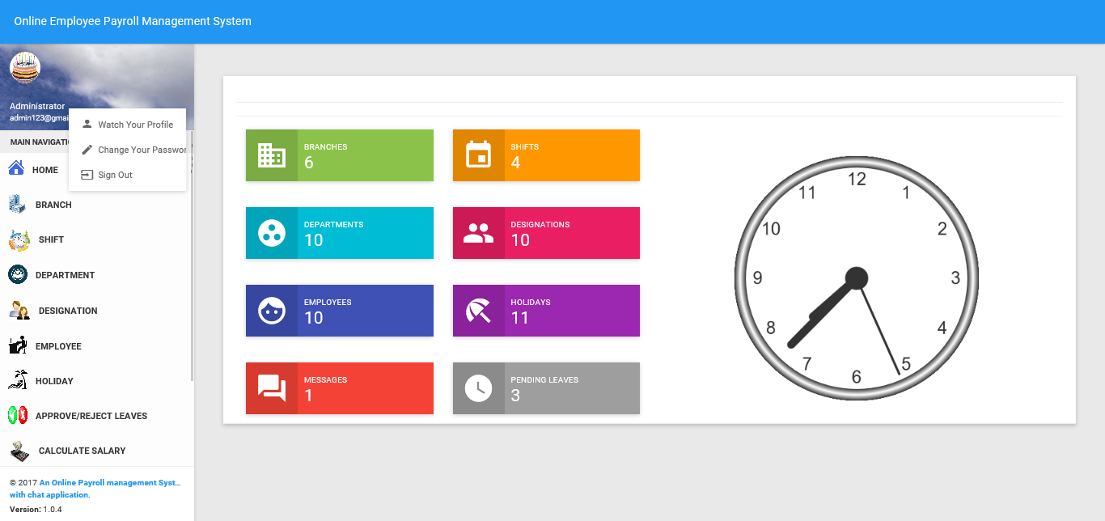

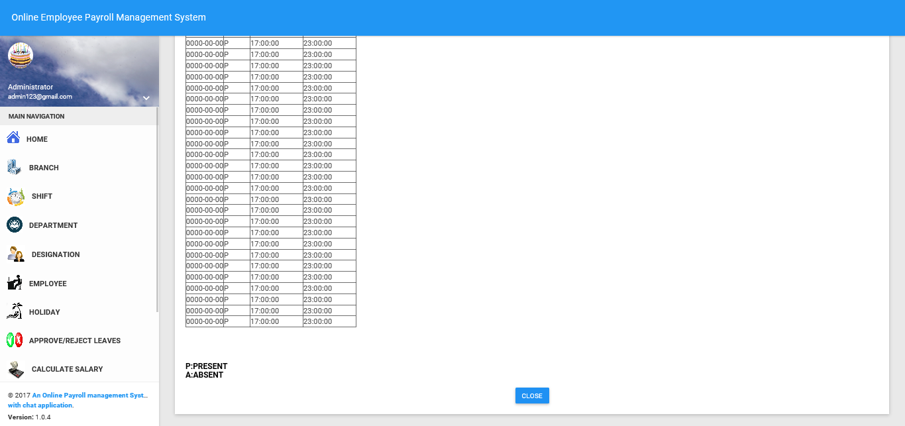

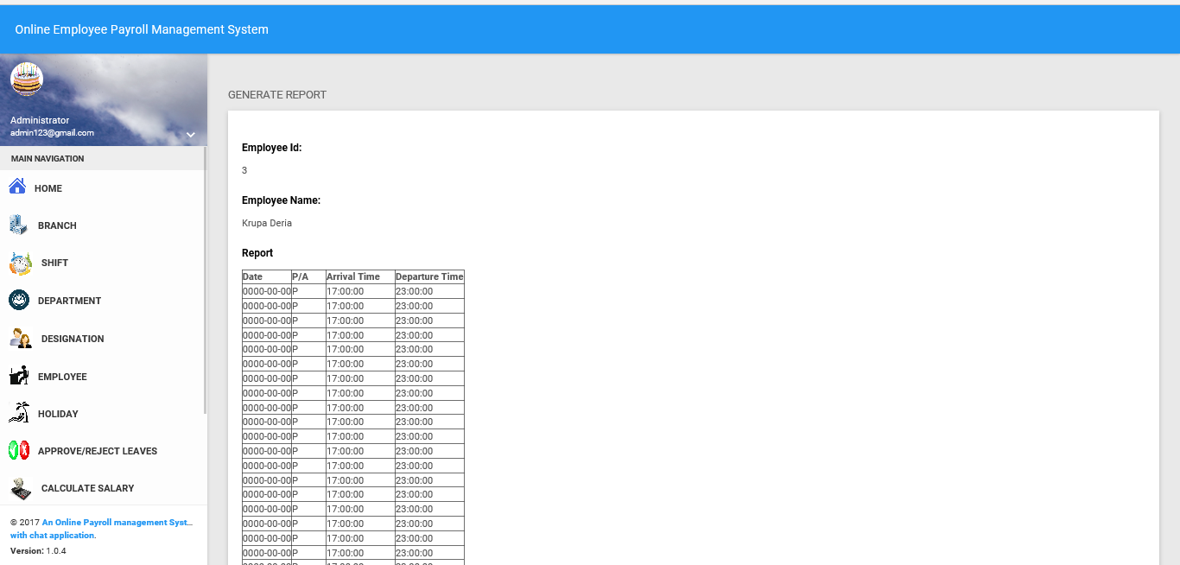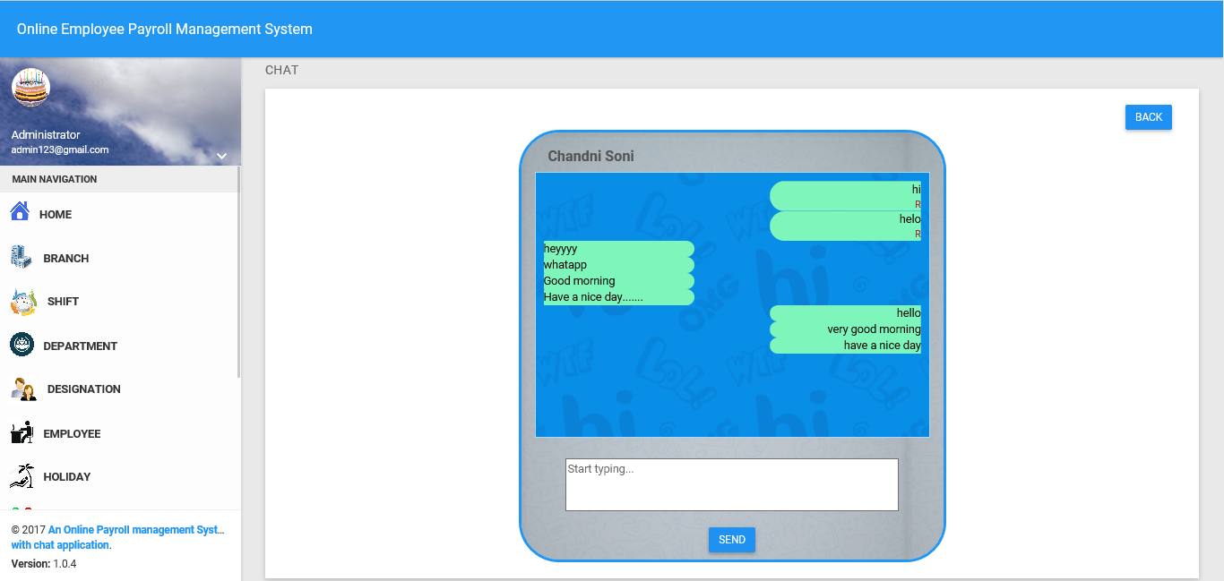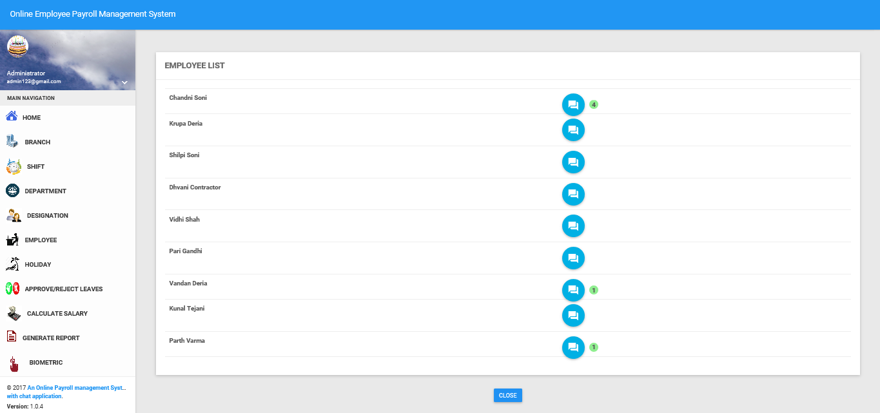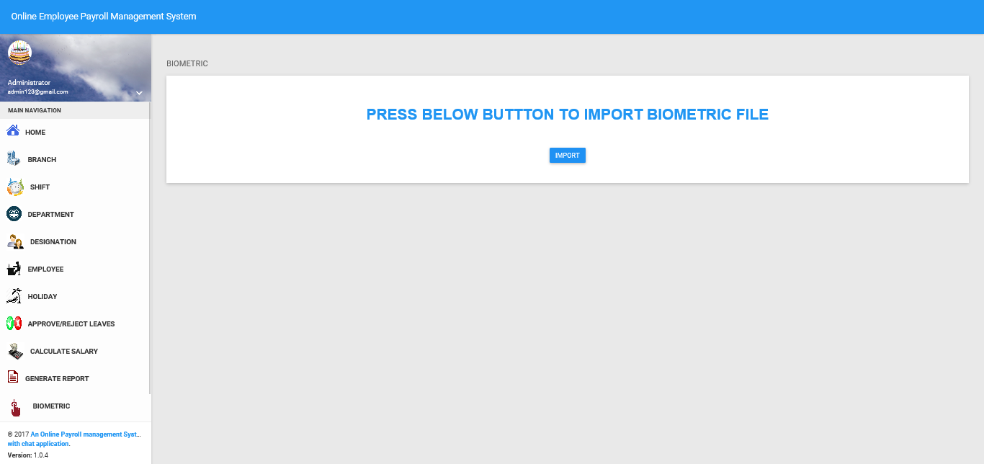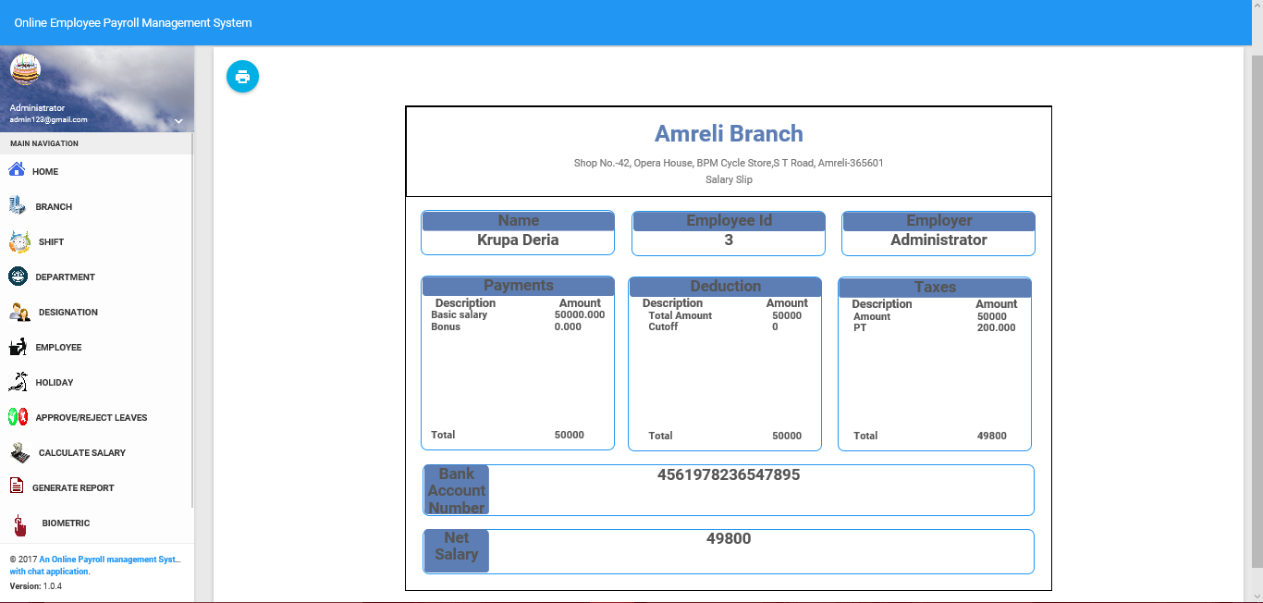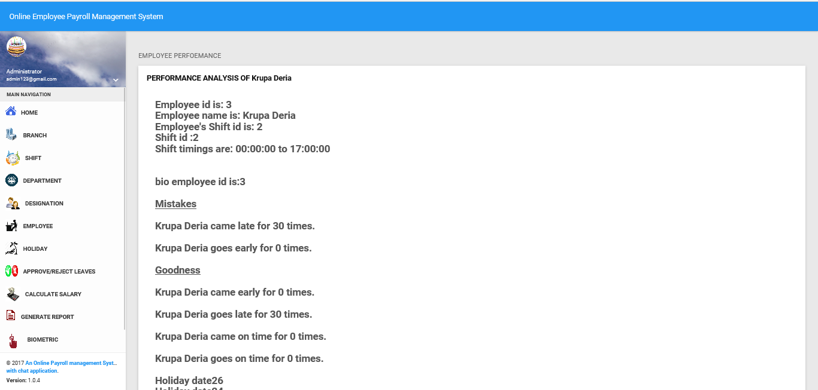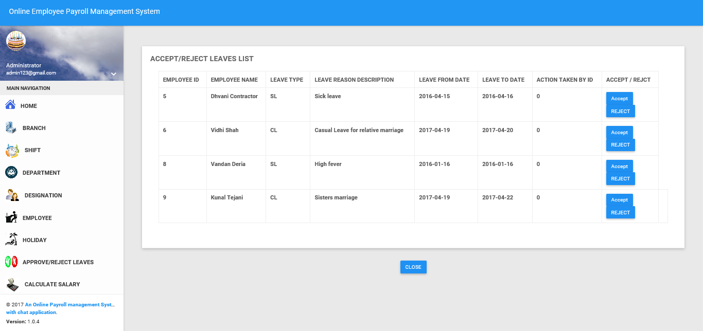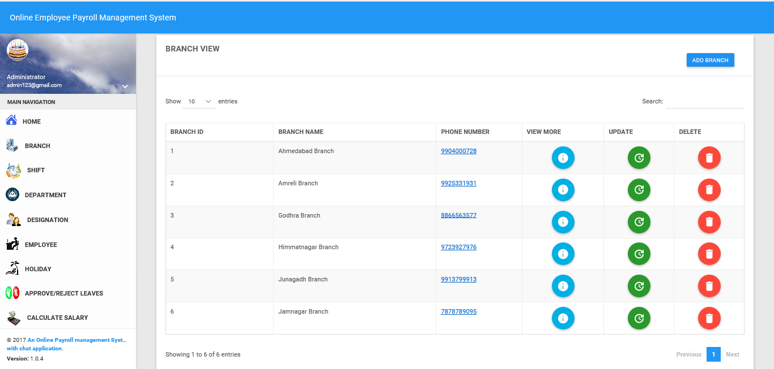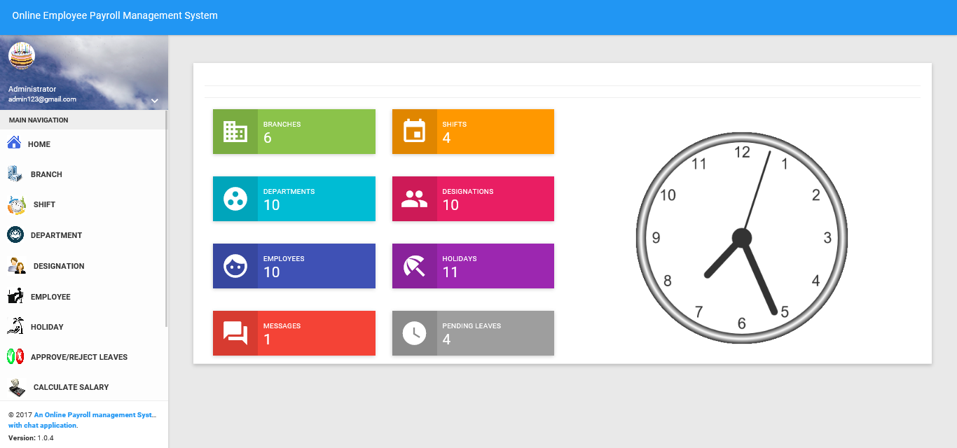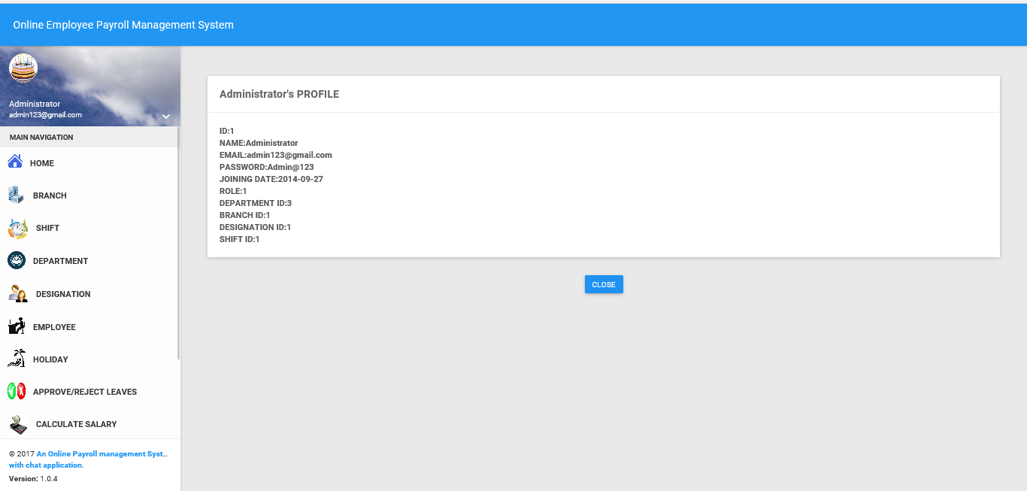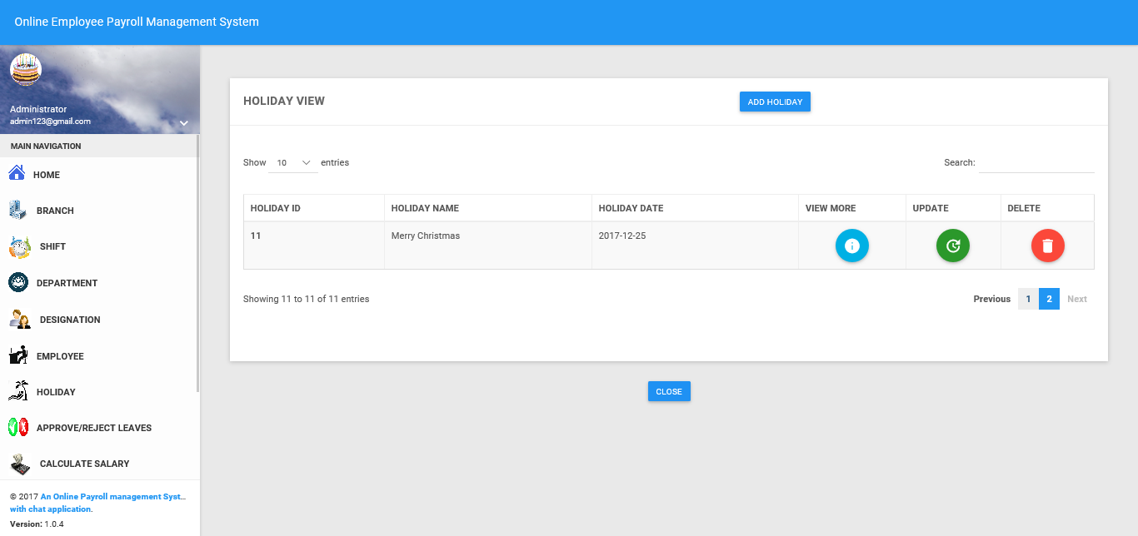

**7.VALIDATION**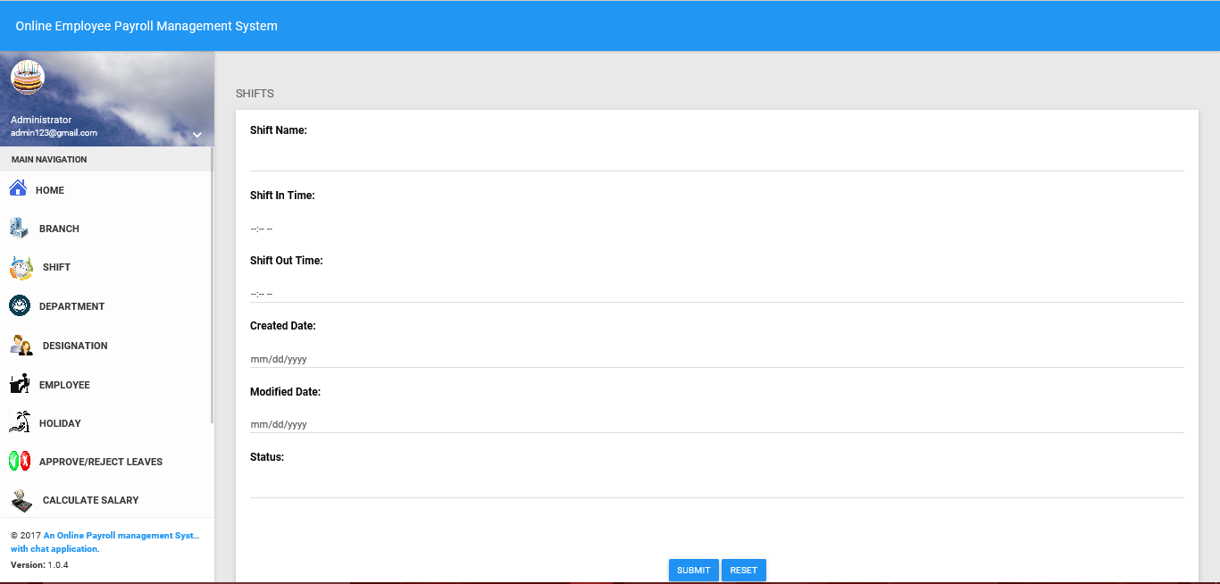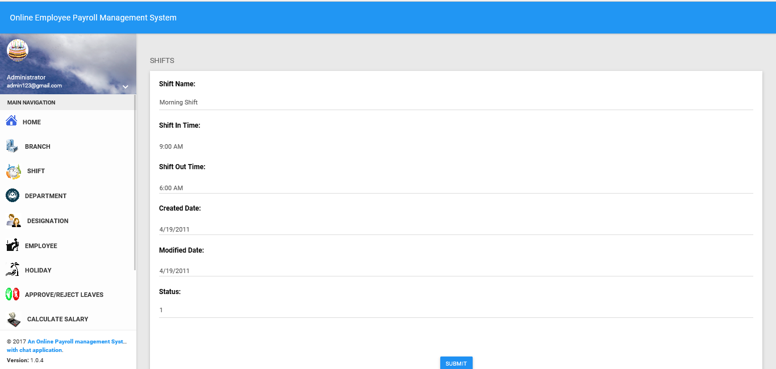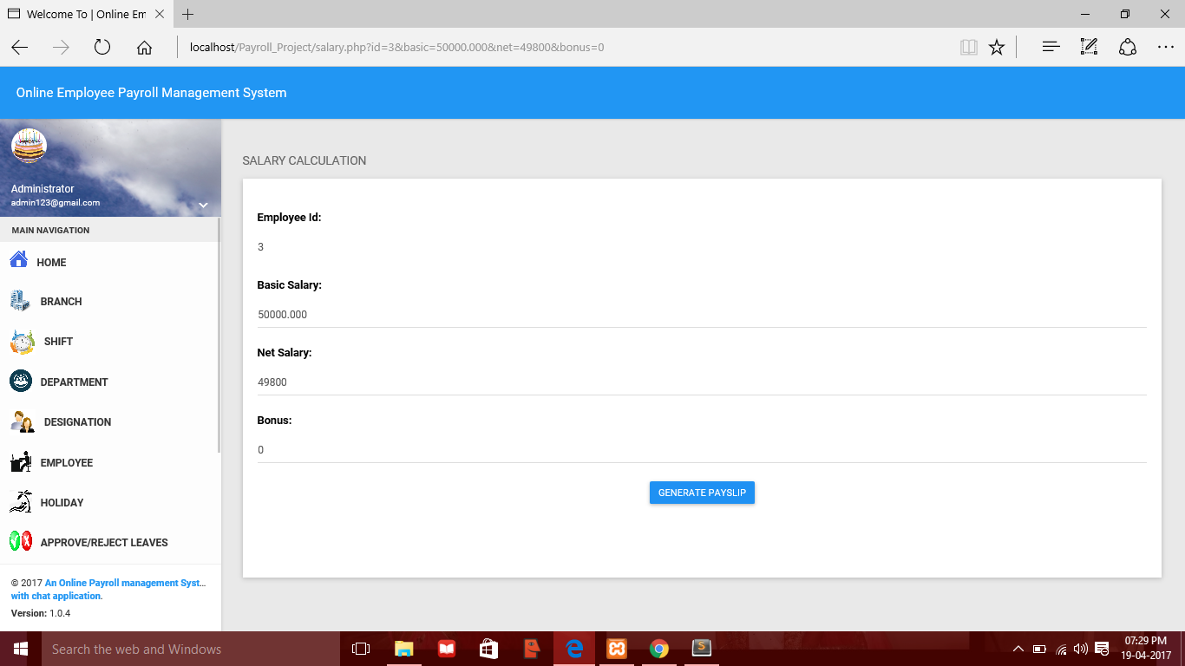

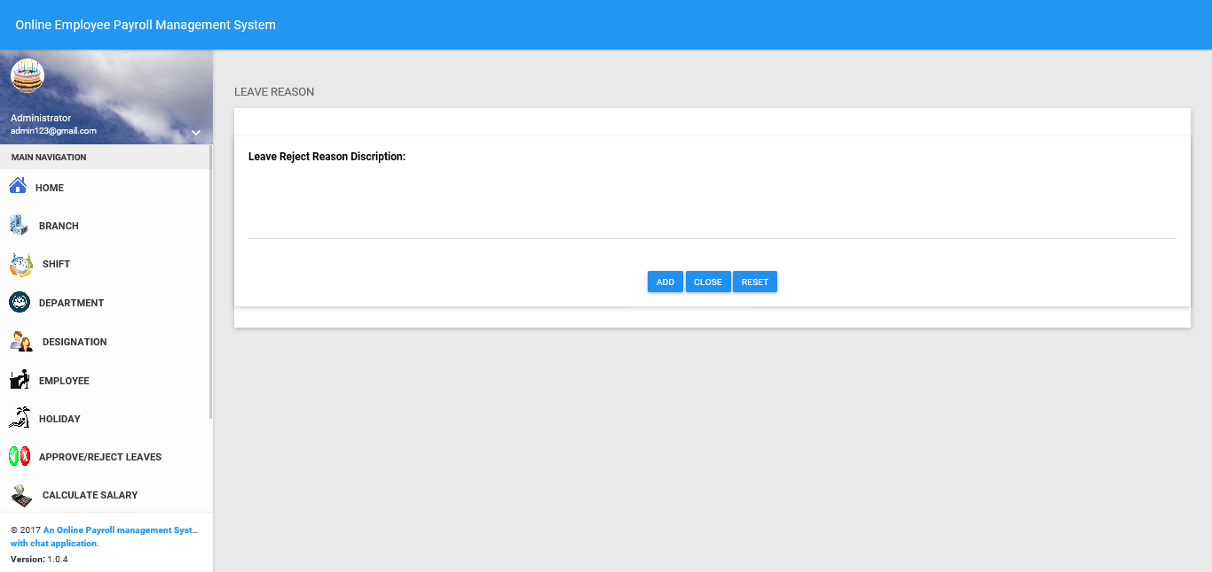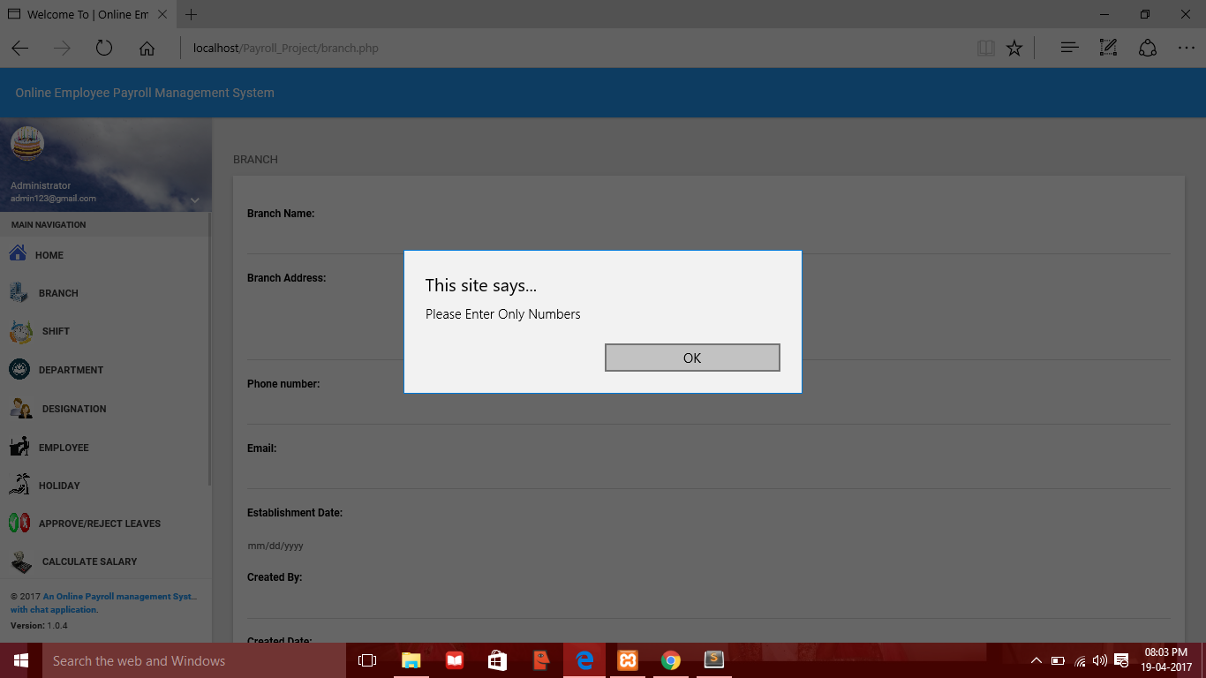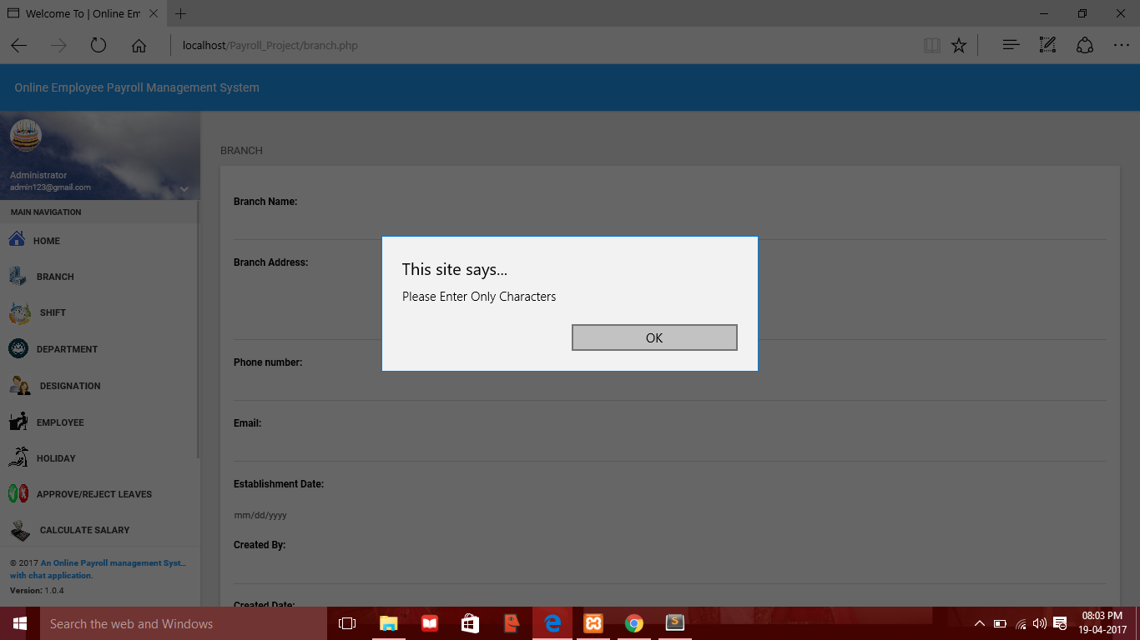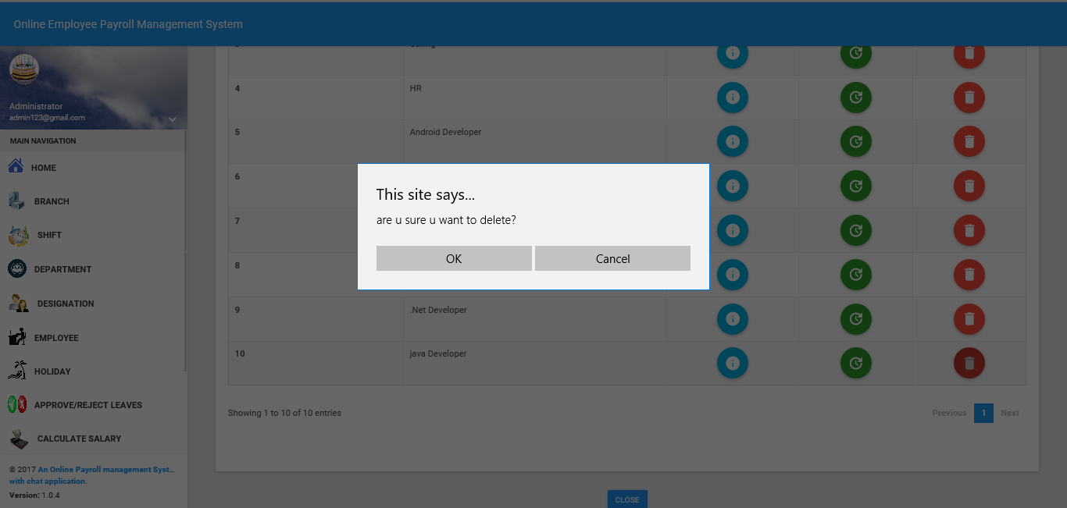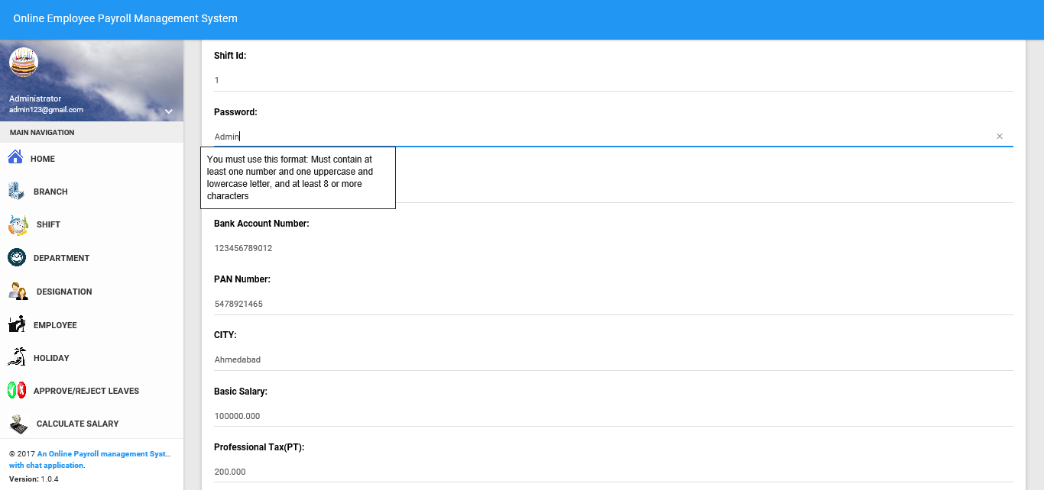

**8. MAINTENANCE**

* Rs. 235 per annum will be charged in future for mainatnenance cost of database.

**9. FUTURE SCOPE**

* Certificates related to payroll or training and experience achieved from company can be printed.
* Loan management feature can be added to provide loans to employees of company
* Online resignation feature can also be added to apply online resignation directly to the directors/CEO of company. The directors/ CEO can also approve/reject resignation on concrete basis of an employee.

**BIBLOGRAPHY**

* Software Engineering by Roger Pressman 7th edition

**REFERENCES FROM WEBSITES**

* www.w3schools.com
* www.academia.edu
* www.studymode.com
* [www.smartsheet.com](http://www.smartsheet.com)