1 **Introduction**

Like every industry, the world of hospitality changes continuously. As a strong economy and new technologies make travel more accessible to people around the world, the industry is growing and expanding in new ways. The hospitality industry in Canada is registering growing numbers year-on-year. Specific objective of this study was to explore the hospitality data of city of Toronto and to explore and compare two regions and their suitability for possible investments in the hospitality business. This report systematically reviews the data for Central Bay Street and St. James Town, aiming to provide a data-driven recommendation to investors on which area is more suitable for investment and which types of venues would most likely prosper in the given location.

* 1. **Background**

Toronto is the capital city of the Canadian province of Ontario. With a recorded population of 2,731,571 in 2016, it is the most populous city in Canada and the fourth most populous city in North America. Toronto is an international centre of business, finance, arts, and culture, and is recognized as one of the most multicultural and cosmopolitan cities in the world.

* 1. **Problem**

Toronto restaurant business is diversified into several distinct categories, and although there are a lot of new pop-up restaurant openings across the city each year, the classical cuisines remain to dominant the city culinary scene, namely: Italian, American, French, and Asian restaurants. Therefore, there are two primary aims of this study: 1. To investigate which of the mentioned areas is more suitable for a new restaurant opening 2. To ascertain which restaurant business is more suitable for the given region.

**1.3 Interest**

This project is aimed at possible investors interested in investments pertaining to the restaurant sector in Toronto.

1. **Data Acquisition and Cleaning**
   1. **Data Sources**

This report leveraged the list of city-designated neighbourhoods in [Toronto](https://en.wikipedia.org/wiki/List_of_neighbourhoods_in_Toronto) to obtain a detailed information pertaining to postcodes. These postcodes were further used to obtain a geographical data, specifically latitude and longitude, through Foursquare API. This step helped to best describe given neighbourhoods and to target the restaurant venues in both areas.

* 1. **Data Cleaning**

First, neighbourhood postcodes were converted into Pandas data frames. Next, by using individual postcodes, neighbourhood coordinates were obtained through Foursquare API (see Figure 1). Finally, datasets were grouped into different clusters which best represented the required data and then split into two final data frames: Central Bay Street and St. James Town. Additionally, several sub-datasets were extracted for various categories, namely: restaurants, cafés, and hotels.

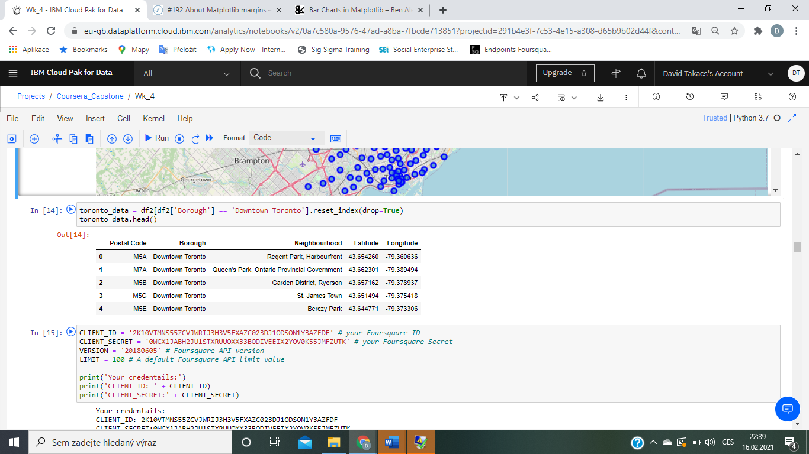

***Figure 1:*** *Original dataset*

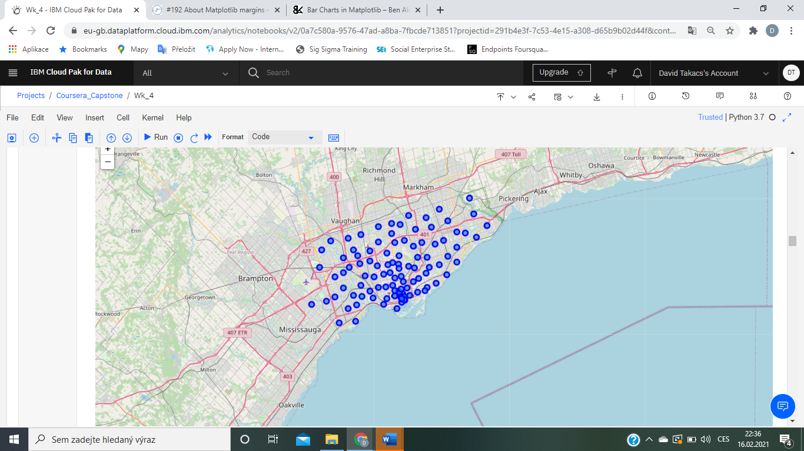

***Figure 2:*** *Neighbourhood coordinates visualisation*

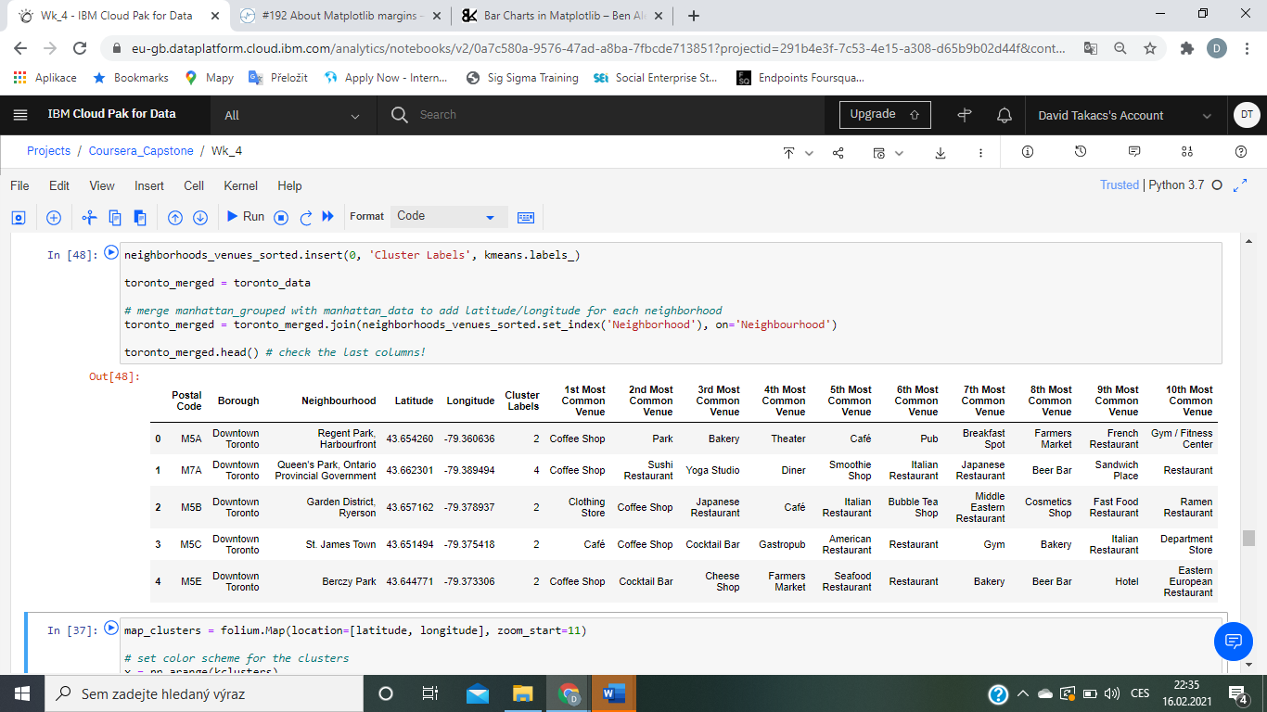

***Figure 3:*** *Final dataset with venues*

# **Methodology**

## **Sample Size**

The dataset chosen for this study included 1219 venues of various types from across Toronto (see Figure 3 for an example).

## **3.2 Data Analysis**

Data analysis included reducing venues from across Toronto into two categories: Central Bay Street and St. James Town. After these data frames were clustered, they were further examined to define what venues are most common in each area (see Figure 4). This method helped to determine overall infiltration of the hospitality sector in both neighbourhoods. Finally, each cluster was examined more in-depth, trying to look at the number of restaurants as well as their types in each neighbourhood in order to determine which neighbourhood represents a better potential for a new restaurant venue.

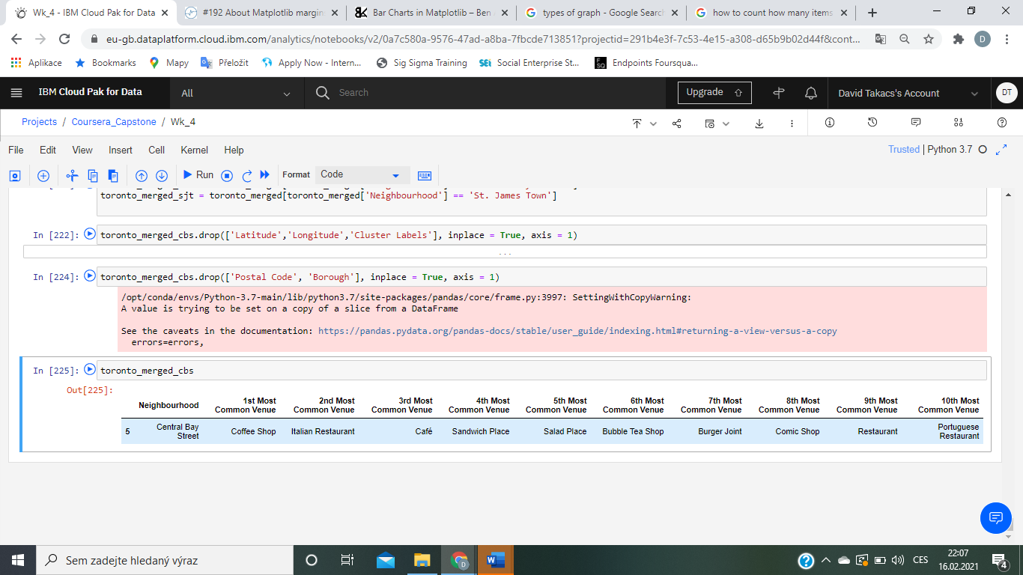

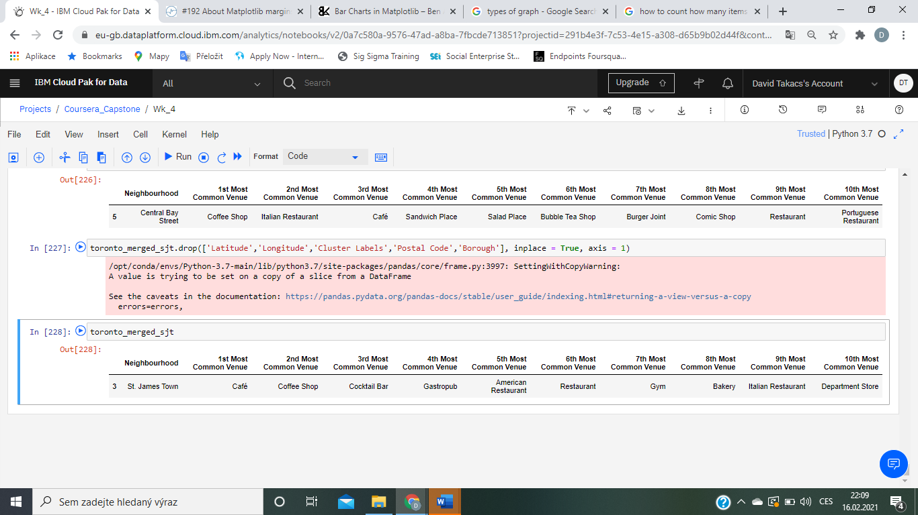

***Figure 4:*** *Most common venues in the target areas*

# **Results and Discussion**

## **4.1 Frequency of Restaurant Venues**

The initial analysis of restaurant venues in each neighbourhood suggests that although both areas might appear similar, their infiltration percentage is distinctly different. For example, as can be seen in Figures 5 and 6, St. James Town has over 30% more restaurant venues in its neighbourhood, which would suggest possible high barriers to enter the market, and therefore, make Central Bay Street more suitable for a possible investment. However, this recommendation has to be taken with caution as there might be other relevant factors such as the density of other venues such as hotels or tourism attractions which were not considered, and which could impact the restaurant density rate.

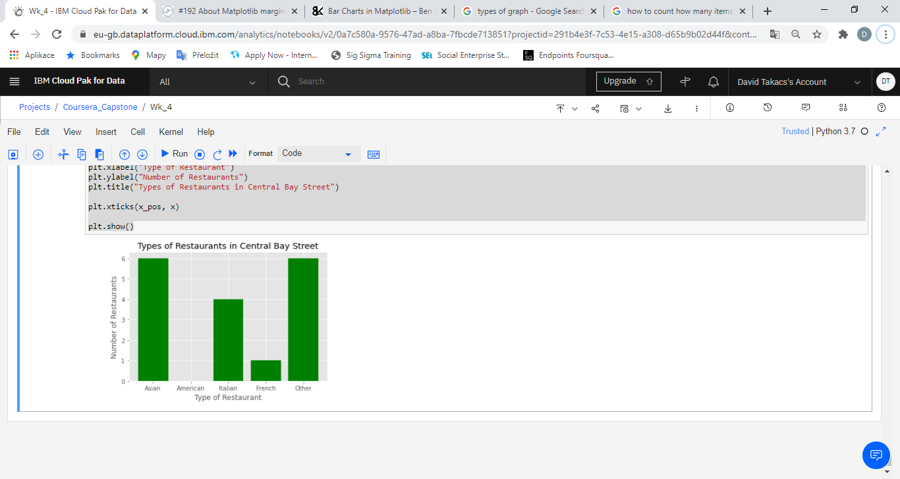

***Figure 5:*** *Numbers and types of restaurants in Central Bay Street*

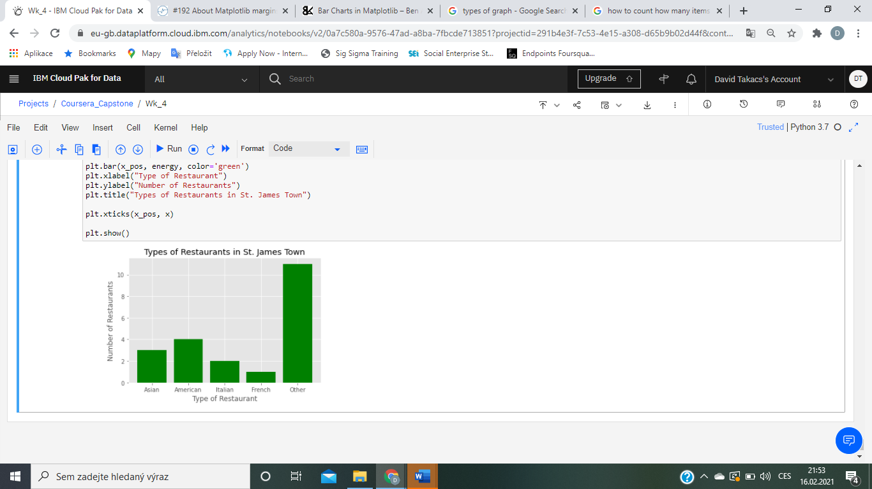

***Figure 6:*** *Numbers and types of restaurants in St. James Town*

## **4.2 Types of Restaurant Venues**

Next step of the analysis involved further examination of venue types in each area. This approach helped to determine which business type might face oversaturated market and therefore lower demand. As can be seen in Figures 7 and 8, each neighbourhood is infiltrated by different restaurant venues, while St. James Town appears to be highly fragmented which suggests lower market entry barriers, Central Bay Street seems to be dominated by two main restaurant venue types: Asian and Italian.



***Figure 7:*** *Restaurant types*

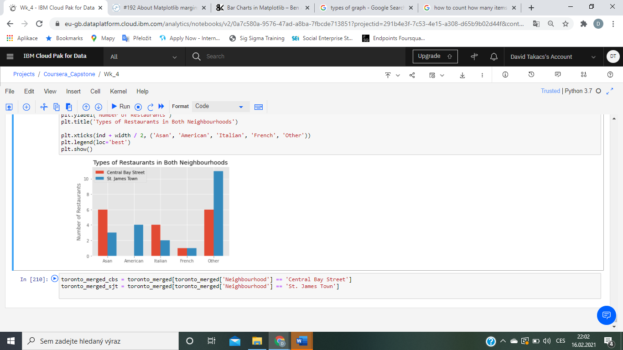

***Figure 8:*** *Comparison of the neighbourhoods*

## **4.3 Relationship with Other Venues in Each Area**

One variable that must be taken with caution is the presence of other venues in the area. For example, increased density of tourism attractions or other attention-attracting venues might represent a factor that might increase the possible popularity of a new venue such as restaurant. Our findings suggest, that although St. James Town is overpopulated with restaurants, there are also other venues such as hotels which might support the hospitality growth in the area. On the other hand, Central Bay Street has lower density of such venues which might suggest lower demand for hospitality services.

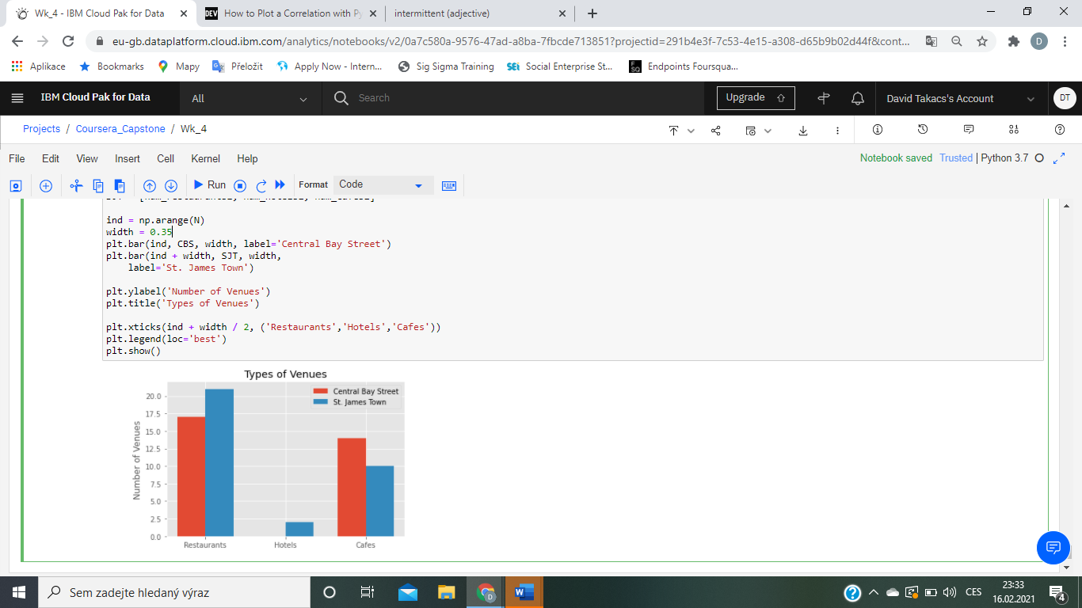

***Figure 9:*** *Representation of other venues in each neighbourhood*

# **Conclusion and Recommendation**

This report systematically reviewed the data for Central Bay Street and St. James Town to provide a data-driven recommendation to investors on which area is more suitable for investment and which types of venues would most likely prosper in the given location. After an in-depth analysis, it can be concluded that although St. James Town is more populated with restaurant venues, the market fragmentation is relatively high, which together with higher density of tourism venues, represents a better opportunity for potential investment. Therefore, taken together, St. James Town should be considered for as a future restaurant venue location.