**Sri Lanka Institute of Information Technology**

**Data warehousing and Business Intelligence**

**Assignment 2**

**Student Registration No: IT20178840**

**Student Name: Weerasinghe T.R**

**Step 1 – Data Source for the Assignment**

I used data warehouse database (MediTech_Analytics_DW) as the data source which I created in Assignment 1.In there , is the fact table and dimensions as fellows,

FactAttendance

DimPatient

DimAppointment

DimClinic

DimDoctor

DimHospital

DimTest

DimDepartment

DimDate

Also, I used snowflake schema to integrate them. I used these data to create OLAP cubes and to generate OLAP operations in Excel and prepare reports in Report Builder.

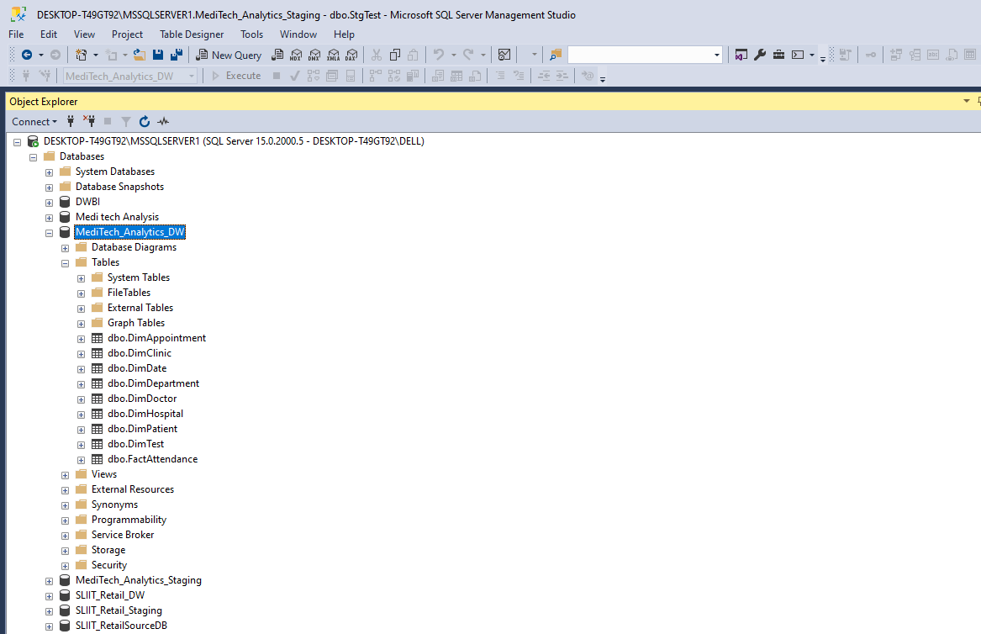

**Step 2 – SSAS Cube Implementation**

Used Tools :-

SSAS

SQL Server Management Studio

SSDT

When creating the OLAP cubes first I created Analysis Services Multidimensional and Data Mining Project on SSDT.

Then I renamed it as “DWBI Assignment 02” .Then we can see folder structure as follow,

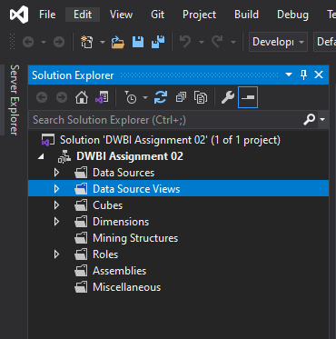

Then the following steps are done ,

1. **Create a Data source**

Under the Data Sources folder in above folder structure, and a new Data Source to create connection with my MediTech_Analytics_DW is added and renamed as DS_ MediTech_Analytics_DW .I used windows login credentials to connect

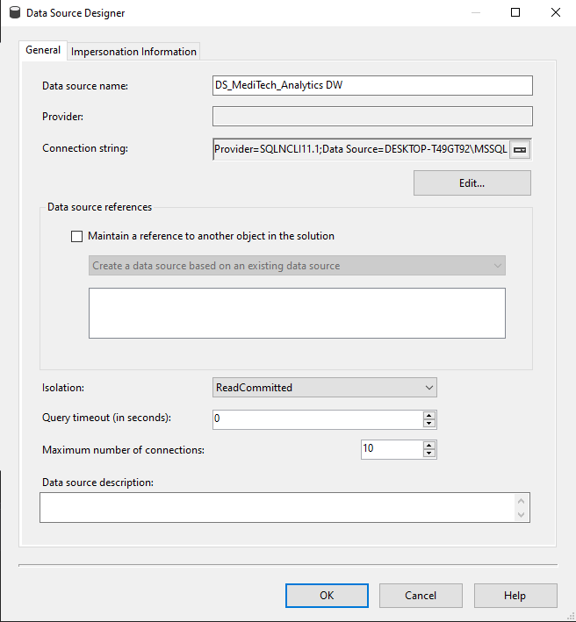

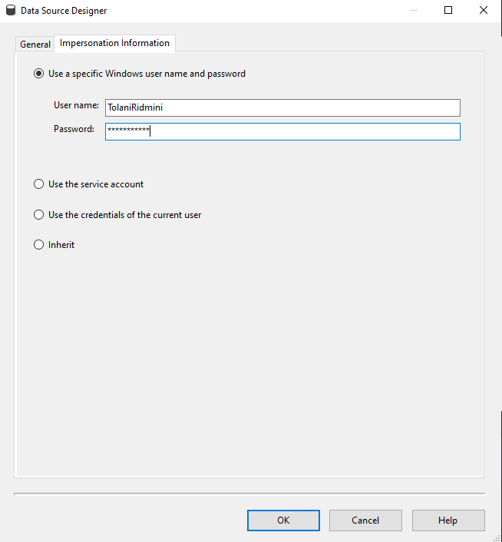

1. **Create a Data Source View**

Under the Data Source Views folder , I added new data source view called DSV_ MediTech_Analytics_DW.

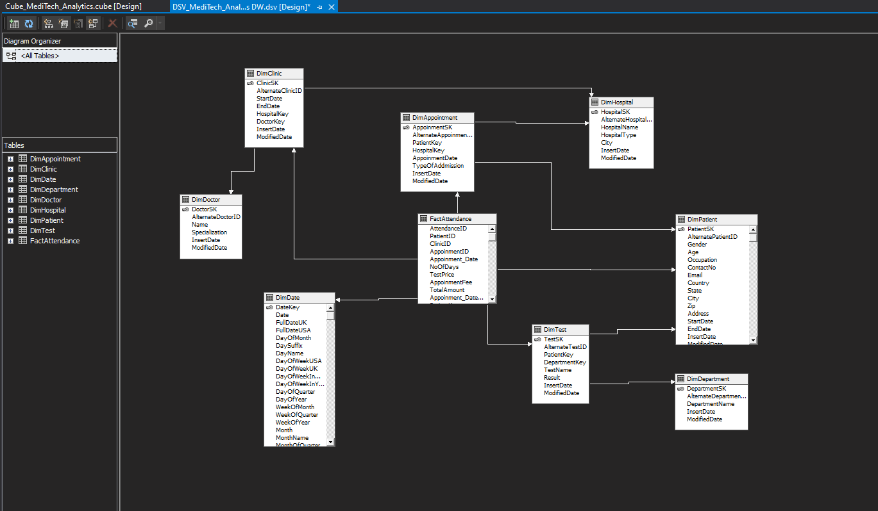

1. **Create a Cube**

Under the Cubes folder I created new cube using above data source view called Cube_ MediTech_Analytics_DW.

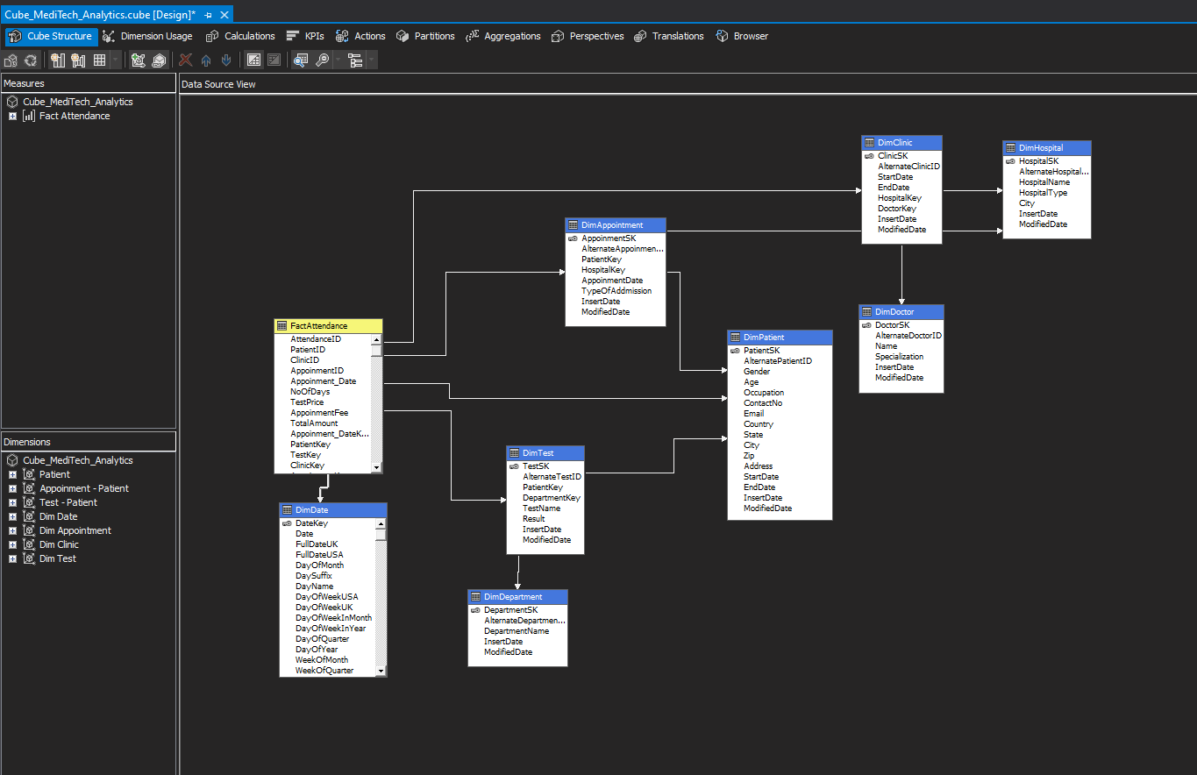

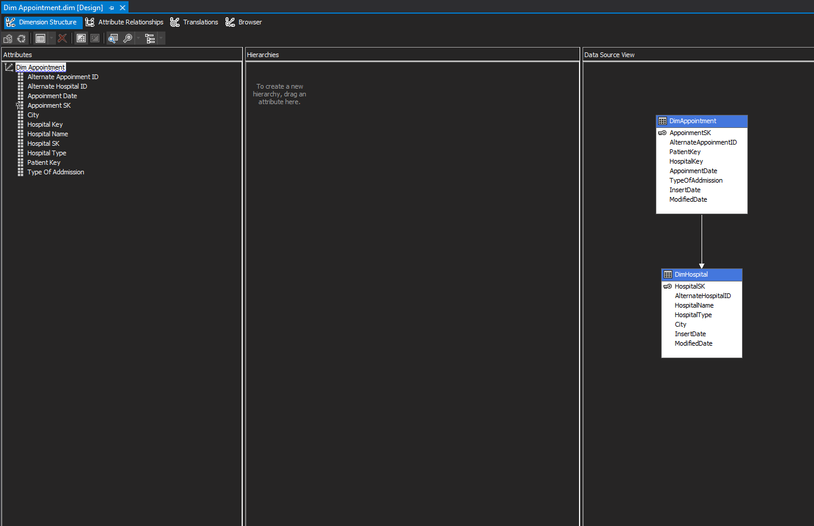Then I added attributes to all dimensions and created hierarchy to relevant dimensions.

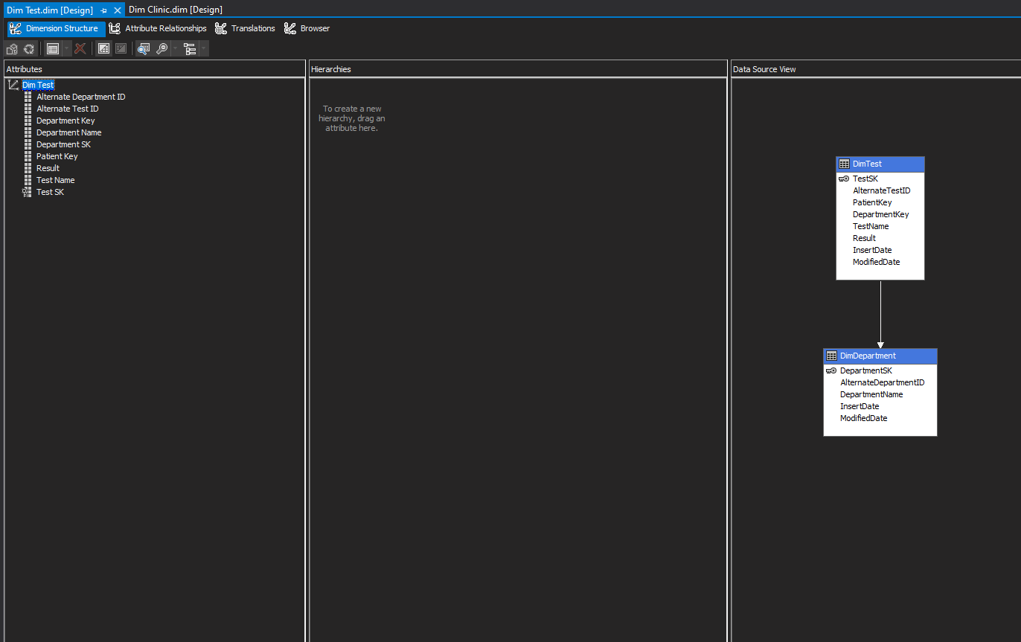

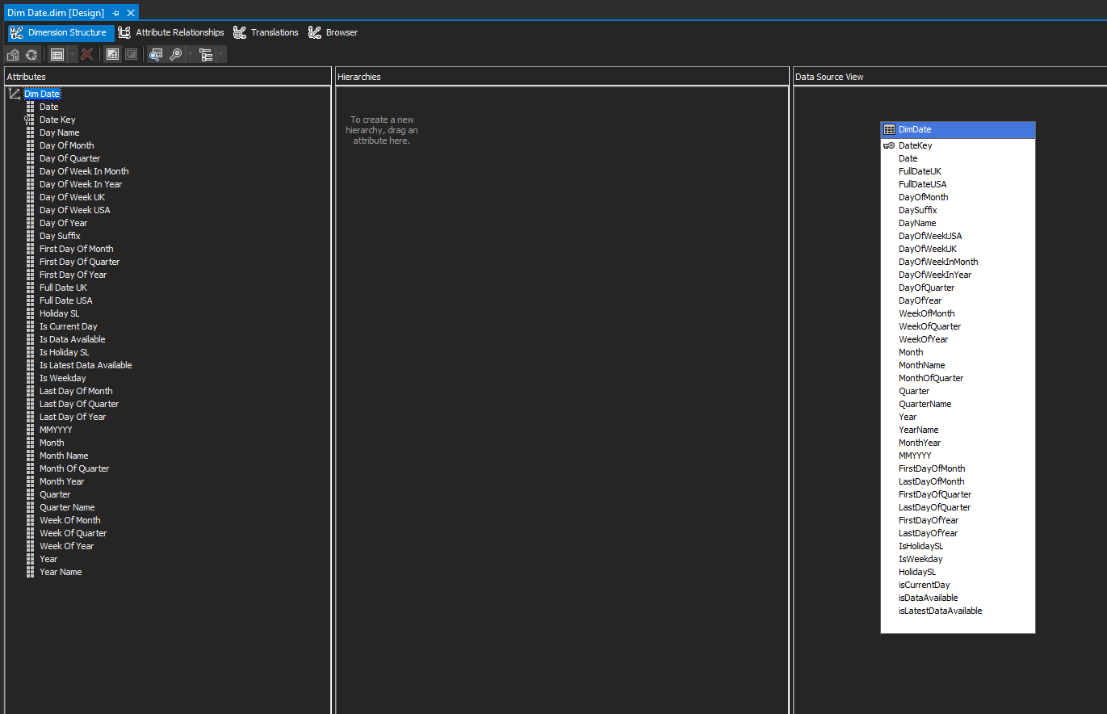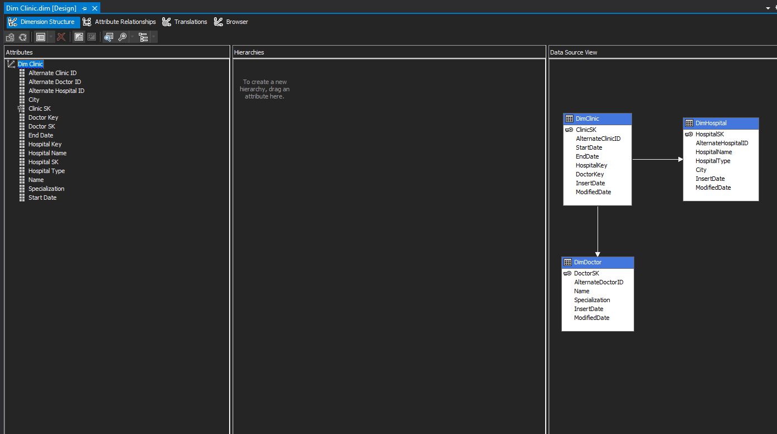

Hierarchy are created.

DimPatient

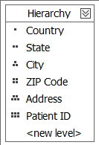

After been deployed folder structure is shown as below,

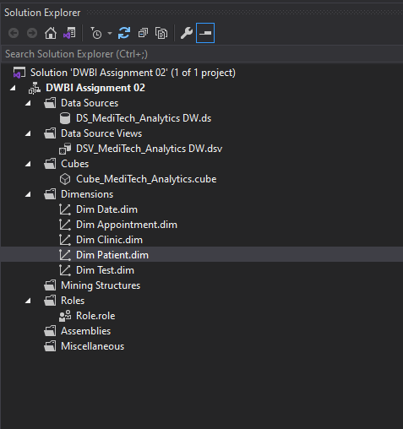

**4.Deploy the Cube**

After finishing all the above steps, the cube is deployed. If it is successfully deployed a message is displayed signifying deployment’s success as shown below.

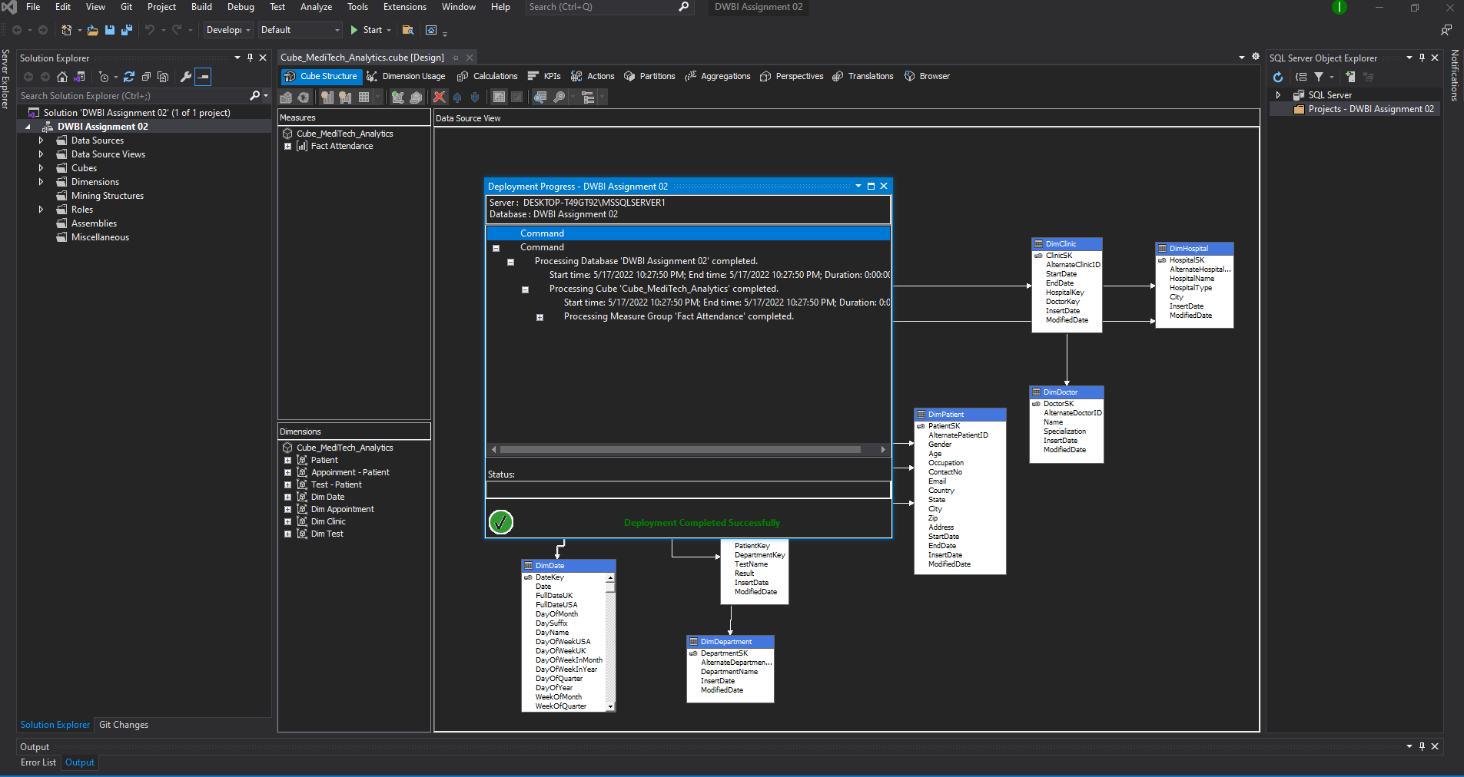

**5.Create KPI**

KPIs are developed based on the needs of the company. It is a measurable value that shows how well a corporation accomplishes essential business objectives. KPIs are used by businesses to assess their progress toward achieving their objectives.

Following Figure shows the KPI which I created after the deploying cube. These are the KPI values which created for MediTech_Analytics. It can be used for determining how much of patients paid more than $4000.

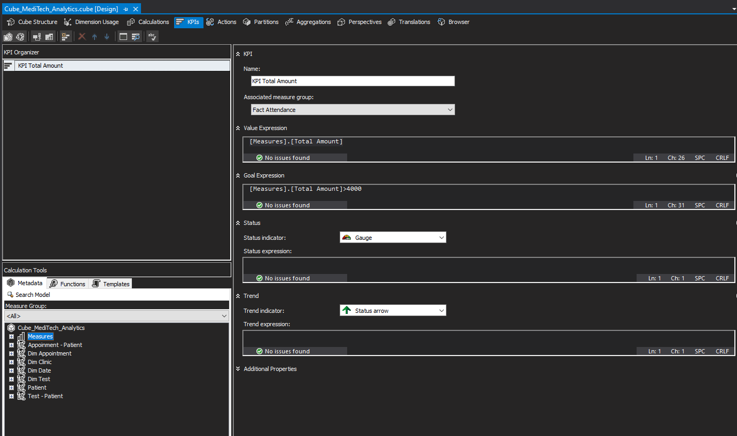

1. **Browse Cube Data**

Browsing data is done via using SSMS. By connecting SSAS to SSMS using instance and MDX queries can generated by selecting the relevant fields from the dimensions.

When browsing cube data, a KPI value or measurement value is compulsory .Otherwise it will not be executed.

Below figure shows how to browse data in SSMS,

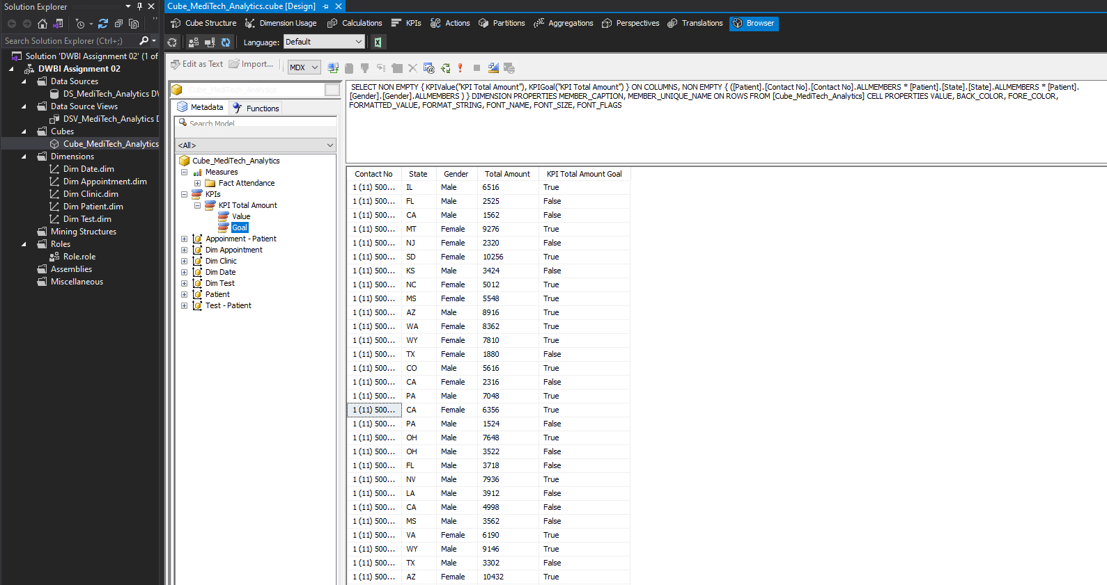

**Step 3 – Demonstration of OLAP Operations**

Used Tools :-

Excel

SQL Server Management Studio

SSAS

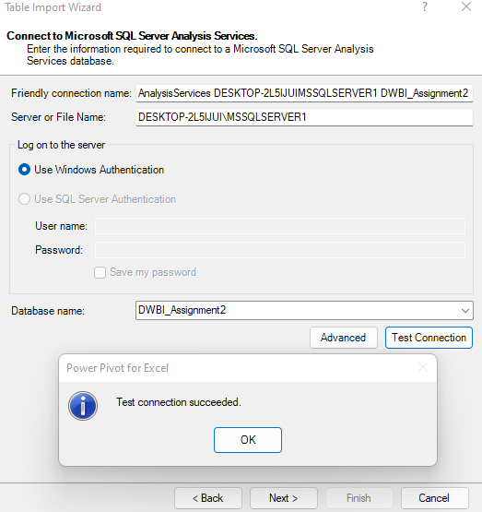To display the OLAP operation first , the Excel is connected to SSAS cube using MDX query. MDX query is created using above process . And below picture show how to connect the Excel to SSAS Cube successfully.

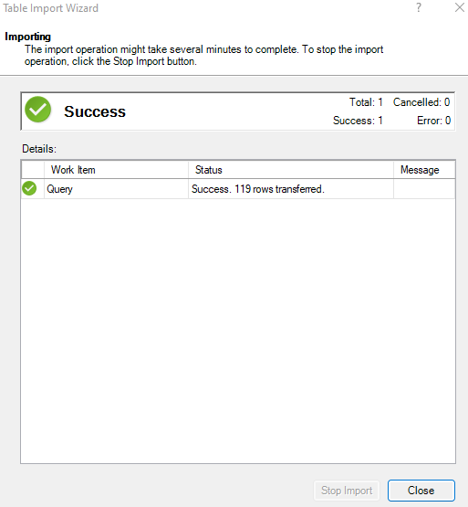

1. **Slice**

Slices are visual filters that can be used to filter data in a pivot table or chart. For the pivot table and pivot chart, I utilized two slices, one for each.

The slices I used to filter my pivot table and pivot chart are shown in the diagram below.

In this excel sheet I added the slicers on Department, when I clicked the Department, I can get the Total NoOfDays which patients attends , Sum of Test Prices and sum of Total amount according of the selected Department. Also, we select more than one department and get details from multiple selections.

And the chart showed Department-wise, Total NoOfDays , sum of Test Prices and sum of total amount.

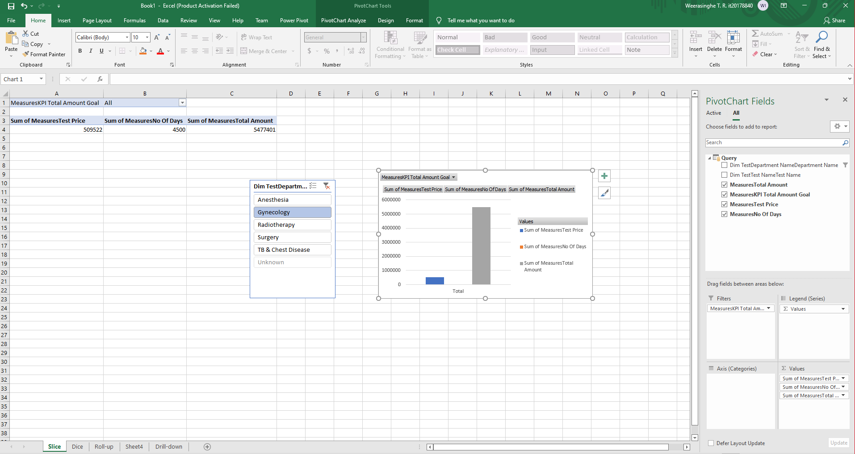

1. **Dice**

Selecting appropriate qualities to group the data by is referred to as dicing the data.

To analyze the data in the pivot table and pivot chart, I utilized two slicers. Those are TestName slicer and DepartmentName slicer. Then, I grouped data according to TestName and DepartmentName .

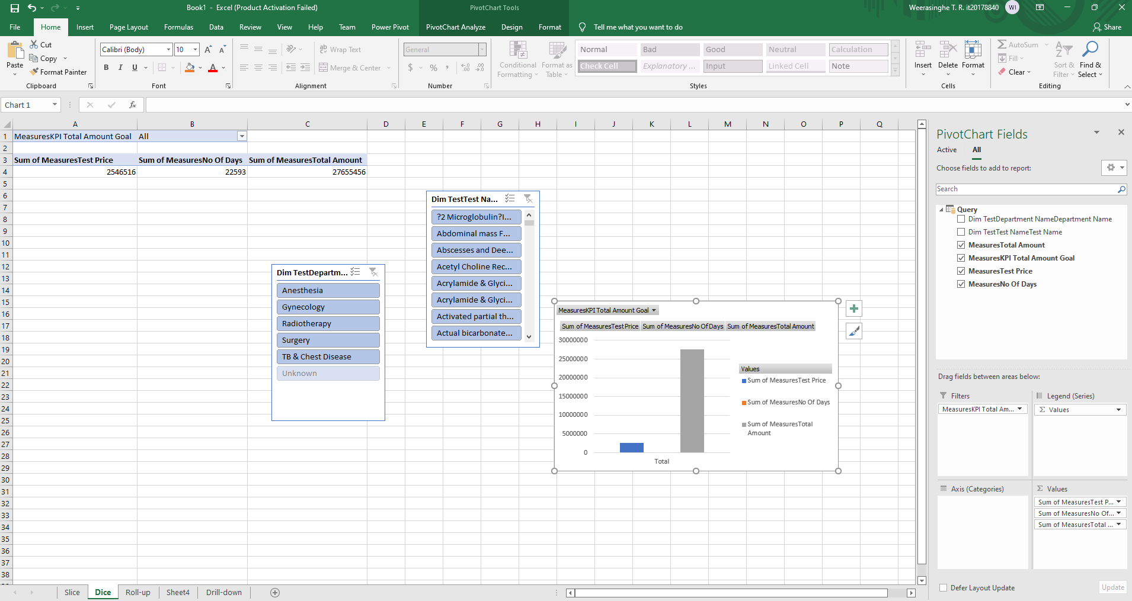

**3.Roll-up**

Climbing up a hierarchy of a dimension to aggregate data is what the Roll up OLAP function in cubes signifies.

In this following excel sheet shows Test price and Total Amount of the patients and NoOfDays they attend to the Clinic.

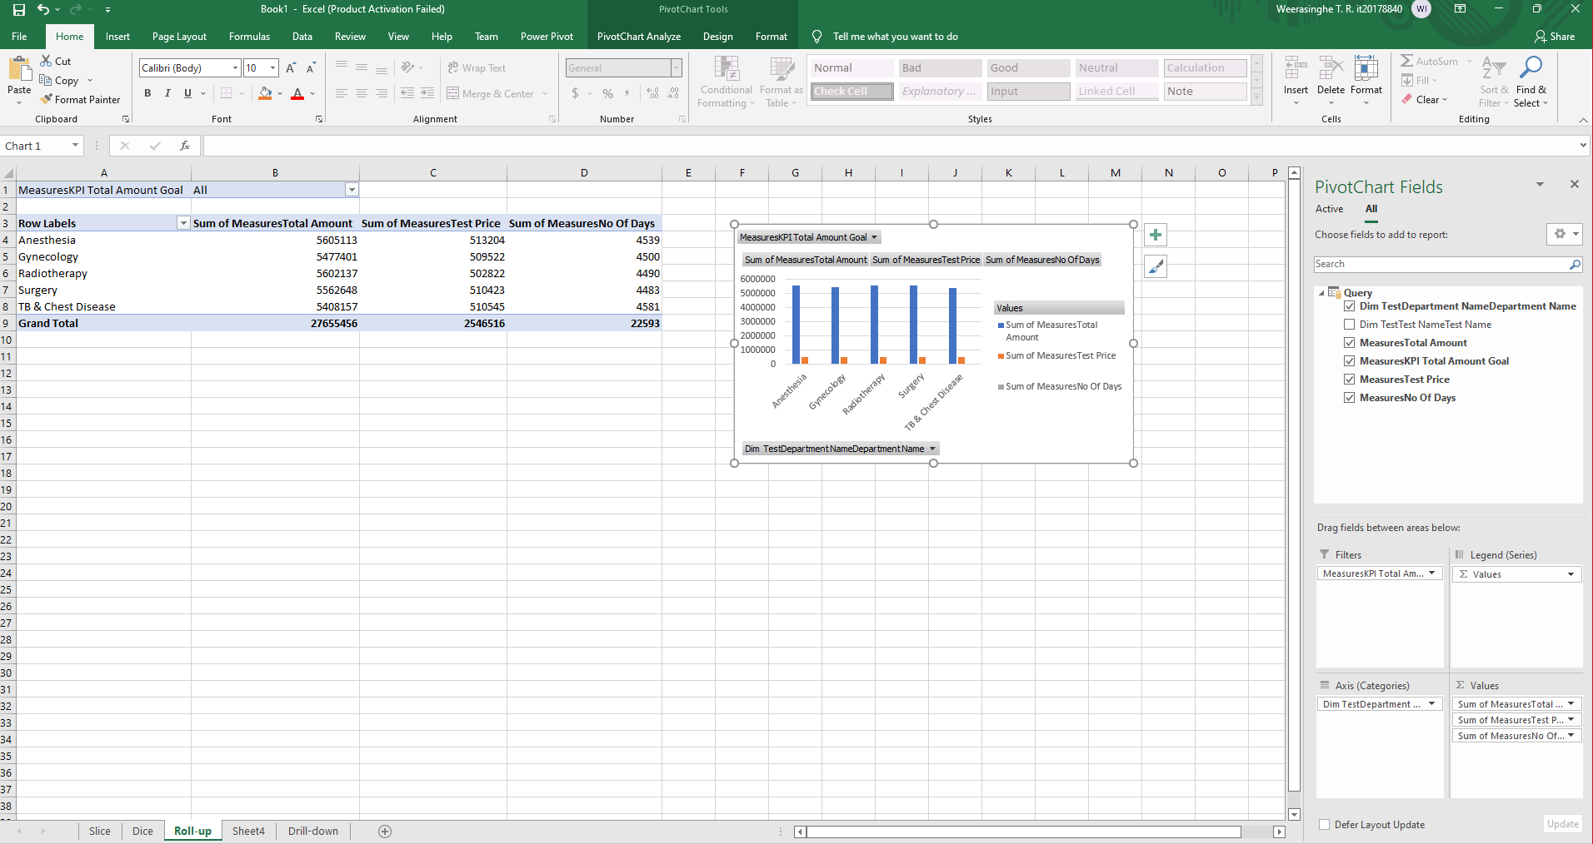

**4.Drill-down**

In cubes, the drill down OLAP function entails navigating through details by moving down a hierarchy of a dimension.

we can view the Test Price and Total Amount TestName wise. This process is the opposite of the roll up operation.

And the graph shows TestName wise sum of Test Price and the sum of Total Amount.

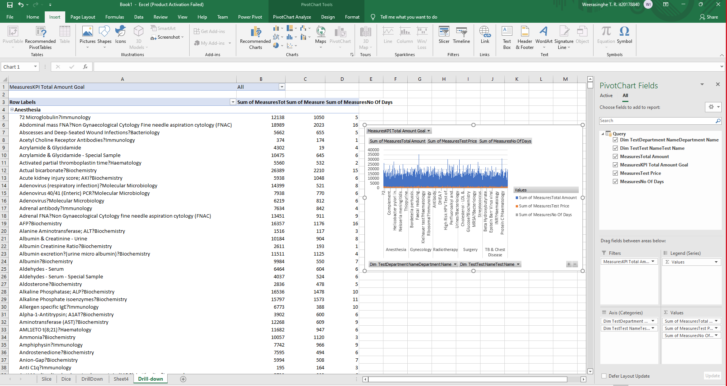

**Step 4 – SSRS Reports**

Used Tools :-

Report server

SSRS web portal

Report Server Configuration Manager

Report Server database

Below figure show the web portal view . In there, the created paginated reports and SSRS folder is displayed .

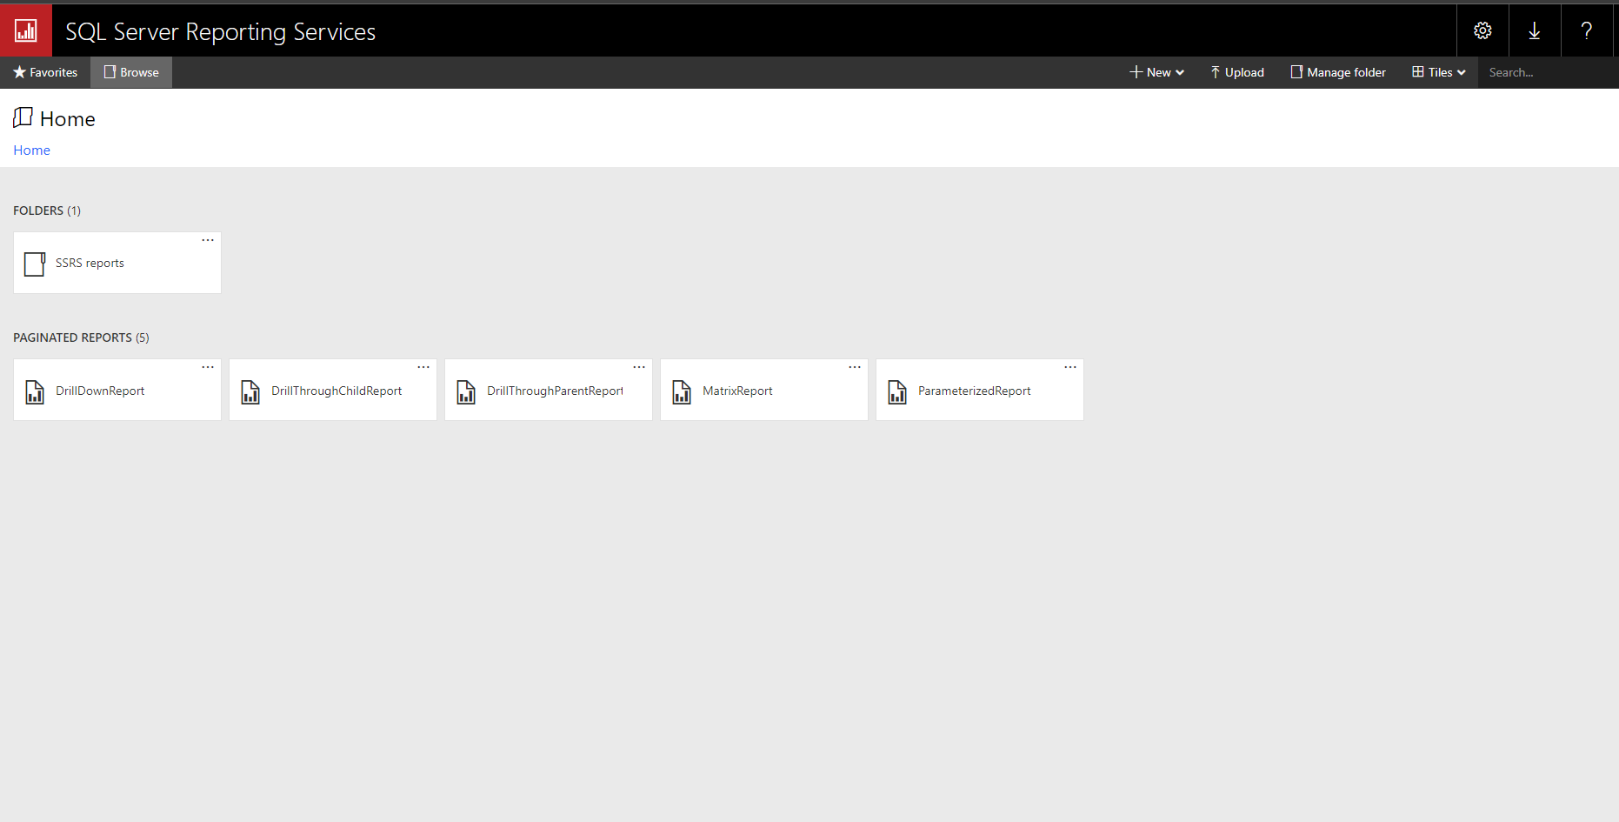

1. **Report 1 : Report with a matrix**

Below report shows year wise test pieces and total amount according to test name clicking the plus sign results can be expanded and will be able to get details from test by test.

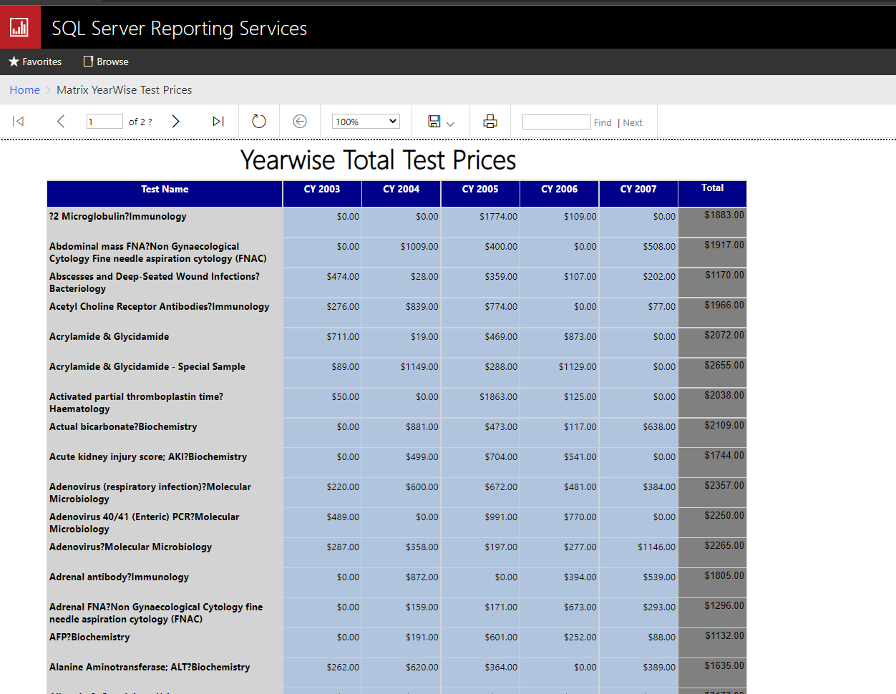

1. **Report 2 : Report with more than one parameter**

In this report I used two parameters of DoctorSK and Department. And multiple options can be selected in the parameter.

Then, it can be can selected values from department drop down and doctorSK drop down and then relevant details related to parameter values is displayed.

Below figures shows two parameters and the result reports of them.

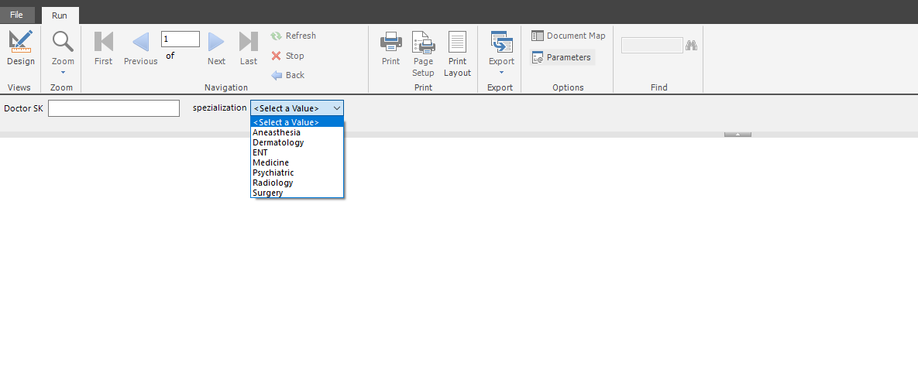

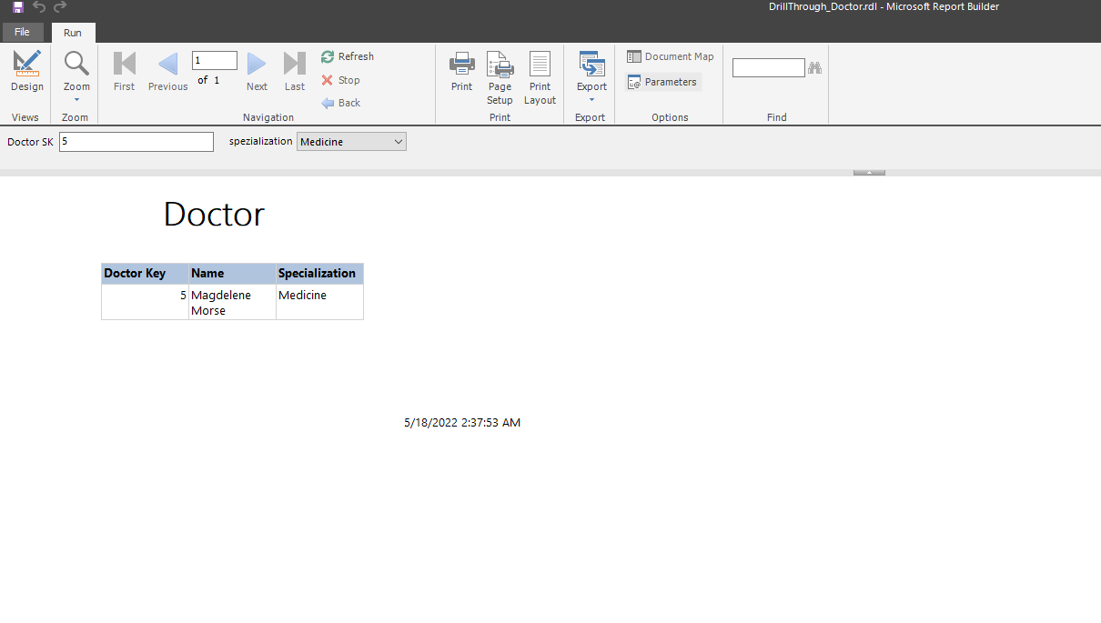

1. 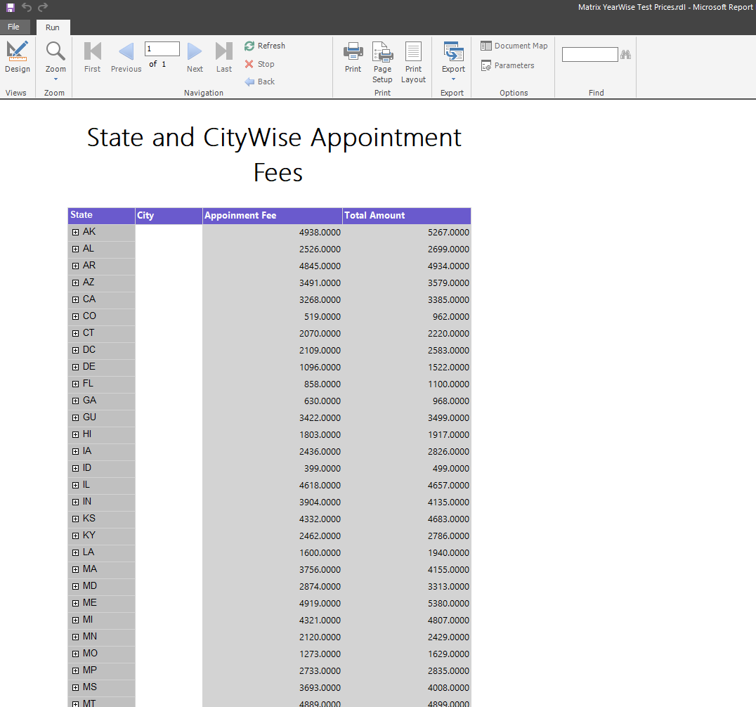**Report 3 : Create an SSRS drill-down report.**

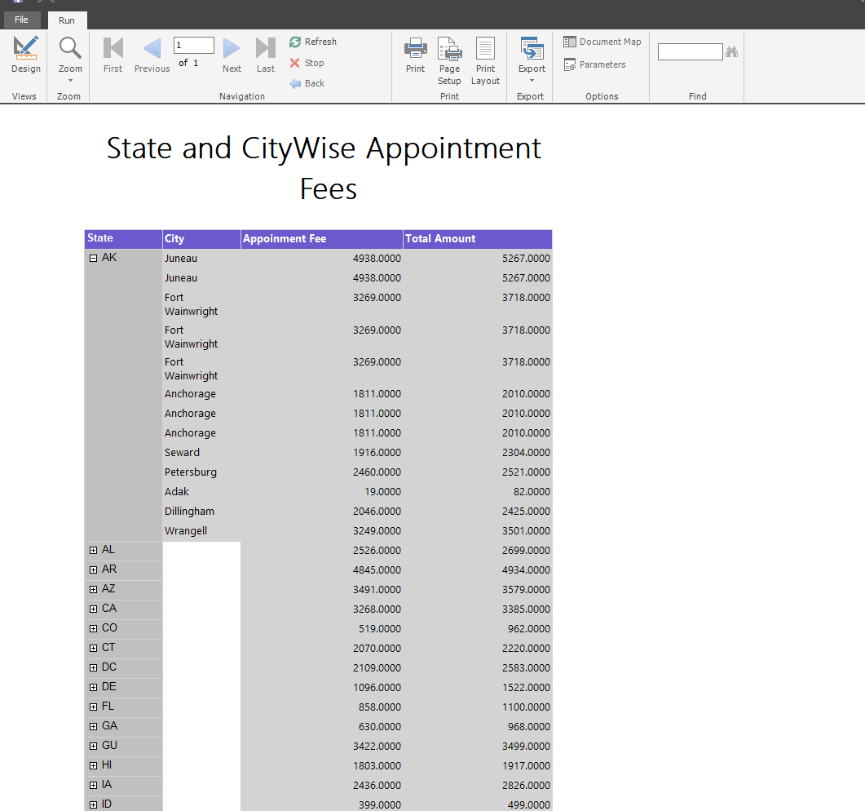

Drill Down Reports allow users to Show or Hide Column Data by using plus and minus symbols.

In here we can view cities are hidden by providing a plus sign. It can be expanded by clicking plus sign to see other hidden fields. In this table, we can find a particular Appointment Fee and Total Amount of the patient by clicking the relevant state and dropping down the correct information from the hierarchy.

1. **Report 4 : Create an SSRS drill-through report**

A drill-through report is one that a user accesses by following a link from another report. Drilling down through a report opens a new window with an entirely different visualization or report.

In this report is visualized health camps according to hospital types. The complete health camp is divided to three health camps where different test are conducted .Then it was used to get the action function of the diagram to get detailed report of the related health camps .

Below figures shows that graphs and detailed reports of each health camp

