* Intro message
* Main page
* Main menu
  + Define Bio Protocol
    - Intro Denaturing
    - Denaturing
    - Annealing
    - Extension
    - Final Extension
  + Load Bio Protocol
    - Dog.txt
    - Cat.txt
    - Horse.txt
    - Tulip.txt
  + Cooldown
  + Settings
    - PID calibration
    - Buzzer On/Off

This is the introduction message after the activation of buzzer (x2 beep) then the user is ready to explore the menu.  
Image 1 Intro message

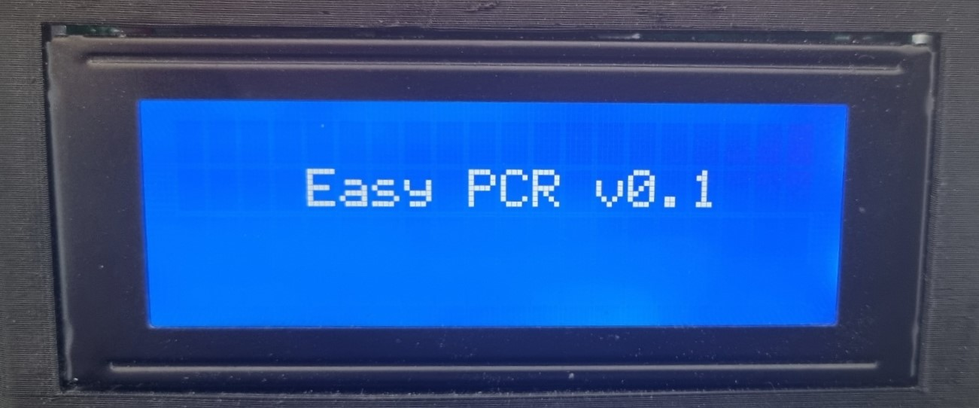

1st line: It appears the stage of each bio protocol (Intro Denaturing, Annealing, Extension, Final Extension)  
2nd line: It appears the temperature of LID heater, left side the current temperature, right side the set temperature which in our case is 100’C  
3rd line: It appears in the left side the temperature for the peltier module (current temperature and set temperature). Also the completion of cycles will demonstrate in that line on the right side.  
4th line: The progress of the whole PCR experiment will appear in %  
Image 2 Main page

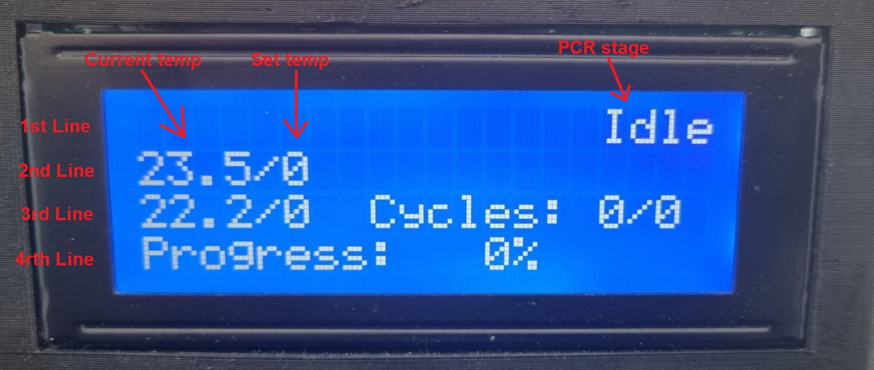

By clicking the push button a menu will appear in the LCD. Rotating the encoder the ‘ > ‘ will move and indicate in which sub-menu will select.  
Image 3 Main menu

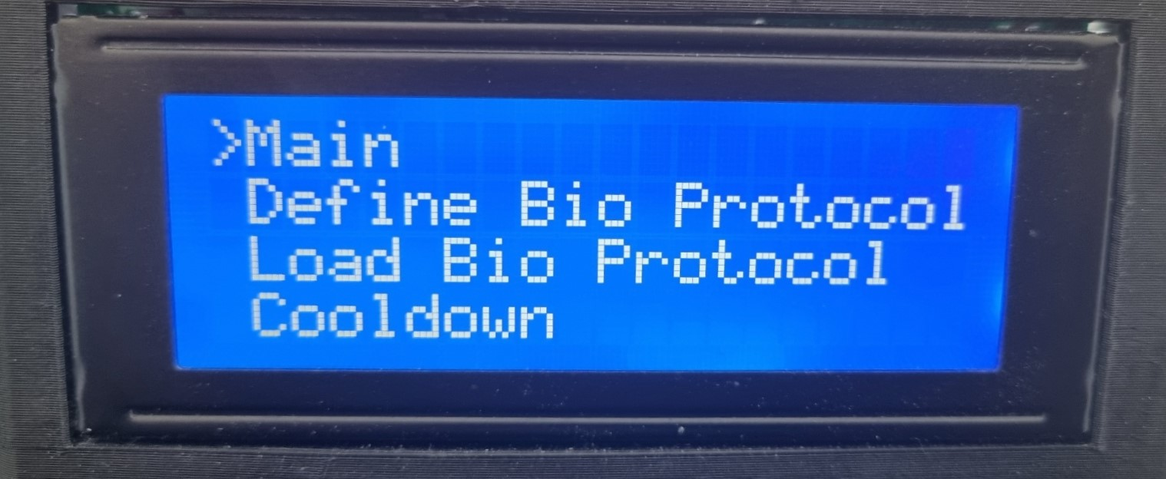

Define Bio Protocol:  
Image 4 Define Bio Protocol

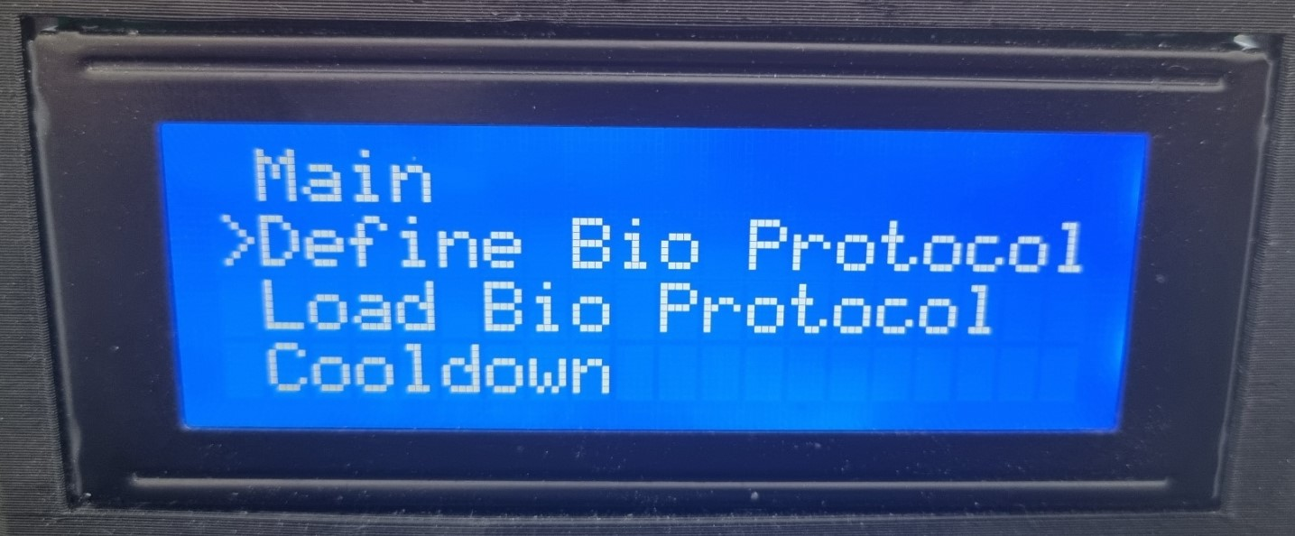

The first stage is Intro Denaturing, the user should define the Temperature, the duration in seconds (min 10 seconds, max 300 seconds. There is a choice to go ‘Back’ in the main menu or select ‘Next’ to continue with the definition of the bio protocol.  
Image 5 Intro Denaturing

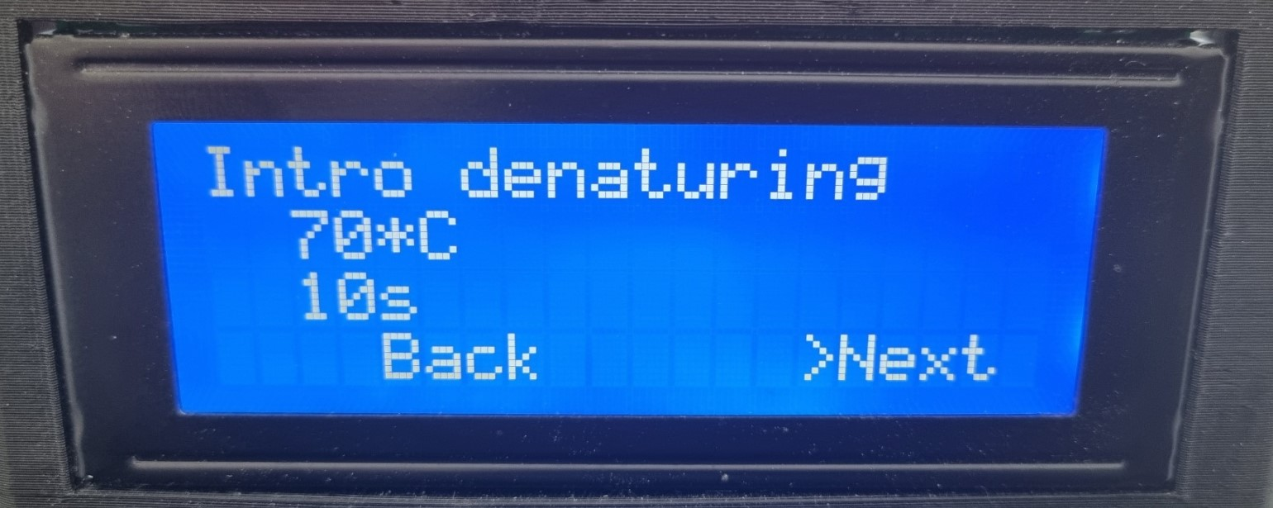

The second stage is Denaturing, the user should define the Temperature in Celsius, the cycles and the duration in seconds. There is a choice to go ‘Back’ in the main menu or select ‘Next’ to continue with the definition of the bio protocol.  
Image 6 Denaturing

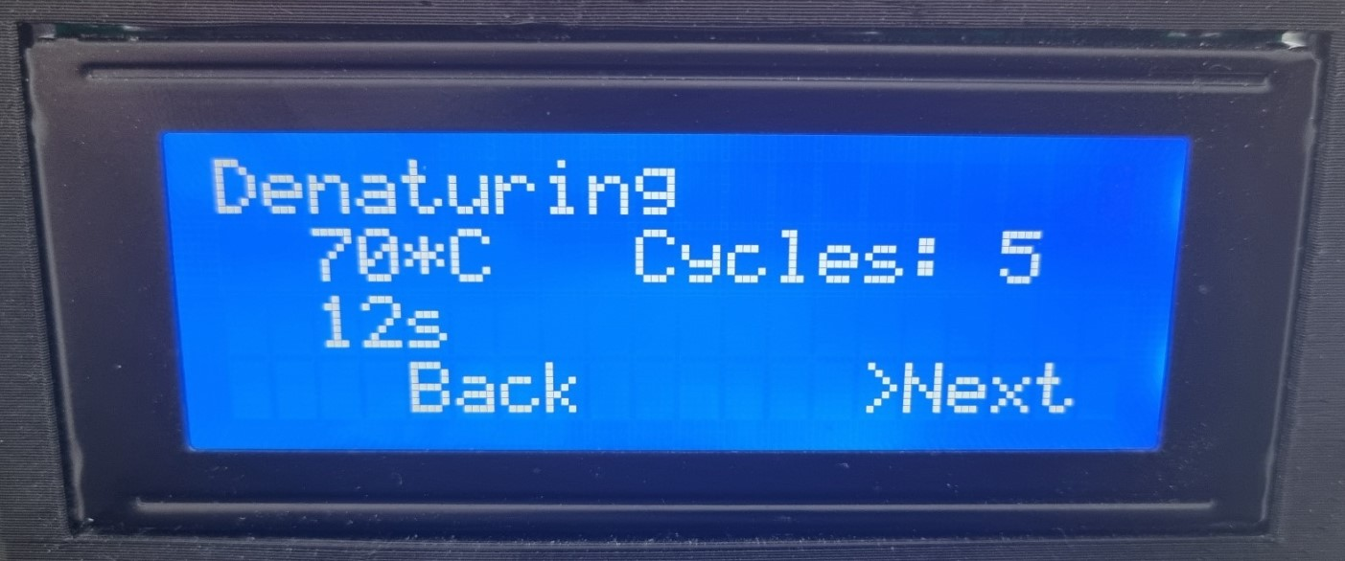

The third stage is Annealing, the user should define the Temperature in Celsius, the cycles and the duration in seconds. There is a choice to go ‘Back’ in the main menu or select ‘Next’ to continue with the definition of the bio protocol.  
Image 7 Annealing

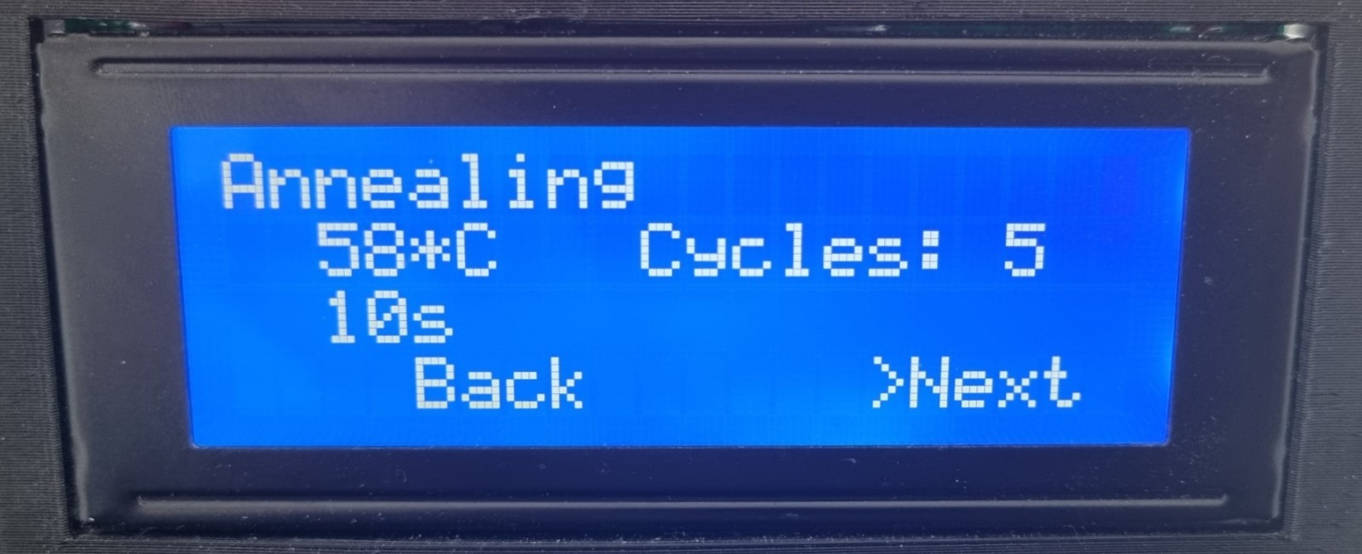

The fourth stage is Extension, the user should define the Temperature in Celsius, the cycles and the duration in seconds. There is a choice to go ‘Back’ in the main menu or select ‘Next’ to continue with the definition of the bio protocol.  
Image 8 Extension

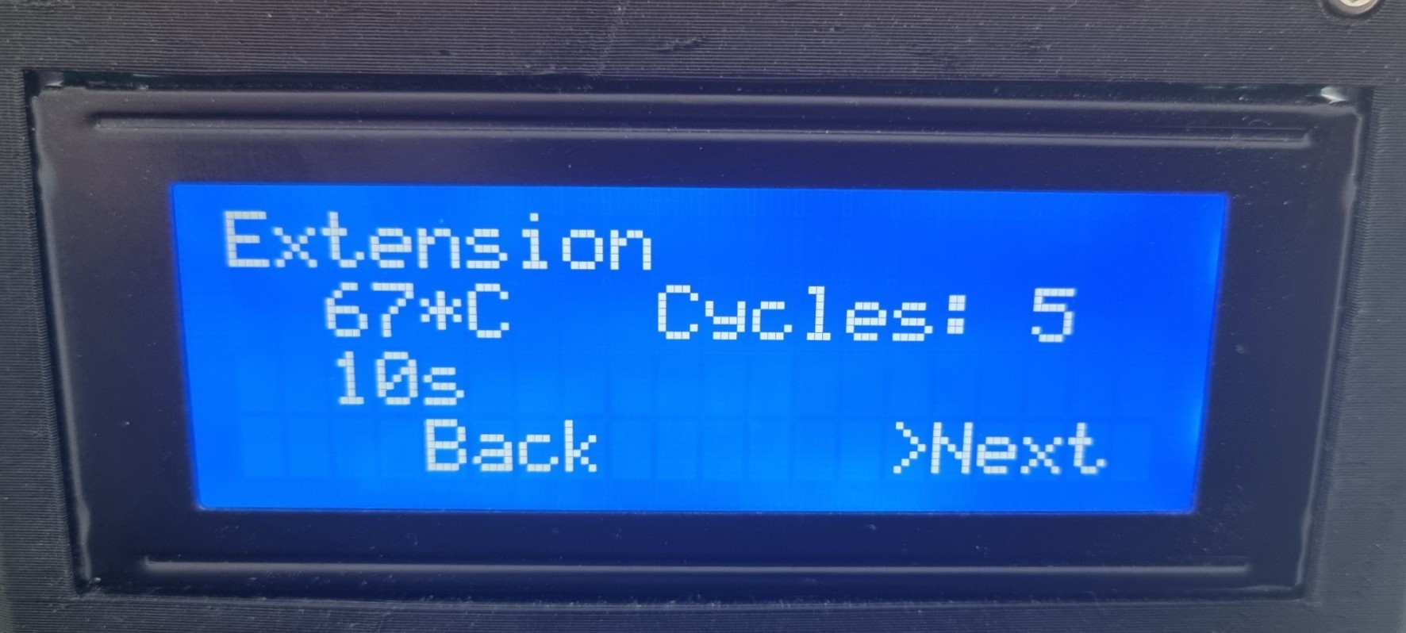

The fifth stage is Final Extension, the user should define the Temperature, the duration in seconds (min 10 seconds, max 300 seconds. There is a choice to go ‘Back’ in the main menu or select ‘ Set ’ to finalize the definition of the bio protocol.

Image 9 Final Extension

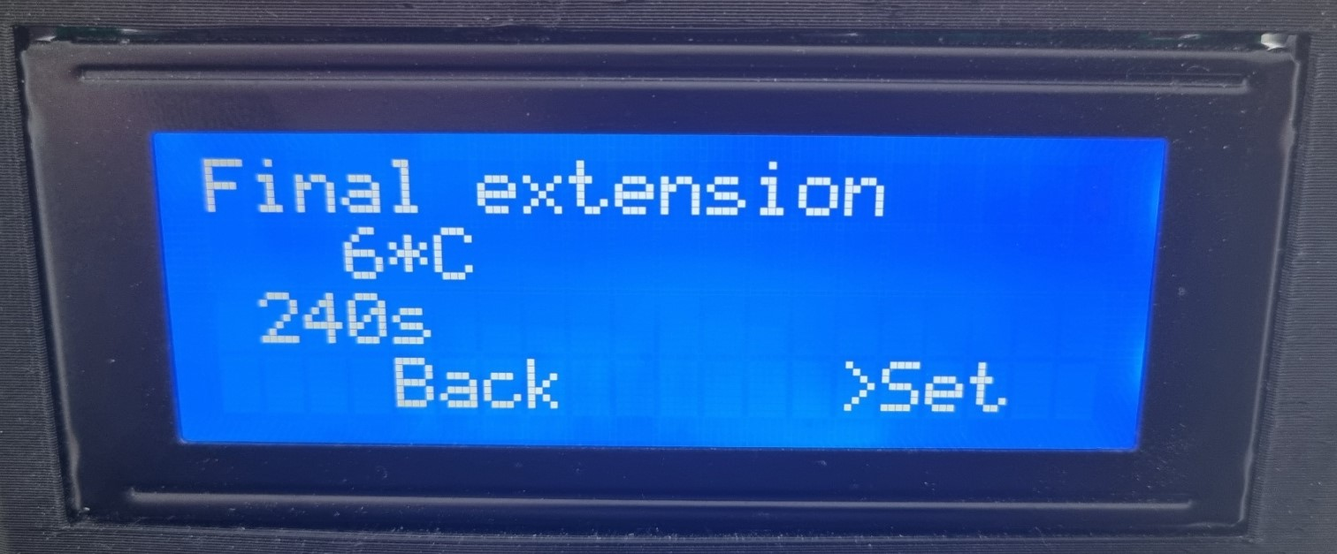

After successfully defined all the stages then a message ‘Bio Protocol defined’ appeared and the thermocycler will start to procedure all the commands.

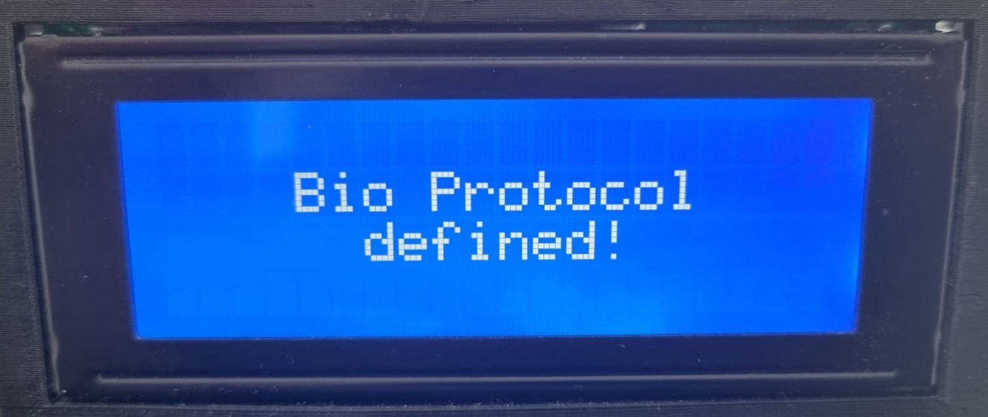

Image 10 Main Page temp, cycles, stage

