CSS

<!DOCTYPE html>
<html>
<head>
<title>Exercise A</title>
<style>
body { background-color: yellow; }
h1 { background-color: #00ff00; }
h2 { background-color: rgb(250, 0, 255); }
</style>
</head>
<body>
<h1>Heading 1 (Green Background)</h1>
<h2>Heading 2 (Purple Background)</h2>
</body>
</html>
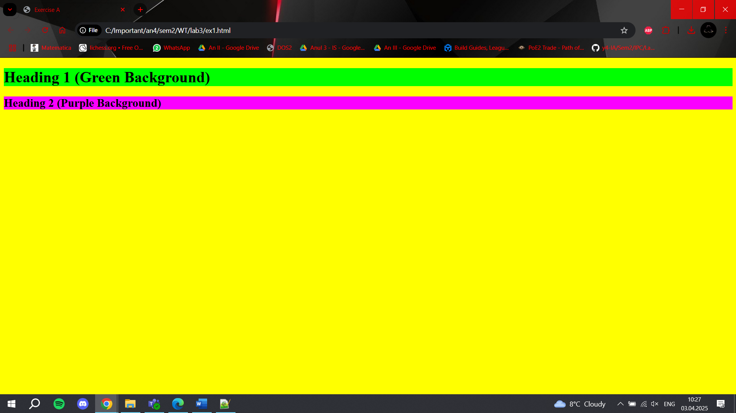
<!DOCTYPE html>
<html>
<head>
<title>Exercise B</title>
<style>
body {
background-image: url('background.jpg');
background-repeat: no-repeat;
background-size: cover;
}
</style>
</head>
<body>
<h1>Page with a Full Background Photo</h1>
</body>
</html>
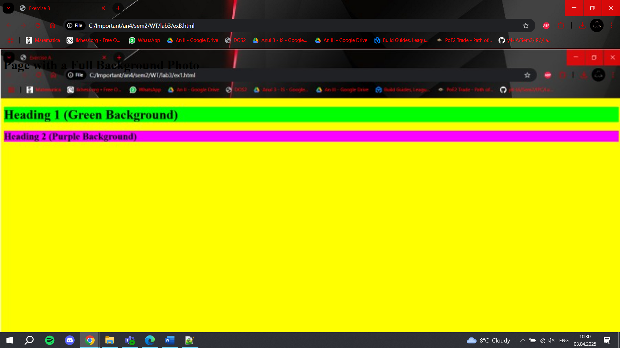
<!DOCTYPE html>
<html>
<head>
<title>Exercise C</title>
<style>
body {
background-image: url('background.jpg');
background-repeat: repeat;
}
</style>
</head>
<body>
<h1>Repeating Background (Tiled)</h1>
</body>
</html>
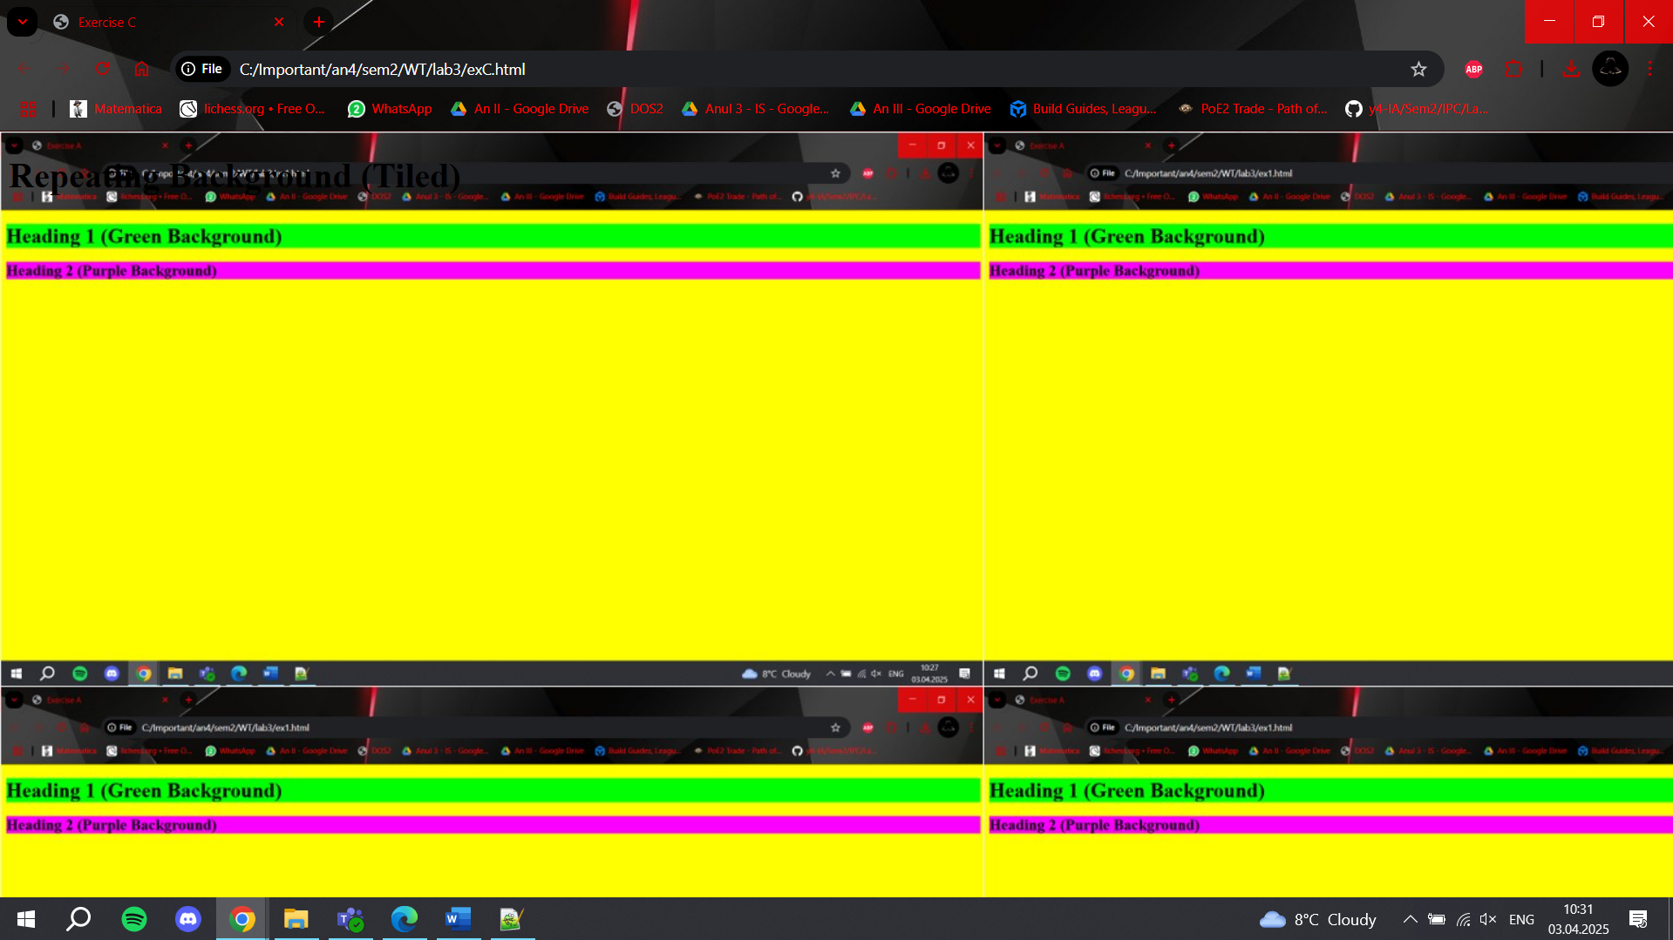
<!DOCTYPE html>
<html>
<head>
<title>Exercise D</title>
<style>
body {
background-image: url('background.jpg');
background-repeat: repeat-y;
}
</style>
</head>
<body>
<h1>Background Repeats Vertically</h1>
</body>
</html>
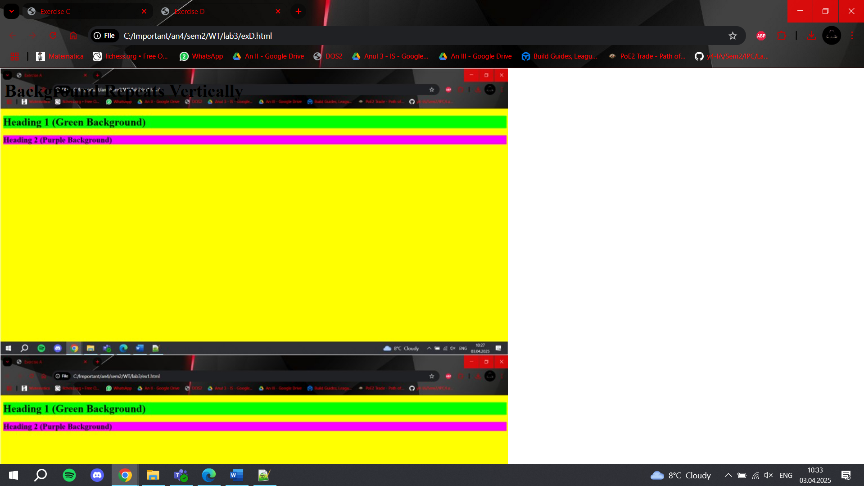
<!DOCTYPE html>
<html>
<head>
<title>Exercise E</title>
<style>
body {
background-image: url('background.jpg');
background-repeat: repeat-x;
}
</style>
</head>
<body>
<h1>Background Repeats Horizontally</h1>
</body>
</html>
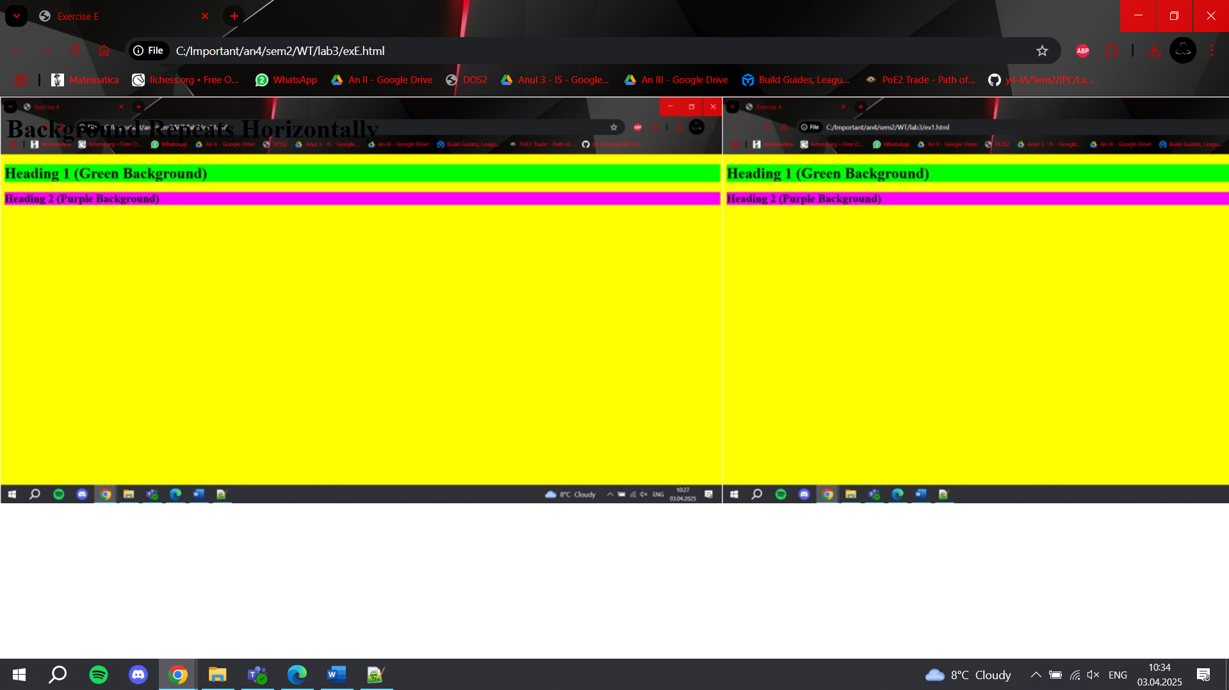
<!DOCTYPE html>
<html>
<head>
<title>Exercise F</title>
<style>
body {
background-image: url('background.jpg');
background-repeat: no-repeat;
background-position: center;
}
</style>
</head>
<body>
<h1>Centered Background Photo</h1>
</body>
</html>
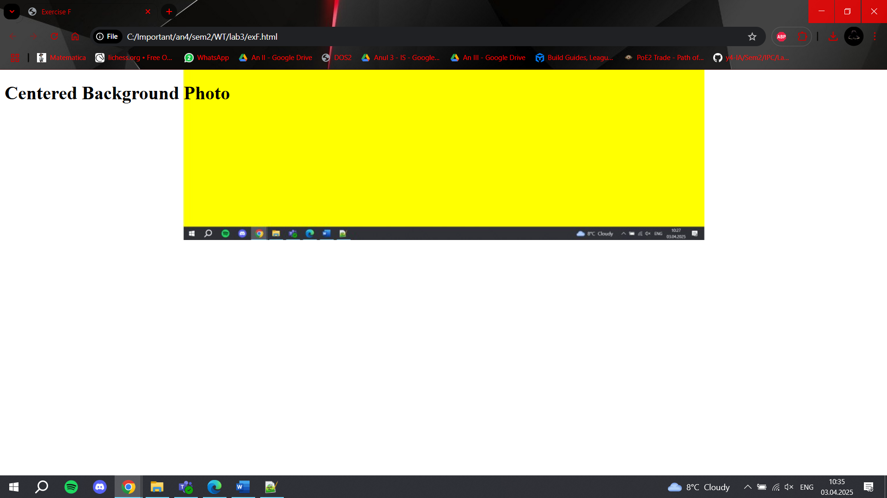
<!DOCTYPE html>
<html>
<head>
<title>Exercise G</title>
<style>
body {
background-image: url('background.jpg');
background-repeat: no-repeat;
background-attachment: fixed;
}
</style>
</head>
<body>
<h1>Fixed Background (No Scroll)</h1>
<div style="height: 2000px;">Scroll to test!</div>
</body>
</html>
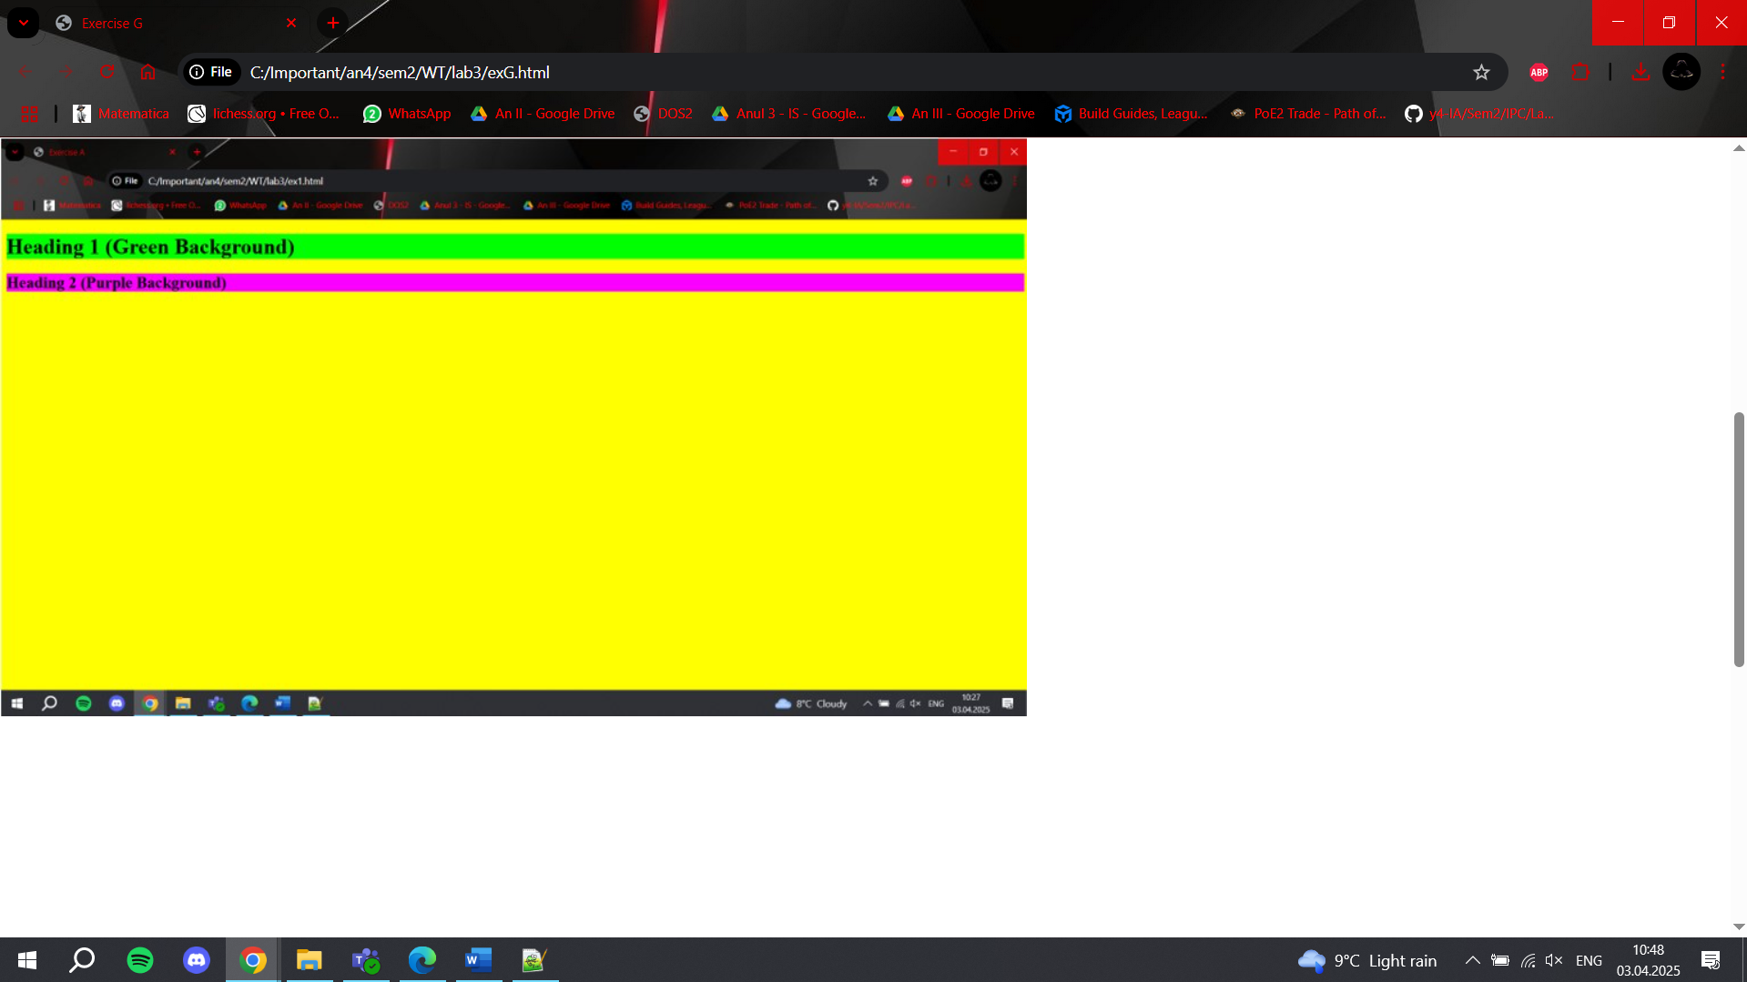
<!DOCTYPE html>
<html>
<head>
<title>Exercise H</title>
<style>
body {
background: green url('background.jpg') center/cover no-repeat fixed;
}
</style>
</head>
<body>
<h1>Green Background + Fixed Centered Photo</h1>
<div style="height: 2000px;">Scroll to test!</div>
</body>
</html>
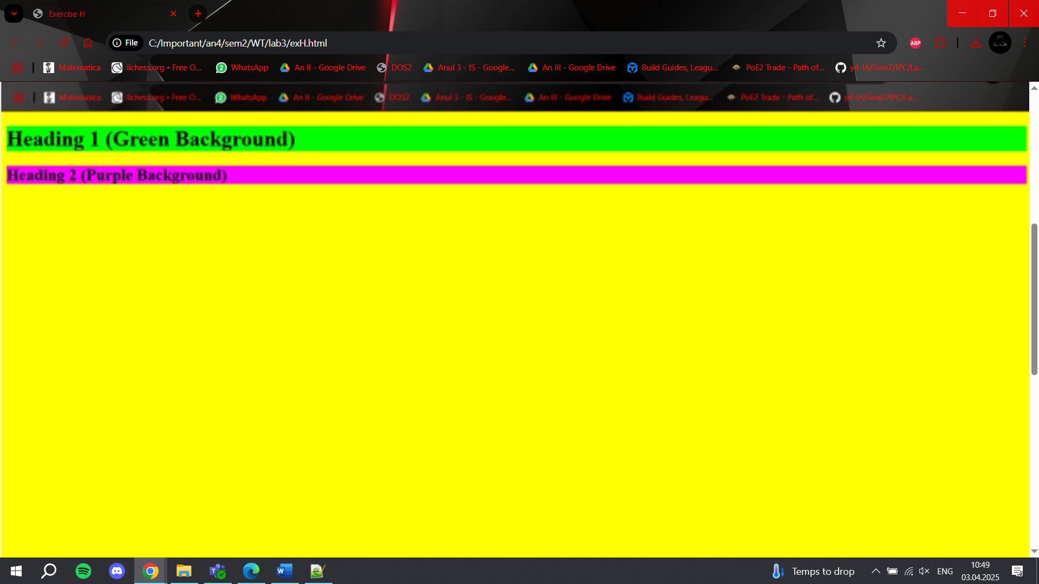
<!DOCTYPE html>
<html>
<head>
<title>Exercise 2 (A-F Combined)</title>
<style>
/* === A: Text Colors === */
h1 {
color: #00ff00; /* Green (hex) */
}
h2 {
color: pink; /* Pink (named) */
}
p {
color: rgb(0, 0, 255); /* Blue (RGB) */
}

/* === B: Letter Spacing === */
h1 {
letter-spacing: -3px; /* Reduced by 3px */
}
h4 {
letter-spacing: 0.5cm; /* 0.5 centimeters */
}

/* === C: Text Alignment === */
h1 {
text-align: center; /* Centered */
}
h2 {
text-align: left; /* Left-aligned */
}
h3 {
text-align: right; /* Right-aligned */
}

/* === D: Text Decorations === */
h1 {
text-decoration: overline; /* Line above */
}
h2 {
text-decoration: line-through; /* Crossed out */
}
h3 {
text-decoration: underline; /* Underlined */
}

/* === E: Paragraph Indentation === */
p {
text-indent: 1cm; /* First line indented */
}

/* === F: Text Transforms === */
.uppercase {
text-transform: uppercase; /* ALL CAPS */
}
.lowercase {
text-transform: lowercase; /* all lowercase */
}
.capitalize {
text-transform: capitalize; /* First Letters Capitalized */
}

/* General Styling for Clarity */
body {
font-family: Arial, sans-serif;
margin: 20px;
}
section {
margin: 30px 0;
padding: 15px;
border: 1px solid #ddd;
border-radius: 5px;
}
</style>
</head>
<body>
<!-- A: Text Colors -->
<section>
<h1>H1: Green Text (Hex #00ff00)</h1>
<h2>H2: Pink Text (Named "pink")</h2>
<p>Paragraph: Blue Text (RGB rgb(0, 0, 255))</p>
</section>

<!-- B: Letter Spacing -->
<section>
<h1>H1: Letter Spacing (-3px)</h1>
<h4>H4: Letter Spacing (0.5cm)</h4>
</section>

<!-- C: Text Alignment -->
<section>
<h1>H1: Centered Text</h1>
<h2>H2: Left-Aligned Text</h2>
<h3>H3: Right-Aligned Text</h3>
</section>

<!-- D: Text Decorations -->
<section>
<h1>H1: Overlined Text</h1>
<h2>H2: Crossed-Out Text</h2>
<h3>H3: Underlined Text</h3>
</section>

<!-- E: Paragraph Indentation -->
<section>
<p>This paragraph has a first line indented by 1cm. Lorem ipsum dolor sit amet, consectetur adipiscing elit. Sed do eiusmod tempor incididunt ut labore et dolore magna aliqua.</p>
</section>

<!-- F: Text Transforms -->
<section>
<p class="uppercase">This paragraph is in uppercase.</p>
<p class="lowercase">THIS PARAGRAPH IS IN LOWERCASE.</p>
<p class="capitalize">this paragraph is capitalized.</p>
</section>
</body>
</html>
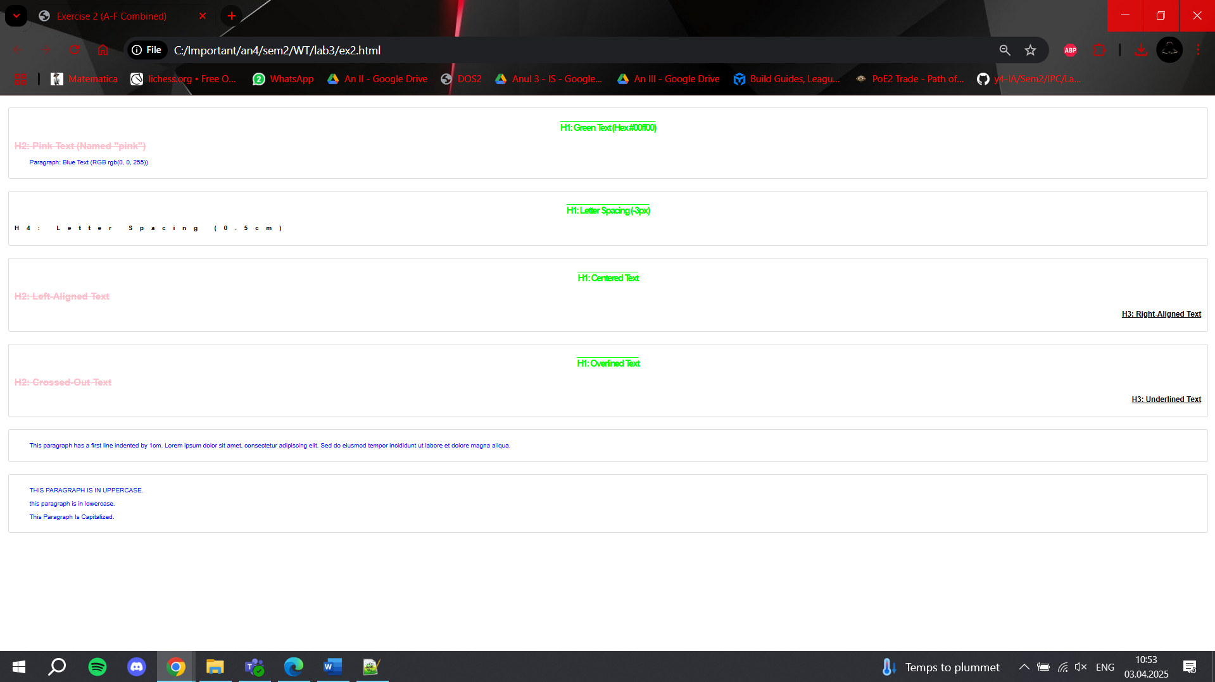

EX3
<!DOCTYPE html>
<html lang="en">
<head>
<meta charset="UTF-8">
<title>Exercise 3 - Font Styles</title>
<style>
h3 {
font-family: "Times New Roman", Times, serif;
}

p {
font-family: "Courier New", Courier, monospace;
font-size: 16px; /* Full-sized font */
}

p.sansserif {
font-family: Arial, Helvetica, sans-serif;
}
</style>
</head>
<body>

<h3>This is an H3 heading using Times font</h3>

<p>This is a paragraph using Courier font.</p>

<p class="sansserif">This is a paragraph with the sans-serif class using Arial font.</p>

</body>
</html>
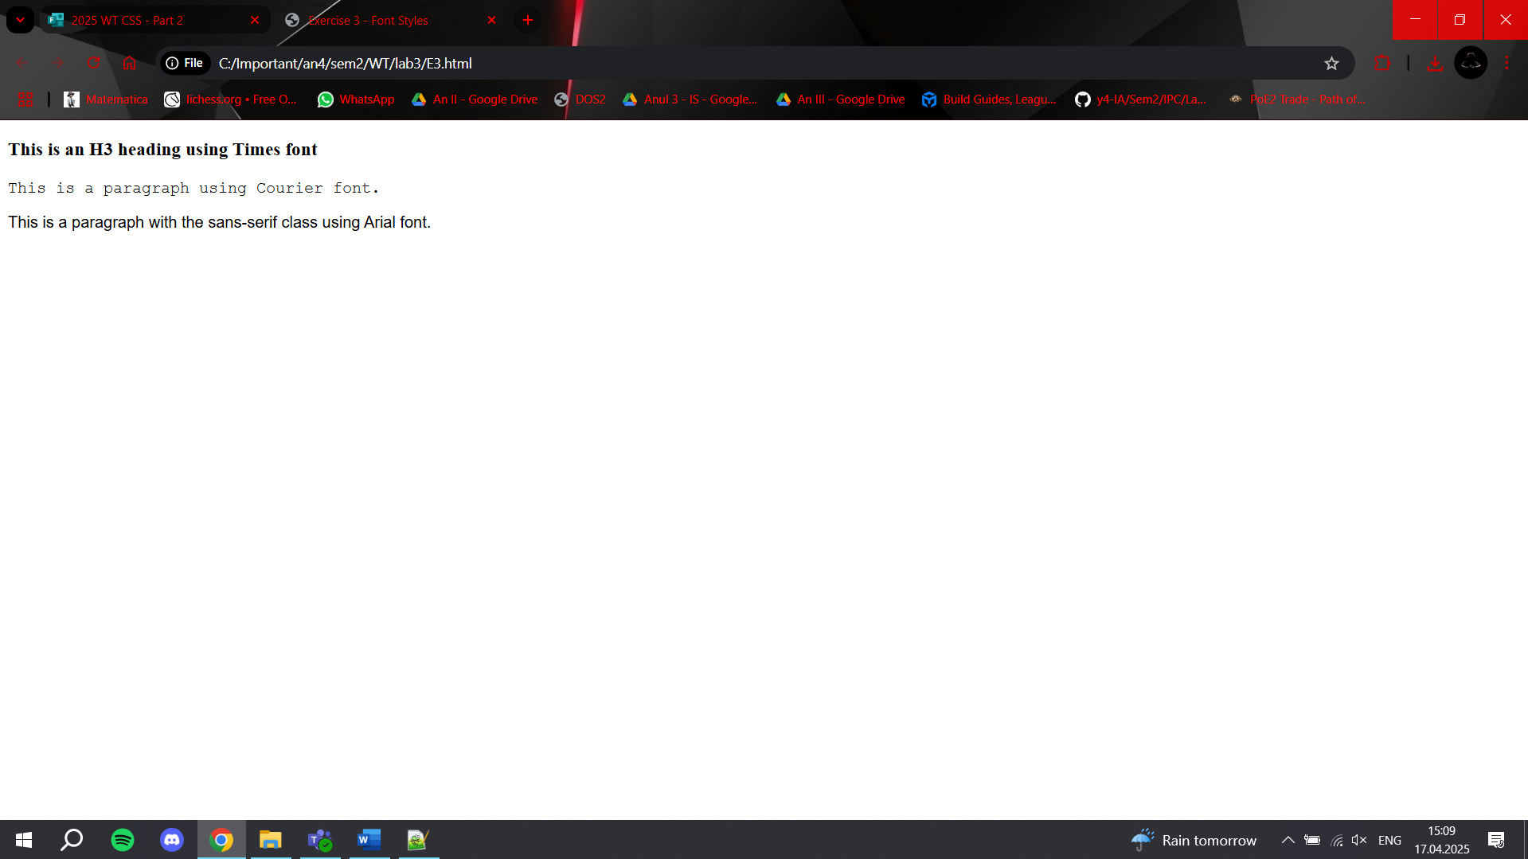
EX4
<!DOCTYPE html>
<html lang="en">
<head>
<meta charset="UTF-8">
<title>Exercise 4 - Font Style</title>
<style>
h1 {
font-size: 150%;
font-style: italic;
}

h2 {
font-size: 130%;
font-style: normal;
}

p {
font-style: oblique;
}

.normal {
font-weight: normal;
}

.thick {
font-weight: bold;
}

.si_mai_gros {
font-weight: 900;
}

.special {
font: italic small-caps 900 12px Arial;
}
</style>
</head>
<body>

<h1>This is an H1 with 50% larger, italic text</h1>
<h2>This is an H2 with 30% larger, normal text</h2>

<p class="normal">Paragraph with normal weight</p>
<p class="thick">Paragraph with bold text</p>
<p class="si_mai_gros">Paragraph with font-weight 900</p>

<p class="special">This paragraph has all font attributes in one line</p>

</body>
</html>
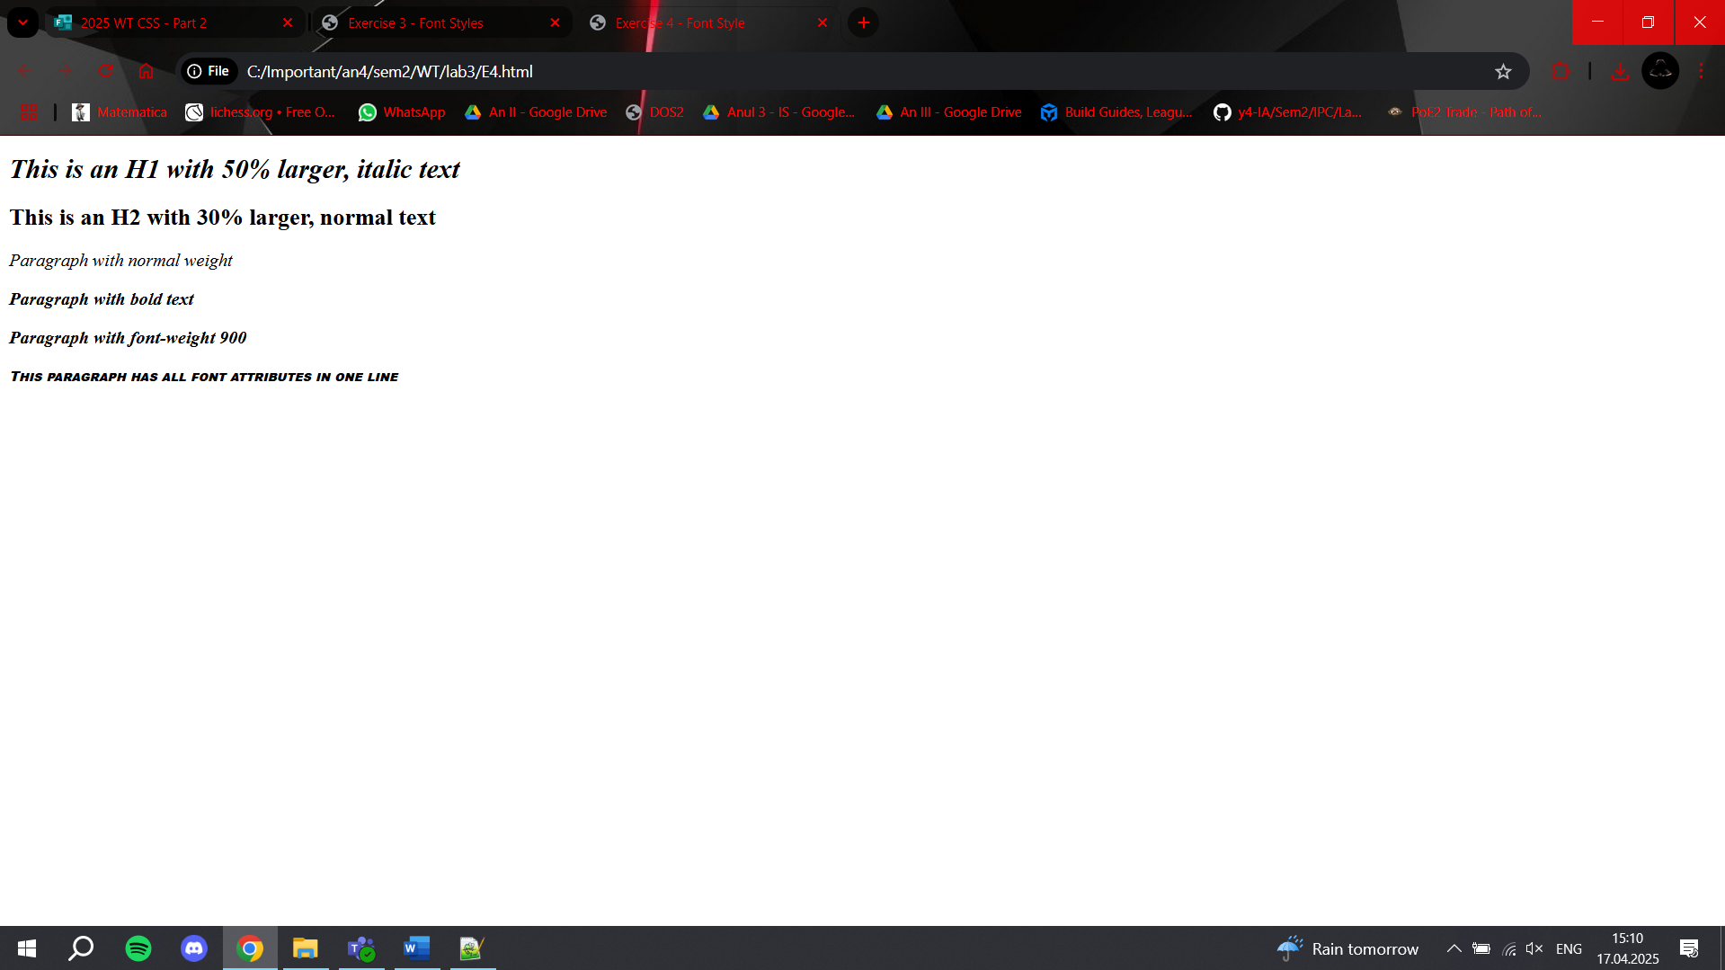

EX5
<!DOCTYPE html>
<html lang="en">
<head>
<meta charset="UTF-8">
<title>Exercise 5 - Pseudo-elements</title>
<style>
p::first-letter {
color: red;
font-size: 150%;
}

p::first-line {
color: red;
text-transform: capitalize;
}
</style>
</head>
<body>
<p>this is a sample paragraph to demonstrate the first-letter and first-line styling using pseudo-elements in CSS.</p>
</body>
</html>
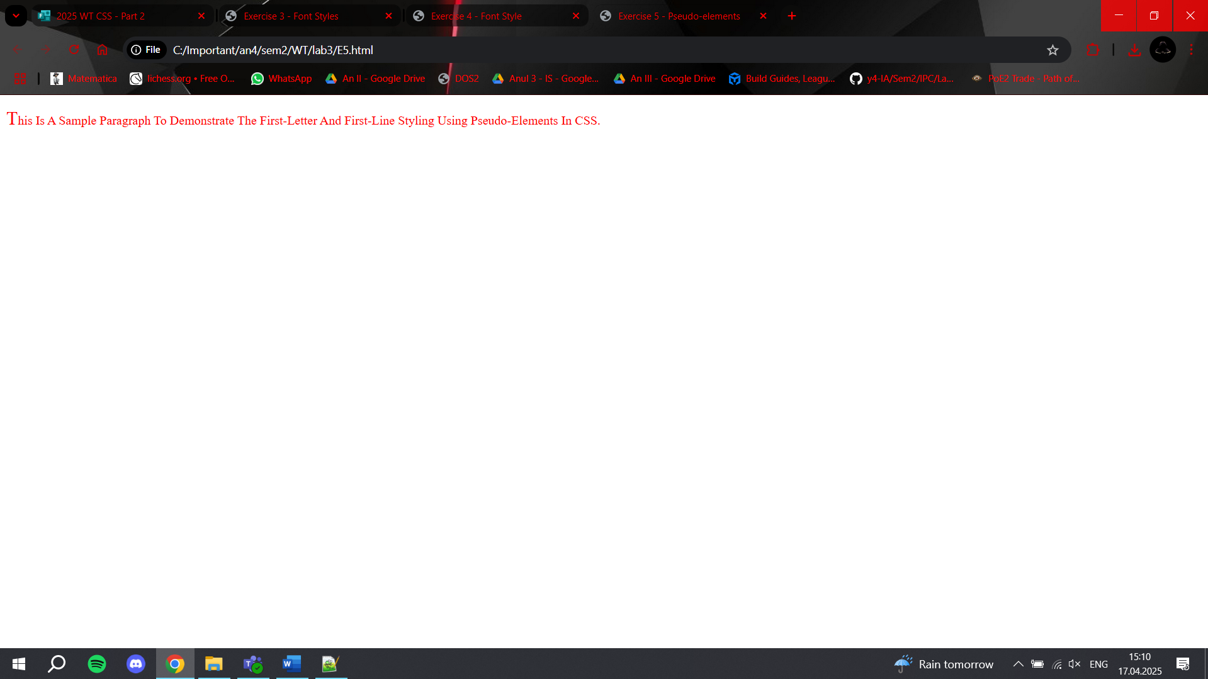

EX6
<!DOCTYPE html>
<html lang="en">
<head>
<meta charset="UTF-8">
<title>Exercise 6 - Font Variant</title>
<style>
.smallcaps {
font-variant: small-caps;
}

.normal {
font-variant: normal;
}

.inherit {
font-variant: inherit;
}
</style>
</head>
<body>
<div style="font-variant: small-caps;">
<p class="smallcaps">This paragraph uses small-caps.</p>
<p class="normal">This paragraph uses normal font-variant.</p>
<p class="inherit">This paragraph inherits font-variant from parent.</p>
</div>
</body>
</html>
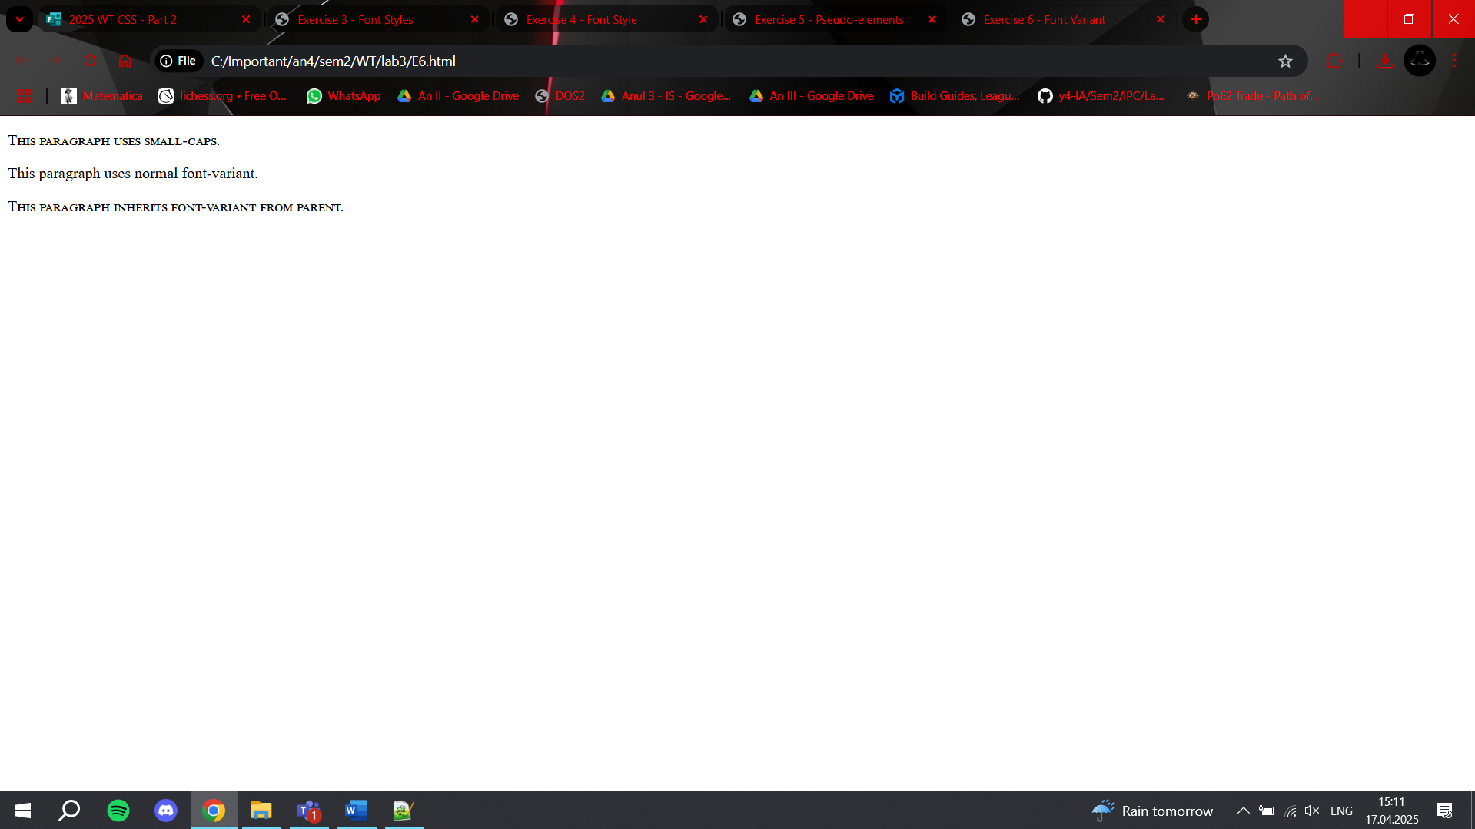

EX7
<!DOCTYPE html>
<html lang="en">
<head>
<meta charset="UTF-8">
<title>Exercise 7 - Letter Spacing</title>
<style>
h1 {
letter-spacing: 1px;
}

h2 {
letter-spacing: 3px;
}

p {
letter-spacing: 5px;
}
</style>
</head>
<body>
<h1>This is an H1</h1>
<h2>This is an H2</h2>
<p>This paragraph has wide letter spacing.</p>
</body>
</html>
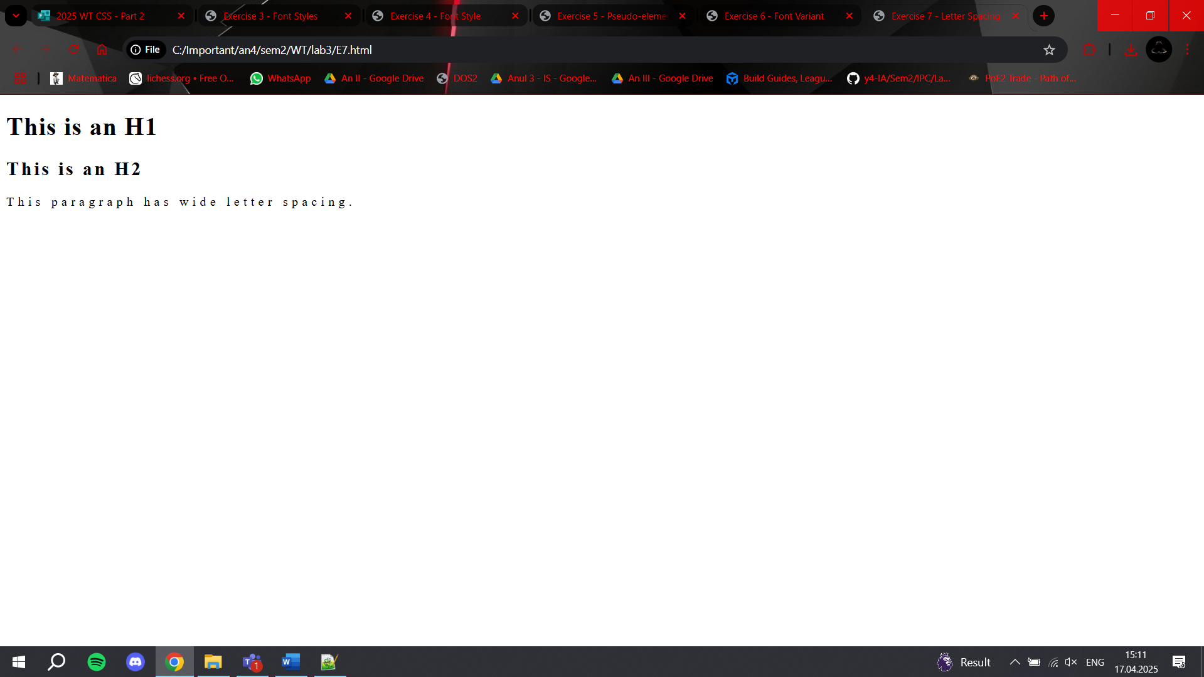

EX1/91
<style>
.small { line-height: 0.4cm; }
.big { line-height: 0.9cm; }
</style>

<p>This is a normal paragraph.</p>
<p class="small">This paragraph has small line spacing.</p>
<p class="big">This paragraph has large line spacing.</p>
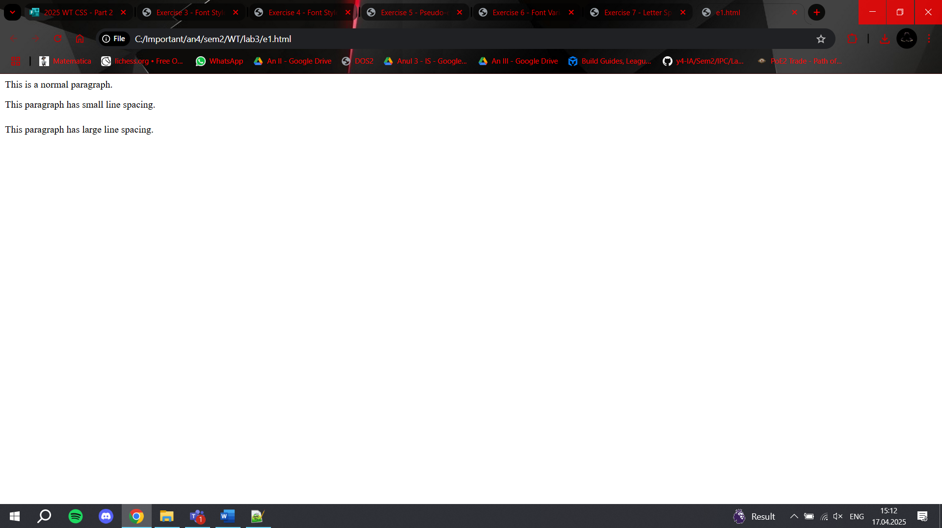

EX2/91
<style>
p { display: inline; }
div { display: none; }

.image-box {
float: right;
margin: 1cm;
border: 1px dotted black;
text-align: center;
}

.image-box img {
display: block;
}
</style>

<p>This is the first paragraph.</p>
<p>And this is the second.</p>
<div>This is the hidden div.</div>

<div class="image-box">
<img src="background.jpg" alt="Example" width="100">
<span>Example Title</span>
</div>


EX3 A,B,C
<style>
.clip {
clip-path: inset(10px 20px 30px 40px); /* top right bottom left */
}
</style>
<img class="clip" src="background.jpg" alt="Clipped">
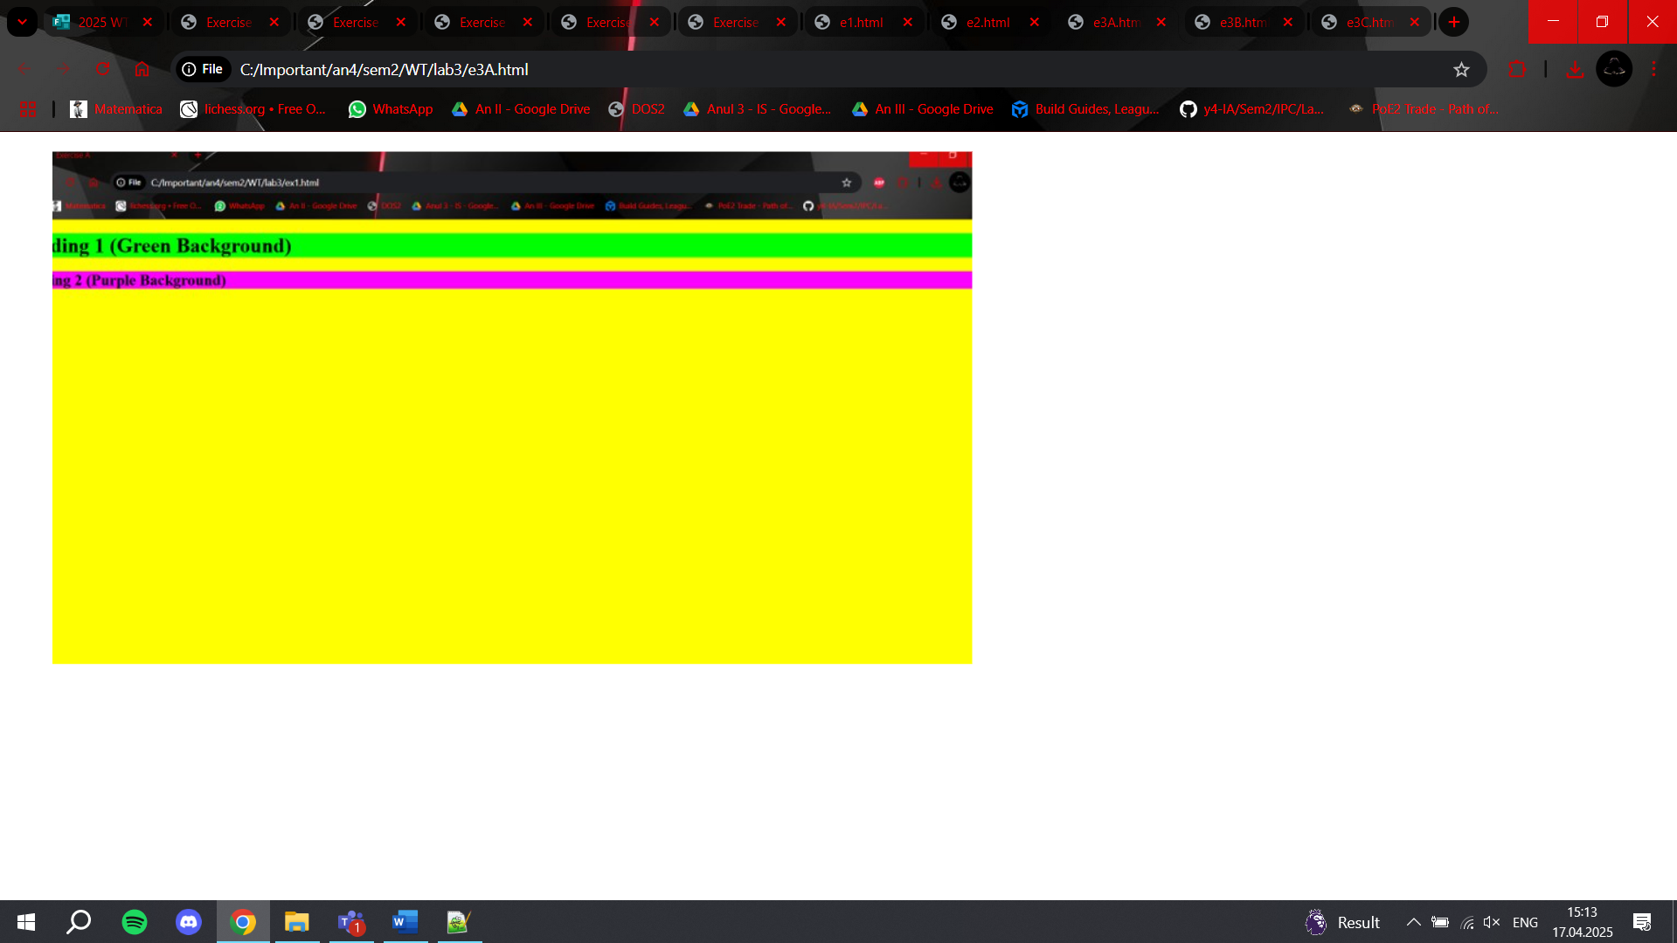

<style>
.scroll-box {
width: 200px;
height: 100px;
overflow: auto;
border: 1px solid black;
}
</style>

<div class="scroll-box">
This is a long block of text that will trigger scrollbars when it overflows the box size.
</div>

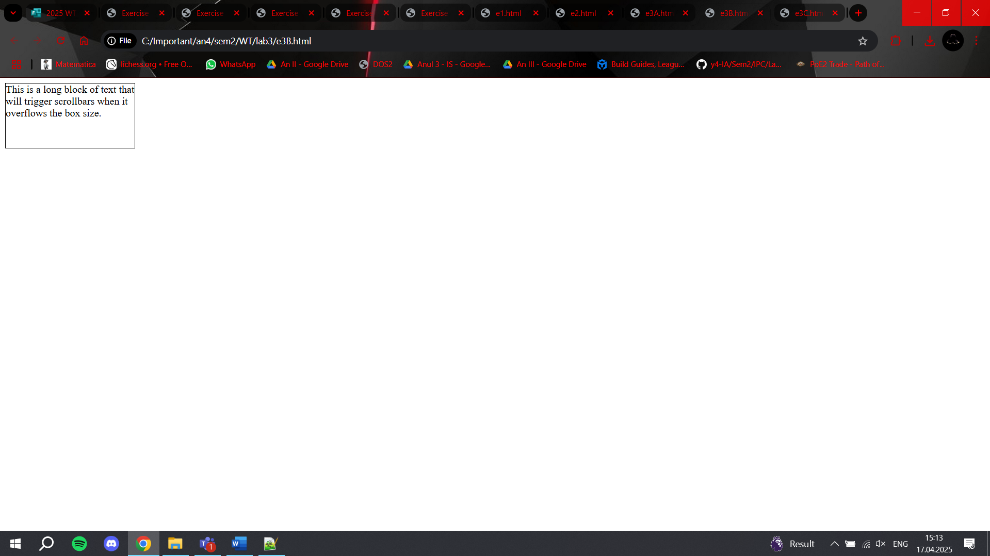

<style>
h1, p {
position: relative;
z-index: 1;
}

.x {
position: absolute;
z-index: -1;
}
</style>

<h1>This is a heading</h1>
<img class="x" src="giff.gif" width="100" height="180">
<p>This is a paragraph over the image.</p>

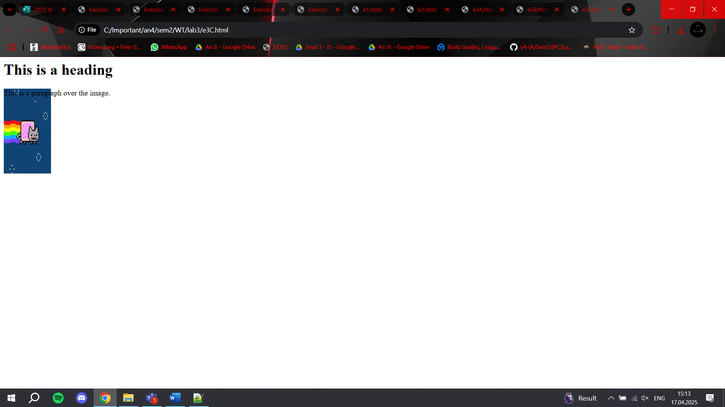

EX4
<style>
a:link { color: red; }
a:visited { color: green; }
a:hover { color: pink; }
a:active { color: blue; }
</style>

<a href="#">Try this link</a>


EX5
<style>
p::first-letter {
color: red;
font-size: 150%;
}

p::first-line {
color: red;
text-transform: capitalize;
}
</style>

<p>this paragraph has pseudo-elements applied for both the first letter and the first line.</p>
