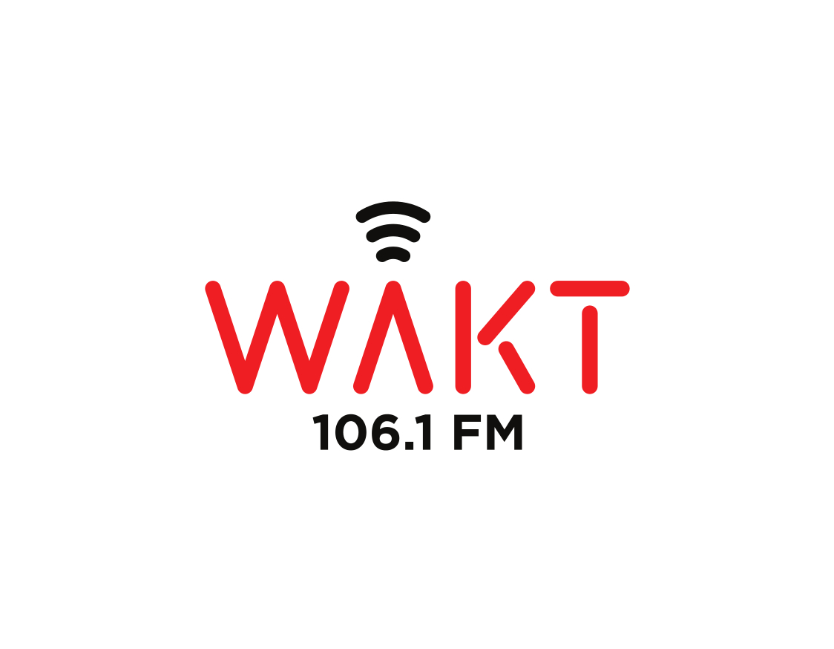

Program Application Form
Please complete and submit to the board of directors for review. You can send it via e-mail to toledoime@gmail.com OR mail it to: Toledo Integrated Media Education 4640 288th St Toledo, OH 43611
Name of Host(s): ________________________________________________________________
Phone number(s): _______________________________________________________________
E-mail address(es): ______________________________________________________________
Mailing address(es): _____________________________________________________________

Title of program: __________________________________________________________
Type of show (circle one): Talk Music Talk + Music Other
Frequency of show (circle one): Daily Weekly Monthly Irregular One-off
Other: ____________

Length of show (circle one): 30 mins 60 mins 90 mins 120 mins
Other: ____________

Preferred air time (circle one): Early AM Morning Afternoon Evening Night
Show description: ____________________________________________________________________________________________________________________________________________________________________________________________________________________________________________________________________________________________________________________________________________________ __________________________________________________________________________________________________________________________________________________________________________
Would your show need to… (circle one for each):
…be broadcast live? Yes No Nice, but not necessary
…accept call-ins? Yes No Nice, but not necessary
…broadcast at remote sites? Yes No Nice, but not necessary
Please describe any broadcasting or media experience you may have on the following lines: _______________________________________________________________________________________________________________________________________________________________________________________________________________________________________________________________

