Smart Automatic Plant Watering System

Abstract
This project presents the design and implementation of a Smart Automatic Plant Watering System using Arduino. The system automates irrigation by analyzing soil moisture, temperature, humidity, and water level conditions, ensuring optimal plant growth while conserving water.

1. Introduction
Water management is a critical challenge in agriculture and domestic gardening. Manual irrigation often leads to overwatering or underwatering. This project proposes an automated solution to address these issues.

2. System Architecture
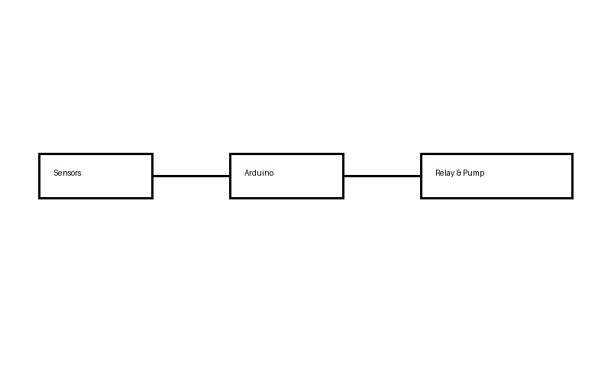

3. Hardware Description
• Arduino Uno
• DHT22 Temperature & Humidity Sensor
• Soil Moisture Sensor (Analog)
• Water Level Sensor
• Relay Module
• DC Water Pump

4. Pin Configuration
DHT22 Data Pin → Digital Pin 2
Soil Moisture Sensor → A0
Water Level Sensor → A1
Relay Control Pin → Digital Pin 8

5. Software Design & Algorithm
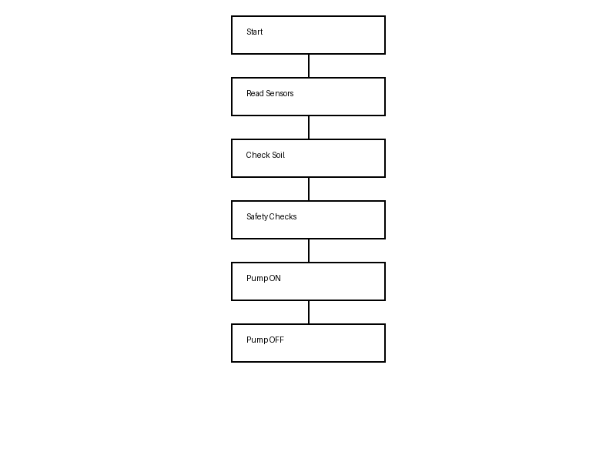

6. Implementation Details
The software is written in Embedded C using Arduino IDE. Sensors are initialized in setup(), while decision logic and actuation are executed in loop().

7. Testing & Results
Test Case 1: Dry Soil → Pump Activated → Successful
Test Case 2: Wet Soil → Pump Skipped → Successful
Test Case 3: High Temperature → Pump Disabled → Successful
Test Case 4: Empty Tank → Pump Disabled → Successful

8. Limitations
• No IoT or remote monitoring
• Fixed threshold values
• Suitable for small-scale use only

9. Future Scope
• Mobile app integration
• Cloud-based monitoring
• AI-based adaptive thresholds
• Solar power integration

10. Conclusion
The developed system demonstrates a reliable, low-cost, and efficient automated irrigation solution suitable for academic and real-world applications.

