## 3.4 Persistent Data Management

The system needs persistent storage of its users, their information, offers, items and their relations with each other And these data must be accessed repeatedly - many times by multiple users - and each request should be returned as fast as possible. For these reasons, using a Relational Database Management System is a must.

While the initial userbase may be small, the system storage infrastructure should be scalable for a growing userbase. Data security is also another concern.

For these reasons, we will be using MySQL as our Database Management solution which covers all of our needs and more. Also, it’s Community Edition - which we use, is open source under the GNU General Public License, helping us reduce costs. It’ll also create an access queue for the data it holds, which allows for reliability in concurrent access scenarios.

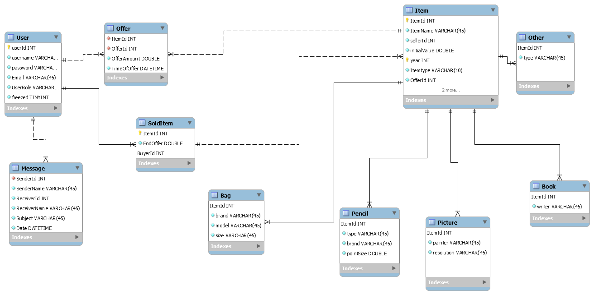

The data scheme for the database is mainly made up of its users, their offers and the auction created by registered user’s. The ‘user’ table holds information needed from each and every user, password (hashed) etc. The ‘registered user’ tables hold additional for each user type’s needed information. This might be an registered user “About Us” text or a auction’s offers. The Admin user resides in neither of these two tables and is the sole entry of ‘user’ table.

‘Item table’ included subtable of the item types.Their are bag, pencil, book, bag and other items.

Finally, there is the ‘messages’ table that hold the messages received by each user

As for encapsulation, the Storage Layer ‘glued’ atop the Database will provide query-independent access to data for the higher layers.