Iris Recognition Using Daugman Algorithm & ANN

In this project we are using Daugman algorithm to extract iris region from the eye image and then this extracted region will be input to ANN algorithm to build an IRIS classification model. After building model it can be applied on any iris test image to recognize person that iris belongs to.

To implement this project we have downloaded iris images of 20 different persons from KAGGLE and below screen showing the dataset details

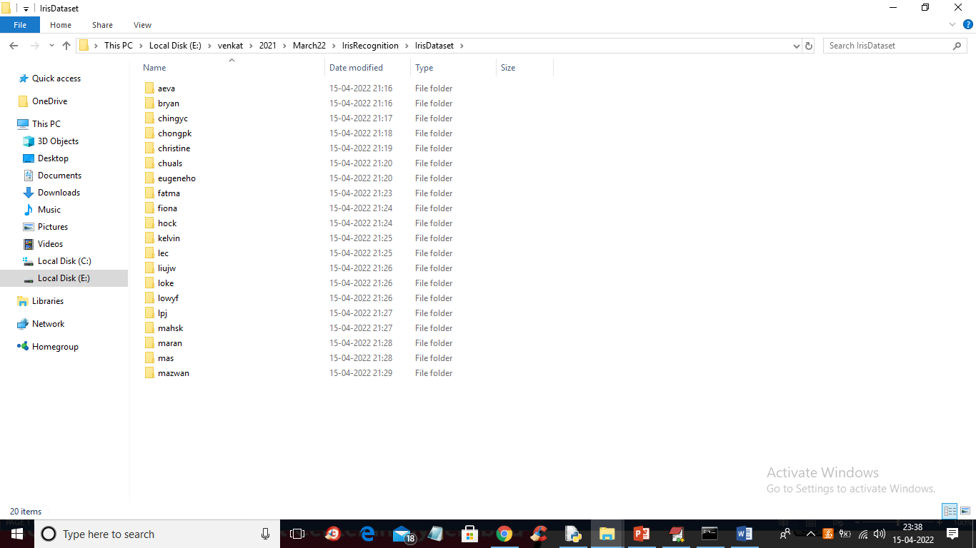

In above screen inside ‘IrisDataset’ we have 20 folders which contains eye images of 20 different peoples and just go inside any folder to view those images

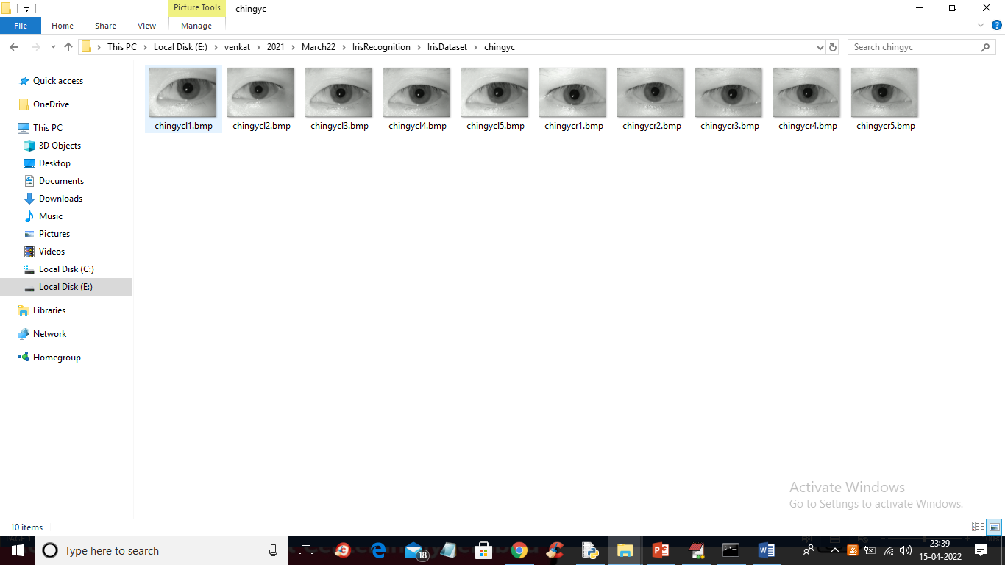

Above images will be applied Daugman algorithm to extract iris region and then feed to ANN model.

To implement this project we have designed following modules

1. Upload Iris Dataset: using this module we will upload dataset images to application
2. Image Preprocessing: using this module we will resize images to equal size and then normalize pixel values
3. Iris Segmentation & Features Extraction: using this module we will apply Daugman algorithm to extract iris region and then extract features or pixel values from that IRIS region
4. Train ANN Algorithm: using this module we will feed extracted features to ANN algorithm to build iris classification or recognition module
5. Iris Classification from Test Image: using this module we will upload eye image and then Daugman will extract IRIS region and then ANN model will recognized/predict person.

SCREEN SHOTS

To run project double click on ‘run.bat’ file to get below output

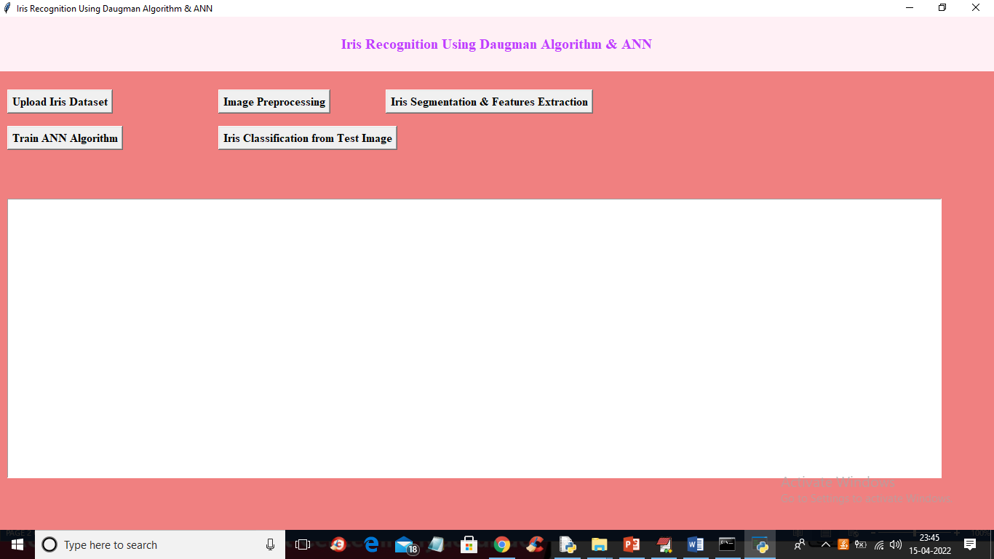

In above screen click on ‘Upload Iris Dataset’ button to upload dataset like below screen

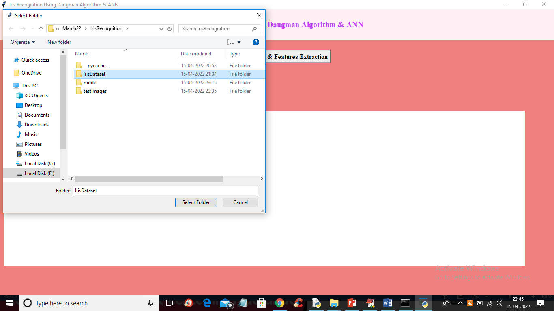

In above screen selecting and uploading ‘IrisDataset’ folder and then click on ‘Select Folder’ button to load dataset and to get below output

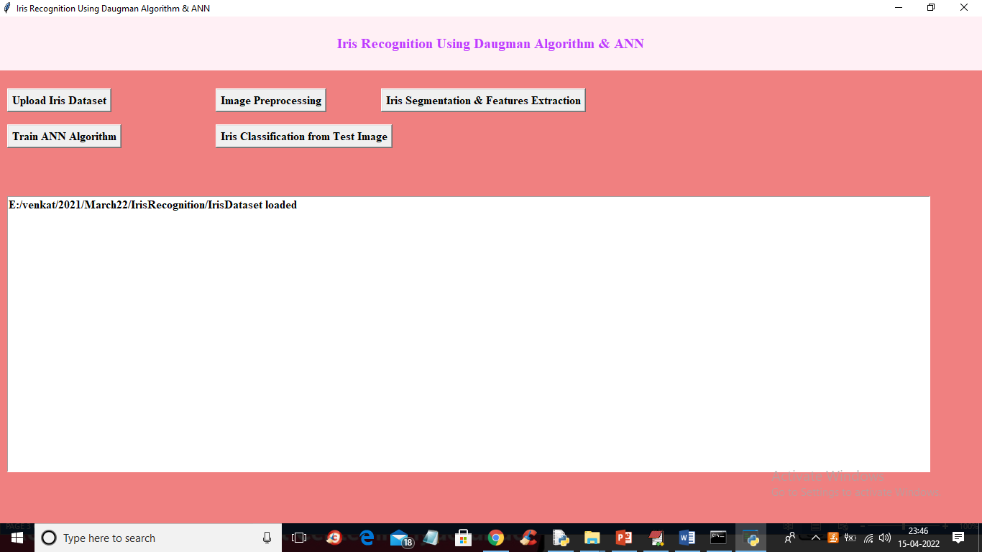

In above screen dataset loaded and now click on ‘Image Preprocessing’ button to normalize pixel values and get below output

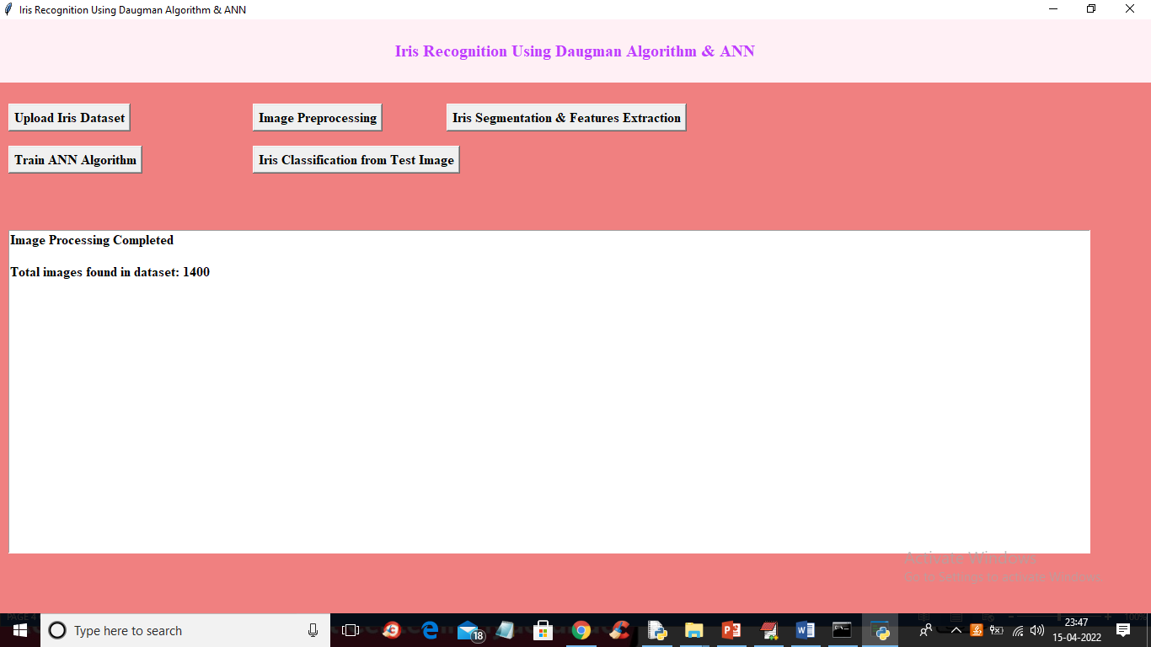

In above screen we can see application processed 1400 images from dataset and now click on ‘Iris Segmentation & Features Extraction’ button to extract iris and then extract features from it

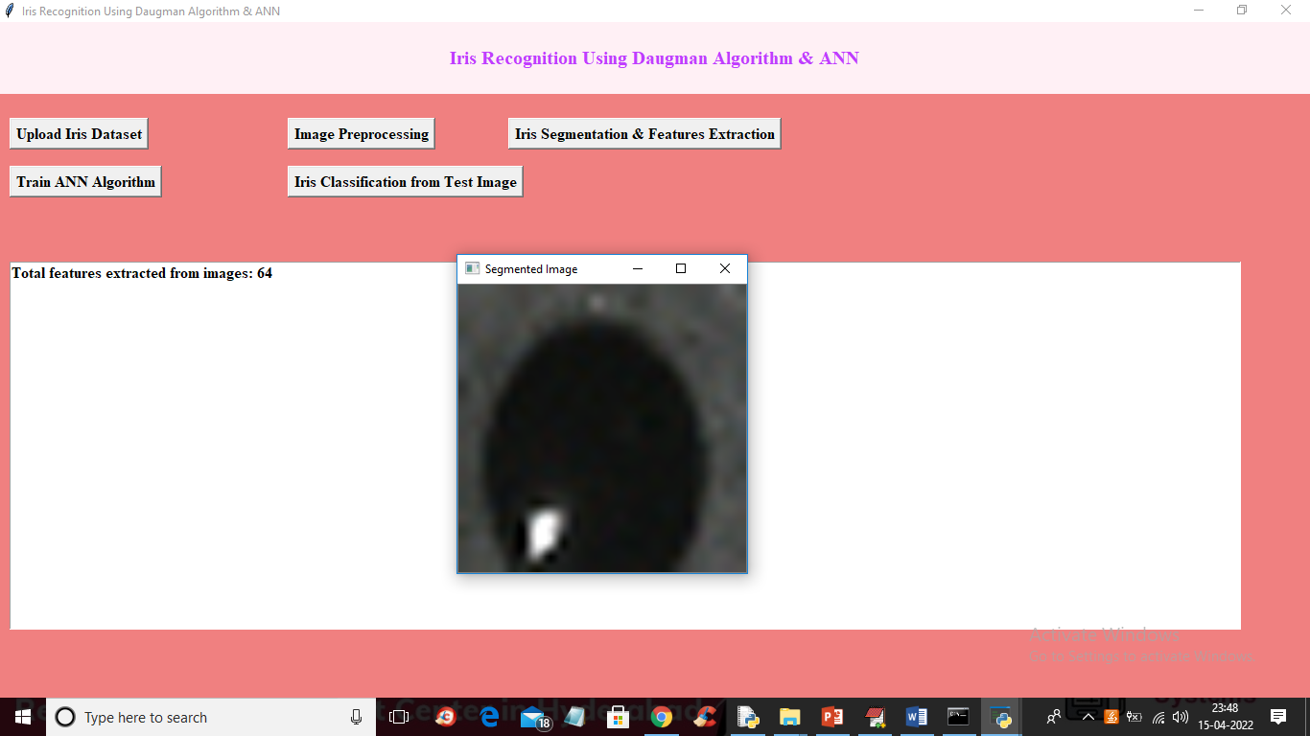

In above screen we can see iris segmented and extracted features from all images and each image will 64 X 64 height and width and in above screen I am displaying one iris segmented image to check whether images are segmented properly or not and now close above image and then click on ‘Train ANN Algorithm’ button to train ANN with extracted features and get below output

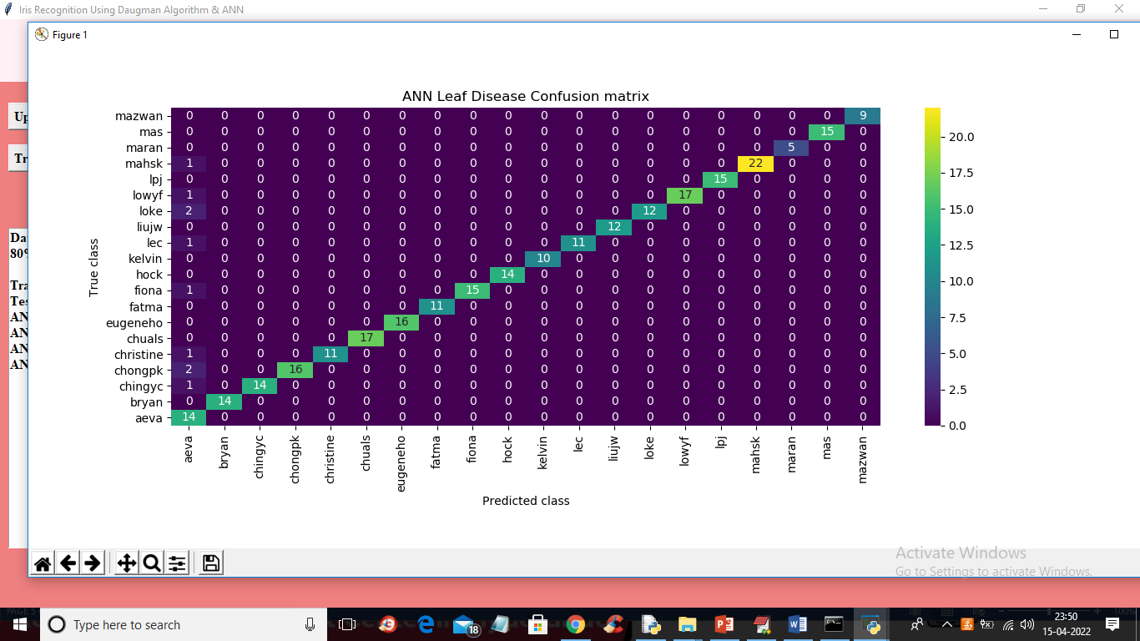

In above screen ANN model generated we got it prediction confusion matrix graph where x-axis represents predicted classes and y-axis represents TRUE classes and in diagnol we can maximum predictions are correct and now close above image to get below output

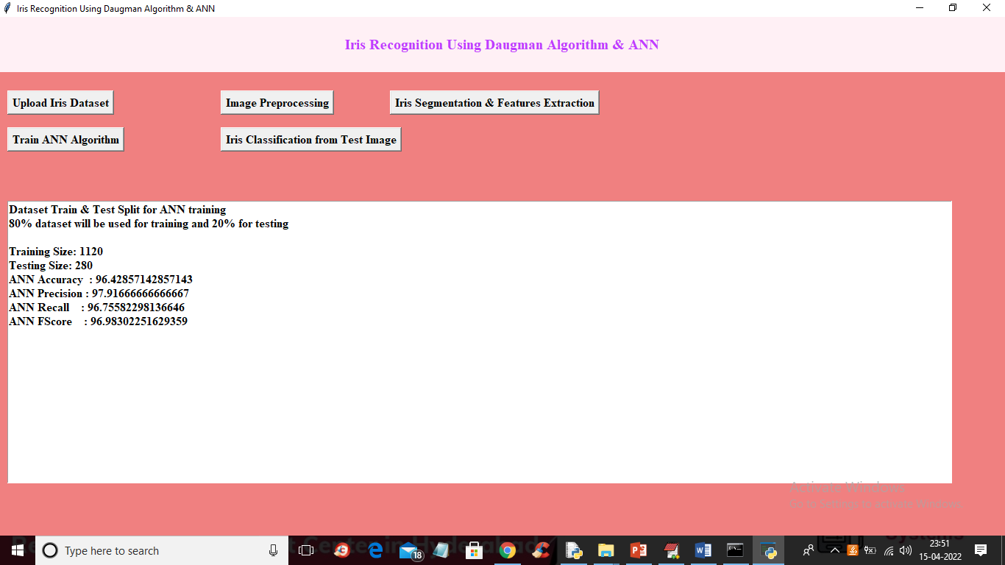

In above screen with ANN we got 96% accuracy and now click on ‘Iris Classification from Test Image’ button to upload test image and get classification or recognition output

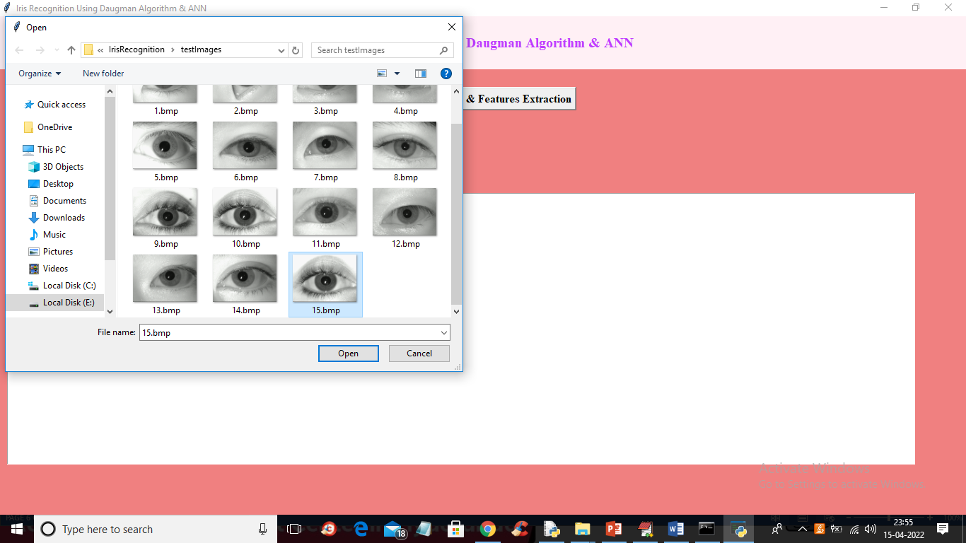

In above screen selecting and uploading ’15.bmp’ and then click on ‘Open’ button to get below output

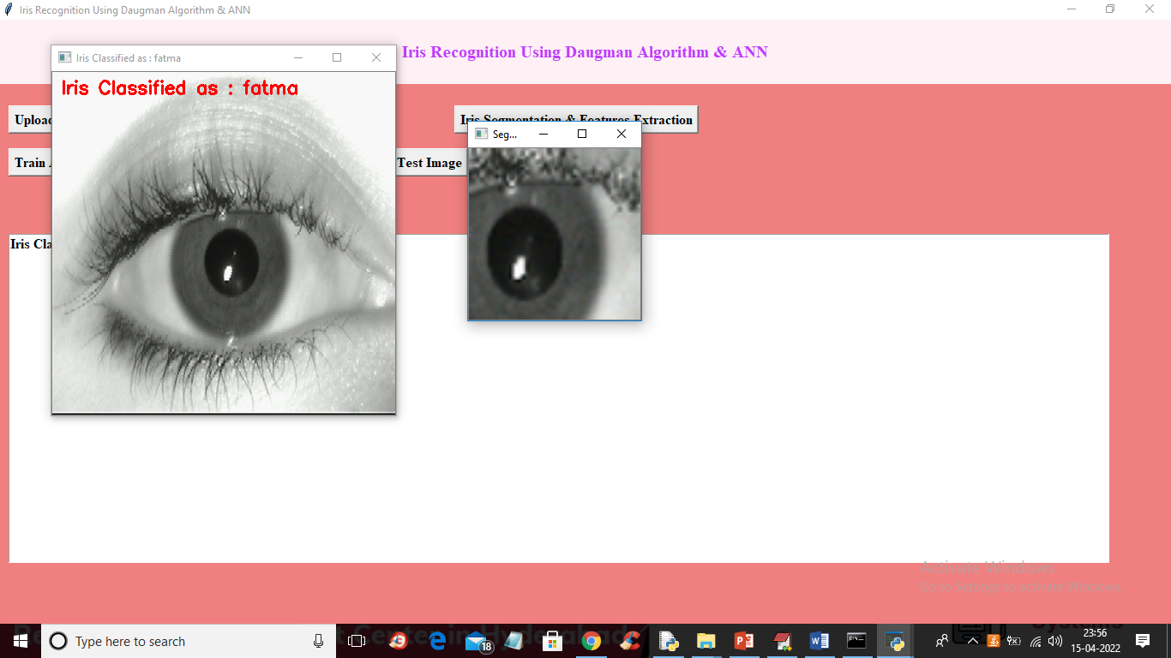

In above screen in red colour text we can see iris classified as ‘Fatma’ and we can see Daugman segmented image and similarly u can upload other images and test

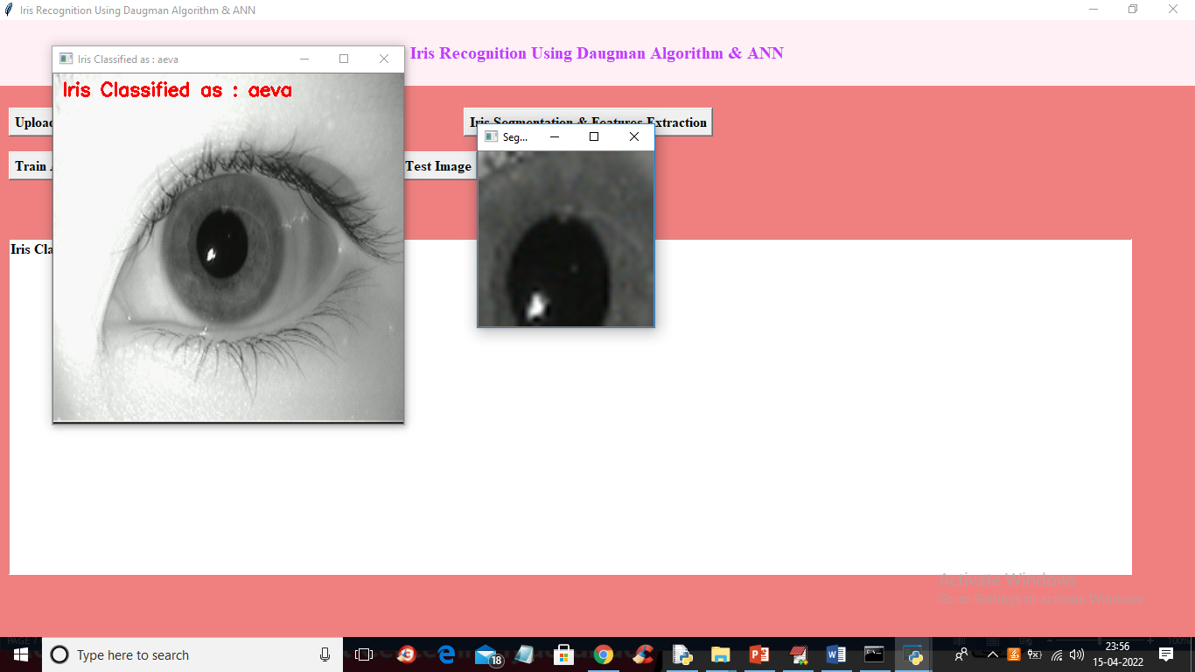

In above screen iris classified as ‘aeva’

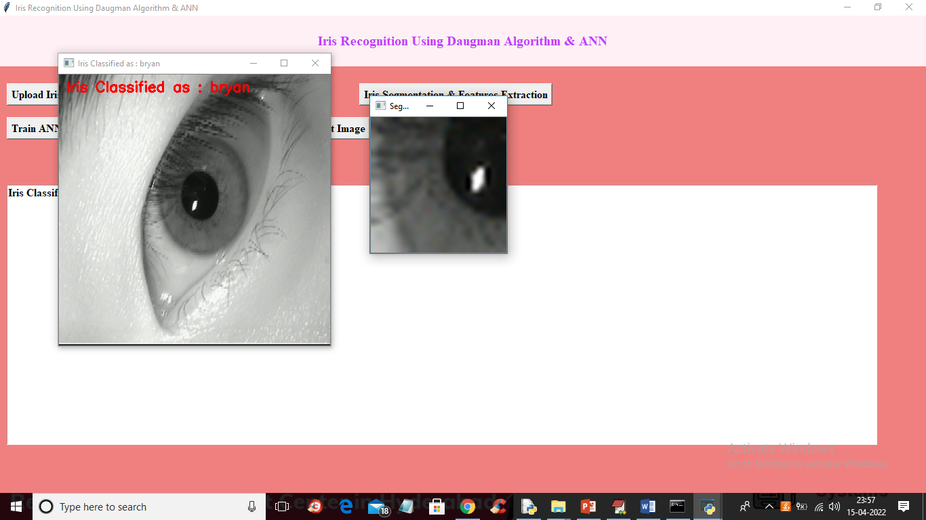

In above screen iris classified as ‘Bryan’