Functionality:

It is a realistic 21 card gameplay.   
The user can select the amount he wants to bet and then he has three options: hold cards, hit and double. The play does not know the dealers cards. The dealers card are randomly generated from js code. 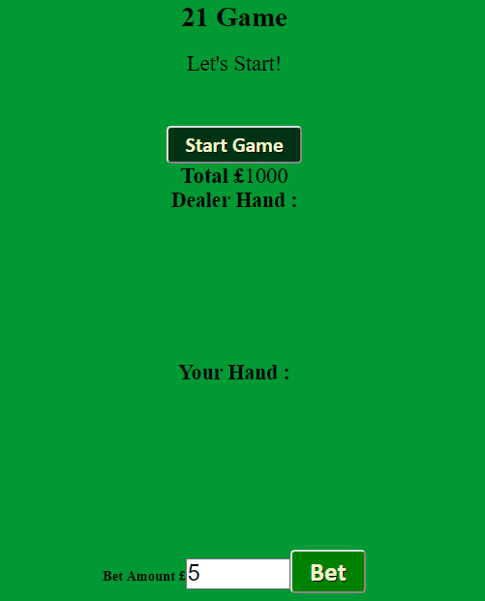

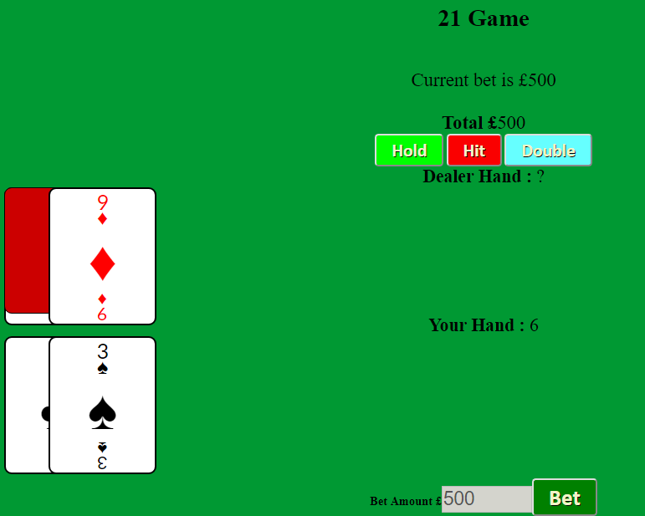

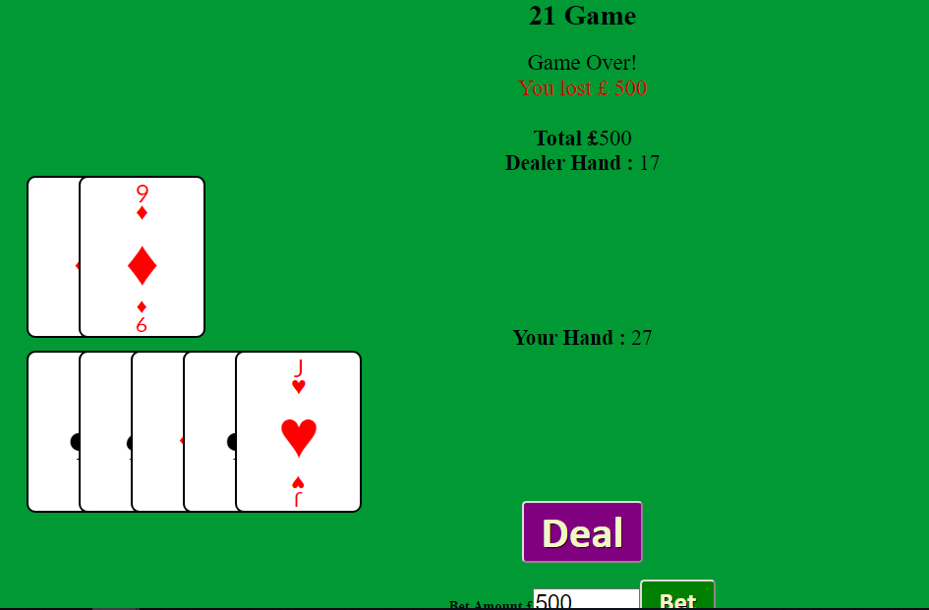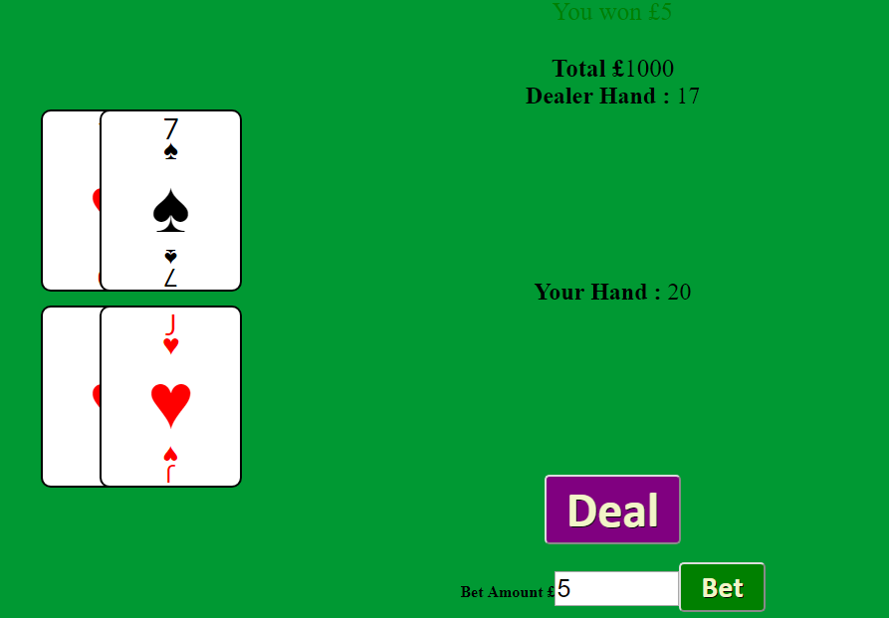

Design:

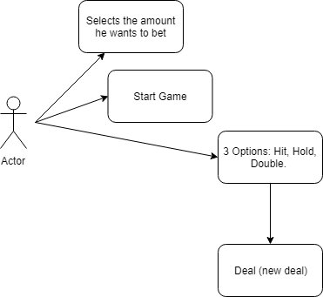

Development Process  
  
A lot of research was done on arrays and on several javascript funtions. Also, there was a research on how to create the, realistic cards, using css.   
I used notepad++ for the coding and I used codenpen.io for the css card style. I used node.js server.  
  
Personal Reflection

I didn’t do the online chat system. I didn’t do the WebSockets. The interface basic.   
The random card functionality works. All buttons works as well.   
The lesson that I would bring from this project into my next project is to not underestimate even the most basic things.