Made by: https://github.com/Tolisking84
Pandemic Resilience System (PRS) - Logbook

Date: May 04, 2025

Contents
1. System Setup and Configuration 3
2. User Authentication and Role-Based Access Control 4
3. Purchase Management with Restrictions 5
4. Merchant Inventory Management 6
5. Vaccination Request and Approval System 7
6. PDF Generation and File Uploads 8
7. Government Administration Features 9
8. Security and Infrastructure Enhancements 10
9. Milestones Achieved 11
Reflection and Future Work 12
Conclusion 13

Overview
The Pandemic Resilience System is a web application developed to facilitate resource allocation and vaccination management in a pandemic scenario. Built using Python with the Flask framework, the system supports three user roles which are, public, merchant, and government, each with tailored functionalities. Public users can purchase essential items and request vaccinations, merchants manage inventory, and government users oversee user accounts and vaccination approvals. The application uses MongoDB for data storage, JWT for secure authentication, and ReportLab for generating PDF documents like receipts and vaccination certificates.
This logbook chronicles the development tasks undertaken to create the system, including backend implementation, database design, user interface integration, and security features. It highlights the key features delivered and the technical challenges addressed during development.

System Setup and Configuration
Tasks Completed:
- Initialized a Flask application with necessary dependencies (e.g., flask, pymongo, pyjwt, reportlab) installed via requirements.txt.
- Configured environment variables using python-dotenv to manage sensitive settings like SECRET_KEY and MONGO_URI.
- Set up logging with logging.basicConfig to output debug information to both a file (app.log) and console, aiding development and troubleshooting.
- Established MongoDB collections (users, merchant_stocks, vaccinations, purchases, audit_logs, pdfs) for data persistence.
- Configured an upload folder (uploads) for storing user-uploaded PDFs, with checks for allowed file types (.pdf).
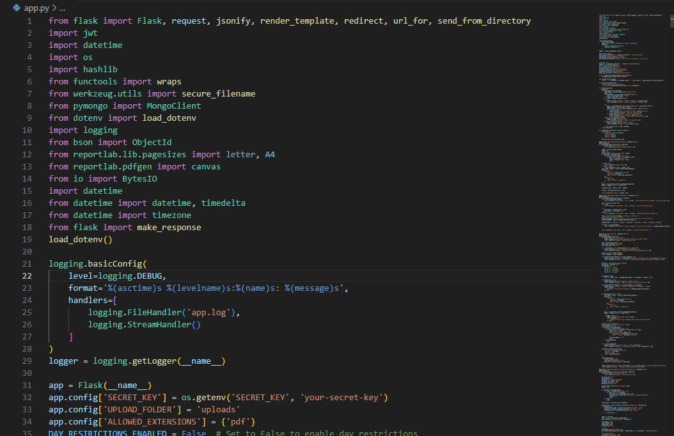
The achievements completed were, to create a robust development environment that supports secure configuration and detailed logging, and ensured seamless integration with MongoDB, enabling scalable data storage for all system components.

User Authentication and Role-Based Access Control
Tasks Completed:
- Implemented user registration (/register) and login (/login) endpoints, supporting three roles: public, merchant, and government.
- Developed a hash_password function using SHA-256 to securely store user passwords in the users collection.
- Created a token_required decorator to enforce JWT-based authentication across protected endpoints, validating tokens via Authorization headers or query parameters.
- Designed a unique user ID generation system (generate_next_user_id) with prefixes (e.g., U for public, M for merchant) to ensure distinct identifiers.
- Added logout functionality (/logout) and role-specific dashboard routes (/public, /merchant, /admin).
The achievements completed were, delivered a secure authentication system that protects user sessions and enforces role-based access and enabled flexible user management with unique IDs and PRS IDs (e.g., PUB-U001-EMAIL5) for traceability.
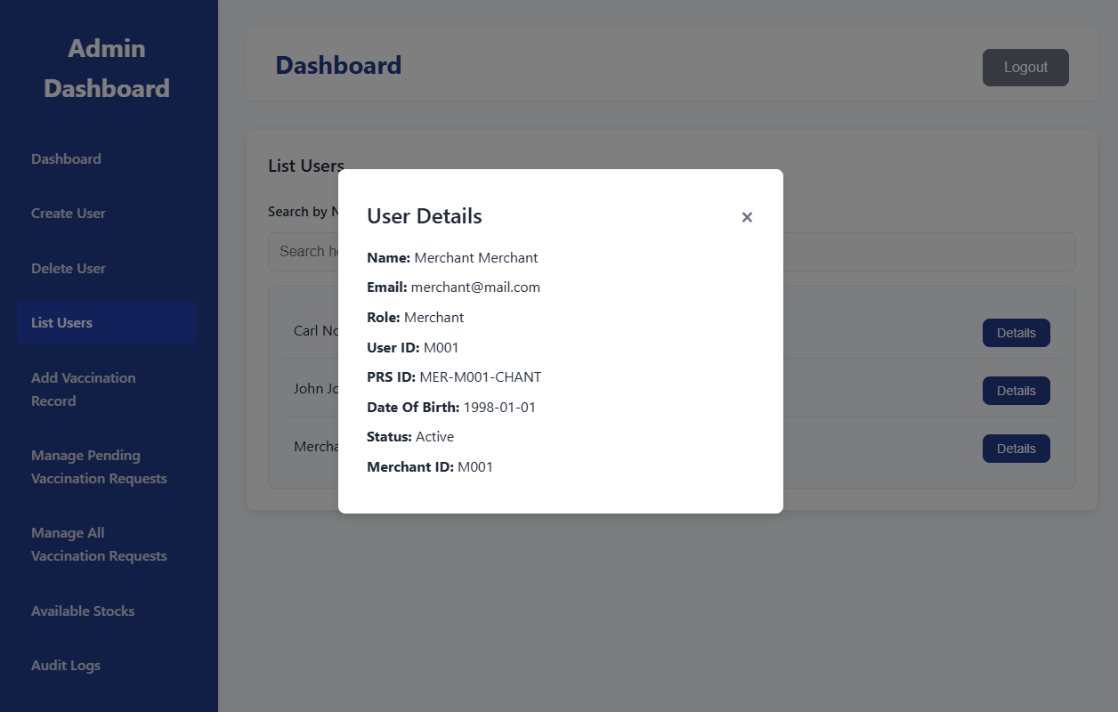

Purchase Management with Restrictions
Tasks Completed:
- Developed the /purchase-item endpoint to allow public users to buy items, with stock updates in the merchant_stocks collection and purchase records in the purchases collection.
- Implemented day-based purchase restrictions in /can-purchase-today/<item_name> and /purchase-item, using the last digit of a user’s birth year to assign allowed purchase days (e.g., digits 0/2 → Monday).
- Added a weekly limit of buying items per user (changes according to merchants desire), enforced via MongoDB aggregation queries to track purchases within a week.
- Created the /allowed-purchase/<item_name> endpoint to inform users of their remaining purchase quota based on stock and limits.
- Integrated audit logging for purchases to track user activity in the audit_logs collection.
The achievements completed were, built a sophisticated purchase system that balances supply and demand through DOB-based restrictions and weekly caps, and ensured accurate stock management and user activity tracking, enhancing system reliability.
Challenges overcome:
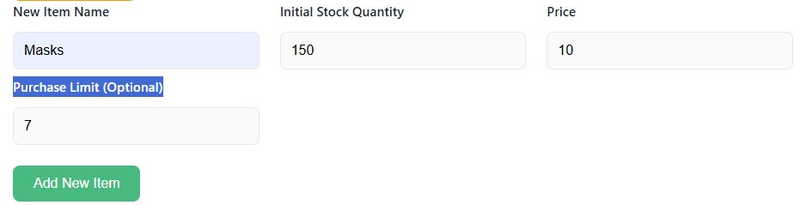
- Designed complex logic to map DOB digits to weekdays, requiring careful testing to ensure consistency across endpoints.

Merchant Inventory Management
Tasks Completed:
- Implemented endpoints for merchants to manage inventory: /add-item, /update-stock, /remove-item, and /batch-update-stock.
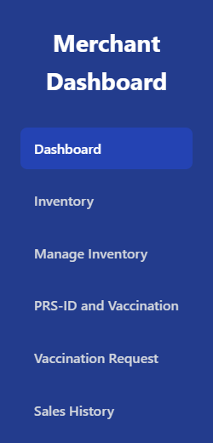
- Stored merchant inventory in the merchant_stocks collection, with fields for item name, stock, price, and optional purchase limits.
- Developed the /merchant-sales endpoint to display sales data, linking purchases to buyer names for merchant visibility.
- Ensured only merchants could access inventory endpoints using the token_required decorator with role checks.
The achievements completed were, provided merchants with comprehensive tools to manage and monitor their inventory and sales, and enabled flexible inventory updates, including batch operations for efficiency.

Vaccination Request and Approval System
Tasks Completed:
- Created the /request-vaccination endpoint for public users to submit vaccination requests, with a limit of 3 pending requests per user.
- Developed government endpoints (/admin/list-vaccination-requests, /admin/approve-vaccination, /admin/reject-vaccination, /admin/update-vaccination-status) to manage requests.
- Implemented user-facing endpoints (/public/vaccination-request-status, /public/clear-vaccination-requests, /public/latest-approved-vaccine) to track and manage requests.
- Added vaccination data storage in the vaccinations collection, including fields for user ID, vaccine type, status, and admin responses.
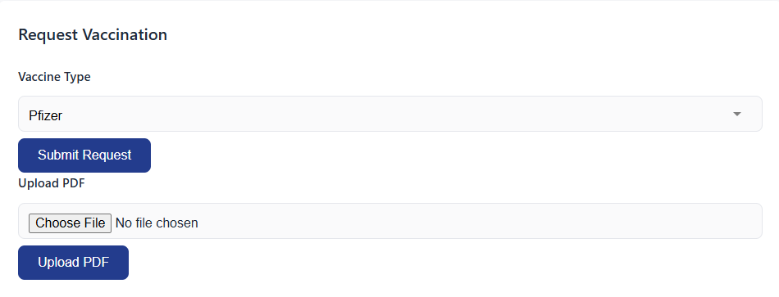
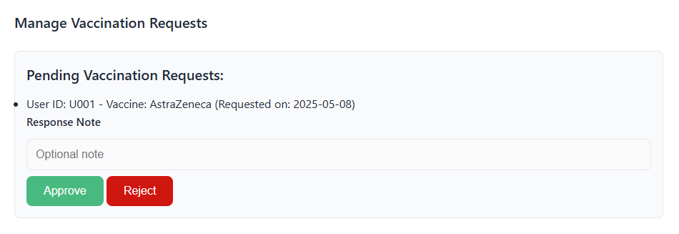
The achievements completed were, delivered a robust vaccination management system that supports request submission, administrative oversight, and user feedback, and ensured scalability by limiting pending requests and providing clear status updates.

PDF Generation and File Uploads
Tasks Completed:
- Implemented /generate-receipt/<item_name>/<quantity> to create PDF receipts for purchases, including buyer, merchant, and item details.
- Developed /generate-vaccination-pdf/<request_id> to generate vaccination certificates with user and vaccination details.
- Used ReportLab to format PDFs on A4 pages with headers, footers, and consistent styling (Helvetica fonts, defined margins).
- Created /upload-vaccination-pdf to allow users to upload PDF vaccination records, stored in the uploads folder with metadata in the pdfs collection.
The achievements completed were, provided professional PDF outputs for critical system functions, enhancing user experience, and enabled secure file uploads with extension validation to support vaccination record submissions.
Challenges overcome:
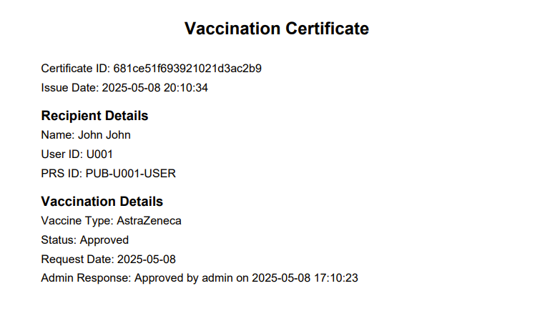
- Mastered ReportLab’s API to achieve precise PDF layouts, requiring experimentation with positioning and formatting.

Government Administration Features
Tasks Completed:
- Developed endpoints for government users: /admin/create-user, /admin/delete-user, /admin/toggle-user-status, /admin/search-users, and /admin/list-users for user management.
- Implemented /admin/statistics to display system metrics (e.g., user counts, vaccination rate).
- Created /admin/audit-logs to provide visibility into system actions (e.g., purchases, user changes).
- Added /admin/list-stocks to view merchant inventories and /admin/list-all-vaccination-requests for comprehensive vaccination oversight.
The achievements completed were, built a powerful administrative interface for government users to oversee and control the system, and enhanced transparency with statistics and audit logs, supporting system monitoring.
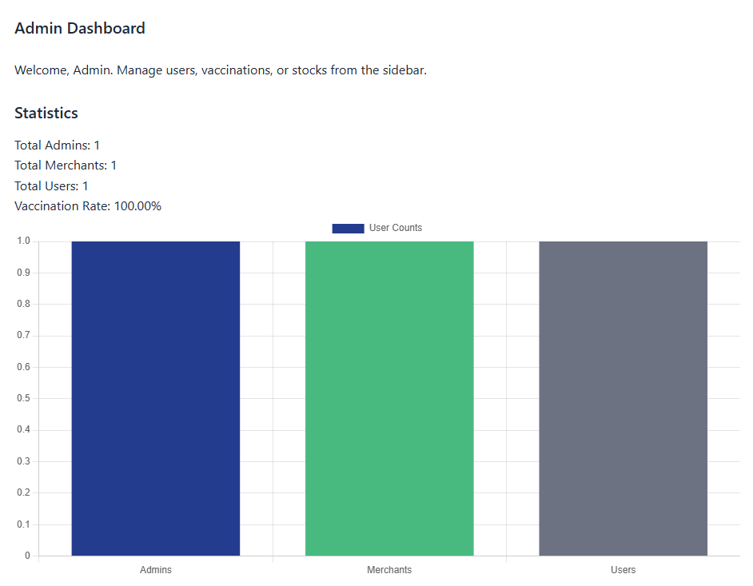

Security and Infrastructure Enhancements
Tasks Completed:
- Configured HTTPS redirection in production using before_request to ensure secure communication.
- Added security headers (Strict-Transport-Security) in after_request to enforce HTTPS.
- Implemented audit logging for key actions (e.g., CREATE_USER, PURCHASE_ITEM) to track system activity.
- Set up SSL support for the Flask server, with fallback to HTTP for development if SSL certificates are unavailable.
The achievements completed were, strengthened system security with HTTPS and audit trails, ensuring data protection and accountability, and provided a flexible server setup that supports both production and development environments.
Challenges overcome:
- Addressed SSL configuration issues by implementing a fallback to HTTP port 5000, ensuring development could proceed without certificate errors.
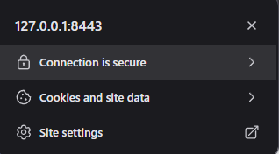

Milestones Achieved

- Initial Setup: Established Flask and MongoDB integration, with logging and environment configuration.

- Core Features: Delivered authentication, purchase restrictions, inventory management, and vaccination workflows.

- Advanced Functionality: Implemented PDF generation, file uploads, and government administration tools.

- Security Implementation: Added JWT authentication, HTTPS, and audit logging to ensure a secure system.

- Completion: Fully functional system deployed with role-specific dashboards and comprehensive endpoints.

Reflection and Future Work
The development of the Pandemic Resilience System was a significant undertaking, requiring integration of multiple technologies (Flask, MongoDB, ReportLab) and careful design of role-based functionalities. Key successes include the robust purchase restriction logic, professional PDF outputs, and secure authentication system. Challenges, such as mastering ReportLab’s PDF formatting and ensuring consistent DOB-based restrictions, were overcome through iterative testing and research.

For future enhancements:
Modularizing app.py into separate files for better maintainability, upgrading password hashing to bcrypt for enhanced security, maybe adding Two-Factor Authentication. Also adding MongoDB transactions to ensure atomic stock updates. With these improvements the system’s strength will increase.

Conclusion
This logbook documents the development of the Pandemic Resilience System, highlighting the creation of a feature-rich web application for pandemic resource management. The implemented features—authentication, purchase controls, inventory management, vaccination workflows, PDF generation, and administrative tools—demonstrate a comprehensive solution tailored to public, merchant, and government needs. The project is run in Python, Flask, and MongoDB, with a focus on secure and user-friendly design.

