General Purpose I/O Lab Exercise:
Basic User Interface

Overview
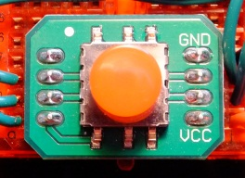  Figure 1. 5-way switch | 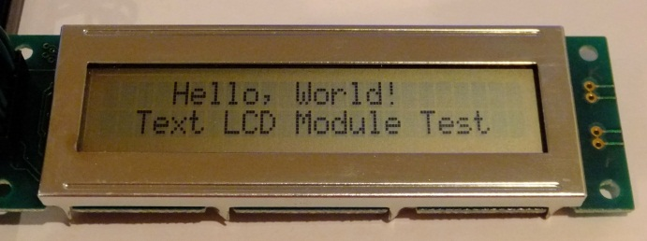  Figure 2. A two line by 24 character LCD module.
For this project you will add switches (see Figure 1) and a text LCD (see Figure 2) to create a simple user interface for the Nucleo-F401RE board. With it you can control your microcontroller and display information for the user.

Switch Interfacing

Hardware
Figure 3. Schematic diagram

Use five momentary switches SW1-SW5 or one multi-way switch to generate user input. You will use the MCU’s built-in pull-up resistors to ensure the signals are logic ones when the switches are open.

Connections
Connect the switch signals to GPIO port signals on the MCU as shown in table below. This matches the pins used in the furnished code.
Table 1. Switch signals and connections
Signal Name | Description | Direction | MCU
SWUp | Up | Input to MCU | PA_1
SWDn | Down | Input to MCU | PB_0
SWLt | Left | Input to MCU | PC_1
SWRt | Right | Input to MCU | PC_0
SWCr | Center | Input to MCU | PA_4
VSS | Ground
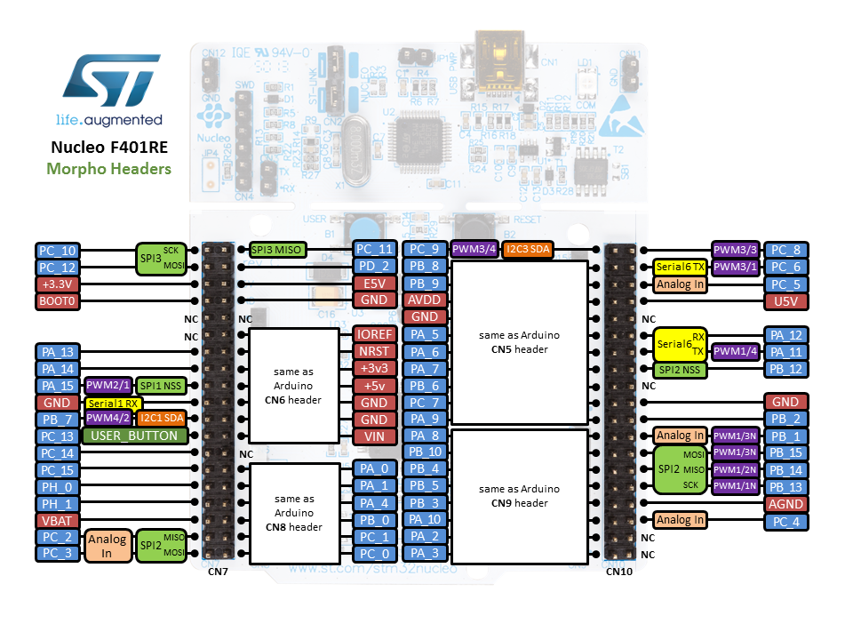
Figure 4. Nucleo-F401RE pinout.

Software

Switch Interface Code
Let’s see how to use the GPIO pins to interface a CORTEX-M4 MCU to a 5-way switch. First, we define a function to initialize all the switches with pull-up resistors.
void switches_init(void) {
gpio_set_mode(P_SW_UP, PullUp);
gpio_set_mode(P_SW_DN, PullUp);
gpio_set_mode(P_SW_LT, PullUp);
gpio_set_mode(P_SW_RT, PullUp);
gpio_set_mode(P_SW_CR, PullUp);
}
Next we define a function to read a switch. Note that a switch returns a value of 0 when pressed (active low).
int switch_get(Pin pin) {
return !gpio_get(pin);
}
Now we can write code to detect when switches are pressed. We will light up different LEDs based on which switches are pressed.

RGB LED Interface Code
We also initialize the RGB LEDs on the MCU board. The LED positions are defined in platform.h.
void leds_init(void) {
// Set 3 led pins to outputs.
gpio_set_mode(P_LED_R, Output);
gpio_set_mode(P_LED_G, Output);
gpio_set_mode(P_LED_B, Output);

leds_set(0, 0, 0);
}
The leds_set function is straightforward; keep in mind the LEDs are active low however.
void leds_set(int red_on, int green_on, int blue_on) {
// Leds are active low
gpio_set(P_LED_R, !red_on);
gpio_set(P_LED_G, !green_on);
gpio_set(P_LED_B, !blue_on);
}

Application Code
In the main function we initialize the switches and LEDs and then call the print_switches and light_leds function.
switches_init();
leds_init();
lcd_init();
lcd_print("Hello World!");

while (1) {
print_switches();
light_leds();
}
Within light_leds, we read the switches switch_get function, and pass the result to leds_set to specify whether each LED should be lit.
void light_leds() {
leds_set(switch_get(P_SW_UP),
switch_get(P_SW_CR),
switch_get(P_SW_DN));
}

LCD Interfacing

Hardware

LCD Controller Concepts
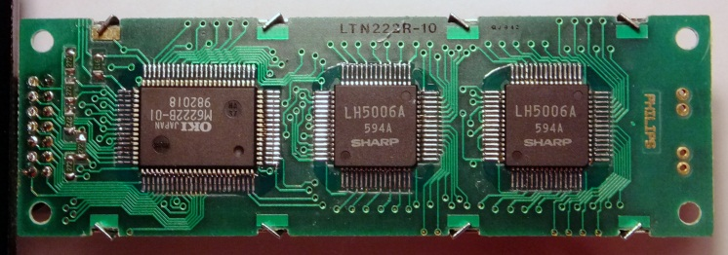
Figure 5. Back of module showing controller and column driver ICs.
The character LCD module shown in Figure 2 consists of an LCD glass panel and several digital logic ICs on the back of the module, shown inFigure 5. The LCD is controlled by an HD44780 or compatible LCD controller IC (in this case, an M6222B-01) and several slave LCD driver ICs (LH5006A).
Figure 6. Block diagram of character LCD module and interface with MCU.
Figure 6 presents a block diagram of the LCD control system and the interface to a microcontroller. The interface consists of three control lines (Enable (E), Read/~Write (R/~W)), and Register Select (RS), and four or eight data lines (DB4-7 or DB8-7). The falling edge of the E signal triggers an operation based upon the state of RS and R/~W, as shown in Table 2.
Table 2. HD44780 LCD Controller Operations
RS | R/~W | Operation
0 | 0 | Write instruction
0 | 1 | Read busy flag and address counter
1 | 0 | Write data
1 | 1 | Read data
The following table shows the typical signal assignments for the LCD interface on a 14 pin connector.
Table 3. HD44780 LCD Controller Interface
Pin | Signal | Description
1 | VSS | Ground
2 | VDD | Power supply
3 | VO | LCD contrast adjustment voltage
4 | RS | Register Select
5 | R/W | Read
6 | E | Enable (Clock signal)
7 | DB0 | Data bus (LSB)
8 | DB1 | Data bus
9 | DB2 | Data bus
10 | DB3 | Data bus
11 | DB4 | Data bus
12 | DB5 | Data bus
13 | DB6 | Data bus
14 | DB7 | Data bus (MSB)
Some LCD controllers have LED backlighting. These may use a 16 pin connector, with pins 15 and 16 connected to the anode and cathode of the LED.

Connections
Allocate the switch and LCD controller signals to GPIO port signals on the MCU. The table below shows the allocations used for the furnished code.
Table 4. LCD signals and connections
Signal Name | Description | Direction | MCU
E | LCDEnable | Output from MCU | PB_10
R/W | Read /Write | Output from MCU | PA_8
RS | RegisterSelect | Output from MCU | PA_9
DB4 | Data bus 4 | I/O to/from MCU | PB_4
DB5 | Data bus 5 | I/O to/from MCU | PB_5
DB6 | Data bus 6 | I/O to/from MCU | PB_3
DB7 | Data bus 7 | I/O to/from MCU | PA_10
VDD | Supply Voltage | Input to LCD Panel
VSS | Ground | Input to LCD Panel

Software

LCD Interface Code
Let’s see how to use the GPIO pins to interface a MCU to an LCD module.
The MCU always drives the three control lines, so they need to be outputs with normal drive capabilities. The data lines are typically written, but may also be read for status information, so they need to be inputs or outputs depending on the communication operation with the LCD. We will initialize them as outputs but switch them to inputs when needed. As inputs, they do not need pull-up or pull-down resistors. As outputs, they only need normal drive capabilities. Let’s use the 4-bit data interface to save pins and wiring effort.
- We use the gpio drivers to set the data pins as inputs / outputs.
static void set_data_dir(PinMode mode) {
uint8_t i;
for (i = 0; i < 4; i++) {
gpio_set_mode((Pin)(P_LCD_DATA[i]), mode);
}
}
- To write data on the 4 bit data bus, we assert the control lines as specified in the LCD controller data manual.
void lcd_write_4bit(uint8_t c) {
int i=0;
gpio_set(P_LCD_RW, 0);
gpio_set(P_LCD_E, 1);

for(i=0; i<4; i++) {
gpio_set(P_LCD_DATA[i], (c & (0x1<<i))>>i);
}
delay_us(1);
gpio_set(P_LCD_E, 0);
delay_us(1);
}
- To read from the LCD, we need to switch the data bus direction to input, read 4 bits of data (the upper nibble), read in 4 more bits of data (the lower nibble), form these nibbles into a byte, and then switch the data bus direction back to output.
uint8_t lcd_read_status(void) {
uint8_t status;
int i;

set_data_dir(Input);
gpio_set(P_LCD_RS, 0);
gpio_set(P_LCD_RW, 1);
delay_us(1);
gpio_set(P_LCD_E, 1);
delay_us(1);

for(i=0; i<4; i++) {
status |= gpio_get(P_LCD_DATA[i]) << (4-i);
}
gpio_set(P_LCD_E, 0);
delay_us(1);
gpio_set(P_LCD_E, 1);
delay_us(1);

for(i=0; i<4; i++) {
status |= gpio_get(P_LCD_DATA[i]) << (4-i);
}
gpio_set(P_LCD_E, 0);
set_data_dir(Output);
return status;
}
- We can use these pieces to initialize the HD44780 LCD controller, as directed in the datasheet.
void lcd_init(void) {
// Set all LCD pins as outputs
gpio_set_mode(P_LCD_RS, Output);
gpio_set_mode(P_LCD_RW, Output);
gpio_set_mode(P_LCD_E, Output);
set_data_dir(Output);
// Have to wait 100ms or more after Power on
delay_ms(100);

// Run LCD initilisation sequence

// Set the device to change mode from 8-bit to 4-bit
lcd_write_cmd(0x30);
delay_ms(5);
lcd_write_cmd(0x30);
delay_us(100);
lcd_write_cmd(0x30);
delay_us(100);
lcd_write_cmd(0x20);
delay_us(100);

// The device is in 8-bit mode when powered up
// At this point it switches to 4-bit mode

// Configure operating mode (number of rows/lines)
lcd_write_cmd(0x28);
delay_us(60);
// Set display off, under-line off and block cursor off
lcd_write_cmd(0x08);
delay_us(60);
// Clear display
lcd_write_cmd(0x01);
delay_ms(4);
// Set the direction of address counter to increment
// and no display shift on data read/write
lcd_write_cmd(0x06);
delay_us(60);
// Set display on, under-line off and block cursor off
lcd_write_cmd(0x0C);
delay_us(60);

lcd_set_cursor(0,0);
lcd_set_cursor_visible(0);
}

Hello, World
Let’s use these modules to create a program which first displays “Hello World!” on the LCD and displays different strings depending on which switch the user has pressed. Within main, we call lcd_init to initialize the GPIO ports which the LCD controller is connected to, and then initialize the LCD controller itself. We then clear the LCD and display the message.
switches_init();
leds_init();
lcd_init();
lcd_print("Hello World!");

Switch Reading and Reporting
Finally, let’s write a function which indicates on the LCD which switch is pressed. First, we set the cursor to the beginning of the area for our message. After reading the switch code, we test until finding the first pressed switch, at which point we print out the name of the switch. If no switches are pressed, we erase anything that was printed there previously.
void print_switches() {
lcd_set_cursor(0, 1);

if (switch_get(P_SW_UP)) {
lcd_print(" Lorem ");
} else if (switch_get(P_SW_CR)) {
lcd_print(" ipsum ");
} else if (switch_get(P_SW_DN)) {
lcd_print(" dolor ");
} else if (switch_get(P_SW_LT)) {
lcd_print(" sit ");
} else if (switch_get(P_SW_RT)) {
lcd_print(" amet ");
} else {
lcd_print(" ");
}
}

