Comparator Lab Exercise:
Voltage Monitor

Overview
In this project you will implement a software based comparator to monitor the voltage from a potentiometer-based divider. You will evaluate the polling software.

Details

Hardware
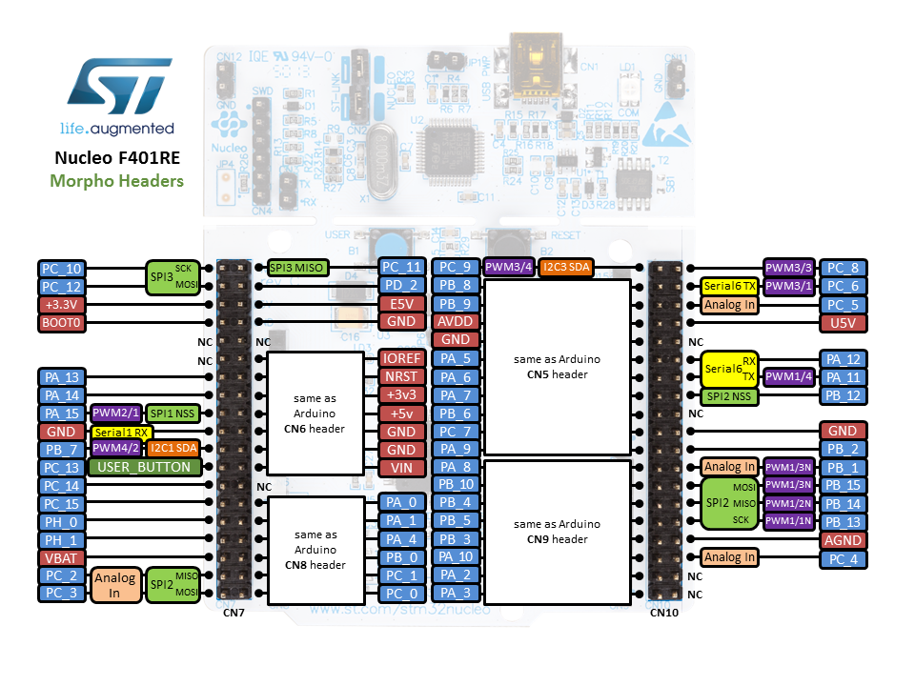
Figure 1. Nucleo-F401RE pinout.

Connections

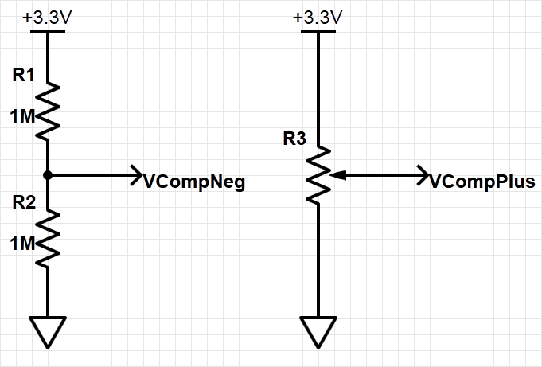
Figure 2. Potentiometer circuit forming voltage divider for comparator monitoring.
Build the circuit shown in Figure 2 on your breadboard. Connect the potentiometer signals to MCU board as shown in table below. This matches the pins used in the lab code.
Table 1. Signals and connections
Signal Name | Description | Direction | MCU
P3V3 | Positive supply voltage | Power
GND | Ground | Power
V_{CompNeg} | Variable input voltage | Input to MCU | PA_0
V_{CompPlus} | Fixed voltage reference | Input to MCU | PA_1

- Compile the supplied lab software for polling operation, load it onto the MCU and run it.
- Measure the 3V3 supply rail, which is divided for the comparator’s negative reference voltage.
V_{3v3}. = ___________V.
- At what input voltage (from the potentiometer) does the LED change color? Use a multimeter to measure this voltage.
- At what input voltage do you expect the LED to change color, given theinput to V_{CompNeg}? Does this match the actual code?
- Change the source code to use interrupts (controlled by the #if in the main function). Verify the code still has the same threshold voltage. What has changed?
- Modify the resistors to change LED color at 1V. Verify that your changes work.

