Exploring a Relational Database using Oracle SQL*Plus and notepad++

Your Login details

Before you start you should have the following:
Write them down so you don’t forget them !
Student Login:
CourseWork Login:
Password:
Host String: @student

Activity Aims

The aim of the SQL activities are:

- Developed knowledge of database programming language SQL in Oracle
- Utilise database programming language SQL for the development of databases applying appropriate standards, conventions and good practise

Activity Introduction

In order to get the most from these exercises you should attempt to:

- Read the explanations and complete the questions
- Complete all parts in the order presented
- Think about the nature of the application itself
- Keep referring to the entity relationship diagram and the table specifications

Professionalism

The purpose of this activity is to develop an understanding of the database programing Structured Query Language in Oracle. It is important to approach it from a professional prospective, to develop skills that apply industry standards and convention throughout.

It is not about finishing first.

The Database Application used in this guide

The entity relationship model is of a contract training department. It is to be stored in an Oracle relational database.

There are ten normalised tables which make up the database. These correspond to the entities shown in the entity relationship diagram below:

course
subject_area
attendance
invoice_item
site
trainer
student
company
course_run
invoice

Entity Relationship Diagram

The naming conventions used in the database are:

Table names are plural versions of entity names
Use is made of underscore;
ie the entity invoice_item corresponds to a table called INVOICE_ITEMS

Primary and foreign keys are all called something_id, for example course_id

Column names are often comprised of several words separated by underscores
eg: trainer_name, course_price

Database Skeleton Table
The tables will hold data representing the following information:

Tables | attribute | Key | Datatype | Constraints\Defaults
subject_areas | subject_id | pk
 | subject_name
 | description
courses | course_id | pk
 | course_title
 | subject_id | fk
 | duration
 | cost
trainers | trainer_id | pk
 | t_firstname
 | t_surname
 | mentor_id
 | rate
 | contact_no
course_runs | running_id | PK
 | site_id | fk
 | course_id | fk
 | trainer_id | fk
 | start_date
attendance | running_id | Pk, fk
 | student_id | pk fk
 | amount paid
sites | site_id | pk
 | site name
 | location
companies | company_id | pk
 | company_name
 | address
 | contact_no
 | no_of_emp
students | student_id | pk
 | st_fname
 | st_sname
 | date_of_birth
 | address
invoices | invoice_id | pk
 | company_id | fk
 | student_id | fk
 | billing_date
invoice_items | invoice_id | pk, fk
 | invoice_item | Pk
 | start_date
 | end_date
 | amount

Oracle Developer

- You will be using a client-based program running under Windows
- Most of the commands you will be using are SQL (Structured Query Language)
- However, there will be some commands which are peculiar to SQL*Plus

Logging into Oracle
- Double click on the file e:\Oracle12c\sqlplus.exe not the one in programs
- Open SQL* Plus on your (client) computer
- Connect your client-based SQL*Plus program to the Oracle server by typing your details:
username@student/password

- Usernames
- List of practical logins attached
- The original password is the same as the login

- Coursework Logins
- If the login you use for coursework is less than 100, your assignment login is the same as your usual login but starts with a 2
  - eg: practical login CSY1026_1 assignment login CSY1026_201
- If your login for coursework is 100 or over, then your assignment login starts with a 3
  - eg practical login CSY1026 _101 assignment login CSY1026 _301

- It can be helpful to add your details to the top of your files

In SQL*PLUS

- At the SQL> prompt enter single or simple SQL command
- For longer commands use an editor eg Notepad++
- Save the command with the extension .txt eg example.txt

- To get SQL*Plus to run the script file use the run command @
- eg if the file ‘example’ was saved in subdirectory ‘databases’ on drive C, type:

@C:\databases\example.txt

before starting

- Create a folder on your USB with the module name eg csy1026
- Files saved in this folder should have the path
d:\csy1026\scripts

- for example the createTest.txt file will have the path
d:\csy1026\createTest.txt

NOTE: files, folders and paths names cannot have spaces in them

Changing your environment

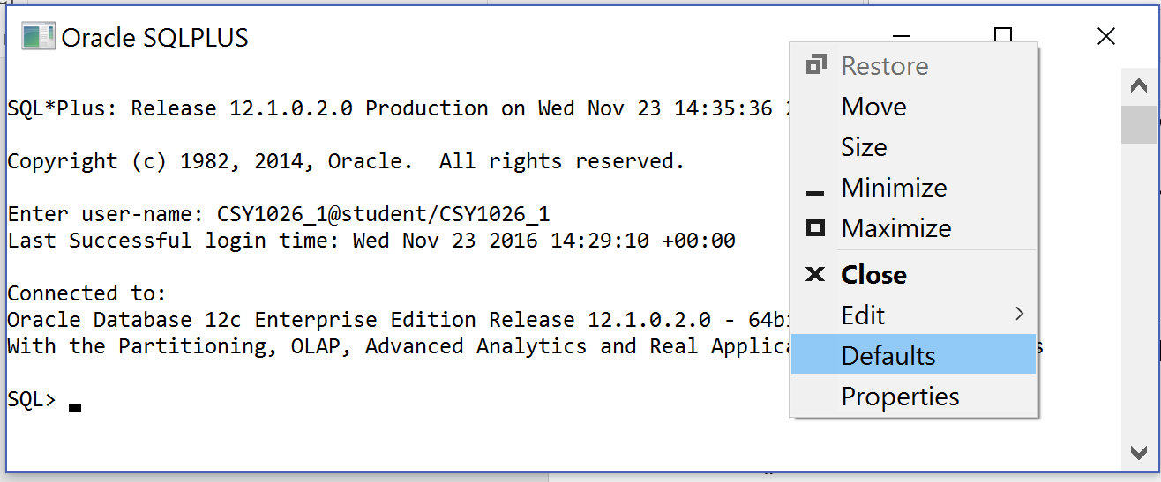

- Once you have logged in you can change environment
- Right click on the top of the window to call the menu
- You will need make any changes in both the Defaults and Properties.

Recommendations:
- In Options, tag ‘quick edit mode’
- In Colour ‘screen text’ and ‘background text’

Activity 1 | Aims
- to introduce the client server structure and become familiars with Oracle SQL
- to introduce the database model for this term
- to change a user password
- to become familiar with using script files and editors
- to apply good practice and standards

Changing your passwords

The ALTER command is used in the data definition language (DDL) to change a table or user structure.

To change passwords the following structure is use

ALTER USER your_user_id IDENTIFIED BY your_new_password;

All commands must end with a semi colon to tell Oracle we’ve finished

To enter a number as a password it should be in double quotes eg “200”
This changes it to a text value

NOTE: Passwords should not start with a number use double quotes or letters

- At the SQL prompt alter your student password to your student number
- Enter the COMMIT command into SQL
- Log off using the EXIT command

- Log on with your coursework login
- At the SQL prompt alter your coursework password to your student number
- Enter the COMMIT command into SQL
- Log off using the EXIT command

Note: One command at a time followed by the semi colon;

If you try to connect with an incorrect user name or password you will get the following error message

ERROR
ORA-01017: invalid username/password: logon denied

ERROR MESSAGES: These are helpful, always read them and try to correct the problem before hand waving! Learn from your mistakes.

- Log on with your student login and new password

Creating your copy of an Oracle relational database

To create your own version of an example relational database on the Oracle server you will need to execute a copy of the script files: createTest.txt, constraintTest.txt, insertTest.txt

These contains SQL DDL create, alter and insert commands

- Download all 4 ‘…test.txt’ script files from blackboard to your csy1026 folder
- Open the script files in Notepad++
- Check the language is set to SQL

- Look at the script files and consider what each one does
- Look at the script file and consider the order of the tables, drops and constraints

- Why are the commands in these orders?

To create tables in your relational database on the Oracle server using the create table commands in the createTest.txt script file, you could copy and paste the files into SQL but the buffer may not be large enough to hold all the data. Only part of the data might be copied and it would therefore be wrong. Instead we can point SQL to our file and it will read from it.

The @ sign is used to point SQL at your commands, using the file path and name ie: if your script file is on drive C: in the ‘database’ folder and an ‘csy1026’ folder, the command would be:

@C:\database\scripts\createtest.txt

Remember: No spaces and don’t forget the extension eg .txt

- What would the command be if the file is on your USB in your module folder?

- At the SQL> prompt enter a command to run the createTest.txt script

Instructions are passed to the Oracle RDBMS to create the various database tables. Oracle RDBMS stores the names of your tables in one of its tables called TAB and USER_OBJECTS

- At the SQL> prompt type SELECT * FROM TAB;
This will list the tables stored in your database

- What tables do you have?

The DESCRIBE command (desc for short) is used to describe a table structure. The DESC command does not show the data stored in the tables.

- Use the DESC table_name command to view each table

- What attributes does the loans table have?

Deleting tables

- To delete some tables in your relational database on the Oracle server using the drop table commands in the droptest.txt script file we point SQL at the droptest.txt file

- At the SQL> prompt enter a command to run the dropTest.txt script
- At the SQL> prompt enter a command to view the tables stored in your database

- The Drop file removes any table with the defined name
- This enables the database to be recreated (handy if you’ve messed up the first version!)
- DROP TABLE commands must be in the correct order of reference

- At the SQL> prompt enter a command to run the drop tables script
- At the SQL> prompt enter a command to view your tables

Using an editor

Commands written in SQL are not stored, only the changes are store in Oracle. Typing commands into a file and saving them means that you have a backup of your code if anything goes wrong and a useful reference for future work (or your assignment).

- Open a new Notepad++ file
- Call the script file yourlogin_wk1.txt eg 26_wk1.txt

- At the top of the file enter the run command
- Put two dashes ( - - ) and a space in front of the run command to prevent looping
- In the editor enter a command to view your tables
Changes in the editor must be saved before it is run

Remember!: Oracle will not accept spaces in file, folder or path names

- Return to the SQL> prompt
- At the SQL> prompt use the @ command to run the new script file

Case in SQL

SQL DDL is not case specific but, when commands are parsed they use the Shared Global Area (SGA) and consistent case and structure makes processing quicker. It is good practise to put all reserved words (Oracle words) in upper case, in Notepad++ they are in green.

Comments in SQL

SQL uses two types of comments, single line and multiple lines. It is good practise to include a comment block at the top of files and additional heading comments throughout.

-- is used for single line comments eg
- - Create Commands

/* … */ is used for multi line comments eg

/*
Student name, module, date
*/

Table Definition
To create tables the following structure is used

CREATE TABLE table_name (
column_name1 DATATYPE,
column_name2 DATATYPE);

To drop tables the following structure is use

DROP TABLE table_name [ PURGE ] ;

Note: Words in square brackets [ ] are optional commands. Don’t include the bracket.
Note: PURGE prevents tables going to the recycle bin

- In the your_login_wk1.txt file, using the examples above and correct case
- Write the command to create the following table
- Give the table the name ‘customers’

Column Name | Datatype
customer_id | NUMBER(5)
firstname | VARCHAR2(15)
surname | VARCHAR2(20)
dob | DATE
gender | CHAR
contact_number | VARCHAR2(15)

- Save the file

- At the SQL prompt> use the @ command to run the script file
- At the SQL> prompt write a command to list your table
- At the SQL> prompt write a command to describe your table

- In the your_login_wk1.txt file, using the examples above and correct case
- Write a command to drop the customer table
- At the SQL prompt> use the @ command to run the script file

- Do you get an error, why?

- At the SQL> prompt write a command to list your table

- Note: If you have BIN files you will need to empty your recycle bin
- Use the PURGE RECYCLEBIN command

- Edit your your_login_wk1.txt file
- Add a comment block at the top of your file, using a multiple line comment
- Add the run command to the file, using a single line comment
- Why do you need to comment out the run command?

- Add headings for your Creates and Drops

- Ensure your files and folders are well structure, tidy and clearly commented
- Save your files
- Commit and Exit SQL ☺

