Product Requirements Document (PRD)
Abnormal AI Communications Assistant (AICA)
Version: 1.0
Owner: Product Management
Date: November 2025

1. Overview

1.1 Product Name
Abnormal AI Communications Assistant (AICA)

1.2 Summary
AICA is an AI-native tool designed to generate high-quality, customer-ready communications during active incidents automatically. It integrates into Abnormal Security's incident response workflow to reduce manual drafting time, enforce consistent tone and formatting, and eliminate the risk of sharing internal-sensitive details.
AICA accelerates response time, supports Incident Commanders and Customer Support teams, and ensures customers receive clear, accurate, trustworthy updates.

2. Problem Statement
During customer-impacting incidents, Incident Commanders(ICs), Engineering Leads, and Customer Support Engineers must produce timely and accurate external communications. These messages are currently drafted manually, often under intense pressure, resulting in delays, inconsistencies, and a heightened risk of exposing internal-only information.
The manual workflow also forces engineers and ICs to split attention between technical triage and communication drafting, slowing response effectiveness. As incident volume and complexity increases, Abnormal needs a scalable, reliable system that reduces cognitive load, shortens communication cycles, and maintains customer trust.
AICA solves this problem by generating incident communications automatically using AI, guided by Abnormal’s tone, style, and compliance guardrails.

3. Goals & Non-Goals
3.1 Goals
1. Reduce incident communication drafting time by over 70%.
2. Create consistent, on-brand drafts for all stages of incidents.
3. Lower the risk of leaking internal technical data through automated safeguards.
4. Enhance communication quality and clarity for customers during incidents.
5. Allow Incident Commanders and Customer Support to focus on mitigation and coordination.
6. Integrate smoothly into Abnormal's existing incident response workflow.

3.2 Non-Goals
AICA will not:
1. Replace human approval for external communications.
2. Serve as a full incident management system.
3. Generate full postmortems or internal retrospectives.
4. Pull data directly from internal engineering logs or monitoring systems.
5. Publish automatically to the StatusPage API in v1.

4. Background & Context
Abnormal Security maintains a high standard for transparent, accurate, and timely communication during incidents. These communications currently rely heavily on human drafting, which varies in quality and speed based on the author, severity, and incident load.
Pain points include:
1. Slow draft creation
2. Tone inconsistency
3. Risk of oversharing
4. Cognitive overload for engineers and ICs
AICA leverages AI to solve these issues at scale.

5. Personas

5.1 Primary Persona, Incident Commander (IC)
Responsibilities: Oversees and coordinates all technical and operational aspects during incidents.
Needs: Rapid communication drafts, minimal cognitive load, safety against oversharing.

5.2 Secondary Persona, Customer Support Engineer (CSE)
Responsibilities: Creates and publishes Status Page updates and customer-facing messages.
Needs: Consistent tone, accurate messaging, guardrails for phrasing and safety.

5.3 Tertiary Persona, Engineering Lead
Responsibilities: Provides technical inputs, timelines, and impact details.
Needs: Ability to turn raw notes into polished summaries without exposing sensitive data.

6. User Stories
1. As an IC, I want to enter structured incident details so the system can generate updates automatically.
2. As a CSE, I want tone-consistent, customer-friendly messaging to reduce rewriting.
3. As an Engineer, I want my raw notes summarized safely for customer-facing updates.
4. As an IC, I want multiple draft options so I can choose the most appropriate version.
5. As a CSE, I want to export approved drafts for the Status Page and customer emails.
6. As a Support Manager, I want communication consistency across all incidents.

7. Key Use Cases

7.1 Initial Incident Notice
Generate the first customer-facing update based on severity, impact, and detected symptoms.

7.2 Ongoing Updates
Summarize progress notes, mitigation steps, and expected next-update times.

7.3 Incident Resolution Message
Produce a final customer communication summarizing resolution, impact window, and next steps.

7.4 Guardrail Enforcement
Automatically remove sensitive terms, prevent root-cause speculation, and adjust tone.

7.5 Review Edit Export Workflow
Users refine drafts and export them to the clipboard, an email template, or a StatusPage snippet.

8. Functional Requirements

8.1 Inputs

1. Incident summary (required).
2. Severity selection (or AI inference).
3. Impacted systems.
4. Customer impact details.
5. Mitigation status.
6. Timeline or Slack log input (optional).
7. Expected next update time (optional).

8.2 Draft Generation
1. AI must generate drafts for:
a. Initial Notice
b. Ongoing Update
c. Resolution
2. Provide multiple versions: Short / Standard / Detailed.
3. Produce strictly customer-appropriate language.

8.3 Guardrails
1. Automatically redact:
a. internal IDs
b. stack traces
c. hostnames/IPs
d. employee names

2. Prevent:
a. speculative causes
b. overly technical detail
c. unverified commitments

8.4 Editing & Regeneration

1. Inline editing must be supported.
2. Users may regenerate drafts with adjusted inputs.
3. Version history retained (in-memory or simple storage).

8.5 Export
1. Export formats:
a. Copy to Clipboard
b. Status Page snippet
c. Email template

8.6 Severity & Update Cadence
1. Severity taxonomy:
a. SEV1 (critical, widespread customer impact)
b. SEV2 (major impact to a subset of customers)
c. SEV3 (moderate degradation, limited scope)
d. SEV4 (minor issue, low impact)

2. Default "next update" cadence:
a. SEV1: every 30 minutes
b. SEV2: every 60 minutes
c. SEV3: every 2 hours
d. SEV4: on meaningful change or daily summary

3. Draft tone adjustments per severity (assertiveness, empathy, detail level).

8.7 Status Page Output Examples
1. Initial Notice (template):
Title: "Service Degradation – [Product/Region]"
Body:
- Impact: [summary]
- Start: [timestamp]
- Current status: [investigating|mitigating]
- Next update: [interval]

2. Ongoing Update (template):
- Progress: [steps taken]
- Mitigation: [actions]
- Customer impact: [scope]
- Next update: [interval]

3. Resolution (template):
- Impact window: [start–end]
- Resolution: [action]
- Customer remediation (if any): [steps]
- Follow-up: [postmortem ETA or none]

9. Non-Functional Requirements

9.1 Reliability
1. Draft generation must complete in <5 seconds (p95).

9.2 Security
1. No sensitive content stored beyond the session unless explicitly saved.
2. No training of external models using incident data.
3. All LLM traffic is HTTPS-encrypted.
4. PII/DLP: Entity detection + redaction for customer names, emails, domains; redact internal identifiers
before display/export.
5. Data retention policy: Default ephemeral session; optional saved drafts retained 30 days with redaction; configurable.

9.3 Usability
1. UI optimized for stressful conditions:
a. minimal steps
b. high readability
c. no unnecessary options

9.4 Scalability
1. Must support multiple simultaneous incidents.
2. Architecture must allow future multi-user collaboration.

10. AI Requirements

10.1 Model Inputs
1. Must accept mixed structured + free-text data.

10.2 AI Pipeline
1. AI must follow this sequence:
Input normalization
Prompt construction
Draft generation
Guardrail checks
Tone normalization
Formatting
Safety evaluation: run disallowed-content checks; block or request edits.

10.3 Contextual Behavior
1. Adjust language based on the incident stage.
2. Avoid hallucinating unknown details.
3. Maintain bounded length (Initial ≤ 150 words, Ongoing ≤ 200 words, Resolution ≤ 250 words).
4. Temperature range: 0.2–0.5 for determinism; max tokens capped per draft type.

10.4 Learning & Adaptation
1. Support future tuning on Abnormal-specific communication datasets.

11. UX Workflow

11.1 Step-by-Step Flow
1. User inputs incident details
2. AI generates multiple draft variants
3. Guardrails filter sensitive content
4. User reviews and edits
5. User approves and exports

11.2 Screen Overview

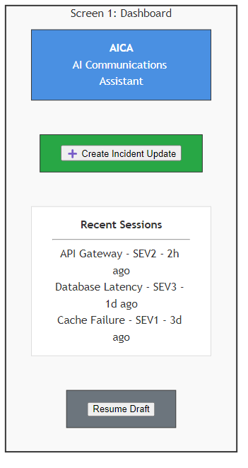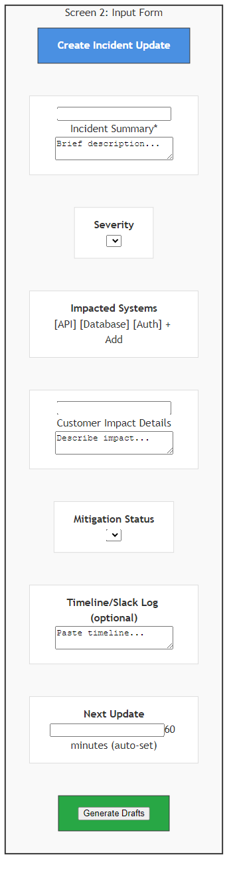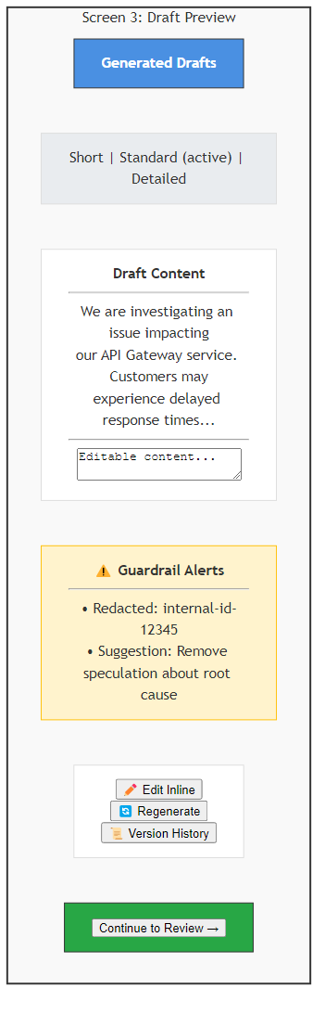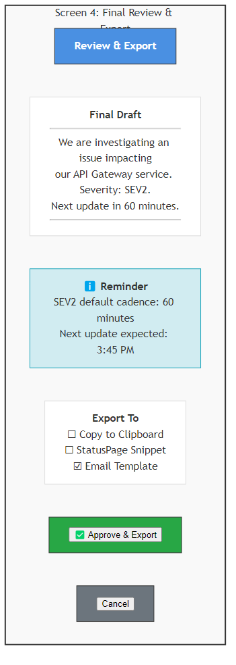

1. Screen 1: Dashboard (Create Incident Update)
2. Screen 2: Input Form
3. Screen 3: AI Draft Preview
4. Screen 4: Final Review & Export

11.3 UX Details
1. Variants switcher: Short / Standard / Detailed tabs.
2. Guardrail alerts: inline warnings with suggested edits.
3. Severity selector: SEV1–SEV4 with auto-cadence display.
4. Approval CTA: "Approve & Export" with export target selection.
5. Accessibility: High-contrast, keyboard-first, readable fonts, minimal cognitive load.

12. Architecture Overview

12.1 High-Level System Components
1. Web Client (React/Next.js or similar)
2. Backend API (FastAPI / Node)
3. AI Orchestration Layer
4. Guardrails Module
5. Template Store
6. Logging/Observability

12.2 Data Flow
User Backend AI Pipeline Guardrails Backend UI

12.2.1 Sequence Diagram (textual)
1. User submits incident inputs → Backend validates & normalizes.
2. Backend calls AI Orchestration with structured prompt.
3. LLM returns draft variants → Guardrails module runs redaction & policy checks.
4. Backend persists ephemeral session state → returns drafts + guardrail notes to UI.
5. User edits/regenerates → repeat AI + Guardrails loop.
6. On approval, Backend formats export (StatusPage/Email/Clipboard) with templates.

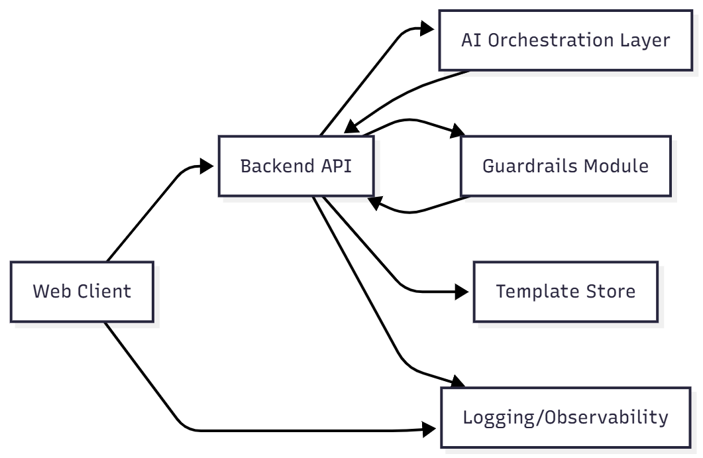

12.3 Security Considerations
1. No long-term storage of sensitive content
2. Strict role-based access
3. Redaction before storing any drafts
4. Observability: Structured logs of actions (generation, redaction, export) with privacy-safe metadata; no
raw incident text in logs.
5. Secrets management: environment-based, rotated keys; no secrets in client.

12.4 Architecture Diagram

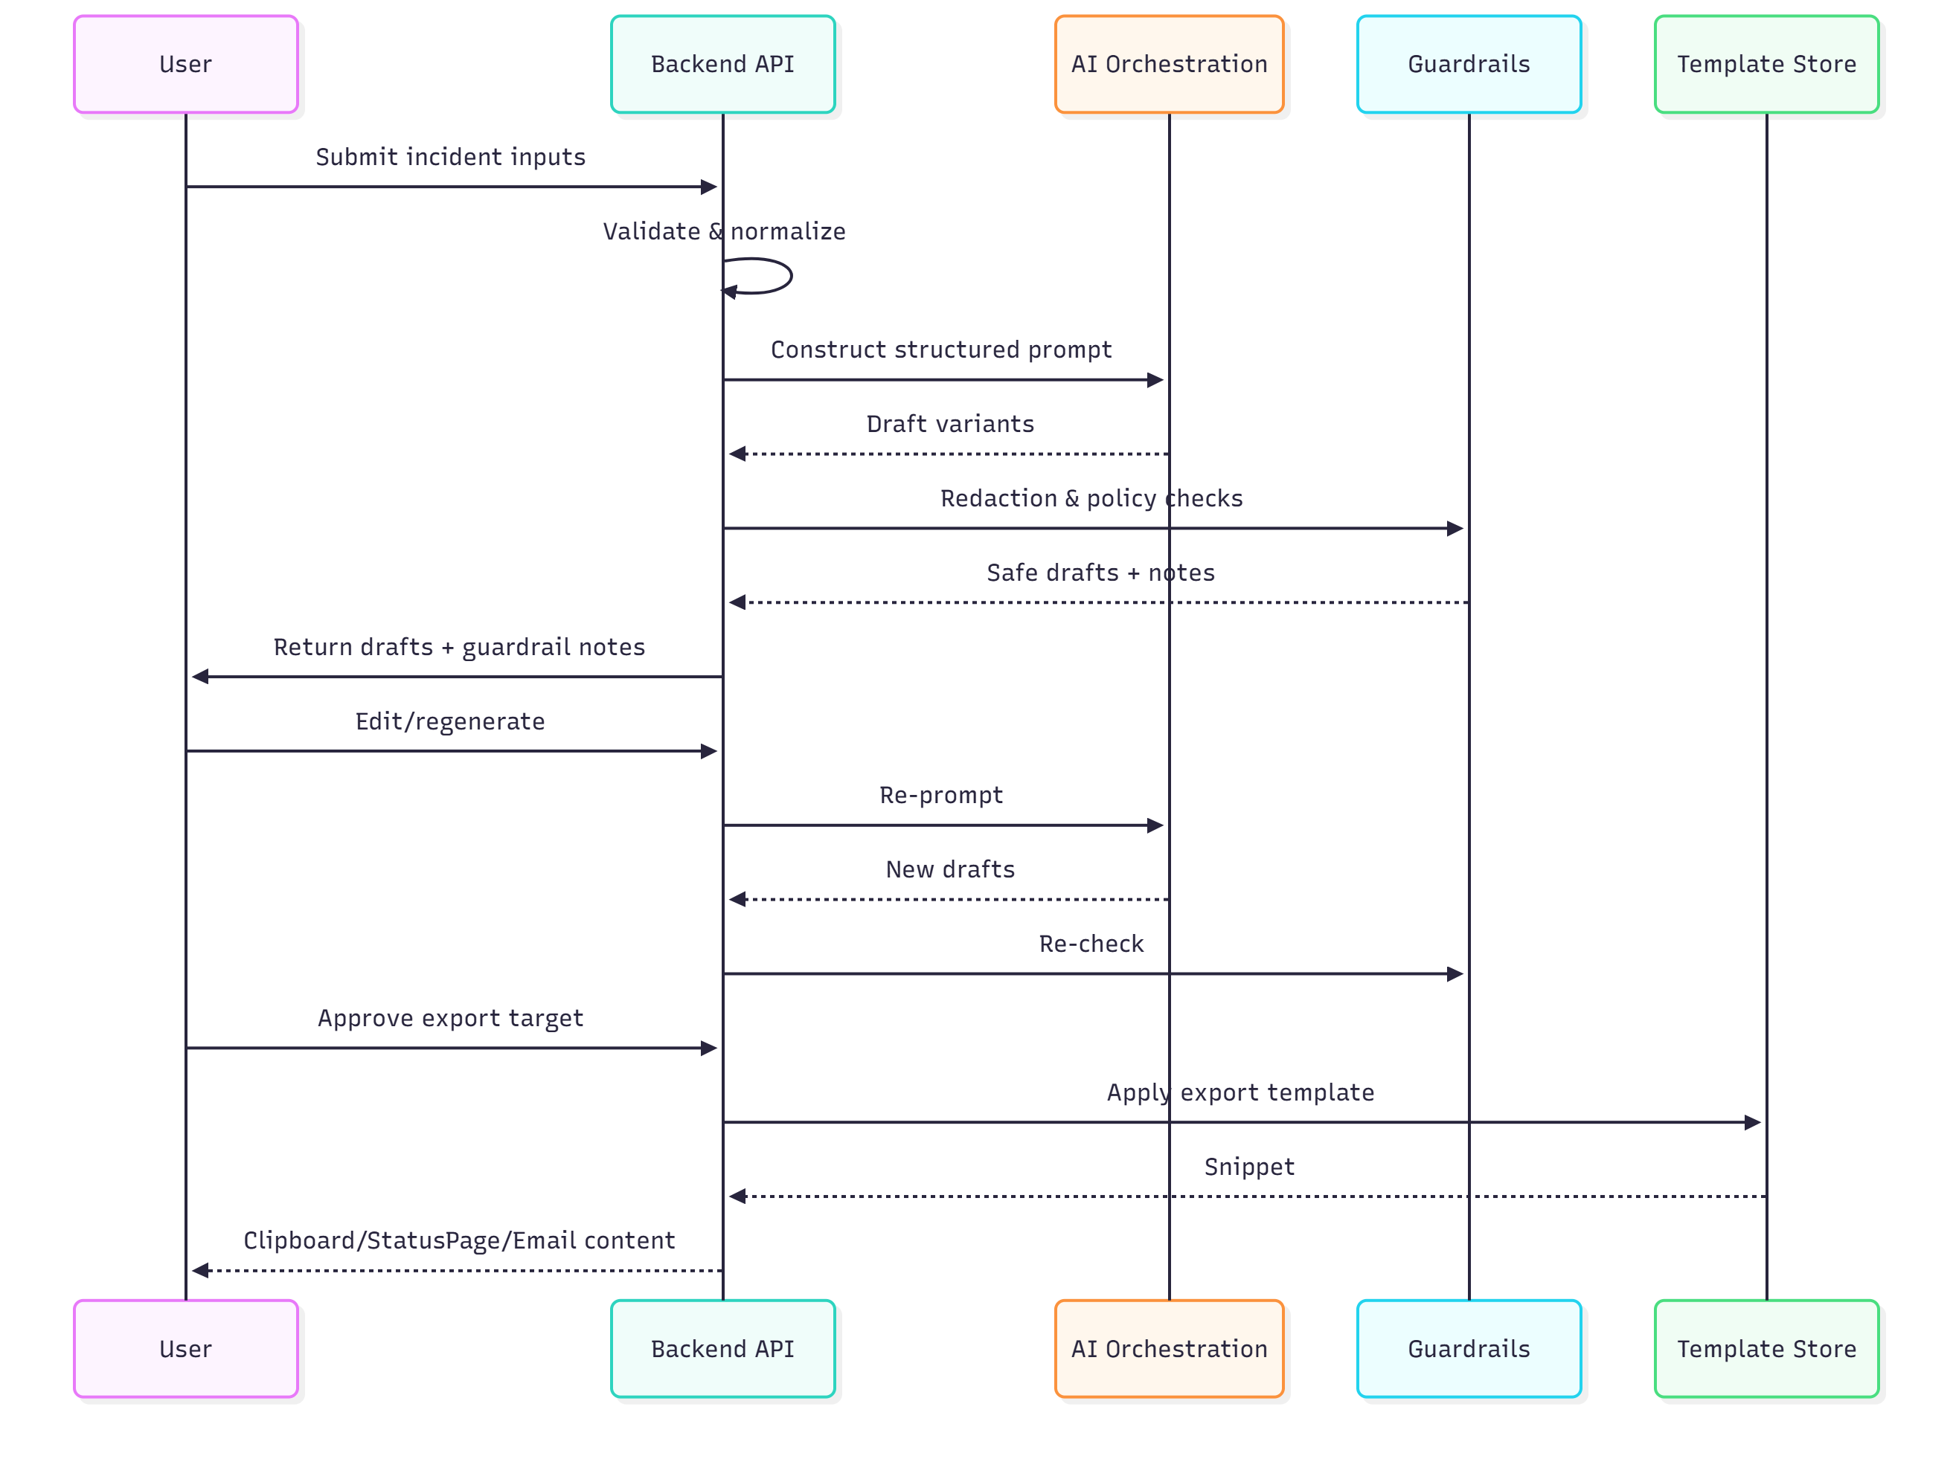
13. Success Metrics
1. Drafting time reduced by >70%.
2. Manual editing reduced to <10% of content.
3. 95%+ consistency with communication style guidelines.
4. 0 guardrail failures (no internal data leaked).
5. Draft generation latency <5s.
6. Adoption: >80% incidents using AICA within 2 months.
7. Safety scores: ≥ 99% disallowed content rate in offline tests.
8. Tone adherence: ≥ 95% match vs guideline rubric on golden set.

14. Acceptance Criteria
AICA v1 is accepted if:
* All required inputs supported
1. AI can generate drafts for all incident stages
2. Guardrails prevent sensitive leakage
3. Drafts editable + exportable
4. Functional prototype works in a browser
5. End-to-end flow is stable
6. Severity-based cadence displayed and applied to drafts
7. Export templates validated against StatusPage constraints

15. v1 Scope
In Scope
1. Incident input form
2. Draft generation + variations
3. Redaction + tone guardrails
4. Editing + regenerate
5. Export options
6. Fully working prototype
Out of Scope
1. StatusPage API integration
2. Real-time collaboration
3. Automated postmortems
4. Full incident timeline reconstruction

16. Risks & Mitigations
- Risk
- Mitigation
- Model hallucination
- Strict system prompts + guardrails
- Sensitive info escaping output
- Regex + LLM guardrail + human review
- Over-reliance on AI
- Mandatory human approval
- Incomplete incident inputs
- Required fields and missing-data alert
- Performance issues
- Async architecture and template caching
- Guardrail false positives
- Policy tuning and user override with justification
- Export mismatches
- Template validation and test snippets

17. Open Questions
1. Should AICA support direct Slack ingestion in v1 or v2?
2. Will Abnormal provide tone/style training samples?
3. Do incident drafts need to be stored long-term?
4. Should the tool support multilingual communications in future versions?
5. Which LLM(s) and hosting options meet compliance/security needs?
6. Do we need customer-specific tone variations or universal style?

18. Guardrail Policy Matrix (Allowed/Disallowed)
Allowed:
- Plain-language summaries of impact and mitigation steps
- Time bounds, incident status, next-update cadence
- Customer instructions (reset, re-auth, workaround) when verified
Disallowed:
- Internal IDs, stack traces, hostnames/IPs, employee names
- Root-cause speculation, unverified commitments or timelines
- Sensitive architecture details or vendor secrets
Action:
- Block or require edit; show suggestions; log policy hit (privacy-safe)

19. Export Format Specifications
StatusPage:
- Max body length: 2,000 chars; markdown-lite (lists, bold)
- No internal URLs; use customer docs links only
Email:
- Subject templates per severity; plain-text fallback; signature block
Clipboard:
- Stripped of hidden metadata; UTF-8 text only

