Question ID: U5
Browser/Version: Google Chrome 126
Date: 11/5/26
Scheme/Hostname/Port: https://codd.cs.gsu.edu:443

Before
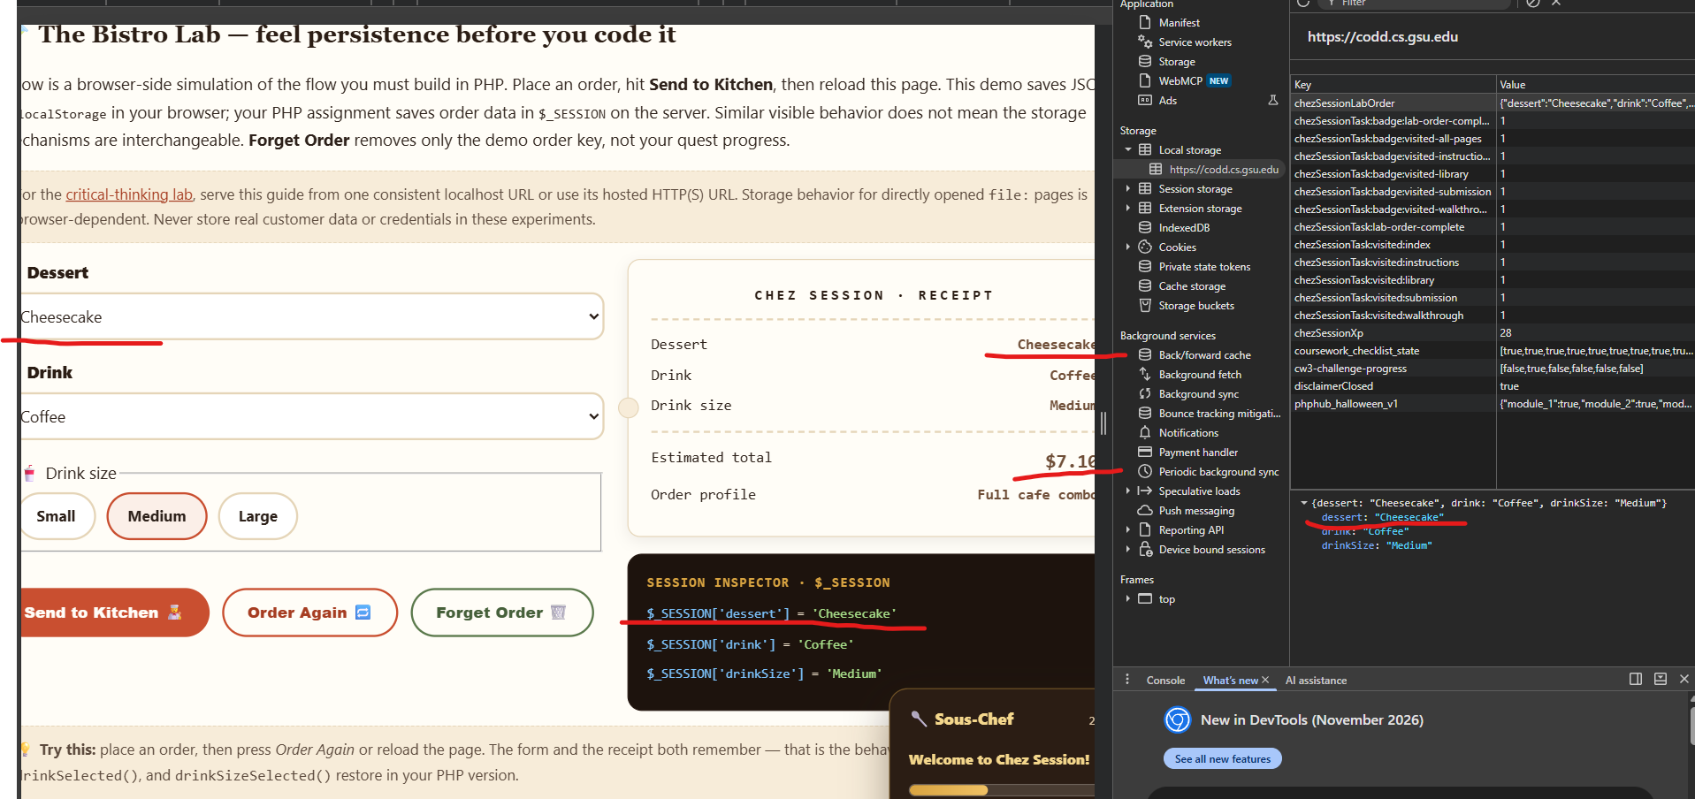
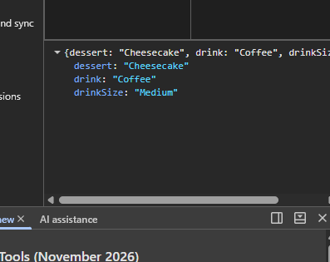
After
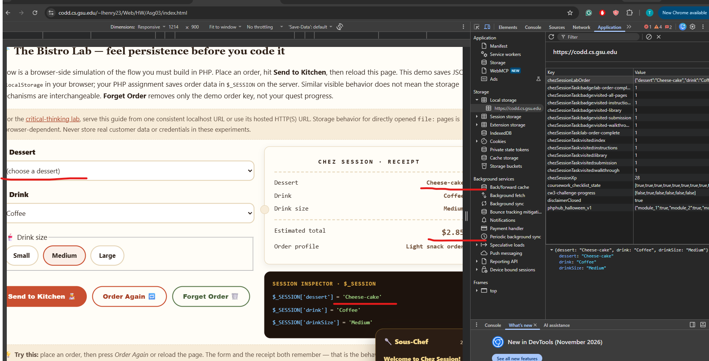
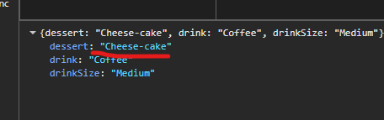

I sought to observe how changing the stored JSON strings in chezSessionLabOrder would affect compatibility. Specifically, I changed the dessert item name from “Cheesecake” to “Cheese-cake”. My prediction for this change was that it would break most of the related UI. The “Cheese-cake” text wouldn’t properly display under the “Dessert” section.

In my compatibility test I selected the options that properly match and wouldn’t cause errors. “Cheesecake”, “Coffee”, and “Medium”. This of course resulted in the page properly saving the values upon reload and displaying the proper information.
For my incompatibility test, which I previously detailed, I observed the following results: After changing the string and reloading the page, “Cheese-cake” still displayed in the Desert section, defying my expectations. Under estimated total, it only accounts for the price of coffee and doesn’t factor in the Cheese-cake price. This gives the appearance that the item is free. Under the Dessert selection menu, “Cheese-cake” doesn’t save and instead it prompts the default of choosing a dessert. Under the session inspector $_SESSION[dessert']'s value was 'Cheese-cake'
These results occurred because the client and server do not immediately sync with each other when another is updated. When the client’s data changes it doesn’t validate that the string variables are in the correct format before storing them. The lab runs on the client allowing it to store “Cheese-cake” with no checks.
To mitigate this issue I propose marking the version number on the client. If the version number sent is different from the version number stored in the server, it will use stored version arrays to map the old strings to match the newer ones. For example, the older version uses “Banana Pudding”, but the newer one uses “Banana-Pudding”. The server detects that the older version is being used and maps “Banana Pudding” to “Banana-Pudding”. If no version matches the changes, prompt the user to reselect. The advantage to this is that it makes it so that the customer doesn’t have to re-enter data. The disadvantage is that every single version must be supported and accounted for on the server. Additionally, if the client manually changes data to not match a version entry on the server, they will have to re-enter values.
Unlike my method, changing PHP session data after a server menu update will immediately compare it to the server when it executes. No version migration is needed.

Pseudo-code
- Stored data is received and version number is checked
- List of if statements with version number
  - Ex: IF VERSION = 1….
    - IF NAME = “Banana Pudding” CONVERT NAME TO “Banana -Pudding”
- Sort through all items, and compare against an array. If they still don’t match, prompt the user to reselect.

Question ID: U4
Browser/Version: Google Chrome 126
Date: 11/5/26
Scheme/Hostname/Port: https://codd.cs.gsu.edu:443

Before
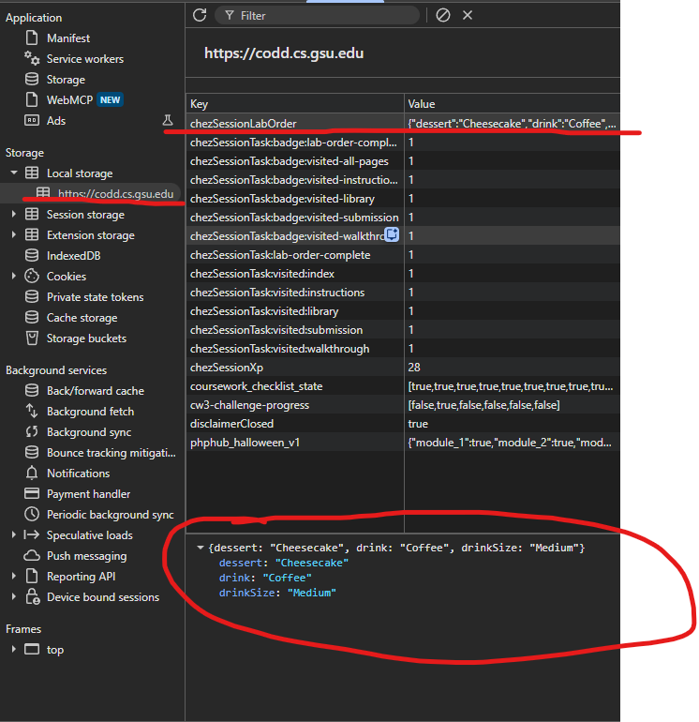
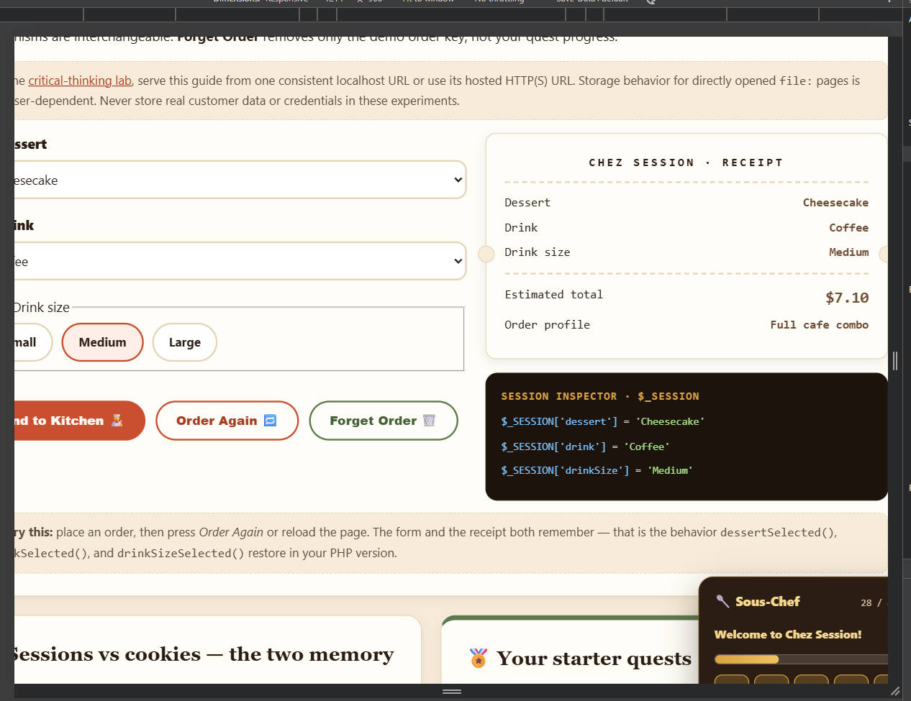
After
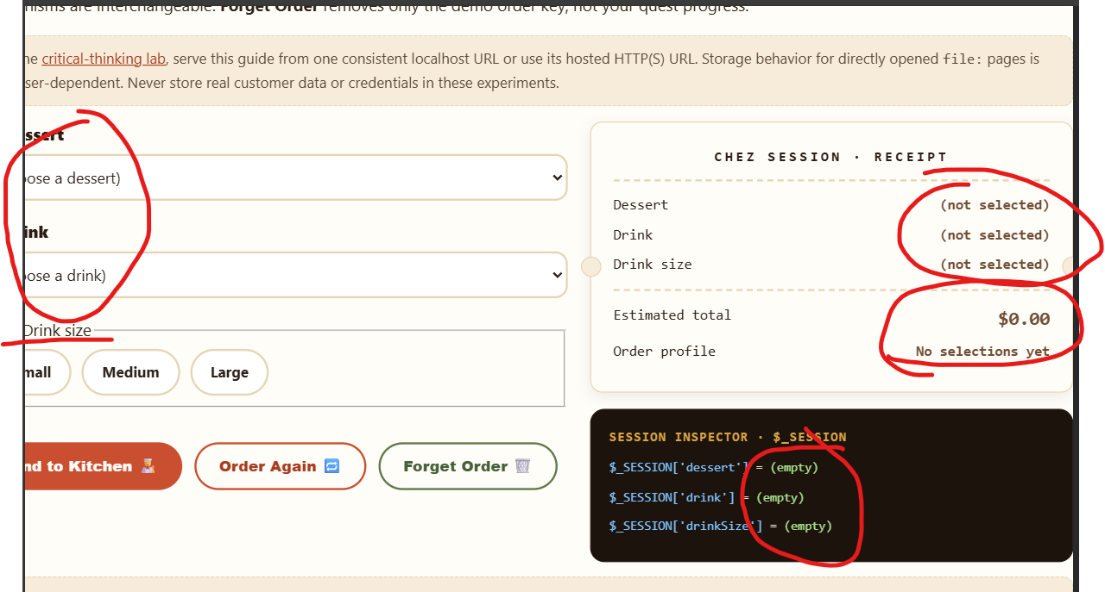
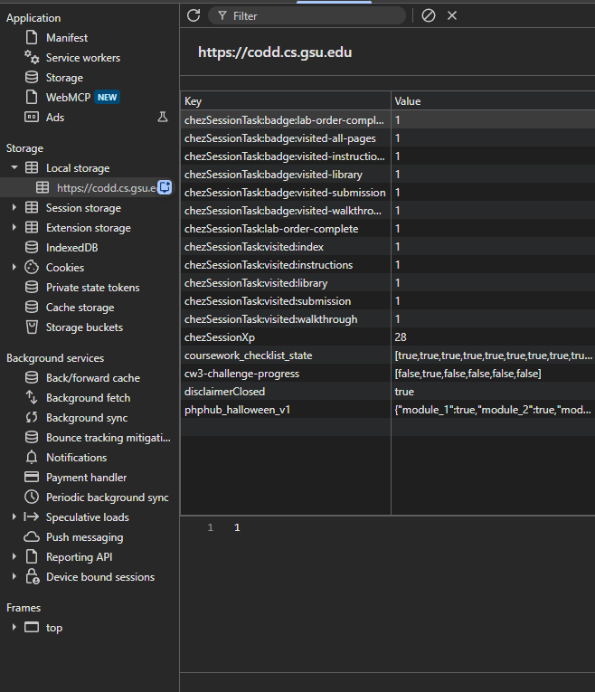

Before (Private)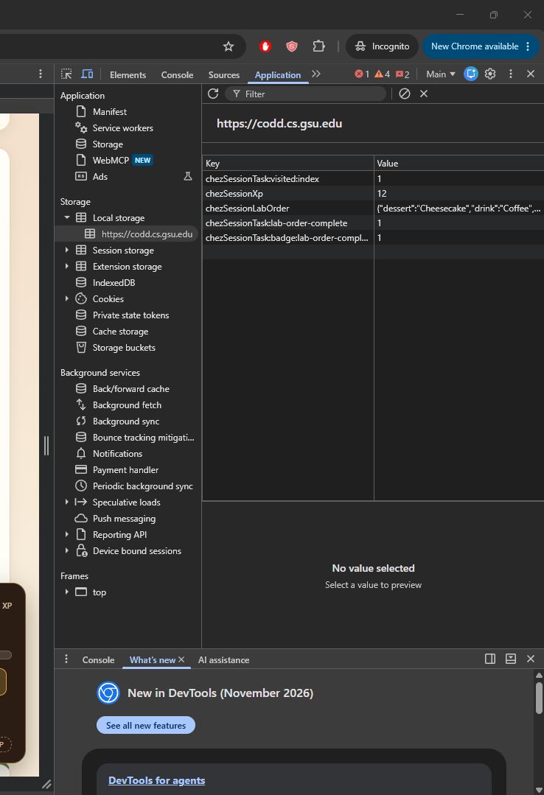

After (Private)
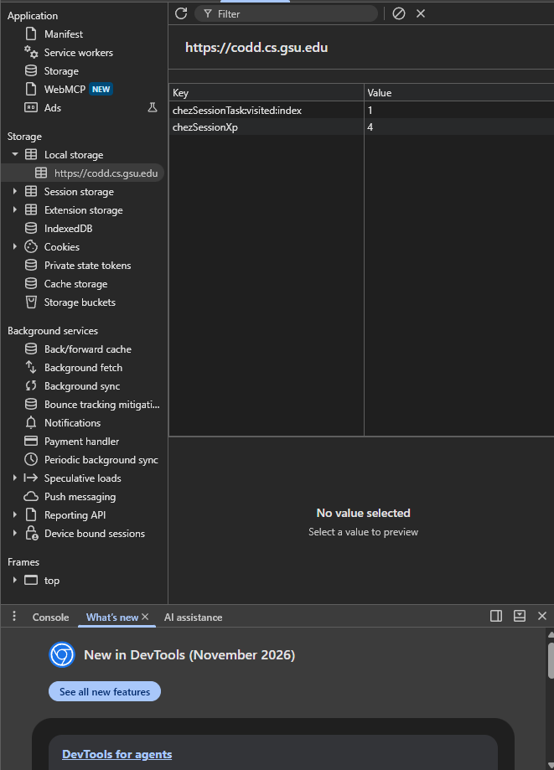
I sought to test how the BistroLab would react to having the chezSessionLabOrder data removed. My prediction for this was that since the client doesn’t have any data saved, it will go back to its default null values upon reloading.

After deleting chezSessionLabOrder, my prediction was accurately reflected. Via the session inspector I can see that all the stored variables are now denoted as “(empty)”. All the selectors went back to their default values. Overall, the page is still intact and operates just like it would if you first loaded it.
The reason for this is that everything is stored on the client (local storage) instead of the server. Since you deleted chezSessionLabOrder, which stores all the client data, Bistro Lab has no record of any past sessions. This could cause problems, even if you don’t manually delete it. If a browser were to change certain settings, all data would be lost.
I conducted the experiment once again, but in a private window. After saving the data, I didn’t delete it, but instead closed and reopened the private window. “chezSessionLabOrder” had disappeared. My initial prediction failed to anticipate this. This happened because when you deal with private windows data is only tied to that specific session. Once it ends, it’s gone forever.
LocalStorage can guarantee that data is saved if a browser crashes or you reload the page, but it can’t guarantee storage when a private window closes since it is tied to that session. Additionally, if browser settings change it can’t guarantee storage.
A competing explanation that is wrong is that data will be stored in the server, giving the illusion of easy recoverability. This assumption is quite dangerous, especially if the data were to be of greater significance. To mitigate this issue I’ve designed the following system. For starters, whenever data is changed, the website will prompt the user with a “WARNING: DATA IS STORED IN LOCAL STORAGE” message. Additionally, there will be a button that the user can press to copy the current settings to their clipboard. It will also append the appropriate receipt information. The advantage to this is that the user can have a reliable way of saving their data. However, a disadvantage is that expecting all users to want to copy their data and store it elsewhere isn’t realistic.

Pseudo Code
- If chezSessionLabOrder is changed:
  - Display Message: “WARNING: DATA IS STORED IN LOCAL STORAGE”
- Button to Copy to Clipboard

AI / Tool Use: Initially, I was struggling with understanding what was required so I asked it to generate a template where I could fill out all the requirements / asked questions.

