Predicting Self-Reported Myocardial Infarction or Coronary Heart Disease from BRFSS 2022: Model Complexity, Threshold Behaviour and Interpretability.

Toluwalope Owoeye
University of Cambridge

Module 5: Machine Learning

Submission date: 17 June 2026

Dataset: Behavioral Risk Factor Surveillance System 2022

GitHub repository:[ ToluOwo2/Module-5]


MSt Healthcare Data Science

Authentication of practice
I confirm that I have fully read and understood the assignment brief for this module. | Y/N

Details
Name Toluwalope | Name surname Owoeye
Submission Date: DD – MM – YY |  | 17–06– 26
Word Count: whole assignment including codes |  | 6921
Word Count: Main body excluding abstract, references and supplementary materials |  | 3286

Permission to share your assignment: delete as appropriate
I do/do not give permission to share my assignment with future MSt participants.

University statement of originality
This assignment is the result of my own work and includes nothing which is the outcome of work done in collaboration except as declared in the Preface and specified in the text. It is not substantially the same as any that I have previously submitted for a degree or diploma or other qualification at the University of Cambridge or any other university or similar institution, or that is being concurrently submitted, except as declared in the Preface and specific in the text. I further state that no substantial part of my Portfolio has already been submitted, nor is being concurrently submitted for any such degree, diploma or other qualification at the University of Cambridge or any other university or similar institution except as declared in the Preface and specified in the text.
I confirm the statement of originality as above | Y/N
Please use the second page of this coversheet if you wish to declare use of AI in your submission.

Questions for reflection
Self-assessment is an important aspect of feedback literacy, which is, in turn, key to the development of expertise. As you proceed through the MSt Healthcare data science programme, we hope that you will make use of the following prompts to assess your own work on assignments. Specific assignment briefs will likely indicate which of these to address for which assessments, but, in general, we expect you to respond to one or two for each assignment on your course.
For each of the questions, do not spend too long answering – keep it brief. For each question you answer, limit yourself to no more than three items. And please remember, this is optional and developmental: these cover sheets are designed to create space for self-assessment and feedback dialogue, rather than additional assignment workload.
- Which aspects of this assignment are you most uncertain about and/or would most like to receive feedback on?
I would most like feedback on whether the balance between methodological detail and critical interpretation is appropriate for this assignment. In particular, I would value feedback on whether the report makes sufficiently clear that the task is survey-based classification of self-reported MI/CHD status rather than clinical diagnosis or prospective cardiovascular risk prediction. I would also appreciate feedback on whether the calibration, threshold and subgroup error analyses are interpreted with the right level of caution.
- What elements are you left pondering after this assignment that you would like to discuss further?
I am left pondering how this type of work could move from internally validated survey-based classification towards clinically useful prediction. In particular, I would like to discuss how external validation, survey weighting, recalibration, clinically adjudicated outcomes and prospective testing would change the interpretation of the model. I am also interested in how subgroup error analysis should be developed into a more formal fairness assessment before any real-world deployment could be considered.
- How have you incorporated feedback from peers and tutors into this assignment?
I incorporated feedback by making the problem definition, modelling objective and success criteria more explicit, and by ensuring that the report did not simply present a model leaderboard. Feedback also shaped the emphasis on leakage control, class imbalance, calibration, threshold analysis and cautious interpretation of self-reported outcomes. I used this feedback to strengthen the link between the literature review, model development choices, evaluation strategy and discussion.
- How, and to what extent, have you been able to incorporate feedback on previous course work into this assignment?
I incorporated previous feedback by making the rationale for analytical choices more explicit and by strengthening the link between the research question, modelling pipeline and evaluation strategy. In this assignment, I aimed to avoid presenting model performance as a simple leaderboard by foregrounding leakage control, class imbalance, calibration, threshold behaviour, stability, runtime and subgroup error patterns. I also placed greater emphasis on reproducibility by using a programmatic dataset download, fixed random seeds, pipeline-based preprocessing, exported outputs, package requirements and a GitHub repository.
- Using the wording in the rubric, how would you describe the quality of the different aspects of your work?
Using the wording of the rubric, I would describe the work as demonstrating critical understanding of machine learning approaches within the healthcare domain, particularly through the comparison of multiple algorithms, leakage-controlled preprocessing and imbalance-aware evaluation. The model development is reproducible and justified, with attention to data acquisition, preprocessing, feature handling, model selection, threshold analysis and stability testing. The evaluation goes beyond headline discrimination by considering PR-AUC, calibration, runtime, uncertainty, interpretability and subgroup error patterns. I think the strongest aspects are the critical interpretation of model performance and the caution around clinical overclaiming. The main limitations are the lack of external validation, the use of self-reported cross-sectional survey data and the exploratory nature of the subgroup analysis.
Declaration of the use of generative AI
Where students engage in permitted use of generative AI in summative assessments, this should be clearly acknowledged. Please ensure that you have included a brief statement about whether you have used AI during the preparation of this assignment. Please see the guidance document and University guidelines on the use of AI on the assignment pages of the VLE. We suggest that you take the time to look at the following guidance on the University of Cambridge blended learning service webpages: https://blendedlearning.cam.ac.uk/artificial-intelligence-and-education/generative-ai-literacy-course
You should include a brief statement using the heading ‘Use of generative artificial intelligence’ that indicates what source(s) you used and how you used them.
If you did not use generative AI to help with any part of your assignment you must also make this clear. Some example statements are below:
- I used chatGPT to help brainstorm the specific content for this assignment, draft the introduction section, and rewrite our draft text to meet the word limit.
- I used Gemini to generate a graphical overview of my theoretical model.
- I did not use any generative artificial intelligence in preparing this assignment.

Which permitted use of generative AI are you acknowledging? | - Outline creation and planning  - Code structuring and debugging support  - Rewriting, editing and proofreading  - Rubric-based feedback and consistency checking
Which generative AI tool did you use (name and version)? | ChatGPT, Claude and DeepSeek
What did you use the tool for? | Generative AI tools were used to support code structuring, debugging, explanation of machine-learning concepts, workflow checking, rubric-based review, reference checking.
How have you used or changed the generative AI’s output? | All AI-generated suggestions were manually reviewed, edited and validated by me. Numerical results were checked against the notebook outputs before inclusion in the report. I accepted AI suggestions only where they improved clarity, structure, grammar, concision or consistency without changing the intended meaning. The final analysis, methodological decisions, interpretation, repository contents and submitted report remain my own responsibility.

Abstract
Background: Cardiovascular disease causes approximately 32% of global deaths, and machine learning models trained on large self-reported health surveys are proposed for population-level cardiovascular classification. Within Behavioral Risk Factor Surveillance System (BRFSS) studies, complex and simple models are often compared using headline discrimination or accuracy, with less attention to calibration, threshold behaviour, stability, runtime and subgroup error variation.
Objective: To determine whether random forest, XGBoost or a multilayer perceptron (MLP) offered a meaningful improvement over logistic regression for classifying self-reported myocardial infarction or coronary heart disease (MI/CHD) status in BRFSS 2022 under leakage-controlled, imbalance-aware evaluation.
Methods: The cohort comprised 440,111 respondents, with 9.03% positive prevalence. Data were split 80/20 with stratification before preprocessing, synthetic oversampling was avoided, and class imbalance was handled through model weighting where supported; the MLP was retained as an unweighted comparator. Four models were evaluated on the held-out test set (n = 88,023) using ROC-AUC, PR-AUC, threshold behaviour, Brier scores, calibration curves, runtime, cross-validation, repeated stratified splits, paired testing, bootstrap resampling, permutation importance, SHAP and subgroup error analysis.
Results: XGBoost achieved the strongest discrimination (ROC-AUC 0.8542; PR-AUC 0.3701), but its advantage over logistic regression was small (+0.0030 ROC-AUC; +0.0033 PR-AUC). Repeated-seed paired tests favoured XGBoost, but the bootstrap PR-AUC confidence interval (−0.0003 to 0.0066) crossed zero. Class-weighted logistic regression, random forest and XGBoost substantially overpredicted reported MI/CHD status in the highest calibration bin. XGBoost trained substantially faster than random forest. Subgroup error analysis revealed variation in operating behaviour across demographic and socioeconomic strata, with false-negative rates spanning approximately 10% to 38% across income groups.
Conclusion: Under conservative multi-criteria evaluation, complex tabular machine learning offered only marginal practical improvement over logistic regression for survey-based MI/CHD classification. XGBoost should be viewed as a marginally stronger classifier, not as a clearly superior or clinically deployable risk model.
1. Introduction
1.1 Background
Cardiovascular disease (CVD) is the leading cause of death worldwide. The World Health Organization estimates that 19.8 million deaths were attributable to CVD in 2022, approximately 32% of all global deaths, with around 85% resulting from heart attack and stroke [1]. In the United States, heart disease remains the leading cause of death for men, women and people of most racial and ethnic groups, and coronary heart disease is its most common form [2–4]. Much of this burden is preventable through modification of behavioural and environmental risk factors [1].
Clinical cardiovascular risk instruments, including Framingham-based risk scores and pooled-cohort ASCVD equations, estimate future cardiovascular or ASCVD risk using directly measured or clinically assessed predictors such as age, cholesterol, blood pressure, smoking and diabetes [8,9]. By contrast, BRFSS captures behavioural, demographic, comorbidity and healthcare-access variables through self-report. This analysis therefore complements rather than substitutes for clinical risk instruments and is framed as survey-based classification of reported MI/CHD status, not clinical diagnosis or prospective cardiovascular risk prediction.
1.2 Dataset rationale
The Behavioral Risk Factor Surveillance System (BRFSS) is the CDC's premier health-related telephone survey, completing more than 400,000 adult interviews annually [5]. Its scale, breadth and routine administration make it suitable for modelling reported MI/CHD status at population scale. The study outcome was the CDC-derived _MICHD variable, based on CVDINFR4 and CVDCRHD4, which records whether a respondent reports a health professional's diagnosis of myocardial infarction, angina or coronary heart disease rather than clinically adjudicated disease [6,7]. Classification outputs may therefore reflect diagnostic access, recall and survey-response behaviour as well as underlying pathology. Pierannunzi et al. found BRFSS self-reported prevalence broadly comparable to other self-report surveys but less concordant with physical-measurement sources [10]. BRFSS also carries coverage and non-response bias and lacks measured biomarkers.
A further consideration is that BRFSS captures prevalent, self-reported diagnosis rather than incident disease. Features linked to healthcare access, screening or routine check-ups may therefore improve classification partly because they correlate with receiving and reporting a diagnosis, not because they represent underlying disease biology alone. This shaped the interpretation of model performance and feature attribution throughout the analysis.
1.3 Literature review and gap
The closest comparator, Imani et al., used BRFSS 2022 to model cardiovascular disease and reported XGBoost as their best-performing model, with accuracy 94.2%, F1 score 85.3% and ROC-AUC 0.94 [11]. Other BRFSS-based CVD studies have applied balancing, feature selection, resampling and ensemble methods across BRFSS 2020, BRFSS 2021, BRFSS 2015 and BRFSS-derived CHD datasets [12–15]. Together, these studies confirm active use of survey data for cardiovascular modelling, but also show wide variation in resampling, validation and reporting.
Across these studies, performance is more often foregrounded through headline discrimination, accuracy, resampling or feature-importance results than through whether complex models meaningfully outperform simple baselines under leakage-controlled, imbalance-aware evaluation [11–14]. Such results are not invalid, but warrant caution in imbalanced, self-reported data where resampling and validation procedures are not transparently separated. This concern is illustrated by documented leakage in a BRFSS CVD workflow, where SMOTE-ENN was applied before the train-test split, risking optimistic performance estimates [16]. This study therefore adopts Imani et al. as its principal comparator while foregrounding what these studies report less consistently: primary resampling-free, calibration- and stability-aware evaluation, subgroup error variation and the self-reported nature of the outcome [11].
1.4 Research objective
This study aimed to determine whether more complex models — random forest, XGBoost and a multilayer perceptron — offered a practically meaningful improvement over logistic regression for classifying self-reported MI/CHD status in BRFSS 2022. The hypothesis was that XGBoost would show the strongest discrimination, with any gain over logistic regression likely to be modest. A practically meaningful improvement was defined as consistent improvement in PR-AUC and ROC-AUC across validation settings, without materially worse calibration, runtime, interpretability or subgroup error behaviour. PR-AUC was prioritised given the approximately 9% positive prevalence and its relevance to imbalanced classification [17].
The specific aims were to: (i) compare model performance using discrimination, PR-AUC, threshold behaviour, calibration, runtime and stability rather than ROC-AUC alone; (ii) assess whether the XGBoost improvement over logistic regression was statistically and practically meaningful; (iii) examine feature attribution using built-in importance, permutation importance and SHAP; and (iv) describe subgroup-level error patterns across selected demographic and socioeconomic groups. Because the outcome was self-reported, model outputs were interpreted as survey-based classification of reported MI/CHD status rather than clinical diagnosis or future cardiovascular risk prediction.
2. Methods
2.1 Study design
This supervised binary classification analysis used the 2022 Behavioral Risk Factor Surveillance System (BRFSS) dataset to classify self-reported myocardial infarction or coronary heart disease (MI/CHD) status [6,7].
2.2 Data source and ethical considerations
The BRFSS 2022 dataset was downloaded reproducibly via kagglehub from a Kaggle mirror of the CDC public-use dataset, with file shape and SHA256 checksum verified before preprocessing [6,28]. BRFSS is a publicly available, de-identified CDC survey dataset [6]. This secondary analysis involved no participant contact or attempt to identify individuals, so no additional institutional ethical approval was sought. Ethical interpretation centred on avoiding diagnostic overclaiming, recognising that self-reported outcomes may reflect healthcare access and diagnosis opportunity, and assessing whether aggregate performance concealed uneven error patterns across demographic or socioeconomic groups.
2.3 Analytical sample and survey weights
Records with missing _MICHD labels were excluded to define the analytical sample; cohort counts and prevalence are reported in Results 3.1. Survey weights were not used because the objective was supervised classification within the analytical sample rather than nationally representative prevalence estimation [6]. Prevalence, performance and subgroup error estimates therefore describe the analysed sample only, limiting transportability to the weighted US adult population.
2.4 Outcome definition and target validation
The target was based on _MICHD, a CDC-derived BRFSS indicator coded as 1 for self-reported MI/CHD and 2 for no self-reported MI/CHD. Before modelling, _MICHD was audited against its component survey items CVDINFR4 (heart attack/MI) and CVDCRHD4 (angina/CHD). A manually reconstructed target matched _MICHD for all 440,111 comparable rows, giving 100% agreement and confirming coding consistency rather than clinical disease status.
2.5 Exploratory data analysis and cohort construction
Exploratory data analysis assessed target prevalence, missingness, variable coding, cardinality, BRFSS survey-code structure and selected subgroup distributions, confirming substantial optional-module and skip-pattern missingness, consistent with the >50% high-missingness exclusion rule, alongside marked class imbalance.

2.6 Data cleaning and leakage control
BRFSS special codes for refusal, uncertainty and inapplicability were handled with variable-specific rules rather than global replacement; for example, 7 or 9 may be valid for SLEPTIM1 but indicate "don't know" or "refused" elsewhere. Variables defining or auditing the outcome (_MICHD, CVDINFR4, CVDCRHD4) were excluded. CVDSTRK3 was also excluded as a conservative clinical-overlap control because stroke is a closely related cardiovascular outcome. Administrative, identifier, survey-design, raw measurement-entry, contextual, high-missingness (>50%) and no-variation variables were removed. After cleaning, 120 raw predictors remained, expanding to 500 one-hot encoded features.
2.7 Feature typing, train-test split and preprocessing
Feature representation was designed around BRFSS survey structure. Predictors were classified as continuous/count-style or categorical/survey-code variables, and numeric variables with 15 or fewer unique values were treated as categorical to reflect BRFSS coding conventions. Data were split 80/20 with stratification using random_state = 42 before any preprocessing object was fitted. The training set contained 352,088 observations, including 31,801 positives, and the held-out test set contained 88,023 observations, including 7,950 positives. Continuous predictors were median-imputed and standardised for scale-sensitive models; categorical predictors were mode-imputed and one-hot encoded using OneHotEncoder(handle_unknown="ignore", min_frequency=50). Logistic regression and the MLP used scaled pipelines, while random forest and XGBoost used unscaled pipelines. Preprocessing objects were cloned within model pipelines to avoid reuse of fitted state.
2.8 Model development and class-imbalance strategy
Four models were compared: logistic regression (interpretable baseline), random forest (non-linear ensemble comparator), XGBoost (main complex tabular model), and a multilayer perceptron (flexible neural-network comparator). Class imbalance was handled through model weighting where supported: logistic regression used class_weight="balanced", random forest used class_weight="balanced_subsample", and XGBoost used scale_pos_weight set to the negative-to-positive training-set ratio. Because the scikit-learn MLPClassifier implementation used here did not support class weighting in the same way as the other models, the MLP was retained as an unweighted neural-network comparator and its threshold behaviour was interpreted cautiously. Synthetic oversampling was avoided to preserve the survey-response structure and reduce leakage risk. Model specifications are summarised in Table 1.
Table 1. Model configurations and imbalance handling.
Model | Pipeline | Imbalance handling | Key parameters
Logistic regression | Scaled | class_weight="balanced" | L2; C=1.0; saga; max_iter=1000; random_state=42
Random forest | Unscaled | class_weight="balanced_subsample" | n_estimators=200; max_depth=20; min_samples_leaf=50; random_state=42
XGBoost | Unscaled | scale_pos_weight≈10.072 | n_estimators=300; max_depth=4; learning_rate=0.05; subsample=0.80; colsample_bytree=0.80; binary logistic objective; histogram tree construction; random_state=42
MLP | Scaled | None supported | Hidden layers (64, 32); ReLU; Adam; alpha=1e-4; batch_size=1024; learning_rate_init=0.001; max_iter=100; early stopping with 10% validation split

2.9 XGBoost hyperparameter tuning
A limited XGBoost tuning sensitivity analysis used RandomizedSearchCV on a stratified 60,000-row training sample with 3-fold cross-validation, optimising PR-AUC across ten parameter combinations. Tuning did not improve held-out performance, so the pre-specified XGBoost model remained the primary specification.
2.10 Model evaluation, threshold analysis and calibration
Model performance was evaluated using discrimination, threshold behaviour, calibration and runtime. ROC-AUC assessed overall discrimination; PR-AUC was prioritised because the positive class was imbalanced [17]. Precision, sensitivity, specificity and F1-score were calculated at the 0.50 threshold, with confusion matrices summarising errors. Accuracy was reported descriptively but not prioritised. Threshold analysis varied the cut-off from 0.05 to 0.95 in 0.05 increments, identifying the F1-maximising threshold and an illustrative high-sensitivity threshold at ≥80% sensitivity, not a clinically validated screening threshold. Calibration was assessed using Brier scores and 10-bin quantile calibration curves to evaluate probability reliability within the held-out BRFSS sample, not to validate clinical risk estimates.
2.11 Stability, statistical testing and bootstrap uncertainty
Stability was assessed using 3-fold stratified cross-validation on a 120,000-row training sample for logistic regression and XGBoost, followed by five repeated stratified 80/20 splits using seeds 42, 101, 202, 303 and 404 for logistic regression, XGBoost and the MLP. Random forest was excluded from repeated-seed analysis for feasibility but retained in the main evaluation. Paired t-tests with Holm correction and 1,000 paired bootstrap resamples of held-out predictions estimated uncertainty in ROC-AUC and PR-AUC differences. Because only five seeds were used, statistical results were interpreted alongside absolute effect size, calibration, runtime, interpretability and subgroup performance.
2.12 Explainability and subgroup error analysis
Explainability used logistic regression coefficients, tree-based feature importance, permutation importance (20,000-row test sample) and SHAP for XGBoost (2,500-case test sample), interpreted as descriptions of fitted model behaviour rather than causal effects. Subgroup error analysis used XGBoost predictions on the held-out test set to examine age, sex, race/ethnicity, education and income groups with at least 500 observations, treated as exploratory error audit rather than formal fairness assessment. Reduced samples were used for computational feasibility while primary model comparison used the full held-out test set.
2.13 Reproducibility and software environment
All analyses were implemented in Python in Google Colab using pandas [21], numpy [22], scikit-learn [23], xgboost [24], scipy [25], matplotlib [26], shap [19] and kagglehub [27], with fixed random seeds throughout. The GitHub repository contains the final notebook, README, requirements files and methods decision log; the notebook regenerates the `outputs/` folder when run.
3. Results
3.1 Analytical cohort and target validation
The final analytical cohort contained 440,111 respondents after excluding 5,021 records with missing _MICHD labels. Of these, 39,751 respondents had self-reported MI/CHD, giving a positive prevalence of 9.03% (Figure 1). The manually reconstructed target from CVDINFR4 and CVDCRHD4 matched _MICHD for all 440,111 comparable rows, confirming coding consistency (Appendix Table A1). After leakage-control exclusions and preprocessing, 120 raw predictors were retained and expanded to 500 one-hot encoded features (Appendix Table A4). The stratified held-out test set contained 88,023 respondents, including 7,950 positive cases (Appendix Table A5). Missingness and subgroup prevalence checks are provided in Appendix A.
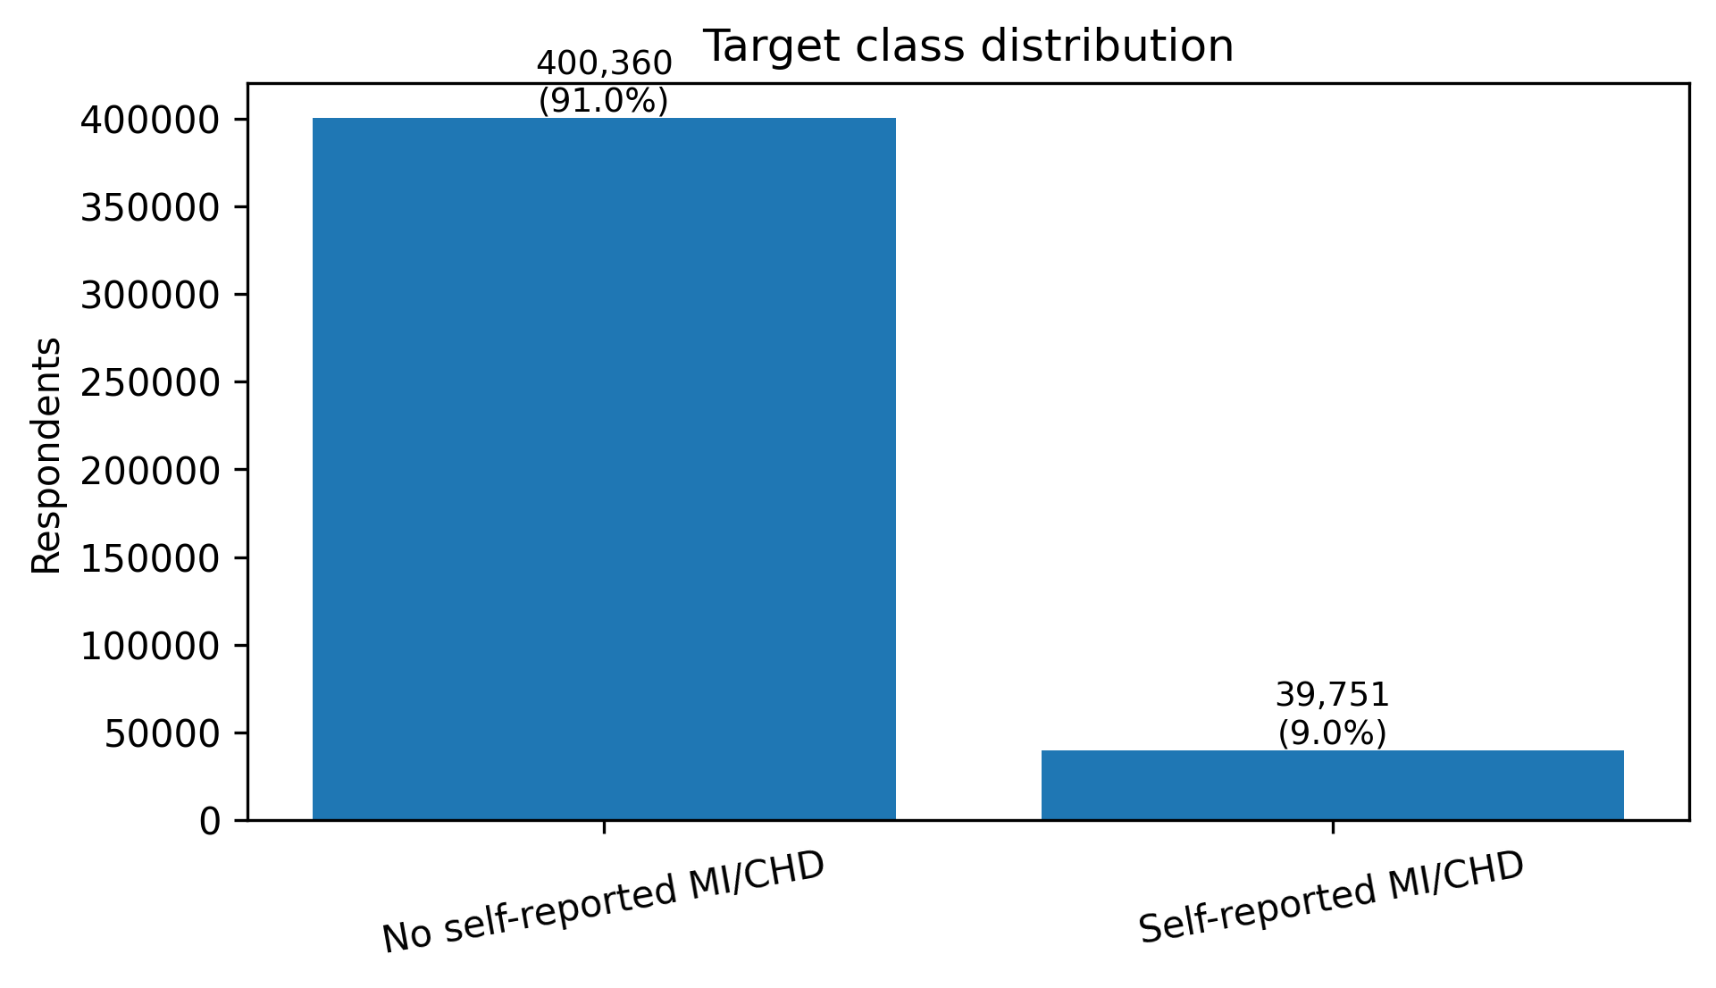
Figure 1. Target class distribution in the analytical sample.
3.2 Primary held-out model performance
Primary held-out performance is shown in Table 2 and Figure 2. All four models showed similar discrimination, with XGBoost performing best but only marginally ahead of logistic regression. XGBoost achieved ROC-AUC 0.8542 and PR-AUC 0.3701, giving small absolute advantages over logistic regression of +0.0030 ROC-AUC and +0.0033 PR-AUC. The limited XGBoost tuning analysis did not improve held-out performance, so the pre-specified XGBoost model was retained (Appendix Tables B2a-B2b).
Table 2. Held-out test-set performance at default threshold 0.50
Model | ROC-AUC | PR-AUC | Precision | Sensitivity | Specificity | F1-score | Brier score | Runtime (s)
Logistic regression | 0.8512 | 0.3668 | 0.2399 | 0.7951 | 0.7499 | 0.3686 | 0.1630 | 785.51
Random forest | 0.8499 | 0.3609 | 0.2441 | 0.7886 | 0.7576 | 0.3728 | 0.1523 | 1449.36
XGBoost | 0.8542 | 0.3701 | 0.2379 | 0.8131 | 0.7415 | 0.3682 | 0.1620 | 48.12
MLP | 0.8525 | 0.3679 | 0.5506 | 0.1020 | 0.9917 | 0.1721 | 0.0676 | 129.92

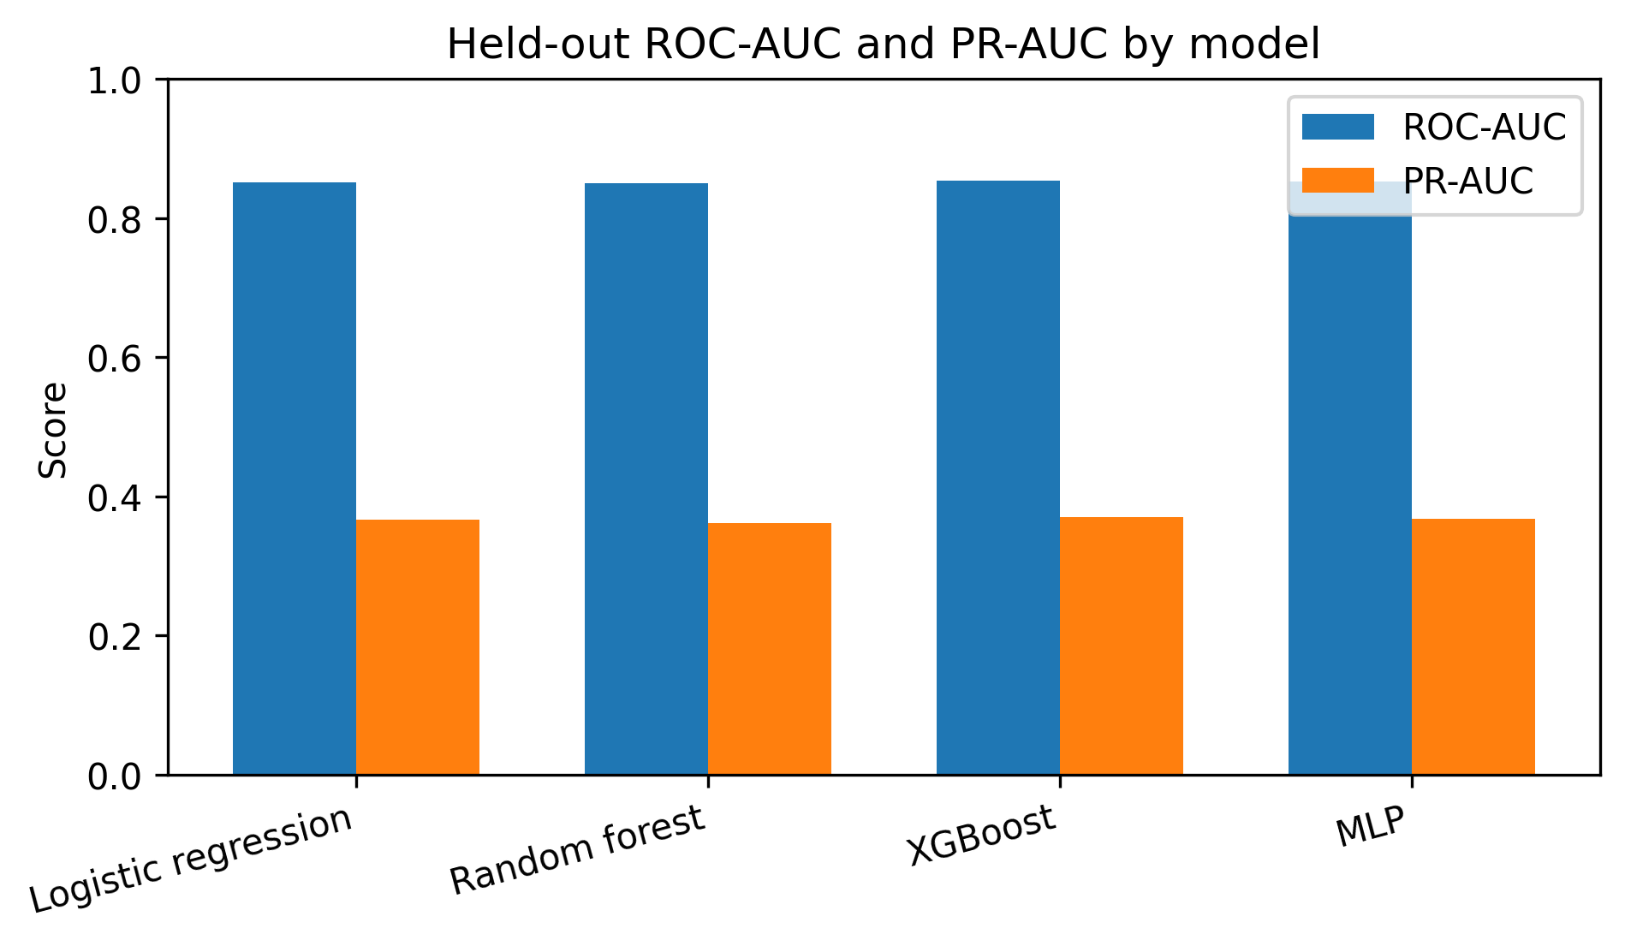

Figure 2. Held-out ROC-AUC and PR-AUC by model.
Default-threshold behaviour differed more than discrimination (Table 2). XGBoost achieved the highest sensitivity at the 0.50 threshold, while random forest produced the highest default-threshold F1-score. The MLP had comparable ROC-AUC and PR-AUC but very low sensitivity at the default threshold, identifying few positive cases. Confusion-matrix counts are provided in Appendix Table B1.
3.3 Threshold behavior and calibration
Threshold analysis is summarised in Table 3 and Figure 3. Model usefulness depended strongly on the chosen operating point. The MLP was particularly threshold-dependent: at 0.50 its sensitivity was only 0.1020, while lowering the threshold to 0.10 increased sensitivity to 0.8216 at the cost of precision. The ≥80% sensitivity operating point was treated as illustrative and not clinically validated.
Table 3. Threshold analysis across primary models.
Model | Operating point | Threshold | Precision | Sensitivity | Specificity | F1-score
Logistic regression | Default | 0.50 | 0.2399 | 0.7951 | 0.7499 | 0.3686
Logistic regression | F1-maximising | 0.70 | 0.3257 | 0.5706 | 0.8827 | 0.4146
Logistic regression | ≥80% sensitivity | 0.45 | 0.2240 | 0.8361 | 0.7124 | 0.3533
Random forest | Default | 0.50 | 0.2441 | 0.7886 | 0.7576 | 0.3728
Random forest | F1-maximising | 0.65 | 0.3223 | 0.5674 | 0.8815 | 0.4111
Random forest | ≥80% sensitivity | 0.45 | 0.2225 | 0.8321 | 0.7114 | 0.3512
XGBoost | Default / ≥80% sensitivity | 0.50 | 0.2379 | 0.8131 | 0.7415 | 0.3682
XGBoost | F1-maximising | 0.70 | 0.3251 | 0.5908 | 0.8782 | 0.4194
MLP | Default | 0.50 | 0.5506 | 0.1020 | 0.9917 | 0.1721
MLP | F1-maximising | 0.25 | 0.3535 | 0.5067 | 0.9080 | 0.4164
MLP | ≥80% sensitivity | 0.10 | 0.2302 | 0.8216 | 0.7272 | 0.3596
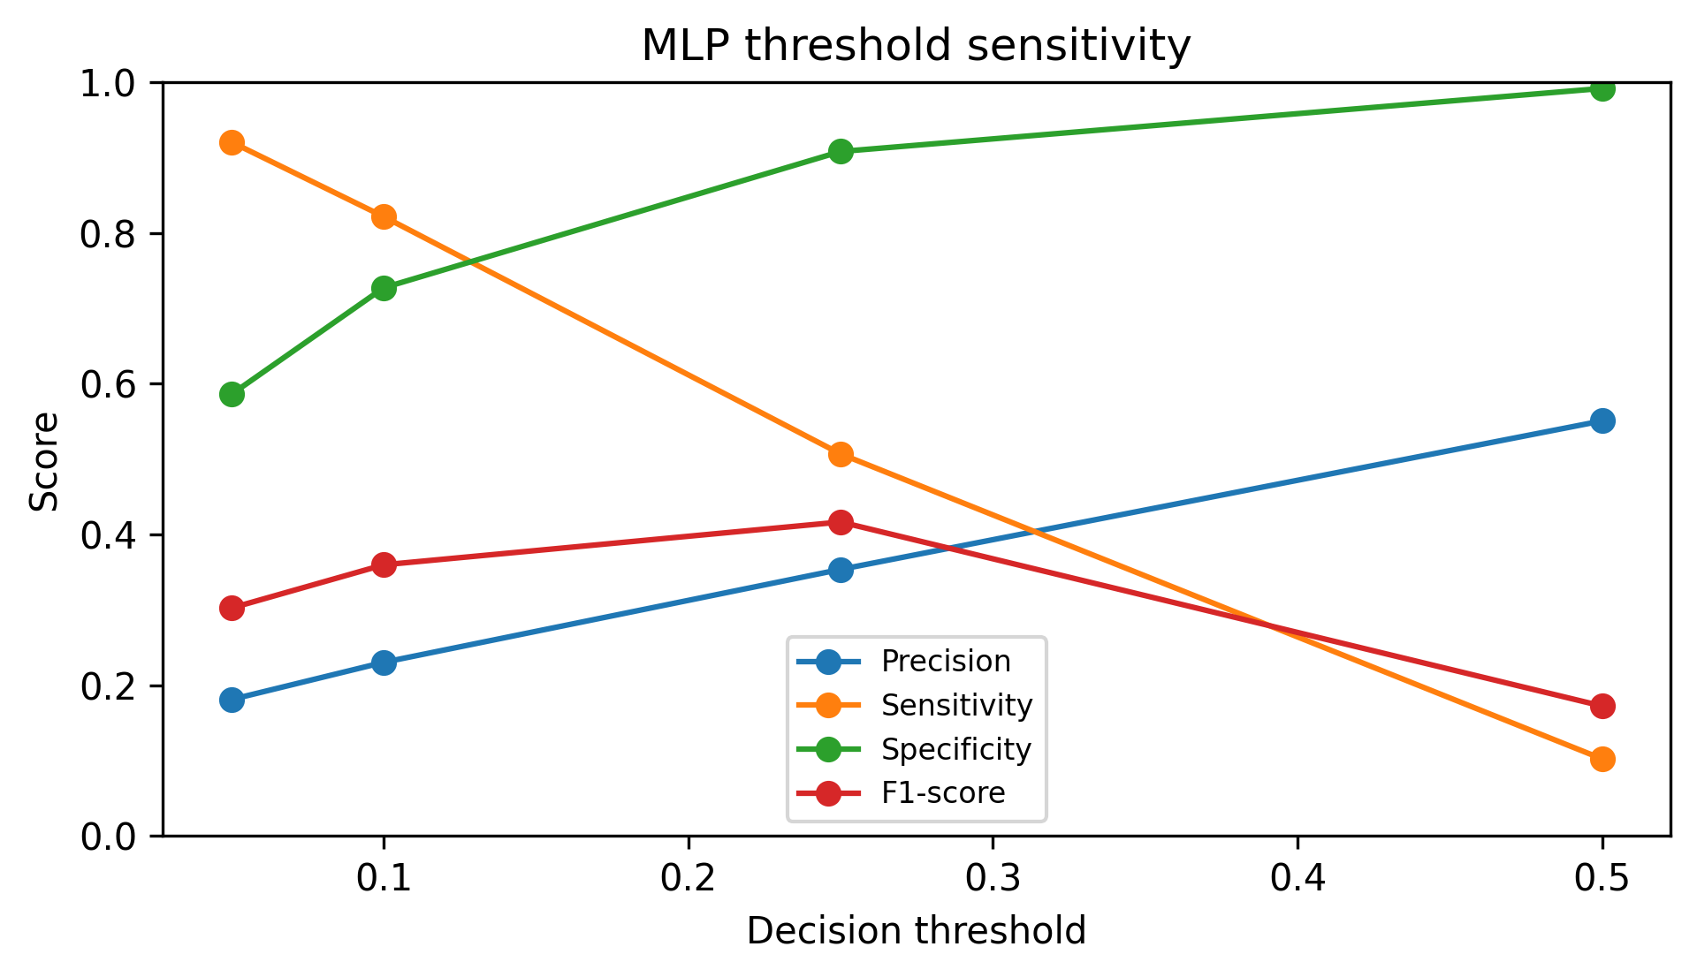
Figure 3. MLP threshold sensitivity across selected decision thresholds.
Calibration results are shown in Table 4 and Figure 4. The MLP had the lowest Brier score, but this reflected conservative probability behaviour rather than useful default-threshold sensitivity and should not be interpreted as overall superiority. Logistic regression, random forest and XGBoost substantially overpredicted reported MI/CHD status in the highest calibration bin, with mean predicted probabilities of 0.8680, 0.7894 and 0.8520 compared with observed event rates of 0.3824, 0.3758 and 0.3870, respectively. Thus, stronger discrimination did not imply reliable probability estimation within the held-out survey sample
.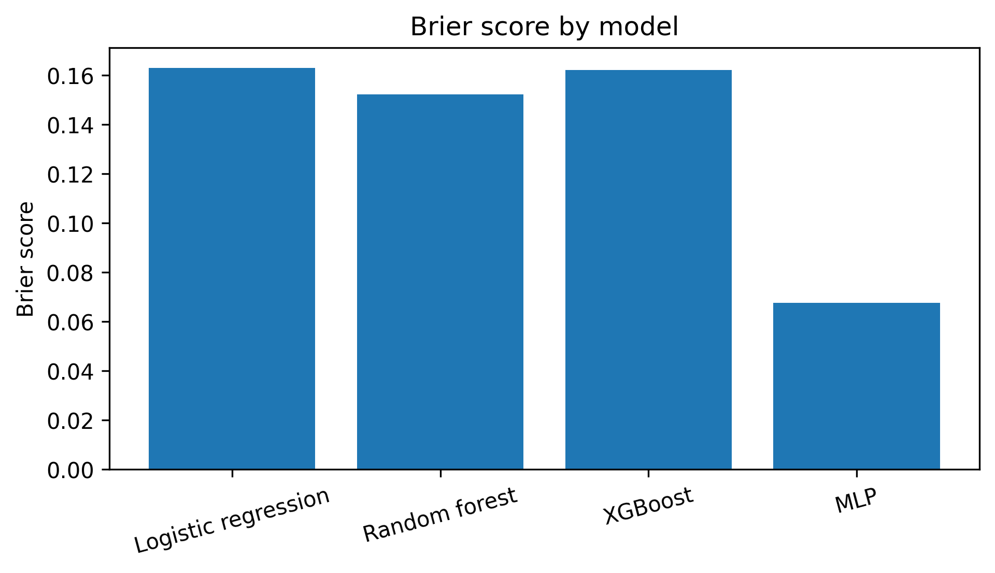
Figure 4. Brier score by model.
Table 4. Highest-bin calibration predicted versus observed event rate.
Model | Highest-bin mean predicted probability | Highest-bin observed rate
Logistic regression | 0.8680 | 0.3824
Random forest | 0.7894 | 0.3758
XGBoost | 0.8520 | 0.3870
MLP | 0.4049 | 0.3859

3.4 Stability and uncertainty
Cross-validation, repeated-seed analysis and bootstrap uncertainty are summarised in Table 5 and Figure 5, with further outputs in Appendix Tables B3-B5. These analyses supported the same overall pattern: XGBoost was consistently among the strongest models, but its advantage over logistic regression was small. Bootstrap analysis estimated an XGBoost-logistic regression ROC-AUC difference of approximately +0.0031, supporting a small discrimination advantage. However, the PR-AUC confidence interval crossed zero, indicating that the imbalance-aware performance advantage was less certain.
Table 5. Stability and uncertainty summary for key comparisons.
Analysis | Comparison | Metric | Result
Repeated seeds | XGBoost - logistic regression | ROC-AUC | +0.0025; Holm-adjusted p = 0.002
Repeated seeds | XGBoost - logistic regression | PR-AUC | +0.0052; Holm-adjusted p = 0.021
Bootstrap, 1,000 resamples | XGBoost - logistic regression | ROC-AUC | +0.0031; 95% CI 0.0022 to 0.0040
Bootstrap, 1,000 resamples | XGBoost - logistic regression | PR-AUC | +0.0032; 95% CI -0.0003 to 0.0066
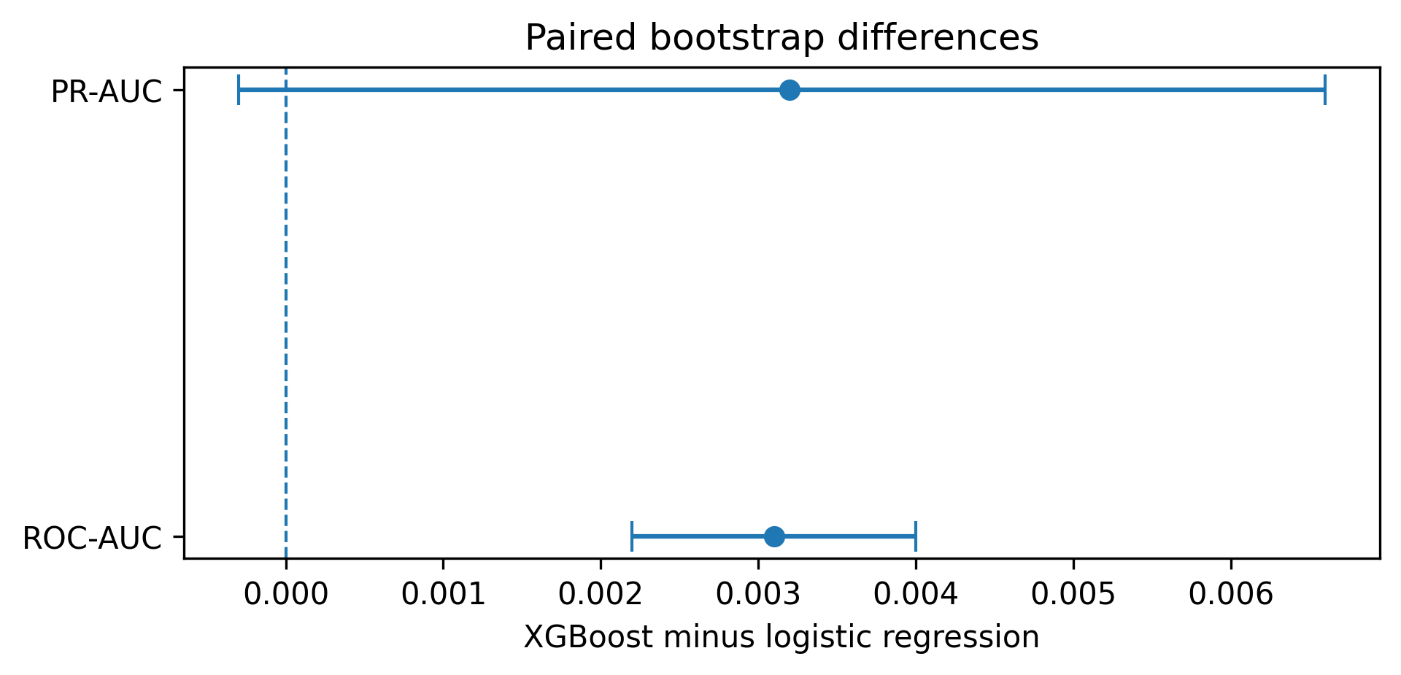
Figure 5. Paired bootstrap differences for XGBoost minus logistic regression.
3.5 Explainability and subgroup error patterns
Explainability results are presented in Figure 6, Appendix Table B6 and Appendix Tables C1-C3. Permutation importance and SHAP showed that the fitted XGBoost model used a mixture of clinical-history, demographic, health-status, healthcare-access and survey-response features, including age-related variables, self-rated general health, diabetes, kidney disease, sex or demographic indicators, healthcare-access variables and non-response-coded survey features. These attribution results describe fitted model behaviour, not causal risk factors, and complicate interpretation in this cross-sectional self-reported design.
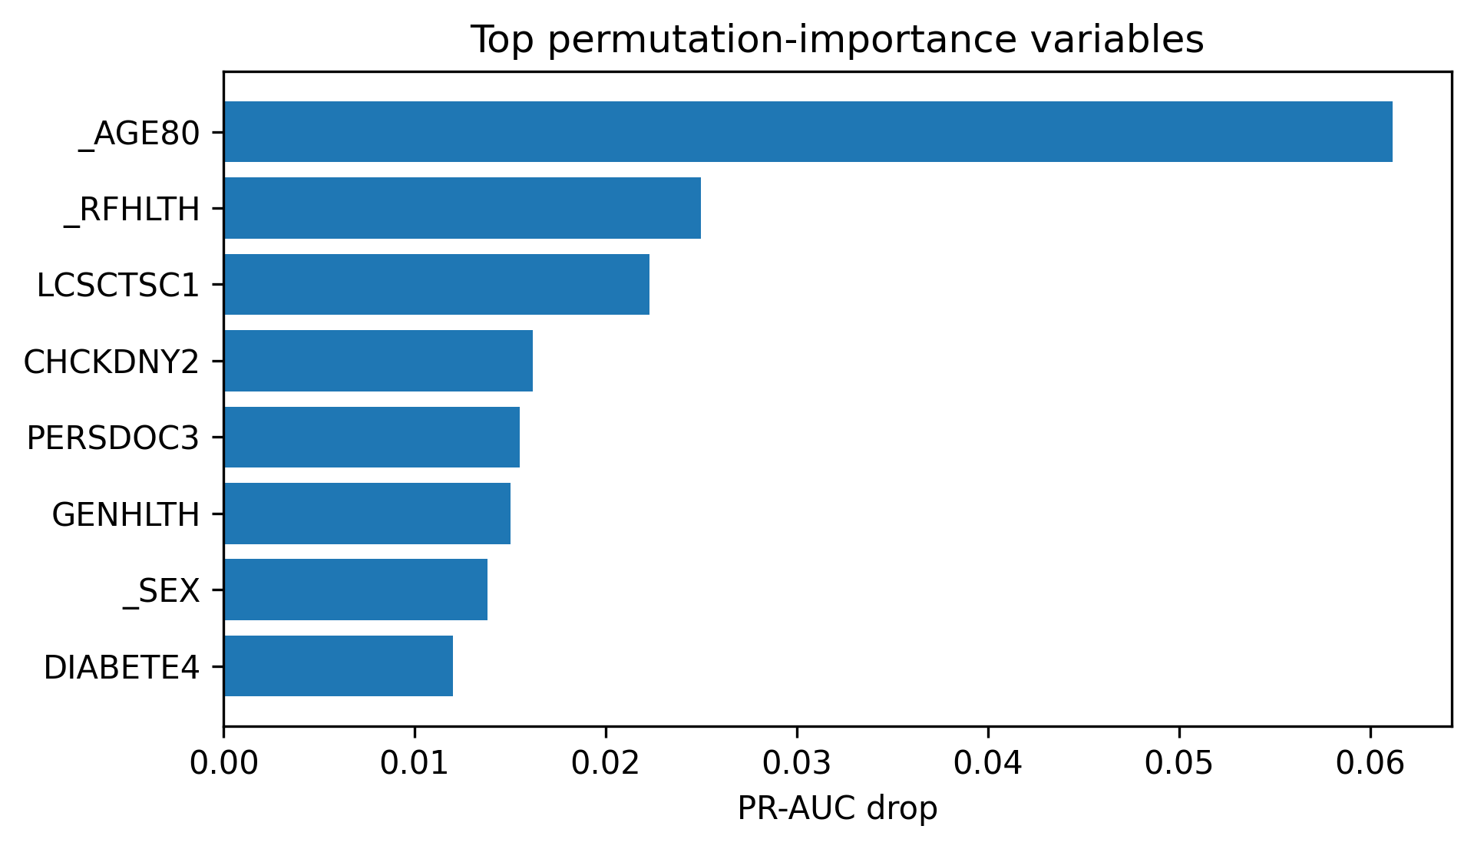
Figure 6. Top permutation-importance variables by PR-AUC drop.
Subgroup prevalence outputs are provided in Appendix Table C4, and subgroup error analysis is summarised in Appendix Table C5. Aggregate performance concealed uneven error patterns across demographic and socioeconomic groups, with variation across age, sex, race/ethnicity, education and income strata. This indicates that overall, ROC-AUC and PR-AUC did not fully describe model behaviour across subgroups. The subgroup analysis was exploratory rather than a formal fairness assessment.

4. Discussion
4.1 Principal findings
This study evaluated whether more complex machine learning models offered a practically meaningful improvement over logistic regression for classifying self-reported MI/CHD status in BRFSS 2022. These findings were consistent with the study hypothesis: XGBoost achieved the strongest held-out discrimination, with ROC-AUC 0.8542 and PR-AUC 0.3701 (Table 2), but its absolute advantage over logistic regression was small (+0.0030 ROC-AUC; +0.0033 PR-AUC). Cross-validation showed similarly narrow separation between logistic regression and XGBoost, and the bootstrap PR-AUC confidence interval crossed zero (Table 5). These analyses supported XGBoost as the strongest model, but suggested that its advantage was modest, internally validated only, and insufficient on its own to justify replacing a simpler logistic regression baseline. The main contribution is therefore not a deployable risk model, but a leakage-controlled benchmark showing that complex tabular machine learning only marginally improved survey-based MI/CHD classification over a simpler baseline.
4.2 Comparison with previous BRFSS-based CVD studies
The lower performance observed here contrasts with some BRFSS-based CVD modelling studies that report higher headline discrimination for complex models. Imani et al., the closest comparator, reported an XGBoost ROC-AUC of approximately 0.94 using BRFSS 2022 [11], substantially higher than the held-out ROC-AUC of 0.8542 in this analysis. This difference should not be interpreted simply as poorer modelling performance. It likely reflects differences in cohort construction, preprocessing, resampling strategy, feature handling and validation design. The present study deliberately used a leakage-controlled, resampling-free pipeline with class weighting rather than synthetic oversampling. Separately, leakage from applying resampling before train-test splitting has been documented in another BRFSS CVD modelling workflow [16], reinforcing the importance of conservative validation. This does not invalidate previous studies, but shows that headline AUCs are not directly comparable without consistent reporting of cohort definition, resampling, leakage control, calibration and validation.
4.3 Practical value of model complexity
The central finding is that model complexity did not automatically translate into meaningful practical advantage. Repeated-seed paired t-tests with Holm correction favoured XGBoost over logistic regression for ROC-AUC (+0.0025, p = 0.002) and PR-AUC (+0.0052, p = 0.021), but paired bootstrap analysis showed that the PR-AUC advantage was not clearly distinguishable from zero (95% CI −0.0003 to 0.0066; Table 5). These results support a small ROC-AUC advantage but weaker evidence of a practically meaningful imbalance-aware gain. A third-decimal improvement is unlikely to justify a more complex model on its own.
4.4 Threshold behaviour, calibration and runtime
Threshold behaviour changed the apparent usefulness of the models more than discrimination alone suggested (Table 3). The MLP illustrated this most clearly: despite competitive ROC-AUC and PR-AUC, its sensitivity at the default 0.50 threshold was only 10.20%; lowering the threshold to 0.10 increased sensitivity to 82.16% at the cost of precision. Calibration also qualified the results (Table 4; Figure 4). In the highest XGBoost prediction bin, the mean predicted probability was 0.8520 while the observed event rate was 0.3870, indicating more than twofold overprediction at the high end. Similar overprediction was observed for logistic regression and random forest, while the MLP’s lower Brier score reflected conservative probability behaviour rather than strong default-threshold classification. Consistent with calibration literature [18], model outputs should be interpreted as classification scores rather than reliable individual risk probabilities without post-hoc recalibration. The F1-maximising threshold of 0.70 was useful within this sample, but should not be interpreted as a calibrated clinical-risk threshold. XGBoost also trained far faster than random forest (48 versus 1,449 seconds; Table 2), making it the more efficient complex comparator, although its overall gain over logistic regression remained small.
4.5 Explainability, subgroup error and ethical interpretation
Explainability analyses reinforced the need for cautious interpretation. Permutation importance and SHAP showed that XGBoost used clinical-history, self-rated health, demographic, healthcare-access and non-response-coded survey features (Figure 6; Appendix Tables C1-C3). These attributions describe fitted model behaviour, not causal risk factors [19]. Healthcare-access variables such as PERSDOC3, CHECKUP1 and LCSCTSC1, alongside clinical-history and health-status features such as diabetes, kidney disease, age and self-rated general health, indicate that model behaviour was not purely a biological disease signal. In this setting, the model may partly distinguish respondents with recognised and reported disease from those without such reports, rather than separating true clinical disease status from non-disease. TRNSGNDR_2.0 ranked highly by mean absolute SHAP value but did not appear among the leading PR-AUC-based permutation-importance variables, suggesting that sparse one-hot encoded categories may influence individual predictions without materially improving aggregate discrimination.
Subgroup error analysis showed that aggregate discrimination concealed uneven operating behaviour across age, sex, race/ethnicity, education and income groups. Across income groups, false-negative rates ranged from approximately 10% to 38%, while false-positive rates ranged from approximately 10% to 52% (Appendix Table C5). This matters ethically because false negatives may fail to identify respondents with reported MI/CHD, while false positives could lead to unnecessary follow-up or inefficient targeting if such a model were used for outreach. These findings should be interpreted as an exploratory fairness-relevant error audit rather than definitive evidence of directional socioeconomic bias. Formal fairness evaluation would be required before any deployment consideration.
4.6 Limitations, strengths and future work
Several limitations follow from the data and design. BRFSS is self-reported and cross-sectional, so the models classify reported prior MI/CHD rather than clinically adjudicated disease or future cardiovascular events. Survey weights were not used for model fitting, meaning that estimates describe the analysed sample rather than weighted US population performance. Reduced samples were used for computationally expensive secondary analyses, and subgroup analyses were exploratory. The findings should therefore be interpreted as internally validated survey-classification performance, not evidence of clinical transportability or deployability.
These limitations are partly offset by leakage control, imbalance-aware evaluation, stability analysis and cautious interpretation of explainability outputs. Future work should apply the same pipeline to later BRFSS years, examine weighted and subgroup-specific performance, recalibrate predicted probabilities in target populations, and test whether the small XGBoost–logistic regression gap persists in clinically adjudicated datasets using reporting standards such as TRIPOD+AI [20].
5. Conclusion
XGBoost was the strongest model for self-reported MI/CHD classification in BRFSS 2022, but its improvement over logistic regression was small, and the bootstrap PR-AUC interval included zero. Once threshold behaviour, calibration, runtime, uncertainty, interpretability and subgroup error patterns were considered, model complexity was not automatically justified. Simpler interpretable baselines therefore remain essential comparators in survey-based healthcare machine learning. For BRFSS-based self-reported MI/CHD classification, XGBoost should be viewed as a marginally stronger classifier, not as a clearly superior or clinically deployable risk model.

6. References
[1] World Health Organization. (2025). Cardiovascular diseases (CVDs). WHO. Available at: https://www.who.int/news-room/fact-sheets/detail/cardiovascular-diseases-(cvds) (Accessed: 31 May 2026).
[2] Centers for Disease Control and Prevention. (2024a). About heart disease. CDC. Available at: https://www.cdc.gov/heart-disease/about/index.html (Accessed: 31 May 2026).
[3] Centers for Disease Control and Prevention. (2024b). Heart disease facts. CDC. Available at: https://www.cdc.gov/heart-disease/data-research/facts-stats/index.html (Accessed: 31 May 2026).
[4] Centers for Disease Control and Prevention. (2024c). About coronary artery disease (CAD). CDC. Available at: https://www.cdc.gov/heart-disease/about/coronary-artery-disease.html (Accessed: 31 May 2026).
[5] Centers for Disease Control and Prevention. (2024d). About BRFSS. CDC. Available at: https://www.cdc.gov/brfss/about/index.htm (Accessed: 31 May 2026).
[6] Centers for Disease Control and Prevention. (2023a). 2022 BRFSS survey data and documentation. CDC. Available at: https://www.cdc.gov/brfss/annual_data/annual_2022.html (Accessed: 31 May 2026).
[7] Centers for Disease Control and Prevention. (2023b). Summary matrix of calculated variables in the 2022 data file. CDC. Available at: https://www.cdc.gov/brfss/annual_data/2022/summary_matrix_22.html (Accessed: 31 May 2026).
[8] D’Agostino, R.B. Sr, Vasan, R.S., Pencina, M.J., Wolf, P.A., Cobain, M., Massaro, J.M. and Kannel, W.B. (2008). ‘General cardiovascular risk profile for use in primary care: The Framingham Heart Study’, Circulation, 117(6), pp.743–753. doi:10.1161/CIRCULATIONAHA.107.699579.
[9] Goff, D.C. Jr, Lloyd-Jones, D.M., Bennett, G., Coady, S., D’Agostino, R.B. Sr, Gibbons, R., Greenland, P., Lackland, D.T., Levy, D., O’Donnell, C.J., Robinson, J.G., Schwartz, J.S., Shero, S.T., Smith, S.C. Jr, Sorlie, P., Stone, N.J. and Wilson, P.W.F. (2014). ‘2013 ACC/AHA guideline on the assessment of cardiovascular risk’, Circulation, 129(25 Suppl 2), pp.S49–S73. doi:10.1161/01.cir.0000437741.48606.98.
[10] Pierannunzi, C., Hu, S.S. and Balluz, L. (2013). ‘A systematic review of publications assessing reliability and validity of the Behavioral Risk Factor Surveillance System (BRFSS), 2004–2011’, BMC Medical Research Methodology, 13, 49. doi:10.1186/1471-2288-13-49.
[11] Imani, M. et al. (2026). ‘Predicting cardiovascular diseases using imbalanced data: An XGBoost-based analysis of the 2022 BRFSS dataset’, American Heart Journal Plus: Cardiology Research and Practice, 63, 100719. doi:10.1016/j.ahjo.2026.100719.
[12] Ara, J., Bhuiyan, H., Roza, I.I. and Nahin, A.S.M. (2026). ‘Importance of balanced datasets with feature selection and ensemble methods on heart disease classification using distinctive machine learning techniques: A comparative analysis’, Scientific Reports, 16, 11706. doi:10.1038/s41598-026-47691-4.
[13] Tompra, K.-V., Papageorgiou, G. and Tjortjis, C. (2024). ‘Strategic machine learning optimization for cardiovascular disease prediction and high-risk patient identification’, Algorithms, 17(5), 178. doi:10.3390/a17050178.
[14] Wanyonyi, M., Morris, Z.N., Musyoka, F.M. and Kitavi, D.M. (2025). ‘Enhanced machine learning and hybrid ensemble approaches for coronary heart disease prediction’, medRxiv [Preprint]. doi:10.1101/2025.07.02.25330708.
[15] Deng, L., Lu, K. and Hu, H. (2025). ‘An interpretable LightGBM model for predicting coronary heart disease: Enhancing clinical decision-making with machine learning’, PLOS ONE, 20(9), e0330377. doi:10.1371/journal.pone.0330377.
[16] Eltawil, M., Byham-Gray, L., Jia, Y., Mistry, N., Parrott, J. and Gohel, S. (2026). ‘Comment on Iacobescu et al. Evaluating Binary Classifiers for Cardiovascular Disease Prediction: Enhancing Early Diagnostic Capabilities. J. Cardiovasc. Dev. Dis. 2024, 11, 396’, Journal of Cardiovascular Development and Disease, 13(1), 46. doi:10.3390/jcdd13010046.
[17] Saito, T. and Rehmsmeier, M. (2015). ‘The precision-recall plot is more informative than the ROC plot when evaluating binary classifiers on imbalanced datasets’, PLOS ONE, 10(3), e0118432. doi:10.1371/journal.pone.0118432.
[18] Van Calster, B., McLernon, D.J., van Smeden, M., Wynants, L. and Steyerberg, E.W. (2019). 'Calibration: the Achilles heel of predictive analytics', BMC Medicine, 17, 230. doi:10.1186/s12916-019-1466-7.
[19] Lundberg, S.M. and Lee, S.-I. (2017). 'A unified approach to interpreting model predictions', Advances in Neural Information Processing Systems, 30, pp.4765–4774. Available at: https://papers.nips.cc/paper/7062-a-unified-approach-to-interpreting-model-predictions (Accessed: 8 June 2026).
[20] Collins, G.S., Moons, K.G.M., Dhiman, P., Riley, R.D., Beam, A.L., Van Calster, B., Ghassemi, M., Liu, X., Reitsma, J.B., van Smeden, M., Boulesteix, A.-L., Camaradou, J.C., Celi, L.A., Denaxas, S., Denniston, A.K., Glocker, B., Golub, R.M., Harvey, H., Heinze, G., Hoffman, M.M., Kengne, A.P., Lam, E., Lee, N., Loder, E.W., Maier-Hein, L., Mateen, B.A., McCradden, M.D., Oakden-Rayner, L., Ordish, J., Parnell, R., Rose, S., Singh, K., Wynants, L. and Logullo, P. (2024). 'TRIPOD+AI statement: updated guidance for reporting clinical prediction models that use regression or machine learning methods', BMJ, 385, e078378. doi:10.1136/bmj-2023-078378.
[21] McKinney, W. (2010). ‘Data structures for statistical computing in Python’, Proceedings of the 9th Python in Science Conference, pp.56–61. doi:10.25080/Majora-92bf1922-00a.
[22] Harris, C.R., Millman, K.J., van der Walt, S.J., Gommers, R., Virtanen, P., Cournapeau, D., Wieser, E., Taylor, J., Berg, S., Smith, N.J., Kern, R., Picus, M., Hoyer, S., van Kerkwijk, M.H., Brett, M., Haldane, A., del Río, J.F., Wiebe, M., Peterson, P., Gérard-Marchant, P., Sheppard, K., Reddy, T., Weckesser, W., Abbasi, H., Gohlke, C. and Oliphant, T.E. (2020). ‘Array programming with NumPy’, Nature, 585, pp.357–362. doi:10.1038/s41586-020-2649-2.
[23] Pedregosa, F., Varoquaux, G., Gramfort, A., Michel, V., Thirion, B., Grisel, O., Blondel, M., Prettenhofer, P., Weiss, R., Dubourg, V., Vanderplas, J., Passos, A., Cournapeau, D., Brucher, M., Perrot, M. and Duchesnay, E. (2011). ‘Scikit-learn: Machine Learning in Python’, Journal of Machine Learning Research, 12, pp.2825–2830. Available at: https://jmlr.org/papers/v12/pedregosa11a.html (Accessed: 16 June 2026).
[24] Chen, T. and Guestrin, C. (2016). ‘XGBoost: A scalable tree boosting system’, Proceedings of the 22nd ACM SIGKDD International Conference on Knowledge Discovery and Data Mining, pp.785–794. doi:10.1145/2939672.2939785.
[25] Virtanen, P. et al. (2020). ‘SciPy 1.0: fundamental algorithms for scientific computing in Python’, Nature Methods, 17, pp.261–272. doi:10.1038/s41592-019-0686-2.
[26] Hunter, J.D. (2007). ‘Matplotlib: A 2D graphics environment’, Computing in Science & Engineering, 9(3), pp.90–95. doi:10.1109/MCSE.2007.55.
[27] Kaggle. (n.d.). ‘kagglehub: Python library to access Kaggle resources’. GitHub. Available at: https://github.com/Kaggle/kagglehub (Accessed: 16 June 2026).
[28] ariaxiong. (n.d.). ‘Behavioral Risk Factor Surveillance System 2022’, Kaggle. Available at: https://www.kaggle.com/datasets/ariaxiong/behavioral-risk-factor-surveillance-system-2022 (Accessed: 16 June 2026).

Appendix: Supplementary Results Outputs
The appendix contains supporting tables and figures referenced in the main Results. Full underlying CSVs and notebook outputs are retained in the repository/exported outputs.
Appendix A. EDA and preprocessing support
Appendix Table A1. Target validation audit.
Item | Value
Comparable rows | 440,111
Consistent rows | 440,111
Inconsistent rows | 0
Agreement | 100%

Appendix Table A2. Missingness band summary in the analytical dataset.
Missingness band | Number of variables
0% | 57
>0% to <=5% | 39
>5% to <=20% | 20
>20% to <=50% | 30
>50% | 181

Note: the protected-variable audit was conducted before final leakage and feature-exclusion filtering; therefore, some audited variables such as HEIGHT3 and WEIGHT2 appear in Appendix Table A3 but were not retained in the final model predictor set.
Appendix Table A3. Protected continuous/count-style variable audit.
Variable | Missing count after protection | Missing rate after protection | Minimum | Maximum
PHYSHLTH | 10,443 | 0.0237 | 0 | 30
MENTHLTH | 8,686 | 0.0197 | 0 | 30
POORHLTH | 193,895 | 0.4406 | 0 | 30
SLEPTIM1 | 5,113 | 0.0116 | 1 | 24
_AGE80 | 0 | 0.0000 | 18 | 80
HEIGHT3 | 27,975 | 0.0636 | 200 | 9752
WEIGHT2 | 41,218 | 0.0937 | 32 | 9352
HTIN4 | 31,744 | 0.0721 | 36 | 95
HTM4 | 27,988 | 0.0636 | 91 | 241
WTKG3 | 41,246 | 0.0937 | 2268 | 29257
_BMI5 | 47,854 | 0.1087 | 1202 | 9964

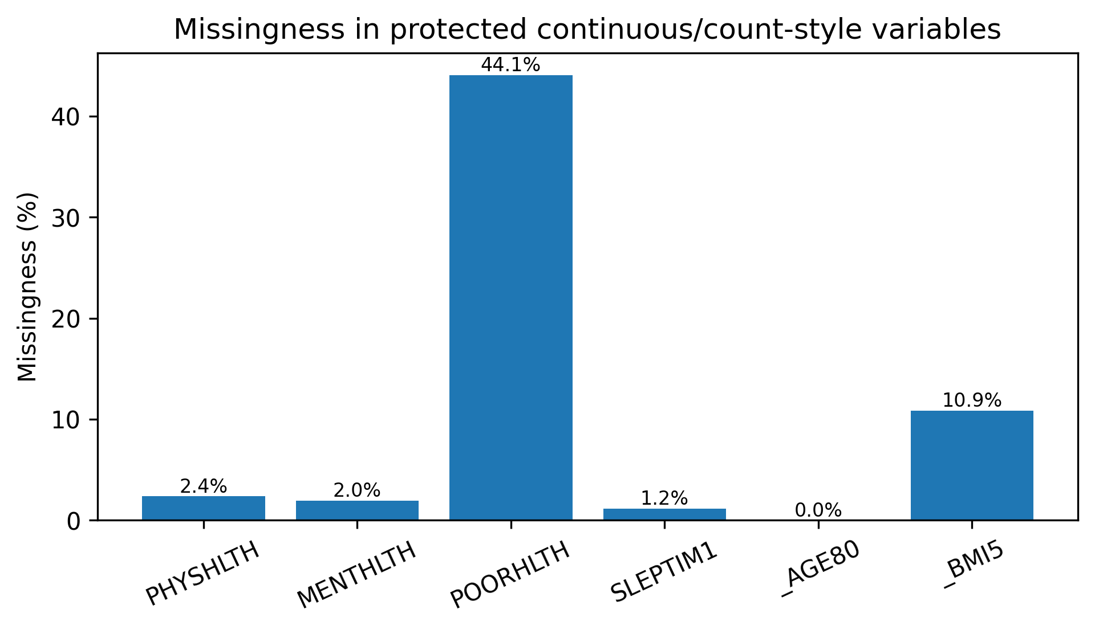
Appendix Figure A1. Missingness in protected continuous/count-style variables.
Appendix Table A4. Feature typing and encoded feature summary.
Feature group | Count
Continuous/count-style predictors | 14
Categorical/survey-code predictors | 106
Total raw predictors retained | 120
Encoded model features after preprocessing | 500

Appendix Table A5. Train/test class balance.
Split | Rows | Negative cases | Positive cases | Positive prevalence
Training | 352,088 | 320,287 | 31,801 | 0.090321
Held-out test | 88,023 | 80,073 | 7,950 | 0.090317

Appendix Table A6. Selected analytical-sample subgroup prevalence values.
Subgroup variable | Group | Positive prevalence
SEXVAR | 1.0 | 11.20%
SEXVAR | 2.0 | 7.12%
_SEX | 1.0 | 11.19%
_SEX | 2.0 | 7.12%
_AGEG5YR | 1.0 | 0.75%
_AGEG5YR | 6.0 | 3.76%
_AGEG5YR | 9.0 | 10.00%
_AGEG5YR | 10.0 | 12.57%
_AGEG5YR | 11.0 | 15.86%
_AGEG5YR | 12.0 | 19.41%
_AGEG5YR | 13.0 | 23.28%
_AGEG5YR | 14.0 | 6.69%

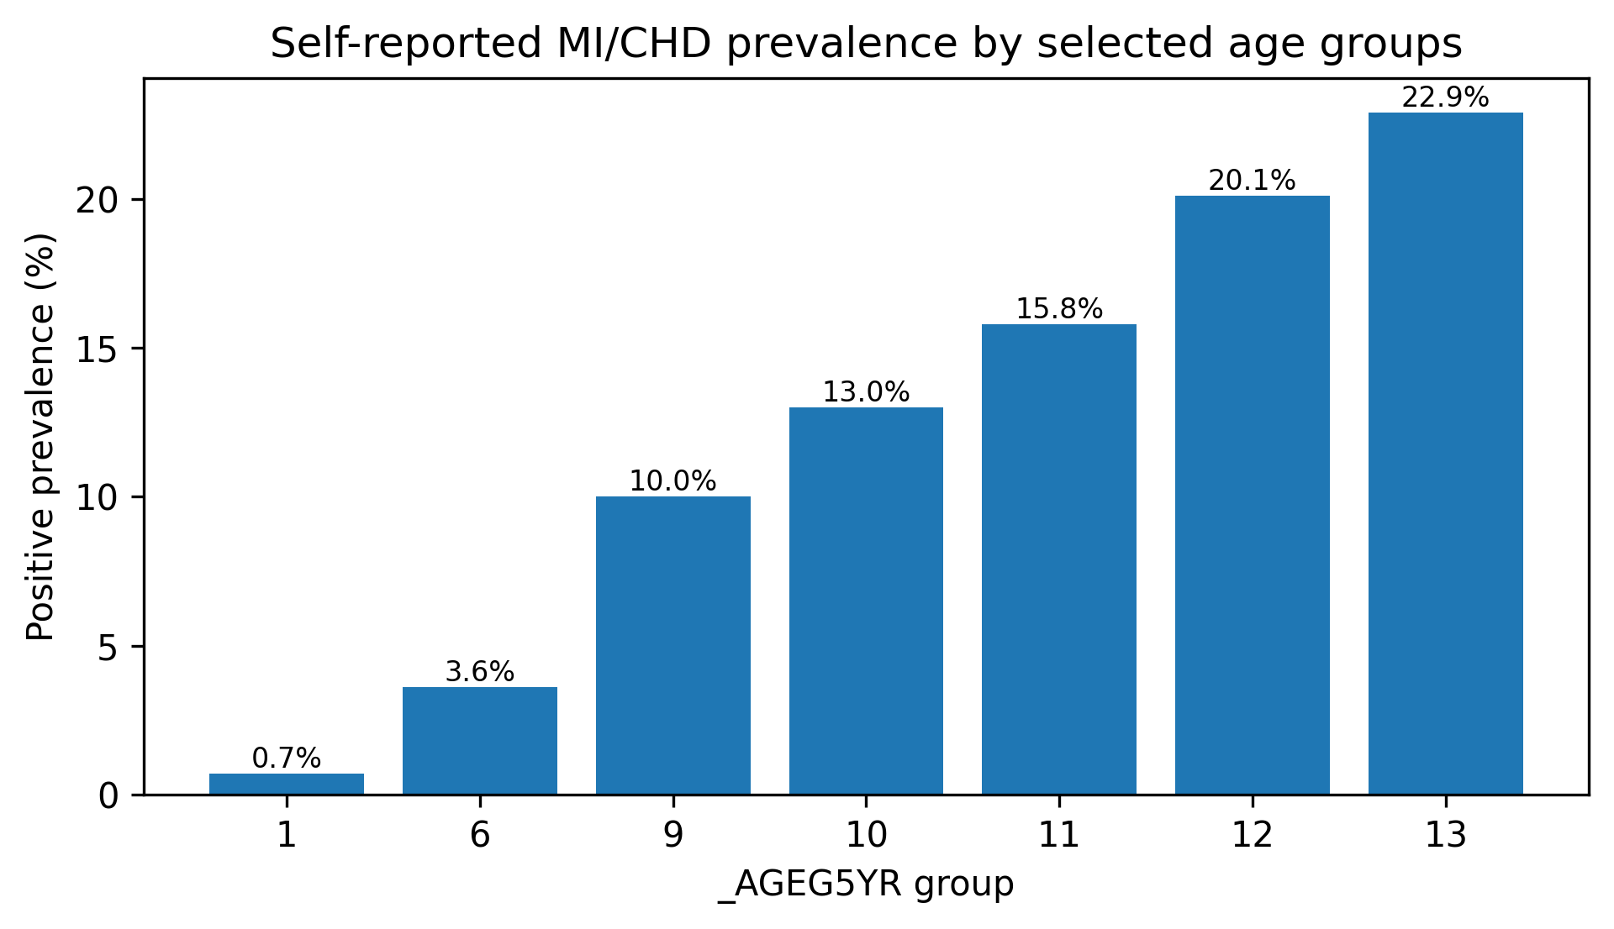
Appendix Figure A2. Self-reported MI/CHD prevalence across selected _AGEG5YR groups in the analytical dataset.

Appendix B. Model diagnostics and sensitivity outputs
Appendix Table B1. Default-threshold confusion-matrix counts.
Model | True positives | False positives | True negatives | False negatives
Logistic regression | 6,321 | 20,030 | 60,043 | 1,629
Random forest | 6,269 | 19,411 | 60,662 | 1,681
XGBoost | 6,464 | 20,702 | 59,371 | 1,486
MLP | 811 | 662 | 79,411 | 7,139

Appendix Table B2a. XGBoost tuning performance summary.
Output | Value
Tuning sample size | 60,000
Cross-validation folds | 3
Parameter combinations | 10
Total fitted candidates | 30
Best cross-validation PR-AUC | 0.3501
Tuned XGBoost held-out ROC-AUC | 0.8497
Tuned XGBoost held-out PR-AUC | 0.3608
Pre-specified XGBoost held-out ROC-AUC | 0.8542
Pre-specified XGBoost held-out PR-AUC | 0.3701

Appendix Table B2b. Selected tuned XGBoost hyperparameters.
Hyperparameter | Selected value
n_estimators | 150
max_depth | 3
learning_rate | 0.05
subsample | 0.80
colsample_bytree | 0.70
min_child_weight | 5

Appendix Table B3. Three-fold cross-validation stability summary.
Model | Mean ROC-AUC | ROC-AUC SD | Mean PR-AUC | PR-AUC SD
Logistic regression | 0.8475 | 0.0017 | 0.3583 | 0.0096
XGBoost | 0.8497 | 0.0017 | 0.3637 | 0.0077

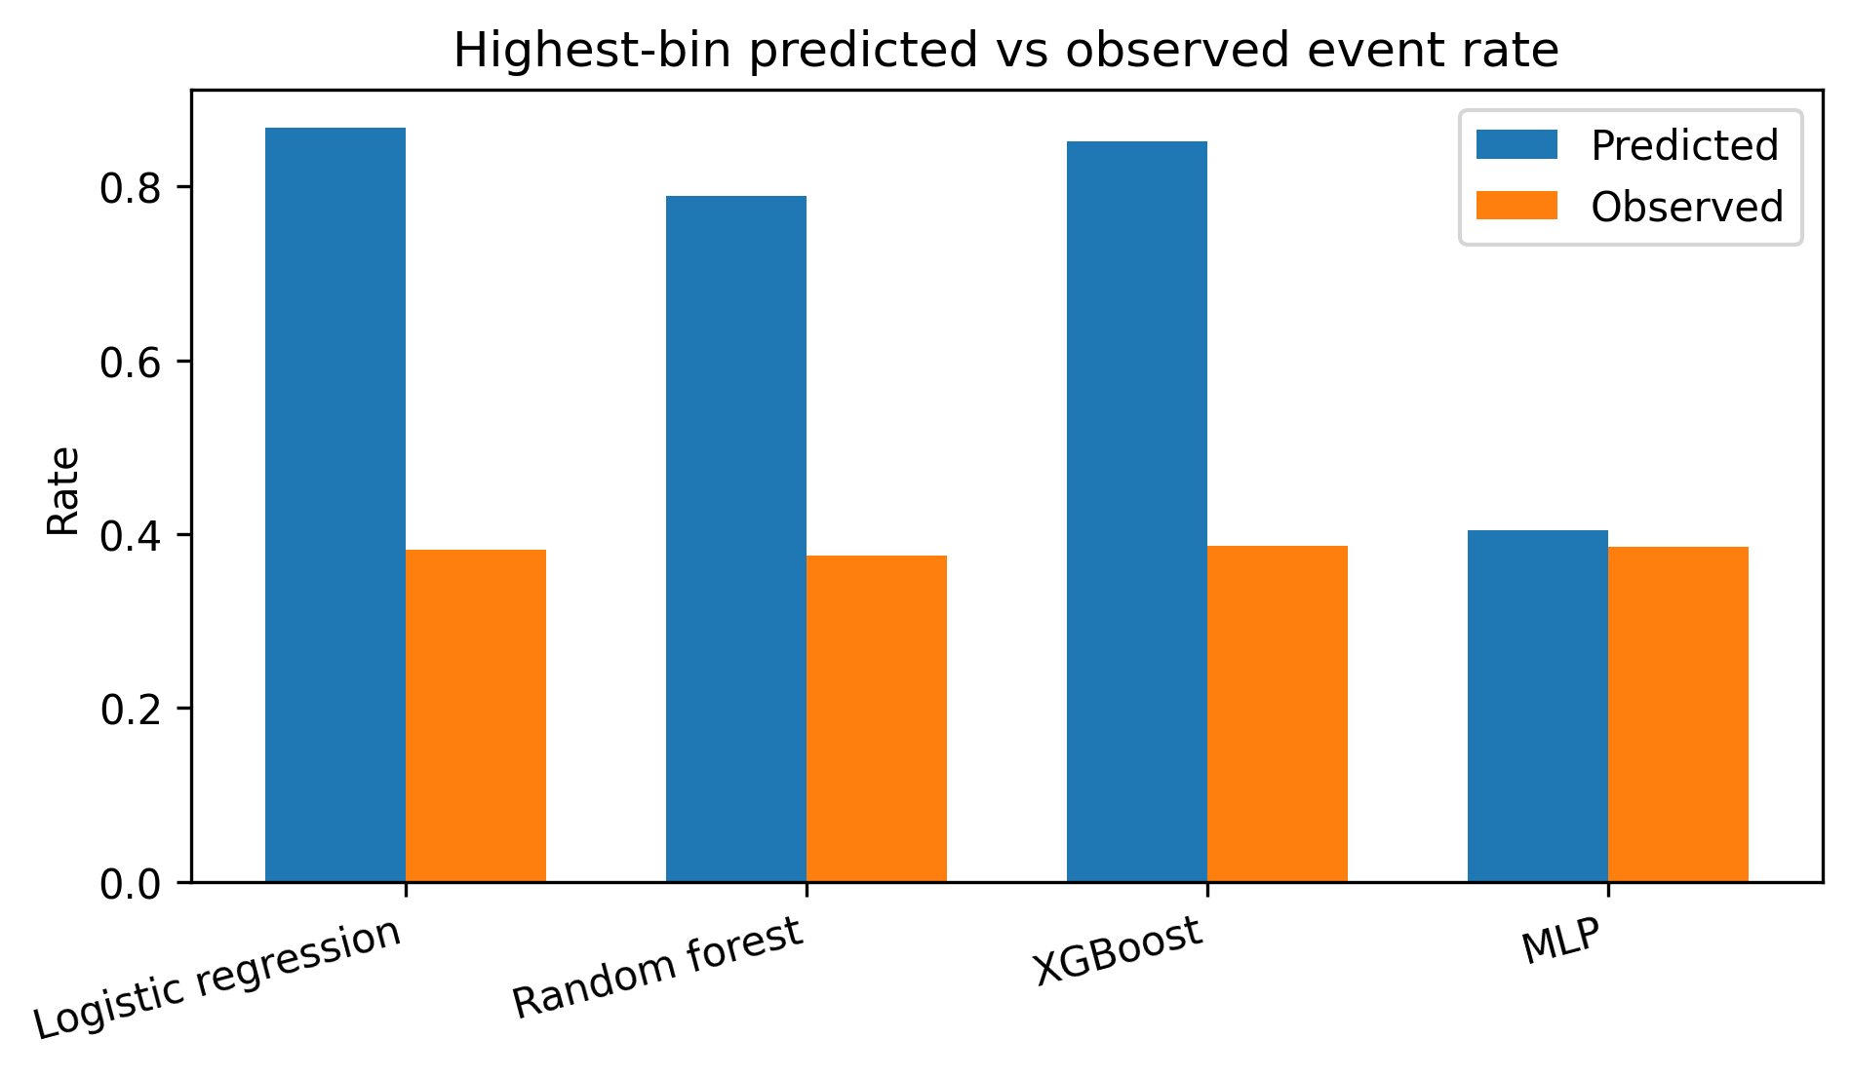
Appendix Figure B1. Highest-bin predicted versus observed event rate.
Appendix Table B4. Repeated-seed model stability summary.
Model | Mean ROC-AUC | Mean PR-AUC | Mean precision | Mean sensitivity | Mean specificity | Mean F1-score | Mean Brier score
XGBoost | 0.8521 | 0.3689 | 0.2369 | 0.8105 | 0.7408 | 0.3666 | 0.1628
Logistic regression | 0.8496 | 0.3636 | 0.2402 | 0.7955 | 0.7501 | 0.3689 | 0.1636
MLP | 0.8505 | 0.3654 | 0.5778 | 0.0847 | 0.9935 | 0.1454 | 0.0678

Appendix Table B5. Repeated-seed paired testing summary.
Comparison | Metric | Mean difference | Holm-adjusted p-value
XGBoost - logistic regression | ROC-AUC | +0.0025 | 0.002
XGBoost - logistic regression | PR-AUC | +0.0052 | 0.021
XGBoost - MLP | ROC-AUC | +0.0016 | 0.026
XGBoost - MLP | PR-AUC | +0.0034 | Not significant after Holm

Appendix Table B6. Top XGBoost built-in encoded feature importances.
Encoded feature | Importance
_AGE_G_6.0 | 0.1702
_AGE65YR_2.0 | 0.1468
_RFHLTH_1.0 | 0.0779
LCSCTSC1_2.0 | 0.0305
_RFHLTH_2.0 | 0.0302
DIFFWALK_1.0 | 0.0285
_AGE80 | 0.0259
EMPLOY1_1.0 | 0.0198
_EXTETH3_1.0 | 0.0176
DIFFWALK_2.0 | 0.0157

Appendix C. Explainability and subgroup outputs
Appendix Table C1. Top permutation-importance variables.
Variable | Permutation importance: PR-AUC drop
_AGE80 | 0.0612
_RFHLTH | 0.0250
LCSCTSC1 | 0.0223
CHCKDNY2 | 0.0162
PERSDOC3 | 0.0155
GENHLTH | 0.0150
_SEX | 0.0138
DIABETE4 | 0.0120

Appendix Table C2. Top encoded SHAP features.
Rank | Top encoded SHAP feature
1 | TRNSGNDR_2.0
2 | DIABETE4_9.0
3 | SDHTRNSP_7.0
4 | DIABETE4_1.0
5 | MEDCOST1_1.0
6 | PERSDOC3_2.0
7 | DEAF_1.0
8 | _AGE80
9 | LCSCTSC1_1.0
10 | LASTDEN4_8.0

Appendix Table C3. Top approximately aggregated original-variable SHAP rankings.
Rank | Top approximately aggregated original SHAP variable
1 | DIABETE4
2 | TRNSGNDR
3 | _AGEG5YR
4 | EMPLOY1
5 | LCSCTSC1
6 | PRIMINSR
7 | PERSDOC3
8 | LASTDEN4
9 | _MRACE2
10 | CHCKDNY2

Appendix Table C4. Selected held-out subgroup prevalence outputs.
Variable | Level/group | N where reported | Positive prevalence
SEXVAR | 1.0 | 41,377 | 0.1114
SEXVAR | 2.0 | 46,646 | 0.0716
_SEX | 1.0 | 41,381 | 0.1114
_SEX | 2.0 | 46,642 | 0.0716
_AGEG5YR | 1 | 5,396 | 0.0067
_AGEG5YR | 6 | 5,695 | 0.0360
_AGEG5YR | 9 | 8,736 | 0.0997
_AGEG5YR | 10 | 9,473 | 0.1303
_AGEG5YR | 11 | 8,548 | 0.1583
_AGEG5YR | 12 | 6,400 | 0.2009
_AGEG5YR | 13 | 7,060 | 0.2286

Appendix Table C5. XGBoost subgroup metric ranges.
Subgroup variable | Groups | N range | Prevalence range | ROC-AUC range | PR-AUC range | Precision range | Sensitivity range | Specificity range | F1-score range | FNR range | FPR range
EDUCA | 5 | 1,563-37,404 | 0.0709-0.1474 | 0.7745-0.8699 | 0.3314-0.4711 | 0.2297-0.2776 | 0.7768-0.8776 | 0.5871-0.8012 | 0.3545-0.4217 | 0.1224-0.2232 | 0.1988-0.4129
INCOME3 | 11 | 2,051-11,777 | 0.0410-0.1844 | 0.7986-0.8708 | 0.2650-0.4540 | 0.2037-0.2795 | 0.6158-0.9002 | 0.4752-0.8975 | 0.3071-0.4265 | 0.0998-0.3842 | 0.1025-0.5248
SEXVAR | 2 | 41,377-46,646 | 0.0716-0.1114 | 0.8450-0.8547 | 0.3056-0.4117 | 0.2102-0.2590 | 0.7385-0.8671 | 0.6889-0.7861 | 0.3273-0.3989 | 0.1329-0.2615 | 0.2139-0.3111
_AGE80 | 63 | 676-7,060 | 0.0013-0.2286 | 0.4960-0.9339 | 0.0026-0.4633 | 0.0000-0.5000 | 0.0000-0.9616 | 0.2255-0.9978 | 0.0000-0.4615 | 0.0384-1.0000 | 0.0022-0.7745
_AGEG5YR | 14 | 1,854-9,473 | 0.0067-0.2286 | 0.7336-0.8435 | 0.0504-0.4487 | 0.0577-0.2690 | 0.0500-0.9616 | 0.2255-0.9955 | 0.0536-0.4204 | 0.0384-0.9500 | 0.0045-0.7745
_AGE_G | 6 | 5,397-31,927 | 0.0067-0.1734 | 0.7686-0.8393 | 0.0693-0.4128 | 0.1154-0.2502 | 0.0874-0.8985 | 0.4354-0.9955 | 0.0994-0.3915 | 0.1015-0.9126 | 0.0045-0.5646
_EDUCAG | 4 | 4,963-37,404 | 0.0709-0.1416 | 0.8191-0.8699 | 0.3506-0.4278 | 0.2297-0.2634 | 0.7768-0.8620 | 0.6021-0.8012 | 0.3545-0.4035 | 0.1380-0.2232 | 0.1988-0.3979
_INCOMG1 | 8 | 4,280-21,251 | 0.0410-0.1584 | 0.8087-0.8708 | 0.2650-0.4180 | 0.2045-0.2673 | 0.6158-0.8850 | 0.5433-0.8975 | 0.3071-0.4105 | 0.1150-0.3842 | 0.1025-0.4567
_RACE1 | 7 | 1,331-63,498 | 0.0363-0.1202 | 0.8322-0.8713 | 0.2526-0.4344 | 0.1974-0.2781 | 0.6250-0.8500 | 0.6985-0.9043 | 0.3000-0.4191 | 0.1500-0.3750 | 0.0957-0.3015
_RACEGR4 | 6 | 1,866-63,498 | 0.0583-0.0982 | 0.8322-0.8826 | 0.2526-0.3849 | 0.1977-0.2451 | 0.6806-0.8333 | 0.7200-0.8348 | 0.3128-0.3776 | 0.1667-0.3194 | 0.1652-0.2800
_SEX | 2 | 41,381-46,642 | 0.0716-0.1114 | 0.8451-0.8547 | 0.3052-0.4120 | 0.2102-0.2591 | 0.7382-0.8673 | 0.6889-0.7861 | 0.3272-0.3989 | 0.1327-0.2618 | 0.2139-0.3111

