TABLE OF CONTENT
CHAPTER ONE 1
1.1. Introduction 1
1.2. Background Of Study 1
1.3. Problem Statement 2
1.4. Aim 3
1.5. Objectives 3
1.6. Significance Of The Study 3
1.6.1. Users 3
1.6.2. Input 3
1.6.3. Output 4
1.7. Limitation 4
1.8. Methodology 4
1.8.1. Source Of Information 4
1.8.2. Languages To Be Used 4
1.9. Definition Of Some Terms 5
1.10. Abbreviations 5
i. NLP : Natural language processing 5
CHAPTER TWO 6
2.0. Introduction 6
2.1. Concept Of Machine Learning And Classification 6
2.2. Related works 7
CHAPTER THREE 9
METHODOLOGY 9
3.1. Introduction 9
3.2. Project Workflow 9
3.3. System Development Model 10
3.3.1. The Iterative Model 10
3.4. Analysis Of Existing And Proposed System 11
3.4.1. Proposed System..........................................................................................................................11

3.4.2. Requirement Elicitation..............................................................................................................11
3.4.3. Requirrement Definition.............................................................................................................12
3.4.3.1. Functional Requirement...........................................................................................................12
3.4.3.2. Non-Functional Requirement Of The System........................................................................12
3.4.4. Requirement Analysis..................................................................................................................13
3.4.4.1. Use Case Diagram.....................................................................................................................13
3.4.4.2. Use Case Description................................................................................................................14
3.5. System Diagram..............................................................................................................................15
3.5.1.1 Activity Diagram........................................................................................................................16
3.5.1.2. Admin/User Activity Diagram.................................................................................................16
3.5.1.3. Architecture Design..................................................................................................................16
3.5.2.1.Class Diagram............................................................................................................................17
3.5.2. Database Design...........................................................................................................................17
3.5.3.1.Entity Relational Diagram.....................................................................................................17
3.6. Summary..........................................................................................................................................18
CHAPTER FOUR.......................................................................................................19
4.1. Introduction.....................................................................................................................................19
4.2. Implementation...............................................................................................................................19
4.2.1 Implementation Tool and Environment.....................................................................................19
4.2.2 Description oOf System Operation..............................................................................................20
4.2.3.1.Database File Page.....................................................................................................................20
4.2.3.2. Welcome Page 21.
4.2.3.3. Sentiment Accessing page 21
4.2.3.4. Product panel 22
4.3 System Testing..................................................................................................................................22
4.3.1 Testing Strategy.............................................................................................................................23
4.4 Summary........................................................................................................................................23
CHAPTER FIVE........................................................................................................24
5.1 Summary..........................................................................................................................................24
5.2 Conclusion........................................................................................................................................25
5.3 Recommendation.............................................................................................................................25
Reference.................................................................................................................................................26
Appendix A.............................................................................................................................................28
Appendix B.............................................................................................................................................30

CHAPTER ONE

Introduction

This chapter serves as fundamental exploration into the realm of product sentimental classification, its dives more on the purpose for what the project is helping out and issues that is in question. Its goes by explaining much on the goals to be achieved after the completion of the project and, also the chapter consist, ranging from background of study, problem statement, aims and objectives, scope, significant of study, methodology and definition of terms. All these listed, gives detail explanation into the exploration of product sentimental classification system.

Background Of Study

Product sentiment classification is one of the recent surfacing valuable tool for businesses to gain insights into customer’s opinions,improve products, and making data-driven decisions based on customer sentiment. It generally play crucial roles for understanding consumer’s behaviour and what the market is saying at some point. Product sentiment classification involves using machine learning/ natural language processing(NLP) techniques to analyze and categorize the sentiment expressed in textual data related to product. It aims to determine whether a piece of text(review/comment) expresses a Positive or Negative sentiment towards a particular product.
In today’s economy, the attention of the world is now shifting totally into digital operation. E-commerce is now taking strong move into digitalize world through the availability of products within the reach of customers at any moment and location. Furthermore, most E-commerce website allows the customers to express what they think and feel about product through mini-blog. In fact, customers are increasingly relying on the experiences of other customers. Our opinion and purchasing decision-making are affected by the experience of others and their feedback about products. We always ask others about their opinion to get the benefit from their experience; hence, the company’s product needs to be improved with all these feedback. However, The manual reading, analysis and summarization of the subjective information (such as sentiments and opinions) in massive texts are costly. Therefore, it is necessary to employ text data mining and natural language processing techniques to automatically extract and analyze sentiments and opinions from them.Sentiment analysis and opinion mining of review texts, as an important research direction, has drawn lots of attention in the field of text data mining and natural language processing (Liu, 2015 & Pang, Lee, et al., 2008).Sentiment classification originated from the analysis and mining of the product review text of e-commerce platforms (Das&Chen, 2001 & Turney, 2002). The reviews in e-commerce platforms have natural user-labeled ratings. On this basis, supervised machine learning methods can be used for sentiment classification.( Pang, et al ,2002).
The standard machine learning algorithms for sentiment classification are normally insertion of data manually for prediction, but in this approach of product sentimental classification system shall handle stream of review into the model for prediction from database where each comment resides, not just analyzing them but, also shall be able to give graphical representation, and also give few most occur statement for precision on action to take.

Problem Statement
Before the advent of machine learning/natural language processing, sentiment extraction from product-related content often relied on manual data collections. Basically, survey and questionnaires are well known for the means of data collection from consumers towards products. This is always involve staff to get questionnaire around communities just to get the opinions and reviews of people about the product in question, although using this method could be effective in the ages where product is just within geographical environment.
But then, using this method might not get proper insight from consumers, as some of the highlighted questions on questionnaire may not allow customers to say their intention towards product and not that alone, the targeted consumers may not be seen or opportune to express as it was when they had the issues with a particular product. It also involve many staff which leads to much capital and resources to be used.
On the hand, product sentiment classification comes into rescue by handling data in large volume within the reach where staff cannot get questionnaire to and accuracy of machine learning algorithm which have significant pattern to get sentiments from consumer’s review.

Aim

To develop a machine learning model for product sentiment classification system.

Objectives

To implement the developed model

To test and evaluate the implemented model

Significance Of The Study
In today’s world business entrepreneur, many has decided to shift attention totally to technopreneur, which makes most of there product they offers are accessible through internet medium of exchanges but, then customers needs to make reviews about what they bought and entrepreneur use the method mentioned in problem statement which cannot in continuously used as it consume much time and resource. So,therefore product sentiment classification comes into place these features for improvements.
- Automated Analysis: product sentiment classification shall enable the process of large volumes of product-related textual data at scale, surpassing the limitations of present mean of data analysis.
- Improved Accuracy: the system utilize the machine learning/natural language processing to cut away and summarize review with simple abject which can Negative or positive review.
- Multi-task processing: product sentiment system will not only work for one product at a time, but as plenty as those product push out for customer provided that the product has review from consumers.
- Availability: product sentiment classification can be used at any point in time provided that reviews/comments keeps coming from consumers.
    - Users
- Product managers, marketing professionals, and analysts seeking insights into product perception.
- Individuals looking for informed purchasing decision based on comprehensive sentiment analysis of products
    - Input
- Reviews, comments, or any textual feedback about product from the database.

    - Output
- Categorizing into sentiments positive and negative assigned to each input text.
- Summarized reports, visualization inform of sentimental distribution or pie chart.

Limitation
- Language variability, difficulty for the system to handle sentiment analysis for multiple language. As its going to be trained on one language. though, possibility for the system to work on other is high only if data is provided.
- System will not provide direct access for users to input review/comment but, only one end of data to be fetched.
- System will not be able to give direct intentions of messages but, only read the meaning into positive and negative.

Methodology
The methodology of product sentimental classification involves the approach to gather required materials for the project documentation and the programming language needed for the implementation of project.
    - Source Of Information
From the beginning of the research, several article are reviewed to come up with this project topic and after conclusion on the topic to choose, those article serves as source of information for this project write up.
    - Languages To Be Used
React is a javascript front end web framework, which make design of user interface more easy and faster, thus therefore, the implementation of the user interface shall make use of react.
Python serves as the major language that shall be use to perform most of the implement at the back-end mechanism. Machine learning aspect shall use python to train model and connection to the database.
Database in the implementation of the database at end point, although from the proposal of project we made mention of two database, we shall make provision for configuration for sql database which make it a choice for the user to pick the preferred one which are Sqlite ,postgresql and Mysqli.

Definition Of Some Terms
- Tokenization : is the process of breaking down a piece of text into smaller units called tokens. These tokens could be words, phrases, or individual characters that are required for analysis.
- Stopwords : are commonly used words in natural language which has no significant meaning in sentence and, are often removed during analysis to prompt a little accuracy.
- Model: are created and trained using historical data or past data and then used to make predictions or perform task on unseen data.
- Countvectorizer :is one of the tools used for converting textual data into a format that machine learning models can understand and process.
- Accuracy: is the percentage measurement that tell how well new data perform on a trained model.
- Training and Testing data: are fundamental components in machine learning used to build and evaluate models. They play critical roles in model development and ensuring the model’s ability to generalize to unseen data
- Pipeline: this provide a structured approach to organizing and executing complex workflows in machine learning, enhancing efficiency and reproduction of model development and deployment.

Abbreviations
- NLP : Natural language processing

CHAPTER TWO
LITRATURE REVIEW

Introduction
This section contains the related projects to product sentimental classification system that had been carried by some researcher or developer. In the recently years, research interest turned strongly towards sentimental analysis in the field of machine learning. As seen in the modern day, technology has it in mind to make every aspect of human race to be simplified. Thus, this aspect of machine learning want information grasp to be easy rather than go through bunch of information before apprehension of messages could be gotten.

Concept Of Machine Learning And Classification

Machine learning is subset of artificial intelligence(AI) that focuses on the development of algorithms and models capable of learning from data. Instead of being explicitly programmed to perform a task, a machine learning system learns patterns and relationships from examples, enabling it to make predictions or decisions on new, unseen data. Thus, this mechanism is applicable to product sentiment classification as those review/comment that will be input shall be new data. But, with the help of machine learning algorithm it will give a close perfect prediction of output.

Classification is a specific task within supervised learning where the goal is to categorize input data into predefined classes or categories. In a classification problem, the machine learning model learns a mapping between input features and discrete output label. But then, classification comes into place in product sentiment classification as the pattern of every machine learning classification algorithm classifies predicted label into distinct categories as it was been trained with data. Therefore, we only need product sentiment classification with absolute two distinct label which brought about the concept of classification from machine learning algorithm.

Related works
Saad and Yang(2019) Aimed for giving a complete tweet sentiment analysis on the basis of ordinal regression with machine learning algorithms. The suggested model included pre-processing tweets as first step and with the feature extraction model, an effective feature was generated. The methods such as SVR, RF, Multinomial logistic regression (SoftMax), and DTs were employed for classifying the sentiment analysis. Moreover, twitter dataset was used for experimenting the suggested model. The test results have shown that the model has attained the best accuracy, and also DTs were performed well when compared over other methods.
Afzaal et al(2019) Have recommended a system approach of aspect-based sentiment classification, that recognized the features in a precise manner and attained the best classification accuracy. Moreover, the scheme was developed as a mobile application, which assisted the tourists in identifying the best hotel in the town, and the proposed model was analyzed using the real-world data sets. The results have shown that the presented model was effective in both recognition as well as classification.
Yousif et al(2019) have presented a multi-task learning method on the basis of CNN and RNN. The structure of the suggested method was helpful for denoting the citation context and feature extraction was done in an automatic way. By considering two freely accessible datasets, the suggested technique was analyzed. The outcomes have shown that the proposed model was improved than conventional models.
Y. Fang, et al(2018) Explained that, the opinions of consumers are expressed in sentiment Chinese phrases. But due to the fuzziness of Chinese characters, traditional machine learning techniques can not represent the opinion of articles properly thereby, proposed a system, Multi-Strategy Sentiment Analysis of Consumer Reviews Based on Semantic Fuzziness that solve the problem.
Xu et al(2020). Introduced a NB method for multi-domain and large-scale Ecommerce platform product review classification of sentiment. Consequently, the parameter evaluation method was extended in NB for continuous learning fashion. Later, for fine-tuning the learned distribution on the basis of three types of assumptions, many ways were introduced for acquiring the best performance. The results have shown that the suggested model has high accuracy in Amazon product and movie review sentiment datasets.

Table 2.0
TABLE FOR COMPARISONS OF RELATED WORK REVIEWED
YEAR | TITLE | ACHIEVEMENT | GAPS
2019 | Twitter Sentiment Analysis Based on Ordinal Regression( Saad and Yang). | Present an approach that aims to extract Twitter sentiment analysis by using different classifiers. | Real-time sentiment analysis in term of handling data stream.
2018 | Tourism Mobile App With Aspect-Based Sentiment Classification Framework for Tourist Reviews(Afzaal et al.). | Mobile App assist the tourists in identifying the best hotel in the town. | Multi-domain adaptability,expanding framework beyond restaurant and hotel.
2019 | Multi-task learning model based on recurrent convolutional neural networks for citation sentiment and purpose classification(Yousif et al.). | Citation sentiment system that intention of an author’s intentions. | Limited integration of qualitative aspects and
2018 | Multi-Strategy Sentiment Analysis of Consumer Reviews Based on Semantic Fuzziness  (Y. Fang, et al.). | A multi-strategy sentiment analysis method system with semantic fuzziness. | Quantitative analysis of modifiers, and analyze compound sentiment phrases of syntactical structure to find better methods for sentiment analysis.
2020 | commerce product review sentiment classification based on a naïve Bayes continuous learning framework(Xu et al). | Efficient continuous naïve Bayes learning framework for e-commerce product review sentiment classification. | No proper representation of the result of the sentiment.

CHAPTER THREE

METHODOLOGY

Introduction
This chapter comprises of the analysis models, design models, the problem statement and including system details such as the Systems Requirement Specification (SRS) document which is majorly focused on only the functional requirements to be provided by the system, software development life cycle (SDLC), systems architectural design, user interfaces, the database designs, and the UML diagrams.

Project Workflow
A project management workflow is a carefully planned sequence of the tasks and activities you need to do to complete a specific project. Figure 3.1, Shows the various stages and activities involved in the development of the proposed system such as requirement gathering, system design, implementation, testing and validation.
Requirement
Gathering

System Design

Implementation

Testing and Validation

Fig 3.0 Process flow diagram

System Development Model
Software development life cycle is the period of time that starts when a product is conceived and ends when the software is no longer available for use. The software life cycle includes a requirement phase, operation and maintenance phase and retirement phase (IEEE) The development methods that is intended to use for the product sentiment classification system is the iterative model which may be considered as an extension of the waterfall model, it offers a means of making the development process more visible. A system prototype can be developed to give end-user a concrete impression on the system capabilities.
    - The Iterative Model
The Iterative SDLC model is an approach of segmenting any large software development process into smaller portions. It does not need the full list of requirements before the project starts. The development process may start with the requirements to the functional part, which can be expanded later. The iterative life cycle model comprises repeating the below-mentioned four stages as a sequence. These are: Requirements Phase, Design Phase, Implementation and Test, Review Phase.The process is repetitive; allow making new versions of the product for every cycle.
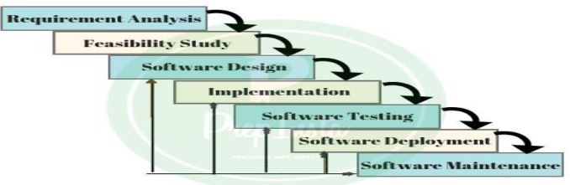
Fig 3.1 Software Development Life cycle
As shown in the figure above, the project have been divided into different phases which are: requirement gathering phase, system design phase, development and implementation phase, testing phase, and operation and maintenance phase.
- Requirement analysis: The requirements for product sentiment classification system. This involves gathering data that is needed for machine learning modeling and for testing of model.
- Design: Detailed designs of the product sentiment classification system based on the requirements of the system are designed.
- Implementation: this phase involves coding the product sentiment classification system from model design to database and manipulation of that data from the database based on the detailed design and specifications.
- Testing: At this stage the system undergoes various stages of testing to ensure that the system is working accordingly, the testing include model testing to get accurate percentage from machine learning model designed.
- Deployment: after testing and bugs are eliminated the system is deployed to its final production environment.
- Maintenance and support: this involves continuous machine learning model maintenance of the system to ensure it continue to predict data efficiently.

Analysis Of Existing And Proposed System
There are various existing product sentiment classification system which offers their own unique features that allows users to make use of it for prediction of sentiment towards customers reviews but, then despite having a lot of them there still lapse.
    - Proposed System
The proposed system is to build easy access to user’s review on each product push out on there e commerce site, and the easy access in the statement would be automation of comment into prediction. On click of product we have the sentiment of a customer towards the product.
Also, the proposed project will allow the user to gain accessing graphical percentage picture and most common words that occur within comments.
    - Requirement Elicitation
Requirements elicitation is the process of gathering and defining the requirements for a software system. The goal of requirements elicitation is to ensure that the software development process is based on a clear and comprehensive understanding of the customer needs and requirements (Wikipedia, 2020). Collection of data can either by interview method or by reference to written text which enables the software developers to have the necessary information required in the development of particular software.

For the purpose of these projects I choose to use one elicitation method namely:
- Online data collection and observation.
    - Requirement Definition
Requirements are statements setting out detailed descriptions of the system functions, services and operational constraints. It provides more specific details about services and functions of a system. It could be part of a contract between client and contractor.
      - Functional Requirement
Here are the functional requirements of the system. These include:
- The application shall be able to update the comment of each product after specified period of time.
- There shall have interface where company’s representative can easily view each product published.
- The application shall be able to present graphical sentiment representation of each product.
- The system shall be able to fetch data(comment) as input from database.
      - Non-Functional Requirement of the System
Nonfunctional requirements refer to behavioral properties that the system must have, such as performance and usability. Non-functional requirements may be more critical than functional requirements, so if they are not met, the system may be useless. Below are some of the nonfunctional requirements that this system should meet up to: which include:
- Reliability: Product sentiment classification system shall operate 99% of the time. This system has to be reliable due to the important role it plays, and the crucial data it handles.
- Accuracy: Product sentiment classification system accuracy is determined by the speed of use executed by its users.
- Availability: Product sentiment classification system shall be 100% available to all the users. The users shall be able to use it 24hrs a day. 4. Portability: Product sentiment classification system has been developed and coded using python for the modeling of machine learning aspect,for the app logic python(flask) is used, front end will use React and Database, Sqlachemy library shall be used which make easy for any sql databases to be used.
- Usability: The app has a user-friendly interface which is self-explanatory and easy to use. It requires no specific training on the user’s part.
    - Requirement Analysis
Requirements Analysis is the process of defining the expectations of the users for an application that is to be built or modified. It involves all the tasks that are conducted to identify the needs of different stakeholders. Therefore requirements analysis means to analyze, document, validate and manage software or system requirements. Requirements may be documented in various forms, usually including a summary list and may include natural-language documents, use cases, user stories, process specifications and a variety of models including data models. (Wikipedia, 2018).
      - Use Case Diagram
A use case represents how a system interacts with its environment by illustrating the activities that are performed by the users and the system’s responses, use cases are a means of expressing user requirements. (Wikipedia, 2019).
In this system there is only one actor(admin) that perform different interaction with the system.
Figure below shows the interactions between the system and actor(admin/user).
The admin/user can view different product loop out from the database into the interface of app. The user can make a click to check sentiment result of the of each product and can also get access to few words to get insight of the sentiment graph.
System

Enter database file

View Product
User
Sentiment Assessment
Most frequent
words

Fig 3.2 Use Case Diagram

      - Use Case Description
Use case descriptions help to provide a text-based representation of how the system behaves and functions from the perspective of the actors involved. They help in documenting and communicating the expected interactions, steps, and outcomes of a specific use case, enabling stakeholders, developers, and testers to understand the system’s behavior and requirements in detail. A use case description typically includes the following components:
- The Name of the Use case
- Description- a brief description what the use-case does
- Actors: The actors involved in the use-case
- Pre-conditions: A Condition that must be true before the use-case can be initiated
- Post-conditions: A condition that must be true after the use-cases
- Basic flow: Describes the primary approach to accomplishing the use-case.
- Alternate flow: Describes the various ways of accomplishing the use-case goal

Name: Enter Database file
Description: the use case describes the input needed for the system to work on.
Actors: User
Pre-conditions: The user have successfully open web app and insert the database file to work with..
Basic Flow: i. The user goes to the home page.
Post-conditions: After insertion of the database file, the users can proceed to the main page..
2.
Name: View Product
Description: the use case describes the process of accessing the each product sentiment on the user interface.
Actors: User
Pre-conditions: The user have successfully open web app and logins is not required.
Basic Flow: i. The user goes to the home page.
ii. The app shows different products .
Alternate Flow: The admin/user can view the products and also select the product they want to access.
Post-conditions: After accessing the products , the admin/users can proceed to the sentiment assessment.
3.
Name: Sentiment accessing
Description: the use case describes the process of accessing the sentiment each product on the user interface.
Actors: User
Pre-conditions: The user have to navigate to product accessing panel .
Basic Flow: i. The user goes to the product assessment panel .
ii. The panel shows different products .
Alternate Flow: The user can select the products and check for the sentiment of the product selected
Post-conditions: After accessing the product’s sentiment, the admin/users can close back to the normal page.
4.
Name: Most Frequent Word Assessment .
Description: the use case describes the process of accessing the most frequent word on each product comments
Actors: User
Pre-conditions: The admin/user have to navigate to product assessment panel .
Basic Flow: i. The Admin/user goes to the product assessment panel .
ii. The panel shows different products .
Alternate Flow: The admin/user can select the products and check for the most frequent word of the product selected
Post-conditions: After accessing the product’s sentiment, the admin/users can close back to the normal page.

System Design
System design is the process of designing the elements of a system such as the architecture, modules and components, the different interfaces of those components and the data that goes through that system. The purpose of the System Design process is to provide sufficient detailed data and information about the system and its system elements to enable the implementation consistent with architectural entities as defined in models and views of the system architecture. (Wikipedia, 2019).
      - Activity Diagram
An activity diagram illustrates the dynamic nature of a system by modeling the flow of control from activity to activity. Typically, activity diagrams are used to model workflow or business processes and internal operations. It uses some of the same modeling conventions.
      - Admin/User Activity Diagram
The activity diagram for the Admin/user starts with the loading app process, followed by different activities available to the admin/user. These activities include Product accessing Sentiment accessing and Most frequent word accessing.

Load the applications
successful

Product accessing panel.

Sentiment accessing

frequent word accessing

Fig 3.3 Admin/user Activity diagram
    - Architecture Design
Architectural design can be perceived to be an early stage of the system design process, representing a link between requirements specification and design processes. It is more of a representation of a system aimed at bringing out a better understanding of the anticipated system behavior. Architectural design entails identification of major system components, their properties, and the communication among them (Sommerville, 2016).
      - Class Diagram
Class diagrams are used when developing an object oriented system model to show the classes in a system and the associations between these classes. An association is a link that indicates that there is a relationship between these classes.
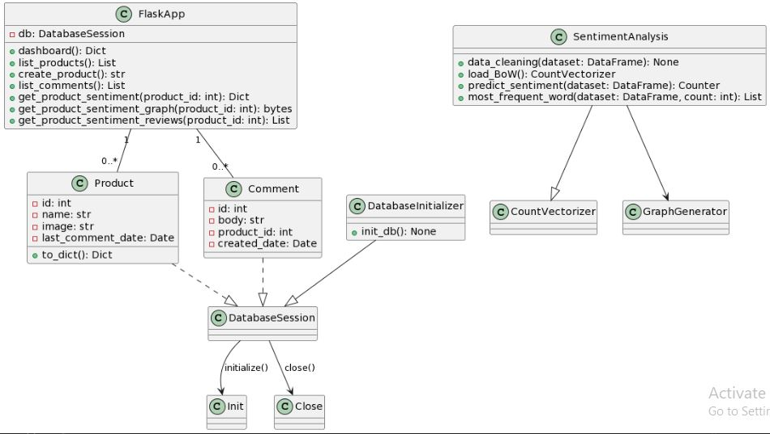
Fig 3.4 class diagram
    - Database Design
Database architecture in businesses and organizations involves the application of programming languages to design software. It mainly involves the design, implementation, development, and maintenance of the computer programs that store and manage data for businesses. The architecture determines the design of a DBMS.

Entity Relational (ER) Diagram
An entity–relationship model describes interrelated things of interest in a specific domain of knowledge. A basic ER model is composed of entity types and specifies relationships that can exist between entities. (Wikipedia, 2016)

Field | Description | Data type
Id | Unique identity of product | int
Product_name | Name of the product | Strings
Product_image | Image that represent | String
Table 3.0 Product table

Table 3.1 Comment table
field | Description | Data type
id | Unique identity | int
Product_id | Relationship between product and comments | int
body | Comment section | strings
Time stamp | Time for each comment | Datetime

ER diagram of the proposed system. In the figure above show the relation between the product table and comment table which explained this way for every product is entitle to many comments. But product will only have one image and name.

Summary
This chapter presents proposed system analysis and design. It further shows how the requirements was gathered and also explained both the functional and non-functional requirements. Different diagrams were also employed to explained different perspective of the system. Among the diagrams used is activity diagram, class and use case diagram. This chapter forms the basis of system implementation system that will follow in the subsequent chapter.

CHAPTER FOUR
SYSTEM IMPLEMENTATION, TESTING AND MAINTENANCE.

  - INTRODUCTION
This chapter contains the system implementation such as implementation tools and Environment, System Requirements, Description of the implemented system, System Testing. It provides a thorough description of how the proposed system is designed as well as how the design is used in implementing the system into actual software using a computer programming language.

  - IMPLEMENTATION
- System implementation is the process of defining how the Information system should be built (i.e. physical system design), ensuring that the information system is operational and used, meeting its quality standard (i.e. quality assurance). It is also said to be a realization of a technical specification or algorithm as a program, software component, or other computer system. It entails the conversion technique, the installation, testing and maintenance of the new system.

    - IMPLEMENTATION TOOLS AND ENVIRONMENT

Implementation Choices
Being machine learning base project, the design and implementation is on python supported environment was used and the stack languages used are the most common language for machine learning. These stack consist of the following tools:
- Python: is a high-level programming language that has gained immense popularity in the field of machine learning due to its simplicity, readability, and the availability of numerous libraries and frameworks specifically designed for machine learning tasks.
- Flask: is a lightweight web framework for Python that is commonly used for deploying machine learning models as web services.
- React: is a JavaScript library commonly used for building user interfaces (UIs) for web applications
- SQLite :is a lightweight relational database management system that is often used in conjunction with machine learning projects, particularly for storing and querying datasets.
Table 4.1 below describes the implementation tools used in building the application.

Table 4.1 Implementation Tools and Environment
Category | Software Used
Operating System Used | Windows 10
Integrated Development Environment | Visual Studio Code
Programming Language | Python, React
Database | SQlite
Web browser | Google Chrome

    - DESCRIPTION OF SYSTEM OPERATION(using sample interface)
This section provide detailed description of the system using pictures/images to describes sample interfaces of the implemented system, followed by an explanations of its each functionality.
      - Database file page

This is the first page that shows users where to input the database file to be predicted.

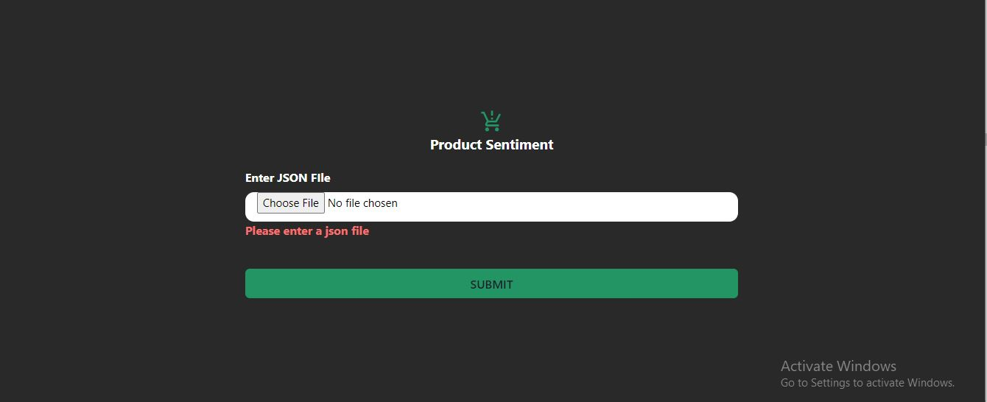
Fig 4.0 Database file page

      - Welcome page
This is the second page after the loading the Database url on the first page, it give an hint about how the system work, though as seen below which is easy to understand and what is meant for.
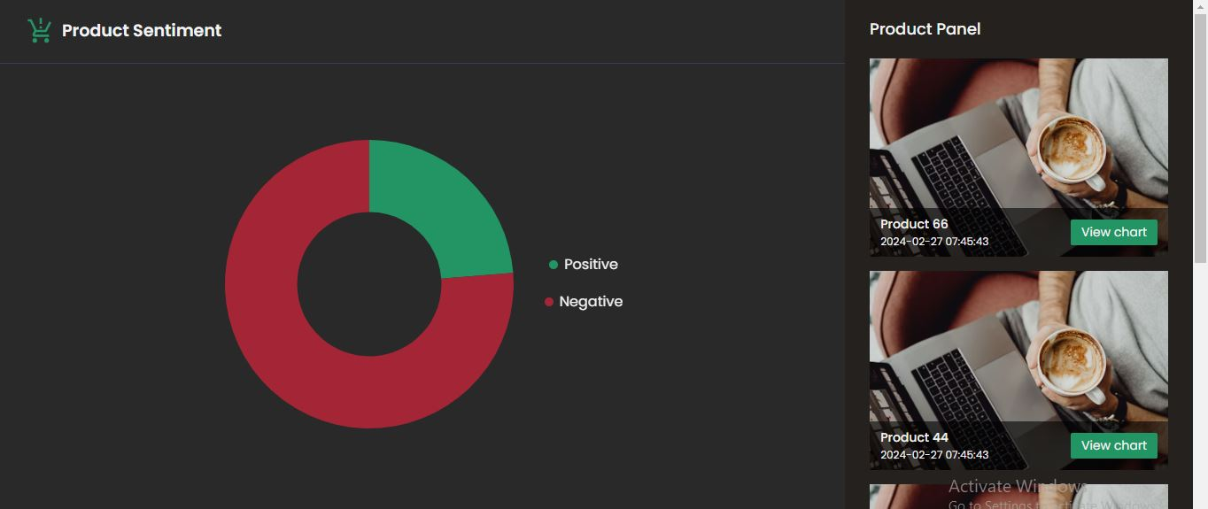
Fig 4.1 welcome page
      - Sentiment Accessing page
This is a page that show visible percentage of the positive and negative of every product accessed and at the down part it shows most common words that occur on the reviews.
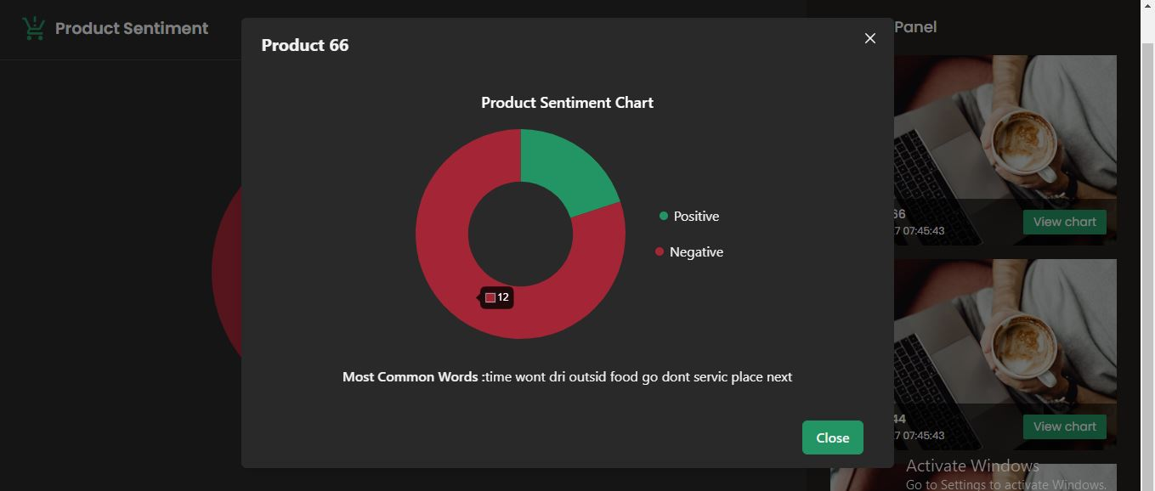
Fig 4.2 sentiment accessing page

      - Product panel
This is a part the product from that database resides in which one can scroll through to select which one to access the sentiment.
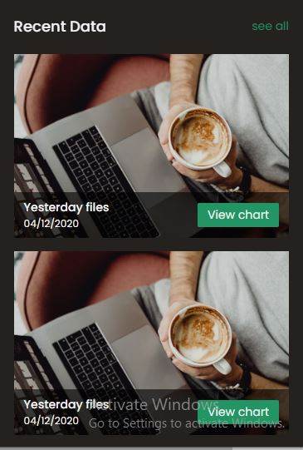
Fig 4.3 product panel

  - SYSTEM TESTING
System testing is a part of software development, with the intent of finding errors and missing operations and also a complete verification to determine whether the objectives are met and the user requirements are satisfied. The ultimate aim is quality assurance. Tests are carried out and the results are compared with the expected document. In the case of erroneous results, debugging is done. Using detailed testing strategies, a test plan is carried out on each module. The major tests performed are model testing and integration testing
    - Testing Strategy
As major design is concern with machine learning model to get most accurate percentage for model to able to work on new data, data are shared into two portion, one for training of model and other for testing the model. On the other hand testing integration of database with model to work hand in hand and overall system testing was also carried out . screenshot below show how data set was tested with model and the result.
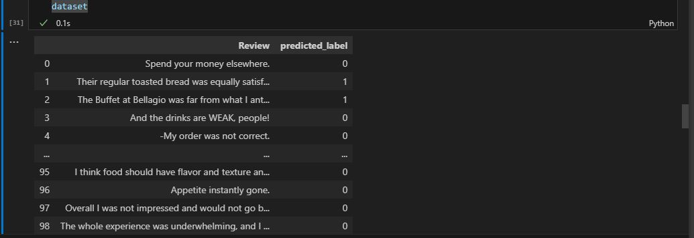
Fig 4.3 model testing

  - Summary
This chapter present the implementation and testing part of the project, the implementation choice of programming language and integrated development environment (IDE), screen capture of the implemented system, description of the coding and system testing.

CHAPTER FIVE
SUMMARY, CONCLUSION AND RECOMMENDATION

  - SUMMARY
Product sentiment classification is system that stand more or less like open application to everyone running E-commerce site for there sales of there product but, with one condition to make it usable for them, having review section for each product on there platform. And it design in such a way that it work any SQl database system and only part of the database needed is product and comment table.
The system was design base on machine learning/ natural language processing with appropriate pre-processing method along side with model of machine learning which has accurate 72% that more confidence about the model.
Flask framework was used for the deployment of the model and React was also used for front end design.
It a system that does not required logins details it free just as mentioned from the first paragraph, it was built to get insight of customers towards each product and on other hand it was made on the ease for analysis for bunch of comment/reviews from consumer. The first chapter emphasized the general overview of the background of the study, the problem statement, the aim of the project revolve around taking the advantage of modern technology which is machine learning/natural language processing techniques to understand customer’s sentiment from comments/reviews by fine grain analysis and objectives of the project besides its scope and limitations. The second chapter (literature review) which describes comprehensible and conversant review of some relevant works completed on sentiment classification and related System review, 5 selected literature work was reviewed in this part, to find out about the work and effort that had been put together to achieve good and quality result.
The three chapter (system analysis and design) gave a comprehensive justification of the SDLC model used in the development of the system which is iterative development model, requirement elicitation-where the requirement of the proposed system were collected through assessment of related works, interviews and observation. The description of the existing system as well as the proposed system was also conversed. The functional and nonfunctional requirement of the current system were also conversed, Use case diagram was used in the analysis part, class and activity diagrams was used for the system design. The four chapter (System implementation, testing and maintenance) covers system implementations, review of developmental tools used and system testing. This converts the design in chapter three to an executable system. Features of the system were shown in this chapter in form of screenshots. System testing describes how the system works by undertaking three(3) different stages of testing namely; machine learning model Testing, Integration Testing, and System Testing.

  - CONCLUSION
In today’s world of technopreneur we understand that everyone is shift attention into E commerce and left every aspect of businesses that deal with physical. Thus, making some method of getting data or response from consumers invalid and those response from consumer makes the entrepreneur to meet up with the demand and want over the product published. Therefore product sentiment classification system present the ease of managing product and feed back from customers, provided that the input process is given into system. The development of product sentiment classification was successful and aim of system is to meet customers demand from there reviews.
  - RECOMMENDATION
For further improvement of the product sentiment classification system, the following are some recommendations.
- User should access through logins details
- The system should have addition feature for instant comment/reviews analysis

REFERENCES
AsadAbdi, Siti MariyamShamsuddin, ShafaatunnurHasan, and JalilPiranMD, "Machine learning-based multi-documents sentiment-oriented summarization using linguistic treatment", Expert Systems with Applications, vol. 109, pp. 66-85, 1 November 2018

Das SR, Chen MY. 2001. Yahoo! for Amazon: Opinion extraction from small talk on the web. In
Proceedings of 8th Asia Pacific Finance Association Annual Conference. Bangkok, Thailand
- Afzaal, M. Usman and A. Fong, "Tourism Mobile App With Aspect-Based Sentiment Classification Framework for Tourist Reviews," IEEE Transactions on Consumer Electronics, vol. 65, no. 2, pp. 233-242, May 2019.

Pang B, Lee L, Vaithyanathan S. 2002. Thumbs up? Sentiment classification using Machine
Learning techniques. In Proceedings of Conference on Empirical Methods in NLP, pp. 79-86

- E. Saad and J. Yang, "Twitter Sentiment Analysis Based on Ordinal Regression," IEEE Access, vol. 7, pp. 163677-163685, 2019

Sommerville, I., Software Engineering, 10th Edition, Addison Wesley, 2016

SaeromPark, JaewookLee, and KyoungokKim, "Semi-supervised distributed representations of documents for sentiment analysis", Neural Networks, vol. 119, pp. 139-150, November 2019.

- Fang, H. Tan and J. Zhang, "Multi-Strategy Sentiment Analysis of Consumer Reviews Based on Semantic Fuzziness," IEEE Access, vol. 6, pp. 20625-20631, 2018

ZiyuanZhao, HuiyingZhu, ZehaoXue, ZhaoLiu, JingTian, Matthew Chin HengChua, and MaofuLiu, "An image-text consistency driven multimodal sentiment analysis approach for social media", Information Processing & Management, vol. 56, no. 6, November 2019.

https://www.geeks4geeks.com/Requirementelicitation/softwareengineering2023

https://www.researchgate.net/systemengineering2018

https://wikipedia/systemengineering/requirments

APPENDIX A
Machine learning Model testing and evidence
Database input page
Product page

Product Panel
Product Sentiment accessing page

APPENDIX B
Code for machine learning
import numpy as np
import pandas as pd

dataset = pd.read_csv('a1_RestaurantReviews_HistoricDump.tsv', delimiter = '\t', quoting = 3)

#stop words generation and processing
def stopwords_processing():
import re
import nltk
nltk.download('stopwords')
from nltk.corpus import stopwords
from nltk.stem.porter import PorterStemmer
ps = PorterStemmer()
all_stopwords = stopwords.words('english')
all_stopwords.remove('not')
return all_stopwords

#data cleaning processing method
def data_cleaning():
corpus=[]
st_words=stopwords_processing()
ps = PorterStemmer()
import re
for i in range(0, 900):
review = re.sub('[^a-zA-Z]', ' ', dataset['Review'][i])
review = review.lower()
review = review.split()
review = [ps.stem(word) for word in review if not word in set(st_words)]
review = ' '.join(review)
corpus.append(review)
return corpus

#Vectorization of the each word
from sklearn.feature_extraction.text import CountVectorizer
cv = CountVectorizer(max_features = 1420)

#Transforming of Cv data
corpus_word=data_cleaning()
X = cv.fit_transform(corpus_word).toarray()
y = dataset.iloc[:, -1].values

# Saving BoW dictionary to later use in prediction
import pickle
bow_path = 'c1_BoW_Sentiment_Model.pkl'
pickle.dump(cv, open(bow_path, "wb"))

#sselecting portion of data for test and training
from sklearn.model_selection import train_test_split
X_train, X_test, y_train, y_test = train_test_split(X, y, test_size = 0.20, random_state = 0)
#using selected model on train portion of the data
from sklearn.naive_bayes import GaussianNB
classifier = GaussianNB()
classifier.fit(X_train, y_train)

# Exporting NB Classifier to later use in prediction
import joblib
joblib.dump(classifier, 'c2_Classifier_Sentiment_Model')

#prediction with the test portion of the data.
y_pred = classifier.predict(X_test)
from sklearn.metrics import confusion_matrix, accuracy_score
cm = confusion_matrix(y_test, y_pred)
print(cm)
accuracy_score(y_test, y_pred)

Implementation of the machine learning model
from collections import Counter
from model import Product, Comment
from flask import Flask, request, send_file
from flask_cors import CORS
import database
import config
from sqlalchemy import text
import pandas as pd
import matplotlib.pyplot as plt
from nltk.corpus import stopwords
from nltk.stem.porter import PorterStemmer
from sklearn.feature_extraction.text import CountVectorizer
import pickle
import joblib
from io import BytesIO

app = Flask(__name__)
CORS(app)
db = database.db_session
# Auto close db connection after each response regardless of success or error
app.teardown_appcontext(database.on_response_close)

@app.get('/dashboard')
def dashboard():
products = []
raw_query = text(f'''
SELECT p.ROWID as pid, {config.product_column_names}, {config.product_column_image},
MAX({config.comment_column_creted_date}) as last_comment_date
FROM {config.product_table_name} p
JOIN {config.comment_table_name} c ON pid = c.{config.comment_product_id}
GROUP BY pid
ORDER BY last_comment_date DESC
''')
result = db.execute(raw_query)
for data in result:
products.append({'id': data[0], 'name': data[1], 'image': data[2], 'last_comment_date': data[3]})
raw_query = text(f'SELECT {config.comment_column_body} FROM {config.comment_table_name}')
result = db.execute(raw_query)
dataset = pd.DataFrame(result)
data_cleaning(dataset)
predictions = predict_sentiment(dataset)
top_words = most_frequent_word(dataset, 11)
res_data = {
'negative': predictions['Negative'],
'positive': predictions['Positive'],
'top_words': [x[0] for x in top_words if x[0] not in ['not']],
'products': products
}
return res_data

@app.post('/submitdb')
def submit_db()
if 'database' not in request.files:
return 'No file part', 400
file = request.files['database']
if file.filename == '':
return 'No selected file', 400
file.save('instance/file.db')
return 'File saved successfully', 200

@app.get('/products')
def list_products():
res_data = []
products = db.query(Product)
for product in products:
res_data.append(product.to_dict())
return res_data

@app.post('/products')
def create_product():
product = Product(**request.get_json())
print(product)
db.add(product)
db.commit()
return ''

@app.get('/comments')
def list_comments():
res_data = []
comments = db.query(Comment)
for comment in comments:
res_data.append(comment.to_dict())
return res_data

@app.get('/products/<int:product_id>/sentiment')
def get_product_sentiment(product_id):
raw_query = text(f'SELECT {config.comment_column_body} FROM {config.comment_table_name} WHERE {config.comment_product_id} = :param')
result = db.execute(raw_query, params={'param': product_id})
dataset = pd.DataFrame(result)
data_cleaning(dataset)
predictions = predict_sentiment(dataset)
top_words = most_frequent_word(dataset, 11)
res_data = {
'negative': predictions['Negative'],
'positive': predictions['Positive'],
'top_words': [x[0] for x in top_words if x[0] not in ['not']]
}
return res_data

@app.get('/products/<int:product_id>/sentiment/reviews')
def get_product_sentiment_reviews(product_id):
raw_query = text(f'SELECT {config.comment_column_body} FROM {config.comment_table_name} WHERE {config.comment_product_id} = :param')
result = db.execute(raw_query, params={'param': product_id})
dataset = pd.DataFrame(result)
data_cleaning(dataset)
top_words = most_frequent_word(dataset, 11)
return [x[0] for x in top_words if x[0] not in ['not']]

def get_stopwords():
eng_stopwords = stopwords.words('english')
eng_stopwords.remove('not')
return eng_stopwords

def data_cleaning(dataset):
ps = PorterStemmer()
corpus=[]
st_words=get_stopwords()
import re
for comment in dataset['body']:
review = re.sub('[^a-zA-Z ]', '', comment)
review = review.lower()
review = review.split()
review = set(review)
review = [ps.stem(word) for word in review if not word in set(st_words)]
review = ' '.join(review)
corpus.append(review)
dataset['body'] = corpus

def load_BoW():
cvFile='c1_BoW_Sentiment_Model.pkl'
cv = pickle.load(open(cvFile, "rb"))
return cv

def predict_sentiment(dataset):
cv = load_BoW()
X_fresh = cv.transform(dataset['body']).toarray()
classifier = joblib.load('Classifier_Sentiment_Model')
y_pred = classifier.predict(X_fresh)
dataset['predicted_label'] = y_pred.tolist()
predictions=[]
for label in dataset['predicted_label']:
if label == 0:
predictions.append("Negative")
else:
predictions.append("Positive")
return Counter(predictions)

def most_frequent_word(dataset, count):
words = ' '.join(dataset['body']).split()
word_count = Counter(words)
return word_count.most_common(count)

database.init_db()
if __name__ == "__main__":
app.run(debug=True)

