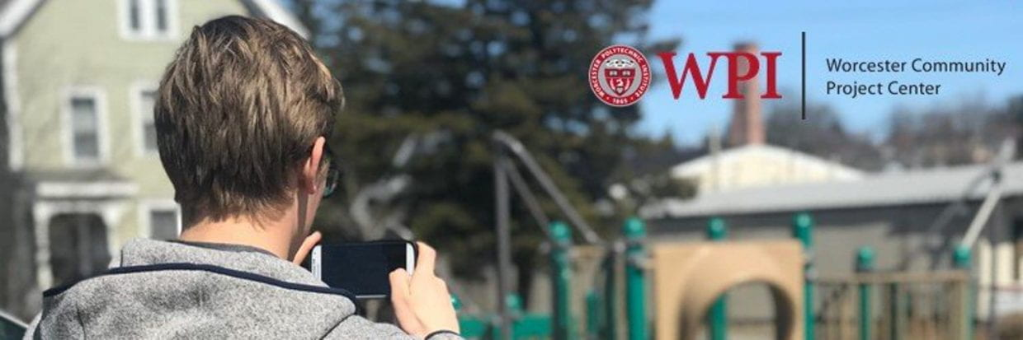

Celebrating the 25th Year of the Worcester Community Project Center

An Interactive Qualifying Project Proposal
submitted to the Faculty of
WORCESTER POLYTECHNIC INSTITUTE
in partial fulfillment of the requirements for the
degree of Bachelor of Science

By
Adam Beckman
Malak Haida
Toluwani Akomolafe

Date:
December 04, 2025

Project Center:
Worcester Community Project Center

Proposal Submitted to:

Sponsor Amanda Wittman

Professor Courtnery Kurlanska
Worcester Polytechnic Institute

This proposal represents work of WPI undergraduate students submitted to the faculty as evidence of a degree requirement. WPI routinely publishes these reports on its web site without editorial or peer review. For more information about the projects program at WPI, see http://www.wpi.edu/Academics/Projects.
Table of Contents
Authorship ii
Introduction 1
Background 3
Measuring Impact 6
Promoting and communicating outcomes 9
Methods 13
Objective 1: Identify key themes and topics 13
Content Analysis 13
Objective 2: Understanding the Impact 14
Interviews 15
Mapping 15
Objective 3: Develop and get feedback on promotional materials 16
Focus Groups 17
Object Response Testing 17
Gantt Chart 17
Conclusion 19
Work Cited 20
Appendices 23
Appendix A 23
Appendix B 25
Appendix C 27
Appendix D 29

AI Assistance Statement:
ChatGPT (OpenAI) was used to assist with grammar, phrasing, and minor edits. All ideas, writing, and analysis are our own.
i

Authorship
Section | Primary Author(s) | Editor(s)
Title Page | Tolu | -
Table of Contents | Tolu | -
Authorship | Tolu | Tolu, Malak, Adam
Introduction | Tolu, Malak, Adam | Tolu, Adam
Background | Tolu | -
Background - Measuring Impact | Adam | -
Background - Promoting | Malak | -
Background - Concluding Remarks | Malak, Tolu, Adam | Malak, Tolu
Methods | Tolu | -
Methods - Objective 1 | Tolu | -
Methods - Objective 2 | Adam, Malak, Tolu | Malak, Tolu, Adam
Methods - Objective 3 | Malak | -
Methods - Gantt Chart | Tolu | Tolu, Adam
Conclusion | Malak | -
Work Cited | Tolu, Adam, Malak | Tolu, Malak
Appendixes | Tolu, Malak | Tolu, Adam, Malak

ii

Introduction
After doing something kind, we often feel a sense of accomplishment—especially when we can celebrate that moment with others. We may want to tell people about the good we’ve done, excited to share that feeling, yet those who weren’t involved might not understand why the action mattered or why it felt meaningful to us. The most effective way to convey the significance of a good deed, especially one that is complex or close to our heart, is to clearly explain its value and impact. The same is true for large-scale community work, where the meaning isn’t always visible unless we take the time to stop, reflect, and tell its story. The upcoming 25th anniversary of the Worcester Community Project Center (WCPC) offers an opportunity to reflect on a remarkable legacy: hundreds of completed projects, more than 100 community partnerships, and countless stories of student learning, community collaboration, and organizational growth. How does a community project center move from a one-time initiative to becoming a lasting force for change? For the WCPC, this question is central to its mission of fostering long-term, meaningful partnerships between universities and the greater Worcester community. Although the WCPC has facilitated numerous and diverse projects over the years, for example, identifying a low-cost translation tool for Humanity ReStore to increase accessibility, the full scope of its impact—the changed lives, the strengthened social networks, the lasting community improvements, and the legacy it leaves behind—is often unrecognized. Without a structured and intentional way to capture and communicate this influence, the WCPC risks overlooking some of its most significant achievements, leading to missed opportunities to deepen community engagement. This project addresses that critical gap.
Our mission as a team is to develop a robust framework to document the WCPC’s participatory impact on both sides of its partnerships: community members and organizations. We aim to move beyond basic metrics and highlight the rich human narratives that truly reflect change. How can we measure the ripple effects of a community garden on neighborhood pride? How do we visualize the trust and collaboration built among stakeholders, residents, policymakers, and local organizations? And how can these insights be transformed into a compelling story that resonates with communities, future WCPC teams, and prospective sponsors?
To do this, we will first describe what WCPC projects involve—including high-impact learning—to clarify their benefits, values, and challenges before assessing their effects on organizations and community members. We will use a mixed-methods strategy that includes Ripple Effects Mapping (REM), social mapping, data repacking, interviews, and focus groups. Grounded participatory research principles and semi-structured interviews with community leaders will help us better understand their experiences, challenges, and successes. These insights will be paired with visual representations such as maps, networks, and diagrams, ensuring that the impact of the WCPC is accessible to a broad audience. Finally, focus groups will help us evaluate the accessibility and clarity of our media products, ensuring that the stories we share genuinely reflect the WCPC’s legacy and effectively celebrate its achievements. Together, these methods provide the foundation for understanding how WCPC projects create change, preparing us to explore the Center’s context and approaches.

Background
What would you say if I told you there is a practice that pushes students beyond the classroom and into the real world, where their actions meet the complex situations communities face every day? At the core of this is the practice of high-impact learning—experiential approaches that shape how students engage with real-world challenges across diverse settings and communities. High-Impact Learning (HIL) broadly describes practices that offer substantial academic advantages for participating students, especially those from populations historically underrepresented in higher education (College of Science and Mathematics, 2023). These approaches provide rich, transformative learning experiences that extend beyond traditional classroom activities, strengthening engagement, persistence, and overall learning. According to Reilly, Langley-Turnbaugh, and Neikirk (2023), high-impact learning enhances students’ academic performance, writing skills, critical thinking, leadership, communication abilities, and personal development. As shown in Figure 1, Pusca and Northwood (2018) outline core characteristics of high-impact practices—dedicated time, exposure to new ideas, real-world application, and continuous assessment—that help explain their strong educational and community outcomes. HIL includes practices such as Project-Based Learning (PBL) and Community-Based Learning (CBL), which offer substantial academic advantages. PBL teaches students to think critically, communicate effectively, and apply classroom knowledge to unscripted, authentic problems. It allows undergraduates to frame, research, and investigate complex real-world problems that span social and technological dimensions for nonprofit organizations and sponsors (Elmes & Loiacono, 2009). CBL, on the other hand, directly connects and engages students with local communities. It involves participatory research that brings students and residents together to address shared issues, building social capital, deepening understanding of community needs, and strengthening collective adaptation in challenging environments (Downs et al., 2009). Together, these experiential approaches demonstrate how hands-on learning links academic study with real-world impact, fostering both community engagement and student growth.

Figure 1
Characteristics of a high-impact practice.
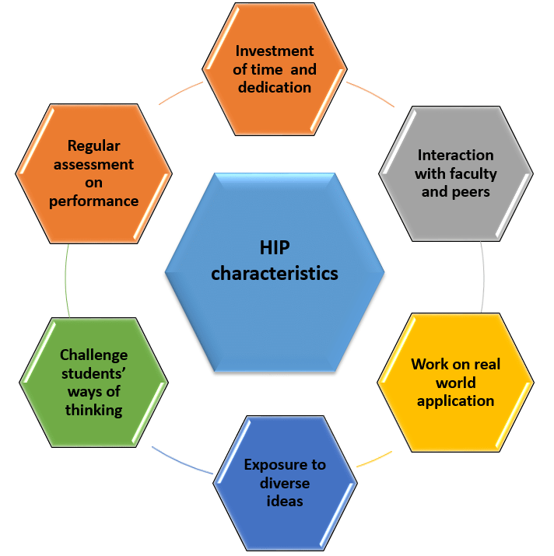
Note. Adapted from Implementation of high-impact practices in engineering design courses by D. Pusca & D. Northwood, 2018, World Transactions on Engineering and Technology Education, 16, 108.

The value of these approaches is proven in their ability to address complex real-world problems while contributing to broader societal goals, specifically through the approach of CBL. For instance, Stephens, Hernandez, and Boyle (2009) describe how collaboration between universities, local government, and research councils in Argentina led to the creation of a Science and Technology Pole, demonstrating how academic–community partnerships can strengthen organizational capacity, innovation, and regional development. This stands as a prime illustration of why CBL consistently produces some of the strongest academic and personal growth outcomes for students (Pusca & Northwood, 2018). But what does this approach offer the communities themselves? CBL supports economic development, improves infrastructure, enhances education and health initiatives, and strengthens neighborhood and school improvement efforts—from installing solar panels to staffing community health centers (Downs et al., 2009). Another clear example comes from CBL placements across urban and rural communities in three South African provinces, where students helped reduce clinic overcrowding and improve access to care (Diab & Flack, 2013). By applying classroom knowledge, students examined patients locally, preventing many from traveling long distances to hospitals or waiting overnight in long lines. Their presence eased hospital congestion and reflected genuine attention to community needs and beliefs. As patients in Limpopo expressed, “they checked me more than the sisters do” and “they did not rush anyone; they took a long time checking me” (Diab & Flack, 2013, p.3). Because of this approach, community leaders and residents viewed the students positively, recognizing that they truly listened. More broadly, CBL fosters sustainable projects that integrate academic learning with real-world application, allowing students to contribute their skills, knowledge, and technical expertise to community challenges (Stephens, Hernandez, & Boyle, 2009).
While these partnerships and high-impact learning methods provide substantial benefits, they also introduce challenges that can complicate collaboration and limit overall impact. Sustaining high-impact learning depends on time, trust, and genuine partnership. Reilly, Langley-Turnbaugh, and Neikirk (2023) argue that students often report feeling limited by time constraints, believing they cannot make a meaningful or lasting difference within short project timelines. Community organizations, meanwhile, prefer longer commitments (ideally a semester or more) so their investment of time is worthwhile and so students can fully understand the partner’s mission, operations, and needs (Downs et al., 2010). This deeper engagement allows student contributions to create a longer-term impact. However, even with these intentions, partnerships can face obstacles. If a community partner has a negative experience with a university or if the university has a poor local reputation, trust can weaken, making engagement more challenging (Reilly, Langley-Turnbaugh, & Neikirk, 2023). Building and maintaining trust requires ensuring that all parties have access to resources and share aligned goals and expectations. Yet these relationships can become hard to navigate when roles are unclear or when the outcomes of collaboration are uncertain. True collaboration requires clear goals, consistent communication, and mutual understanding between all partners (Downs et al., 2010). In essence, community-based learning can create meaningful benefits for both students and communities; however, understanding whether these efforts yield the intended outcomes requires careful evaluation. To ensure that community partnerships remain effective, sustainable, and responsive to local needs, we now turn to the importance of measuring impact.

Measuring Impact
Understanding a project's effectiveness is important to ensure it best serves a targeted community. Measuring impact refers to systematically assessing whether a project creates the changes it intends to, how those changes occur, and the extent to which the project itself is responsible for them (Gertler et al., 2016).
Many community-based projects require external funding to continue running, which requires community support. So one goal of impact evaluation is to maintain public support for a program (Michel & Schneider, 2025). Because these projects are increasingly complex, people have a harder time staying up to date on their progress, which leads them to question how effective they truly are (Michel & Schneider, 2025). For that reason, the demand for impact evaluation is high and will continue to increase for the foreseeable future (Michel & Schneider, 2025; Chazdon et al., 2017). People need more than quantitative data showing improvements in community health due to a project; they also require evaluations that explain the extent to which the project contributes to the changes observed (Michel & Schneider, 2025; Gertler et al., 2016). Another goal of impact evaluation is to help improve the quality and efficiency of a program (Gertler et al., 2016).
To effectively and properly assess the impact of a project, the project needs to have a descriptive agenda. A descriptive agenda describes the intended outcomes of a project and describes the methods and procedures that will be taken to accomplish the desired outcomes. Such a preemptive approach allows researchers and the community to make suggestions to make changes to a project (Gertler et al., 2016). Such changes make a project more effective at accomplishing desired outcomes, change project goals to better suit the community’s needs, and make the project more efficient at accomplishing the same outcomes (Michel & Schneider, 2025; Gertler et al., 2016). Simply stating the goals of a project and analyzing how well the project accomplished those goals is not enough to help a community understand the effectiveness of a project (Gertler et al., 2016). The project also requires a preliminary analysis of how the project will theoretically accomplish desired results (Gertler et al., 2016). A Theory of Change (ToC) is a description of how a project is supposed to accomplish desired results (see Figure 2 below) (Michel & Schneider, 2025; Gertler et al., 2016). A good ToC would provide room for a detailed analysis of impact analysis of not only the final results but also all of the resulting details used to accomplish desired outcomes.
Figure 2
Results Chain that implements Theory of Change (ToC)
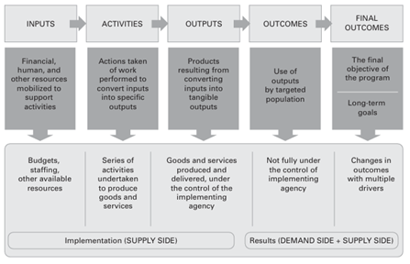
Note: This is a diagram that describes the resources, activities, and allocation of resources that serve as a plan to accomplish a desired outcome.

One way to analyze the impact of a project that is intended to serve a community specifically is by using the Community Capital Framework (CCF). The CCF provides 7 different categories of community capital, or categories that describe how healthy a community is Figure 3 (Chazdon et al., 2017, Greene et al., 2022). The CCF is often used in custom procedures for assessing the big picture of the impact of a project or intervention in question.

Figure 3

Community Capital Framework (CCF)
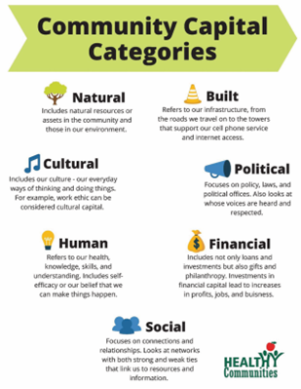
Note: A community capital describes how healthy a specific aspect of a community is.

Ripple Effects Mapping (REM) is an impact evaluation method that examines how assets could affect other assets Figure 4. An asset is a piece of qualitative data that can affect one or more categories of community capital (Chazdon et al. 2017; Greene et al., 2022). REM examines direct effects of a project causing other indirect effects (Chazdon et al., 2017, Harris, 2024). REM presents a visual and pragmatic way of analysing impact, which makes it easier for stakeholders and community members to get involved in analysing impact along with researchers (Chazdon et al., 2017; Greene et al., 2022; Harris, 2024). One limitation of REM, however, is that REM only provides a surface-level analysis of the relationships between effects that are both directly or indirectly caused by a project. Another method for impact evaluation that examines a causal relationship is Realist Evaluation (Harris, 2024). Realist Evaluation is used to examine the hidden effects caused by a project. REM and Realist Evaluation can be used together as a method called Realist Ripple Effects Mapping (RREM) to examine beyond the surface-level effects observed by REM. In essence, these measurement tools not only reveal what changes occur within a community but also provide the evidence needed to communicate those changes clearly and credibly.
Figure 4

Ripple Effects Map of Turning the Tide on Poverty (Tide)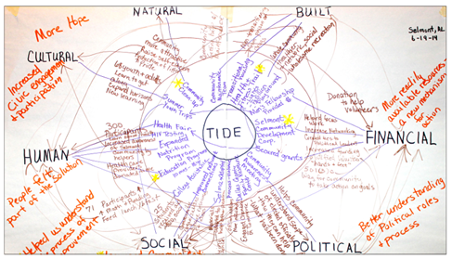
Note: Tide on Poverty (Tide) is a project that aims to help local citizens make their voices heard in their local communities with a topic of dialogue being about poverty.

With the CCF to map assets to community capitals and the visuals to display how assets affect other assets from REM, intended and unintended changes can be revealed from impact analysis (Chazdon et al., 2017). By understanding how and why impact happens, projects are better positioned to share their results in ways that build trust and engagement. This connection between evaluation and communication sets the foundation for promoting a project’s work effectively, which the next section explores.

Promoting and communicating outcomes
Once we have assessed the projects or programs, we must focus on communicating those results to the broader community. Strong measurement tools help us evaluate and present our outcomes, but they remain secondary to our core priority: fostering authentic, meaningful participation. This requires a strategic communication framework that goes beyond simple campaigning to authentic and real public engagement. This section will outline a four-part framework for developing effective public outreach and engagement: firstly by setting strategy in audiences and community’s insights, secondly by translating the collected data and project outcomes into a compelling narrative and storyline, thirdly by recurrently validating this obtained narrative with factual evidence, and finally, by leveraging this foundation to build a long-lasting, durable community institution and legacy.
Understanding our community participants is the foundational task. This deep, empathetic knowledge of their beliefs, drivers, and lived experiences is the primary data for any effective initiative. Andreasen’s (2005) "marketing mindset" is crucial here, as it insists we value this audience understanding not as an afterthought, but as the core idea of design. This discipline helps us avoid strategies built on internal assumptions, which inevitably lead to participant mismatch and poor outcomes. However, we must apply this "marketing mindset" to our other key audiences as well: the university (seeking validation and academic impact) and potential funders (seeking accountability and scalable results). For these audiences, our measurement tools, like surveys, interviews, and basic analytics, become a way to translate what we learned from the community into something easier for outsiders to understand (Andreasen, 2005; Schensul & LeCompte, 2013). These tools help us take the deep, personal, and qualitative parts of our work and turn them into numbers and clear explanations that sponsors expect when they review a project’s impact (Downs et al., 2009; Gertler & World Bank, 2016; Michel & Schneider, 2025). Therefore, effective participatory work usually follows two paths: first, focusing on strong engagement with the community, and at the same time, collecting supporting measurements. The measurement tools should be used to record and learn from the process, not to control it. This approach helps make sure the work stays meaningful for the community, while also providing information that can support funding and wider institutional backing.
The next major step, once the community is understood, is to determine how to frame the project’s message. Storytelling will play a central role in this process. Connecting the project’s message to the community’s core beliefs and emotions (Benford & Snow, 2000) helps make raw data, such as interviews, survey results, and statistics, persuasive and personally relevant to the audience. The narrative is what makes the public pay attention and care enough to participate; therefore, creating an impactful storyline and relying on behavioral tools that will measure these participations is essential. The legitimacy of a story and the verifiable evidence to build trust within a community are foundational to transforming a compelling narrative into a credible claim. To achieve this, a project must systematize an evidence-based record, moving beyond vague assertions to maintain a detailed "impact log" of specific, tangible outcomes (Hough, 1984). This disciplined documentation serves a dual purpose: it provides the raw data for formal impact measurement, and more importantly, it forms the undeniable foundation for persuasive public claims about the project's success, thereby securing community trust and legitimizing the entire endeavor. (Downs et al., 2009; Gertler & World Bank, 2016; Michel & Schneider, 2025).
Figure 5

Arnstein's Ladder of Citizen Participation.
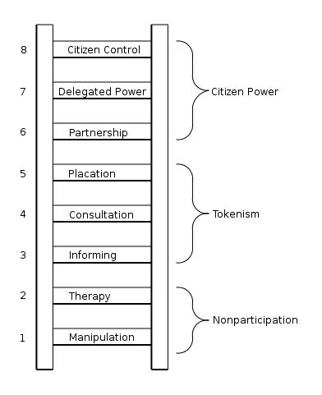

Note. Visual representation adapted from Arnstein (1969).
The ultimate ambition of this strategic communication process is to leverage resonant storytelling and documented credibility to evolve the project beyond a single initiative into a durable community institution. (Andreasen, 2005; Downs et al., 2009; Reilly, Langley-Turnbaugh, & Neikirk, 2023). This transition can be understood through the lens of Arnstein's (1969) Ladder of Citizen Participation (see Figure 5). The initial stages of Informing and Consultation align with building the foundational narrative and gathering evidence. However, the strategic goal is to climb the ladder toward genuine Partnership and Citizen Control, where the community takes ownership. By synthesizing consistent and meaningful public engagement, the project cultivates a strong, trusted "brand" that acts as a promise for quality and reliability, fostering long-term support and allegiance (Eshuis, 2012). This transformation is critical, as it shifts the project's identity from a temporary intervention to a permanent fixture, thereby ensuring its long-lasting influence and embedding it as a self-sustaining force within the community. In essence, the path to profound and measurable public impact is not a matter of chance but of a deliberate, integrated strategy. By first grounding the approach in a deep understanding of the audience, then translating technical outcomes into a resonant narrative, rigorously supporting that narrative with verifiable evidence, and ultimately leveraging this credibility to build a trusted brand, a project transcends its immediate goals.(Reilly, Langley-Turnbaugh, & Neikirk, 2023). This cohesive process ensures that initial engagement matures into lasting behavioral change and cements the initiative's legacy as a durable and indispensable community institution.
This change is crucial because it turns the organization’s identity from something temporary into a permanent fixture. This ensures its influence continues and roots it within the community as a self-sustaining force. In essence, achieving a deep and measurable public impact does not happen by accident. It requires a careful, connected plan. The process starts by building a strategy on a solid understanding of the audience. It then turns project results into a story people connect with, backs up that story with hard evidence, and finally uses that credibility to create a trusted brand. To fully support this shift, the communication strategy also requires deliberate promotion tactics that help the story spread and build momentum. Alongside strong messaging, the project must activate channels that maximize visibility—such as leveraging social media platforms, partnering with local organizations, and encouraging word-of-mouth sharing through community leaders and participants. This is how a project moves beyond its initial goals. This unified process makes sure that early involvement grows into lasting change and secures the project's legacy as a strong and essential community institution.

Methods
The goal of our project is to assist the Worcester Community Project Center (WCPC) in documenting the stories and impact on individuals and communities. Our objectives that we will outline will guide us in selecting effective strategies and methods to measure the WCPC’s impact on the greater Worcester area.
Our objectives are:
- Identify the different themes and topics of WCPC.
- Understand the Impact of the WCPC on a key aspect of the greater Worcester Community
- Develop and get feedback on promotional materials
This will help ensure that we establish clear plans for promoting and sharing the data we collect—and that any outreach efforts are supported and validated by the community.

Objective 1: Identify key themes and topics
Our first objective is to develop a deep understanding of WCPC projects—their goals, accomplishments, challenges, and overall impact on the community through their community-based learning experiences. To achieve this, we will identify the major themes and topics represented in WCPC projects over the past twenty-five years. This understanding will guide our approach to analyzing patterns and relationships that reveal how WCPC projects have shaped the Worcester community.

Content Analysis
To do this, we will conduct a content analysis of the WCPC website and the Gordon Library database. This will involve reviewing past projects—including their locations, sponsors, partner organizations, and focus areas—and identifying recurring topics that appear throughout the project archive (Columbia University Mailman School of Public Health, n.d.). After identifying these themes, we will use network mapping to visually represent how projects, organizations, and themes connect to one another. Network mapping is a method that helps researchers organize and interpret relationships within a community by showing who collaborates with whom, how groups interact, and which themes or organizations appear most frequently across a body of work (Weyer, Bezerra, & De Vos, 2019).
Building on our content analysis, we will apply network mapping to visualize, transform, and organize the themes and project information identified into an accessible visual structure.. By mapping connections among projects, sponsors, student groups, and recurring focus areas, we can identify clusters, highly connected partners, and prominent themes that emerge across time. This allows us to move beyond simply listing WCPC projects and instead observe broader patterns of engagement and better understand the WCPC’s long-term community impact (De Vreese et al., 2016). Through this approach, we can begin answering: “What patterns or themes are revealed from this content analysis when we map WCPC’s projects?” The resulting relationship map will illustrate how the WCPC has built a network of community partners, organizations, and student groups, what these groups accomplished together, and how these networks continue to support Worcester.
In essence, combining content analysis with network mapping strengthens our ability to understand WCPC’s impact. The content analysis identifies the key themes, organizations, and project characteristics (see Appendix A), while network mapping translates these findings into a visual representation that reveals how projects fit together across time and community networks. This approach helps us see not just what the WCPC has done, but how its work has shaped relationships, strengthened partnerships, and supported different neighborhoods over the past twenty-five years. By visually layering themes, locations, organizations, and project relationships, we will develop a clearer and more accessible understanding of the WCPC’s long-term influence—fulfilling the core purpose of Objective 1.

Objective 2: Understanding the Impact
After gaining an understanding of the themes, connections, and partnerships of the projects and interventions of the WCPC, we would like to understand how such projects and interventions have impacted the community. Thus, the second objective is to perform an impact assessment on one or more projects the WCPC has been involved in. The second objective will provide qualitative data that thoroughly describes the impacts of a given program on one or more themes. To obtain the qualitative data that rigorously highlights the impact of a given program, we will be using Ripple Effects Mapping (REM). The purpose of REM is to visually describe the effects that have impacted members of the community in the form of chains of effects that resemble a ripple of sorts.

Interviews
To obtain the qualitative data necessary for Ripple Effects Mapping (REM), we will be using semi-structured interviews. These interviews will be conducted with two key groups: community leaders, who can provide a broad overview of the program’s impact and strategic influence, and general community members, who can share their personal experiences and perspectives. The use of semi-structured interviews allows us to guide the conversation toward our specific research areas while remaining open to participants’ unique insights, ensuring we gather targeted and relevant qualitative data (Greene, Stroope, & Holston, 2022). Each interview is expected to last approximately 45–60 minutes (see Appendix B). Semi-structured questions will balance guided inquiry with flexibility, enabling participants to share detailed stories and insights, and interviews will be audio-recorded with participants’ consent, supplemented with detailed notes.
Semi-structured interviews serve as the primary method for collecting rich, personal stories. This method provides essential qualitative evidence for assessing program impact and understanding the multiple challenges faced by participants. After transcription, an initial thematic analysis will be conducted to identify key effects, relationships, and patterns, providing the foundational data for REM and for evidence-based impact assessment.
Sample questions for semi-structured interviews may include (more in Appendix C):
- “Can you describe a specific experience you had with the program and how it affected you or your community?”
- “What challenges did you face, and how did the program influence those challenges?”
- “Were there any outcomes you did not expect, and how did they occur?”
- “How has the program shaped relationships or collaborations within the community?”
- “What aspects of the program do you think had the most impact, and why?”

Mapping
We will not just be recording and writing notes about interviews. We will also be constructing a visual diagram to visualize a network of the chains of effects of the project we are analyzing the impact of. This is the REM map that resembles the ripples of a pebble. The participants in the interview will also be involved in constructing the REM map with us through the answers they provide us. We will create a REM map for each of several in-person interviews we will conduct across multiple participants.
For the final result of our impact assessment, we will create one large, cohesive map that will be built from many smaller maps constructed during the interviews. In each interview, we will ask guiding questions (see Appendix C), and based on participants’ responses, we will create a small REM map that shows the causal relationships between the effects revealed. Some effects may have more than one causal link to an outcome originating from the program being assessed (Harris, 2024). An effect refers to an outcome, either direct or indirect, that is caused by a project in question. For example, an effect can be used to describe a change in a neighborhood as a result of a project's implementation. Thus, an effect of a project can be linked to more than one effect. Insights from community leaders will help strengthen our understanding of how these effects are connected, allowing for a more sophisticated explanation of these relationships (Chazdon et al., 2017). Once we have completed all interviews with community leaders and members, we will be able to further examine these links by analyzing the effects from multiple viewpoints, resulting in multiple small REM maps that contribute to the final combined map. Lastly, once we finish creating REM maps during these interviews, we will be ready to combine all of the REM maps into one large, cohesive REM map, providing a more sophisticated explanation of the links between effects. With a large REM map that visualizes the impact assessment we have conducted, we will be ready to package the results of our impact assessment for a wider audience to engage with.

Objective 3: Develop and get feedback on promotional materials
To achieve this objective, we will begin by creating initial promotional materials that translate the WCPC’s work into clear, accessible, and engaging content. We will use science communication and data repacking to transform the project’s findings into narratives and visuals that reflect the community’s experiences and values. Science communication is the practice of sharing research and technical information in ways that are understandable and meaningful to non-experts. Data repacking involves organizing and presenting raw data—such as survey results, interviews, and statistics—in a way that is easy to understand and highlights the key messages for the audience. This approach allows the materials to move beyond presenting information and instead communicate the WCPC’s impact in a way that is relatable and meaningful to a broader audience. Once these draft materials are developed, we will assess their effectiveness through structured feedback from community members.

Focus Groups
Focus groups will allow us to gather a small group of 8 –10 community participants from the WCPC client database and local community center newsletters to facilitate discussion about how they perceive the materials, what messages they identify, and how the content aligns with their understanding of the WCPC’s mission (see Appendix D). Each focus group session will last approximately 90 minutes and will take place in private in the Worcester community project center. These discussions will help reveal not only what participants think but also the reasoning and emotions behind their interpretations. Sessions will be audio-recorded with participant consent, and a note-taker will capture non-verbal cues and key points. After the sessions, the recordings will be transcribed verbatim. The transcripts and notes will then be analyzed using thematic analysis to identify common themes, strengths, and areas for refinement.

Object Response Testing
Object response testing will complement the focus groups by capturing participants’ immediate reactions to the individual materials. This method helps us understand first impressions—what captures attention, what may be confusing, and what elements resonate on a quick, instinctive level. These rapid responses will help identify whether the materials communicate effectively at a glance, which is essential for public-facing communication. Following both methods, a final round of brief follow-up interviews will help confirm key adjustments before finalizing the promotional materials.
In essence, combining focus groups with object response testing strengthens our ability to refine promotional materials that accurately and compellingly represent the WCPC’s work. Each method provides a different layer of insight—deeper interpretation through group discussion and immediate interpretation through rapid response. Together, they ensure the final materials are clear, engaging, and grounded in the community’s perspectives, fulfilling the purpose of our last objective.

Gantt Chart
Table 1
Project Timeline for WCPC Method Objectives.
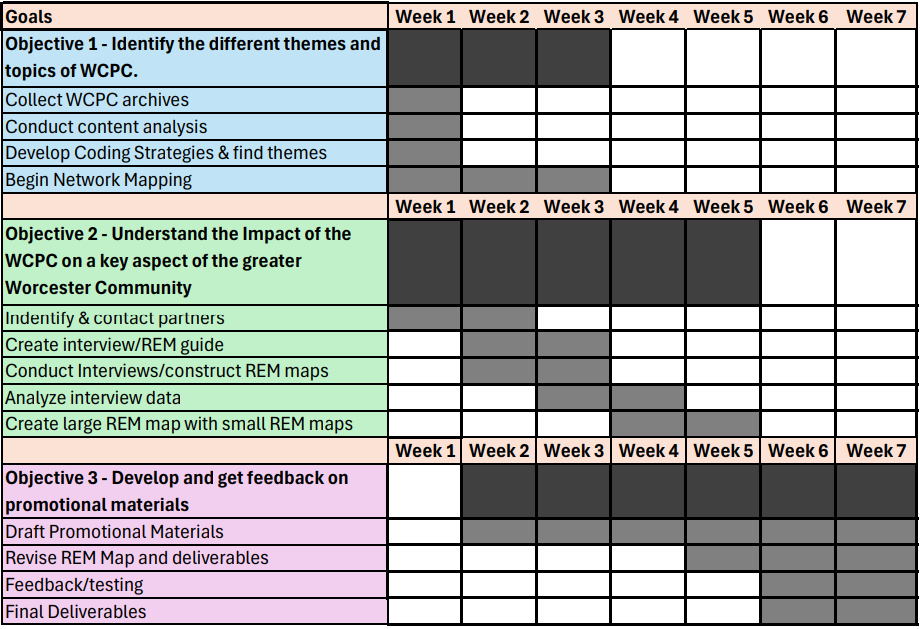Note. Timeline created by the authors using Microsoft Excel (2025).

Conclusion
Through this project, we aim to understand the Worcester Community Project Center’s impact by examining its work from multiple perspectives, which include the themes and topics that appear across its projects, the relationships it builds, and the experiences of the people connected to it. By relying on different analysis methods like content analysis, social mapping, and network mapping, supported by tools like interviews, we were able to identify not only what WCPC has accomplished but also how deep-rooted partnerships and successful projects shape the broader Worcester community and evolve over time.
Our research results highlight areas of focus that are recurring. They show how organizations and student groups remain interconnected through WCPC initiatives and ideas. Additionally, these findings reveal patterns and how participants describe the center’s influence, providing rich insight into the personal and collective experience that drives the WCPC’s impact. By combining structural analysis with qualitative narrative, we are able to capture measurable outcomes and nuanced stories.
Our project will demonstrate the value of approaching community-engaged work, thanks to the lived experiences that offer a more complete view of the WCPC’s impact and provide the foundation for strengthening future partnerships, refining programs, and ensuring that the center’s initiatives continue to support meaningful community engagement and long-term impact.

Work Cited
Andreasen, A. R. (2005). Social Marketing in the 21st Century (1st ed.). SAGE Publications,
Incorporated. https://doi.org/10.4135/9781483329192

Arnstein, S. R. (1969). A ladder of citizen participation. Journal of the American Planning
Association, 35(4), 216–224. https://doi.org/10.1080/01944366908977225

Benford, R. D., & Snow, D. A. (2000). Framing Processes and Social Movements: An Overview
and Assessment. Annual Review of Sociology, 26(1), 611–639. https://doi.org/10.1146/annurev.soc.26.1.611

Chazdon, Scott; Emery, Mary; Hansen, Debra; Higgins, Lorie; Sero, Rebecca. (2017). A Field Guide to Ripple Effects Mapping. Retrieved from the University Digital Conservancy, https://hdl.handle.net/11299/190639.

Chumo, I., Kabaria, C., & Mberu, B. (2025). Social mapping of marginalized and vulnerable
groups in urban informal settlements: A participatory action research approach. Frontiers in Sustainable Cities, 7, 1693073. https://doi.org/10.3389/frsc.2025.1693073

College of Science and Mathematics. (2023). What Makes a HIP a HIP? Fresnostate.edu.
https://csm.fresnostate.edu/hips_in_csm/what-makes-a-hip-a-hip.html

Columbia University Mailman School of Public Health. (n.d.). Content analysis method and
examples. Columbia Public Health. https://www.publichealth.columbia.edu/research/population-health-methods/content-analysis

De Vreese, R., Leys, M., Fontaine, C. M., & Dendoncker, N. (2016). Social mapping of
perceived ecosystem services supply – The role of social landscape metrics and social hotspots for integrated ecosystem services assessment, landscape planning and management. Ecological Indicators, 66, 517–533. https://doi.org/10.1016/j.ecolind.2016.01.048

Diab, P., & Flack, P. (2013). Benefits of community-based education to the community in South
African health science facilities. African Journal of Primary Health Care & Family Medicine, 5(1), 474. https://doi.org/10.4102/phcfm.v5i1.474

Downs, T. J., Ross, L., Mucciarone, D., Calvache, M.-C., Taylor, O., & Goble, R. (2010).
Participatory testing and reporting in an environmental-justice community of Worcester, Massachusetts: a pilot project. Environmental Health, 9(1), Article 34. https://doi.org/10.1186/1476-069X-9-34

Downs, T. J., Ross, L., Patton, S., Rulnick, S., Sinha, D., Mucciarone, D., Calvache, M.,
Parmenter, S., Subedi, R., Wysokenski, D., Anderson, E., Dezan, R., Lowe, K., Bowen, J., Tejani, A., Piersanti, K., Taylor, O., & Goble, R. (2009). Complexities of holistic community-based participatory research for a low-income, multi-ethnic population exposed to multiple built-environment stressors in Worcester, Massachusetts. Environmental Research, 109(8), 1028–1040. https://doi.org/10.1016/j.envres.2009.08.005

Elmes, M., & Loiacono, E. T. (2009). Project-based service-learning for an unscripted world: The
WPI IQP experience. International Journal of Organizational Analysis, 17(1), 23-39. https://www.proquest.com/docview/198605428?accountid=29120&pq-origsite=primo&sourcetype=Scholarly%20Journals

Eshuis, J. (2012). Branding in governance and public management. Routledge.

Gertler, P., & World Bank, contributor. (2016). Impact evaluation in practice (Second edition.).
World Bank. https://www.worldbank.org/en/programs/sief-trust-fund/publication/impact-evaluation-in-practice

Greene, M., Stroope, J., & Holston, D. (2022). Adapting Ripple Effect Mapping to a Virtual
Survey Format. Journal of Extension, 60(1). https://doi.org/10.34068/joe.60.01.10

Harris, K., Nobles, J., Ryan, L., Szedlak, C., Taylor, H., Hawkins, R., Cline, A., Smith, E., & Hall,
A. (2024). Towards realist-informed ripple effects mapping (RREM): positioning the approach. BMC Medical Research Methodology, 24(1), Article 259. https://doi.org/10.1186/s12874-024-02371-7

Hough, L. M. (1984). Development and evaluation of the" accomplishment record" method of
selecting and promoting professionals. Journal of applied psychology, 69(1), 135. https://psycnet.apa.org/fulltext/1984-11173-001.pdf

Michel, J., & Schneider, K. (2025). Demystifying impact evaluation: an impact evaluation
framework. Frontiers in Epidemiology (Online), 5, 1460997. https://doi.org/10.3389/fepid.2025.1460997

Pusca, D., & Northwood, D. (2018). Implementation of high-impact practices in engineering
design courses. World Transactions on Engineering and Technology Education, 16, 108–114.
Reilly, S., Langley-Turnbaugh, S., & Neikirk, M. (2023). Building and Broadening Place-Based
Community Engagement: A Case Study. Collaborations (Coral Gables, Fla.), 6(1). https://doi.org/10.33596/coll.108
Stephens, J. C., Hernandez, M. E., & Boyle, M. E. (2009). Learning from university-community
partnerships (past and present) for sustainable development (GPMI Working Papers No. 2009-04). George Perkins Marsh Institute, Clark University.

Weyer, D., Bezerra, J. C., & De Vos, A. (2019). Participatory Mapping in a Developing Country
Context: Lessons from South Africa. Land, 8(9), 134. https://doi.org/10.3390/land8090134

Appendices

Appendix A
Content Analysis
Purpose:
This appendix explains how we will create a structured database from archived WCPC project information using content analysis. The goal is to systematically organize project data into categories that allow us to identify patterns, themes, and relationships across 25 years of WCPC work. This database will serve as the foundation for a later method named network mapping, described in Objective 1. However, the focus is on coding and organizing data that will be used later to create a physical network map.
Confidentiality & Voluntariness:
Because this stage only involves analyzing WCPC archives and publicly available project information, no personal or private participant data is collected.
Materials:
- Microsoft Excel for organizing archived project data into categories.
- WCPC website and Google Scholar.
Procedure for Content Analysis:
Analyze WCPC Projects -> Divide into Categories -> Identify Patterns/Themes -> Code the Data
All archived project data will first be organized in Excel using the following categories:
- Project Name
- Sponsor/Organization
- Project Type
- Location
- Theme/Topic
- Year active
- Outcome
This dataset will later support visualization and mapping, but is primarily intended for coding and pattern identification.
Table 2
Content Analysis Data (Preview for Network Mapping)
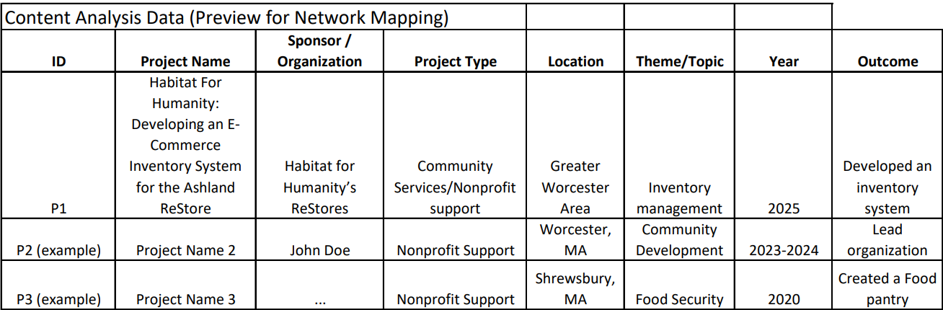
Note. Timeline created by the authors using Microsoft Excel (2025).
The first row represents an actual project from the WCPC website, while the last two rows are placeholders for demonstration. From this dataset, we can identify frequent patterns to choose from. For example, Nonprofit Support projects appear most often, and themes like Inventory Management and Community Development recur across multiple projects.

Appendix B
Semi-Structured Interview Guide for Community Leaders
Contact Information for WCPC Reference:
General WCPC Contact: gr-WCPC-C26 – gr-wcpc-c26@wpi.edu
Professor Contact: Courtney Kurlanska – cbkurlanska@wpi.edu
Purpose:
We are researching to better understand the perspectives of community leaders on partnerships and barriers to participation in Worcester. Your insights are invaluable.
Procedure:
This interview will take about 30-45 minutes. I will ask you a series of questions about your experiences and observations. With your permission, I would like to audio-record this conversation to ensure I accurately capture your thoughts. The recording will be stored securely and deleted after it is transcribed.
Confidentiality & Voluntariness:
Your participation is completely voluntary. You may skip any question or stop the interview at any time. Your responses will be kept confidential. In any reports, we will use a pseudonym or refer to you generally as a 'community leader' unless you give us specific permission to use your name and title.
Questions? Do you have any questions for me before we begin?
Consent: Do I have your permission to begin the audio recording? And do you consent to participate in this interview?"
Sample Interview Questions:
- Can you tell me about your role in the community?
- Can you tell me your past experiences with outside organizations?
- Can you tell me your past experiences with WCPC?
- What does a truly collaborative partnership between the university and the community look like to you?
- How can organizations like WCPC best communicate their findings back to the community?

Appendix C
Sample Interview Questions

Consent:

Do we have your permission to audio record this interview? You are not required to answer any questions you do not wish to answer. You may exit the interview at any time.

For Community Leaders:

Purpose:

To gain a better understanding of the big picture of a project/intervention. More specifically, we aim to understand the goals of a project.

Sample Questions:

1. Can you provide your perspective on the program’s overall impact and influence?
2. What challenges do you see the program addressing, and how effectively are they managed?
3. If we shared maps of WCPC projects, what would you want those visuals to show?
3. How has the program influenced collaborations or relationships within the community?
4. Which outcomes do you feel are most important, and why?
5. Are there any additional effects of the program that are not immediately obvious?

For Community Members:

Purpose:

To gain a better understanding of the impact a project in question has had on the community in the eyes of the general public.

Sample Questions:

1. Can you describe a specific experience you had with the program and how it affected you or your community?
2. What personal challenges did you face, and how did the program help or affect them?
3. Were there any outcomes you did not expect, and how did they occur?
4. How has your participation shaped your interactions or connections in the community?
5. Which parts of the program have been most meaningful to you, and why?

Appendix D
Focus Groups
Purpose:
To gather feedback from community members, organizations, and WCPC representatives on the specific materials, findings, and draft presentations we are developing. This feedback will help ensure that our final storytelling media accurately reflects participants’ experiences, is accessible, meaningful, and highlights the aspects of WCPC’s work they find most important.
Procedure:
We will hold small focus group sessions (around 20–30 minutes) where participants can review draft materials, provide feedback on clarity, accessibility, and emphasis, and discuss which information they feel should be highlighted. A note-taker will record major themes and suggestions, and the sessions will also be audio-recorded.
Participants:
Community members, organizational representatives, and WCPC staff who are familiar with WCPC projects or have experience participating in them.
Guide:
- Short introduction/consent script:
  - Thank you for participating in our focus group today. We are working on a project with the WCPC to better understand how we should share and promote the data we are collecting about the WCPC’s impact over the last twenty-five years.
  - Your participation is completely voluntary. You may skip any question or stop at any time. We will not record your name, and all responses will remain anonymous. We will be taking notes, but no identifying information will be included. Do you have any questions before we start?
- Guiding questions:
  - What is your first impression of this material? Does it capture your attention?
  - What storytelling format feels most engaging to you?
  - Looking at the draft materials, what specific elements make the information about community impact easy to understand?
  - What, if anything, in these materials makes the information about impact confusing or hard to follow?
  - Does this material reflect the program’s work accurately?
  - What style should WCPC use, and how does the style of these draft materials match that ideal?
  - Are there any elements that feel unnecessary or distracting?
  - What media do you rely on most for getting updates about local community work?
- Any materials we will show the participants (example: if we made a website, maps, or videos, we would share them with the group).

Scenario: We will now show you the draft materials (e.g., website, maps, videos). Please share your immediate reactions, what works well, and what could be improved.

