Dynamic Diagrams Tool

*Draft User Manual*

***CECS 543 Advanced Software Engineering Team1 Project***

*CaliforniaStateUniversity, Long Beach*

*CollegeofEngineering*

*ComputerEngineering/ComputerScienceDepartment*

***Philip Brack***

***Tom Hoinacki***

***Ayan Kar***

***Ravi Mahana***

***Michael Ngo***

***Yang Zhao***

***Panos Zoumpoulidis***

***Spring 2011***

Draft User Manual

Contents

1 Introduction 4

1.1 Project Description 4

1.2 Features 4

1.2.1 Diagrams 4

1.2.2 Objects 4

1.2.3 Diagram Conversion 4

1.3 Minimum Hardware and Software Requirement 4

2 Getting Started 4

2.1 Start Page 5

2.2 Project 5

2.3 Objects 10

2.4 Diagrams 15

2.5 Generate an ORV 26

2.6 Convert a DFD to an Architecture Chart 27

2.7 Convert a CFD to an STT 29

3 Operation Modes 30

3.1 Project Mode 30

3.1.1 New Project 30

3.1.2 Open Project 30

3.1.3 Save Project 30

3.1.4 Exit Project 30

3.2 Object Mode 31

3.2.1 Create Object 31

3.2.2 Edit Object 31

3.2.3 Delete Object 31

3.3 Diagram Mode 31

3.3.1 Create Diagram 31

3.3.2 Open Diagram 31

3.3.3 Save Diagram 31

3.3.4 Close Diagram 31

3.3.5 Remove Diagram 31

3.3.6 Rename Diagram 31

3.3.7 Clean Diagram 31

3.4 Converting Mode 31

3.4.1 Convert from DFD to Architecture Chart 31

3.4.2 Convert from CFD to STT 31

4 Advanced Features 32

5 Command Syntax and System Operations 32

# Introduction

## Project Description

Dynamic Diagrams Tool (DDT) is a powerful CASE tool that will significantly reduce the time spent on creating, modifying or deleting the various software engineering graphical representation models that are required during the procedure of designing a software product. Users can create or manipulate various types of objects and diagrams easily via a very user friendly interface. DDT also facilitates two types of automatic diagram conversion.

## Features

### Diagrams

Users are able to work on 5 types of diagram using DDT, including Control Flow Diagram (CFD), Data Flow Diagram (DFD), Data Model Diagram, Entity Relationship Diagram (ERD) and ClassHierarchy Diagram.

### Objects

Three types of Object are supported, including Concrete Object, Abstract Data Object and State Machine Object.

### Diagram Conversion

Two types of Diagram Conversion are available.

1. Convert a DFD to an Architectural Chart

2. Convert a CFD to an State Transition Table (STT)

## Minimum Hardware and Software Requirement

Processor: 600 MHz processor

Memory: 100 MB

Hard Disk: 100 MB available space

Input Device: Keyboard, Mouse

Operating System: Windows XP/ Windows Vista/Windows 7

# Getting Started

**Welcome to the world of Dynamic Diagrams Tool**



figure 2-1 Welcome Page

## Start Page

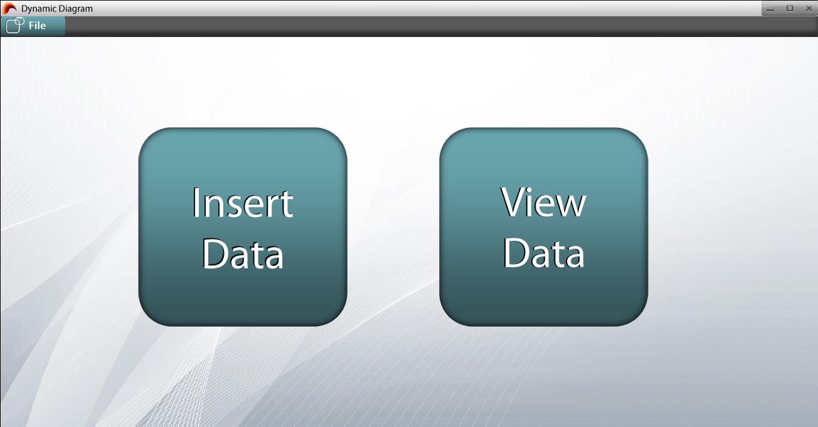

figure 2-2 Main Page

## Project

#### Create Project

From the ***Start Page***,

***File => New Project***

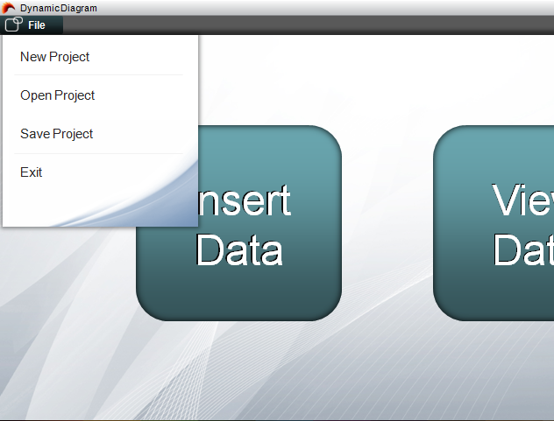

figure 2-3 Create project

Enter Project Name.

Click **Finish**.

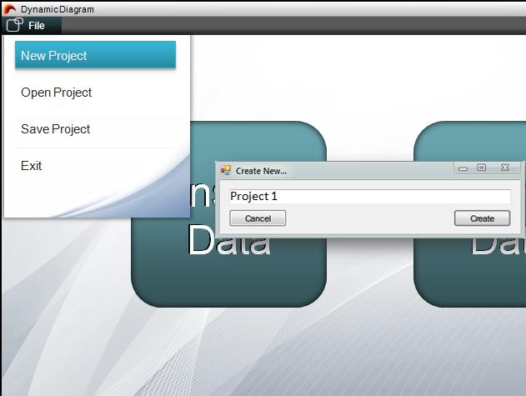

figure 2-4 Enter project name

Then you will be lead to the Data input page.

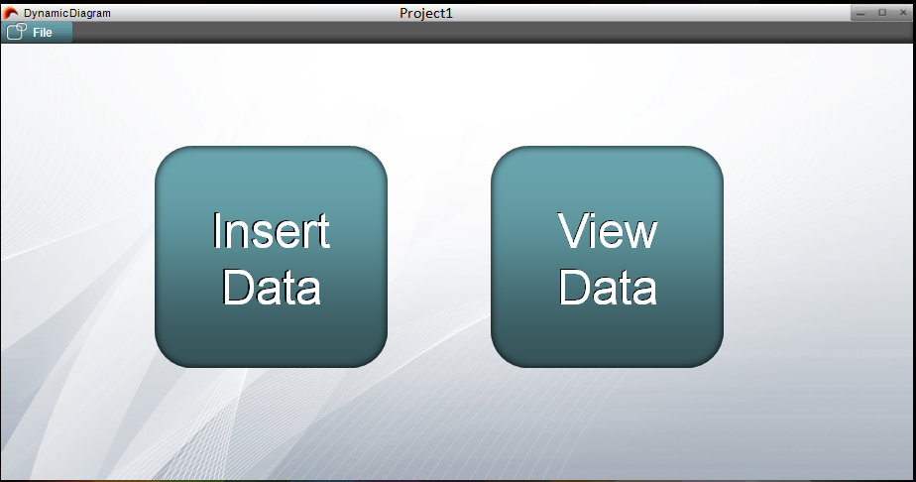

figure 2-5 Create project finished

#### Open a existing Project

From the ***Start Page,***

***File => Open Project***

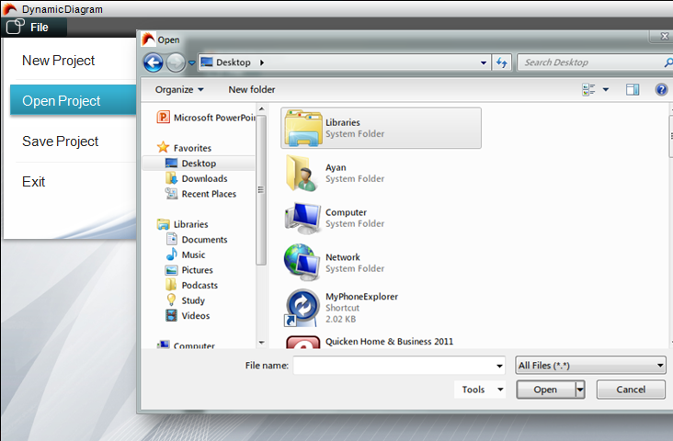

figure 2-6 Open project

Select a saved Project file and Click ***OK***

You will be lead to the Main Page

#### Save Project

From the ***Start Page,***

***File*** => ***Save Project***

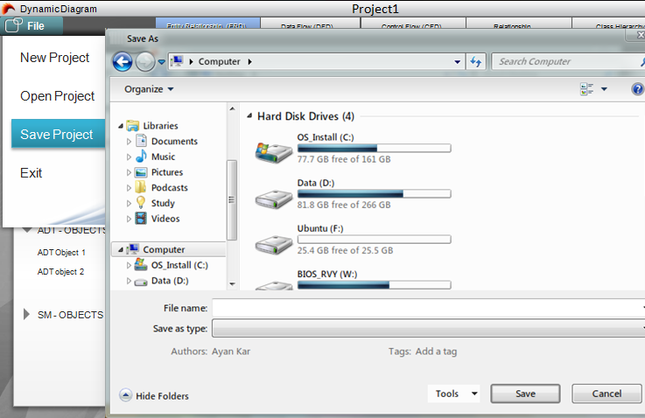

figure 2-7 Save project

Choose Directory and Click OK

#### Exit Project

From the ***Start Page***,

***File*** => ***Exit***

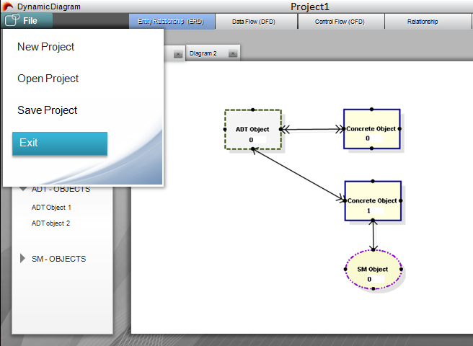

figure 2-8 Exit project

## Objects

#### Object Explorer View

From the **S*tart Page***

Click ***Insert Data***

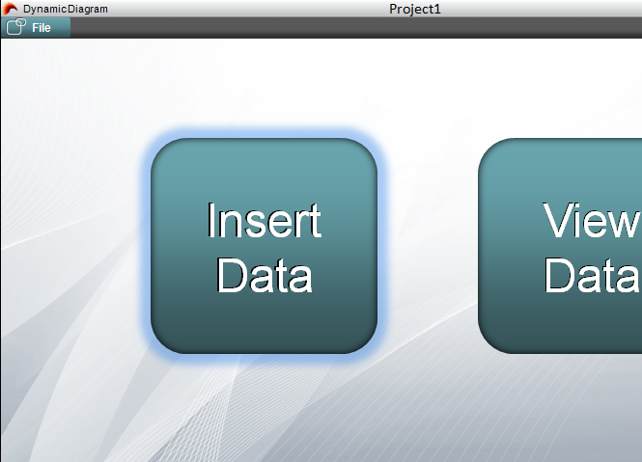

figure 2-9 Insert Data

It will lead you to the ***Object Explorer***

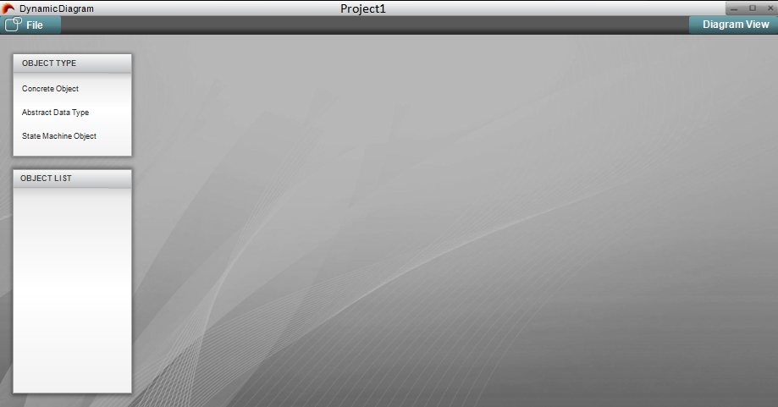

figure 2-10 Object Explorer

Click ***Diagram View*** to browse to ***Diagram (View Data) Mode***

#### Create an Object

##### Create a Abstract Data Object

##### Create a Concrete Object

***Object Explorer*=> *OBJECT TYPE*=>**Right Click ***Concrete Object =>NEW***

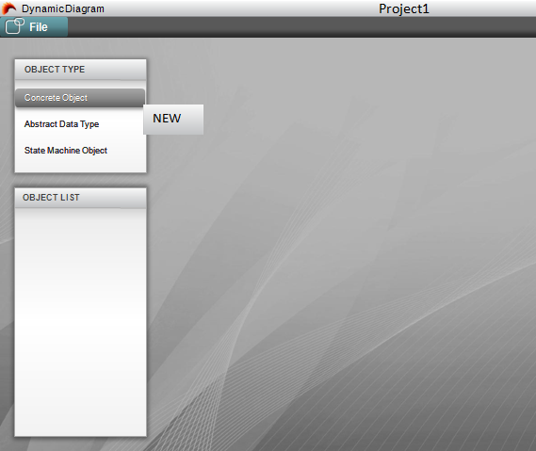

figure 2-11 Create Concrete Object

Then you will have to edit the object

Fill in the text boxes, and click ***Save*** to finish.

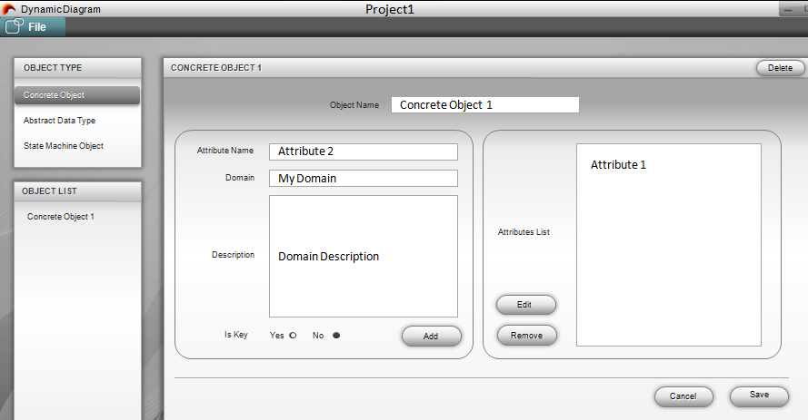

figure 2-12 Edit the Created Object

Object successfully created.

##### Create a State Machine Object

#### Edit an Object

##### Select an Object to Edit

Select an Object => Right Click => ***EDIT***

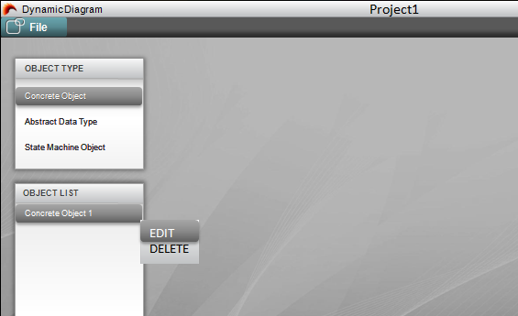

figure 2-13 Select an Object to Edit

##### Edit a Abstract Data Object

##### Edit a Concrete Object

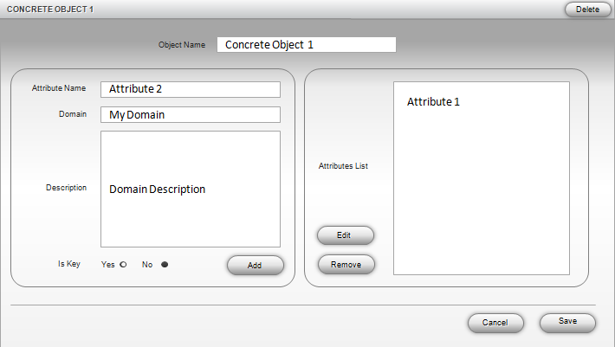

figure 2-14 The Object Editing menu for Concrete Object

##### Edit a State Machine Object

#### Delete an Object

##### Select an Object => Right Click => *DELETE*

#### 

figure 2-15 Delete an Object

## Diagrams

#### Sample Diagrams

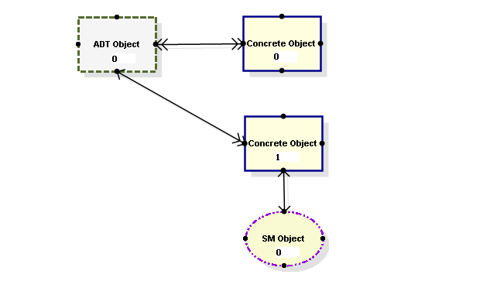

figure 2-16 Sample ERD

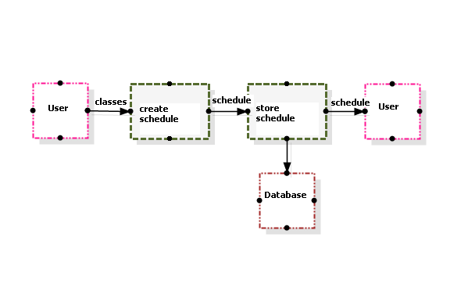

figure 2-17 Sample DFD

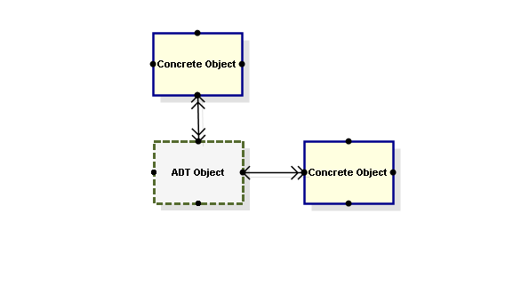

figure 2-18 Sample ORV

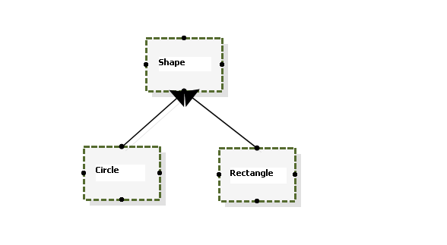

figure 2-16 Sample Class Diagram

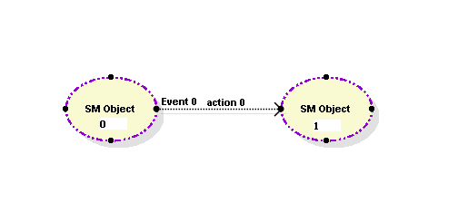

figure 2-16 Sample CFD

#### Diagram View

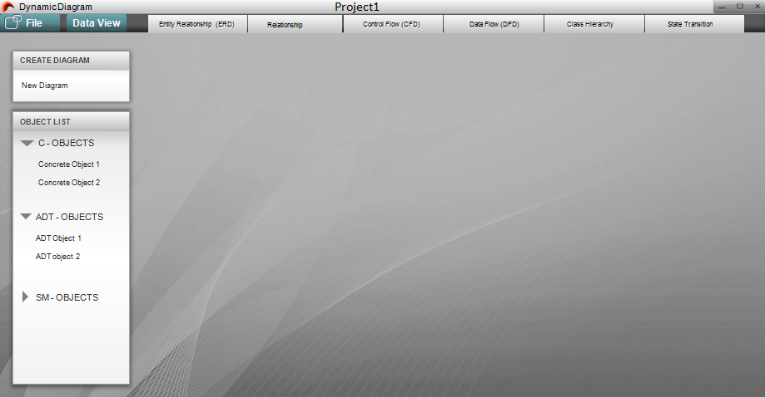

figure 2-17 Diagram View

Click ***Data View*** to browse to the ***Object*** (***Insert Data) Mode***

#### Create a Diagram

##### Create a Entity Relationship Diagram

From the Diagram View

Select ***ERD*** from the ***Diagram Type Bar***

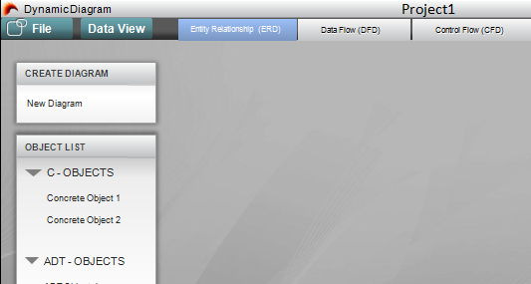

figure 2-18 Select diagram type

***CREATE DIAGRAM*** => Click ***New Diagram***

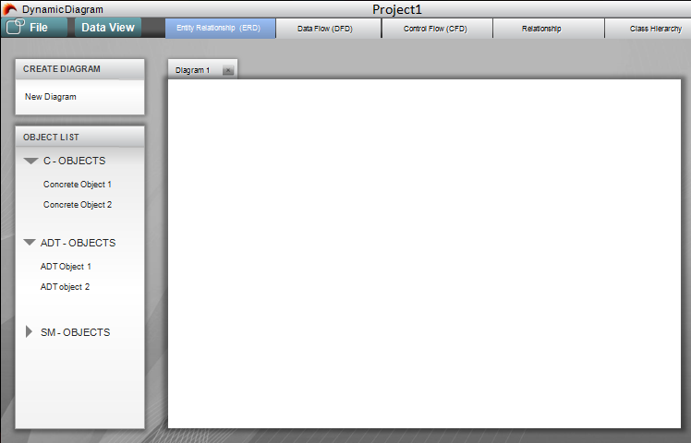

figure 2-19 New ERD

##### Create a Control Flow Diagram

From the Diagram View

Select ***CFD*** from the ***Diagram Type Bar***

***CREATE DIAGRAM*** => Click ***New Diagram***

##### Create a Data Flow Diagram

From the Diagram View

Select ***CFD*** from the ***Diagram Type Bar***

***CREATE DIAGRAM*** => Click ***New Diagram***

##### Create a Data Model Diagram

From the Diagram View

Select ***CFD*** from the ***Diagram Type Bar***

***CREATE DIAGRAM*** => Click ***New Diagram***

##### Create a Class Hierarchy Diagram

From the Diagram View

Select ***CFD*** from the ***Diagram Type Bar***

***CREATE DIAGRAM*** => Click ***New Diagram***

#### Rename a Diagram

#### Open a Diagram

Click the ***Tab*** of the ***selected Diagram***.

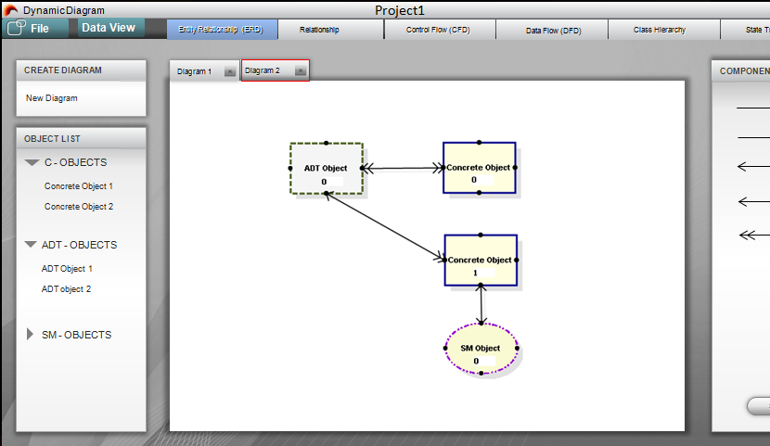

figure 2-20 Open a Diagram

#### Remove a Diagram

Click the ***Close Button*** of the ***selected Diagram***

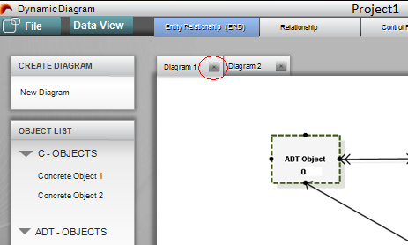

figure 2-21 Delete a Diagram

Then you will have to confirm to delete.

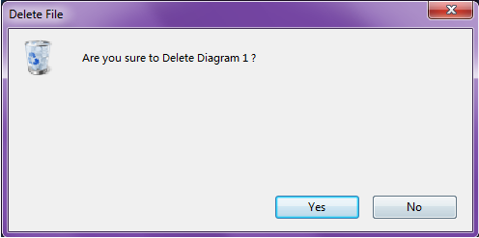

figure 2-22 Confirm to Delete

#### Manipulating Objects

##### Add an Object to the canvas

Press the ***Left Button*** of your mouse on the ***selected Object***,

Hold the ***Left Button***.

Drag the chosen Object to the ***Canvas***

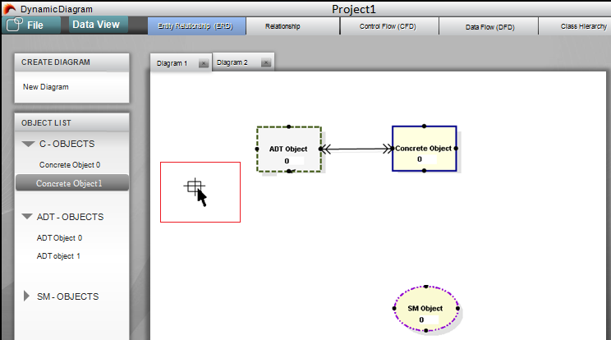

figure 2-22 Drag Concrete Object 1 to Diagram1(Step1)

Release the ***Left Button***.

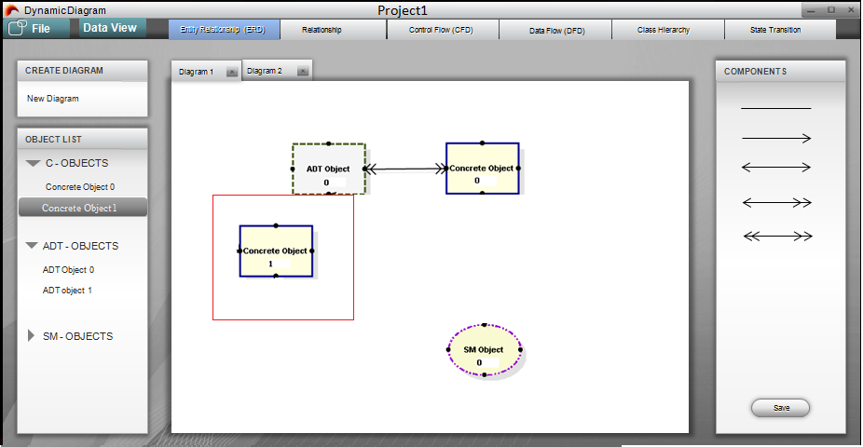

figure 2-23 Drag Concrete Object 1 to Diagram1 (Step2)

##### Drag an Object

Press the ***Left Button*** of your mouse on the ***selected Object***,

Hold the ***Left Button***.

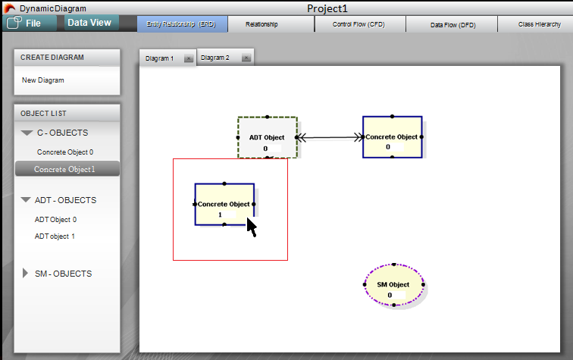

figure 2-24 Drag Concrete Object 1 on Diagram1 (Step1)

move your cursor to the position you want, and release the ***Left Button***.

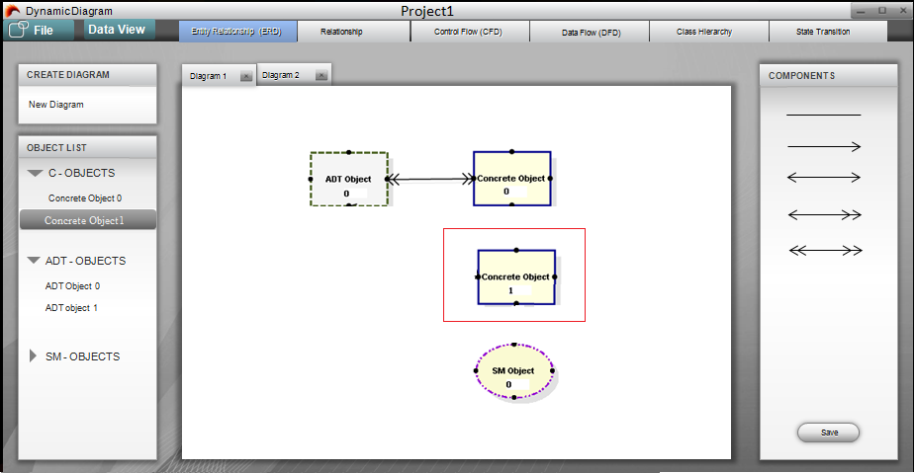

figure 2-25 Drag Concrete Object 1 on Diagram1 (Step2)

##### Connect Objects

Select a ***Connection*** on the right side

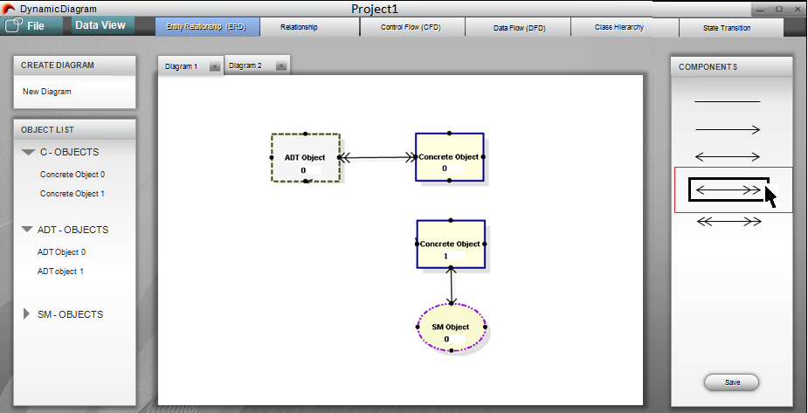

figure 2-26 Connect ADT Object1 and Concrete Object 1 (Step1)

Press the ***Left Button*** on a ***Connection Point*** of ADT Object 1,

hold the ***Left Button***.

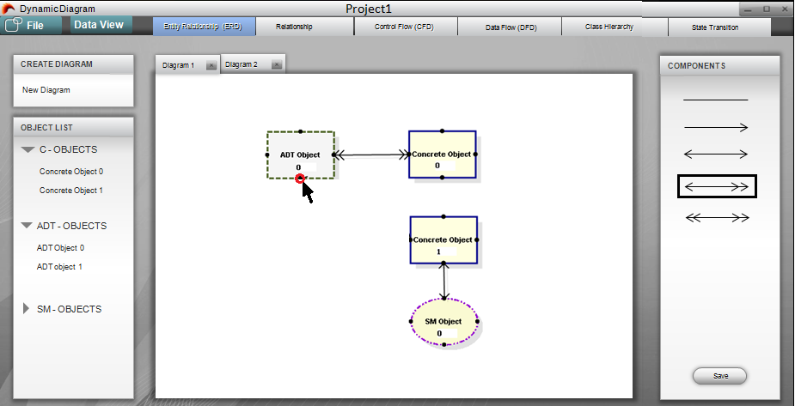

figure 2-27 Connect ADT Object1 and Concrete Object 1 (Step2)

Move the Mouse to ***a Connection Point*** of Concrete Object1

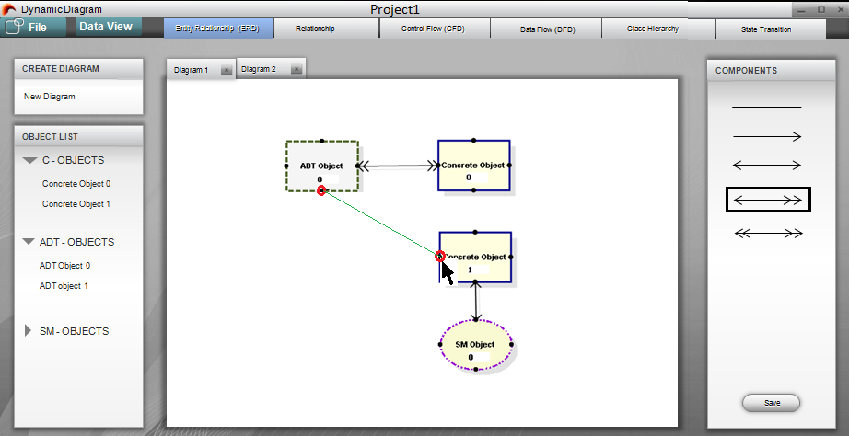

figure 2-28 Connect ADT Object1 and Concrete Object 1 (Step3)

Release the ***Left Button.*** Connection Established***.***

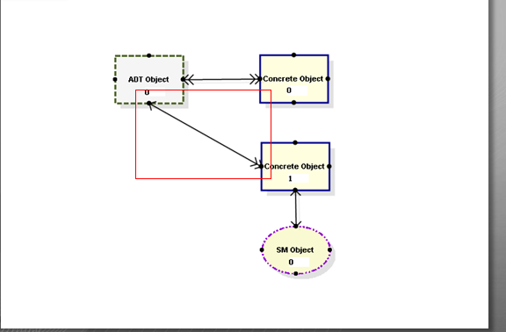

figure 2-29 Connect ADT Object1 and Concrete Object 1 (Step4)

## Generate an ORV

Select ***Relationship*** on the ***Diagram Type Bar***

Right click the chosen ***ERD*** ***Object.***

Select ***ORV***

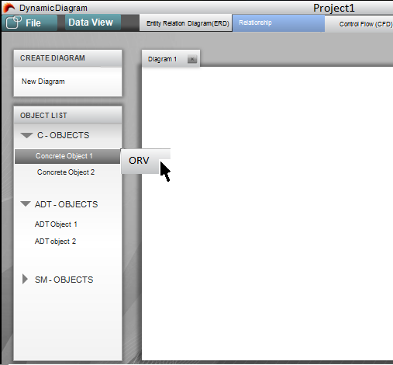

figure 2-30 Generate ORV Chart (Step1)

ORV Generated.

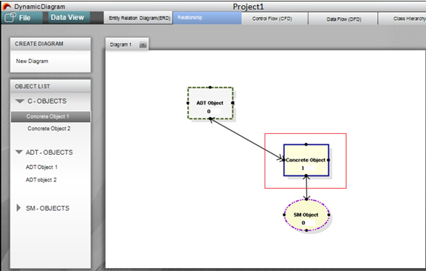

figure 2-31 ORV Generated

## Convert a DFD to an Architecture Chart

Open a ***DFD***

Click the Type of ***Conversion*** you want

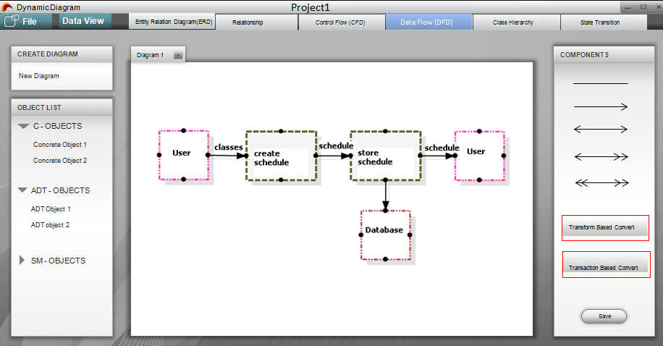

figure 2-32 DFD to Architecture Chart

#### Transform Based Conversion

A popup window to ask which Objects you choose as ***processing Objects.***

figure 2-33 Transform Based Conversion Popup Window

Select Objects and Click Convert

figure 2-34 Generated Architecture Chart

#### Transaction Based Conversion

A popup window to ask which Objects you choose as a ***Dispatcher.***

figure 2-35 Transaction Based Conversion Popup Window

Select Objects and Click Convert

figure 2-36 Generated Architecture Chart

## Convert a CFD to an STT

Select a ***CFD***

Click the ***STT Button*** on the right side.

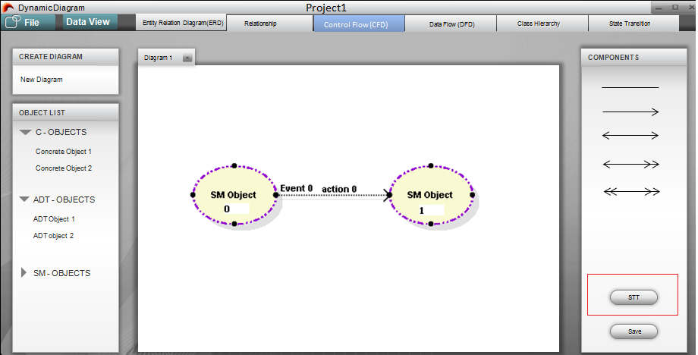

figure 2-37 CFD to STT

STT Generated.

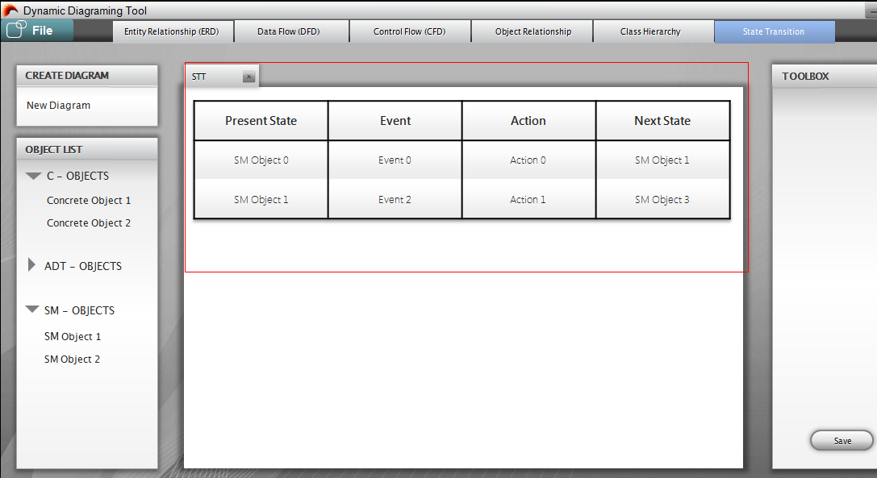

figure 2-38 STT Generated

# Operation Modes

## Project Mode

### New Project

Create a new Project

### Open Project

Open an existing project from a project file

### Save Project

Save the current Project

### Exit Project

Close the project, exit the program

## Object Mode

### Create Object

Create a new Object and enter attributes

### Edit Object

Edit an existing object

### Delete Object

Delete an existing object

## Diagram Mode

### Create Diagram

Create a new empty diagram

### Open Diagram

Open an existing diagram

### Save Diagram

Save an existing diagram

### Close Diagram

Close an existing diagram

### Remove Diagram

Remove an existing diagram

### Rename Diagram

Rename an existing diagram

### Clean Diagram

Clean an existing diagram

## Converting Mode

### Convert from DFD to Architecture Chart

### Convert from CFD to STT

# Advanced Features

#### Status Bar and Process Bar

#### Group and Ungroup objects

#### Undo and Redo

#### Multiple Selectable Tabs

# Command Syntax and System Operations