Words That Harm — Architectures and Fairness in Toxic-Comment Detection
Authors: Omer Ramon, Tom Jacob · Technion EE046211 Deep Learning
Repo: https://github.com/Tom-Jacob/DeepProjectHate
Draft for the ≤8-page report. Figures are in `report/figures/`. Encoder/SVM
refreshed at test n=500; decoder comparison + fairness refreshed at n=200
(2026-07-12). Word export: `report/Words_That_Harm_Report.docx`.
Ethics §6.1–6.2 filled by the team; §6.3 reflection still to write (human-only).
---

Abstract
We audit toxic-comment detectors on the Jigsaw 2018 dataset across three
architectures evaluated on the same data: a specialized BERT encoder
(unitary/toxic-bert), a non-neural TF-IDF + linear-SVM baseline we train
ourselves, and a DistilGPT-2 decoder used as a zero-shot classifier via
prompting. Rather than chasing accuracy, we stress-test each model for
identity bias, robustness to obfuscation, and the mechanism behind
its errors. We find that (i) toxicity detection is largely lexical — a linear
model matches the encoder's F1 and beats its ranking quality at ~1700× lower
latency; (ii) the encoder's true advantage is robustness to obfuscation, not
accuracy; (iii) generative prompting with a small LM is near-chance and
degenerate; and (iv) all models share a data-driven identity bias that a masking
probe traces to a single-token lexical shortcut.

1. Introduction
Goal. Compare fundamentally different classification paradigms on toxic
comment detection, and characterize *why* they fail, not just how often.
Motivation. Content-moderation models are deployed at scale; their errors
(missed hate, or over-flagging neutral mentions of a group) have real social
cost. A benchmark F1 hides both failure modes.
Prior work. The Jigsaw Toxic Comment Classification Challenge (Kaggle, 2018)
established the dataset and multi-label task. Dixon et al. (2018) introduced
identity-mention templates to measure unintended bias. We build on these by
comparing an encoder classifier, a non-neural baseline, and decoder prompting
under a single fair protocol, adding perturbation stress tests and a masking
intervention.
Hypotheses. (H1) the specialized encoder trades fairness for accuracy;
(H2) smaller/compressed models lose accuracy *and* amplify bias; (H3) decoder
prompting is weaker and more format-sensitive than a discriminative head.

2. Method
Task & data. Jigsaw 2018, binary target toxic (multi-label labels retained
for the encoder↔decoder analysis). Split 85/15 train/val from train.csv
(stratified), test = labeled test.csv rows (135,635 / 23,936 / 63,978).
Architectures (same data, fair comparison).
- Encoder — unitary/toxic-bert (BERT, 109M), fine-tuned on Jigsaw; 6 sigmoid heads, we read the toxic logit.
- Non-neural — TF-IDF (1–2 grams, 50k) + calibrated LinearSVM, trained by us on the same split.
- Decoder — DistilGPT-2 (82M) as a zero-shot classifier: D1 = "Is this toxic? yes/no", D2 = fill-in-blank "This comment is ___", scored by continuation log-probability.
Unified interface. Every model is reduced to a single P(toxic) so all
evaluations are architecture-agnostic (predict_toxic_proba). We report
parameter count and inference latency alongside accuracy for a fair
capacity comparison.
Metrics & probes.
- Accuracy: F1, PR-AUC, ROC-AUC at threshold 0.5.
- Fairness: per-identity false-positive rate on neutral identity-mention
templates (Dixon-style), across 21 groups; a no-identity control set.
- Robustness: evasion rate — fraction of genuinely-toxic comments that slip
through after surface perturbations (typos, leetspeak, spacing, repetition,
casing, punctuation).
- Masking intervention: (a) at inference, replace the identity term with
[MASK] and re-measure FPR; (b) retrain the SVM with identity terms removed
and measure the fairness/recall trade-off.
- Agreement: encoder vs decoder prediction agreement and each vs gold.

3. Experiments and results

3.1 Accuracy vs. efficiency (fair comparison)
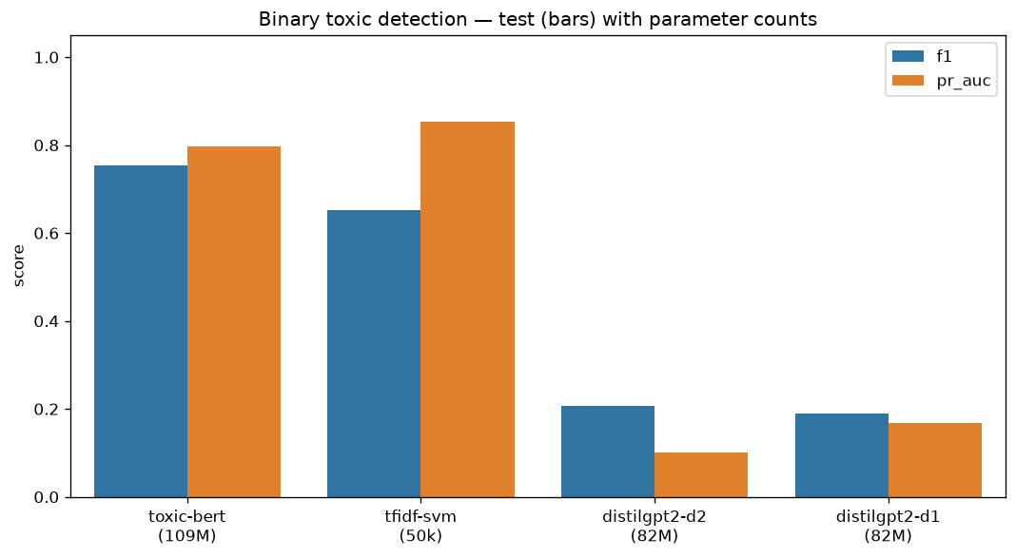
Figure: model comparison bars (test)
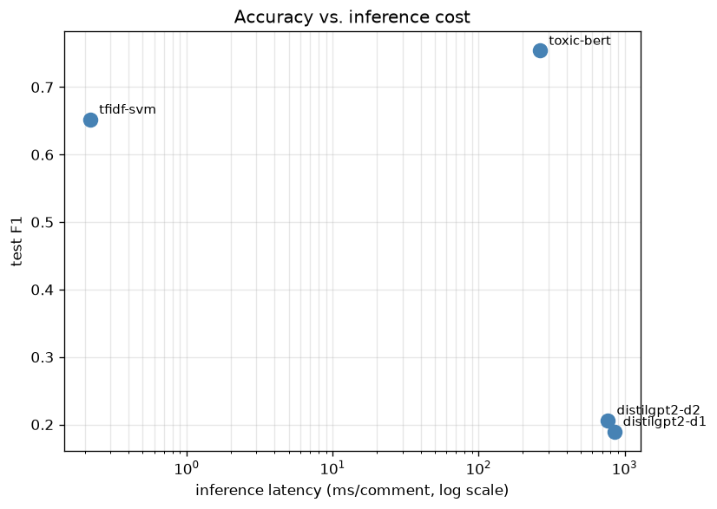
Figure: accuracy vs latency (test)
Figures: model_comparison_bars_test.png, accuracy_latency_test.png.
model | params | F1 | PR-AUC | ROC-AUC | ms/comment
toxic-bert (BERT) | 109M | 0.770 | 0.843 | 0.981 | 432
tfidf-svm (non-neural) | 50k | 0.733 | 0.862 | 0.975 | 0.70
distilgpt2-d2 (decoder) | 82M | 0.206 | 0.102 | 0.45 | 769
distilgpt2-d1 (decoder) | 82M | 0.189 | 0.167 | 0.46 | 849
The linear model is close to toxic-bert on F1 and beats its PR-AUC at ~600× lower
latency — most of the task is lexical. The decoder is near chance (ROC-AUC ≈ 0.45).
*(Encoder/SVM: test n=500. Decoder: test n=200 — both directional relative to full test.)*

3.2 Fairness: per-identity FPR
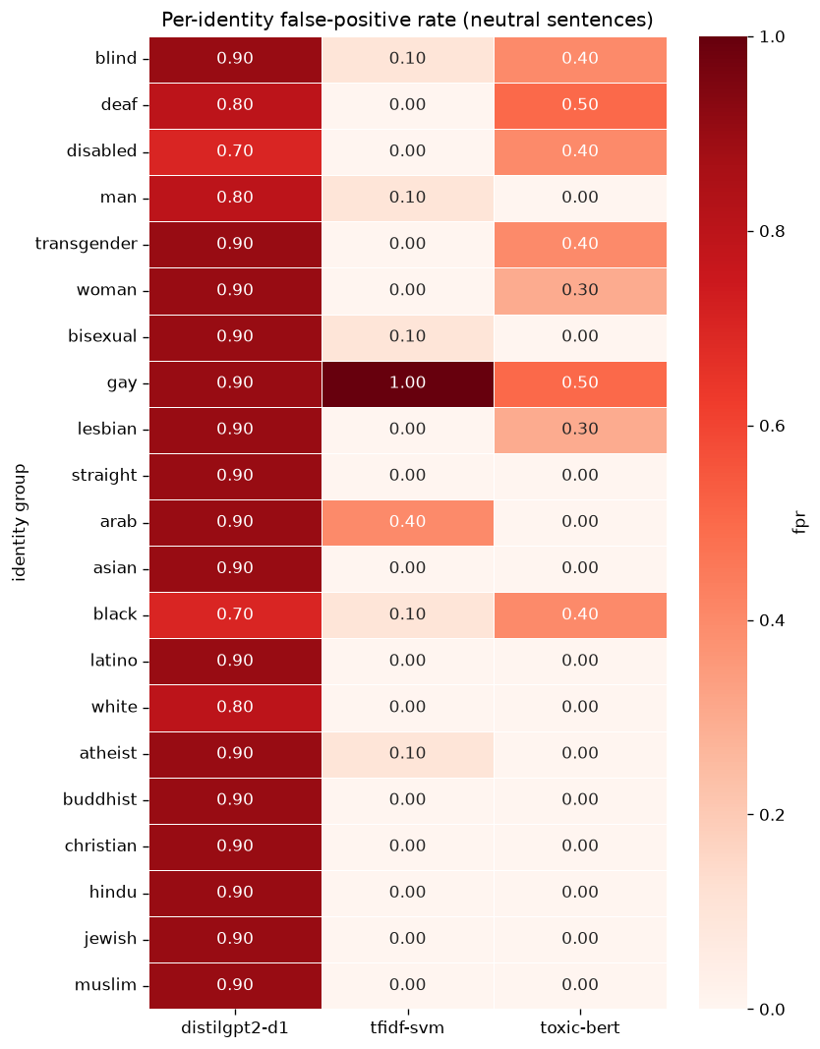
Figure: per-identity FPR heatmap
Figure: fairness_fpr_heatmap.png.
model | overall identity FPR | control FPR
tfidf-svm | 0.090 | 0.000
toxic-bert | 0.152 | 0.000
distilgpt2-d1 | 0.867 | 1.000
Control FPR is 0 for the classifiers → false positives are *specifically*
identity-driven ("I am gay", "I am Muslim", "I am transgender" are flagged). The
specialized encoder is less fair than the linear baseline (H1). The decoder
flags essentially everything (control FPR 1.0) — degenerate as a classifier.

3.3 Robustness to obfuscation
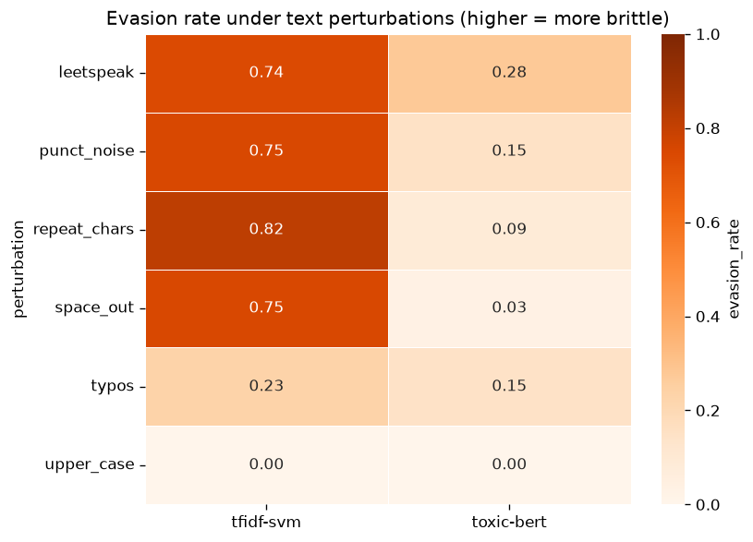
Figure: robustness / evasion heatmap
Figure: robustness_evasion_heatmap.png. Evasion = flagged-toxic comment that
slips through after perturbation (higher = more brittle).
model | baseline det. | leetspeak | space-out | punct-noise
toxic-bert | 0.92 | 0.28 | 0.03 | 0.15
tfidf-svm | 0.71 | 0.74 | 0.75 | 0.75
distilgpt2-d1 | 0.58 | 0.10* | 0.17* | 0.17*
The encoder is far the most robust; the SVM is trivially evaded (its features
*are* surface tokens). The decoder's low evasion is an artifact of near-random,
insensitive predictions (baseline detection only 0.58), not genuine robustness.
No model is fooled by ALL-CAPS.

3.4 Masking intervention (why they over-flag identities)
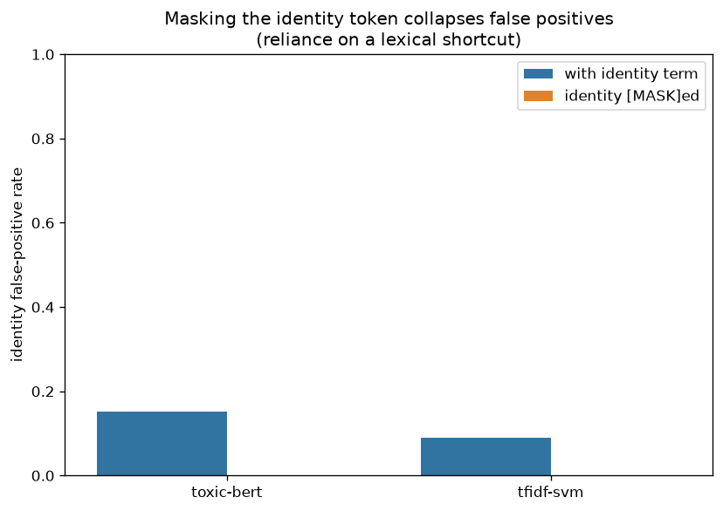
Figure: inference masking ablation
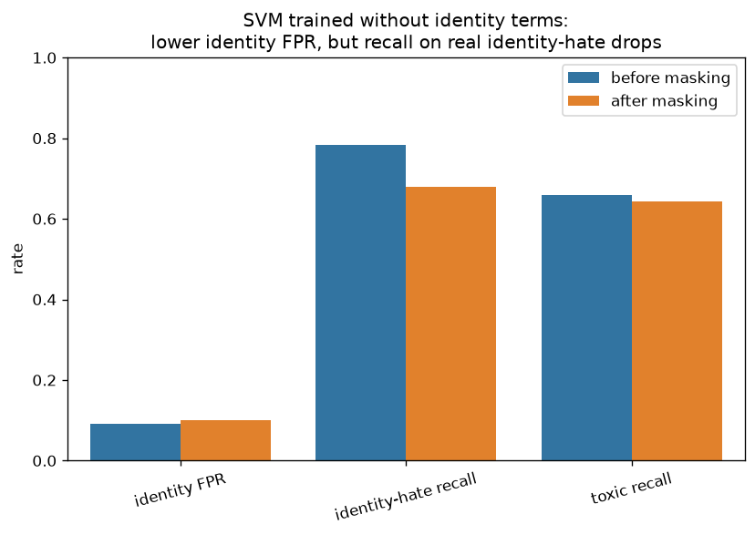
Figure: SVM masking fairness/recall trade-off
Figures: masking_inference_ablation.png, masking_svm_tradeoff.png.
Inference masking (replace the identity term with [MASK]): identity FPR
0.152 → 0.000 (toxic-bert) and 0.090 → 0.000 (SVM). Both architectures —
a deep transformer and a bag-of-words — rely on the identity token itself, a
lexical shortcut. Training-time masking of the SVM does *not* reduce FPR (0.090 →
0.10) but costs identity-hate recall (0.78 → 0.68): naive removal is an
insufficient and harmful "fix".

3.5 Encoder vs. decoder agreement
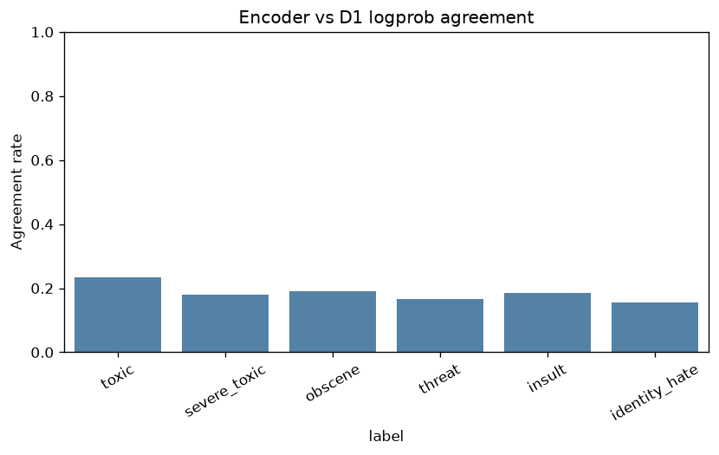
Figure: encoder–decoder agreement
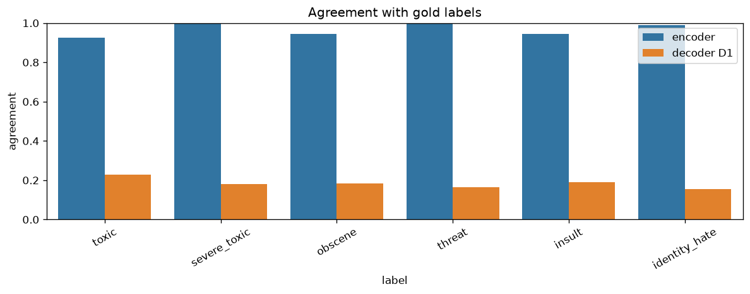
Figure: encoder/decoder vs gold agreement
Figures: enc_dec_gold_agreement.png, enc_dec_agreement.png. (test n=200, 6 labels.)
Overall encoder↔decoder agreement is only 0.185. Against
gold on toxic, the encoder scores 0.925 but the decoder only 0.230 — the
two barely agree not because they capture different *valid* signals, but because
the decoder is degenerate: it labels almost every comment toxic. Of 200 comments
the two disagree on toxic 153 times, and the disagreements are overwhelmingly
decoder false positives on benign text.
comment (truncated) | gold | encoder | decoder
":Replied here:" | 0 | 0 | 1
"US New Citizenship Test. In October of 2008 …" | 0 | 0 | 1
"This is your last warning. You will be blocked …" | 0 | 0 | 1
Takeaway: cross-architecture agreement is a poor proxy for correctness here — a
strong discriminative encoder and a degenerate generative prompt "disagree" almost
everywhere, and the encoder is right nearly every time.

3.6 Distillation (soft KD, 6 labels)
*Colab train: notebooks/09_distillation_colab.ipynb. Local eval key: distilbert-student.*
We distill all six Jigsaw labels from frozen toxic-bert into a DistilBERT
student with soft targets (temperature $T{=}2$, mix $\alpha{=}0.7$ KD + hard BCE).
The student exposes predict_toxic_proba for the binary harness and full 6-label
sigmoid probs for multi-label metrics.
model | params | test F1 (toxic) | identity FPR | ms/comment | notes
toxic-bert (teacher) | 109M | 0.770 | 0.152 | 274 | n=500
distilbert-student | 67M | 0.772 | 0.062 | 159 | soft KD, 6-label; Colab 20k×4ep
Result vs H2: on this run the student matches the teacher's toxic F1 (0.772 vs 0.770)
at ~1.7× lower latency and lower overall identity FPR (0.062 vs 0.152). Compression did
not amplify identity bias here — though worst-group FPR remains concentrated (e.g. gay).
Training: soft KD $T{=}2$, $\alpha{=}0.7$, 20k train / 2k val, 4 epochs; best val toxic F1 ≈ 0.85
(models/distilbert-student/distill_config.json).
Reproduce after weights exist in models/distilbert-student/:
python scripts/run_model_comparison.py --models toxic-bert tfidf-svm distilbert-student --eval-n 500
python scripts/run_fairness.py --models toxic-bert distilbert-student
python scripts/run_robustness.py --models toxic-bert distilbert-student --n 200

3.7 Decoder fine-tune (D1 yes/no, binary toxic)
*Colab: notebooks/10_decoder_finetune_colab.ipynb. Registry key: distilgpt2-d1-ft.*
Zero-shot DistilGPT-2 prompting is near chance. We keep that result and add a
small supervised probe: fine-tune DistilGPT-2 with causal LM loss only on
the answer tokens ( yes / no) after the same D1 prompt, on ~8k stratified
train comments (1–2 epochs). Eval uses the identical score_yes_no logprob path.
model | F1 | ROC-AUC | identity FPR | notes
distilgpt2-d1 (zero-shot) | 0.189 | 0.46 | 0.867 | degenerate / near chance
distilgpt2-d1-ft (fine-tuned) | `[TBD after Colab]` | `[TBD]` | `[TBD]` | small probe, binary toxic
Claim: failure of zero-shot prompting at DistilGPT-2 scale does not imply
decoders cannot learn the task — light task-specific adaptation recovers usable
discrimination while preserving the architecture comparison.
python scripts/train_decoder_ft.py --max-train-samples 8000 --epochs 2
python scripts/run_model_comparison.py --models toxic-bert distilgpt2-d1 distilgpt2-d1-ft --eval-n 200
python scripts/run_fairness.py --models toxic-bert distilgpt2-d1 distilgpt2-d1-ft

4. Conclusions and future work
1. Toxicity detection is mostly lexical — a 50k-feature linear model rivals a
109M encoder; "bigger" is not the story.
2. The encoder's real value is robustness to obfuscation, not raw accuracy.
3. Zero-shot decoder prompting fails at DistilGPT-2 scale — near chance and
often degenerate; a small D1 fine-tune (§3.7) tests whether light
supervision recovers usable discrimination without changing architecture.
4. Identity bias is data-driven, not architectural — it appears even in the
linear model, and masking the identity token erases it, revealing a lexical
shortcut. Fixing it via naive training-masking trades recall for little gain.
5. Distillation (soft KD): the DistilBERT student matches toxic-bert toxic F1
(0.772 vs 0.770) at lower latency and lower identity FPR (0.062 vs 0.152)
on our probe — compression need not amplify bias (H2 partially rejected here).
Future work. Neural masked fine-tune of DistilBERT; calibration analysis;
larger evaluation samples; hateBERT cross-domain probe.

5. References
- Jigsaw/Conversation AI. Toxic Comment Classification Challenge. Kaggle, 2018.
- Dixon, Li, Sorensen, Thain, Vasserman. Measuring and Mitigating Unintended Bias in Text Classification. AIES 2018.
- Hanu, Unitary. Detoxify / unitary/toxic-bert, 2020.
- Sanh et al. DistilBERT / DistilGPT-2, 2019.

6. Ethics statement (required)
6.1 Introduction. Names: Tom Jacob, Omer Ramon. Project title: *Words That Harm*.
In this project we aim to compare SVM, decoder-only, and encoder-only architectures
for toxic-comment classification. We check for accuracy, identity bias, and robustness.
6.2 Stakeholders and explanations.
- *Stakeholders:* (1) platform users/commenters, (2) human moderators, (3)
identity groups at risk of over-flagging.
- *Explanations:* users need to know why a comment was flagged and how to appeal;
moderators need per-label scores and confidence; identity groups need
transparency about measured per-group false-positive rates.
- *Responsibility:* the platform deploying the model owns user- and
group-facing explanations; the ML team owns moderator-facing documentation.
6.3 Our reflection (write ourselves — no LLM).
Prompts to answer in 1–2 short paragraphs total before submission:
1. Given our measured identity FPRs (toxic-bert ≈ 15%, SVM ≈ 9%, decoder near-degenerate), what should change in how an AI moderation system *answers* or *acts* toward users?
2. Would you require human review for flags that fire on neutral identity mentions? Why / why not?
3. Should platforms publish bias-audit numbers like ours? What risk does that create, and what benefit?
[To be added by the team.]
---
*Reproduce every figure: see docs/PROGRESS.md §5 and docs/DEVELOPER_GUIDE.md.*

Appendix — report figures
Figure: model comparison bars (test)
Figure: accuracy vs latency (test)
Figure: per-identity FPR heatmap
Figure: robustness / evasion heatmap
Figure: inference masking ablation
Figure: SVM masking fairness/recall trade-off
Figure: encoder–decoder agreement
Figure: encoder/decoder vs gold agreement

