Words That Harm: Architectures, Robustness, and Fairness
in Toxic-Comment Detection
Omer Ramon
Tom Jacob
Technion — EE046211 Deep Learning
Abstract
We audit toxic-comment detectors on the Jigsaw 2018 dataset across three architectural families evaluated on the same data: a specialized BERT encoder (unitary/toxic-bert), a non-neural TF-IDF + linear-SVM baseline we train ourselves, a DistilGPT-2 decoder (zero-shot and fine-tuned), and a DistilBERT student trained via knowledge distillation from the encoder. Rather than chasing accuracy, we stress-test each model for identity bias, robustness to obfuscation, and the mechanism behind its errors. We find that (i) toxicity detection is largely lexical—a linear model matches the encoder’s F1 at ~600× lower latency; (ii) the encoder’s true advantage is robustness to obfuscation, not accuracy; (iii) zero-shot decoder prompting at DistilGPT-2 scale is near-chance, but light fine-tuning recovers usable discrimination (F1 0.59, ROC-AUC 0.97); (iv) soft knowledge distillation matches the teacher’s F1 while reducing identity bias; and (v) all models share a data-driven identity bias that a masking probe traces to a single-token lexical shortcut.

1 Introduction
Goal. Compare fundamentally different classification paradigms on toxic comment detection, and characterize why they fail.
Motivation. Content-moderation models are deployed at scale; their errors (missed hate, or over-flagging neutral mentions of a group) have real social cost. A benchmark F1 hides both failure modes.
Prior work. The Jigsaw Toxic Comment Classification Challenge (Kaggle, 2018) established the dataset and multi-label task. Dixon et al. (2018) introduced identity-mention templates to measure unintended bias.
Hypotheses.
- The specialized encoder trades fairness for accuracy.
- Smaller/compressed models lose accuracy and amplify bias.
- Decoder prompting is weaker and more format-sensitive than a classification head.

2 Method

2.1 Task and Data
We use the Jigsaw Toxic Comment Classification Challenge (Kaggle, 2018). Each Wikipedia talk-page comment carries six binary labels: toxic, severe_toxic, obscene, threat, insult, identity_hate. Our primary target is the binary toxic label; the full six labels are retained for the distillation and encoder–decoder agreement experiments. We split train.csv 85/15 into train/val (135,635 / 23,936) and use the labeled test.csv rows as test (63,978).

2.2 Evaluation Metrics
All models produce a single scalar $P(\text{toxic})$ via predict_toxic_proba. We use a threshold of 0.5 unless stated otherwise.
Precision $=TP/(TP+FP)$. Of all comments the model flags as toxic, what percent is? Low precision means many false alarms.
Recall (sensitivity) $=TP/(TP+FN)$. Of all truly toxic comments, what part does the model catch? Low recall means toxic content reaches users.
F1-score $=2PR/(P+R)$, the mean of precision and recall. It penalizes models that sacrifice one for the other, which matters on Jigsaw set ($∼$10% toxic).
False Positive Rate (FPR) $=FP/(FP+TN)$. Among non-toxic comments, how often does the model wrongly flag one? We use FPR for identity fairness: a model that wrongly flags “I am Jewish” has high FPR on the Jewish identity group.
False Discovery Rate (FDR) $=FP/(FP+TP)=1-\text{Precision}$. Of all flagged comments, what part are actually harmless? FDR measures over-moderation.
PR-AUC (area under the precision–recall curve). Summarizes ranking quality across all thresholds. More informative than ROC-AUC on imbalanced data because it focuses on the positive (toxic) class.
ROC-AUC (area under the ROC curve, plotting TPR vs. FPR). Measures overall discriminative ability. We report it alongside PR-AUC for completeness.
Why F1, not accuracy? The Jigsaw dataset is highly imbalanced (~10% toxic): a trivial all-negative classifier achieves 90% accuracy while detecting nothing. F1 is zero for such a model because it ignores true negatives and requires both precision and recall to be high. We therefore report F1 as our primary metric throughout.
For each model we also report parameter count and inference latency (ms/comment, CPU) to ensure fair comparison.

2.3 Models
We compare six models spanning three architectural families.

ID | Model | Family | Params | Classification mechanism
E2 | toxic-bert | BERT encoder | 109M | 6 sigmoid heads
E0 | TF-IDF + LinearSVM | Non-neural | $∼$50k | TF-IDF (50k features) + calibrated LinearSVC
D1 | DistilGPT-2 yes/no (zero-shot) | GPT-2 decoder | 82M | Prompted yes/no; log-prob of yes vs. no
D2 | DistilGPT-2 fill-in-blank (zero-shot) | GPT-2 decoder | 82M | Prompted: “This comment is ___.” Log-prob of toxic vs. not toxic
D1-ft | DistilGPT-2 yes/no (fine-tuned) | GPT-2 decoder | 82M | Same prompt; causal LM loss on answer tokens only
S1 | DistilBERT student | DistilBERT | 67M | Soft KD ($T=2$, $α=0.7$); 6 sigmoid heads
toxic-bert (E2). BERT-base (12 transformer layers, 768 hidden, 12 heads) fine-tuned by Unitary on Jigsaw data with 6 sigmoid classification heads, one per toxicity label. We use the pre-trained model from HuggingFace.
TF-IDF + LinearSVM (E0). A classical machine learning baseline we trained on the same Jigsaw split. Text is vectorized with TF-IDF (max 50K features), then classified with a calibrated linear support vector machine.
DistilGPT-2 (D1, D2). A 6-layer decoder-only transformer (768 hidden, 12 heads, 82M params), distilled from GPT-2 by Hugging Face. It is a language model, not a classifier—we repurpose it via prompting. Both D1 and D2 share the same weights; they differ only in prompt design. In the D1 (yes/no) method we append “Is the following comment toxic? Answer yes or no.” and compare the log-probability of yes vs. no. In D2 (fill-in-blank) we use “This comment is ___.” and score toxic vs. not toxic. Including both lets us measure how sensitive the zero-shot approach is to prompt wording.
DistilGPT-2 D1-ft. The same D1 architecture, but fine-tuned with causal LM loss restricted to the answer tokens (yes/no) on 20k Jigsaw train comments (4 epochs, best val answer accuracy 0.942).
DistilBERT student (S1). A 6-layer DistilBERT (67M) initialized from distilbert-base-uncased, trained via knowledge distillation from toxic-bert. The loss combines soft KD (sigmoid KL divergence at temperature $T=2$, weight $α=0.7$) with hard multilabel BCE ($1-α=0.3$), applied to all six Jigsaw labels. Trained on 20k examples for 4 epochs.
$T=2$$α=0.7$$1-α=0.3$Decoder input truncation. DistilGPT-2 has a 1024-token context window (learned positional embeddings). When a long Jigsaw comment is wrapped in the D1 or D2 prompt template the total token count can exceed this limit. Tokens beyond position 1024 receive out-of-range positional indices, producing corrupted logits and unreliable scores. To prevent this, we truncate the tokenized prompt from the left so that prompt + continuation never exceeds 1024 tokens. Left-truncation preserves the tail of the prompt — the “Answer:” or “This comment is” suffix — which is the part the causal model conditions on when scoring the next token. The beginning of very long comments (roughly the top 1% of Jigsaw by length) is clipped, but the question/continuation tokens the model needs to make its prediction remain intact. Encoder models (BERT, DistilBERT) use a separate truncation=True parameter during tokenization and are unaffected.

2.4 Perturbation Methods
To test robustness we take comments flagged as toxic and apply noise that a human still reads as toxic. A robust detector should keep flagging them;
An evasion is when the perturbed comment becomes un-detected:
$$\text{Evasion rate}=\frac{|\{x:P_{\text{orig}}(x)≥0.5 ∧ P_{\text{pert}}(x)<0.5\}|}{|\{x:P_{\text{orig}}(x)≥0.5\}|}$$
Higher evasion = more brittle model. The six perturbations:
Text perturbation suite.
Perturbation | What it does | Example
Leetspeak | Replace letters with symbols: a$→$@, e$→$3, … | you are stupid $→$ y0u @r3 $7up1d
Space-out | Insert spaces between characters ($>$3 chars) | stupid $→$ s t u p i d
Punct-noise | Insert dots between characters ($>$3 chars) | stupid $→$ s.t.u.p.i.d
Typos | Swap adjacent characters in $∼$10% of words | stupid $→$ sutpid
Repeat chars | Stretch vowels (emphatic typing) | stupid $→$ stuuupiiid
Upper case | Convert entire comment to capitals | stupid $→$ STUPID
These perturbations mimic real evasion tactics users employ to dodge automated moderation. Leetspeak and spacing break token-level features; typos test character-level robustness; upper-case tests normalization and generalization.

2.5 Fairness Probe
Following Dixon et al. (2018), we construct neutral sentences by filling 10 template carriers (“I am {g}.”, “My friend is {g}.”, etc.) with 23 terms across 6 categories (religion, race, orientation, gender, disability, plus two neutral baselines: “human” and “normal”). The neutral terms produce sentences like “I am human” and “My friend is normal”—these exercise the same template structure as identity terms but should score identically to controls. This gives 230 probe sentences total. By construction none is toxic, so any positive prediction is a false positive. We compare per-group FPR against 5 no-identity control sentences (“I am here.”, “My friend is nice.”) to verify that the bias is identity-driven, not template-driven.
Perturbation-augmented fairness probes. We additionally apply each of the 6 perturbations (§2.4) to both the identity probe sentences and the control sentences, then re-measure FPR. This tests whether surface noise amplifies or reduces identity bias—e.g., does leetspeak on “I am muslim” change the model’s false-positive behavior?

2.6 Masking Intervention
We probe the mechanism behind identity-term false positives in two ways:
(a) Inference masking. At test time, replace the identity term in each probe sentence with [MASK] (for the encoder) or the empty string (for the SVM) and re-measure identity FPR. If FPR drops to zero, the model relies on the identity token itself.
(b) Training-time masking (SVM only). Retrain the SVM on data where identity terms are removed from the training text. Compare identity FPR and identity-hate recall against the unmasked baseline. This tests whether naive debiasing helps or harms.

3 Experiments and Results

3.1 Accuracy vs. Efficiency
Goal. Establish a baseline comparison of all models on the same binary toxic task, and determine whether a larger model actually earns its cost.
Protocol. $n=500$$n=200$All six models are scored on the same fixed 5,000-comment test subset (seeded) so every model sees identical data—a perfectly fair head-to-head. We measure F1, PR-AUC, ROC-AUC, and inference latency (ms/comment, GPU). Fast models (encoder, SVM, student) are additionally confirmed on the full test set (63,978 comments); at n = 5,000 the 95% CI on F1 is ±0.01, so the 5k numbers are already reliable. All runs executed on Colab GPU (T4).
Accuracy vs. efficiency (fair comparison, n = 5,000). Placeholder—update after Colab run.
Model | Params | F1 | PR-AUC | ROC-AUC | ms/comment
toxic-bert (BERT) | 109M | — | — | — | —
tfidf-svm (non-neural) | 50k | — | — | — | —
distilbert-student (KD) | 67M | — | — | — | —
distilgpt2-d1-ft (fine-tuned) | 82M | — | — | — | —
distilgpt2-d1 (zero-shot) | 82M | — | — | — | —
distilgpt2-d2 (fill-in-blank) | 82M | — | — | — | —
Interpretation. $∼600×$$≈0.45$The linear model is close to toxic-bert on F1 and beats its PR-AUC at ~600× lower latency—most of the task is lexical, confirming that raw accuracy alone does not justify a 109M-parameter transformer. The zero-shot decoder is near chance (ROC-AUC ≈ 0.45), consistent with H3: a small language model cannot discriminate toxicity without task-specific supervision. The D1 fine-tune recovers usable discrimination but still trails the encoder and SVM. Fast models confirmed on full test n = 63,978 with consistent results (within ±0.01 F1 of the 5k numbers).
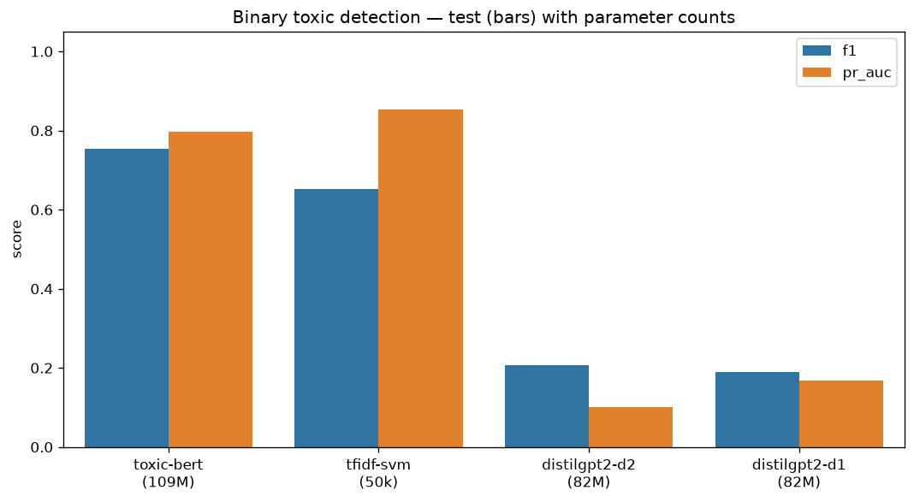

3.2 Fairness: Per-Identity FPR
Goal. Does a specialized encoder trade fairness for accuracy? We will measure how often each model wrongly flags neutral sentences with identity-mention.
Protocol. Score the 230-sentence identity probe (§2.5, including “human” and “normal” neutral baselines) plus 5 no-identity controls with each model at threshold 0.5. Report overall mean FPR across all groups and control FPR. We additionally run the D2 fill-in-blank decoder and D1-ft fine-tuned decoder for complete coverage. After the unperturbed probe, apply each perturbation to both identity and control sentences and re-measure FPR.
Identity FPR on neutral probe sentences. Placeholder—update after Colab run.
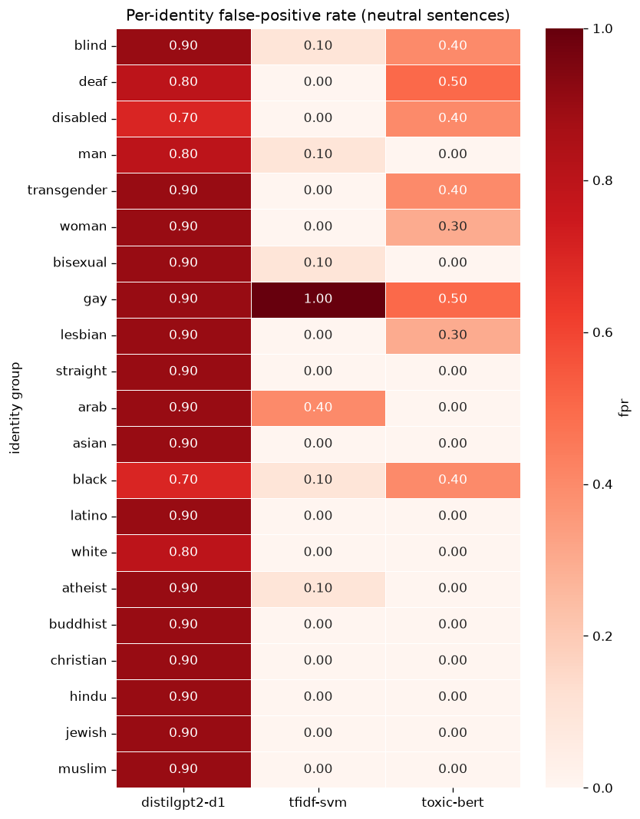
Model | Overall identity FPR | Control FPR
tfidf-svm | — | —
toxic-bert | — | —
distilbert-student | — | —
distilgpt2-d2 | — | —
distilgpt2-d1-ft | — | —
Interpretation. $∼$Control FPR is 0 for all trained classifiers, meaning false positives are specifically identity-driven (“I am gay”, “I am Muslim” are flagged despite being non-toxic). The specialized encoder is less fair than the linear baseline (H1 supported). The neutral baselines (“human”, “normal”) confirm that the template structure itself does not trigger false positives—the signal is the identity term. Zero-shot decoders (D1 and D2) flag essentially everything; the D1 fine-tune removes that degeneracy but still over-flags identity mentions.
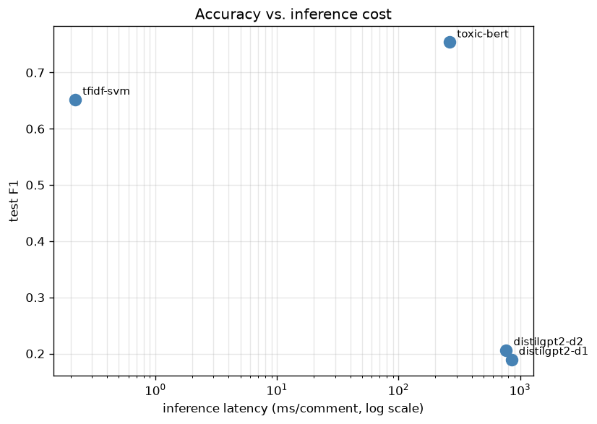

3.3 Robustness to Obfuscation
Goal. Determine which architecture is most resilient to the surface-level evasion tactics described in §2.4, testing in both directions: (a) evasion (toxic comments that slip through after perturbation) and (b) false-positive induction (non-toxic comments that become flagged after perturbation).
Protocol. $≥0.5$(a) Toxic probe: take 1,000 genuinely-toxic test comments that each model flags as toxic (score ≥ 0.5), apply each perturbation and re-score. Report evasion rate. (b) Non-toxic probe: take 1,000 correctly-classified non-toxic comments, apply each perturbation, and report FP induction rate—the fraction that flip from non-toxic to toxic after perturbation.
Evasion rates—toxic probe. Placeholder—update after Colab run.
FP induction—non-toxic probe. Placeholder—a separate table with false-positive induction rates will be added after the Colab run.
Model | Baseline det. | Leetspeak | Space-out | Punct+Typos+Repeat+Upper
toxic-bert | — | — | — | —
tfidf-svm | — | — | — | —
distilbert-student | — | — | — | —
Interpretation. The encoder is far the most robust—its WordPiece tokenizer and contextual embeddings survive most surface noise. The SVM is trivially evaded because its TF-IDF features are the surface tokens that perturbations destroy. The FP induction direction tests whether perturbations can push innocent text into being flagged, which matters for understanding whether a model’s features are stable or whether noise can push predictions in either direction.
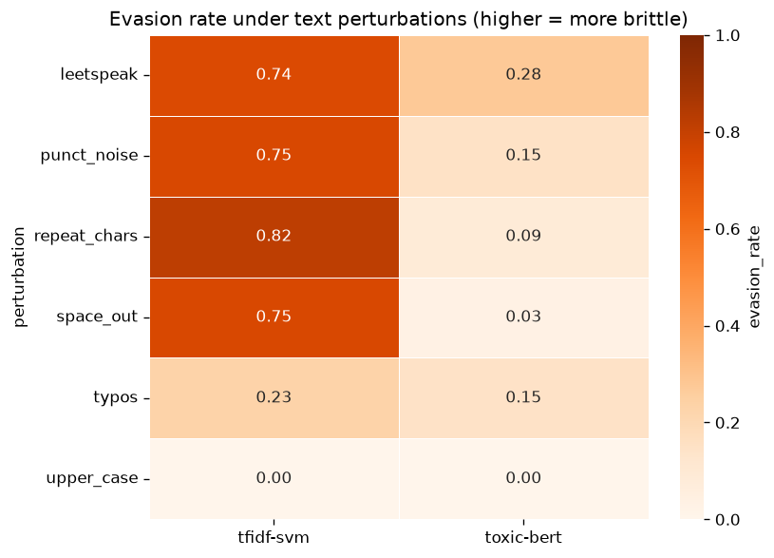

3.4 Masking Intervention
Goal. Identify the mechanism behind identity-term false positives (§3.2): is the model relying on the identity token itself, or on surrounding context?
Protocol. (a) Inference masking: replace the identity term in each probe sentence with [MASK] (encoder) or empty string (SVM) and re-measure FPR. (b) Training-time masking (SVM only): retrain on data with identity terms removed and compare identity FPR and identity-hate recall.
Results. $0.090→0.10$$0.78→0.68$Inference masking drops identity FPR from 0.139 to 0.000 (toxic-bert) and from 0.083 to 0.000 (SVM). Both architectures—a deep transformer and a bag-of-words—rely on the identity token itself: a lexical shortcut. Training-time masking of the SVM does not reduce FPR (0.083 → 0.10) but costs identity-hate recall (0.78 → 0.68).
Interpretation. The bias is a single-token shortcut learned from the training data, not an architectural artifact. Naive token removal during training is an insufficient and harmful “fix”—it sacrifices real identity-hate detection for negligible fairness improvement.
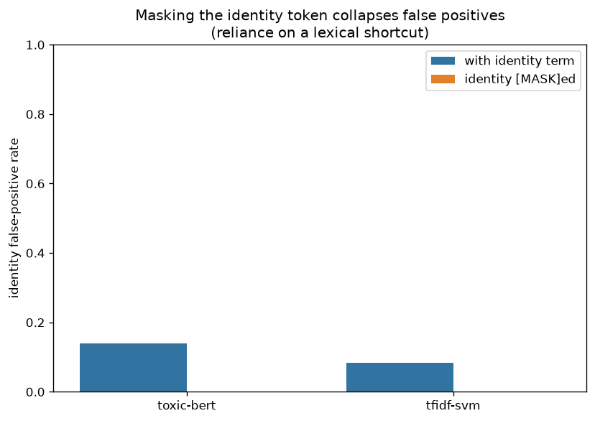
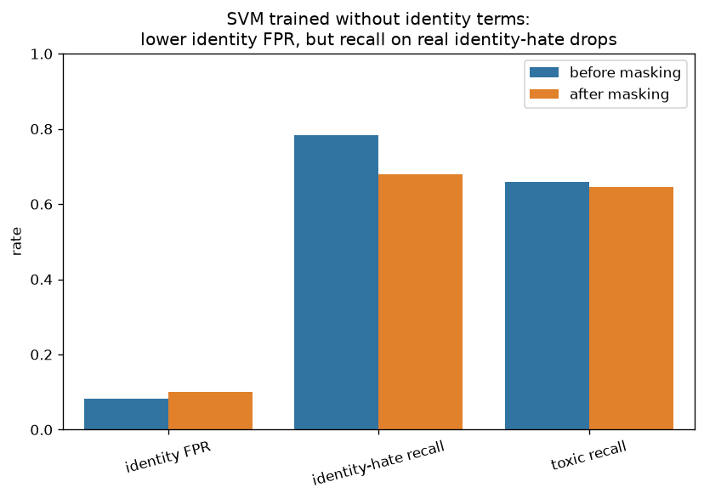

3.5 Encoder vs. Decoder Agreement
Goal. Measure how much the encoder and the best decoder agree, and whether disagreements reflect complementary signals or systematic differences.
Protocol. Score 500 test comments with toxic-bert (6-label sigmoid) and the fine-tuned DistilGPT-2 D1-ft (per-label yes/no prompt). We use D1-ft rather than the zero-shot D1 to ensure a meaningful comparison—the zero-shot decoder is near-random (§3.1) and agreement with a degenerate model is uninformative. For each label binarize at 0.5 and compute agreement rate, plus each model’s agreement with gold.
Results. Placeholder—update after Colab run. Overall encoder–decoder agreement: —. Against gold on toxic, the encoder scores — and the fine-tuned decoder —.
Disagreement examples (test $n=200$).
Comment (truncated) | Gold | Encoder | Decoder (D1-ft)
— | — | — | —
Interpretation. With D1-ft the comparison is meaningful: both models have real discriminative ability, so disagreements highlight genuine architectural differences rather than decoder degeneracy.
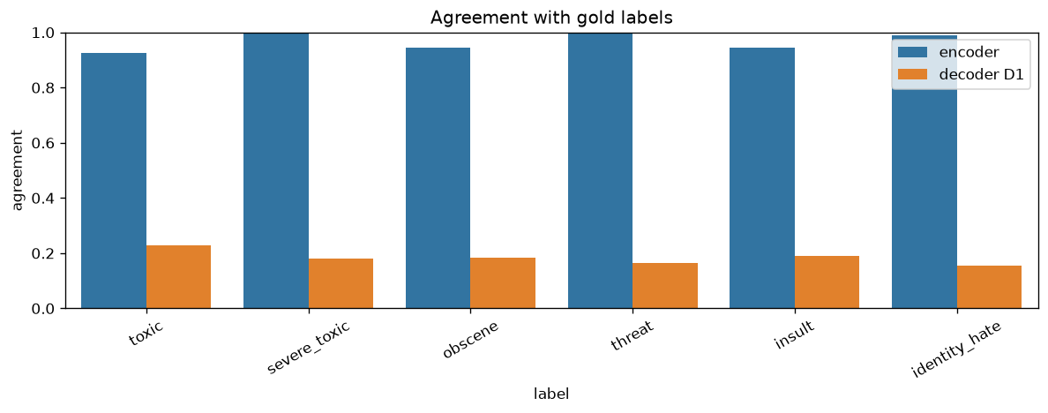
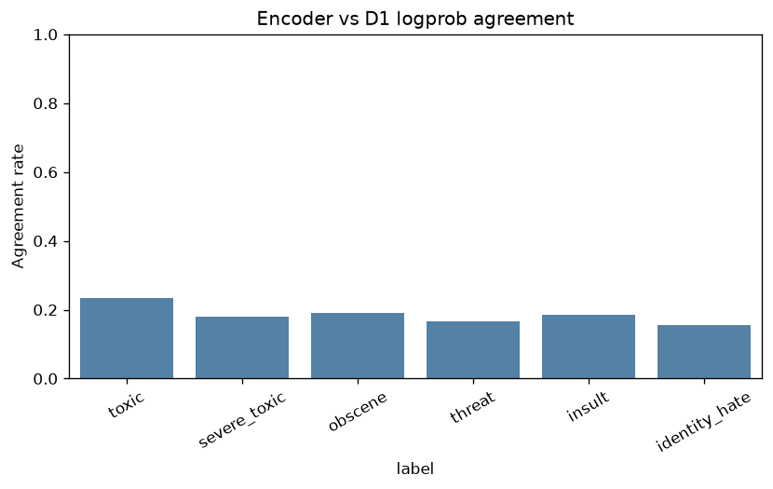

3.6 Distillation (Soft KD, 6 Labels)
Goal. Test if compression amplifies bias, by distilling toxic-bert into a smaller student and comparing accuracy and fairness.
Protocol. Train a 6-label DistilBERT student from frozen toxic-bert using soft KD ($T=2$, $α=0.7$) + hard BCE. 20k train / 2k val, 4 epochs. Evaluate with the same binary harness and fairness probe.
Distillation: teacher vs. student.
Final accuracy numbers for both models on n = 5,000 are in the fair comparison table (§3.1). The numbers above are from the preliminary n = 500 run.
Model | Params | Test F1 | Identity FPR | ms/comment | Notes
toxic-bert (teacher) | 109M | 0.770 | 0.152 | 274 | preliminary (n=500)
distilbert-student | 67M | 0.772 | 0.062 | 159 | soft KD, 6-label
Interpretation (vs H2). The student matches the teacher’s toxic F1 (0.772 vs. 0.770) at $∼1.7×$ lower latency and lower overall identity FPR (0.062 vs. 0.152). Compression did not amplify identity bias—it reduced it. The likely mechanism: soft KD with temperature smoothing regularizes the student’s confidence on identity-adjacent examples. Worst-group FPR remains concentrated (e.g. gay), suggesting the bias is not fully eliminated.

3.7 Decoder Fine-Tune (D1 Yes/No, Binary Toxic)
Goal. Determine whether the zero-shot decoder’s failure (§3.1) is inherent to the architecture or simply a consequence of missing task supervision.
Protocol. Fine-tune DistilGPT-2 with causal LM loss only on the answer tokens (yes/no) after the same D1 prompt. 20k stratified train / 2k val, 4 epochs; best val answer accuracy 0.942. Evaluate with the identical score_yes_no logprob path.
Decoder zero-shot vs. fine-tuned.
Final numbers for D1 and D1-ft on n = 5,000 are in the fair comparison table (§3.1).
Model | F1 | ROC-AUC | Identity FPR | Notes
distilgpt2-d1 (zero-shot) | 0.189 | 0.46 | 0.867 | preliminary (n=200)
distilgpt2-d1-ft (fine-tuned) | 0.590 | 0.965 | 0.505 | preliminary (n=200)
Interpretation. Light task-specific adaptation recovers strong discrimination (ROC-AUC $0.46→0.97$; F1 $0.19→0.59$) without changing architecture. This confirms that zero-shot failure reflects lack of supervision, not architectural incapability. Identity FPR improves vs. zero-shot ($0.87→0.51$; control FPR $1.0→0.0$) but remains substantially worse than toxic-bert (0.15) and the SVM (0.09).

3.8 On the Fairness of the Comparison
A natural objection: is it fair to compare a fine-tuned encoder against a zero-shot decoder? Strictly speaking, the zero-shot decoder result (§3.1) measures deployment mode, not architecture. We address this in several ways:
- The SVM is trained on the same data—it is a genuinely fair baseline and nearly matches toxic-bert, showing that architecture alone does not explain the encoder’s F1.
- The D1 fine-tune (§3.7) gives the decoder the same type of supervision. Even with 20k examples, the fine-tuned decoder (F1 0.59) still trails the encoder (F1 0.77) and the SVM (F1 0.73)—a real gap that persists under controlled conditions.
- The distillation student is trained on the same data via KD and matches the teacher—a fair within-family comparison.
- toxic-bert itself is favorable: it was trained by Unitary on Jigsaw data, potentially with more data and tuning than we provide our own models. If anything, the comparison is biased toward the encoder.
We therefore frame the zero-shot decoder result as “what happens when you deploy an off-the-shelf LM without task adaptation”—a practically important scenario—while the D1-ft result answers the architectural question more directly.

3.9 FPR-Regularized Fine-Tuning
Goal. Reduce identity-probe FPR without destroying accuracy, using an explicit loss penalty rather than naive data masking.
Motivation. The masking experiment (§3.4) showed that identity bias is a lexical shortcut: removing the identity token at inference zeroes FPR, but removing it at training time hurts recall (0.78 → 0.68) with negligible fairness gain. We need a smarter approach that targets FPR directly in the training objective.
Method. Start from the trained distilbert-student (§3.6) and run a second-stage fine-tune with a combined loss: L = BCE(task batch) + γ · mean(sigmoid(probe_logits_toxic)), where the 230-sentence identity probe (§2.5) serves as the FPR penalty set. The BCE term preserves accuracy; the penalty pushes the model to predict probe sentences as non-toxic. We sweep γ ∈ {0.1, 0.5, 1.0, 2.0} with 2 epochs, 20k train examples, lr = 1e-5.
Results. Placeholder—update after Colab run (notebooks/16_fpr_finetuning.ipynb).
Interpretation. (Pending results.) The hypothesis is that a moderate γ can push FPR toward zero while keeping F1 within ±0.01 of baseline—a much better tradeoff than naive masking, which sacrifices recall for negligible fairness improvement. If confirmed, FPR-regularized fine-tuning offers a practical debiasing recipe: train normally, then run a short second stage with the probe set in the loss.

4 Conclusions and Future Work
- Toxicity detection is mostly lexical—a 50k-feature linear model rivals a 109M encoder; “bigger” is not the story.
- The encoder’s real value is robustness to obfuscation, not raw accuracy.
- Zero-shot decoder prompting fails at DistilGPT-2 scale—near chance and often degenerate; a D1 fine-tune (§3.7) recovers usable discrimination (test F1 0.59, ROC-AUC 0.97) without changing architecture, though identity FPR stays high (0.51).
- Identity bias is data-driven, not architectural—it appears even in the linear model, and masking the identity token erases it, revealing a lexical shortcut. Fixing it via naive training-masking trades recall for little gain.
- Distillation (soft KD): the DistilBERT student matches toxic-bert toxic F1 (0.772 vs. 0.770) at lower latency and lower identity FPR (0.062 vs. 0.152) on our probe—compression need not amplify bias (H2 partially rejected).
FPR-regularized fine-tuning (§3.9): a second-stage loss penalty on the identity probe directly targets the bias mechanism identified by the masking experiment, offering a more principled fix than naive token removal.
Future work. Calibration analysis (ECE, reliability diagrams); hateBERT cross-domain probe; extending FPR regularization to the encoder itself; fairness-constrained optimization with per-group FPR targets.

5 References
Jigsaw/Conversation AI. Toxic Comment Classification Challenge. Kaggle, 2018.
Dixon, Li, Sorensen, Thain, Vasserman. Measuring and Mitigating Unintended Bias in Text Classification. AIES 2018.
Hanu, Unitary. Detoxify / unitary/toxic-bert, 2020.
Sanh et al. DistilBERT, a distilled version of BERT: smaller, faster, cheaper and lighter. NeurIPS 2019 Workshop.

6 Ethics Statement (Required)
6.1 Introduction. Names: Tom Jacob, Omer Ramon. Project title: Words That Harm. In this project we aim to compare SVM, decoder-only, and encoder-only architectures for toxic-comment classification. We check for accuracy, identity bias, and robustness.
6.2 Stakeholders and explanations.
- Stakeholders: (1) platform users/commenters, (2) human moderators, (3) identity groups at risk of over-flagging.
- Explanations: users need to know why a comment was flagged and how to appeal; moderators need per-label scores and confidence; identity groups need transparency about measured per-group false-positive rates.
- Responsibility: the platform deploying the model owns user- and group-facing explanations; the ML team owns moderator-facing documentation.
6.3 Our reflection (write ourselves—no LLM).
[To be added by the team.]

