Transmission Control Protocol (TCP)

1.1 Brief Introduction
The Transmission Control Protocol (TCP) offers a reliable, byte-oriented, connection-oriented transport service, in contrast to the unreliable datagram service used by the Internet Protocol (IP).
The TCP protocol belongs to the transport layer and can be used as an alternative to the User Datagram Protocol (UDP), which offers a connectionless transport service. 应用层协议所服务的用户都是应用程序，它们通过Socket获得TCP协议实例所提供的服务。To implement the transport service, the TCP layer uses the Internet Protocol (IP).
From an application's view, the TCP service can be divided into the following properties :
- Connection orientation: TCP provides connection-oriented service where an application must first request a connection to a destination and then use the connection to transfer data.
- Peer-to-peer communication: Each TCP connection has exactly two endpoints.所谓的端对端通信。因此一个TCP Connection可以由源地址，源端口，目的地址和目的端口这4元组表示。
- Complete reliability: TCP guarantees that the data sent across a connection will be delivered exactly as sent, with no data missing or out of order.
- Full-duplex communication: A TCP connection allows data to flow in either direction and allows either application program to send data at any time. TCP can buffer outgoing and incoming data in both directions, making it possible for an application to send data and then to continue computation while the data is being transferred.
- Byte-stream interface: We say that TCP provides a stream interface in which an application sends a continuous sequence of octets across a connection. That is, TCP does not provide a notion of records, and does not guarantee that data will be delivered to the receiving application in pieces of the same size in which it was transferred by the sending application. 如果一方的应用程序先传1 0字节，又传2 0字节，再传5 0字节，连接的另一方将无法了解发方每次发送了多少字节。收方可以分4次接收这8 0个字节，每次接收2 0字节。TCP对字节流的内容不做任何解释，TCP不知道传输的字节流是二进制数据还是ASCII字符、EBCDIC字符或其他类型数据。对字节流的解释由TCP连接双方的应用层完成。
- Reliable connection startup: TCP requires that, when two applications create a connection, both must agree to the new connection; duplicate packets used in previous connections will not appear to be valid responses or otherwise interfere with the new connection.
- Graceful connection shutdown: An application program can open a connection, send arbitrary amounts of data, and then request that the connection be shut down. TCP guarantees to deliver all the data reliably before closing the connection.
关于TCP Header的内容请参见附录E。

1.2 Implementing the TCP Protocol instance
本节主要集中在连接建立后TCP的数据传输流程。连接如何建立，终止以及连接状态的转换在下一节中讲述。至于其他的一些机制，比如流量控制，拥塞控制，计时重传等也会在其他小节中讲述。

1.2.1 Handling Incoming TCP Segments
我们知道，在ip_local_deliver_finish()函数中，对组装好了的IP Packet去调用高层的Protocol Instance的Handler，对于IP来说，上一层的Protocol Instance可能是ICMP，IGMP，TCP和UDP。对于TCP Protocol Instance来说，它的Handler是tcp_v4_rcv()。
下面是tcp_v4_rcv()函数的基本流程图。
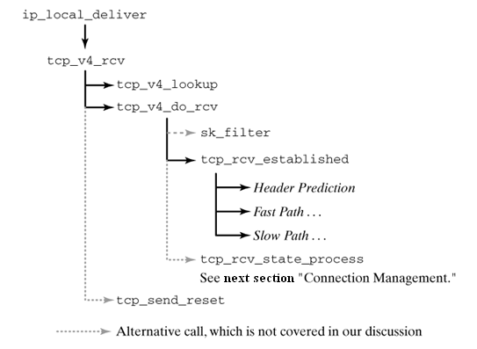
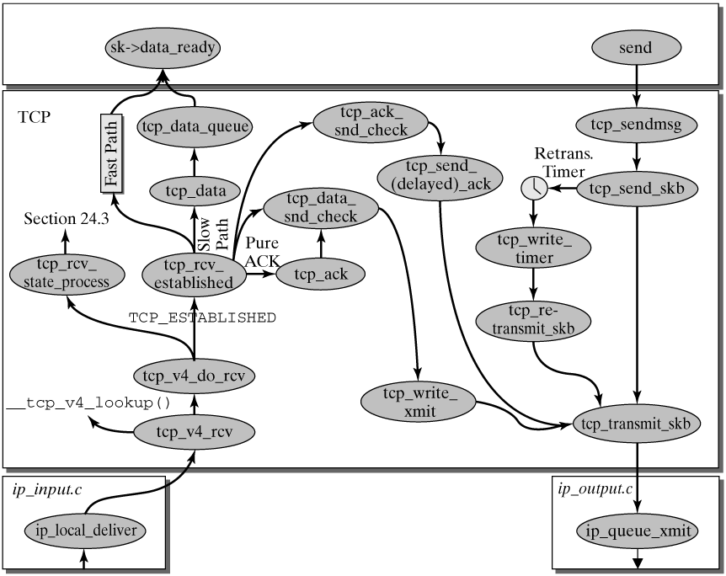
由于tcp_v4_rcv(skb, len)很复杂，这里只介绍与本节相关的部分。
- Firstly, it checks for whether the packet in the form of the socket buffer, skb, is really addressed to this computer (skb->pkt_type == PACKET_HOST). If so, then the IP packet header is removed, and the protocol processing continues; otherwise, the socket buffer is dropped:
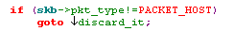
- 调用tcp_v4_lookup()。It searches the hash table of the active socket for the socket or sock structure. The IP addresses and the ports of the two communication partners and the network device index, skb->dst->rt_iif at which this segment arrived are the parameters used. If a socket with these addresses and ports can be found, the tcp_v4_do_rcv() function continues with an appropriate handling routine, depending on the connection state. If no socket can be found, then tcp_send_reset() sends a RESET segment.
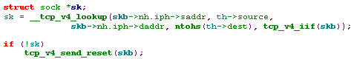
- 如果当前的连接状态是TCP_TIME_WAIT，则做相应的处理：
- If socket filters are activated, the sk_filter() function checks the socket buffer. If the result is negative, the packet is dropped：
- 最后调用tcp_v4_do_rcv()。
这时，流程走到了tcp_v4_do_rcv()，它主要根据当前的连接状态来做不同的操作：
- TCP_ESTABLISHED: With a connection established, the socket buffer is further processed in tcp_rcv_established().
- If the socket is in one of the other states, the function tcp_rcv_state_process() will processes the socket buffer. 这里主要是连接状态的转换了，我们留在下节讲述。
这一节主要讲述当前连接状态是ESTABLISHED时，Packet是如何处理的。这时会调用tcp_rcv_established(sk, skb, skb->h.th, skb->len)：
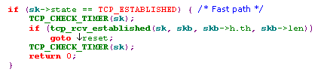
tcp_rcv_established(sk, skb, th, len)
Linux中处理处于ESTANBLISHED状态的TCP segment时会用到Fast Path和Slow Path：
- Fast Path is used to handle the ideal case of an incoming packet. The most common cases occurring in a normal TCP connection should be detected as fast as possible and processed optimally, without having to test for marginal cases(边界情况), which normally won't occur in this situation.
- Slow Path is used for all packets not corresponding to the ideal case and requiring some special handling. For example, if a packet had to be manipulated to deal with a transmission error, or if it is a retransmitted packet, it is processed in Slow Path by appropriate error-correction mechanisms.
Packets are processed in Fast Path in the following two situations:
- The segment received is a pure ACK segment for the data sent last (no duplicate ACK).
- The segment received includes data expected next, so that they are consecutive with the data received until then.
Fast Path is not accessed in the following situations (and so a detailed protocol-handling process is performed in Slow Path):
① Unexpected TCP flags: The process continues in Slow Path if a SYN, URG, FIN, or RST flag is set. These cases are detected by the Header Prediction described later. (
注：只要接受的Packet的TCP首部，SYN或URG或FIN或RST中任意标志置位，则会交由Slow Path处理。
② If the sequence number of an incoming segment does not correspond to the sequence number expected next (tp->rcv_nxt), then the segment is either a retransmitted segment or an out-of-order segment
注：，若该等式不成立，则该Packet是一个out-of-order segment或是重传的segment，交由Slow Path处理).
③ Both communication partners exchange data: Fast Path cannot be used except in situations where the relevant TCP instance either only sends or only receives (i.e., where either the sequence number or the acknowledgement number remains constant.)
注：当TCP instance 只发送Packet时acknowledge number不会变，变的是sequence number；而Receive Packet后发送ACK时，sequence number不会变，变的是acknowledge number。如果一方的TCP Instance 在Receive Packet的同时也发送Packet，则说明另一方也同时发数据以及接收数据，这种情况只能在Slow Path中处理。
④ The current TCP instance sent a Zero Window (i.e., no transmit credit can currently be granted to the communication partner).
注：当Receive Packet一方之前发送了一个Zero Windows，表明当前的Receive Window是0，表明当前这个TCP Instance不能再接收Packet了，此时如果又接收到一个Packet，则应该交由Slow Path处理。在发送一个Packet时会调用tcp_select_window()去计算当前的Receive Window，如果当前window是0，则pred_flags置为0从而禁止Fast Path：
⑤ Unexpected TCP options are processed in Slow Path. The Timestamp is the only option that can be handled in Fast Path.
注：如果TCP Header中包含有除Timestamp以外的Option，则交由Slow Path处理。Fast Path只能处理Option只有Timestamp的情形。
下面仔细分析tcp_rcv_established(sk, skb, th, len)函数，该函数的主体结构如下：
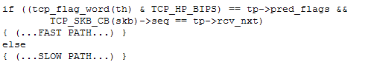
这个比较运算就是所谓的“Header Prediction”，它主要检查上述第①②④情况，其他会在FAST PATH中去检查。
Fast Path
如果Header Prediction通过了，表明当前TCP Instance的Receive Window不为0，且该Packet的SYN或URG或FIN或RST均没有置位，且该包是期望要接收的下一个 Packet，且Header中要么没有Option，要么除了Timestamp外，没有其他的Option，这时就开始进入Fast PATH的处理了(注：这时TCP State是ESTANBLISHED)
1) 首先它会检查TCP首部长度是不是只包含Timestamp Option(此时长度为32字节)，如果首部长度是32字节，但Option字段的内容并非是Timestamp，则跳转到Slow Path，否则处理Timestamp Option：
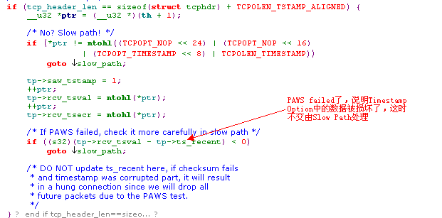
2) 接着检查整个Packet的长度是否小于等于Header的长度，如果等于Header长度，则表明该Packet是一个Acknowledge Packet；若小于Header的长度，则discard该Packet；
如果是Acknowledge Packet，它会调用tcp_ack()处理该Acknowledge Packet, 并释放该sk_buff，并调用tcp_data_snd_check()去检查是否有本地Packet需要发送(因为收到ACK会更新发送窗口tp->snd_una，通常是在tcp_ack()中更新发送窗口)，如果有则发送数据。所有这些都操作完成后，返回0：
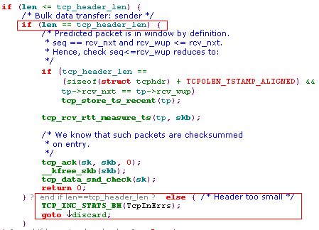
3) 如果Packet的长度大于Header的长度，则表明该Packet中包含有下一个所期望的数据(负载)，这时：
① 判断该payload是否可以直接copy到用户地址空间：
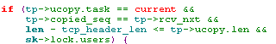
如果上述条件满足，则then the statistics of this connection are updated, the relevant process is informed, the payload is copied into the receive memory of the process, the TCP packet header is removed, and, finally, the variable with the sequence number expected next is updated：
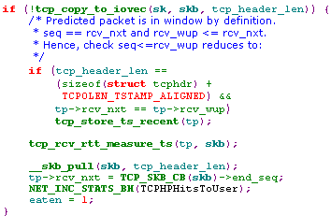
能拷贝到用户空间的数据一定是连续的。
若上述条件不满足，即the payload cannot be directly copied into the user-address space, then the availability of buffer memory in the socket is checked, statistical information is updated, the TCP packet header is removed, the packet is added to the end of the socket's receive queue, and, finally, the sequence number expected next is set：
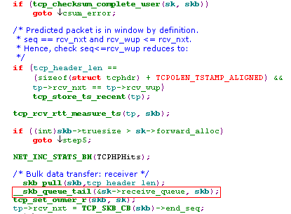
② 调用tcp_event_data_recv(),All management tasks arising from the receipt of a payload segment are completed in the tcp_event_data_rcv() function.
③ 检查tp->snd_una和Packet Header中的ACK Number是否一致，如果不一致，则需要处理该ACK，这个和第二步一样：
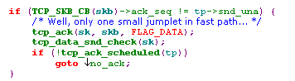
注：在tcp_ack()函数中handle了invalid ACK Number的情况。处理了ACK后，它会更改snd_una和snd_wnd，它也会更新congestion window, 这样就会改变发送的限制，所以这时调用tcp_data_snd_check(struct sock *sk)，去检查是否可以发送更多的数据:
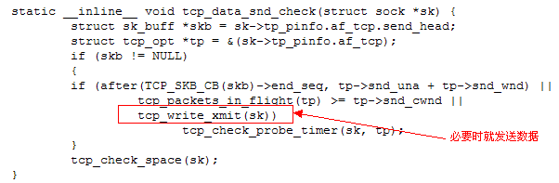
tcp_data_snd_check(sk) checks on whether data is ready and waiting in the transmit queue, and it starts the transmission, if permitted by the transmit window of the sliding-window mechanism and the congestion-control window. 它取出write_queue中的首个Packet，查看它的大小是否在transmit window以及congestion window的范围内，如果在，则调用tcp_write_xmit()发送它(该函数会连续发送write_queue中的数据直到条件不允许，或者transmit window或者congestion window)。
④ Finally, the process checks whether an acknowledgement has to be sent as response to the receipt of this segment, in the form of either Delayed ACK or Quick ACK。无论收到的Packet是否拷贝到了User-Address space, 都要发送ACK，或者Quick ACK或者Delayed ACK.
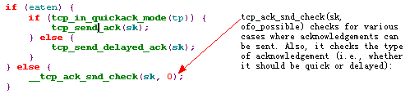
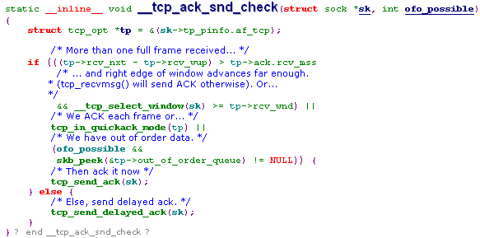
Slow Path
如果Header Prediction未通过，则进入Slow Path:
1) 检验TCP Header中的校验和。我们知道TCP Header的校验和是校验TCP Header+Data的，如果校验未通过，则Drop该Packet：
2) The Timestamp option is checked in tcp_fast_parse_options(), and the PAWS check works out whether the packet has to be dropped (tcp_paws_discard()):
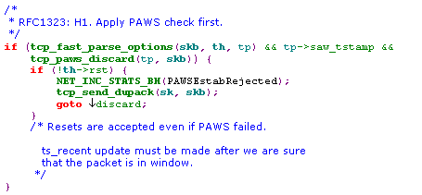
3) 判断收到的Packet的数据范围是否在有效的范围内，若不在，则立刻发送ACK：
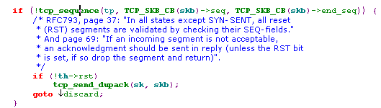
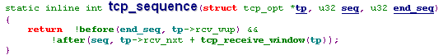
从代码可以看出，如果Packet的数据是已经确认过的数据，则会立刻发送ACK。
4) If the RST flag is set, tcp_reset resets the connection (changes connection state and deactivates timer), and the socket buffer is freed:
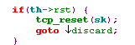
5) If the TCP packet header contains a Timestamp option, then tcp_replace_ts_recent() updates the recent timestamp stored locally:
6) If the SYN flag is set to signal an error case in an established connection, then tcp_reset() resets the connection: (在ESTANBLISHED状态下收到连接请求包的情况：)
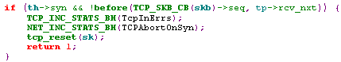
7) If the ACK flag is set, the tcp_ack() function processes the acknowledgement:
8） If the URG flag denotes that the packet contains priority data, then this data is processed in tcp_urg()：
9) Invoke tcp_data_queue() process the payload. Among other things, this includes a check for sufficient space in the receive buffer and insertion of the socket buffer into the receive queue or the out-of-order queue:
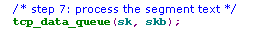
10) Finally, two methods, tcp_data_snd_check() and tcp_ack_snd_check(), are invoked to check on whether data or acknowledgements waiting can be sent.
补充资料：
tcp_data_queue(struct sock *sk, struct sk_buff *skb)处理payload，首先它判断palyload的内容是否为0，若是则直接Drop该Packet：
接着“脱壳”：
如果该Packet的内容是连续的话(tp->rcv_next==seq)，则这时和Quick Path中的流程一样，只不过需要检查Receive 窗口是否为0：
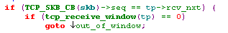
out_of_window的处理实际上就是drop该Packet，然后返回。
如果内容这时不连续，这时就要分成若干情况了：
Case 1: 如下图所示：
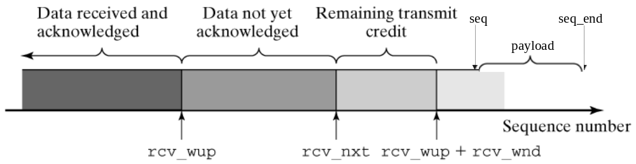
这时，会作为out of window进行处理：
Case 2： 如下图所示：
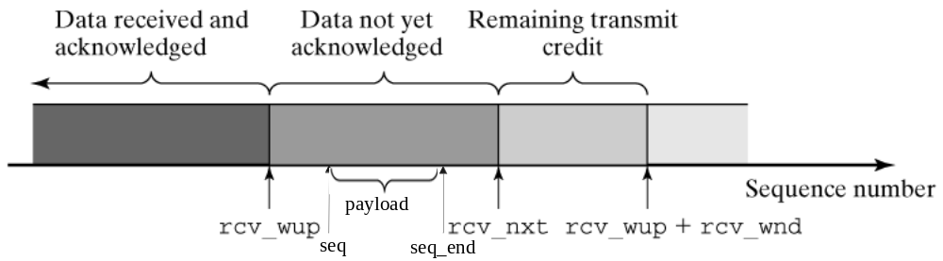
这表示数据retransmit过了，处理方法是Force an immediate ack：
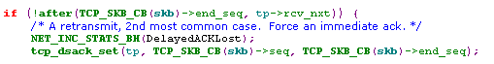
Case 3：如下图所示：
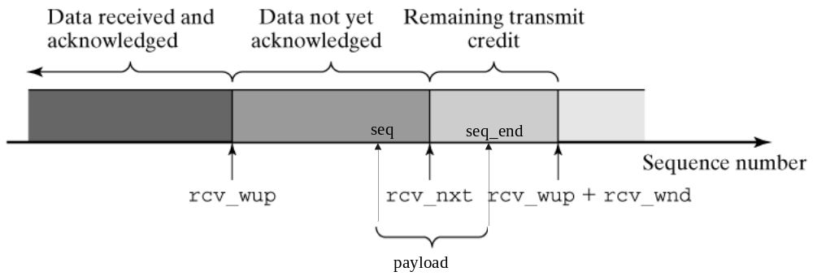
这里发生了overlap，处理会分成2个部分：会将[seq,rcv_nxt]的数据当做retransmit的数据，立即发送一个ACK，而将[rcv_nxt, seq_end]的数据作为内容连续时的操作：
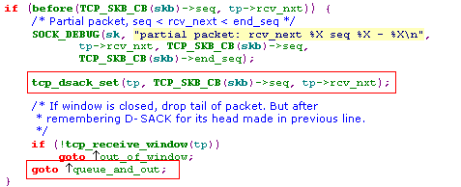
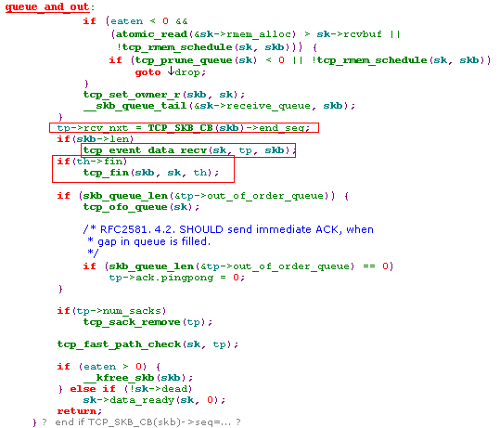
Case4：如下图所示：
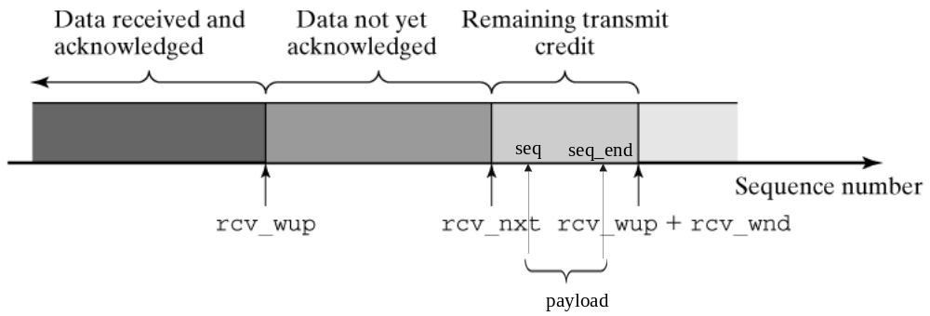
这时，会将该packet链入out-of-order queue中，这时会发送ACK(重复的ACK，ack Number都是rcv_nxt，因为收到失序的packet时，不会更新rcv_nxt)：
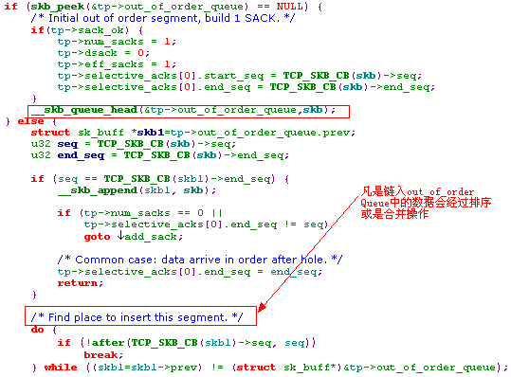
所有不连续的Packet放入out_of_order_queue中，当收到相应的“断片”时(rcv_nxt ~ seq)，会调用tcp_ofo_queue()从out_of_order Queue中找出可以merge的pakcet，然后一起处理，将整合出的packet链入receive_queue中。
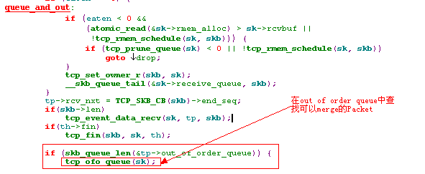
对于不连续的Packet，其实还有1种极端的情况，如下图所示：
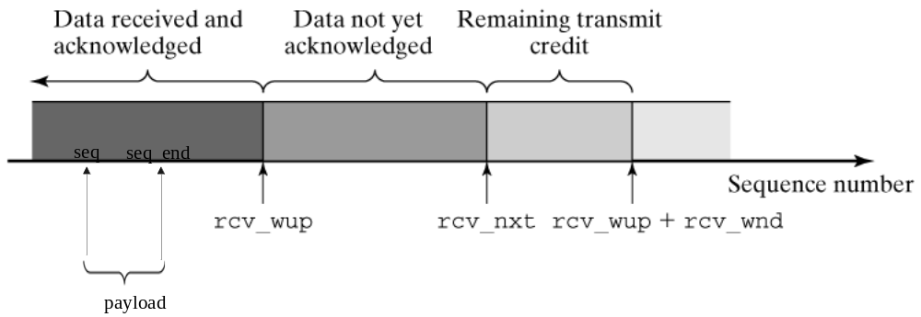
这表示收到了已经确认过的Data，这时会发送二次确认，然后drop它，而对这种情况的处理早在Slow path 第三步中就处理了：

1.2.2 Sending TCP Segments
This section describes how payload is sent over a TCP instance (i.e., how TCP segments containing payload are transmitted). The transmission of acknowledgements (ACKs) is initiated by incoming TCP segments or by the Delayed ACK timer.
系统调用sys_send(int fd, void * buff, size_t len, unsigned flags)作为Socket API的内部函数，如下所示：
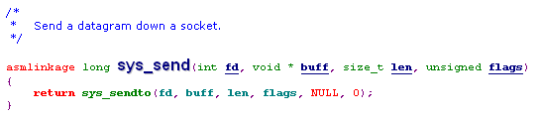
首先它根据fd(注：文件标示符，Unix中一切都用文件表示，当创建一个socket时，会返回一个相应的文件标示符，就像打开文件一样)找到相应的socket，即struct socket。一个TCP 连接对于TCP通信双方来说都有一个struct socket 结构，而每个struct socket结构引用一个struct sock结构，而sock结构中又引用一个tcp_opt结构，它是记录着该TCP连接的属性。若找不到相应的socket结构，则出错返回：
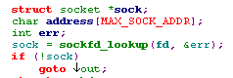
接着把要发送的数据的起始地址和大小等信息记录到一个struct iovec结构中：
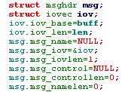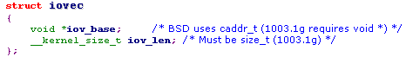
接着调用socket的操作集合中的sendmsg：
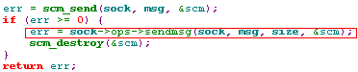
对socket进行操作的集合用一个struct proto_ops结构表示，其中的sendmsg和recvmsg就是用于发送和接收数据的：
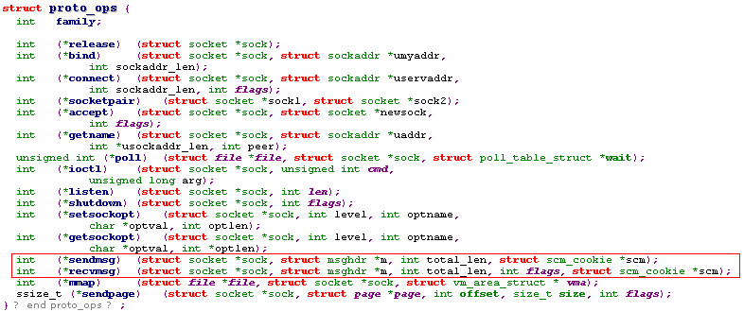
而每个socket对应的proto_ops结构是：inet_seqpacket_ops
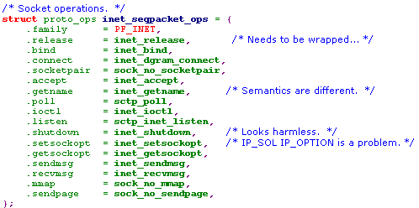
即对应的inet_sendmsg():
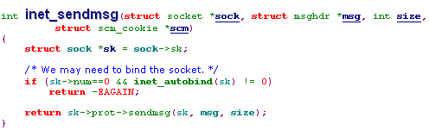
它主要调用sock结构中的prot函数指针集合的sendmsg，而对于每个sock结构来说，它的prot结构就是tcp_prot，即tcp_sendmsg:
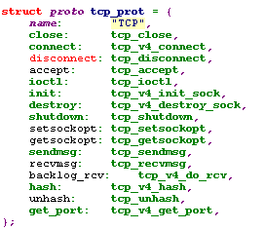
因此随后调用sendmsg(),即tcp_sendmsg(struct sock *sk, struct msghdr *msg, int size)。

tcp_sendmsg(struct sock *sk, struct msghdr *msg, int size)
1) 首先，it checks on whether the connection has already been established and on whether it is in the ESTABLISHED or CLOSE_WAIT state. If no connection has been established yet, the system call waits in wait_for_tcp_connect() for a connection：
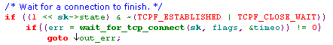
注：如果当前的状态不是ESTABLISHED或CLOSE_WAIT，则根据打开socket时NON_BLOCK标志设置与否来调用wait_for_tcp_connect()：如果NON_BLOCK标志置位，则直接返回-EAGAIN，如果没有置位，则一直等待直到状态为ESTANBLISHED或CLOSE_WAIT，在等待的过程中，如果状态变成了FIN_WAIT1或FIN_WAIT2或TIME_WAIT或LAST_ACK或CLOSED或CLOSING，则返回-EPIPE:
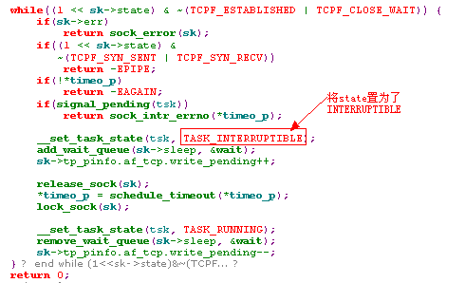
2) 接着调用tcp_current_mss(sk)得到当前的MSS值(TCP segment数据部分的最大长度)。在sock结构的transmit queue(sk->write_queue)里有很多待发的packet，它是一个链表，这个链表的元素都是sk_buff结构，新的sk_buff结构总是插入链表的尾部(FIFO)，早来的早发。如果此时write_queue中为空，则立刻分配一个sk_buff，否则检查write_queue中的最后一个sk_buff的数据长度是否超过了MSS：如果超过了则重新分配一个sk_buff(它的数据空间大小为MSS)，把待发数据从用户空间拷贝到sk_buff中；如果没有超过，则将数据拷贝到该sk_buff中，直到把它填满(达到MSS值)，如果数据还没有拷贝完，则重新分配一个sk_buff，将剩下的数据拷贝进去。这样做的结果是write_queue中每个sk_buff的数据部分，除了最后一个外全是满的(达到MSS值)，有效利用了空间。
3) 在利用系统调用sys_send()发送数据时，如果flag中有MSG_OOB，则表示发送的数据时urgent data，则包含该数据的sk_buff结构需要更新TCP Header中的Urgent Pointer；另外如果flag中无MSG_MORE标志或者write_queue中的数据过多,远远超过已push过的数据时，会自动给sk_buff的TCP Header中加入PUSH标志。关于PUSH标志是内核根据write_queue中的情况自动识别添加的，而Urgent Pointer则需要flag中有MSG_OOB标志：
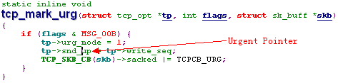
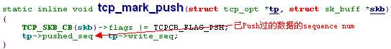
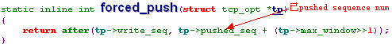
4) Finally, the __tcp_push_pending_frames() routine takes TCP segments from the socket transmit queue (tp->write_queue) and starts sending them.
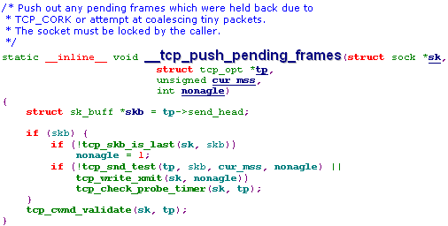
- 首先它取出write_queue中的第一个未发出的Packet，调用tcp_snd_test(tp, skb, cur_mss, nonagle)检查此刻是否可以发送该Packet：It verifies the criteria specified in RFC 1122 to ensure standard-compliant behavior and, mainly, that there is sufficient space in transmit and congestion-control windows and what the Nagle algorithm says with regard to sending this packet.(这里检查会用到Send Window——看每个packet的right edge是否超出了发送窗口和拥塞控制——Nagle算法)。
- 如果可以发送，则调用tcp_write_xmit(sk, nonagle)：只要当前的TCP State不是TCP_CLOSE (即使到了TIME_WAIT状态，也可以发送ACK) ，它就会持续从write_queue中取得Packet，每取一个，都调用tcp_snd_test()检查是否可以发送，如果可以则调用tcp_transmit_skb()发送它，然后再取下一个，再检查，再发送：
注：即使不能发送，它也已经放在write_queue中了。
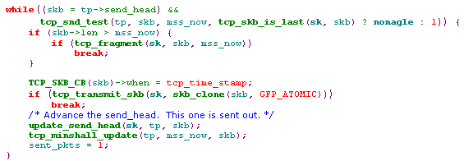
注：Data segments can also be fragmented (tcp_fragment()) before the maximum segment size is exceeded.
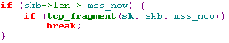
MSS是传输层协议对从应用层传递来的数据大小的一种约束。如果传递下来的数据大于MSS，则需要分段。与MSS密切相关的一个参数是网络设备接口的MTU，以太网的MTU是1500(MTU不包括Mac Header)，基本IP首部长度为20，TCP首部是20，所以MSS的值可达1460(MSS不包括协议首部，只包含应用数据)。如果存在IP option或者TCP Option的话， MSS会相应减少。
之前我们是根据tp->mss_cache的值将要发送的数据添加到sk_buff中的，因为每个network device对应的MSS是不一样的，经过路由选择后，相应的MSS会发生变化（发生变化时，会更新tp->mss_cache的值）。如果发生了变化(dst->pmtu != tp->pmtu_cookie)，就要查看当前skb的长度是否超过了新的MSS，若超过了，则调用tcp_fragment()。
tcp_fragment()的作用就是将一个skb分解为2个skb，保证这两个skb的长度不超过当前的MSS，且它们的TCP Header的内容作了相应的修改(主要修改序号部分，但源/目的端口号不变)，
- tcp_transmit_skb(sk, skb) is responsible for completing the TCP segment in the socket buffer, skb, and for subsequently sending it over the Internet Protocol(会调用ip_queue_xmit()).
注：tcp_transmit_skb()有很多函数会调用它，这里只考虑在ESTABLISHED状态下，发送正常Packet的情形(可能有ACK标志，或者Urgent Pointer)。事实上如果发送SYN或者FIN或者发送单独的ACK都会调用tcp_transmit_skb().所以该函数需要Cover各种不同的情形。我们介绍后面的章节后再来讨论它。这里先说个大概：
该函数里不会做任何有关是否能够发送的检查，只有这些检查通过的情况，才会调用它。tcp_transmit_skb(sk, skb) is responsible for completing the TCP segment in the socket buffer, skb, and for subsequently sending it over the Internet Protocol. To this end, it first fills the TCP packet header with the appropriate values from the opt structure (tcp_opt结构，每个TCP socket都有对应一个tcp_opt结构)—for example, much like an explicit transmit credit specified by tcp_select_window(). tcp_syn_build_options()(MSS选项) registers the TCP options for SYN packets, and tcp_build_and_update_options() registers the options for all other packets.
Subsequently, all actions required to send a payload-carrying segment or a segment with its ACK flag set are executed:
- If the ACK flag is set, the number of permitted Quick ACK packets is decremented in the tcp_event_ack_sent() method (provided that the connection is in the Quick ACK mode). Subsequently, the timer for delayed ACKs is stopped, because the next step sends an acknowledgement.(讲述了Delayed ACK后再来看它)
- If the segment to be sent carries payload, we first have to check for whether an interval corresponding to the retransmission timeout has elapsed since the last data segment (stored in tp->lsntime) was sent. If this is the case, then the congestion window, snd_cwnd, is set to the minimum value (tcp_cwnd_restart), as specified in RFC 2861.
Subsequently, the function pointer tp->af_specific->queue_xmit()，which references the corresponding transmit function—depending on the Internet Protocol version (e.g., ip_queue_xmit() for IPv4)—passes the socket buffer to the IP layer for transmission.
Finally, the tcp_enter_cwr() method adapts the threshold value for the slow-start algorithm. This completes the transmit process for the TCP segment within the TCP instance, unless no acknowledgement arrives for this packet during the retransmission timeout, so that it would have to be retransmitted.
推测：只有发送了的Packet得到了确认，不然，它会一直呆在write_queue中，随时需要retransmit。
重复一遍，一个TCP 连接对于TCP通信双方来说都有一个struct socket 结构，而每个struct socket结构引用一个struct sock结构，而sock结构中又引用一个tcp_opt结构，它是记录着该TCP连接的属性。无论接收还是发送Packet，都缓存在sock结构的receive_queue和write_queue中。
每个TCP连接都有自己的输出缓冲区和输入缓冲区：其大小以tcp_opt结构的sndbuf字段和rcvbuf字段标识(bytes)，另外，也有receive_queue和write_queue维护输出Packet队列和输入Packet队列，它们之间的结构关系如下：
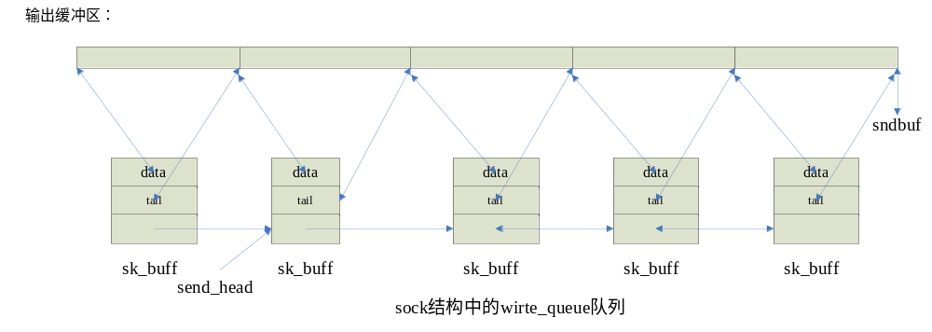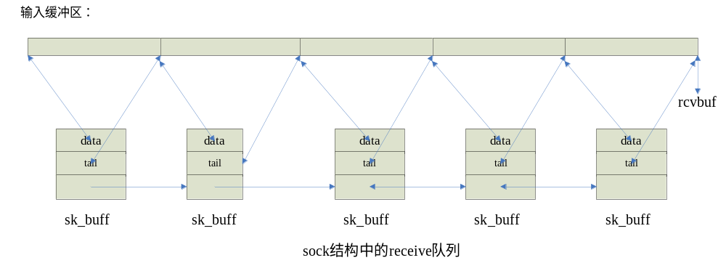
其中sk_buff结构是从socket buffer cache分配的，如果该cache没有，则调用kmalloc请求内存。
TCP instance是以一个packet为单位发送，且Packet的数据长度多数情况下都达到了MSS长度(MSS长度与MTU密切相关)，除了最后一个Packet可能没满。当发送一个packet时，它会检查是否可以这个packet，从拥塞控制、nagle算法，发送窗口各个方面检查，如果通过，就发送该packet，否则不发送。
不能发送的packet会一直留在write_queue中；即使发送出去了，也要等到对方收到并收到相应的ACK后才能从write_queue中释放：当收到相应的ACK更新后，它会更新snd_una以及发送窗口大小，然后查看在write_queue所有end_seq小于ACK num的packet，并将它们从write_queue中释放：
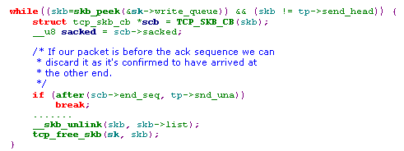
自顶向下，看看user process是如何发送数据的：
  - 调用API send()或sendto()，并将相关socket的fd、用户数据指针以及长度作为参数传递。
  - 进入系统调用的内核实现部分：先通过fd找到相应的socket数据结构，然后将用户数据的指针以及长度放入一个iovec的结构中。
  - 调用tcp_sendmsg：当前的socket的state不是ESTABLISHED，则会进入INTERUPTIBLE等待；如果是就将用户数据拷贝到一个sk_buff中，并添加到write_queue中的尾部（该sk_buff可能是一个新的sk_buff，也可能是队列中最后一个sk_buff），总的说来，write_queue中只可能最后一个sk_buff没有填满(填满的意思是数据部分达到MSS)。send_head是write_queue中没有发送的第一个packet，这时陆续将从send_head开始，陆续发送write_queue中的packet，直到不能发送为止(拥塞控制，发送窗口或nagle算法)。
- 每次发送一个Packet都是调用ip_queue_xmit()，它为该packet选择路由加上相应的IP Header后，就调用dev_queue_xmit(dev)将该packet链入相应网络设备的output queue中，依次从该网络设备的output queue中取出packet，调用dev-> hard_start_xmit(skb, dev)将该packet发送出去，直到达到流量控制的限制或网络设备的环形缓冲区满为止。
● dev-> hard_start_xmit(skb, dev)将该Packet链入环形缓冲区中，然后给网络适配器发送传输命令，然后返回。注：只有当环形缓冲区不为满时才会调用dev->hard_start_xmit(skb, dev)，因此hard_start_xmit中并不检查环形缓冲区是否为满，它默认环形缓冲区不满。
4) 返回。这时相关的数据已经写入一个sk_buff中，且该sk_buff已经处于write_queue队列中，可能该sk_buff没有真正被发送出去(拥塞控制 /*以后发送窗口更新或拥塞"解除"时会继续发送的。比如内核收到一个packet，软中断中处理该packet时发现ACK置位，这时它会调用tcp_ack()处理该Acknowledge Packet, 并释放该sk_buff，并调用tcp_data_snd_check()去检查是否有本地Packet需要发送(因为收到ACK会更新发送窗口tp->snd_una，通常是在tcp_ack()中更新发送窗口)，如果有则发送数据*/ 或者已处于网络设备的output queue中，但网络设备的环形缓冲区已满 /*以后会利用不同时刻的软中断来继续发送的*/)。返回值是写入数据的大小（已链入write_queue队列中的数据大小），可能返回值小于参数length(欲写入的长度)，因为缓冲区 e已经满了。
注：对于非阻塞IO，遇到sock状态错误(不处于TCP_ESTABLISHED或TCPF_CLOSE_WAIT状态)或输出缓冲区满情况下，会直接返回错误或已发送的数据的长度；对于阻塞IO，遇到这样情况，会阻塞当前进程(TASK_INTERUPTIBLE)直到状态和缓冲区符合条件。
自下而上，看如何接收数据：
- 当网卡收到Packet时，会产生一个中断，中断处理程序首先分配一个sk_buff结构，然后将收到的数据拷贝到sk_buff结构的数据部分，然后将sk_buff链入Per-CPU变量softnet_data[cpu].input_pkt_queue中。每个CPU都有一个input queue,当前CPU接收的packet就放到该CPU的input queue中；最后trigger软中断NET_RX_SOFTIRQ。中断程序结束。
- 软中断NET_RX_SOFTIRQ处理程序net_rx_action()会从当前CPU的input queue中一个一个取出Packet进行处理，直到处理Packet的时间(for 循环的时间)超过1个滴答或是已经处理了net_dev_max_backlog(300)个包。每次处理Packet的过程如下：
分析帧头得出处理函数为ip_rcv() -------→ 查找路由信息后，得出处理的函数为ip_local_deliver() -----→ 从IP Header中的protocol字段得出下一个处理函数为tcp_v4_rcv() ------→ 如果当前state为ESTABLISHED，则将该packet链入receive_queue中并更新相关的管理数据。
3) 用户进程调用API read()读取某个socket的数据时，就查看receive_queue中packet，并读取其中的数据，已读完的packet就从receive_queue中释放，并更新接收窗口rcv_wnd的值(在发给对方的Packet中的TCP Header的window字段)

1.3 Connection Management
TCP协议是面向连接的。为了维护连接的可靠性，它给一个TCP 连接定义了12种状态。这一节主要介绍这12种状态以及状态是如何变化的。
一个TCP连接的状态放在它对应sock结构的state字段中。总的来说一个TCP连接的状态分为三个阶段：建立连接阶段，数据传输阶段和终止连接阶段。根据当前连接的状态，对收到的Packet的处理是不同的。
The tcp_rcv_state_process() function handles mainly state transitions and the management work for the connection. Depending on the connection state, there are different actions when a packet is received:
- In the CLOSED state: The packet is dropped.
- In the LISTEN state: If ACK or SYN flags are set, then the connection establishment is registered, and data is ignored.
注：连接建立阶段只focus Packet Header中的ACK或SYN标志，忽略payload
- In the SYN_SENT state: tcp_rcv_synsent_state_process() checks for correct connection establishment, and the connection is moved to the ESTABLISHED state. If this fails, then the remaining flags are processed.
- If the PAWS check finds an error, then a DUPACK is returned, and the function is exited.
- Subsequently, the sequence number is checked, and if a packet arrived out of order, then a DUPACK is returned and the packet is dropped.
- If the RST flag is active, the connection is reset and the packet is dropped.
- If a timestamp is present in the segment header, the recent timestamp stored locally is updated.
- If the SYN flag is set, but invalid due to the sequence number, the connection is reset and the packet is dropped.
- If the ACK flag is active, the next action is different, depending on the state:
  - In the SYN_RCVD state: The connection state changes to ESTABLISHED, and the acknowledgement is processed.
  - In the FIN_WAIT_1 state: The connection state changes to FIN-WAIT2 and the TIMEWAIT timer is set.
  - In the CLOSING state: Transition to the TIMEWAIT state occurs, if the packet is not out of order.
  - In the LAST_ACK state: The socket is reset, and the state changes to the CLOSED state, if the packet is not out of order.
- If the URG flag is active, then the urgent data is processed (by the tcp_urg() function).
- If the packet contains payload, then this data is processed or dropped, or an RST packet is sent, depending on the connection state.
- The packet is deleted in all other cases.

1.3.1 Establishing a Connection
通信两端利用TCP传输数据必须首先建立连接。涉及建立连接的4种State如下：
- TCP_LISTEN: After passive opening, the local TCP waits for a SYN as a request to establish a connection.
注：当passive opening后，状态就变成了TCP_LISTEN. 一般是服务器程序调用listen()系统调用将state从TCP_CLOSE变成TCP_LISTEN.
- TCP_SYN_SENT: After sending a SYN, the local TCP waits for a connection establishment by the TCP instance of the communication partner.
注：一般发生在client主动连接Server时，这时会调用tcp_v4_connect()，它先将状态变成TCP_SYN_SENT，然后调用tcp_connect()去发送了一个SYN Packet.
- TCP_SYN_RECV: The local TCP waits for an acknowledgement that the connection has been established (ACK and SYN).
注：When the TCP in the server receives the SYN character in the LISTEN state, it changes to the SYN_RECV state. 接着再发送SYN+ACK给另一端。
- TCP_ESTABLISHED: The connection is established, and the two communicating partners can exchange data; the connection-establishment phase was exited.
当初始化一个sock结构的时候，将state设置为TCP_CLOSE。
下面介绍在建立连接阶段，各个状态的变化。
- Transition from TCP_CLOSE to TCP_SYN_SENT
To establish the connection, the client sends a packet with the SYN flag set, and then changes from the TCP_CLOSE state to the SYN_SENT state.当调用Socket API中的 connect时，内核会调用tcp_v4_connect()，该函数首先会设置TCP状态为TCP_SYN_SENT，然后调用tcp_connect()函数，该函数会发送一个SYN标记的Packet。
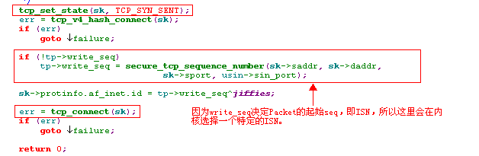
- Transition from TCP_LISTEN to TCP_SYN_RECV
Server端应用程序会调用listen()这个Socket函数，将该TCP连接状态置为TCP_LISTEN. 这时如果收到了一个SYN的Packet，这时就会分配一个新request sock结构，其state是TCP_NEW_SYN_REC,该sock结构随着请求信息链入了半连接队列中，并用该新sock结构向另一端发送SYN+ACK。
注：同样在向另一端发送SYN时，也会选择ISN。

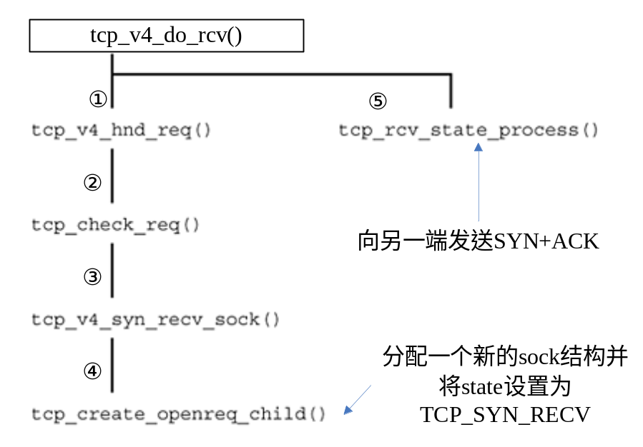
- Transition from TCP_SYN_SENT to TCP_ESTABLISHED
After it has received a packet with the SYN and ACK flags set, the client TCP sends an ACK to the server and changes from the TCP_SYN_SENT state into the TCP_ESTABLISHED state:
注：从代码上看，是先改变状态，然后发送ACK。
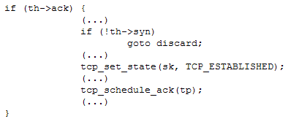
- Transition from TCP_SYN_RECV to TCP_ESTABLISHED
From the TCP_SYN_RECV state, the server switches to the TCP_ESTABLISHED state as soon as it receives an ACK character(Server的request sock接到这个ACK，然后间接从半连接队列中找到对应的监听套接字，监听套接字处理这最后的ACK，这时会生成真正的新套接字，并新套接字状态设置为TCP_ESTABLISHED，并将其链入ehash[]链表中):
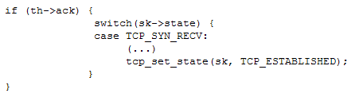
- Transition from TCP_SYN_SENT to TCP_SYN_RECV （非典型情况）
If client TCP is in TCP_SYN_SENT state and receives only one packet with the SYN flag set, it returns a packet with the SYN and ACK flags set to the server and changes into the TCP_SYN_RECV state. This happens when both TCP protocol instances start establishing a connection simultaneously. 也就是说两端同时调用connect()将state置为TCP_SYN_SENT并向对方发送SYN Packet，然后它们各自都收到了相应的SYN Packet，这时会将State设为TCP_SYN_RECV，并向对方发送SYN+ACK。
同时打开就没有所谓Server和Client端的概念了。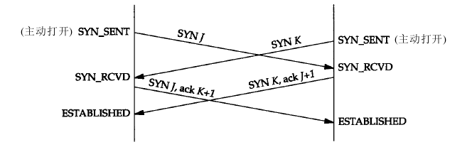

1.3.2 Tearing Down a Connection
A connection between two communicating partners can be terminated in either of two different ways: graceful close and abort.
- Graceful close: The higher-layer protocols of both computers start tearing down the connection either simultaneously or consecutively. TCP monitors this process and ensures that the connection is not disestablished unless all data has finally been transmitted.
- Abort: A higher-layer protocol forces the establishment to be torn down. In this case, the process of tearing down a connection is not monitored, and so data can be lost.
涉及到终止一个连接的状态一共有7种：TCP_FIN_WAIT1，TCP_FIN_WAIT2，TCP_TIME_WAIT，TCP_CLOSE，TCP_CLOSE_WAIT，TCP_LAST_ACK，TCP_CLOSING。
下面看看各种状态之间的转换：
- Transition from TCP_ESTABLISHED to TCP_FIN_WAIT1
我们首先假定通信双方的状态都是TCP_ESTABLISHED,当一方想终止向对方发送数据就可以发送一个FIN来终止这个方向上的连接。通常情况下，发送FIN是应用层关闭的结果。
Specifically, a computer, A, initiates the connection closing by sending a packet with the FIN flag set to computer B and then switches to the TCP_FIN_WAIT1 state.
无论是通过tcp_close()还是tcp_shutdown(),它们都会执行下面的语句：
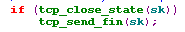
当TCP的state是TCP_ESTABLISHED，通过tcp_close_state()将state变为TCP_FIN_WAIT1，接着向对方发送FIN。发送FIN时有两种情况：如果当前write_queue里没有Packet了，就单独创建一个skb作为FIN发送出去；否则取出write_queue中的第一个Packet ，设置它的Header中的FIN标志，这是最后一次从write_queue中发送Packet了。
即使现在的状态是TCP_FIN_WAIT1，它还是可以接收Packet的。但它不能发送Packet了。发送TCP Segment的State必须是TCP_ESTABLISHED或TCP_CLOSE_WAIT。
- Transition from TCP_ESTABLISHED to TCP_CLOSE_WAIT
如果一方收到一个Packet且设置了FIN标志，则它将state从TCP_ESTABLISHED 变为TCP_CLOS_WAIT，然后发送ACK：
从代码的角度看，其代码调用轨迹如下：
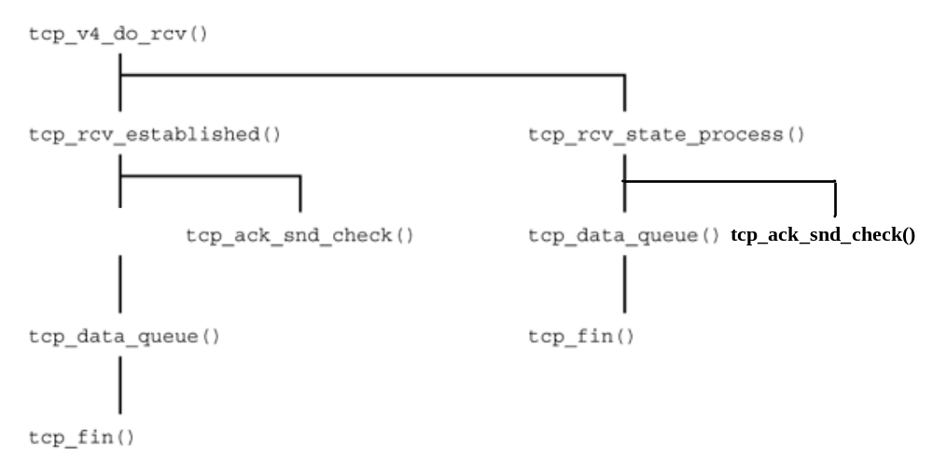
尽管现在的State变成了TCP_CLOSE_WAIT，但它还是可以通过tcp_sendmsg()发送Packet的。但是它是不能接收新的Packet的(即seq>=rcv_nxt，ACK除外)：
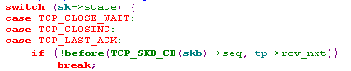
- Transition from TCP_FIN_WAIT1 to TCP_FIN_WAIT2
当B收到相应的ACK后(A发送给B的FIN的相应ACK)，会将state从TCP_FIN_WAIT1变为TCP_FIN_WAIT2：
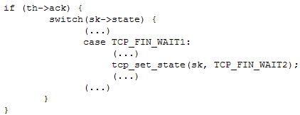
即使状态变成了TCP_FIN_WAIT2，但它还是可以正常接收Packet的。只是它不能发送Packet了。
- Transition from TCP_CLOSE_WAIT to TCP_LAST_ACK
While in the TCP_CLOSE_WAIT state, TCP tries to pass all data from the receive buffer to the higher-layer protocol as quickly as possible. TCP sends a FIN character to the TCP in computer A only if the local application in computer B has no more data to send. This confirms the connection teardown process, and the TCP in computer B switches to the LAST_ACK state.
同样是调用这两个Function，前者将state从TCP_CLOSE_WAIT变成TCP_LAST_ACK，后者发送一个带有FIN标志的Packet，这里同样看write_queue中是否还有Packet，如果没有则新分配一个skb，否则单独从write_queuq中取出第一个Packet并设置FIN标志。
状态是TCP_LAST_ACK时，它不能发送Packet且也不会接收任何新数据了(ACK除外)。
- Transition from TCP_FIN_WAIT2 to TCP_TIME_WAIT
As soon as the TCP in the TCP_FIN_WAIT2 state in computer A receives a FIN character from computer B, it sends an ACK and switches into the TCP_TIME_WAIT state:
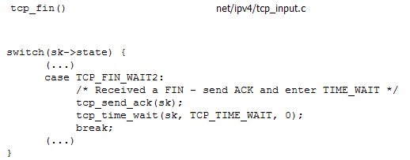
TCP_TIME_WAIT一个特殊的状态，后面将要讲述它。
- Transition from TCP_LAST_ACK to TCP_CLOSE
目前state是处于TCP_LAST_ACK，当它收到对方最后发送的ACK后，它将状态置为TCP_CLOSE.
- Transition from TCP_FIN_WAIT1 to TCP_TIME_WAIT
目前TCP的状态是TCP_FIN_WAIT1，这时如果它收到了一个Packet，它的ACK和FIN标志同时存在，这时它首先将状态变成TCP_FIN_WAIT2(Response to ACK), Immediately afterwards, the function tcp_rcv_state_process() uses tcp_data_queue() to invoke the tcp_fin() function, if a FIN was set additionally. Next, an ACK is sent from within the tcp_fin() function, and the state is moved to TCP_TIME_WAIT(Response to FIN).
- Transition from TCP_FIN_WAIT1 to TCP_ CLOSING (非典型)
Transition from TCP_CLOSING to TCP_TIME_WAIT(非典型)
这2种状态的改变涉及到一个非典型的情况——同时关闭：
当应用层发出关闭命令时，两端均从TCP_ESTABLISHED变为TCP_FIN_WAIT1。这将导致双方各发送一个FIN，两个FIN经过网络传送后分别到达另一端。收到FIN后，状态由TCP_FIN_WAIT1变迁到TCP_CLOSING，并发送最后的ACK。当收到最后的ACK时，状态变化为TCP_TIME_WAIT:
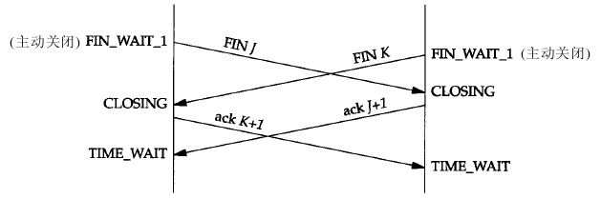
最后我们来看看TCP_TIME_WAIT状态的一些性质:
1) 当state处于TCP_TIME_WAIT时，必须在TCP_TIME_WAIT状态下停留2倍的MSL(Maximum Segment Lifetime)，这样可以让TCP再次发送最后的ACK以防止它丢失。
2) 正常情况下只有在Client执行主动关闭才有可能进入TCP_TIME_WAIT状态(同时关闭是个例外)，Server是执行被动关闭的，通常不会进入该状态，这就暗示如果我们终止一个客户程序，并立即启动这个客户程序，这个新客户程序不会重用相同的本地端口。(处于TCP_TIME_WAIT状态的连接，它所使用的socket pair——两端的IP地址和端口号均不能被再用，四元组不能完全相同，另一端的IP地址和端口号不会变，这里主要是指本端的IP地址和端口号)。而Server不一样，它们的端口号都是固定的，所以当服务器程序终止一个已经建立连接时，并试图重新启动这个连接时，因为这时还处于TCP_TIME_WAIT状态，服务器程序不能把它这个固定端口赋予它。
3) 在连接处于2MSL等待时，任何迟到的Packet都被丢弃。因为处于2MSL等待的，由该socket pair定义的连接在这段时间不能再用，因此当要建立一个有效的连接时，属于较早的连接(相同的socket pair)的迟到Packet都会被丢弃。
4) 处于2MSL等待状态时，是不能发送任何Packet的。可以在特定的条件下可以接收如下Packet： a SYN packet, SYN-ACK packet, and a RST packet. The connection is reestablished when an SYN packet arrives under certain conditions. Also, an ACK is sent as a response to a SYN-ACK packet under certain conditions. In contrast, an RST packet is normally sent as a response to an RST packet.
5) 当2MSL时间超过的时候，会将该连接状态从TCP_TIME_WAIT变成TCP_CLOSE。

[补充阅读]
当一个socket关闭的时候，是通过两端互发信息的四次握手过程完成的，当一端调用close()时，就说明本端没有数据再要发送了。这好似看来在握手完成以后，socket就都应该处于关闭CLOSED状态了。但这有两个问题，
第一：我们没有任何机制保证最后的一个ACK能够正常送达
第二：网络上仍然有可能有残余的数据包(wandering duplicates，或老的重复数据包)，我们也必须能够正常处理。
假设最后一个ACK丢失了，服务器会重发它发送的最后一个FIN，所以客户端必须维持一个状态信息，以便能够重发ACK；如果不维持这种状 态，客户端在接收到FIN后将会响应一个RST，服务器端接收到RST后会认为这是一个错误。如果TCP协议能够正常完成必要的操作而终止双方的数据流传输，就必须完全正确的传输四次握手的四个节，不能有任何的丢失。这就是为什么socket在关闭后，仍然处于 TIME_WAIT状态，因为他要等待以便重发ACK。
如果目前连接的通信双方都已经调用了close()，假定双方都到达CLOSED状态，而 没有TIME_WAIT状态时，就会出现如下的情况: 现在有一个新的连接被建立起来，使用的IP地址与端口与先前的完全相同，后建立的连接又称作是原先连接的一个化身。还假定原先的连接中有数据报残存于网络之中，这样新的连接收到的数据报中有可能是先前连接的数据报。为了防止这一点，TCP不允许从处于 TIME_WAIT状态的socket建立一个连接。处于TIME_WAIT状态的socket在等待两倍的MSL时间以后（之所以是两倍的MSL，是由于MSL是一个数据报在网络中单向发出到认定丢失的时间，一个数据报有可能在发送途中或是其响应过程中成为残余数据报，确认一个数据报及其响应的丢弃需要两倍的MSL），将会转变为CLOSED状态。这就意味着，一个成功建立的连接，必然使得先前网络中残余的数据报都丢失了。
由于TIME_WAIT状态所带来的相关问题，我们可以通过设置SO_LINGER标志来避免socket进入TIME_WAIT状态，这可以通过发送RST而取代正常的TCP四次握手的终止方式。但这并不是一个很好的主意，TIME_WAIT对于我们来说往往是有利的。

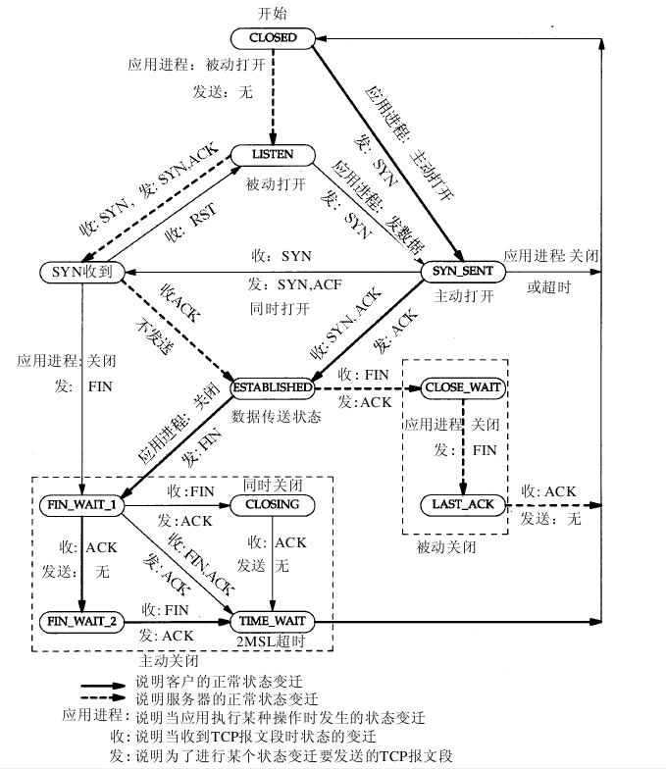

1.4 Protocol Mechanisms for Data Exchange
1) Flow Control
Consequently, flow control can be used to prevent the receive buffer of a receiving TCP instance from overflowing, which would cause additional incoming packets to be dropped (参见tcp_data_queue()中out_of_window的处理). To implement flow control, the TCP protocol uses the sliding-window mechanism. This mechanism is based on the assignment of explicit transmit credits by the receiver. (接收者明确定义一个接收窗口，其大小作为transmit credit)
下图分别从Sender和Receiver的角度来看Flow Control是如何实现的：
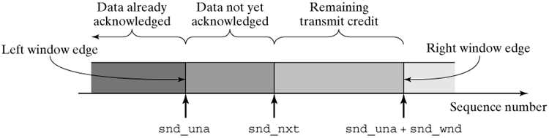
图1 View from Sender
snd_una和snd_nxt都是tcp_opt结构中的字段，snd_una指示了已发送数据并得到了ACK确认的序号(这个字段一般在处理ACK确认时更新)；而snd_nxt则只是已发送数据还没得到ACK确认的序号（这两个的值可能相等）。snd_wnd是可发送窗口，这个字段是根据收到的tcp segment header中的window字段更新的（通常在收到ACK并处理ACK时更新：tcp_ack()->tcp_ack_update_window()）。要发送的Packet会一直呆在write_queue中，直到该Packet对应的序号已经得到确认(end_seq<snd_una)，这时会将该Packet从write_queue中移除。

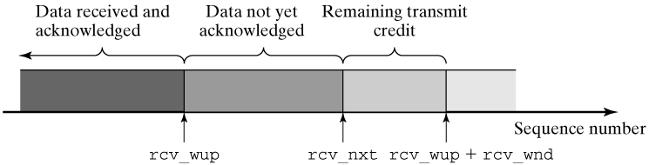
图1 View from Receiver
rcv_wup和rcv_nxt都是tp_opt中的字段。rcv_wup字段代表数据已收到并已发送了ACK的序号；rcv_nxt表示已收到数据但还没有发送ACK的序号(由于Delay ACK机制的存在，这两个值可能不等，rcv_nxt只在收到连续的Packet时才会更新。连续是指序号连续)。rcv_wnd代表接受窗口的大小，它主要是由Receiver Buffer中的空间大小决定，在发送Packet时，会时刻更新该rcv_wnd来作为Header中的window字段的值:
只要用户进程不从Receive Buff中读取出数据，则这些Packet会一直在receive_queue中。
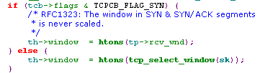
- 确定snd_wnd
前面已经讲过，snd_wnd是在处理ACK的过程中设定的 tcp_ack()->tcp_ack_update_window()：
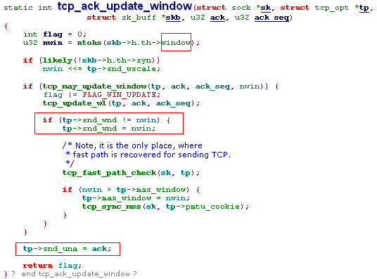
它根据ACK中的window字段来设定snd_wnd，且根据ACK字段设定snd_una。
tcp_ack()只会处理确认序号在(snd_una, snd_nxt)之间的ACK Packet
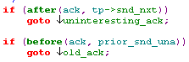
- 确定rcv_wnd
每当调用tcp_transmit_skb()发送一个Packet时(无论它是SYN Packet还是FIN Packet或者Payload Packet，ACK Packet)，它都会调用tcp_select_window()去更新rcv_wnd，并将rcv_wnd设置为Header的window字段 (window字段指示receive buffer中还剩下多少字节， window字段值决定对方的发送窗口snd_wnd的值)：
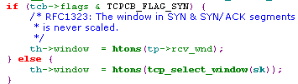
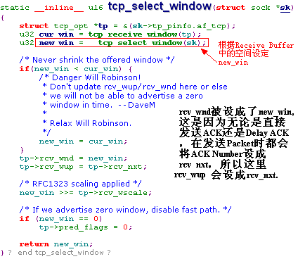
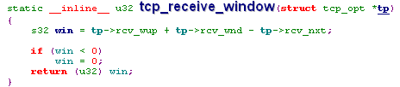

2) Zero-Window Probing
想象这样的情形，如果Receiver中没有可用的Receiver Buffer了，这时the sender receives an acknowledgement with a new advertising window having size 0, which means that it must not send more data. (snd_wnd只能在处理ACK时更新)。现在sender不能发送数据了，它唯一能做的是receive a new window size (i.e., a new transmit credit) only together with a new packet. If the receiver does not have data to send, or if it was also granted a window having size 0, then the two communicating partners would wait eternally to be able to continue sending data. 这就像发生死锁一样了。
可以利用Zero-Window Probing来解决这个问题。
它的原理是这样的：This mechanism is based on an additional timer, the probe timer. When this timer expires, a TCP packet is sent even the advertising window has size 0. This packet consists only of a packet header; it does not carry payload, because data must not be transmitted in this situation. The communication peer acknowledges this packet, and, if the other end was able to remove its congestion, at least to some extent, in the meantime, then a window larger than 0 is granted together with this acknowledgement, so that the transmission of data can be resumed. If the window size 0 occurs again, then the communication peers have to wait until the probe timer expires to send another probing packet. (总是snd_wnd为0的那一方发送probing packet) 。
当probe timer 到期时，相应的Handler是tcp_probe_timer(), 如果数据发送出去了没有收到ACK(注:tp->packets_out: snd_una后面的数据包, snd_nxt-snd_una)或者没有Packet需要发送(write_queue为空)，则清空计数器probes_out并返回(因为可以通过收到ACK来更新snd_wnd)：
注：probes_out计数器是记录发送probe packet的次数。
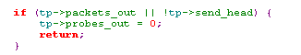
另外如果多次发送probe packet(超过了15次)，则表明该TCP连接存在严重的问题，这时打印一个错误消息并通过tcp_done()关闭该连接：
如果probe_out还没有到达15，则调用tcp_send_probe0(sk)去发送一个没有payload的TCP segment。
tcp_send_probe0() 首先调用 tcp_write_wakeup(sk)发送一个没有payload的TCP segment，此时如果还有数据发送出去了没有收到ACK或者没有Packet需要发送(write_queue为空)，则清空计数器probes_out并返回； Otherwise, these parameters are incremented after a probe packet has been sent, and the zero-window probe timer is restarted, so that it expires again after some time.
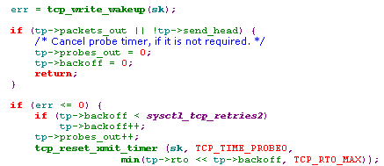
重点在于tcp_write_wakeup()。
tcp_write_wakeup(sk) checks for whether the transmit window is of size null and for whether the beginning of the data segment in skb is still within the transmit window range (snd_una + snd_wnd). In the case of a zero-window problem discussed so far, the transmit window has 0 size, so the tcp_xmit_probe_skb() method is invoked in the else branch. It generates the desired zero-window probe packet.
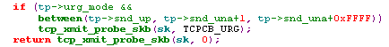
However, if the above condition is met, and if there is at least one packet in the transmit queue that is within the transmit window range, then we probably have a silly window syndrome situation. A packet that corresponds to the requirements of the current transmit window is generated and sent by tcp_transmit_skb().
注：如果skb的长度大于目前可发送的长度(seg_size =tp->snd_una+tp->snd_wnd-TCP_SKB_CB(skb)->seq)，则将该skb分成2个skb，一个的长度为可发送的长度seg_size，一个的长度为len-seg_size，且发送seg_size长度的skb。
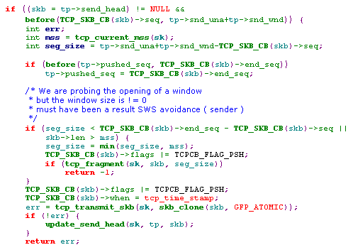
tcp_xmit_probe_skb(sk, urgent) creates a TCP segment without payload, because the transmit window has size 0, and data currently must not be sent. alloc_skb() procures a socket buffer having length MAX_TCP_HEADER. As mentioned above, no payload is sent, and the packet consists only of the TCP packet header.
注：将seq设为snd_una-1, The old sequence number causes the counterpart to send an acknowledgement （因为收到已确认过的数据，会立即发送一个ACK）。 Together with this ACK, it also sends the current transmit window size, which is now, it is hoped, larger than 0.
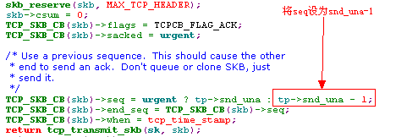
tcp_ack_probe(sk, ack) is invoked in tcp_ack() when a TCP segment with the ACK flag set is received and if it is suspected to be a reply to a zero-window probe segment. 根据该ACK Packet中的window字段更新snd_wnd，之后根据更新后的snd_wnd，判断tp->send_head是否在有效的send window中，如果是，则调用tcp_clear_xmit_timer() 停止zero-window probe timer；不然就调用tcp_reset_xmit_timer()重启probe timer:
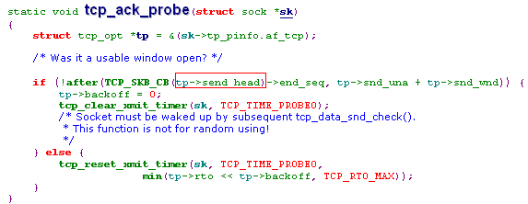
总的说来，假设A为snd_wnd为0的一方，B为另一方(B的receive buffer满了)。当probe timer expire后，A向B发送probing packet,且该probing packet的seq为snd_una-1,这样B收到该probing packet后会立刻发送一个ACK，如果可能的话，B会根据它的receive buffer更新该ACK中的window字段。A收到该ACK后，会根据window字段更新snd_wnd，然后再tcp_ack_probe()中检查snd_wnd是否可以发送write_queue中的第一个packet了，如果可以就清除probe timer，否则就reset probe timer。等到probe timer expire后，再一次向B发送probing packet。
3) Congestion
Flow Control只是会保证2端的传输层不会因为overflow而使得数据丢失(因为如果接收到的数据超过了receive buffer，则直接drop掉了)，而实际上overflow也会发生在IP Instance中。
Buffer overflows can occur in the forwarding systems—more specifically, in the queues of the Internet Protocol—when they are not emptied fast enough and more data arrives than can be sent over a network adapter.
这主要发生在路由器中，路由器主要是转发Packet，当Packet从接口A转发到接口B时，若接口A连接的是快速的局域网，而接口B连接的是慢速的广域网，这时路由器的输出流小于输入流，路由器的接收缓存会overflow而导致路由器Drop后续的Packet，这时该路由器就会发生拥塞。（路由器“吃”的太快——收到的Packet很多，而“消化”的太慢——发送的Packet太少，结果：绝食！）
既然Congestions occur mainly in the IP instances in forwarding systems，那TCP Instance会提供什么方法来发现并避免congestion出现呢？
- Congestion Dectection (拥塞检测)
This means that recognizing congestion is a basic prerequisite for using the congestion-handling and congestion -prevention methods. The TCP protocol has several mechanisms to detect congestions and uses various algorithms to respond to congestion. ( 下面是TCP协议中检测congestion的方法)
- A retransmission timer waits for a certain period of time for an acknowledgement once a packet has been sent. If no acknowledgement arrives, it is assumed that congestion caused the packet to be lost. The initial response to a lost packet is the slow-start phase, which, from a certain point on, is replaced by the congestion-avoidance algorithm. Both methods will be introduced in the following section.
- The receipt of duplicate acknowledgements (dupacks) is an indication that a data segment was lost, because, although subsequent segments arrive, they cannot be acknowledged, because of cumulative ACK segments. In this case, it is normally not assumed that a serious congestion occurred, because subsequent segments were actually received. For this reason, the more recent TCP versions (TCP Reno, TCP New Reno) do not respond to a loss by means of the slow-start phase, but instead by means of the fast retransmit and fast recovery methods, which will be introduced further along.
- Slow-Start and Congestion Avoidance
慢启动算法的原理是新Packet进入网络的速率(发送Packet的速率)应该与另一端返回ACK的速率相同(接收到相应ACK的速率)。
通常情况下，慢启动算法和拥塞避免算法是一起实现的。为了实现它们，内核为每个TCP连接定义了2个变量(相应的tcp_opt结构中)：
- snd_cwnd：拥塞窗口，代表当前可在网络中存在的Packet个数。
- snd_ssthresh：它是一个Threshold value，防止拥塞窗口在慢启动阶段指数级增长。
初始化一个TCP连接时，snd_cwnd值为2，而snd_ssthresh值为0x7fffffff
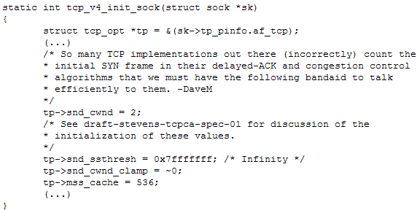
慢启动与拥塞避免算法：
通过初始化sock结构，将该TCP连接中的snd_cwnd置为2，而snd_ssthresh置为65535，不管现在连接是否已经建立(ESTABLISHED)，每当它收到一个ACK，则会在tcp_ack()中对snd_cwnd增1。一旦发生retransmission timer expires，表明这时网络出现了拥塞，将snd_ssthresh置为当前snd_cwnd/2, 且将snd_cwnd置为1：
snd_ssthresh = snd_cwnd/2;
snd_cwnd = 1;
这时进入慢启动阶段，这时只要收到一个ACK，在tcp_ack()中对snd_cwnd增1。 如果snd_cwnd > snd_ssthresh，则表明此时进入了拥塞避免阶段，这时，对snd_cwnd增1/snd_cwnd。直到又发生了retransmission timer expires，这时再将snd_ssthresh置为当前snd_cwnd/2, 且将snd_cwnd置为1，这样又进入慢启动阶段，如此重复下去。
从代码的角度来说，当收到一个ACK时，在tcp_ack()函数中会调用下面的函数，对这个2个变量更新：
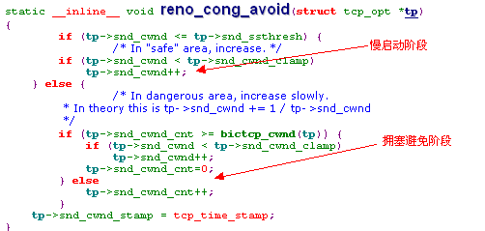
另外，当发生retransmission timer expired时，This timer triggers whenever a transmitted data segment has not been acknowledged by the time the retransmission timeout (RTO) expires. It is assumed that the data segment or its acknowledgement was lost. 这时会调用tcp_enter_loss(), 它将snd_ssthresh置为当前snd_cwnd/2, 且将snd_cwnd置为1：
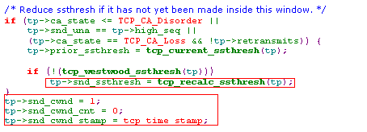
下图是一个实例：
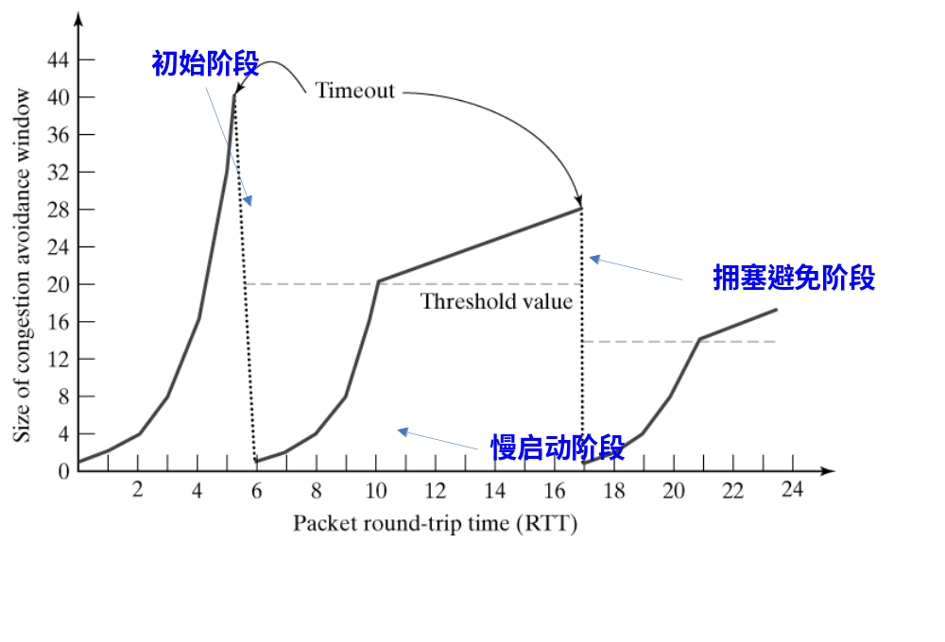
之前讲过，有2种方式判断当前网络发生了拥塞，一个是RTO expired，另一个就是收到重复的ACK。RTO expired这种情形利用慢启动拥塞避免算法，而收到重复的ACK时会怎样呢？
- Fast Retransmit and Fast Recovery
先以一个实例说明收到重复ACK的情况：
Packet5, 6, 7都是ACK，且ACK Number是一样的。这就是所谓的重复ACK。原因在于Packet 2 丢失了。这样B收到失序的Packet 3, 4时并不更新rcv_nxt，而是向A发送ACK，因为rcv_nxt没有更新，所以ACK Number就都是一样的了。如果收到了3个或3个以上的重复ACK，TCP Instance就会认为一个Packet丢失了，这时我们会重传丢失的Packet(根据ACK Number在write_queue中找出相应的Packet)，而无需等待RTO expired。接着会执行快速恢复算法。
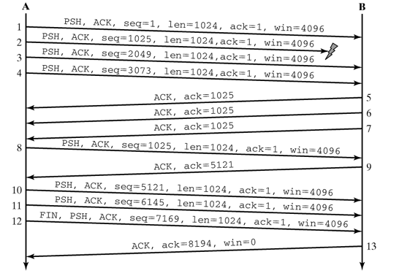
重传算法和快速恢复算法：
1) 当收到第3个重复的ACK时，将snd_ssthresh设置为当前拥塞窗口snd_cwnd的一半。重传丢失的报文段。设置snd_cwnd为snd_ssthresh加上3：
snd_ssthresh = snd_cwnd / 2;
snd_cwnd = snd_ssthresh + 3;
2) 每次收到另一个重复的ACK时，snd_cwnd增加1并发送1个Packet (如果此时可以发送的话，即tcp_snd_test()返回true的话)。
3) 当下一个确认新数据的ACK到达时，设置snd_cwnd为snd_ssthresh（在第1步中设置的值）。注：这个A C K应该是在进行重传后的一个往返时间内对步骤1中重传的确认，且这个A C K也应该是对丢失的分组和收到的第1个重复的ACK之间的所有中间报文段的确认。这时调用reno_cong_avoid(), 此后接收到一个ACK，将snd_cwnd增加1/snd_cwnd(因为此时snd_cwnd>snd_ssthresh了)，这时就是标准的拥塞避免阶段了。
- Congestion Avoidance
为了避免过多的Packet充斥网络使得网络变得拥塞，TCP 协议也实现了若干机制。
1) Delayed ACK
为了避免过多单独的ACK充斥网络(ACK没有任何payload，全是Header)，TCP实现了Delayed ACK机制，The acknowledgement is delayed so as to eventually be sent together with the data (which is also called piggybacking) and so as to enable TCP to accumulate several acknowledgements. The delayed transmission of acknowledgements is implemented by using the delack timer（40ms）.
2) Nagle Algorithm
背景知识：
为什么要引入Nagle算法呢，这和“糊涂窗口综合症”有关：
Issue 1：如果发送端为产生数据很慢的应用程序服务，例如，一次产生一个字节。这个应用程序一次将一个字节的数据写入发送端的TCP的缓存。如果发送端的TCP没有特定的指令，它就产生只包括一个字节数据的报文段。结果有很多41字节的IP数据报就在互连网中传来传去。
解决的方法是防止发送端的TCP逐个字节地发送数据。必须强迫发送端的TCP收集数据，然后用一个更大的数据块来发送。发送端的TCP要等待多长时间呢？如果它等待过长，它就会使整个的过程产生较长的时延。如果它的等待时间不够长，它就可能发送较小的报文段。Nagle算法是一个很好的解决方法。
Issue 2：接收端的TCP可能产生糊涂窗口综合症，如果它为消耗数据很慢的应用程序服务，例如，一次消耗一个字节。假定发送应用程序产生了1000字节的数据块，但接收应用程序每次只吸收1字节的数据。再假定接收端的TCP的输入缓存为4000字节。发送端先发送第一个4000字节的数据。接收端将它存储在其缓存中。现在缓存满了。它通知窗口大小为零，这表示发送端必须停止发送数据。接收应用程序从接收端的TCP的输入缓存中读取第一个字节的数据。在输入缓存中现在有了1字节的空间。接收端的TCP宣布其窗口大小为1字节，这表示正渴望等待发送数据的发送端的TCP会把这个宣布当作一个好消息，并发送只包括一个字节数据的报文段。这样的过程一直继续下去。一个字节的数据被消耗掉，然后发送只包含一个字节数据的报文段。
Issue2有两种建议的解决方法：
- Clark解决方法：只要有数据到达就发送确认，但宣布的窗口大小为零，直到或者缓存空间已能放入具有最大长度的报文段，或者缓存空间的一半已经空了。
- 延迟的确认：这表示当一个报文段到达时并不立即发送确认。接收端在确认收到的报文段之前一直等待，直到输入缓存有足够的空间为止。延迟的确认防止了发送端的TCP滑动其窗口。当发送端的TCP发送完其数据后，它就停下来了。这样就防止了这种症状。
下面我们看看Nagle算法是如何实现的。
Nagle算法的实现主要是tcp_nagle_check()，它会在tcp_snd_test()中被调用。如果要阻止当前的Packet发送(可能payload太少)，则tcp_nagle_check()返回true，否则返回false。
Nagle算法主要有5个Check Point：
① 如果该Packet的长度大于或等于MSS，则没有理由阻止它，返回false。否则执行下一个Check Point。
② 如果该Packet含有特殊内容，比如(e.g., FIN or URG packets)，则需要立即发送它，返回false。否则执行下一个Check Point。
③ 检查是否设置了Socket选项TCP_CORK，如果设置了，表明only complete packets will be sent，这时返回true，否则执行下一个Check Point。
④ 检查是否设置了Socket选项TCP_NODELAY，如果设置了，表明要禁用Nagle算法，则返回false。否则执行下一个Check Point。
⑤ 如果当前所有发送的Packet都收到了确认，即tp->packets_out为0，则返回false，即允许其发送，即使它的payload很“小”(“小”是指小于MSS)。否则则判断是否有一个未被确认的“小”Packet，如果是，则返回true，否则返回false。
⑥ 等待时间或是超时200ms，则允许发送。(等待着攒数据)
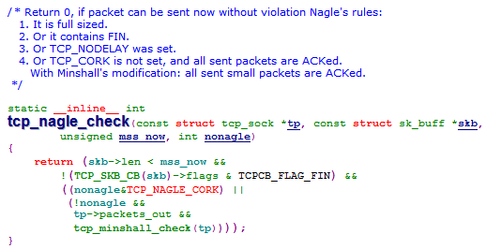
Nagle算法只允许TCP连接上最多只能有一个未被确认的“小”分组，而在该确认到达之前，协议栈继续收集接下来的“小”分组，并把它们合并在一起，在确认到达后，以一个分组的形式发送出去
补充：
每每发送一个Packet时，都要调用tcp_snd_test()，它检查当前能否发送这个Packet。Check Point有下面几个：
  - 是否为ugent模式，如果是，返回true。否则执行下一个Check Point。
  - 调用tcp_nagle_check()，执行Nagle算法。
  - 检查拥塞窗口，当前网络中的Packet是否大于拥塞窗口。注意当前网络中Packet的计算方法是这样的，其中packets_out是发送了但没有得到确认的包的个数，即snd_nxt-snd_una;retrans_out是指需重传的Packet的个数；left_out是指网络中丢失包的个数与由SACK确认的数据包的个数(无SACK时，duplicate ack也使该计数增1)的总和：
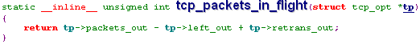
  - 检查发送窗口，看当前的Packet是否超出了发送窗口。
注：后三项要同时满足才能发送这个packet.

