花了半天，把epoll的实现大体看了下，这里稍总结下：
epoll相关的三个用户态API接口：
1、epoll_create函数
函数声明：int epoll_create(int size)
该函数生成一个epoll专用的文件描述符。它其实是在内核申请一空间，用来存放你想关注的socket fd上是否发生以及发生了什么事件。
size就是你在这个epoll fd上能关注的最大socket fd数。
2、epoll_ctl函数
函数声明：int epoll_ctl(int epfd, int op, int fd, struct epoll_event *event)
该函数用于控制某个epoll文件描述符上的事件，可以注册事件，修改事件，删除事件。
参数：
epfd：由 epoll_create 生成的epoll专用的文件描述符；
op：要进行的操作例如注册事件，可能的取值EPOLL_CTL_ADD（注册）、EPOLL_CTL_MOD （修改）、EPOLL_CTL_DEL（删除）
fd：关联的文件描述符；
event：指向epoll_event的指针；
如果调用成功返回0,不成功返回-1
3、epoll_wait函数
函数声明:int epoll_wait(int epfd,struct epoll_event * events,int maxevents,int timeout)
该函数用于轮询I/O事件的发生；
参数：
epfd:由epoll_create 生成的epoll专用的文件描述符；
epoll_event:用于回传代处理事件的数组；
maxevents:每次能处理的事件数；
timeout:等待I/O事件发生的超时值(单位我也不太清楚)；-1相当于阻塞，0相当于非阻塞。一般用-1即可
返回发生事件数

select/poll的缺点在于：
1.每次调用时要重复地从用户态读入参数。
2.每次调用时要重复地扫描文件描述符。
3.每次在调用开始时，要把当前进程放入各个文件描述符的等待队列。在调用结束后，又把进程从各个等待队列中删除。
在实际应用中，select/poll监视的文件描述符可能会非常多，如果每次只是返回一小部分，那么，这种情况下select/poll显得不够高效。 epoll的设计思路，是把select/poll单个的操作拆分为1个epoll_create+多个epoll_ctrl+一个wait。此外，内核 针对epoll操作添加了一个文件系统”[eventpoll]”，每一个或者多个要监视的文件描述符都有一个对应的eventpollfs文件系统的 inode节点，主要信息保存在eventpoll结构体中。而被监视的文件的重要信息则保存在epitem结构体中。所以他们是一对多的关系。由于在执 行epoll_create和epoll_ctrl时，已经把用户态的信息保存到内核态了，所以之后即使反复地调用epoll_wait，也不会重复地拷贝参数，扫描文件描述符，反复地把当前进程放入/放出等待队列。这样就避免了以上的三个缺点。（其实两个的实现原理是相同的。）
接下去看看它们的实现：

主要代码路径与文件 linux/fs/eventpoll.c linux/include/linux/eventpoll.h

[cpp]view plaincopy

- SYSCALL_DEFINE1(epoll_create, int, size)
- {
- if (size <= 0)
- return -EINVAL;
- return <span style="color:#ff0000;">sys_epoll_create1</span>(0);
- }

[cpp]view plaincopy

- SYSCALL_DEFINE1(epoll_create1, int, flags)
- {
- int error;
- struct eventpoll *ep = NULL;

- /* Check the EPOLL_* constant for consistency. */
- BUILD_BUG_ON(EPOLL_CLOEXEC != O_CLOEXEC);

- if (flags & ~EPOLL_CLOEXEC)
- return -EINVAL;
- /*
- * Create the internal data structure ("struct eventpoll").
- */
- error = ep_alloc(&ep); /*申请eventpoll 结构*/
- if (error < 0)
- return error;
- /*
- * Creates all the items needed to setup an eventpoll file. That is,
- * a file structure and a free file descriptor.
- */
- error = anon_inode_getfd("[eventpoll]", &eventpoll_fops, ep,flags & O_CLOEXEC);
- /* 从eventpoll类型文件系统中申请inode结点，遵循linux中一切皆是文件的思想anon_inode_getfd 这个函数申请了 inode结点，挂载了eventpoll_fops文件操作函数集,并将ep设为了file->private_data变量，后面可以看到ep 都是从private_data中取出来的,最后申请了一个空闲的fd，将file与之关联，最后将fd返回用户态*/
- if (error < 0)
- ep_free(ep);

- return error;
- }

[cpp]view plaincopy

- 主要数据结构：
- struct eventpoll {
- spinlock_t lock;
- struct mutex mtx;
- /* Wait queue used by sys_epoll_wait() */
- wait_queue_head_t wq;
- /* Wait queue used by file->poll() */
- wait_queue_head_t poll_wait;
- /* List of ready file descriptors */
- struct list_head rdllist;
- /* RB tree root used to store monitored fd structs */
- struct rb_root rbr; /*红黑树根结点*/
- /*
- * This is a single linked list that chains all the "struct epitem" that
- * happened while transfering ready events to userspace w/out
- * holding ->lock.
- */
- struct epitem *ovflist;
- /* The user that created the eventpoll descriptor */
- struct user_struct *user;
- };

[cpp]view plaincopy

- static int ep_alloc(struct eventpoll **pep) /*申请函数*/
- {
- int error;
- struct user_struct *user;
- struct eventpoll *ep;

- user = get_current_user();
- error = -ENOMEM;
- ep = kzalloc(sizeof(*ep), GFP_KERNEL);
- if (unlikely(!ep))
- goto free_uid;
- spin_lock_init(&ep->lock); /* 对锁，信号量 ，各种链表进行初始化操作*/
- mutex_init(&ep->mtx);
- init_waitqueue_head(&ep->wq);
- init_waitqueue_head(&ep->poll_wait);
- INIT_LIST_HEAD(&ep->rdllist);
- ep->rbr = RB_ROOT; /* 设置为红黑树的根结点*/
- ep->ovflist = EP_UNACTIVE_PTR;
- ep->user = user;
- *pep = ep;
- return 0;
- free_uid:
- free_uid(user);
- return error;
- }

create后的数据结构关系如下：
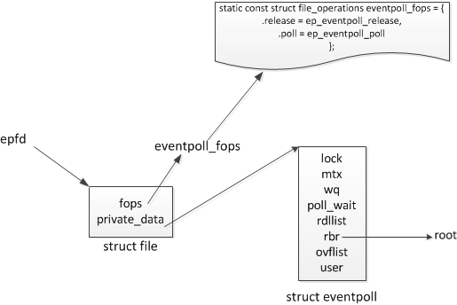

我们继续看epoll_ctl
[cpp]view plaincopy

- SYSCALL_DEFINE4(epoll_ctl, int, epfd, int, op, int, fd, struct epoll_event __user *, event)
- {
- int error;
- struct file *file, *tfile;
- struct eventpoll *ep;
- struct epitem *epi;
- struct epoll_event epds;

- error = -EFAULT;
- if (ep_op_has_event(op) &&
- copy_from_user(&epds, event, sizeof(struct epoll_event)))/*从用户态拷贝至内核态*/
- goto error_return;

- /* Get the "struct file *" for the eventpoll file */
- error = -EBADF;
- file = fget(epfd); /*通过epfd得到file结构 epfd是通过epoll_create创建的*/
- if (!file)
- goto error_return;

- /* Get the "struct file *" for the target file */
- tfile = fget(fd); /*通过fd得到file结构 fd是需要监听的描述字*/
- if (!tfile)
- goto error_fput;

- /* The target file descriptor must support poll */
- error = -EPERM;
- if (!tfile->f_op || !tfile->f_op->poll)
- goto error_tgt_fput;

- /*
- * We have to check that the file structure underneath the file descriptor
- * the user passed to us _is_ an eventpoll file. And also we do not permit
- * adding an epoll file descriptor inside itself.
- */
- error = -EINVAL;
- if (file == tfile || !is_file_epoll(file))
- goto error_tgt_fput;

- /*
- * At this point it is safe to assume that the "private_data" contains
- * our own data structure.
- */
- ep = file->private_data; /* epoll_create创建的eventpoll结构如此得到*/

- mutex_lock(&ep->mtx);

- /*
- * Try to lookup the file inside our RB tree, Since we grabbed "mtx"
- * above, we can be sure to be able to use the item looked up by
- * ep_find() till we release the mutex.
- */
- epi = ep_find(ep, tfile, fd); /* 去ep里找fd是否存在对应的epi，epi又是个新的数据结构，见下面, 该函数主要完成红黑树查找过程，并返回查找结构*/

- error = -EINVAL;
- switch (op) {
- case EPOLL_CTL_ADD: /* 对于ADD来说*/
- if (!epi) { /*如果为空即没找到，那么就插入*/
- epds.events |= POLLERR | POLLHUP;
- error = ep_insert(ep, &epds, tfile, fd); /*调用insert进行插入操作*/
- } else
- error = -EEXIST; /*对于新add命令，而之前epi又存在，则返回错误*/
- break;
- case EPOLL_CTL_DEL: /* 删除命令*/
- if (epi)
- error = ep_remove(ep, epi);
- else
- error = -ENOENT;
- break;
- case EPOLL_CTL_MOD: /* 修改命令*/
- if (epi) {
- epds.events |= POLLERR | POLLHUP;
- error = ep_modify(ep, epi, &epds);
- } else
- error = -ENOENT;
- break;
- }
- mutex_unlock(&ep->mtx);

- error_tgt_fput:
- fput(tfile);
- error_fput:
- fput(file);
- error_return:

- return error;
- }

[cpp]view plaincopy

- 主要数据结构： epitem 描述的是一个需要监听的描述符，通过eventpoll结构中的红黑树进行联系管理
- struct epitem {
- /* RB tree node used to link this structure to the eventpoll RB tree */
- struct rb_node rbn; /* 红黑树节点信息*/
- /* List header used to link this structure to the eventpoll ready list */
- struct list_head rdllink;
- /*
- * Works together "struct eventpoll"->ovflist in keeping the
- * single linked chain of items.
- */
- struct epitem *next;
- /* The file descriptor information this item refers to */
- struct epoll_filefd ffd;
- /* Number of active wait queue attached to poll operations */
- int nwait;
- /* List containing poll wait queues */
- struct list_head pwqlist;
- /* The "container" of this item */
- struct eventpoll *ep;
- /* List header used to link this item to the "struct file" items list */
- struct list_head fllink;
- /* The structure that describe the interested events and the source fd */
- struct epoll_event event;
- };

[cpp]view plaincopy

- static int ep_insert(struct eventpoll *ep, struct epoll_event *event,
- struct file *tfile, int fd)
- {
- int error, revents, pwake = 0;
- unsigned long flags;
- struct epitem *epi;
- struct ep_pqueue epq; /* pollqueue结构

- if (unlikely(atomic_read(&ep->user->epoll_watches) >=
- max_user_watches))
- return -ENOSPC;
- if (!(epi = kmem_cache_alloc(epi_cache, GFP_KERNEL))) /*申请epi结构
- return -ENOMEM;

- /* Item initialization follow here ... */
- INIT_LIST_HEAD(&epi->rdllink);
- INIT_LIST_HEAD(&epi->fllink);
- INIT_LIST_HEAD(&epi->pwqlist);
- epi->ep = ep;
- ep_set_ffd(&epi->ffd, tfile, fd); /*设置ffd结构*/
- epi->event = *event;
- epi->nwait = 0;
- epi->next = EP_UNACTIVE_PTR;

- /* Initialize the poll table using the queue callback */
- epq.epi = epi;
- init_poll_funcptr(&epq.pt, ep_ptable_queue_proc); /*最重要的工作就是设置了这个poll函数*/

- revents = tfile->f_op->poll(tfile, &epq.pt); /*进行注册poll函数的调用，ep_ptable_queue_proc调用过程请结合文件操作函数集fops调用过程，这里不再分析*/

- error = -ENOMEM;
- if (epi->nwait < 0)
- goto error_unregister;

- spin_lock(&tfile->f_lock);
- list_add_tail(&epi->fllink, &tfile->f_ep_links);
- spin_unlock(&tfile->f_lock);

- ep_rbtree_insert(ep, epi); /* 插入到红黑树中*/

- spin_lock_irqsave(&ep->lock, flags);

- if ((revents & event->events) && !ep_is_linked(&epi->rdllink)) {
- list_add_tail(&epi->rdllink, &ep->rdllist); /*如果有期待的事件发生，则将rdllink挂接到rdlist 就绪队列中去*/

- /* Notify waiting tasks that events are available */
- if (waitqueue_active(&ep->wq))
- wake_up_locked(&ep->wq); /*判断是否需要唤醒*/
- if (waitqueue_active(&ep->poll_wait))
- pwake++;
- }

- spin_unlock_irqrestore(&ep->lock, flags);

- atomic_inc(&ep->user->epoll_watches);

- /* We have to call this outside the lock */
- if (pwake)
- ep_poll_safewake(&ep->poll_wait); /*进行唤醒操作*/

- return 0;

- error_unregister:
- ep_unregister_pollwait(ep, epi);

- spin_lock_irqsave(&ep->lock, flags);
- if (ep_is_linked(&epi->rdllink))
- list_del_init(&epi->rdllink);
- spin_unlock_irqrestore(&ep->lock, flags);

- kmem_cache_free(epi_cache, epi);

- return error;
- }

[cpp]view plaincopy

- static void ep_ptable_queue_proc(struct file *file, wait_queue_head_t *whead,poll_table *pt)
- {
- struct epitem *epi = ep_item_from_epqueue(pt);
- struct eppoll_entry *pwq;

- if (epi->nwait >= 0 && (pwq = kmem_cache_alloc(pwq_cache, GFP_KERNEL))) {
- /* 申请一个eppoll_entry 结构 ，类似于select(poll)中使用的等待结构的那个entry结构
- init_waitqueue_func_entry(&pwq->wait, ep_poll_callback); 初始化等待队列节点，注册通知回调函数*/
- pwq->whead = whead;
- pwq->base = epi;
- add_wait_queue(whead, &pwq->wait); /* 这里的whead为ep的poll_wait结构，就是红黑树根结点的poll_wait*/
- list_add_tail(&pwq->llink, &epi->pwqlist);
- epi->nwait++;
- } else {
- /* We have to signal that an error occurred */
- epi->nwait = -1;
- }
- }
- 主要数据结构：
- struct eppoll_entry {
- /* List header used to link this structure to the "struct epitem" */
- struct list_head llink;
- /* The "base" pointer is set to the container "struct epitem" */
- struct epitem *base;
- /*
- * Wait queue item that will be linked to the target file wait
- * queue head.
- */
- wait_queue_t wait;
- /* The wait queue head that linked the "wait" wait queue item */
- wait_queue_head_t *whead;
- };

- struct ep_pqueue {
- poll_table pt;
- struct epitem *epi;
- };

上面的代码就是ep_insert中要做的最重要的事：创建struct eppoll_entry，设置其唤醒回调函数为ep_poll_callback，然后加入设备等待队列（注意这里的whead就是上一章所说的每个设 备驱动都要带的等待队列）。只有这样，当设备就绪，唤醒等待队列上的等待着时，ep_poll_callback就会被调用。每次调用poll系统调用， 操作系统都要把current（当前进程）挂到fd对应的所有设备的等待队列上，可以想象，fd多到上千的时候，这样“挂”法很费事；而每次调用 epoll_wait则没有这么罗嗦，epoll只在epoll_ctl时把current挂一遍（这第一遍是免不了的）并给每个fd一个命令“好了就调 回调函数”，如果设备有事件了，通过回调函数，会把fd放入rdllist，而每次调用epoll_wait就只是收集rdllist里的fd就可以了 ——epoll巧妙的利用回调函数，实现了更高效的事件驱动模型
我们弄一幅图看下期间错综复杂的关系
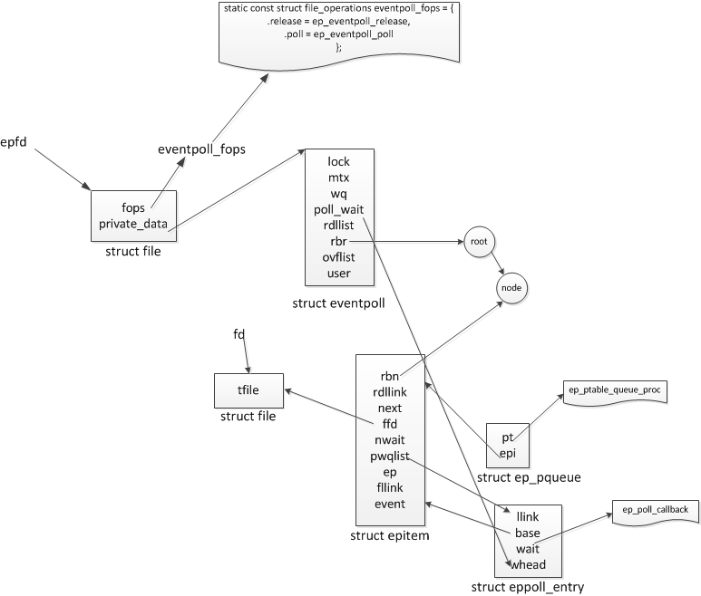

ep_poll_callback会干什么了——肯定是把红黑树上的收到event的epitem（代表每个fd）插入ep->rdllist中，这样，当epoll_wait返回时，rdllist里就都是就绪的fd了
list_add_tail(&epi->rdllink, &ep->rdllist);

我们最后看个wait函数
[cpp]view plaincopy

- SYSCALL_DEFINE4(epoll_wait, int, epfd, struct epoll_event __user *, events,
- int, maxevents, int, timeout)
- {
- int error;
- struct file *file;
- struct eventpoll *ep;

- /* The maximum number of event must be greater than zero */
- if (maxevents <= 0 || maxevents > EP_MAX_EVENTS)
- return -EINVAL;

- /* Verify that the area passed by the user is writeable */
- if (!access_ok(VERIFY_WRITE, events, maxevents * sizeof(struct epoll_event))) {
- error = -EFAULT;
- goto error_return;
- }

- /* Get the "struct file *" for the eventpoll file */
- error = -EBADF;
- file = fget(epfd);
- if (!file)
- goto error_return;

- /*
- * We have to check that the file structure underneath the fd
- * the user passed to us _is_ an eventpoll file.
- */
- error = -EINVAL;
- if (!is_file_epoll(file))
- goto error_fput;

- /*
- * At this point it is safe to assume that the "private_data" contains
- * our own data structure.
- */
- ep = file->private_data;

- /* Time to fish for events ... */
- error = ep_poll(ep, events, maxevents, timeout); /* 最核心的在这里进行ep_poll,即对ep这个点上面的东西进行poll*/

- error_fput:
- fput(file);
- error_return:

- return error;
- }

- static int ep_poll(struct eventpoll *ep, struct epoll_event __user *events,
- int maxevents, long timeout)
- {
- int res, eavail;
- unsigned long flags;
- long jtimeout;
- wait_queue_t wait;

- /*
- * Calculate the timeout by checking for the "infinite" value (-1)
- * and the overflow condition. The passed timeout is in milliseconds,
- * that why (t * HZ) / 1000.
- */
- jtimeout = (timeout < 0 || timeout >= EP_MAX_MSTIMEO) ?
- MAX_SCHEDULE_TIMEOUT : (timeout * HZ + 999) / 1000;

- retry:
- spin_lock_irqsave(&ep->lock, flags);

- res = 0;
- if (list_empty(&ep->rdllist)) { /*怪不得效率高，只看ep->rdllist */
- /*
- * We don't have any available event to return to the caller.
- * We need to sleep here, and we will be wake up by
- * ep_poll_callback() when events will become available.
- */
- init_waitqueue_entry(&wait, current); /*空的话就睡眠，至到被唤醒*/
- wait.flags |= WQ_FLAG_EXCLUSIVE;
- __add_wait_queue(&ep->wq, &wait);

- for (;;) { /*被唤醒的话就进去处理*/
- /*
- * We don't want to sleep if the ep_poll_callback() sends us
- * a wakeup in between. That's why we set the task state
- * to TASK_INTERRUPTIBLE before doing the checks.
- */
- set_current_state(TASK_INTERRUPTIBLE);
- if (!list_empty(&ep->rdllist) || !jtimeout)
- break;
- if (signal_pending(current)) {
- res = -EINTR;
- break;
- }

- spin_unlock_irqrestore(&ep->lock, flags);
- jtimeout = schedule_timeout(jtimeout);
- spin_lock_irqsave(&ep->lock, flags);
- }
- __remove_wait_queue(&ep->wq, &wait);

- set_current_state(TASK_RUNNING);
- }
- /* Is it worth to try to dig for events ? */
- eavail = !list_empty(&ep->rdllist) || ep->ovflist != EP_UNACTIVE_PTR;

- spin_unlock_irqrestore(&ep->lock, flags);

- /*
- * Try to transfer events to user space. In case we get 0 events and
- * there's still timeout left over, we go trying again in search of
- * more luck.
- */
- if (!res && eavail &&
- !(res = ep_send_events(ep, events, maxevents)) && jtimeout) goto retry;
- /*发事件到用户态，将准备好的fd等传到用户态*/
- return res;
- }

Reference:
http://www.cnblogs.com/Anker/archive/2013/08/17/3263780.html
http://blog.csdn.net/hsly_support/article/details/8831117

