Network Packet in Linux
本章主要介绍网络通信中的Packet（包）在Linux是如何表示的。
Linux的网络实现定义了两种最主要的抽象：
- Socket Buffer(简称：skb)：它抽象了整个内核网络处理中Packet的概念。一个Socket Buffer结构对应于一个接受或发出的Packet。
Cite: Socket buffers are data structures used to represent and manage packets in the Linux kernel. The socket buffer is the structure used to address and manage a packet over the entire time this packet is being processed in the kernel.
- Network Device：下一章讲述。

2.1 struct sk_buff
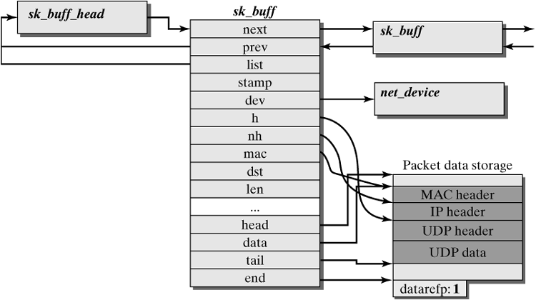
一个Packet是由一个sk_buff的数据结构实例表示的，如上图所示。一个sk_buff数据结构由2部分组成：
- Packet Data。Packet data storage由head和end指针界定，存放着实际在网络中传输的数据，对应PDU。
- Management Data。一个Packet在内核中处理的时候，内核需要额外的数据去管理该Packet，这些数据是与实现相关的，它们没有存储在实际的报文中。实际上它们作为ICI的一部分。（其余部分是其他Interface Parameters）。
Packet的报文数据部分：
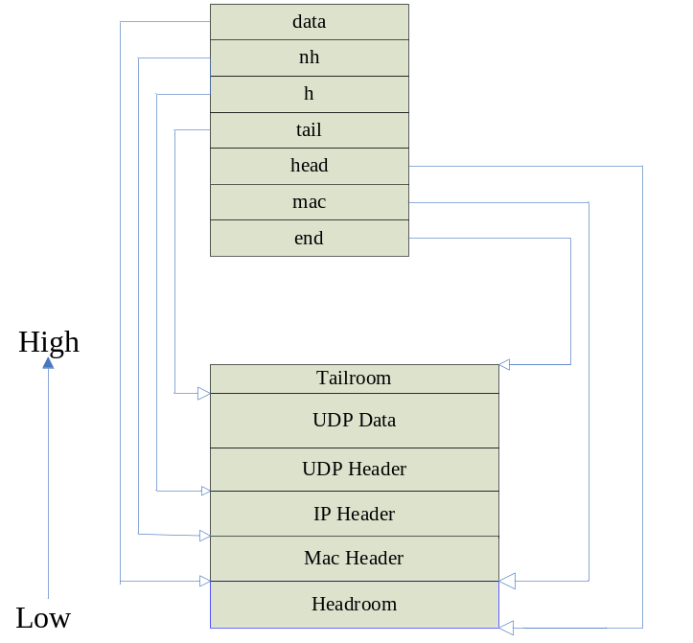
sk_buff的结构声明如下，本章只介绍常用的几个字段：
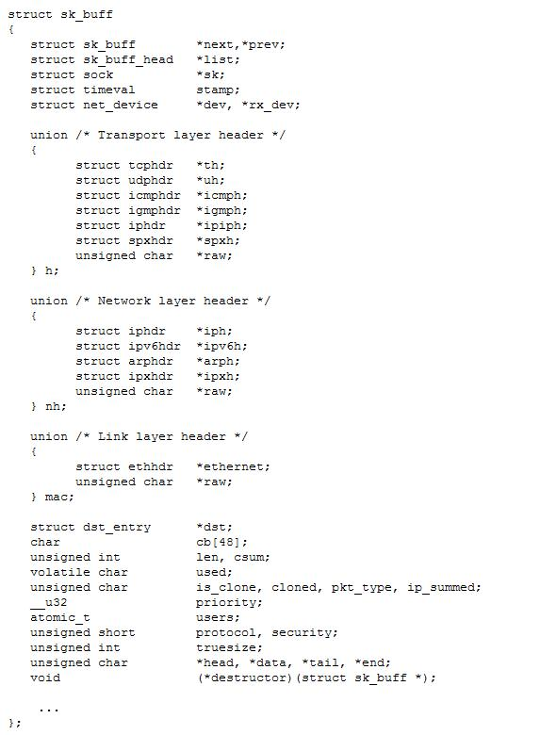
- 每个sk_buff一定位于某个Queue中。指针next，prev指向与当前sk_buff位于同一队列的下一个/前一个sk_buff。而list指向当前sk_buff所在的那个队列。
Notes：队列一定是struct sk_buff_head类型：
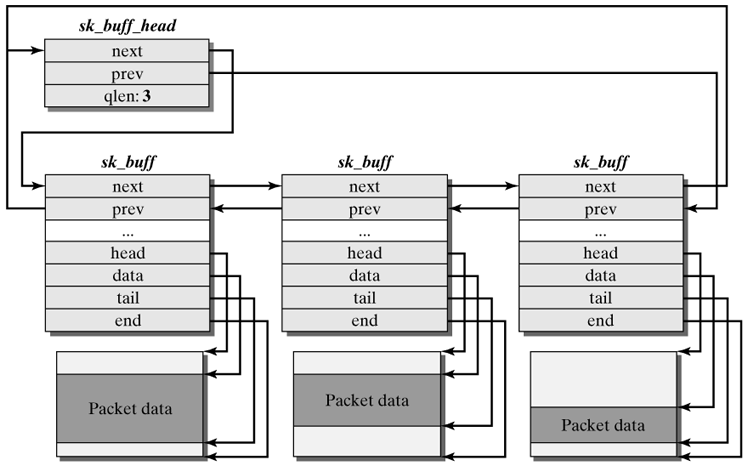
如图所示，一个sk_buff队列就是一个sk_buff_head类型的实例，其中qlen字段表示队列的长度。
- sk points to the socket that created the packet. For a software router, the driver of the network adapters creates the socket buffer structure (sk_buff). This means that the packet is not assigned to a valid socket, and so the pointer points to null。(socket就是套接口)。
- stamp specifies the time when the packet arrived in the Linux system (in jiffies).(jiffies是指按滴答数计时)。
- dev and rx_dev are references to network devices, where dev states the current network device on which the socket buffer currently operates. Once the routing decision has been taken, dev points to the network adapter over which the packet should leave the computer. Until the output adapter for the packet is known, dev points to the input adapter. rx_dev always points to the network device that received the packet.
- dst refers to an entry in the routing cache, which means that it contains either information about the packet's further trip (e.g., the adapter over which the packet is to leave the computer) or a reference to a MAC header stored in the hard header cache.
- h, nh, and mac are pointers to packet headers of the transport layer (h), the network layer (nh), and the MAC layer (mac). These pointers are set for a packet as it travels across the kernel.
- len designates the length of a packet represented by the socket buffer. This considers only data accessible to the kernel. This means that only the two MAC addresses and the type/length field are considered in an Ethernet packet（因为它们是在Kernel中加上去的，而不是在网络适配器中）. The other fields (preamble, padding, and checksum) are added later in the network adapter, which is the reason why they are not handled by the kernel.
- data, head, tail, end: The data and tail pointers point to currently valid packet data. Depending on the layer that currently handles the packet, these parameters specify the currently valid protocol data unit (PDU).
- pkt_type specifies the type of a packet, which can be one of the following: PACKET_HOST, PACKET_BROADCAST, PACKET_MULTICAST, PACKET_OTHERHOST, PACKET_OUTGOING, PACKET_LOOPBACK, PACKET_FASTROUTE.
Type | Specification
PACKET_HOST | A packet a sent to the local host
PACKET_BROADCAST | A broadcast packet
PACKET_MULTICAST | A multicast packet
PACKET_OTHERHOST | A packet not destined for the local host, but received by special modes (e.g., the promiscuous mode).(网卡的特殊设置)
PACKET_OUTGOING | A packet leaving the computer.
PACKET_LOOPBACK | A packet sent from the local computer to itself.
PACKET_FASTROUTE | A packet fast-forwarded between special network cards.
注意：During cloning of socket buffers, several sk_buff structures will still point to the same packet data space：
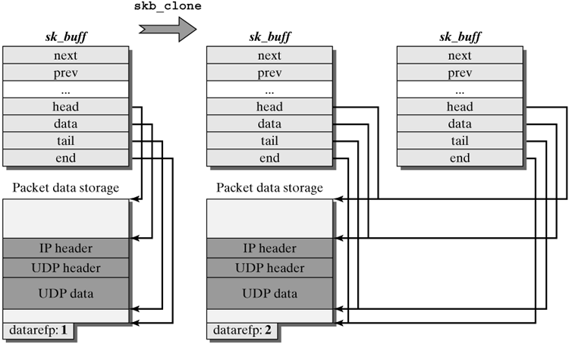
补充资料：
创建sk_buff实例时要么是在内核堆栈里，要么就是在内核的动态存储空间中。如果创建都是在内核动态存储空间中，请求内存的操作是很费时的，特别是多次请求。所以Linux内核提供了socket buffer cache的机制：
- 每个CPU管理一个队列：skb_head_cache，它保存着不再使用的sk_buff实例。它只是一个简单的socket buffer queue。
- There is a central stack for consumed sk_buff structures (skbuff_head_cache).
If there are no more sk_buff structures available for the current CPU, then kmem_cache_alloc() is used to try obtaining a packet from the central socket-buffer cache (skbuff_head_cache). If this attempt fails, then kmalloc() is eventually used.
当一个sk_buff使用完毕，内核会释放它的Packet Data Storage，然后调用skb_head_to_pool()将这个sk_buff实例插入当前CPU的skb_head_cache中，以此达到复用的目的。注意：这种复用只针对于sk_buff实例本身，不包括相应的Packet Data Storage，因为每个sk_buff实例的Packet Data Storage的大小是不同的，每个Packet Data Storage直接利用kmalloc请求内存。
当套接字向传输层协议（TCP或UDP）发送数据时，会根据数据发送的大小生成一个sk_buff实例，而sk_buff实例的Packet Data Storage也是根据发送大小从kmlloc分配的动态内存，但是它也预留了一些空间（headroom和tailroom）；当该套接字继续发送数据时，数据就会添加到之前那个sk_buff实例中直到该sk_buff实例的数据部分达到MSS值。事实上，每次分配sk_buff实例的时候就将它的Packet Data Storage设置成mss_cache_std + sk->sk_prot->max_header，这个肯定比MSS值大了。
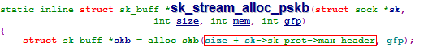
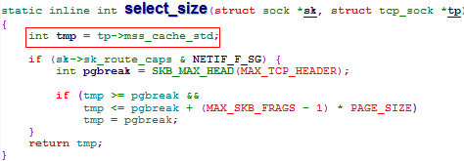

PS：即使开始分配的Packet Data Storage不足，sk_buff还可以利用skb_shared_info结构进行“切片”，将这个sk_buff剩下的数据放到另外一个地方：
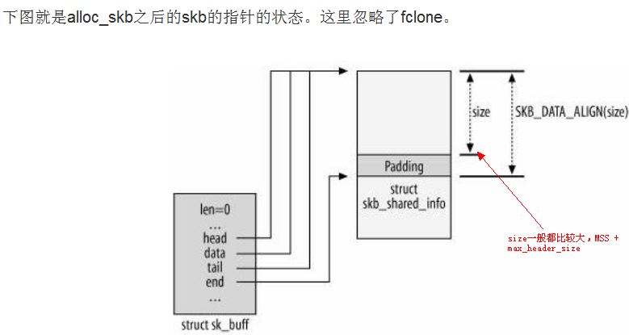
参考：http://blog.csdn.net/q345852047/article/details/7415748

