IP Multicast for Group Communication

1.1 Introduction
1) 单播、广播与多播的区别：
① Unicast：Unicast is the classic form of communication between two partners. When a unicast communication service is used to transmit data to several receivers, then this has to be done independently of one another in several transmit processes. This means that the cost for the data transport increases in proportion to the number of receivers:
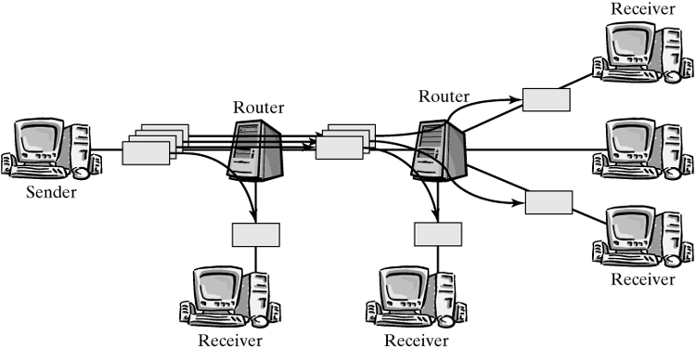
② Broadcasting：It means that all participants in a communication network that can be reached over a specific medium receive the distributed data packets, regardless of whether they are interested in it.
注：这只是对于局域网而言。一般而言，router收到广播的IP Packet，对于Destination IP是255.255.255.255，则它不会转发，这是受限的广播IP地址；而对于指向子网的广播地址，则通常会将input设置为ip_local_deliver；可能其他硬件路由器可以转发指向所有子网/指向网络的广播数据包，但Linux本身并不支持，如果用Linux模拟Router的话。
③ Multicast：In contrast to broadcast, only stations that are members of that group receive data packets。In the Internet, this is implemented by defining groups, and each Internet computer can subscribe to groups. Once a system has demonstrated its interest in participating in a multicast group, it will receive packets addressed to this group. With multicast, data packets are not transmitted separately for each receiver. Instead, they are transmitted once and then replicated (复制) in the appropriate branching points (在Routers中转发时复制) and delivered to the receivers：
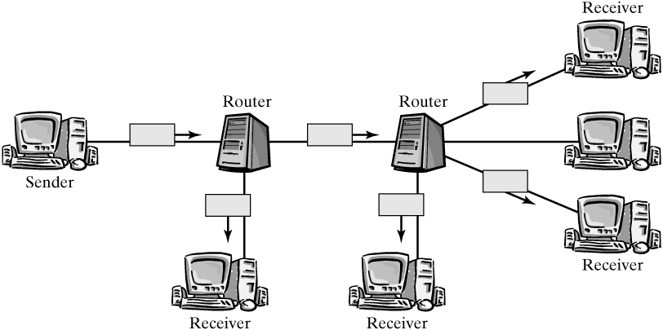
2) IP 多播
任何sender都可以发送多播Packet，只要它的Destination IP地址是个多播地址。Normally, the sender doesn't know who is currently a member of a group, how many members are subscribed to a group, or where these members are located.
Joining and leaving groups is handled by the Internet Group Management Protocol (IGMP); routers distribute their group information over multicast routing protocols. An end system tells its local multicast router only the IP address of the group it wants to join. The router will then have to find out how it can get the multicast data from the Internet. Joining and leaving of groups for computers in a local area network are handled by the Internet Group Management Protocol. ( 注：End System通过向local multicast router发送IGMP Packet来joining或leaving一个多播组，对于end system来说，加入或离开一个多播组意味着修改mc_list in the in_device structure以及mc_list in the net_device structure., 同时物理网卡中的mc_list也要改变)
So-called multicast distribution trees are built to distribute multicast packets between routers across the entire network. The data packets are then distributed along these trees to the individual receivers and local area networks. These distribution trees are built by multicast routing protocols.
注：这些都是支持多播的路由器需要干的活儿，而 multicast distribution tress是根据multicast routing protocols形成的，这个和路由表的形成过程类似。
As in routing in the Internet, the control path and the data path are also separated here, as can be clearly seen in the implementation under Linux：
- The data path (i.e., forwarding and replicating of multicast packets) is defined by the information in the multicast routing table. (查询多播路由表，这个和查询路由表的情况类似)
- The information in the multicast routing table is procured over the control path, by the multicast routing protocols and IGMP (multicast distribution tree的形成过程和路由表的形成过程类似).

1.2 Multicast Data Path in the Linux Kernel
我们这里不详述Router中多播路由表的形成过程，包括IGMP。这里主要论述当Router收到一个多播Packet时，内核如何处理它。
注意：
只有多播Router(硬件或是软件模拟的)才会有多播路由表，通过查询多播路由表去复制和转发。End system而言，只是会检查该多播Packet是否属于自己定制的一个Group，如果是，则交由ip_local_deliver进一步处理，否则就Drop它。

1.2.1 Multicast Support on the MAC Layer
通常网卡仅接收那些目的MAC地址为该网卡MAC地址或广播地址的帧。MAC广播地址为0xFFFFFFFFFFFF。当然如果网卡处于混合模式，则它接受所有流经的帧。对于目的MAC地址是多播地址，则需要对网卡进行配置，使得它可以接受1个或多个目的MAC地址是多播地址的帧。还记得set_multicast_list这个驱动函数吗？它就是配置网卡可接受MAC多播地址的函数。
Cites：How can the network adapter know to which groups IP subscribed? To solve this problem, each network adapter manages a list with multicast group addresses that should be received on this adapter. If the network adapter can support hardware filtering of multicast packets (一般的网卡都支持这个功能), then a driver method transfers this list to the adapter (set_multicast_list()). The adapter can then filter without disturbing the central processing unit.
The active multicast groups of a network device's IP instance are maintained in the mc_list of the in_device structure. When an application joins an IP multicast group, the IP group address and some other information are recorded in this list. In addition, ip_eth_mc_map() computes the appropriate MAC group address (for Ethernet networks，将多播IP地址转换成多播MAC地址，有可能会冲突，一个多播MAC地址可能对应多个多播IP地址。) and adds it to the list dev->mc_list. Once set_multicast_list() has updated the card, the network adapter should be able to receive packets for this group. The following Pic shows schematically how groups are managed in the IP instance and in the network device,
注：Function ip_check_mc() checks on whether the local computer is currently a member of the multicast group mc_addr(多播IP地址，作为参数传入的). For this purpose, the list of active groups of the network device's IP instance (mc_list in the in_device structure) is checked and compared against the group address passed. If a match is found, then one is returned;
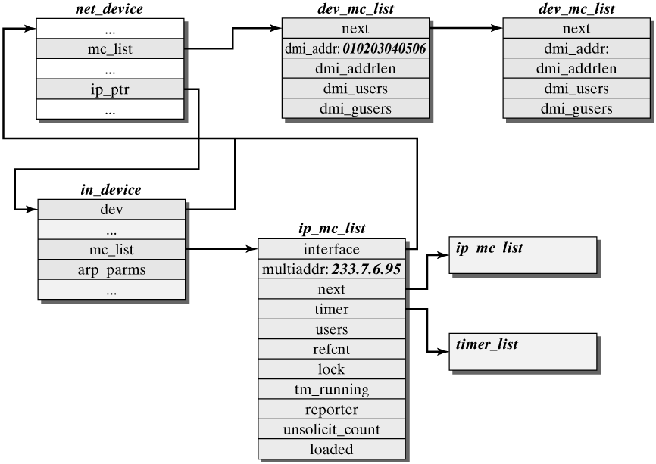

1.2.2 Multicast Data Path in the Internet Protocol
我们这节讲的是Linux内核如何处理一个IP多播包的。这里主要是讲接受到一个IP多播包时的内核处理过程。至于发送IP多播包则是很简单的，主要是查询IP路由表，对于end system来说，IP多播地址对应的output是默认路由(因为找不到相应的entry)，这样就会将该多播包发送给默认的Router(通常是Local Router)，然后router再去查询多播路由表。End system是没有多播路由表的。
结合下面的简图，介绍当网卡收到一个IP多播包的情形。
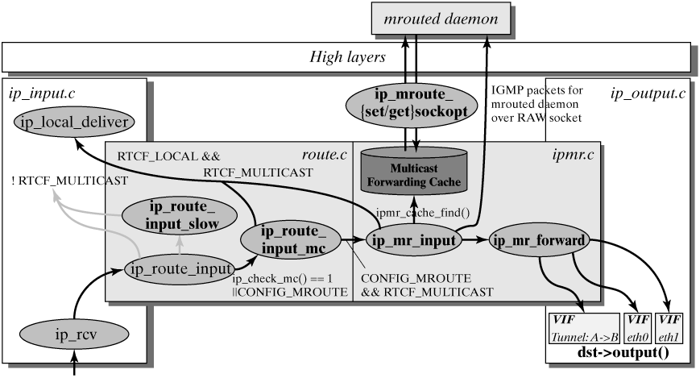
- 和其他IP Packet一样调用ip_rcv(), 其中会调用ip_route_input()去查询路由。这里首先会查看route cache，如果route cache里找不到，则会检查该IP Packet的目的IP地址是否为多播地址，如果是则调用ip_route_input_mc()，否则调用ip_route_input_slow()。
- ip_route_input_mc()根据station是end system还是多播路由器来决定input。如果是end system，首先检查station是否是该Group的一个成员，利用ip_check_mc()函数，若是则将input设为ip_local_deliver，并在route cache中添加一项，type为RTN_MULTICAST，否则，则Drop该Packet；如果是多播路由器，则把input设置为ip_mr_input。
- 对于end system而言，这时会调用ip_local_deliver()将该Packet交由上层协议实例处理。而对于多播router来说，它调用ip_mr_input()：The first thing to be checked is whether the packet is an IGMP packet for the multicast routing daemon. If so, the packet is delivered to this daemon over the raw socket. Subsequently, the function ipmr_cache_find() searches the multicast forwarding cache for a matching entry for the skb packet. If no matching entry can be found, then a local packet (RTCF_LOCAL，如果本机属于该Group的话) is passed to ip_local_deliver(), and packets that have to be forwarded are added to the queue for incomplete routing entries (unresolved queue in the mfc_cache structure). As soon as the routing daemon has determined the route, these packets are forwarded by ip_mr_forward(). If a valid entry was found in the multicast forwarding cache, then ip_mr_input() passes a pointer to this routing entry to the function ip_mr_forward, which duplicates and forwards the packet. Finally, packets marked local (RTCF_LOCAL) are passed upwards by ip_local_deliver. (有可能该多播路由器属于某个Group，同时该Group还有其他成员需要它转发。)
注：广播和多播仅应用于U D P，它们对需将Packet同时传往多个接收者的应用来说十分重要。T C P是一个面向连接的协议，它意味着分别运行于两主机（由I P地址确定）内的两进程（由端口号确定）间存在一条连接。当一个主机收到多播数据报时，它必须向属于那个多播组的每个进程均传送一个复制。这和单个进程收到单播U D P数据报的U D P不同。使用多播，一个主机上可能存在多个属于同一多播组的进程。
在IP发送一个Packet时，查询路由表时，ip_route_output_slow()里会查看目的IP地址是否为广播地址或多播地址，若是广播地址或是多播地址，它将output设置为ip_mc_output()，且它会检查本机是否为多播地址代表组中的一员，若是，则将flags设为RTCF_LOCAL(广播地址一定将flags设为RTCF_LOCAL)。接着在ip_mc_output()中，若flags中有RTCF_LOCAL，则将该Packet发给自身，然后调用__ip_finish_output()将该包发送出去。(无论是多播Router还是End System，它发送多播Packet时，都只是直接将Packet发送出去，而不会查询多播路由表去调用ip_mr_forward()。)
补充资料：
Multicast packets can be received and sent in either of two different ways: either directly over the network adapter in a LAN, or packed inside a second unicast IP packet and transported through a tunnel （一个IP隧道也由一个net_device表示）. To prevent having to distinguish these two cases in the entire multicast implementation, an abstraction—the so-called virtual network device or virtual interface (VIF)—was introduced for both types. 我们将vif_device作为转发多播数据报的逻辑单位，一个MFC entry中可能会含有多个vif_device结构，表示转发给该多播数据包需要向这些vif_device转发。
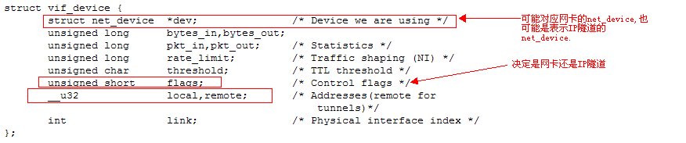
表示IP隧道的net_device结构：
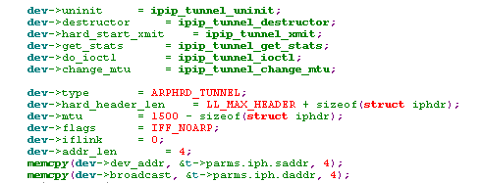
有关IP隧道的介绍，请参考附录D。

