**Skill Report**

**Frequency of important terms for this month per company**

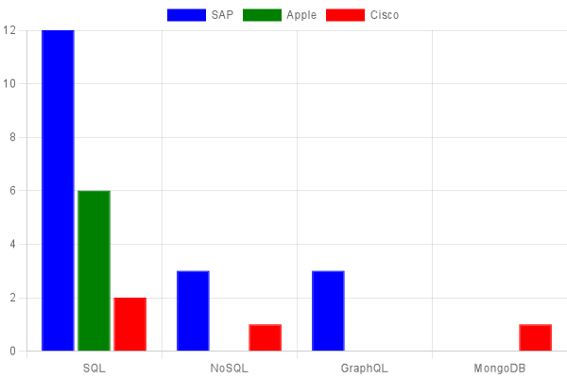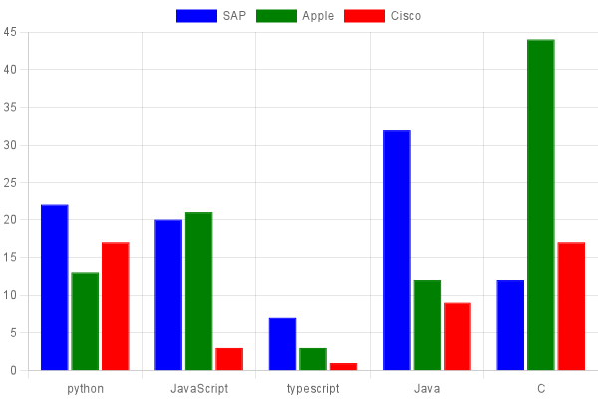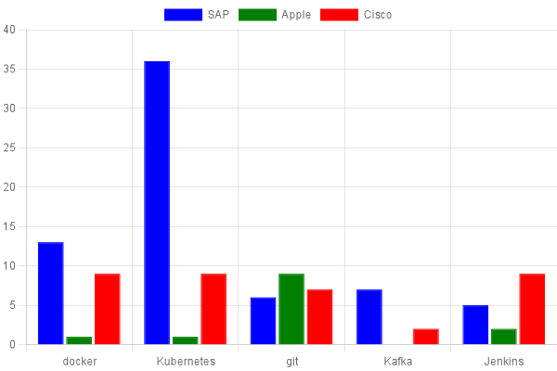

**Frequency over time of important terms (all companies combined)**

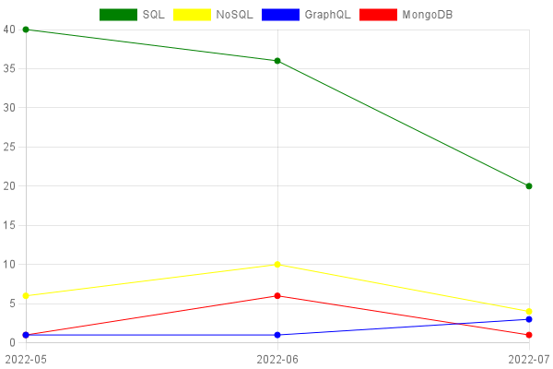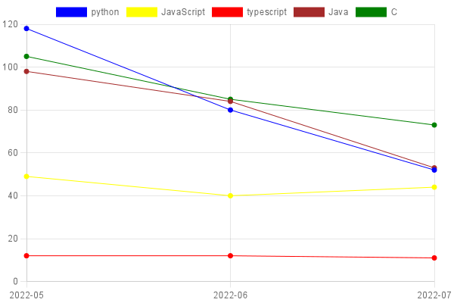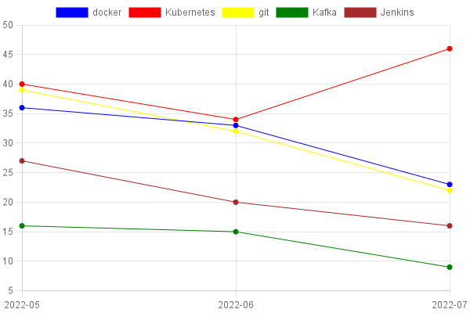

**General Information**

[SAP Sketch Engine Corpus](https://app.sketchengine.eu/#dashboard?corpname=user%2FTomRSch%2Fskills_sap)

[Apple Sketch Engine Corpus](https://app.sketchengine.eu/#dashboard?corpname=user%2FTomRSch%2Fskills_apple)

[Cisco Sketch Engine Corpus](https://app.sketchengine.eu/#dashboard?corpname=user%2FTomRSch%2Fskills_cisco)