Femicide trends at the start of the 21st. century: prevalence, risk factors and national public health actions

Richard Whittington* 1, 2, 3

Alina Haines-Delmont 3, 4

Johan Hakon Bjorngard 5

1 St. Olav’s University Hospital, Centre for Research and Education in Security, Penology and Forensic Psychiatry, Østmarkveien, 7040 Trondheim, Norway. Email: [richard.whittington@ntnu.no](mailto:richard.whittington@ntnu.no). Phone 00447759314337

2 Norwegian University of Science and Technology (NTNU), Institute of Mental Health, PO Box 8905, Trondheim NO-7491, Norway

3 University of Liverpool, Department of Public Health, Policy and Systems, Waterhouse Building, Liverpool L69 3BX, United Kingdom

4 Manchester Metropolitan University, Department of Nursing, Faculty of Health, Psychology and Social Care, Brooks Building, Bonsall Street | Manchester M15 6GX, United Kingdom. Email: A.Haines@mmu.ac.uk

5 Norwegian University of Science and Technology (NTNU), Department of Public Health and Nursing, Oya Helsehus, Hakon Jarls Gate, Trondheim, Norway. Email: [johan.h.bjorngaard@ntnu.no](mailto:johan.h.bjorngaard@ntnu.no)

*corresponding author

5453 words

Keywords: femicide, inequality, national income, public health, prevention

# Abstract

Lethal violence requires a gender-based analysis which recognizes that femicide is different from homicide in many ways. Structural factors such as national income and wealth equality together with government policies may influence the scale of the problem globally. In this study, data from two large open-access international surveys were combined to examine anti-femicide actions (n=1333 countries) and temporal femicide prevalence trends (n=66 countries) in the context of national income and wealth inequality factors. The United Nations Survey of Crime Trends and Operations of Criminal Justice Systems (UN-CTS) was used to estimate femicide rates per country 2003-2014 and the World Health Organisation (WHO) Global Status Report on Violence Prevention provided data on policy initiatives in place by 2014. Results indicate that femicide rates decreased over the study period by 32% worldwide and by 33% in low-inequality countries, but increased by 26% in low- and medium-income countries. The structural factors of low income and high inequality were significantly negatively associated with the 2014 femicide rate, but the overall number of adopted anti-femicide actions was not linked. Structural factors must be addressed alongside policy and legal initiatives if significant gains are to be made toward eradicating violence against women and girls.

# Introduction

Homicide is the most serious consequence of human violent behaviour and the risk of dieing as a result of aggression by other people remains a significant feature of life for many people around the world. Homicide has been defined by the United Nations for statistical purposes as “unlawful death inflicted upon a person with the intent to cause death or serious injury” with three key elements: interpersonal killing, harmful intent and unlawfulness (UNODC 2015). It is considered to be distinct from intentional harm in conflict situations such as war and other forms of non-conflict violent deaths such as killing in the context of self-defence or legal interventions such as lawful execution or assisted suicide (UNODC 2019).

The phenomenon of unlawful killing furthermore is different for women and men (Dawson and Carrigan 2021). The risk factors for ‘homicide with a female victim’ are very different from those with male victims in many ways and this indicates the need to consider fatal violence from a gendered perspective (Garcia-Vergara, Almeda et al. 2022). The term femicide has been introduced to highlight this distinction (Marcuello-Servós, Corradi et al. 2016, Luque González, Apunte Guerra et al. 2022) and to emphasise that the perpetrator-victim relationship varies greatly between femicide and homicide. In particular, women who are killed are very likely to be killed by an intimate partner (82% of homicides with a female victim), but this applies to less than a fifth (18%) of men who are killed (UNODC 2019). As a result of this recognition of separate dynamics, distinctive theoretical approaches have been applied to understanding femicide specifically including those based in feminist, human rights and decolonial perspectives (Corradi, Marcuello-Servós et al. 2016).

Whilst the global femicide rate overall is about one fifth of that for homicide for males (World Health Organisation 2017), it is still estimated that about 81,000 women and girls were killed in 2020, with 58% of these deaths being inflicted by an intimate partner (UNODC 2022). Within this overall global picture, femicide rates are highly variable between countries but they have been quite stable over time. Several countries in South and Central America (e.g. El Salvador, Guatemala, Guyana) have the highest rates globally with more than 8/100,000 of the female population subjected to lethal violence (Nowak 2012). The worldwide femicide rate for girls aged 0-14 years remained below 1/100,000 in the period 2008-17 but that for females aged 15-29 years increased somewhat over the same time period (UNODC 2019). The temporal pattern is complex and again country-specific. South Africa, for example, had very high femicide rates in the period 2004-9 but this rate was significantly lower in this period than it had been in the 1990’s (Abrahams, Mathews et al. 2013). Such longitudinal trends are examined further in the study reported here.

A wide range of factors are known to be associated with fatal and non-fatal violence rates regardless of gender. These include income inequality, divorce rates, population growth, development, age, urbanicity and alcohol consumption (Nivette 2011, Pickett and Wilkinson 2011, Wolf, Gray et al. 2014). National wealth and social inequality in particular are two factors which relate to (combined gender) homicide rates worldwide. Rates are lower in high-income countries than middle- and low-income countries and have dropped more steeply in these countries in the first decade of the 21st. century. Even more importantly, high levels of inequality are persistently linked with high violence rates. Amongst OECD countries which are members of the Organisation for Economic Co-operation and Development (OECD) Portugal and the USA are examples (relatively unequal and violent) at one end of the scale and Japan and Norway (relatively equal and low violence) at the other end (Pickett and Wilkinson 2011).

However, much of our knowledge on this issue is limited in two ways. Firstly, little of this previous research separates out homicide and femicide rates which, as noted above, are influenced by different dynamics and thus require distinctive analyses (Matias, Gonçalves et al. 2020). Secondly, the emphasis has been on identifying social risk factors to improve prediction of violence rather than examining the potential for effective interventions to reduce it. Relatively little attention has been paid to important questions about effective policy interventions which national governments can adopt especially in relation to preventing the specific problem of femicide. This study sought therefore to focus specifically on femicide and to examine both risk factors and actions which have been taken at the national level around the world to reduce femicide rates.

Global efforts to address violence in general and femicide in particular have been framed over the past two decades by a public health perspective (World Health Organisation 2017). The WHO Global Campaign for Violence Prevention (GCVP) has adopted such a framework since its inception in 2002 and provides robust data on governmental activities in this area (Whittington and McGuire 2020). Data from the GCVP indicates that overall the global homicide rate is falling but does not provide a breakdown of this trend by gender (World Health Organisation 2014).

A key element of the WHO approach is encouraging governments to develop National Action Plans (NAPs) designed to reduce specific types of violence. These plans are co-ordinated strategies based on the public health model and implemented at the national level. A range of priority violence types have been targeted through a NAP approach i.e. interpersonal violence, youth violence, sexual violence, child maltreatment, intimate partner violence and elder abuse; but most countries that have developed NAPs have done so under the general strategy of reducing violence against women in particular (UN 2012). This gender-based approach prioritises sexual violence and intimate partner violence which are particularly relevant to women but do not exclude other types of violence to which women are exposed as often or more so than men. An overview in 2012 indicated that at least 35 countries worldwide had adopted a NAP targeting violence against women in the decade 1999-2010 (UN 2012). The majority of these NAPs were developed in low- or middle-income countries (LMICs) such as Cambodia, Liberia, and Mozambique.

Beyond NAPs, the WHO GCVP Global Status Report (World Health Organisation 2014) surveyed specific anti-violence public health interventions adopted by member states in terms of legislation, policy, interventions and data-gathering. Some of these actions can be characterized as specifically targeting femicide and non-fatal violence directed against women in particular. For example, the approach adopted in Peru is often cited as best practice with an action plan which includes "several agencies with specialized task forces [working] toward femicide reduction and prosecuting the abusers, including emergency centers for women, a hotline for victims of violence against women, and the Specialized Police Squad for Prevention Against Domestic Violence." The Report provides a unique perspective on what actions have been taken around the world since the start of the millennium to reduce violence against women and, when combined with violence rates over the same period, can enable preliminary conclusions to be drawn about the association between actions and improvements.

The aims of this study therefore were to examine (1) global trends in femicide in the period 2003-2014 in the context of national wealth and inequality; and (2) key national policy and legislative actions taken by UN member states with regard to violence against women over the same time period.

# Method

## Data sources

A secondary data survey research design was adopted. An integrated dataset was constructed by combining data from two main sources:

1. **Femicide prevention actions:** the WHO country profiles (n=133) published in the Global Status Report on Violence Prevention (World Health Organisation 2014, World Health Organisation 2022) were accessed. This is a national-level dataset specifying public health actions implemented to address violence in each country up to and including the survey year (2012). To construct these profiles, a questionnaire covering 10 domains was developed and piloted by the WHO based on actions recommended in previous guidance (World Health Organisation 2002) as guided by an international expert committee. The 5 core domains were: data availability and rates; action plans and agency involvement in violence prevention; prevention policies and laws in 5 areas (child maltreatment, youth violence, intimate partner violence, sexual violence and elder abuse), health services for victims of violence and legal services. A National Data Coordinator in each country was identified by the WHO and was responsible for gathering information within their jurisdiction from relevant stakeholders in government, police forces, education services and non-governmental organisations. The questionnaire was available in 8 languages and administration was supported through webinar training and completion protocols including a glossary. Multisectoral responses were co-ordinated at a national consensus meeting in each country to produce a single national data set. Submitted responses were validated where possible by WHO through comparison to independent databases. The survey was implemented by WHO over 24 months from mid-2012 to mid-2014.

The published questionnaire responses (World Health Organisation 2014) were loaded by the research team into an SPSS v 23 file for analysis. To identify gender-specific initiatives in each country, a 17 item Anti-Femicide Action Index (AFAX) was constructed by selecting actions listed in the questionnaire which were deemed by two members of the research team coding independently to be particularly relevant to femicide prevention. The following items in this index were scored yes/no for implementation by 2014.

National Action Plans (2 items)

1. National action plan for sexual violence

2. National action plan for intimate partner violence (IPV)

National prevention initiatives (7 items)

3. Medico-legal services for victims of sexual violence

4. Dating violence prevention in schools

5. Microfinance and gender equality training

6. Social and cultural norms change (IPV)

7. School and college programmes for sexual violence prevention

8. Physical environment changes for sexual violence prevention

9. Social and cultural norms change (sexual violence)

National legislation (8 items)

10. Against child marriage

11. Against statutory rape

12. Against female genital mutation

13. Against rape in marriage

14. Allowing removal of violent spouse from home

15. Against rape

16. Against contact sexual violence without rape

17. Against non-contact sexual violence

1. **Femicide rates and proportions:** femicide rate per 100,000 of female population and femicides as a proportion of all homicides per country per year 2003-2014 were calculated from the United Nations Office for Drugs and Crime (UNODC) statistical series on recorded homicide (UNODC 2022) for those countries with at least one observation during the period (n=66 countries: see Figure 1). UNODC requests data from member states on intentional homicide offences by sex on an annual basis using the United Nations Survey of Crime Trends and Operations of Criminal Justice Systems (UN-CTS) instrument. Intentional homicide is defined in this dataset as “unlawful death inflicted upon a person with the intent to cause death or serious injury" and includes murder, honour killing, serious assault leading to death, death as a result of terrorist activities, dowry-related killings, femicide, infanticide, voluntary manslaughter, extrajudicial killings (and) killings caused by excessive use of force by law enforcement/state officials”. A focal point contact in each country completed the instrument in consultation with police or other law enforcement agencies.

## Statistical analysis

Femicide rate per 100,000 population for each country was calculated using SPSS (IBM Corp. Released 2016. IBM SPSS Statistics for Windows, Version 24.0. Armonk, NY: IBM Corp.) as follows:

Number of femicides per year = Number of homicides (females and males combined) * Proportion of homicides with a female victim (source: UNODC 2022)

Femicide rate per 100,000 population per year = Number of femicides / Female population (source:World Bank 2022)

These rates were examined according to national income listed in the Global Status Report on Violence Prevention (World Health Organisation 2014) which was dichotomized into high income (HIC n=41 countries) and low/middle income (LMIC n=92) countries and national inequality. The latter was listed in the Global Status Report according to the Gini coefficient and dichotomized for analysis into low inequality (Gini 25.00-35.30, n=37 countries) and moderate/high inequality (Gini 35.31-65.77, n=74 countries).

The sample size of countries with available data varied across the datasets and study period. Whilst there was very little missing data in the Global Status Report (World Health Organisation 2014), recording and reporting of data necessary for calculating rates from the UNODC was patchy. Data availability was very low in 2003 (n=10 countries) but exceeded 25 for every other year, exceeded 40 from 2007 onwards and exceeded 50 from 2010 onwards. Ideally each country would have 12 annual homicide datapoints (one each for the years 2003-2014) but 65/133 countries had no data at all and only 8/133 had a complete series. Data was more complete from high income countries (HICs) compared to low- and middle-income countries (LMICs) (complete data: HIC 17%, LMIC 1%; no data 24% HIC, 60% LMIC, chi-sq=<.001) and low inequality countries (LIqC) compared to high inequality countries (HIqC) (complete data: LIqC=13.5%, HIqC=0%; no data LIqC=30%, HIqC=49%, chi-sq=0.52).

Poisson regression was used to estimate incidence rate ratios (IRR) and measured precision with 95% confidence intervals (CIs) using Stata. For countries with data for several years, a within-country IRR was estimated over the period using a within-country poisson estimator (xtpoisson, Stata)

# Results

## **Femicide rates 2003-2014**

In total, there were 278,638 femicides estimated to have occurred across the whole period 2003-2014 but, as noted above, this is a significant underestimate as many countries did not report rates and/or proportions for every year. Figure 1 reports the mean femicide rate per 100,000 population over the 12 year period for each country with at least one available datapoint. The number of annual datapoints per country is noted in brackets next to each country in Figure 1.

Insert Figure 1 about here

Table 1 shows the femicide rate per 100,000 of population over the study period and the relative risk compared to 2003 as the base year. The overall rate for all countries combined was 31.8% lower at the end of the period. It remained stable for much the early part of the period with the main reduction occurring from 2010 onwards. In parallel, the relative risk rate was significantly lower than 2003 for all but one year from 2010 onwards. A within-country sensitivity analysis using data only from countries with more than one datapoint indicated a similar trend over time with a relatively stable rate in the earlier period and the main reduction occurring after 2010. This suggests a robust trend which is not an artefact of data reporting.

Insert Table 1 about here

Table 1 also compares femicide rates according to income and equality levels. Overall levels of femicide and trends over time varied significantly according to country income level and inequality level. Lower income and higher inequality countries had substantially higher rates of femicide across the study period: 47.8% higher in LMIC compared to HIC and 13.1% higher in HIqC compared to LIqC. Whilst femicide rates declined substantially in high income (-54.2%) and low inequality (-65.8%) countries, rates increased in lower income countries and remained relatively unchanged in more unequal societies.

Figures 2 and 3 report incidence rate ratio (IRR) trends over time according to country income and equality level. IRRs were substantially higher in HIC at the start of the period but the small number of countries with adequate data at this point makes the estimate very imprecise. In contrast, at the end of the period the IRR was significantly lower in HIC (95% CI: 0.59-0.81) than LMIC (95% CI: 0.85-1.52) and had been lower throughout most of the period. Trends did not differ substantially according to equality levels until 2009 but diverged after that point and were significantly lower in 2014 in LICs (95% CI: 0.25-0.48) than in HICs (95% CI: 0.66-1.12).

Insert Figures 2 and 3 about here

## **National actions adopted to reduce violence against women**

Table 2 reports the number of countries adopting each anti-femicide action in the AFAX index

Insert Table 2 about here

The least implemented actions were enacting a law against female genital mutilation and adopting programmes for either dating violence prevention in schools or microfinance and gender equity training (<60% of countries). The mean number of actions (out of 17) adopted by participating countries was 13.5 (95% CI 13.03 – 13.97) and every country had taken at least 3 actions with 83% of countries taking 12 or more actions. Most countries (n=92, 69.7%) had implemented NAPs on both sexual violence and IPV but 26 countries (19.7%) had no NAP for either problem.

The only actions to vary significantly according to country income were laws against mutilation, and implementation of microfinancing and gender equity programmes. Laws against genital mutilation were significantly more likely to be implemented in HICs (70.7%) than in LMICs (41.3%) (chisq=9.82, p=.002). Conversely, microfinancing and gender equity programmes were significantly more common in LMICs (70.7%) than HICs (29.3%) (chisq=19.92, p=.001). These actions were also the only ones to vary significantly by inequality. Laws against mutilation were significantly more likely to be adopted in low inequality countries (73.0%) than in higher inequality countries (40.5%) (chisq=10.39, p=.001). NAP implementation and the total number of actions implemented did not differ according to income or inequality.

## **Relationship of anti-femicide actions, structural features and femicide rate**

Structural factors were significant predictors of the 2014 femicide rate when entered into a linear regression (income: beta=1.54, SE=0.63, standardized beta=0.39, t=2.46, p=0.019; inequality: beta=1.21, SE=0.57, standardized beta=0.31, t=2.12, p=0.041). However, anti-femicide actions (NAPs, number of laws and number of programmes) were not significant in this analysis.

# Discussion

This study combined data from three datasets to provide a unique picture of both femicide trends in the first two decades of the 21st. century and actions adopted by countries around the world to address the phenomenon. There is evidence that global femicide rates decreased substantially over the study period with 2014 rates being 31% lower than in 2003. However, the decrease is limited to high income countries who together reported a 54% drop while low- and medium-income countries experienced a substantial increase. Wealth inequality also attenuated the overall reduction as the rate in high- and medium-inequality countries remained stable whilst that in low inequality countries fell by two-thirds. The latter is a remarkable reduction and may reflect a one-off rate in 2014 (0.86) with a 33% reduction by 2013 (1.67) being a more robust estimate.

Structural factors are clearly associated with femicide rates. Over the whole study period, rates were nearly twice as high in LMICs and 13% higher in HIq These structural factors were also much stronger predictors of the national femicide rate in 2014 than the actions adopted by national governments to address the problem. This supports the known association between inequality and general violence (Ferguson and Smith 2021) and clearly indicates that underlying social issues related to income and wealth equality must be addressed alongside efforts to introduce laws and intervention programmes which operate mainly at the individual level. The impact of these laws and programmes can be swamped by that of the wider social wealth issues although clearly their structural nature makes them harder to tackle without substantial political commitment and efforts.

The study confirms a regular finding that women in certain specific countries and regions of the world experience highly disproportionate exposure to femicide risk (UNODC 2022). During the study period, four of the five countries with the highest rates were in Central America and the remainder of the ten riskiest countries were in the Caribbean or South America. This is a remarkable cluster of danger with the rate in some of these countries more than four times the global average. Some of these countries are characterised by both high inequality and low incomes, but since many other countries with these features do not have such high rates, more specific local factors must be operating. These might include gender issues such as widespread misogyny and wider problems such as general lawlessness and hybrid warfare (Shaw and Young 2021).

Against the tide of structural forces, anti-femicide actions have clearly been widely adopted across the world at least partly as a result of the WHO campaign to address interpersonal violence and gender issues relating to health. Three quarters of countries around the world have followed the lead provided by the WHO and adopted a National Action Plan designed to address sexual or intimate partner violence. More than four-fifths of countries reported that they had implemented at least 12 of the anti-femicide actions in the checklist and certain actions had been implemented by more than 90% of countries. Legal actions were more common than intervention programmes which may reflect the higher level of investment required for the latter but there is an increasing evidence base for successful multimodal interventions in this area which can be implemented as part of a national strategy (Bourey, Williams et al. 2015).

NAPs, if they truly reflect the detailed UN recommendations as set out in the Handbook, require substantial governmental efforts to galvanise and coordinate legal, health and other sectors within a country as a platform for sustained and effective targeting of the problem. In that case, adherence by governments around the world is impressive and could be accurately considered to be a genuinely global movement to improve women’s lives. However, a NAP in itself is only a document which is relatively cheap and easy to produce. Follow-up by governments and by the WHO itself is necessary to identify the extent to which such documents lead to action on the ground and ultimately a cultural shift amongst relevant services and mass changes in perpetrator behaviour.

Income and inequality had relatively little association with the likelihood of implementing specific actions. Only laws against genital mutilation and microfinance / gender equity training varied according to these structural factors with each operating in different directions. The intensive implementation of microfinance training in low-income countries (Jewkes, Gibbs et al. 2014)is particularly noteworthy as it requires significant investment to provide the training and has good potential to begin addressing the structural factors which have been identified as so strongly associated with femicide rates internationally. The effectiveness of such programmes also has increasing support from controlled trials in LMICs around the world (Whittington and McGuire 2020).

Our approach relies on the quality of data in a number of datasets and clearly there are limitations which must be acknowledged. Whilst the WHO dataset of anti-femicide actions is largely complete and based on a robust methodology, the response from each country is a snapshot of a highly complex set of phenomena provided by a government reporting on itself. The potential for reporting bias and unintended inaccuracies is very high. It is also important to recall that the actions specified in the WHO dataset are undated. Whilst they must have been implemented by the date on which the survey was completed (2012) they may have been introduced prior to 2002 or towards the end of the study period. In the first case, they indicate early adoption of an intervention (e.g., a law passed in the 1990s) but do not therefore indicate any new interest in the problem by a particular government. In the second case (e.g., a new programme implemented in 2010) they may have not had sufficient time to influence outcomes.

The UNODC dataset relies on accurate reporting by criminal justice systems around the world with varying cultural norms, legal definitions and data-quality systems (Vives-Cases, Goicolea et al. 2016). Also, unlike the WHO dataset, a major limitation here is the amount of data missing on femicide rates for the 133 countries. Only 6% of countries had a complete series of UNODC data for the whole study period and some estimates in Figure 1 are based on a single point in the 12 year period. Furthermore, the presence of data gaps was highly associated with the key structural variables of income and inequality. The patchy availability of data is likely to have contributed to the relatively low overall femicide count here (278,638 over 12 years) compared to the estimate of 81,000 per year (equivalent to 972,000 over 12 years) made recently by the UN (UNODC 2022). For all these reasons, some caution should be exercised when considering the findings here.

Nevertheless, it is reasonable to conclude that global femicide rates declined in the first decade or so of the 21st. century and that national governments around the world have adopted a wide range of actions to address the problem. Some of these actions will have been stimulated by the WHO campaign which continues through a range of other policy initiatives (UN Women 2020). One death is too many and rates are not declining as quickly or substantially as needed to eradicate this ongoing epidemic. But governments have a policy framework they can follow and a range of evidence-based interventions they can implement to deliver on their duties to women facing this ultimate form of violence.

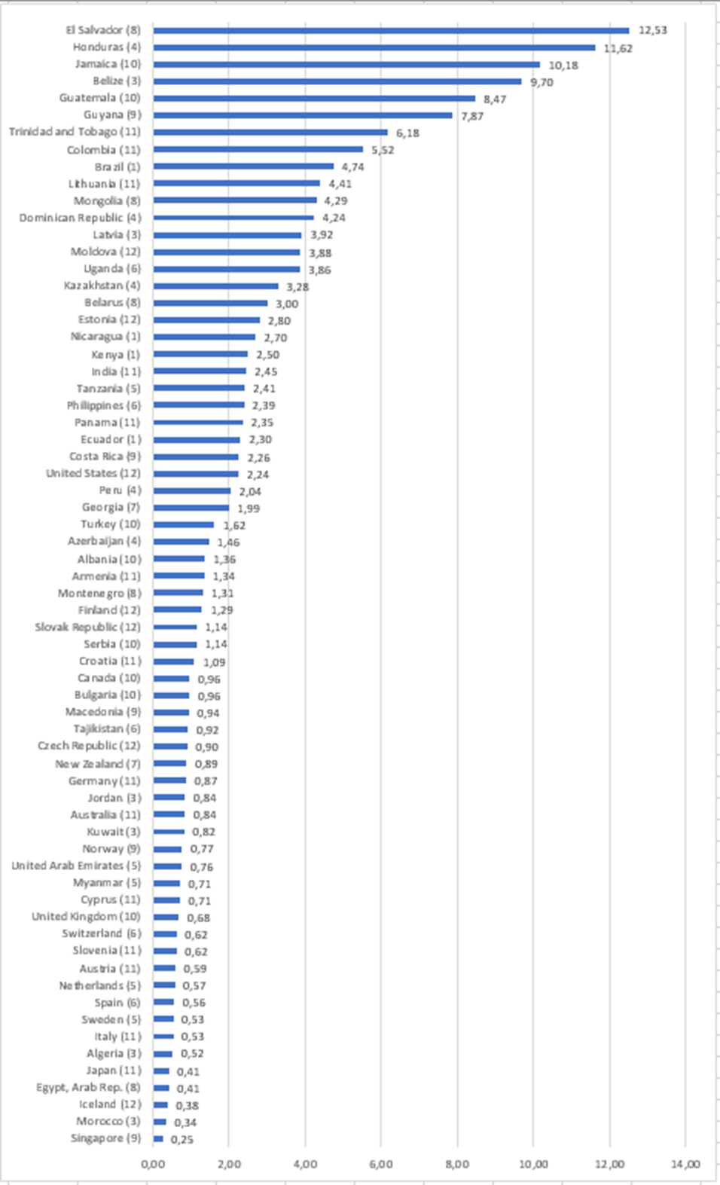

Femicide rate per 100,000 population females 2003-14*

*Countries reporting one or more annual datapoints 2003-14

|  |  |  |  |  |  |  |  |  |
| --- | --- | --- | --- | --- | --- | --- | --- | --- |
| Table 1: Femicide rate per 100,000 population and relative risk compared to 2003 | | | | | | | | |
| Year | Femicide rate per 100,000 population | | | | | Relative risk (2003 base) | | | |
|  |  | Level of income | | Level of inequality | | IRR All countries | 95% CI | | |
|  | All countries | Low-medium | High | High-medium | Low | Lower | Upper | |
| 2003 | 2.48 | 2.51 | 2.36 | 2.36 | 2.52 | 1.00 |  |  | |
| 2004 | 2.37 | 2.77 | 1.56 | 2.67 | 2.46 | 1.05 | 0.83 | 1.32 | |
| 2005 | 2.20 | 2.63 | 1.43 | 2.30 | 2.34 | 0.93 | 0.87 | 1.00 | |
| 2006 | 2.25 | 2.69 | 1.44 | 2.37 | 2.38 | 0.95 | 0.89 | 1.01 | |
| 2007 | 2.34 | 2.80 | 1.43 | 2.46 | 2.48 | 0.99 | 0.92 | 1.06 | |
| 2008 | 2.30 | 2.74 | 1.40 | 2.32 | 2.46 | 0.97 | 0.89 | 1.06 | |
| 2009 | 2.35 | 2.89 | 1.30 | 2.52 | 2.46 | 0.99 | 0.90 | 1.09 | |
| 2010 | 1.81 | 2.10 | 1.21 | 2.47 | 1.64 | 0.76 | 0.63 | 0.93 | |
| 2011 | 1.87 | 2.20 | 1.18 | 2.49 | 1.73 | 0.79 | 0.66 | 0.95 | |
| 2012 | 1.82 | 2.16 | 1.14 | 2.22 | 1.74 | 0.77 | 0.64 | 0.92 | |
| 2013 | 1.97 | 2.40 | 1.10 | 2.76 | 1.67 | 0.83 | 0.59 | 1.18 | |
| 2014 | 1.69 | 3.16 | 1.08 | 2.32 | 0.86 | 0.72 | 0.53 | 0.97 | |
| All years | 2.11 | 2.53 | 1.32 | 2.44 | 2.12 |  |  |  | |

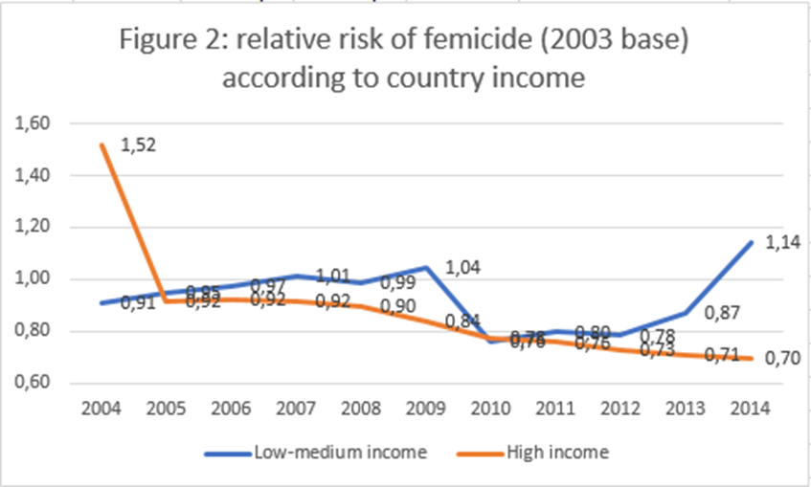

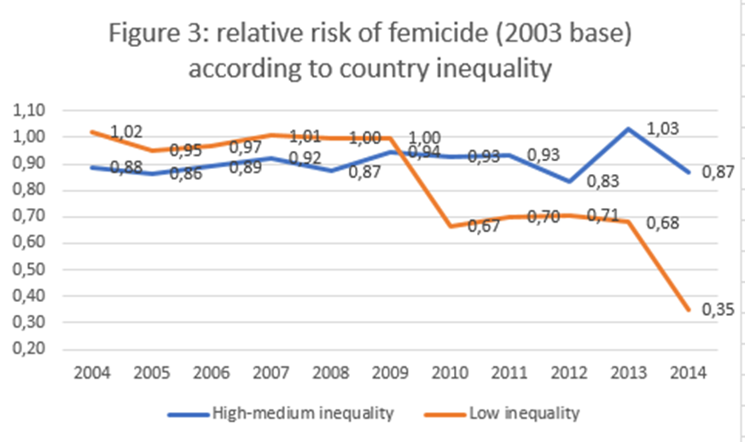

|  |  |  |
| --- | --- | --- |
| Table 2: countries adopting each anti-femicide action |  |  |
|  | N | % |
| NAP for sexual violence | 99 | 74.4 |
| NAP for IPV | 99 | 74.4 |
| Victim services: medico-legal services for sexual violence | 124 | 93.2 |
| Programme for dating violence prevention in schools | 70 | 52.6 |
| Programme for microfinance and gender equity training | 77 | 57.9 |
| Programme for social and cultural norms change – IPV | 116 | 87.2 |
| Programme for school and college – sexual violence prevention | 107 | 80.5 |
| Programme for physical environment change | 99 | 74.4 |
| Programme for social and cultural norms change – sexual violence | 118 | 88.7 |
| Law against child marriage | 120 | 90.2 |
| Law against statutory rape | 132 | 99.2 |
| Law against female genital mutilation | 67 | 50.4 |
| Law against rape in marriage | 91 | 68.4 |
| Law allowing removal of violent spouse from home | 96 | 72.2 |
| Law against rape | 131 | 98.5 |
| Law against contact sexual violence without rape | 126 | 94.7 |
| Law against non-contact sexual violence | 118 | 88.7 |

Abrahams, N., S. Mathews, L. J. Martin, C. Lombard and R. Jewkes (2013). "Intimate Partner Femicide in South Africa in 1999 and 2009." PLOS Medicine **10**(4): e1001412.

Bourey, C., W. Williams, E. E. Bernstein and R. Stephenson (2015). "Systematic review of structural interventions for intimate partner violence in low- and middle-income countries: organizing evidence for prevention." BMC Public Health **15**(1): 1165.

Corradi, C., C. Marcuello-Servós, S. Boira and S. Weil (2016). "Theories of femicide and their significance for social research." Current Sociology **64**(7): 975-995.

Dawson, M. and M. Carrigan (2021). "Identifying femicide locally and globally: Understanding the utility and accessibility of sex/gender-related motives and indicators." Current Sociology **69**(5): 682-704.

Ferguson, C. J. and S. Smith (2021). "Examining homicides and suicides cross-nationally: Economic factors, guns and video games." International Journal of Psychology **56**(5): 812-823.

Garcia-Vergara, E., N. Almeda, B. Martín Ríos, D. Becerra-Alonso and F. Fernández-Navarro (2022). "A Comprehensive Analysis of Factors Associated with Intimate Partner Femicide: A Systematic Review." International Journal of Environmental Research and Public Health **19**(12): 7336.

Jewkes, R., A. Gibbs, N. Jama-Shai, S. Willan, A. Misselhorn, M. Mushinga, L. Washington, N. Mbatha and Y. Skiweyiya (2014). "Stepping Stones and Creating Futures intervention: shortened interrupted time series evaluation of a behavioural and structural health promotion and violence prevention intervention for young people in informal settlements in Durban, South Africa." BMC Public Health **14**(1): 1325.

Luque González, A., A. B. Apunte Guerra, J. E. Robles Briones, J. Á. Coronado Martín and J. C. Morales-Intriago (2022). Analysis of the Concept of Femicide: A Study of 102 Concepts. Handbook of Research on Digital Violence and Discrimination Studies. F. Özsungur. Hershey, PA, USA, IGI Global**:** 44-71.

Marcuello-Servós, C., C. Corradi, S. Weil and S. Boira (2016). "Femicide: A social challenge." Current Sociology **64**(7): 967-974.

Matias, A., M. Gonçalves, C. Soeiro and M. Matos (2020). "Intimate partner homicide: A meta-analysis of risk factors." Aggression and Violent Behavior **50**: 101358.

Nivette, A. E. (2011). "Cross-National Predictors of Crime: A Meta-Analysis." Homicide Studies **15**(2): 103-131.

Nowak, M. (2012). Femicide: A Global Problem (Research Note 14). Geneva.

Pickett, K. and R. Wilkinson (2011). The Spirit Level: Why Greater Equality Makes Societies Stronger. New York, Bloomsbury.

Shaw, D. O. and E. W. Young (2021). "Varieties of post-civil war violence." Violence: An International Journal **2**(2): 227-252.

UN (2012). Handbook for National Action Plans on Violence Against Women. New York, United Nations Entity for Gender Equality and the Empowerment of Women.

UN Women (2020). Intensification of efforts to eliminate all forms of violence against women: Report of the Secretary-General. New York.

UNODC (2015). International Classifciation of Crime for Staistical Purposes (ICCS) version 1.0. Vienna, United Nations Office on Drugs and Crime.

UNODC (2019). Global Study on Homicide. Vienna, United Nations Office on Drugs and Crime.

UNODC (2019). Global Study on Homicide. Gender-related killing of women and girls. Vienna, United Nations Office on Drugs and Crime,.

UNODC. (2022). "The 2018 United Nations Survey of Crime Trends and Operations of Criminal Justice Systems (2018 UN-CTS)." Retrieved 06/04/22, 2022, from <https://www.unodc.org/unodc/en/data-and-analysis/statistics/crime/cts-data-collection.html>.

Vives-Cases, C., I. Goicolea, A. Hernández, B. Sanz-Barbero, A. K. Gill, A. C. Baldry, M. Schröttle and H. Stoeckl (2016). "Expert Opinions on Improving Femicide Data Collection across Europe: A Concept Mapping Study." PLOS ONE **11**(2): e0148364.

Whittington, R. and J. McGuire (2020). Violence Rewired: Evidence and Strategies for Public Health Action. Cambridge, Cambridge University Press.

Wolf, A., R. Gray and S. Fazel (2014). "Violence as a public health problem: An ecological study of 169 countries." Social Science & Medicine **104**(0): 220-227.

World Bank (2022). Databank.

World Health Organisation (2002). World Report on Violence and Health. Geneva, WHO.

World Health Organisation (2014). Global Status Report On Violence Prevention. Geneva, Switzerland.

World Health Organisation (2014). Global Status Report on Violence Prevention 2014. Geneva.

World Health Organisation. (2017). "Global Campaign for Violence Prevention." from <http://www.who.int/violence_injury_prevention/violence/global_campaign/en/>.

World Health Organisation (2022). Violence Prevention Information System (Violence Info). WHO.