Random Forest Explanation

* Random Forest is an ensemble learning method for classification, which means it combines several learning algorithms together which improves the predictive performance compared to using any of the algorithms alone
* They operate by constructing a multitude of [decision trees](https://en.wikipedia.org/wiki/Decision_tree_learning) at training time and outputting the class that is the [mode](https://en.wikipedia.org/wiki/Mode_(statistics)) of the classes (classification) or mean prediction (regression) of the individual trees.
* Say you are trying to predict whether an image contains a hand. If you have, for example, 1000 random forests, each of them will predict a class (hand or no hand) **for the same test feature** (# of skin-colored pixels).
* Also, a subset of all random forests will look at a random set of features (eg. fingers, thumbs, …) and vote what they think it is.
* After each feature has had a vote, the higher level decision tree will determine whether or not the image is of a hand.

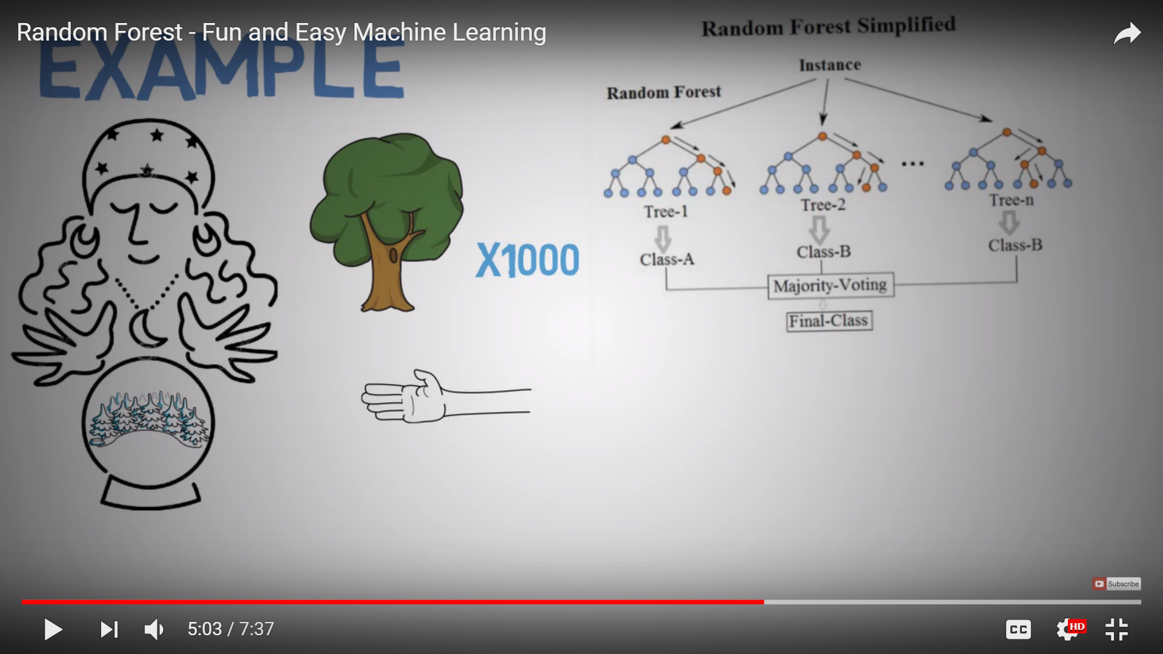

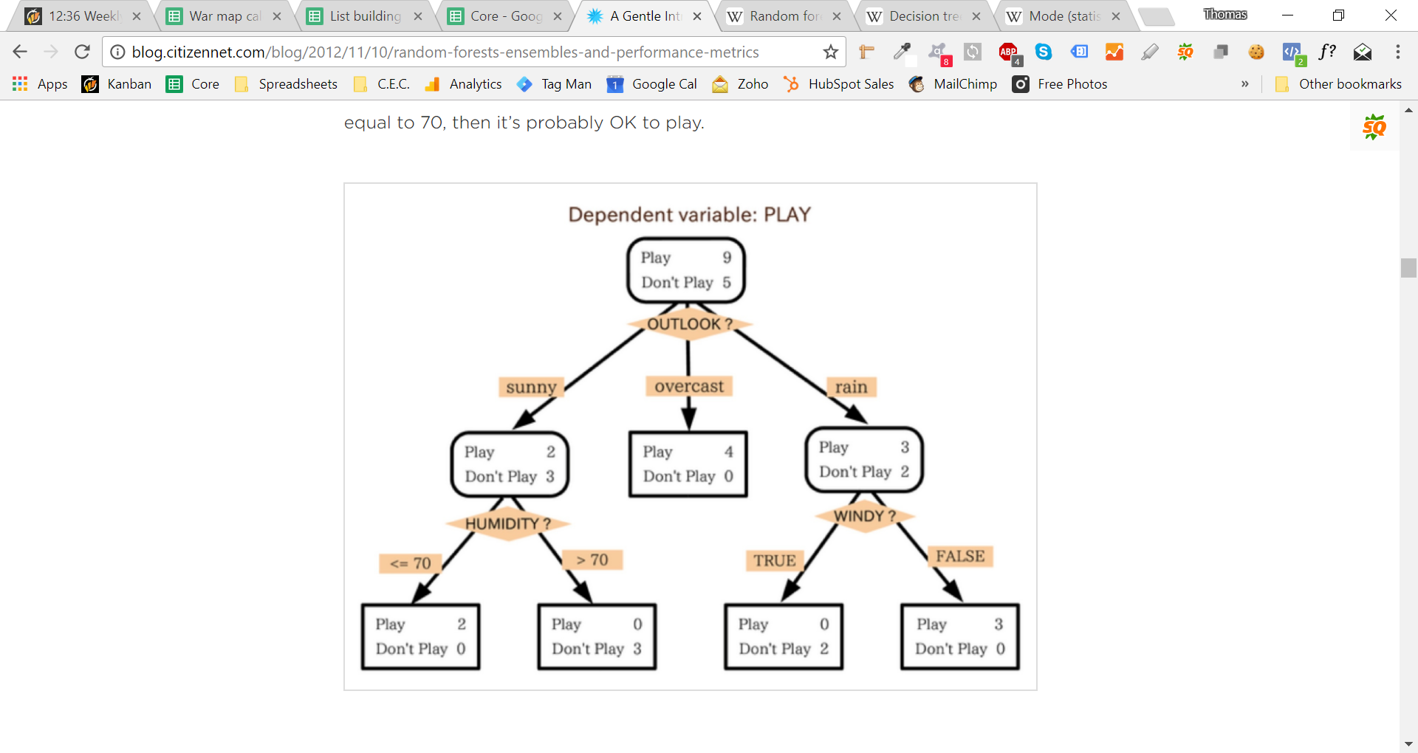

* Cross Validation: If you had 100 different images, and wanted to determine whether an image contained a face, you could train your data to find the best possible weights to assign to each input/predictor variable (eg. contains_nose) **for 99/100** images, and then use that trained algorithm to predict the 100th. Do that process for each of the 100 images.